Architectural Enhancements to YOLOv12 for Improving Detection of Thoracic Pathologies in Chest X-rays

Ruxandra Andro
Computer Science Department
Technical University of Cluj-Napoca
Cluj-Napoca, Romania
andro.re.ruxandra@student.utcluj.ro
Cristian-Cosmin Vancea
Computer Science Department
Technical University of Cluj-Napoca
Cluj-Napoca, Romania
cristian.vancea@cs.utcluj.ro

Abstract—In recent years, artificial intelligence has played a pivotal role in advancing medical imaging, particularly in the early detection of thoracic diseases through chest X-rays. Latest efforts have been successful in proposing deep learning solutions for accurate classification of different pathologies. The objectives have been refocused towards improving the detection of different signs of disease. We propose an original deep learning model for affected area detection. The model is based on the YOLOv12 object detection architecture, which was enhanced specifically for medical use cases. The improvements include attention mechanisms, deformable convolutions, and feature aggregation modules such as FPN and PANet. We created a custom dataset, mainly a combination of two public chest X-ray datasets, which were augmented to train our model. Experimental results demonstrate that the proposed model achieves a mAP@0.5 of 0.374 and a Recall of 0.519, outperforming existing models, including baseline YOLOv12, YOLOv11, YOLOv8, and Faster R-CNN on these key metrics. Despite the architectural enhancements, inference time remained competitive at 6.3 ms per image. The model shows high reliability in identifying four key thoracic pathologies: cardiomegaly, aortic enlargement, pulmonary nodules/masses, and pleural effusion. These findings suggest that optimized YOLOv12-based models can serve as effective diagnostic support tools in clinical and remote healthcare settings.
Keywords—YOLOv12, chest X-ray, thoracic pathology detection, CBAM, deformable convolution, deep learning, object detection, Faster R-CNN

Introduction
Chest radiography is among the most frequently employed diagnostic imaging techniques, with an estimated 3.6 billion chest X-rays performed annually worldwide [1], especially for pulmonary and cardiac assessments. X-rays represent one of the most commonly used diagnostic imaging techniques due to their affordability, wide availability, and diagnostic utility in identifying pulmonary, cardiac, and skeletal abnormalities. However, interpreting chest X-rays remains a significant challenge, even for trained radiologists, due to overlapping anatomical structures, subtle visual cues, and variability in image quality [2]. These complexities can lead to diagnostic inaccuracies, particularly in resource-limited settings with a shortage of radiologists.
Recent advancements in deep learning, specifically Convolutional Neural Networks (CNNs), have greatly enhanced automated image analysis in medical contexts [3]. CNN-based systems like ChestNet [4], which incorporate attention mechanisms, have improved detection of thoracic diseases, such as pleural effusion and cardiomegaly. Yet, most models still underperform on grayscale medical images, mainly due to their training on natural image datasets and lack of mechanism focus on varying scales and context.
Nowadays, object detection frameworks from the YOLO (You Only Look Once) family [5] are renowned for their real-time performance and high throughput, but their typical designs and training regimes are tailored to RGB datasets like COCO [6]. Recently, YOLOv12 [7] has emerged as the latest evolution, integrating attention-centric modules – notably Area Attention and R-ELAN – to enhance feature representation while preserving fast inference. Based on thorough analysis, we focused our interest on YOLOv12 due to its novel attention mechanisms, which enable more precise localization and robustness when analyzing complex medical images such as chest X-rays.
In this study, we propose an original medical-adapted YOLOv12 model for thoracic pathology detection in chest X-ray images. The architecture incorporates several key enhancements tailored to our domain, including the integration of several deep learning specific modules:
- the Convolutional Block Attention Modules (CBAMs) emphasize diagnostically relevant channel and spatial features;
- the use of deformable convolutions accommodates variations in lesion shapes and anatomical positions;
- the addition of a high-resolution branch and an extra detection head – through the extension of the feature aggregation pathway FPN/PANet – improves the sensitivity to small-scale abnormalities.
The model is trained and evaluated on a custom dataset, generated by merging and augmenting two public chest X-ray collections with annotations corresponding to four target classes of lesion: cardiomegaly, aortic enlargement, pulmonary nodules/masses and pleural effusion. We compare its performance against prior YOLO versions and the benchmark Faster R-CNN, analyzing key metrics such as mean Average Precision (mAP), Precision, Recall and inference speed.
In summary, this work contributes a custom-optimized YOLOv12 model for X-ray medical imagery, tailored for fine-grained thoracic abnormality detection. The proposed approach includes several key innovations:
- Architectural enhancements, including: 1) insertion of a high-resolution detection head P2 to improve localization of small lesions; 2) integration of CBAM attention modules at deeper levels, P4 and P5, respectively, to refine feature focus; 3) inclusion of deformable convolutions in the backbone to enhance adaptability to irregular lesion shapes.
- Development and use of a curated thoracic pathology dataset, combining filtered subsets of VinBigData and NIH ChestX-ray14, harmonized into four common pathology classes.
- The improvements are validated through extensive tests against state-of-the-art models using most common key metrics.
The remainder of this paper is organized as follows: Section II reviews related work on automated pathology detection in medical imaging, with an emphasis on CNN- and YOLO-based models. Section III describes the proposed architecture, detailing the custom adaptations introduced in YOLOv12 for improving chest X-ray analysis. Section IV outlines the datasets, the preprocessing steps and the training setup, followed by performance analysis with most relevant metrics. Section V summarizes the main findings and finally, section VI discusses future research directions.

Related Work
The concept of automated pathology detection in chest X-ray imaging has received increasing attention due to its importance in early diagnosis and triage support, particularly in overburdened healthcare systems. Traditional methods based on manual interpretation are prone to variability and errors, especially in complex thoracic cases. Recent advances in deep learning have significantly improved detection performance, with models such as CNNs and Vision Transformers showing great promise in clinical image analysis. To contextualize our proposed YOLOv12-based architecture, this section reviews relevant approaches classified across several categories.

Traditional feature-based methods
Earlier medical image analysis methods relied heavily on handcrafted features, such as texture descriptors or shape-based heuristics. These approaches required expert knowledge and manual preprocessing, often leading to limited generalizability across datasets.
We underline the impact of radiomics-based techniques [8][9], which extracted predefined statistical and morphological features from regions of interest, later classified using machine learning models. Although interpretable and data-efficient, their performance was highly dependent on accurate segmentation and lacked robustness in complex scenarios.

CNN-based deep learning methods
Convolutional Neural Networks (CNNs) [10] have revolutionized the field of medical image analysis by enabling automatic learning of hierarchical visual representations directly from pixel-level data. Through convolutional filters, pooling layers, and deep network architectures [11], CNNs can efficiently capture both local and high-level semantic features from X-rays or MRI scans, improving performance in classification, detection, and segmentation tasks.
Compared to radiomics, CNN models eliminate the need for manual feature engineering and offer superior scalability when large, annotated datasets are available. According to [12], their reliance on local receptive fields can limit their ability to model long-range dependencies across spatially distant regions of the image, which is critical in thoracic pathology detection where lesions may present in diverse anatomical locations.

Vision Transformers in medical imaging
To overcome the local limitations of CNNs, Vision Transformers (ViTs) have been proposed as an alternative architecture [12][13]. Based on self-attention mechanisms, ViTs can capture global spatial relationships and dependencies between distant image regions. This allows for better context modeling in complex diagnostic tasks, such as differentiating between overlapping or diffused pathologies in chest radiographs.
A recent study [14] has demonstrated that ViTs outperform CNNs in tasks like COVID-19 or pneumonia detection, particularly when trained on large datasets. However, ViTs often require significantly more data and computational resources, and may underperform when training samples are limited.

Hybrid and multi-modal models
To combine the strengths of CNNs and Transformers, hybrid architectures such as TransMed [15] have been developed for multi-modal classification tasks. These models use CNNs (e.g. ResNet-50 [16]) to extract local features from medical images and integrate them with Transformer-based encoders to model long-range dependencies and cross-modal relationships, such as combining radiographic data with clinical text. TransMed has demonstrated improved performance in various diagnostic scenarios, including classification of parotid tumors and joint abnormalities.

Object detection in chest imaging
While classification models detect disease presence, object detection frameworks like Faster R-CNN [17] and YOLO [18] enable spatial localization of abnormalities in radiographs. These models not only identify whether a pathology is present but also pinpoint its exact location within the image.
Faster R-CNN achieves high accuracy in tasks such as pulmonary nodule detection, though it requires more inference time due to its two-stage architecture: an initial region proposal network (RPN) identifies candidate areas, followed by a second stage that classifies and refines these detections.
The alternative YOLO model is a one-stage detector, which predicts object locations and classes in a single pass through the network. This streamlined approach provides fast and reasonably accurate detection, making it attractive for real-time applications and easily tailored for fine-grained specific details [19]. Moreover, YOLO-based models have been successfully applied in medical imaging tasks such as COVID-19 and tuberculosis detection, particularly in thoracic radiographs. Their real-time inference capabilities make them suitable for time-sensitive clinical environments, despite generally lower precision compared to two-stage detectors [20][21].
Recent advancements in YOLO-based models adapted for medical imaging continue to show remarkable promise. For instance, a YOLOv11-derived model [22], redesigned with modules such as DCNv2 and DynamicConv, significantly boosted detection accuracy in pneumonia diagnosis tasks, achieving strong generalization and low inference latency. While employing noise-suppression mechanisms that significantly improved both detection accuracy and speed for thoracic pathologies, the more recent NSEC YOLO model [23] further reinforces the applicability of the YOLOv12 family in clinical imaging tasks.
Unlike ViT-based approaches, which achieve strong accuracy, but depend on very large datasets and substantial computational resources, YOLO offers a faster and more practical solution for medical tasks with limited training data. Our contribution goes beyond prior YOLO-based studies by integrating attention modules, deformable convolutions, and enhanced multi-scale aggregation within YOLOv12. This combination, not previously explored in medical imaging, improves sensitivity to small and variable lesions while maintaining real-time inference speed.

Proposed Solution
After carefully analyzing the pros and cons of existing models, the standard YOLOv12 architecture was selected as the base model. One of its main innovations is the use of A2C2f blocks (also referred to as Residual-Enhanced Local Attention Networks, or R-ELAN), which combine area-based attention and lightweight feed-forward layers, to enhance local feature extraction. These modules improve the model's ability to capture spatial relationships and refine representations across multiple scales, without significantly increasing computational cost.

Key aspects of our model architecture
To tailor the YOLOv12 architecture to the specific requirements of thoracic pathology detection in chest radiography, several structural enhancements were necessary to improve sensitivity to small or low-contrast lesions and to leverage multi-scale localization. The following subsections outline the architectural changes adopted in our approach.

Insertion of high-resolution detection branch P2
To enhance the detection of small or poorly contrasted thoracic lesions, a supplementary detection head was introduced at the P2 resolution level (1/4 scale). This high-resolution branch enables predictions on fine-grained feature maps, increasing the model's ability to localize subtle abnormalities that may be lost through successive downsampling in deeper layers.
In a standard YOLO architecture, detections are typically performed at low resolution P3, P4 and P5 levels, where repeated spatial reductions often lead to loss of fine details – an important drawback when identifying early-stage or low-contrast pathologies. By extending the PANet to also propagate features up to the P2 level, the model gains improved spatial granularity while retaining semantic richness from deeper layers.
As illustrated in Fig. 3, the proposed architecture incorporates this enhancement, with the newly added P2 branch emphasized by a dashed outline. This modification was integrated into the neck of the network through additional upsampling and feature concatenation blocks, enabling high-resolution predictions with minimal disruption to the original architecture.

Integration of enhanced attention modules
To improve the model’s focus on diagnostically relevant regions, Convolutional Block Attention Modules (CBAMs [24]) were integrated into the neck section of YOLOv12.
CBAM refines feature maps by sequentially applying channel attention and spatial attention (Fig. 1), allowing the network to selectively emphasize informative features and suppress irrelevant ones. In medical imaging, thoracic lesions are often subtle, with low contrast or irregular textures that make them difficult to distinguish from surrounding tissue. By incorporating CBAMs, the model is guided to attend more precisely to such areas, improving robustness in scenarios involving overlapping structures or diffuse patterns.
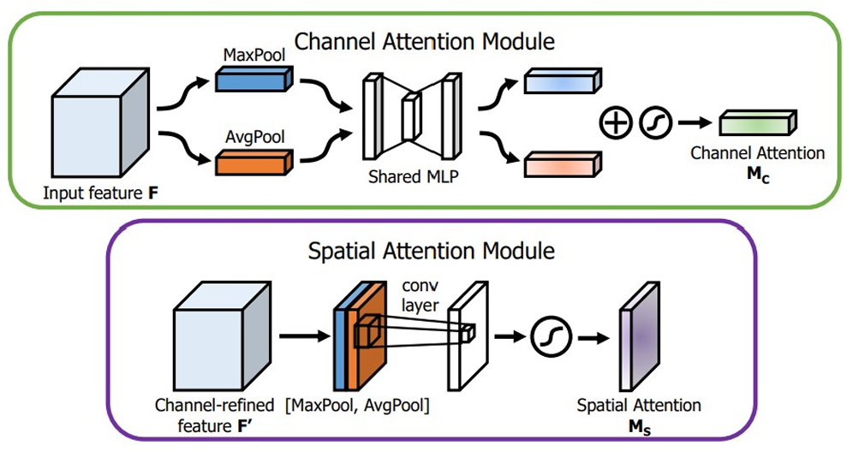
Fig. 1. Structure of the CBAM attention mechanism [24]
The modules were inserted multiple times, just before the detection heads, at resolution levels P4 and P5 (Fig. 3), which are rich in semantic features, but more prone to spatial detail loss. This choice enables a recalibration mechanism sharpening the network’s ability to localize significant details in deeper layers.

Convolution replacement with deformable convolution
Standard convolution operates with fixed geometric sampling patterns, which limits their ability to adapt to irregular or distorted shapes. In medical imaging, the lesions often vary in size, shape and orientation. To address such limitation, we replaced a convolutional layer in the backbone with deformable convolution. Deformable convolutions dynamically learn offsets for sampling locations, allowing the receptive field to adapt its shape based on local image content. Fig. 2 illustrates the concept of deformable convolution, where learnable offsets guide the sampling pattern of the convolutional kernel, improving localization of complex structures in thoracic pathologies.
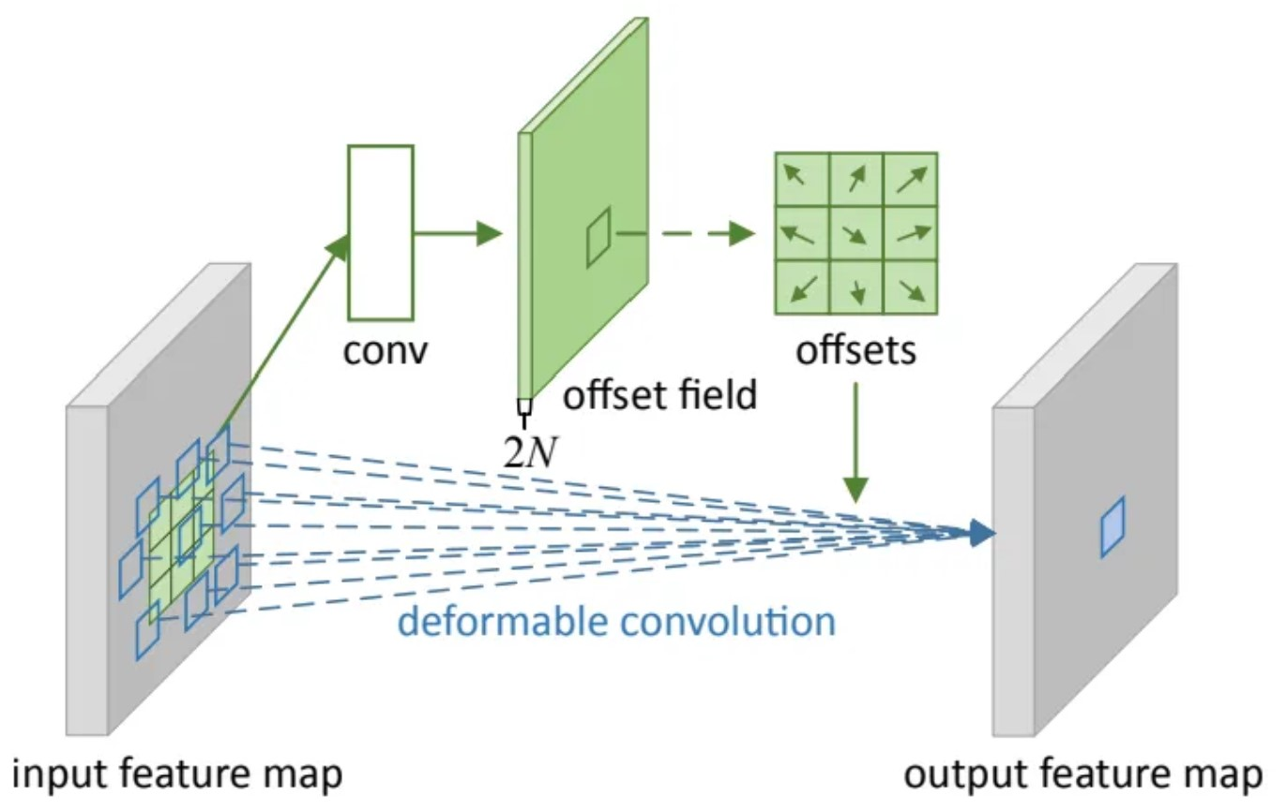
Fig. 2. Deformable convolution strategy depicted [25]

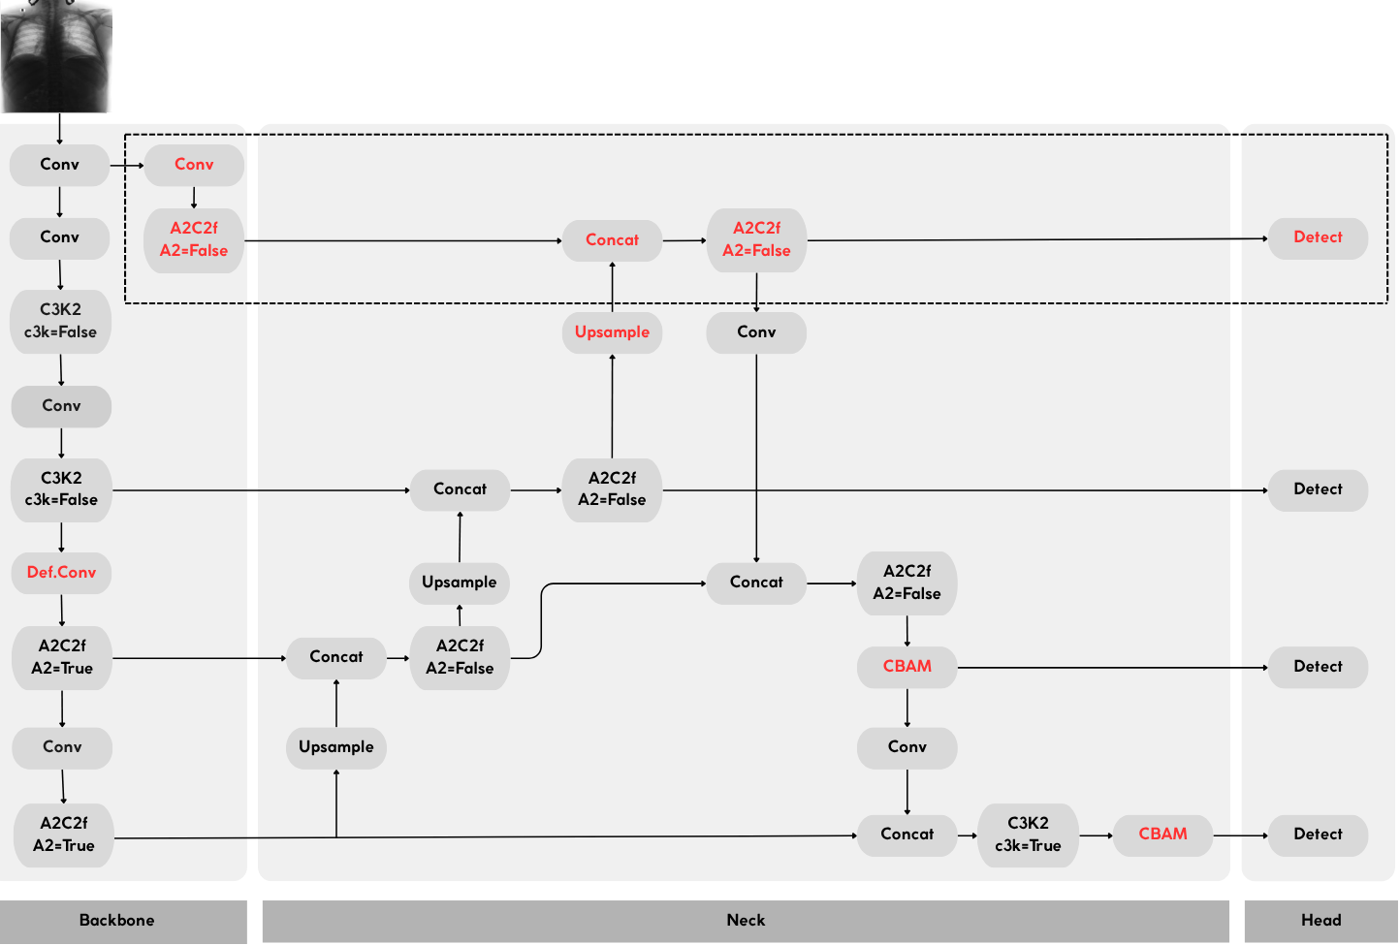
Fig. 3. Architecture of the proposed model (in dashed outline – the high-resolution detection branch added to YOLOv12; in red – other changes)

In the proposed architecture, the deformable convolution layer was inserted in the deeper region of the backbone (Fig. 3) to enhance feature extraction at low resolutions, where high-level semantic information is present, but fine spatial details may be lost. This placement maximizes the impact on spatial adaptability, while keeping the computational overhead minimal.

Extension of the Feature Pyramid and PANet
To support the newly added P2 level, the Feature Pyramid Network (FPN) was extended to propagate features to higher-resolution layers, enabling more precise detection of small-scale lesions. This propagation ensures that semantically rich features from deeper layers reach the P2 scale. While the FPN was extended through additional upsampling, to generate high-resolution representations at P2, the PANet structure was preserved for detection levels P3 to P5. In the bottom-up path, PANet continues to refine and merge features from P3 upwards but does not incorporate P2 in the fusion process. This design choice reduces computational overhead, while allowing P2 to retain fine-grained spatial detail, specifically optimized for small-object detection.
Overall, the combined effect of the extended FPN and the preserved PANet improves the model's multi-scale representation capacity, leveraging both localization accuracy and contextual awareness across lesion sizes.

Incremental model prototypes
We developed a series of intermediate YOLOv12 prototypes to progressively evaluate the impact of each architectural enhancement. An ablation study and quantitative results are presented in Section IV.D.

Experimental Results
We conducted a series of experiments using two medical imaging datasets composed of annotated chest X-rays. The evaluation focused on both quantitative results and qualitative observations, highlighting the model's ability to detect subtle thoracic abnormalities. In this section, we present the experimental setup, the training behavior and detection performance.

Datasets and experimental setup
The training and evaluation of the proposed model were carried out using a combination of two publicly available datasets:
- VinBigData Chest X-ray Abnormalities Detection: This dataset [26] contains 18,000 chest radiographs in DICOM format, each annotated with bounding boxes associated to 14 types of thoracic abnormalities confirmed by expert radiologists. For this study, only the four most frequent pathology classes were retained, to ensure sufficient sample size per class.
- NIH ChestX-ray BBox Subset: A filtered subset of the NIH ChestXray14 dataset [27], containing 880 images that match the four retained classes from VinBigData. All annotations were converted to a unified bounding box format to ensure compatibility and consistency across datasets.
After merging and filtering, the final dataset consisted of 3975 images, distributed across five classes: aortic enlargement (1117 instances), cardiomegaly (981), nodule/mass (398), pleural effusion (439), and normal (1040). A stratified split was applied to preserve class proportions, resulting in 70% training, 15% validation, and 15% test sets.
All images were resized to 768×768 pixels. To address class imbalance, especially for underrepresented categories like nodule/mass and pleural effusion, the training set was supplemented with extensive data augmentation, bringing each class to approximately 1,000 samples. Applied transformations included: random rotations, contrast and brightness variation, Gaussian noise injection and CLAHE (Contrast Limited Adaptive Histogram Equalization) enhancement. Advanced augmentations such as Mosaic, MixUp, and Copy-Paste were intentionally disabled to reduce the risk of overfitting in this medical context.
To ensure a fair comparison, all YOLOv12 variants were trained using the same hyperparameters, initialized with pretrained COCO weights. Training used a batch size of 32, 768×768 image resolution, AdamW optimizer with 5-epoch warmup, and L2 weight decay of 0.0005. Similarly, the Faster R-CNN model was initialized with a pretrained ResNet50 backbone and adapted to our classes. This consistent setup allows for reproducible and comparable results across all models.

Evaluation metrics
To assess detection performance, we used the standard set of object detection metrics:
- Intersection over Union (IoU) is a standard metric used to evaluate the overlap between the predicted bounding box (B_{pred}) and the ground truth (B_{gt}): $IoU=\frac{Area\left(B_{pred}∩B_{gt}\right)}{Area\left(B_{pred}∪B_{gt}\right)}$ (1)
- Precision (P) indicates the proportion of correct predictions among all predicted bounding boxes: $Precision=\frac{TP}{TP+FP}$ (2)
- Recall (R) reflects the model’s ability to detect all relevant objects: $Recall=\frac{TP}{TP+FN}$ (3)
- Average Precision (AP) is computed for each class as the area under the Precision–Recall curve: $AP=\int_{0}^{1}{Precision\left(r\right)dr}$ (4)
- mean Average Precision (mAP) represents the average AP across all N classes. We report mAP@0.5 (using IoU ≥ 0.5) and mAP@0.5:0.95 (averaged over IoU thresholds from 0.5 to 0.95 with 0.05 step): $mAp=\frac{1}{N}\sum_{i=1}^{N}{AP_{i}}$ (5)

Results in the training phase
Fig. 4 illustrates the training dynamics, showing the evolution of loss values for our best model, YOLOv12_proposed. The consistent decrease in both box and classification losses suggests stable convergence and effective learning without signs of overfitting.
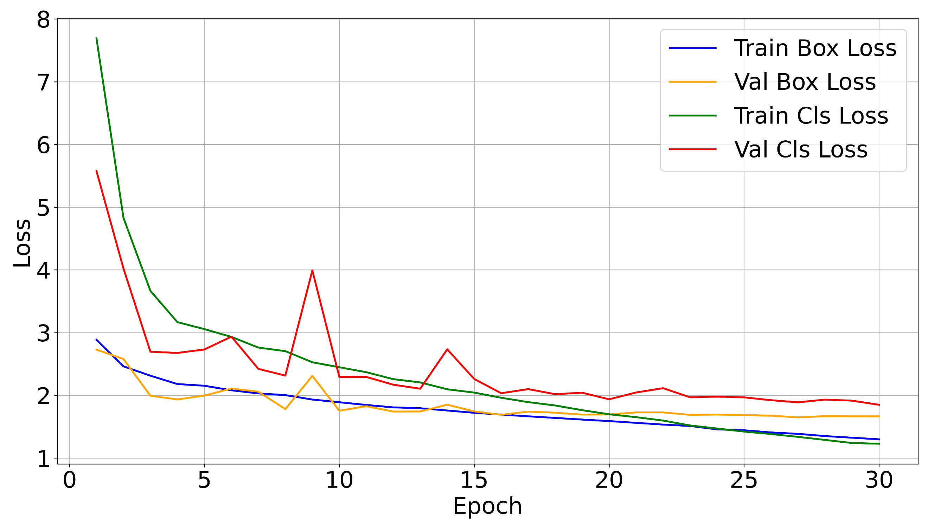
Fig. 4. Evolution of the loss function components during training for our best model
We conducted initial tests on the validation split, which consisted in monitoring the mean Average Precision (mAP) behavior during training. Considering the objectives of our work, we have chosen the mean Average Precision (mAP) metrics, which are most relevant for the detection task. Fig. 5 highlights the progressive increase in mAP for our best model. This happens in conjunction with the decrease of the loss function, demonstrating a good convergence in the training process. m@AP@0.5:0.95 is usually below m@AP@0.5 due to its more constraining threshold values.
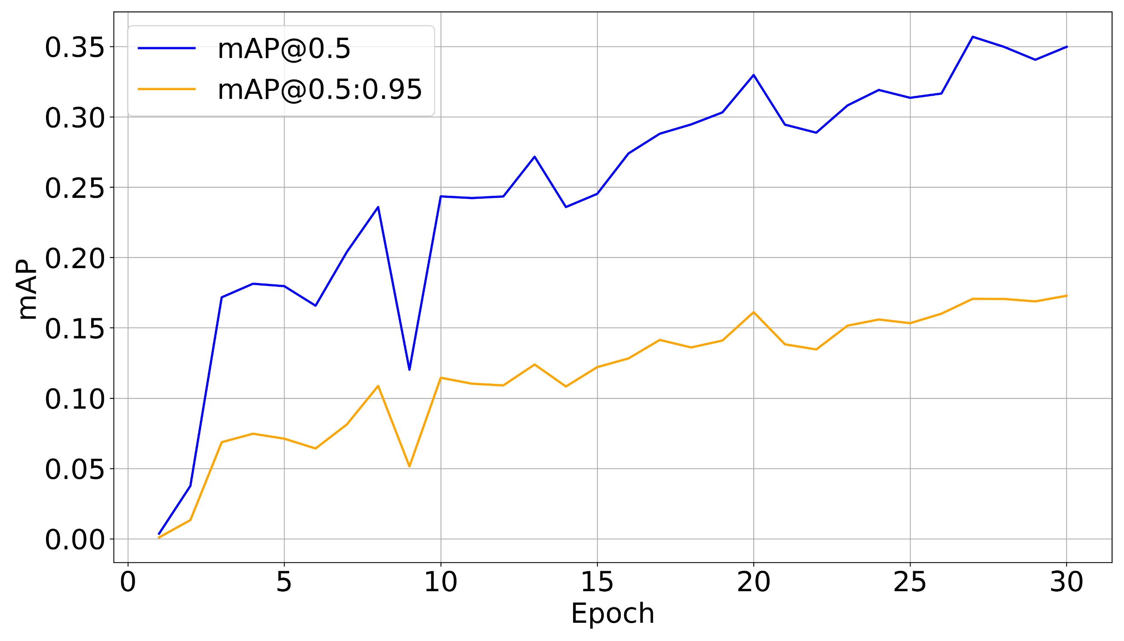
Fig. 5. Evolution of key performance metrics in the training phase for our best model. Results were registered for the validation set

Results obtained on the test set
For the evaluations performed on the test set we used the following standard metrics: Precision, Recall, mAP@0.5, and mAP@0.5:0.95. Additionally, we also monitored the inference time. The tests were performed on a station equipped with two Intel Xeon@2.2GHz CPU cores, 12GB of RAM, and Nvidia A100 GPU card hosting 40GB of VRAM.

Ablation Study
To assess the impact of each architectural component, we intiated an ablation study using intermediate YOLOv12 prototypes (TABLE I. ). We emphasize the following aspects:
- YOLOv12_wHR (/w High Resolution): Adding a P2 detection head improved sensitivity to small nodules by providing higher-resolution features, but slightly reduced Precision due to more false positives.
- YOLOv12_wHR_CB: CBAM modules on P3, P4 and P5 enhanced Recall by focusing on low-contrast or diffuse regions, with minor Precision trade-offs.
- YOLOv12_wHR_CB_DC: Replacing standard convolutions with deformable convolutions on P3 and P4 allowed the network to adapt to irregularly shaped lesions. Nevertheless, the simultaneous use of CBAM and DeformConv (DC) occasionally introduced redundancy, leading to unstable performance for small or poorly defined abnormalities, and increased inference time.
- YOLOv12_proposed: The final configuration refines these components by selectively applying CBAM only to higher receptive-field levels (P4, P5), retaining DeformConv on P4, and preserving the P2 branch for small-object detection (Fig. 3). This design balances sensitivity and stability, yielding the best trade-off between Precision, Recall, and inference time.
Overall, the ablation study shows that each module contributes to specific aspects of performance – P2 improves sensitivity to small lesions, CBAM enhances focus on relevant regions, and Deformable Convolutions adapt to irregular shapes. Their combination in the proposed model balances these trade-offs, yielding the most robust overall performance.
- Performance of the proposed models on the test set
Model | Precision | Recall | mAP@  0.5 | mAP@  0.5:0.95 | Time  [ms]
YOLOv12_wHR | 0.291 | 0.496 | 0.354 | 0.178 | 6.3
YOLOv12_wHR_CB | 0.320 | 0.479 | 0.335 | 0.172 | 6.6
YOLOv12_wHR_ CB_DC | 0.319 | 0.491 | 0.342 | 0.173 | 7.9
YOLOv12_proposed | 0.373 | 0.519 | 0.374 | 0.178 | 6.3

Comparison with state-of-the-art
To comprehensively evaluate the proposed architectures, we compared their performance against state-of-the-art object detection models:
- YOLOv8 [28]: Being one of the latest evolution in the YOLO family, YOLOv8 adopts an anchor-free detection mechanism, directly regressing object coordinates without relying on predefined anchor boxes. This reduces complexity and improves generalization across diverse datasets. The model features a modular architecture (Backbone–Neck–Head) offering a good balance between accuracy and inference speed.
- YOLOv11 [29]: An improved version of YOLOv8, YOLOv11 retains the anchor-free structure, but integrates additional attention mechanisms—particularly the C2PSA (Cross-Stage Partial Spatial Attention) blocks—designed to enhance spatial focus on small or overlapping objects. The architecture increases model depth and complexity, to boost detection accuracy in more challenging scenarios.
- Faster R-CNN [17]: A two-stage detector known for its high precision, especially in medical imaging tasks. It first proposes candidate regions using a Region Proposal Network (RPN), followed by classification and bounding box regression. While computationally heavier and slower, it has been previously established as a reliable standard for medical detection tasks due to its superior localization capabilities.
As shown in TABLE II. , our model achieved higher Recall and mAP@0.5 compared to the baseline YOLOv12, while maintaining competitive performance on the remaining metrics: only 0.004 under YOLOv11 for mAP@0.5:0.95, and 0.01 less then YOLOv8 for Precision. Although our model shows a slightly lower Precision compared to some baselines, the gain in Recall is clinically more relevant. Particularly for thoracic pathologies, missing a true lesion (False Negative) can have severe consequences for patient outcomes, potentially delaying diagnosis or treatment. By contrast, a higher number of False Positives primarily results in additional examinations or follow-up, which, while inconvenient, is less critical than missing a pathology. Therefore, the design choice favoring higher Recall provides a safer trade-off in clinical practice, ensuring subtle or small lesions are less likely to be missed.
- Performance vs. state-of-the-art models
Model | Precision | Recall | mAP@  0.5 | mAP@  0.5:0.95 | Time  [ms]
YOLOv12_proposed (ours) | 0.373 | 0.519 | 0.374 | 0.178 | 6.3
YOLOv12 | 0.381 | 0.446 | 0.359 | 0.175 | 4.5
YOLOv11 | 0.334 | 0.510 | 0.355 | 0.182 | 6.5
YOLOv8 | 0.383 | 0.489 | 0.353 | 0.180 | 1.9
Faster R-CNN | - | - | 0.271 | 0.115 | 17.5

Despite the additional layers, the inference time increased from 4.5 ms for the baseline YOLOv12 to 6.3 ms per image (+40%). Nevertheless, this moderate increase remains compatible with real-time clinical requirements, while providing notable improvements in detection performance.

Performance on the Nodule/Mass category
The Nodule/Mass class is known to be particularly challenging to detect due to the small size and ambiguous appearance of such lesions in chest radiographs. The focus on the Nodule/Mass class is motivated both by its inherent visual difficulty and its clinical significance. Nodules are often subtle and difficult to distinguish from background structures in medical images. Therefore, any performance gain in this class directly contributes to the practical utility of the model in real-world diagnostic scenarios.
According to TABLE III. our YOLOv12_proposed model achieved a substantial improvement over the baseline YOLOv12, with a +0.092 gain in mAP@0.5, alongside notable increases in mAP@0.5:0.95 (+0.042) and Recall (+0.066) for this class. The top result for mAP@0.5:0.95 was achieved by our YOLOv12_wHR_CB model, while YOLOv12_proposed classified 3rd, with only 0.007 below YOLOv8.
- Detection performance on Nodule/Mass class
Model | Recall | mAP@0.5 | mAP@0.5:0.95
YOLOv12_proposed (ours) | 0.233 | 0.182 | 0.070
YOLOv12 | 0.167 | 0.091 | 0.032
YOLOv11 | 0.166 | 0.119 | 0.060
YOLOv8 | 0.217 | 0.157 | 0.077
Faster R-CNN | - | 0.066 | 0.015
YOLOv12_wHR (ours) | 0.100 | 0.045 | 0.018
YOLOv12_wHR_CB (ours) | 0.200 | 0.171 | 0.093
YOLOv12_wHR_ CB_DC (ours) | 0.217 | 0.104 | 0.046

These improvements indicate an enhanced sensitivity to fine details and small-scale abnormalities, an essential requirement in the early detection of thoracic diseases.
To further validate the effectiveness of the proposed YOLOv12_proposed model, a series of qualitative experiments were conducted by visually comparing its predictions with other state-of-the-art models, including YOLOv8s, YOLOv11s, YOLOv12, and Faster R-CNN. The selected examples highlight challenging cases involving subtle or small lesions from the Nodule/Mass category, known for their detection difficulty due to low contrast and ambiguous appearance in chest radiographs.
Case 1 – Subtle pulmonary nodule
Fig. 6 illustrates a test case containing a small pulmonary nodule, which is challenging to detect due to its reduced size, low contrast, and peripheral placement. The green box represents the ground truth provided by expert radiologists. The interpretation of results among the tested models is based on the following assessments:
- YOLOv12_proposed successfully detected the lesion and estimated a confidence score of 0.29 for the bounding box, with an IoU above 0.5. Although the confidence is not high, it exceeds the detection threshold and aligns well with the ground truth, resulting in a valid True Positive sample. This indicates improved sensitivity to low-contrast and small-scale abnormalities.
- YOLOv8 detected the lesion with a confidence of 0.27, higher than 0.25 detection threshold. The prediction overlaps well with the ground truth, qualifying as a valid True Positive, although with lower confidence compared to the proposed model.
- YOLOv11 produced a False Positive, incorrectly identifying a pleural effusion on the opposite side of the image, unrelated to the ground truth lesion.
- YOLOv12 failed to detect the nodule altogether, with no valid predictions above the threshold. Consequently, there is no visible result in Fig. 6 for this model.
- Faster R-CNN generated multiple predictions, but none accurately matched the ground truth. The “Nodule/Mass” box was misaligned despite a confidence of 0.59. Additional predictions, such as “Cardiomegaly” and “Aortic enlargement” were False Positives, reflecting limited localization accuracy for small lesions.
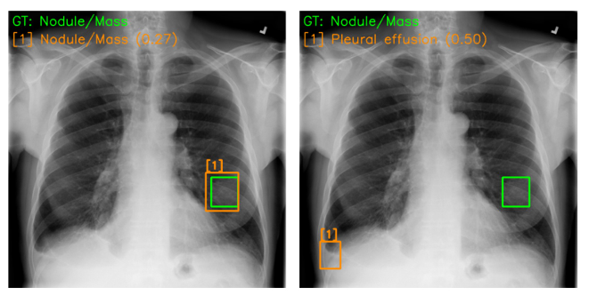
(a) YOLOv8 (b) YOLOv11
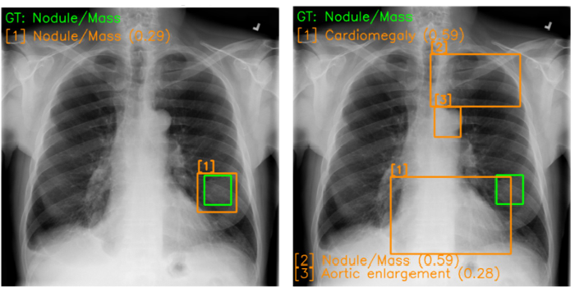
(c) YOLOv12_proposed (d) Faster R-CNN
Fig. 6. Detection results for a challenging nodule/mass situation
This case demonstrates the capability of the proposed model to detect clinically relevant lesions even when they are small, ill-defined or located in difficult regions of the image.
Case 2 – Prominent ground-truth nodule
In a second example (Fig. 7), the ground truth nodule is centrally located and more visually distinguishable. This case represents a typical pathology with better contrast and a defined structure. Upon detailed analysis we emphasize the following observations:
- Our model (YOLOv12_proposed) predicted the lesion with a confidence of 0.85, correctly aligning the bounding box with the ground truth.
- Faster R-CNN also detected the lesion, but with a lower confidence (0.82) and a less accurate bounding box placement. Additionally, it generated a False Positive for Aortic enlargement, which is not supported by the image.
- The other YOLO baselines (YOLOv8s, YOLOv11s and YOLOv12s, respectively) failed to detect the lesion. Either no prediction was made, or the confidence was below threshold.
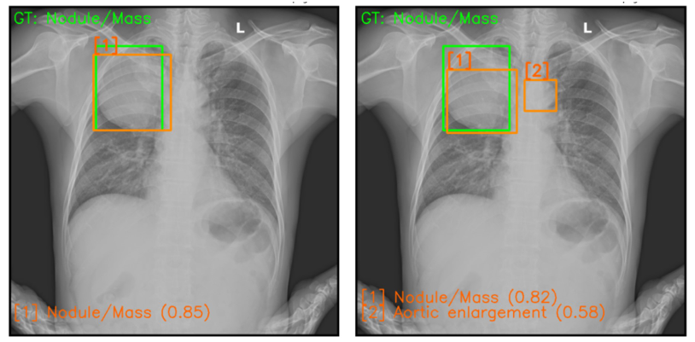
(a) YOLOv12 proposed (b) Faster R-CNN
Fig. 7. Detection results in the case of a prominent nodule/mass
This example emphasizes the superior localization capability of the proposed model, especially for clinically important findings that require high confidence and precision.

Conclusions
In this study we present a custom-optimized YOLOv12-based object detection model tailored for thoracic pathology detection in grayscale chest X-ray images. The proposed model was trained and evaluated on a curated dataset of over 3,900 chest radiographs, derived from the VinBigData and NIH ChestX-ray14 datasets, focusing on four clinically relevant lesions: cardiomegaly, aortic enlargement, pulmonary nodules/masses and pleural effusion.
To enhance detection sensitivity for subtle and low-contrast anomalies, the YOLOv12 architecture was refined through several targeted modifications, including a supplementary P2 resolution branch for improved localization of small lesions, CBAM attention modules to refine channel and spatial focus, and deformable convolutions to adapt to irregular lesion shapes. These changes collectively improved both feature representation and spatial adaptability without significantly increasing computational complexity.
Experimental results showed that the proposed model outperformed standard YOLO versions (YOLOv8, YOLOv11 and YOLOv12) and Faster R-CNN in key detection metrics. Specifically, it achieved the highest mAP@0.5 of 0.374 and Recall of 0.519, while maintaining a low inference time of 6.3 ms per image, confirming its suitability for real-time clinical applications. By combining accurate localization, fast inference, and architectural efficiency, this work demonstrates the potential of enhanced YOLOv12-based detectors in assisting diagnostic workflows, particularly in resource-constrained healthcare environments.

Future Work
Future research will focus on enhancing thoracic lesion detection through several directions. First, we aim to expand the dataset by incorporating more diverse and balanced chest X-ray collections including scarcer pathologies, to improve generalization across all classes. Second, we plan to develop a multi-modal model by integrating clinical metadata (e.g., age, symptoms) alongside image data, potentially increasing diagnostic accuracy. Additionally, we consider integrating lesion segmentation using specialized models like YOLOv12-seg [7], enabling precise pixel-level localization, critical for clinical interpretation. Lastly, to ensure transparency, we will integrate interpretability methods such as Grad-CAM [30], allowing clinicians to visualize the model’s decision basis. These improvements aim to create a more reliable, explainable, and clinically applicable diagnostic support tool.

Acknowledgment
This work is supported by the project “Romanian Hub for Artificial Intelligence-HRIA”, Smart Growth, Digitization and Financial Instruments Program, MySMIS no. 334906.

References
- I. Ullah, F. Ali, B. Shah, S. El-Sappagh, T. Abuhmed, and S. H. Park, “A deep learning based dual encoder–decoder framework for anatomical structure segmentation in chest X-ray images,” Scientific Reports, vol. 13:791, 2023, pp. 1–14.
- World Health Organization (WHO) health topics, “Chest radiography in tuberculosis detection: summary of current WHO recommendations and guidance on programmatic approaches,” [Online]. Available: https://www.who.int/publications/i/item/9789241511506
- E. Çallı, E. Sogancioglu, B. van Ginneken, K. G. van Leeuwen, and K. Murphy, “Deep Learning for Chest X-ray Analysis: A Survey,” Medical Image Analysis, vol. 72:102125, 2021, pp. 1–29.
- H. Wang and Y. Xia, “ChestNet: A Deep Neural Network for Classification of Thoracic Diseases on Chest Radiography,” arXiv preprint arXiv: 1807.03058, 2018, pp. 1–8.
- R. Sapkota, M. Flores-Calero, R. Qureshi, C. Badgujar, U. Nepal, A. Poulose, P. Zeno, U.B.P. Vaddevolu, S. Khan, M. Shoman, H. Yan, and M. Karkee, “YOLO advances to its genesis: A decadal and comprehensive review of the You Only Look Once (YOLO) series,” Artificial Inelligence Review, vol. 58:274, 2025, pp. 3–83.
- T.-Yi Lin, M. Maire, S. Belongie, J. Hays, P. Perona, D. Ramanan, P. Dollár, and C.L. Zitnick, “Microsoft COCO: Common Objects in Context”, Proceedings of European Conference on Computer Vision (ECCV), 2014, pp. 740–755.
- Ultralytics, “YOLO12: Attention-Centric Object Detection,” Ultralytics YOLO Docs, Ultralytics YOLO Vision. [Online]. Available: https://docs.ultralytics.com/models/yolo12
- P. Lambin, E.R. Velazquez, R. Leijenaar, S. Carvalho, R.G.P.M. van Stiphout, P. Granton, C.M.L. Zegers, R. Gillies, R. Boellard, A. Dekker, and H.J.W.L. Aerts, “Radiomics: Extracting more information from medical images using advanced feature analysis,” European Journal of Cancer, vol. 48, Issue 4, 2012, pp. 441–446.
- H.J.W.L. Aerts, E.R. Velazquez, R.T.H. Leijenaar, C. Parmar, P. Grossmann, S. Carvalho, J. Bussink, R. Monshouwer, B.H.-Kains, D. Rietveld, F. Hoebers, M.M. Rietbergen, C.R. Leemans, A. Dekker, J. Quackenbush, R.J. Gillies, and P. Lambin, “Decoding tumour phenotype by noninvasive imaging using a quantitative radiomics approach,” Nature Communications, vol. 5:4006, 2014, pp. 1–9.
- L. Alzubaidi, J. Zhang, A. J. Humaidi, A. Al-Dujaili, Y. Duan, O. Al-Shamma, J. Santamaria, M. A. Fadhel, M. Al-Amidie, and L. Farhan, “Review of deep learning: concepts, CNN architectures, challenges, applications, future directions,” Journal of Big Data, vol. 8:53, 2021, pp. 1–74.
- B.A. Fabian and C.-C. Vancea, “Efficient Methods for Improving Brain Tumors Diagnosis in MRI Scans Using Deep Learning,” Proceedings of IEEE International Conference on Intelligent Computer Communication and Processing (ICCP), 2024, pp. 1–8.
- S. Takahashi, Y. Sakaguchi, N. Kouno, K. Takasawa, K. Ishizu, Y. Akagi, R. Aoyama, N. Teraya, A. Bolatkan, N. Shinkai, H. Machino, K. Kobayashi, K. Asada, M. Ko matsu, S. Kaneko, M. Sugiyama, and R. Hamamoto, “Comparison of Vision Transformers and Convolutional Neural Networks in Medical Image Analysis: A Systematic Review,” Journal of Medical Systems, vol. 48:84, 2024, pp. 1–22.
- R. Yamashita, M. Nishio, R.K.G. Do, and K. Togashi, “Convolutional neural networks: an overview and application in radiology,” Insights into Imaging, vol. 9, 2018, pp. 611–629.
- Z.R. Murphy, K. Venkatesh, J. Sulam, and P.H. Yi, “Visual Transformers and Convolutional Neural Networks for Disease Classification on Radiographs: A Comparison of Performance, Sample Efficiency, and Hidden Stratification,” Radiology: Artificial Intelligence, vol. 4(6):e220012, 2022, pp. 1–10.
- Y. Dai, Y. Gao, and F. Liu, “TransMed: Transformers Advance Multi-Modal Medical Image Classification,” Diagnostics, vol. 11(8):1384, 2021, pp. 1–15.
- K. He, X. Zhang, S. Ren, and J. Sun, “Deep Residual Learning for Image Recognition,” Proceedings of IEEE Conference on Computer Vision and Pattern Recognition (CVPR), 2016, pp. 770–778.
- S. Ren, K. He, R. Girshick, and J. Sun, “Faster R-CNN: Towards Real-Time Object Detection with Region Proposal Networks,” Transactions on Pattern Analysis and Machine Intelligence (PAMI), vol. 39, 2017, pp. 1137–1149.
- J. Redmon, S. Divvala, R. Girshick, and A. Farhadi, “You Only Look Once: Unified, Real-Time Object Detection,” Proceedings of IEEE Conference on Computer Vision and Pattern Recognition (CVPR), 2016, pp. 779–788.
- I. Vijoli and C.-C. Vancea, “Towards Improving Real-Time Surveillance Systems with Enhancement Techniques for Deep Learning Models,” Proceedings of IEEE International Conference on Intelligent Computer Communication and Processing (ICCP), 2024, pp. 01–08.
- M.A. Al-Antari, S.M. Han, and T.-S. Kim, “Evaluation of deep learning detection and classification towards computer-aided diagnosis of breast lesions in digital X-ray mammograms,” Computer Methods and Programs in Biomedicine, vol. 196:105584, 2020, pp. 1–15.
- Y. Xie, Z. Wu, X. Han, H. Wang, Y. Wu, L. Cui, J. Feng, Z. Zhu, Z. Chen, “Computer-Aided System for the Detection of Multicategory Pulmonary Tuberculosis in Radiographs,” Journal of Healthcare Engineering, vol. 2020:9205082, 2020, pp. 1–12.
- Y. Xie, B. Zhu, Y. Jiang, B. Zhao, and H. Yu, “Diagnosis of pneumonia from chest X-ray images using YOLO deep learning,” Frontiers in Neurorobotics, vol. 19:1576438, 2025, pp.1–13.
- X.Y. Zhang, L.J. Liu, X. Yang, L. Liu, and W. Peng, “NSEC-YOLO: Real-time lesion detection on chest X-ray with adaptive noise suppression and global perception aggregation,” Journal of Radiation Research and Applied Sciences, vol. 18:101281, 2025, pp. 1–12.
- S. Woo, J. Park, J.-Y. Lee, and I.S. Kweon, “CBAM: Convolutional Block Attention Module,” Proceedings of the European Conference on Computer Vision (ECCV), 2018, pp. 3–19.
- A.I. Aramendia, “Deformable Convolutional Networks (DCNs) : A Complete Guide”, Medium, 2024. [Online]. Available: https://medium.com/@alejandro.itoaramendia/deformable-convolutional-networks-a-complete-guide-eadd9f1f8ce2
- H.Q. Nguyen, K. Lam, L.T. Le, et al. “VinDr-CXR: An open dataset of chest X-rays with radiologist’s annotations,” Scientific Data 9:429, 2022, pp. 1–7.
- X. Wang, Y. Peng, L. Lu, Z. Lu, M. Bagheri, and R.M. Summers, “ChestX-Ray8: Hospital-Scale Chest X-Ray Database and Benchmarks on Weakly-Supervised Classification and Localization of Common Thorax Diseases,” Proceedings of IEEE Conference on Computer Vision and Pattern Recognition (CVPR), 2017, pp. 3462–3471.
- Ultralytics, “Explore Ultralytics YOLOv8,” Ultralytics YOLO Docs. [Online]. Available: https://docs.ultralytics.com/models/yolov8
- Ultralytics, “Ultralytics YOLO11,” Ultralytics YOLO Docs. [Online]. Available: https://docs.ultralytics.com/models/yolo11
- R.R. Selvaraju, M. Cogswell, A. Das, R. Vedantam, D. Parikh, D. Batra, “Grad-CAM: Visual Explanations from Deep Networks via Gradient-Based Localization,” Proceedings of IEEE International Conference on Computer Vision (ICCV), 2017, pp. 618–626.

