|  |  |  |
| --- | --- | --- |
|  | E84: Introduction to Electrical Engineering  Lab 1 Sample Report |  |

The objective of this lab is to become familiar using the features of the myDAQ for signal measurement and generation, and to become familiar with analysis, simulation, fabrication, and measurement of circuits.

**Warm-Up Problems**

1. Figure 1 shows a voltage divider.

 

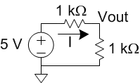

Figure 1 Voltage Divider

1. Figure 2 shows an RC low-pass filter with a time constant  = RC. 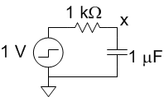

Figure 2 RC low-pass filter

According to E59 notes, the step response is:

1. x(t) = 

The output for a sinusoidal input of frequency f0 is:

(b) 

**Laboratory**

The laboratory component involves simulating and measuring the voltage divider and low-pass filter, as well as testing the multimeter, signal generator, and oscilloscope on the myDAQ.

**2) MultiSim Simulation**

Figure 3 shows the circuits being simulated in MultiSim.

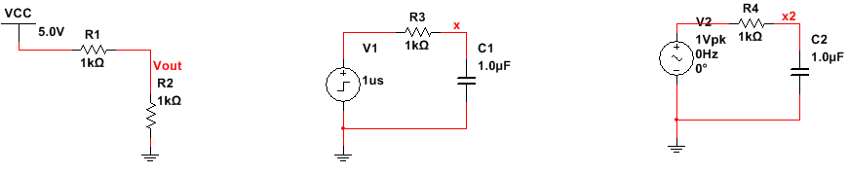

Figure 3 MultiSim schematics of test circuits

A DC analysis finds Vout = 2.5 V and the current through R1 = 2.5 mA, as expected.

Figure 4 shows the step response of the RC circuit. The output reaches nearly full value after 5 1 ms time constants.

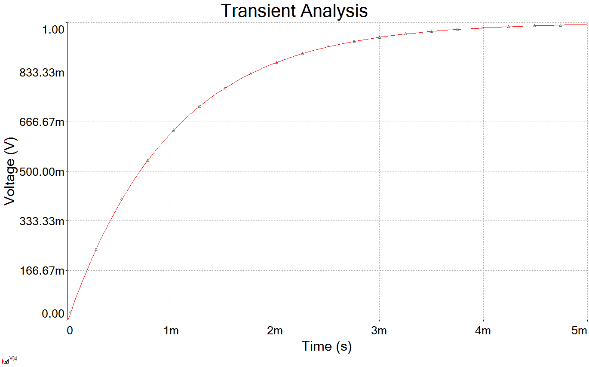

Figure 4 Transient analysis of RC circuit

Figure 5 shows a Bode plot of the magnitude and phase. Measuring with a cursor shows that the magnitude reaches -3dB at a corner frequency of 159 Hz. This matches expectation of a corner at 

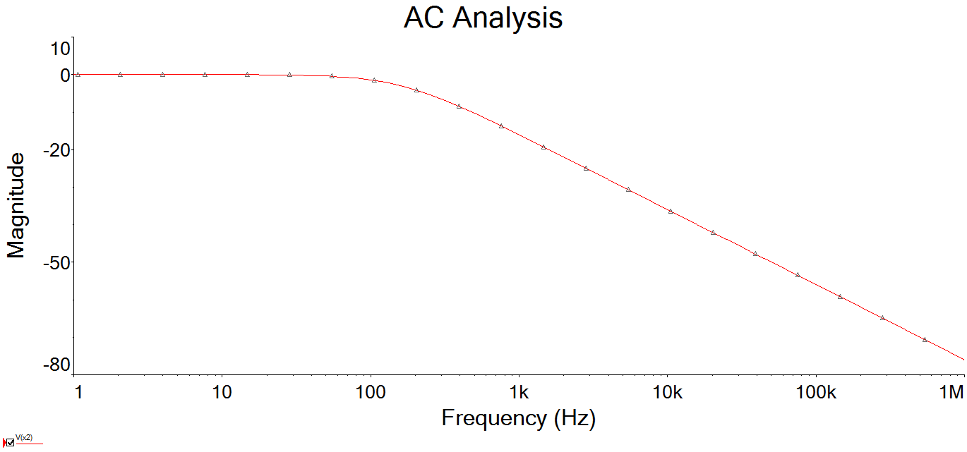

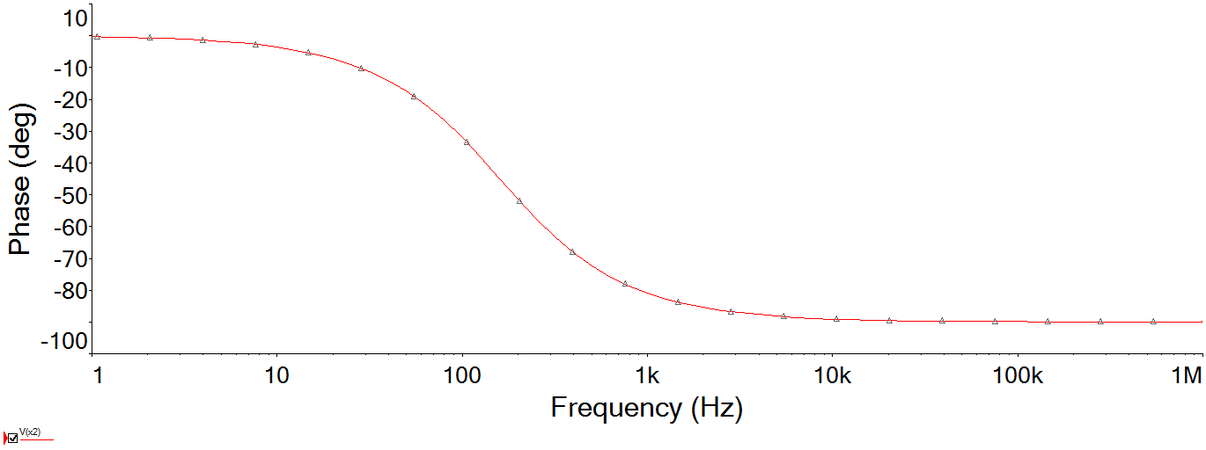

Figure 5 Bode Plot of RC circuit

**4) Power Supply and Multimeter**

The myDAQ multimeter measured 4.94, 14.99, and -15.02 V on the 5, 15, and -15 V outputs, which is within the specs (4.0-5.2, 14.0-15.3, and -14.0 to -15.3 V). Note that the 5V output dropped to 4.78 V when loaded with the voltage divider.

The two 1k resistors measured 994 and 988 , which is within the +/- 5% tolerance.

A voltage divider using these resistors produced an output of 2.38 V while drawing a current of 2.41 mA. The expected results with actual component values are  and . Thus, the measurements match expectations to within the resolution of the multimeter.

**5) Signal Generator and Oscilloscope**

Figure 6 plots the measured output of the signal generator using the myDAQ oscilloscope for a 1 kHz square wave. The 10 kHz sinusoid should be within the bandwidth of the device, while a 100 kHz triangle wave should display distortion because it is too close to the sampling rate of the myDAQ. However, on a Mac running Parallels, the ELVISmx function generator was unable to produce either waveform because of USB limitations.

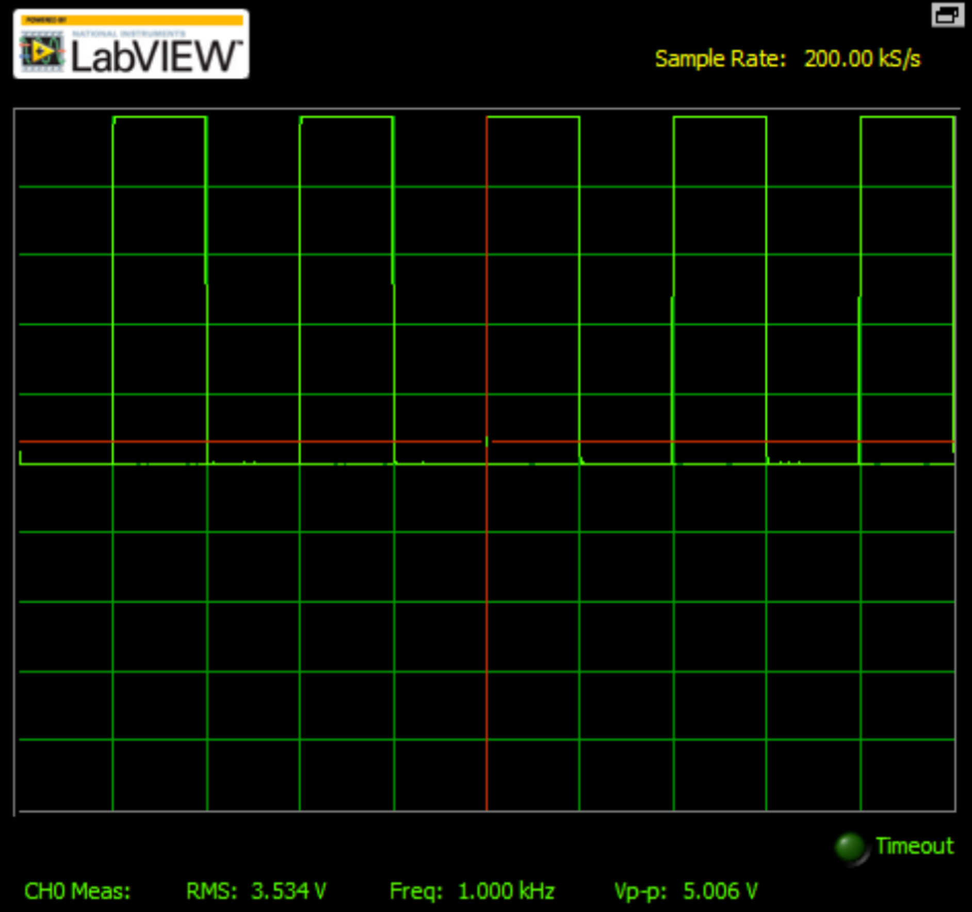

Figure 6 Signal generator outputs

Figure 7 plots the measured output of the RC circuit driven by a 200 Hz square wave. As expected, the response is an exponential like the step response. The square wave is high for 0.5/200Hz = 2.5 ms, or about 2.5 time constants, so the output does not quite swing between 0 and 1. The time constant to reach ln 2 = 0.693 V is 1.14 ms, as compared to  = 1 ms expected. The mismatch is likely primarily due to the 20% tolerance on the electrolytic capacitor.

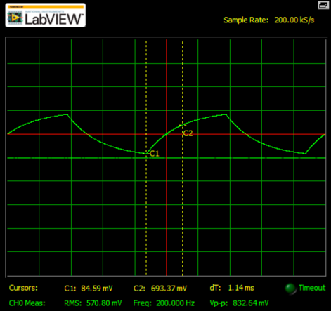

Figure 7 RC circuit square wave response