|  |  |  |
| --- | --- | --- |
|  | E84: Introduction to Electrical Engineering  Lab 10: Active Filters |  |

**Warm-Up**

1. Derive the transfer function of the following twin-T filter. Let  be the potentiometer wiper position in the range [0,1] with 1 being at the top. Put the function in canonical 2nd order form and determine 0 and Q in terms of R, C, and . Make a Bode plot for  = 0.9.

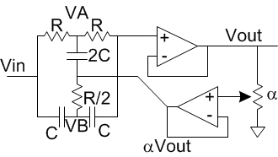

1. Derive the transfer function of the following Sallen-Key low-pass filter. Make a Bode plot.

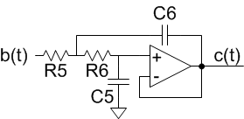

**Lab**

Select component values for your filter circuit board and assemble and test the board with those values. You will find SMT components in a cabinet in the lab and may wish to pick some through-hole components from the stockroom if you don’t have values you want in your kit. The board should perform the following functions

* Eliminate 60 Hz powerline noise. Specifically, 60 Hz noise should be attenuated by at least 20 dB, while frequencies below 50 and above 70 Hz should be attenuated by less than 3 dB. The width of the twin-T notch filter is configurable using the potentiometer. Use C = 270 pF and use components with 1% tolerances. Run Monte Carlo simulations in MultiSim to show that you meet these specifications across a range of component variations.
* Antialias filter to allow for a low sampling rate. The antialias filter should have a passband of 0-140 Hz and a stopband of 1 KHz and above to allow for 2 KHz sampling. The attenuation should be < 3 dB in the passband and > 30 dB in the stopband.

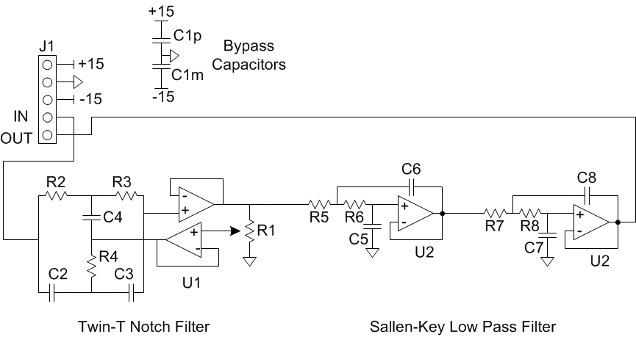

**Extra credit**: test your ECG with and without the filter board. Show that the filter board eliminates 60 Hz noise and does not distort the ECG waveform.

What to turn in:

* Hand analysis of the filter component value selection
* Multisim Bode plots showing that the filters agree with the hand analysis and meet the specifications. Perform Monte Carlo analysis to show that the 60 Hz notch is robust across process variation.
* Measurement results showing that the circuit frequency response matches the Multsim predictions and the specifications. Pay special attention to frequencies of interest such as the shape of the notch and the transition between pass and stop band.
* Extra credit, if applicable
* How long did you spend on this lab?