|  |  |  |
| --- | --- | --- |
|  | E84: Introduction to Electrical Engineering  Lab 2: Resistive Circuits |  |

**Warm-Up**

1) Compute the voltage at node x for each of the following circuits:

(a) 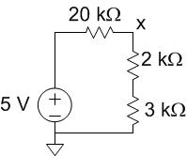 (b) 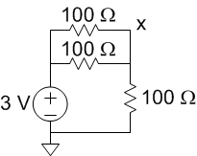 (c) 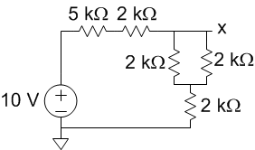

2) Compute the voltage at node x in terms of digital inputs D2:0, which are each 0 or 1 V. Explain how this circuit could be useful. How could it be extended from 3 to N digital inputs?

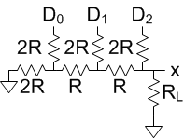

(see lab part on back!)

**Lab**

1. Design and build a circuit with a potentiometer from your kit that produces an output voltage in the range of 0-5 V as you turn the knob of the pot.
2. Design, analyze, simulate, build, and test an attenuator that produces an output voltage equal to approximately 1/10 of the input voltage. Specifically, when the source impedance does not exceed 1000 , the load impedance is at least 10 k, and the resistors are within 5% of nominal, the attenuation should be in the range [0.08, 0.12]. Test the attenuator with no source or load resistors.
3. Set the output of the potentiometer circuit to 2.5 V. Then connect it to the attenuator. Measure the output. Compare with expectation and resolve any discrepancies.

**Extra Credit:**

Determine the power produced by a solar cell under room lighting and preferably under direct sunlight. Use alligator clips to connect to your panel.

Measure the open circuit voltage and the short circuit current. Also, plot output voltage, current, and power for various resistive loads. What load gives you maximum power in the room? In direct sunlight? How much more power do you observe in sunlight? What types of devices could you power with this solar cell?