|  |  |  |
| --- | --- | --- |
|  | E84: Introduction to Electrical Engineering  Lab 5: Op-Amps & Diodes |  |

**Warm-Up**

1. The following circuit adds an ideal op-amp follower between the potentiometer and attenuator that you analyzed in Lab 2. Determine the relationship of Vout to wiper position x (in the range [0,1]). What is the benefit of the op-amp?

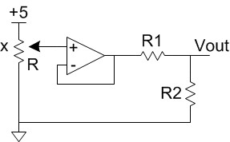

1. Give an expression for Vout vs. Vin for the following circuit with ideal op-amps. (Hint: you should be able to do this by inspection.)

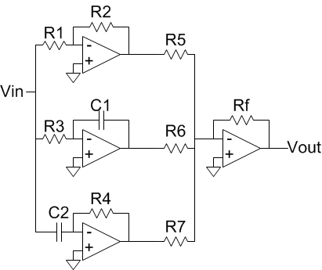

1. PID controller

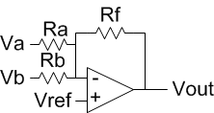

1. Single-Supply Inverting Amplifier
2. Compute the gain of an inverting amplifier if the op-amp has a finite, frequency-dependent gain A. Suppose R1 = 1k and R2 = 10k and A = 106/f. What is the gain at 1 Hz? At 10 kHz? At 100 KHz?

**Lab**

An *electrocardiograph* (ECG or EKG) plots the electrical activity of the heart against time. The following oscilloscope trace shows a typical ECG waveform. The spikes are called the *QRS complex* and correspond to muscle contraction during heart beats, with a typical interval of 0.5-1 second depending on a subject’s heart rate. The signal is very small, on the order of a few millivolts, and the source impedance is high.

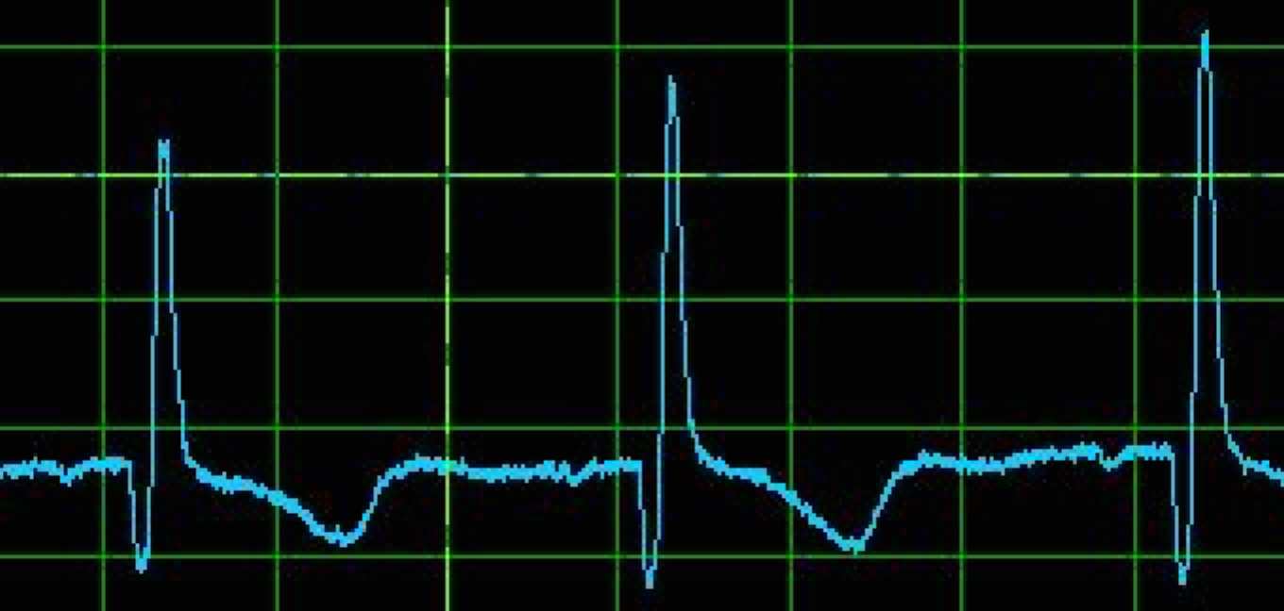

Build a two-lead ECG. Two adhesive electrodes (available in the lab) go on your upper chest, above and to the left and right of your heart. A third reference electrode goes on your lower abdomen and connects to ground. These electrodes can be connected to your amplification circuit with alligator clips and long wires. The signal of interest is the difference between the two electrodes. Amplify the signal by an instrumentation amplifier composed of three dual-supply op-amps (two non-inverting amplifiers and a differential amplifier) discussed in class. Properly adjust overall voltage-gain (by adjusting the resistors in your circuit) so that the output signal is readable on a myDAQ. Describe the signal, including the amplitude, DC offset, and frequency.

Keep this circuit on your breadboard because you will filter the ECG output in a later lab.