|  |  |  |
| --- | --- | --- |
|  | E84: Introduction to Electrical Engineering  Lab 7: RLC Filters |  |

**Warm-Up**

1. Find the complete response (including both transient and steady state response) of an RC series circuit to (a) a unit step input x(t)=u(t) and (b) a sinusoidal input x(t)=cos(t)u(t) applied across both R and C, when the voltage across C is considered as the outpt y(t)=vc(t). Assume vc (t)=1 for t<0. Sketch the waveform of y(t).
2. In the circuit below, V0=10 V, R1=R2 =2 k R3=5 k C F, the circuit is in steady state at t<0. Find voltages v1(t) and v2(t) across R1 and R2, and the currents i1(t) and i2(t) through R1 and R2, after the switch is closed at t=0. Sketch these four signals over time.

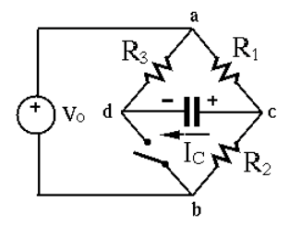

**Lab**

1. Design a low-pass filter using no more than three passive components. The filter should have a passing band of 0 ~ 1.6 kHz with no attenuation, and a signal of 5 kHz should be attenuation by 20 dB.
2. Generate a Bode plot for the filter. Feed a sinusoidal signal x(t)=cos(2ft) as the input to the filter and find the gain for f=10, 100, 500, 1000, 2000, 3000, 4000, and 5000 Hz. Compare your results with expectations.
3. Use the same components to implement a high-pass filter with a passing band for f>1.6 kHz, then repeat part 2)
4. Use the same components to implement a band-pass filter with the passing band centered at 1.6 kHz, then repeat part 2)
5. Build a tunable square wave oscillator using a 555 timer. It should produce a square wave alternating between 0 and 5 V with a duty cycle of 50%, and a frequency tunable from 100 Hz to 20 kHz by adjusting a potentiometer. Listen to the generated signal by a speaker or earphone to determine the upper limit of your hearing range. (You may need to use a op-amp follower to drive the speak/earphone.)
6. Filter the signal generated by the oscillator by each of the three filters built previously and then listen to the filtered signal when its frequency sweeps from 100 Hz to 20 kHz.