|  |  |  |
| --- | --- | --- |
|  | E84: Introduction to Electrical Engineering  Lab 8: Solution |  |

**Warm-Up**

1. Find the complete response (including both transient and steady state response) of an RC circuit to a sinusoidal input v(t)=2 cos( t) applied across R=1 k and C=1 F in series, after a switch is closed at t=0. The voltage across C is vc(t)=-1 for t<0. Find and sketch the waveform of vc (t) for t>0.

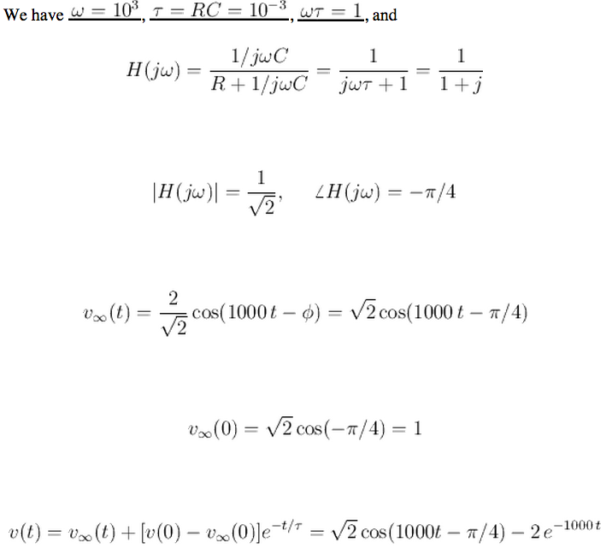

1. In the circuit below, V0=10 V, R1=R2 =2 k R3=1 k L mH, the circuit is in steady state at t<0. Find i1(t) , i2(2), and i3(t) through R1, R2, and R3, respective, as well as vL(t) and iL(t) after the switch is closed at t=0. Sketch these variables over time.

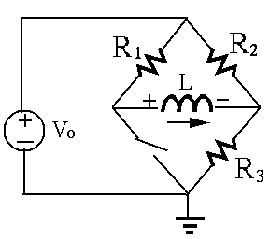

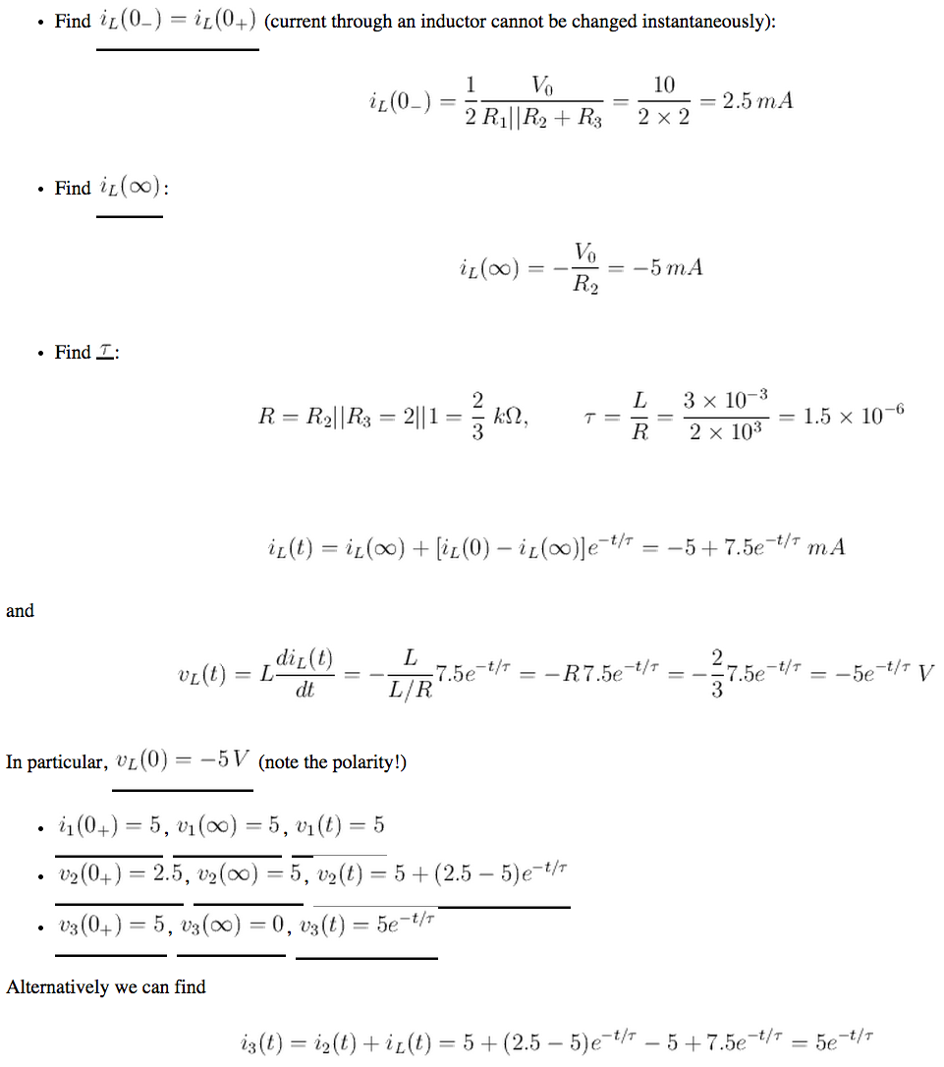

1. In the circuit below, V=10 V, R1=R2 =1 k C F, the voltage across C is vc(t)=0 for t<0. Both switches are open until at t=0 switch S1 is closed, and at t=1 ms switch S2 is closed. Find voltage vc(t) for t>0, and sketch the function over time.

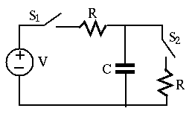

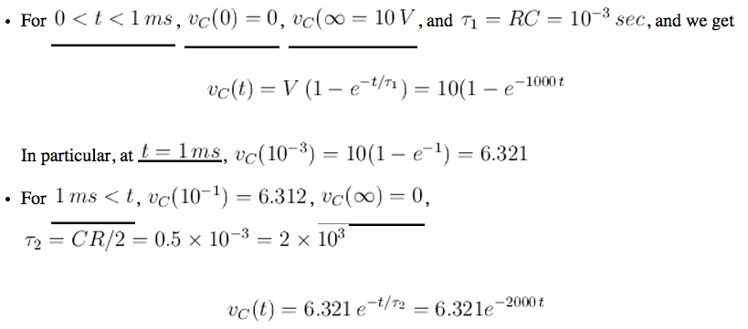

**Lab**

1. Design a band-pass filter using no more than three passive components. The filter should have a passing band around the frequency at about f = 5 kHzand a bandwidth about f = 5 kHz. Derive the frequency response function and sketch a Bode plot. Generate both linear plot (from 0 to 10 kHz) and Bode plots (from 0 to 100 kHz) for the magnitude of the filter as a function of frequency (by Multisim). Feed a sinusoidal signal x(t)=cos(2ft) as the input to the filter and find the gain for f=1, 2, 5, 10, 20, and 50 kHz. Compare your results with analysis and Multisim expectations.

Consider using an RLC series circuit. When the voltage across R is used as the output, the circuit is a band pass filter.

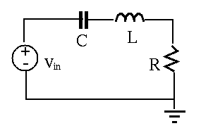

For fn= 5 x103 Hz, i.e.,  n= 2 5 x103 =  104 , we need LC=1/ n2 =10-9,

For R/L =  = 2 f = 2  x 103 = 31416, we need R=L  =  10-3 =31.4  

We can choose C=10-6 F and L=10-3 H. However, as the resistance of the 1 mH inductor is approximately 15.7   the resistance of R needs to be 31.4 - 15.7 = 15.7 

Hint: the impedance of the RLC circuit is the resistance of R at its resonant frequency. When R is low the circuit draws a lot of current from the source. Due to the output impedance of myDAQ, its output voltage may be significantly reduced and distorted. In this case an op-amp follower may need to be used to buffer the heavy load for it to get the expected input.

1. Repeat the steps from 1) with the same three components to implement a low-pass filter with a passing band for all f<5 kHz, then repeat part 1).
2. Repeat all steps in 1) for a high-pass filter with a passing band for all f>5 kHz.

BP, LP, and HP plots (linear plots on the left, Bode plots on the right):

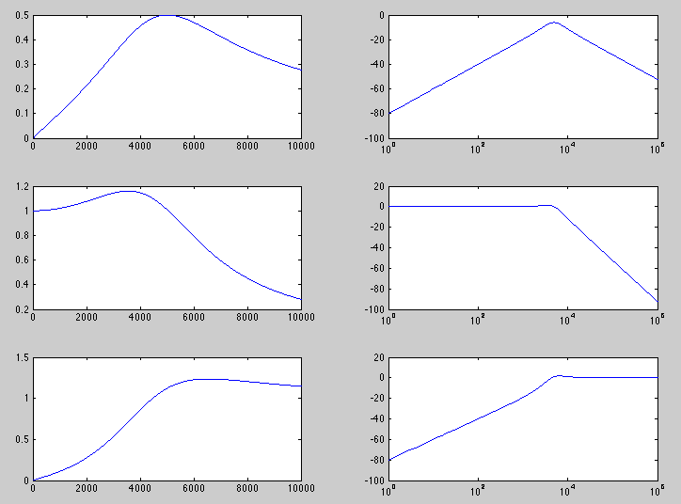

1. Build a tunable square wave oscillator using a 555 timer. It should produce a square wave alternating between 0 and 5 V with a duty cycle of 50%, and a frequency tunable from 100 Hz to 20 kHz by adjusting a potentiometer. Listen to the generated signal on a buzzer or speaker to determine the upper limit of your hearing range. (You may need to use an op-amp follower to drive the speak/earphone.)
2. Set your square wave to 4 KHz and listen to the output with and without the low-pass filter. Explain the differences.

What to Turn In

* Schematics for your three filters and 555 timer
* Frequency response functions and component values for the filters
* Plots of frequency response from hand analysis, Multisim, and physical measurement. Explain any discrepancies.
* A photograph of your breadboard with the 555 timer and low-pass filter
* Notes on the upper end of your hearing range and the auditory impact of filtering a square wave.