
COVENANT UNIVERSITY
CANAANLAND, KM 10, IDIROKO ROAD, P.M.B 1023, OTA, OGUN STATE, NIGERIA.

TITLE OF EXAMINATION: B.Eng DEGREE EXAMINATION
COLLEGE: Engineering
DEPARTMENT: Electrical & Information Engineering
SESSION: 2015/2016 SEMESTER: ALPHA
COURSE CODE: EIE411 CREDIT UNIT: 3
COURSE TITLE: COMPUTER ORGANIZATION AND ARCHITECTURE
INSTRUCTION: Answer QUESTION ONE and any other THREE questions in
the Answer Booklet provided. SHOW all workings.
TIME: 3 HOURS

QUESTION 1 (COMPULSORY) (25 MARKS)
- You are to design the memory subsystem of a computer system and you are provided with Static RAM (SRAM) and Dynamic RAM (DRAM).
  - State three differences between the two. (3 Marks)
  - Which of them would you use to design a cheaper high capacity memory assuming access time is not important? (2 Marks)
  - Which of them would use for a faster memory assuming cost is not a problem? (2 Marks)
  - What kind of design would you recommend to optimize both cost (low cost) and speed (faster)? (2 Marks)
- Explain with a properly labeled diagram the computer multi-level memory hierarchy.
(5 Marks)
- The parameters of a 2-level cache are provided in Table Q1. Calculate the average memory access time of the cache. (6 Marks)
Table Q1: Cache Parameters
 | Level 1 | Level 2
Local hit rate | 96% | 60%
Hit time | 4ns | 12ns
Miss penalty | - | 120ns

- A computer CPU has an 8-bit adder in the ALU.
  - Show the steps the adder will use to perform the arithmetic operation:
43 – 89 using 2’s complement: (4 Marks)
  - Convert the result back to decimal (1 Mark)
(Hint: Show all workings neatly)

QUESTION 2 (15 MARKS)
- What is an ALU? Draw the symbols and truth tables of these three logic gates:
AND, OR, and NOT. (4 Marks)
- Explain six (6) differences between Intel’s CPU and an ARM’s CPU. (3 Marks)
- Mention four (4) examples each of CISC and RISC Architecture. (4 Marks)
- What is SCSI, and differentiate between SCSI and ATA (IDE, EIDE)? (4 Marks)

QUESTION 3 (15 MARKS)
- A computer system is represented with the block diagram in Fig. Q3.
- What architecture does this represent? (1 Mark)
- Mention two advantages of this architecture over the alternative architecture.
(2 Marks)
- i. Describe the IEEE 754 Single and Double Precision Floating Point Specifications.
(6 Marks)
ii. Represent 9.625 in the IEEE 754 Single Precision Floating Point Format. (6 Marks)

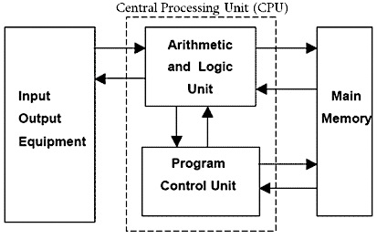
Figure Q3: Block Diagram for Question 2

QUESTION 4 (15 MARKS)
- State any two functions of the I/O module that interfaces between the system bus and peripheral devices. (2 Marks)
- Suppose, you were asked to review the architecture of a processor for an aviation project,
  - Explain the major drawback of the Programmed I/O technique. (2 Marks)
  - Briefly explain the following three other I/O techniques:
Interrupt-driven I/O, DMA and Channel I/O (9 Marks)
  - State any two methods for identifying the interrupting module in an interrupt-driven I/O. (2 Marks)

QUESTION 5 (15 MARKS)
- Mention any three operating system software used in handheld and wearable devices. (3 Marks)
- Suppose, you were asked to review the architecture of a processor,
  - Briefly explain the difference between a serial bus and a parallel bus. (2 Marks)
  - Calculate the total addressable memory (in KBytes) of a computer with 8-bit memory word size and 16-bit address bus size. (3 Marks)
  - I/O devices read/write data either a character/byte at a time or in blocks of bytes. Give two examples each for block and character devices. (4 Marks)
- Describe the solid-state drive and contrast it with the traditional magnetic drive.
(3 Marks)

QUESTION 6 (15 MARKS)
- State the overall function of a processor’s control unit. What is the relationship between instructions and micro-operations? (3 marks)
- List the four registers required in a fetch cycle of a generic instruction execution process.
(2 marks)
- Compare zero-, one-, two-, and three-address machines by writing programs to compute
F = (A - B)/(C + (D *E))
for each of the four machines. The instructions available for use are provided in Table Q6. Identify, with examples, the instruction set architecture of the two- and three-address machines.
(10 marks)
Table Q6: A Simple Instruction set for zero-, one-, two- and three- address machines.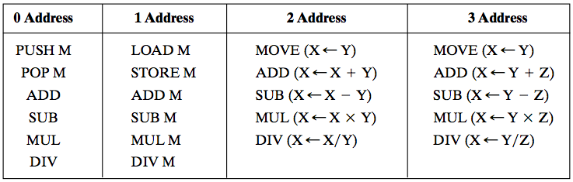

COVENANT UNIVERSITY
CANAANLAND, KM 10, IDIROKO ROAD, P.M.B 1023, OTA, OGUN STATE, NIGERIA.

TITLE: B.Eng DEGREE EXAMINATION SOLUTIONS AND MARKING GUIDE
COLLEGE: Engineering SCHOOL: Applied Engineering
DEPARTMENT: Electrical & Information Engineering
SESSION: 2015/2016 SEMESTER: ALPHA
COURSE CODE: EIE411 CREDIT UNIT: 3
COURSE TITLE: COMPUTER ORGANIZATION AND ARCHITECTURE

QUESTION 1 (25 MARKS)
- You are to design the memory subsystem of a computer system and you are provided with Static RAM (SRAM) and Dynamic RAM (DRAM).
  - Explain the three differences between the two. (3 Marks)
Answer:
Any three of these answers (1 mark each)
- SRAM is made up of 4 transistors per memory cell while DRAM is made up of 1 transistor and 1 capacitor per memory cell.
- SRAM does not require refreshing while DRAM requires refreshing.
- SRAM is normally used for cache while DRAM is normally used for main memory.
- DRAM has high storage density than SRAM.
- DRAM provides cheaper storage cost per bit than SRAM.
- SRAM is faster than DRAM.

  - Which of them would you use to design a cheaper high capacity memory assuming access time is not important? (2 Marks)
Answer
DRAM. Because it provides cheaper memory.
  - Which of them would you use for a faster memory assuming cost is not a problem? (2 Marks)
Answer
SRAM. because it is faster.

  - What kind of design would you recommend to optimize both cost (low cost) and speed (faster)? (2 Marks)
Answer:
A hierarchical design where a small amount of the faster SRAM is used to cache the data most likely to be needed in the near future; and the cheaper DRAM is used in large quantity to provide high capacity storage at cheaper cost.

- Explain with a properly labeled diagram the computer multi-level memory hierarchy.
(5 Marks)
Answer:
The memory hierarchy describes the way computer memory system is designed to achieve high capacity storage with low latency at low cost. (1 Mark)

Small amount of fast memory is placed closer to the CPU while large and slower memory is placed further from the CPU. (1 Mark)

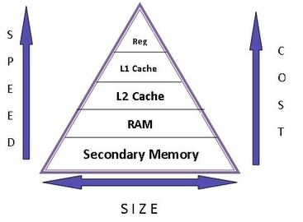
Correct and properly labelled diagram (3 Marks)

- The parameters of a 2-level cache are provided in Table Q1. Calculate the average memory access time of the cache. (5 Marks)
Table Q1: Cache Parameters
 | Level 1 | Level 2
Local hit rate | 96% | 60%
Hit time | 4ns | 12ns
Miss penalty | - | 120ns

Answer
For multi-level cache:
(1 Mark)
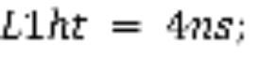
(1/2 Mark)
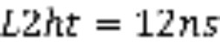
(1/2 Mark)
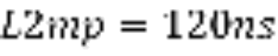
(1 Mark)
(1 Mark)
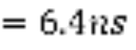 (1 Mark)

- A computer CPU has an 8-bit adder in the ALU.
  - Show the steps the adder will use to perform the following arithmetic using 2’s complement: 43 – 89 (show all workings) (4 Marks)

Answer
2 | 89
 | 44 | 1
 | 22 | 0
 | 11 | 0
 | 5 | 1
 | 2 | 1
 | 1 | 0
 | 0 | 1
2 | 43
 | 21 | 1
 | 10 | 1
 | 5 | 0
 | 2 | 1
 | 1 | 0  (1/2 Mark)
 | 0 | 1

(1/2 Mark)

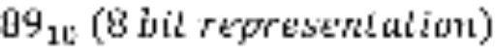 | 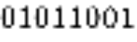  (1 Mark)
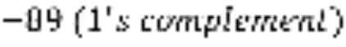 | 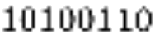
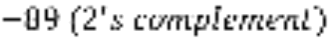 | 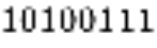  (1 Mark)
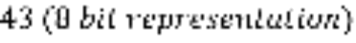 | 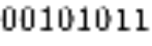  (1 Mark)
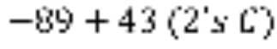 | 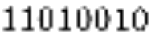

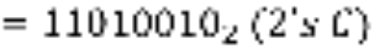

  - Convert the result back to decimal (show all workings) (1 Mark)
Answer:
Decoding 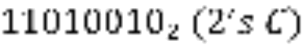 back to decimal:
Since the first bit is 1, the result is negative.
(or any other method used to get the result)

QUESTION 2

  - What is an ALU? (1 Mark)

ANSWER:
An arithmetic logic unit (ALU) is a digital electronic circuit used to perform arithmetic and logic operations. It represents the fundamental building block of the central processing unit (CPU) of a computer. In addition to ALUs, modern CPUs contain a Control Unit (CU) and Registers. (1 Mark)

  - Draw the symbols and truth tables of these three logic gates: AND, OR, and NOT.
(3 Marks)
ANSWER:
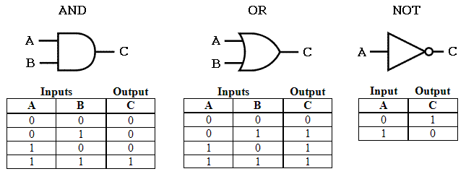
(3 Marks)

  - Explain six (6) differences between Intel’s CPU and an ARM’s CPU. (3 Marks)

ANSWER:
- Instructions - RISC has fewer instructions than CISC. CISC generally have hundreds of instructions whereas RISC usually has a lot less. To do complex tasks, RISC CPUs must combine simple operations from their reduced instruction set. The instruction cycle in CISC is more complex than RISC, so RISC can be more efficient at performing simpler tasks.
- Physical size - in order to handle all those instructions CISC CPUs are larger and require more silicon to make.
- Speed - RISC CPUs run at a lower clock speed than CISC CPUs. They can perform simpler tasks more quickly than CISC, but more intensive tasks will be better on a CISC CPU. However, smartphones and tablets are generally not used to do intensive tasks like playing the most hi-spec advanced games.
- Energy consumption - because CISC CPUs are larger, they use more electricity. RISC CPUs are designed to use less power and they can go into 'sleep mode' when not actively processing a program.
- Design - smartphones and tablets combine their processing architecture into a system on a chip (SOC). As RISC CPUs are much smaller than CISC, more functions (including the memory and other hardware) can be combined with the CPU in one chip. CISC CPUs are usually built into a system, which has a heat sink and fan to cool them down. Smartphones or tablets do not have space for heat sinks or fans.
- Cost - RISC CPUs use less power and are cheaper to make. (3 Marks)

  - Mention four (4) examples each of CISC and RISC Architecture. (4 Marks)

ANSWER:
Examples of CISC architecture: (2 Marks)
- Digital equipment corporation VAX computer
- IBM 370 computer
- Intel 386, 486, Pentium, Pentium Pro, Pentium II, Pentium III
- Motorola’s 68000, 68020, 68040, etc

Examples of RISC Architecture: (2 Marks)
- DEC Alpha
- ARM
- MIPS
- Atmel AVR

  - What is SCSI, and differentiate between SCSI and ATA (IDE, EIDE) (4 Marks)

ANSWER:
Definition of SCSI (2 Marks)
- Small Computer System Interface.
- A high-speed, intelligent peripheral I/O bus with a device independent protocol. It allows different peripheral devices and hosts to be interconnected on the same bus. Depending on the type of SCSI, you may have up to 8 or 16 devices connected to the SCSI bus.
- There is a large variety of peripheral devices available for SCSI, including hard disk drives, floppy drives, CDs, optical storage devices, tape drives, printers and scanners to name a few.

SCSI vs. ATA (IDE, EIDE) (2 Marks)
- SCSI does not utilize the CPU for data transfer management.
- SCSI is more expensive than EIDE
- SCSI can handle more devices

QUESTION 3 (15 MARKS)
- A computer system is represented with the block diagram in Fig. Q3.
- What architecture does this represent? (1 Mark)
Figure Q3: Block Diagram for Question 2

Answer: Von Neumann Architecture

- Mention two advantages of this architecture over the alternative architecture.
(2 Marks)
Answer:
Any two advantages of Von Neumann over Harvard Architecture (any 2, 1 mark each):
- Development of the Control Unit is cheaper and faster.
- Uses one bus which is simpler for the control unit design.
- All installed memory can be used for either data or instruction

  - Describe the IEEE 754 Single and Double Precision Floating Point Specifications.
(6 Marks)
Answer:
- Single Precision
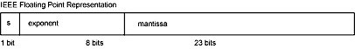
In 32-bit single-precision floating-point representation:
- The most significant bit is the sign bit (S), with 0 for positive numbers and 1 for negative numbers. (1 Mark)
- The following 8 bits represent exponent (E). (1 Mark)
- The remaining 23 bits represents fraction (F). (1 Mark)

- Double Precision
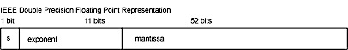

In 64-bit double-precision floating-point representation:
- The most significant bit is the sign bit (S), with 0 for positive numbers and 1 for negative numbers. (1 Mark)
- The following 11 bits represent exponent (E). (1 Mark)
- The remaining 52 bits represents fraction (F). (1 Mark)

  - Represent 9.625 in the IEEE 754 Single Precision Floating Point Format
(6 Marks)
Answer:
2 | 9
 | 4 | 1  (1 Mark)
 | 2 | 0
 | 1 | 0
 | 0 | 1

0.625*2 | 1.25
0.25*2 | 0.5
0.5*2 | 1.0
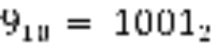
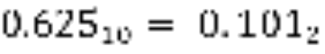
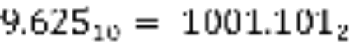
(1 Mark)
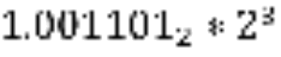
(1/2 Mark)
Since number is positive, sign bit, 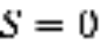
(1 Mark)
Actual exponent 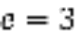
Biased exponent
(1 Mark)

IEEE 754 Single Precision Floating Point Representation
(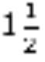Marks)
(32 bits)
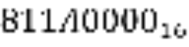

QUESTION 4 (15 MARKS)
- State any two functions of the I/O module that interfaces between the system bus and peripheral devices. (2 Marks)
Answer:
The I/O Module provides the following functions (any two answers, 1 mark each):
- Control and timing
- Processor communication
- Device communication
- Data buffering
- Error detection

b)
  - Explain the major drawback of the Programmed I/O technique. (2 Marks)
Answer:
In the programmed I/O technique, when the CPU issues a read or write command it has to wait for and repeatedly check the I/O module for when it is ready. The CPU does no other thing but wait for the I/O module until it is ready. This slows down the performance of other tasks by the CPU.

  - Briefly explain the following three other I/O techniques: Interrupt-driven I/O, DMA, Channel I/O (9 Marks)
Interrupt-Driven I/O:
In the Interrupt-Driven I/O, the CPU issues read command. The I/O module gets data from peripheral whilst CPU does other work. I/O module interrupts CPU when ready, CPU requests data and I/O module transfers the data. (3 Marks)
DMA:
In DMA, CPU provides the DMA controller with read/write command, device address, Starting address of memory block for data and the amount of data to be transferred. CPU carries on with other work. DMA controller deals with the transfer and sends interrupt when finished. (3 Marks)
Channel I/O:
Channel I/O uses a self-contained processor. CPU sends relatively small channel programs to the controller via the channel to handle I/O tasks, which the channel and controller can, in many cases, complete without further intervention from the CPU. When I/O transfer is complete or an error is detected, the controller communicates with the CPU through the channel using an interrupt. (3 Marks)

  - State any two methods for identifying the interrupting module in an interrupt-driven I/O. (2 Marks)
Answer:
Any two. 1 mark each.
- Different line for each module
- Software poll
- Daisy Chain or (Hardware poll)
- Bus Master (bus arbitration).

QUESTION 5 (15 MARKS)

- Mention any three Operating System Software used in handheld and wearable devices.
(3 Marks)
Answer:
Any 3.
- Android
- iOS
- Windows Phone OS
- Blackberry OS
- WebOS/Palm OS
- Symbiam, etc.

  - Briefly explain the difference between a serial bus and a parallel bus. (2 Marks)
Answer:
A serial bus consist of a single data line for transmitting data one bit at a time while a parallel bus consists of multiple data lines for transmitting data several bits at a time.

  - Calculate the total addressable memory size (in KBytes) of a computer with 8-bit memory word size and 16 bit address bus size. (3 Marks)
Answer:
Total addressable locations = 2¹⁶
Size of each location = 8 bits = 1 byte
Total addressable memory = 2¹⁶ * 1 byte = 64kB

  - I/O devices read/write data either a character/byte at a time or in blocks of bytes. Give two examples each for block and character devices. (4 Marks)
Block Devices (2 Marks):
- Disk drive
- CD / DVD ROM

Character Devices (any two) (2 Marks):
- Main Memory
- Keyboard / Mouse
- Network Interface Card

- Describe the solid state drive (SSD) and contrast it with the traditional magnetic drive. (3 Marks)

Answer:
A solid-state drive (SSD) uses semiconductor integrated circuit to as memory to store data persistently. Unlike the magnetic drive, it contains no actual disks, nor a drive motor. It has no moving parts

QUESTION 6 (15 MARKS)
a) State the overall function of a processor’s control unit. What is the relationship between instructions and micro-operations?
Answer:
The control unit of a processor performs two tasks: (2 marks)
  - It causes the processor to step through a series of micro-operations in the proper sequence, based on the program being executed.
  - It generates the control signals that cause each micro-operation to be executed.
A computer executes instructions in a fetch/execute cycle to perform a specific task. Each cycle has a number of steps called micro-operations. Micro-operations are the functional, or atomic, operations of a processor. (1 mark)

- List the four registers required in a fetch cycle of a generic instruction execution process.
Answer:
The four registers, with their functions, required in a fetch cycle of a generic instruction execution process are (2 marks)
- Memory Address Register (MAR) - Specifies address of a location in memory for read or write opcode. It is connected to address bus.
- Memory Buffer Register (MBR) - Holds data to be written to memory or the word most recently read from the memory. It is connected to data bus
- Program Counter (PC) - Holds address of next instruction to be fetched
- Instruction Register (IR) - Holds last instruction fetched

- Compare zero-, one-, two-, and three-address machines by writing programs to compute
F = (A - B)/(C + (D *E))
for each of the four machines. The instructions available for use are provided in Table Q6. Identify, with examples, the instruction set architecture of the two- and three-address machines.
(10 marks)
Table Q6: A Simple Instruction set for zero-, one-, two- and three- address machines.

Answer
The sequence of instructions for computing F = (A - B)/(C + (D *E)) is provided in Table Q6.1, according to zero-, one-, two-, and three-address machines. (8 marks)
The number of instructions required is also provided.
The architecture of the two-address machine such as Intel 8086 is Complex Instruction Set Architecture (CISC) while the architecture of the three-address machine such as ARM is Reduced Instruction Set Architecture (RISC). (2 marks)

 | Table Q6.1: Implementation of F = (A - B)/(C + (D *E)) by zero-, one-, two- and three- address machines.
 | Stack/0 address | 1 address | 2 address | 3 address
 | PUSH A | LOAD D | MOVE R1, A | MOVE R1, A
 | PUSH B | MUL E | SUB R1, B | SUB R2, R1, B
 | SUB | ADD C | MOVE R2, D | MOVE R3, D
 | PUSH C | MOVE F | MUL R2, E | MUL R4, R3, E
 | PUSH D | LOAD A | ADD R2, C | ADD R5, R4, C
 | PUSH E | SUB B | DIV R1, R2 | DIV R3, R2, R5
 | MUL | DIV F | MOVE R1, F | MOVE F, R3
 | ADD | STORE F
 | DIV
 | POP F
Number of instructions | 10 | 8 | 7 | 7

