Topics

* Water pollution/sanitation
* Natural disasters
* Milk carton boat
* Seismometer
* Tidal power generation
  + <https://www.youtube.com/watch?v=SDt5DPtp2n0>

**Final Idea!**

***Earthquake***

Concepts to touch

* Resonance and height
* Conditions for SHM and how buildings exhibit SHM (despite being inverted pendulum)
* Foundation shakes during earthquakes which causes horizontal stress
  + Show with the different soil experiment
  + Or flexible foundation (springs)
* Tuned mass damping (See below)
* Connect dowels together to show shear walls and cross braces

Points to remember:

* Emphasise how it connects to buildings in real life

**Links and Resources:**

OG experiment and link: https://www.iris.edu/hq/inclass/video/resonance__boss_demo_models_building_resonance

<http://pmaweb.caltech.edu/~phy003/handout_source/Inverted_Pendulum/Ph3.Chapter.TheInvertedPendulum.pdf>

Analysis of simple inverted pendulum.

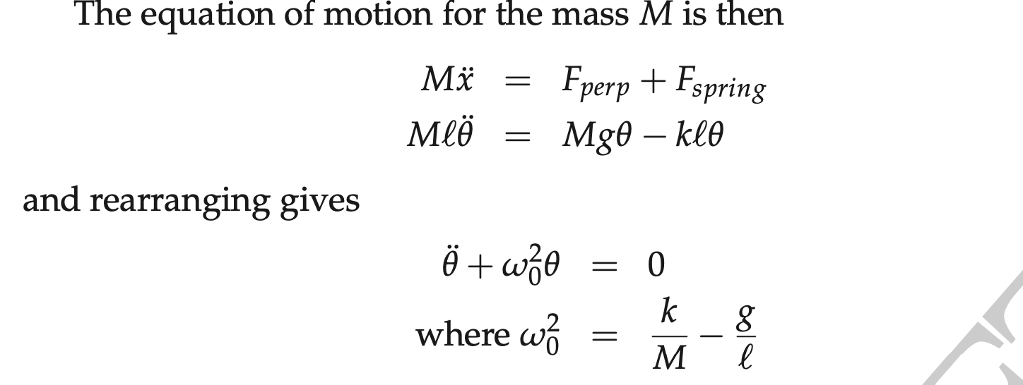

#### <https://www.bigrentz.com/blog/earthquake-proof-buildings> - ways of earthquake proofing

#### <https://www.protradecraft.com/why-do-buildings-fall-during-earthquakes> :

#### **Two-dimensional models help visualize the simple issues**

To make sense of it, architects and engineers use models like a two-dimensional array of lines representing columns and beams, or a single line lollipop with circles representing the building's mass. Even when simplified to this degree, these models can be quite useful, as predicting a building's response to an earthquake is primarily a matter of physics.

Most collapses that occur during earthquakes aren't caused by the earthquake itself. Instead, when the ground moves beneath a building, it displaces the foundation and lower levels, sending shock waves through the rest of the structure and causing it to vibrate back and forth.

The strength of this oscillation depends on two main factors:

* The building's mass, which is concentrated at the bottom
* Its stiffness, which is the force required to cause a certain amount of displacement

Along with the building's material type and the shape of its columns, stiffness is largely a matter of height. Shorter buildings tend to be stiffer, so they are less likely to shift, while taller buildings are more flexible.

#### **You can tune a building to earthquake resonance**

So in the equation representing their relationship, stiffness and natural frequency are proportional to one another, while mass and natural frequency are inversely proportional.

What happened in Mexico City was an effect called resonance, where the frequency of the earthquake's seismic waves happened to match the natural frequency of the mid-sized buildings. Like a well-timed push on a swing set, each additional seismic wave amplified the building's vibration in its current direction, causing it to swing even further back and so on, eventually reaching a far greater extent than the initial displacement.

Today, engineers work with geologists and seismologists to predict the frequency of earthquake motions at building sites to prevent resonance-induced collapses, taking into account factors such as soil type and fault type, as well as data from previous quakes.

Low frequencies of motion will cause more damage to taller and more flexible buildings, while high frequencies of motion pose more threat to structures that are shorter and stiffer.

Engineers have also devised ways to absorb shocks and limit deformation using innovative systems: Base isolation uses flexible layers to isolate the foundation's displacement from the rest of the building, while tuned mass damper systems cancel out resonance by oscillating out of phase with the natural frequency to reduce vibrations.

In the end, it's not the sturdiest buildings that will remain standing, but the smartest ones.

<https://www.iris.edu/hq/inclass/animation/building_resonance_the_resonant_frequency_of_different_seismic_waves> - from quincy, talks about resonance and height as well as soil vs bedrock

Some animations: <https://www.youtube.com/watch?v=I1NWtVaTg7I>

Tuned mass damping: <https://practical.engineering/blog/2016/2/14/tuned-mass-dampers-in-skyscrapers>

<http://physics.wooster.edu/JrIS/Files/Web_Article_Huang.pdf>

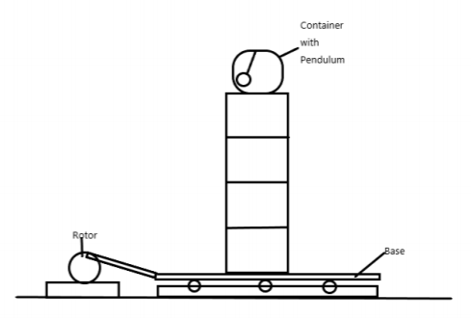

^^how to attach tuned mass damper to our buildings

Materials

* Sand pail/planters
* Rock
* Sand
* Long skinny dowels (flexible)
* boxes/tennis balls

VIDEO

* What our activity is
* How it relates to sustainability and the philippines
* What it teaches
* And a demonstration