AU_1_2_4

AU_1_left - vertical change between points 21 and 27 (moving apart)

AU_2_left – vertical change between (average of 19 and 20) and 36 (moving apart)

AU_1_right – vertical change between 22 and 27 (moving apart)

AU_2_right – vertical change between (average of 24 and 23) and 45 (moving apart)

AU_4_down - vertical change between points (average 21+22) and 27 (coming closer)

AU_4_high – horizontal change between 21 and 22 (moving brows closer)

AU_4_low – horizontal change between 21 and 22 (moving brows closer)

AU_1_up - vertical change between (average 19+20+23+24) and 27 (moving apart)

AU_5_7

AU_5 _left– vertical change of (average 41+40) and (average of 37 and 38) (moving apart)

AU_5 _right – vertical change of (average 43+44) and (average of 47 and 46) (moving apart)

AU_7 _left – vertical change of (average 36+39) and (average of 40 and 41) (coming closer)

AU_7 _right – vertical change of (average 42+45) and (average of 47 and 46) (coming closer)

(high, low depend on amount of change)

AU_10_12

Right AU_12 – vertical change of 33 and 54 (high, low, asym and uni depend on amount of change)

Left AU_12 – vertical change of 48 and 33 (high, low, asym and uni depend on amount of change)

AU_10 - vertical change of 33 and (average of 50 and 52)

AU_14

Right AU_14, Left AU_14 - area of red rectangle in the picture below

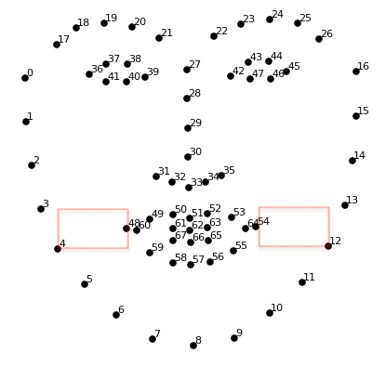

AU_17

AU_17 – area of red rectangle in the picture below

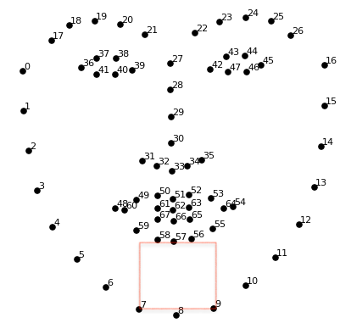

AU_24

AU_24 – vertical difference between 51 and 57 (coming closer)

AU_25_26

AU_25 – vertical difference between 51 and 57 (moving apart slightly)

AU_26 – vertical difference between 33 and 57 (moving apart highly)

AU_55_56

Left Tilting – line (between 36 and 45) angle change to the left

Right Tilting – line (between 36 and 45) angle change to the right

Nose_Wrinkle

nose_wrinkle – area of red rectangle in the picture below

