**Dapper**

**Dapper** - bu SQL so'rovlari natijalarini C# sinflari bilan taqqoslaydigan Stack Exchange vositasi. Ishlash tizimi EntityFreamwork ga ham o’xshaydi,ammo undan tezroq ishlaydi, Hammamiz biladigan <https://stackoverflow.com/> saytining qidiruv zimi ham Dapper yordamida tuzilgan.

Shuningdek Dapper oldingi Ado.Net ning avlodi hisoblanadi.Shuning uchun ham tuzilma Ado.Net bilan bir hil desa ham bo’ladi.

Endi amaliyot bilan shug’ullansak, Man Dapper bilan ishlash ko’nikmasini shakllantirish uchun,kompyuterni uncha qiynamaydigan bir nechta dasturlarni o’rnatib olaman.VsCode, MsSqlLocalDb, Dotnet lar bo’lsa bo’ldi.

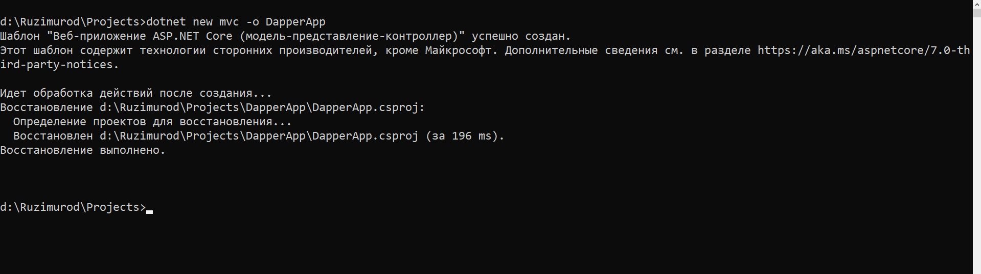

dotnet new mvc –o DapperApp

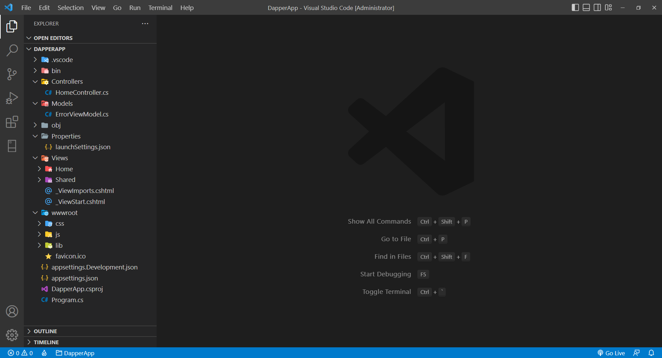

Proyektga yangi kutubxonalarni qo’shamiz.

dotnet add package Microsoft.Data.SqlClient

dotnet add package Dapper

Yangi database qurib olamiz.

CREATE DATABASE Users

Yangi jadval qurdik. (Bu kodlar faqat MsSql uchun)

CREATE TABLE People (

    Id INT PRIMARY KEY,

    FullName VARCHAR(MAX),

    Age INT NOT NULL,

    Email VARCHAR(MAX) NOT NULL

);

Jadvalni to’ldirdik. (Bu kodlar faqat MsSql uchun)

INSERT INTO People VALUES

   (1,'Ruzimurod Abdunazarov',19,'ruzimurodabdunazarov2003@mail.ru');

INSERT INTO People VALUES

   (2,'Eldor Axmedov',18,'eldor04@mail.ru');

INSERT INTO People VALUES

   (3,'Umid Abdusattorov',35,'umid.abdusattorov@mail.ru');

INSERT INTO People VALUES

   (4,NULL,11,'testor06@mail.ru');

INSERT INTO People VALUES

   (5,'Farzona Holmo''minova',16,'farzona2007@mail.ru');

INSERT INTO People VALUES

   (6,'Doston Ibragimov',30,'dostonI23@mail.ru');

INSERT INTO People VALUES

   (7,'Jasur Tursunov',25,'jasur13@mail.ru');

INSERT INTO People VALUES

   (8,NULL,24,'testor2@mail.ru');

INSERT INTO People VALUES

   (9,'Mohichexra Davronova',16,'mohichexra2007@mail.ru');

INSERT INTO People VALUES

   (10,'Davron Sattorov',26,'davron165@mail.ru');

Keyin umumiy malumotlar ombori quyidagicha bo’ladi.

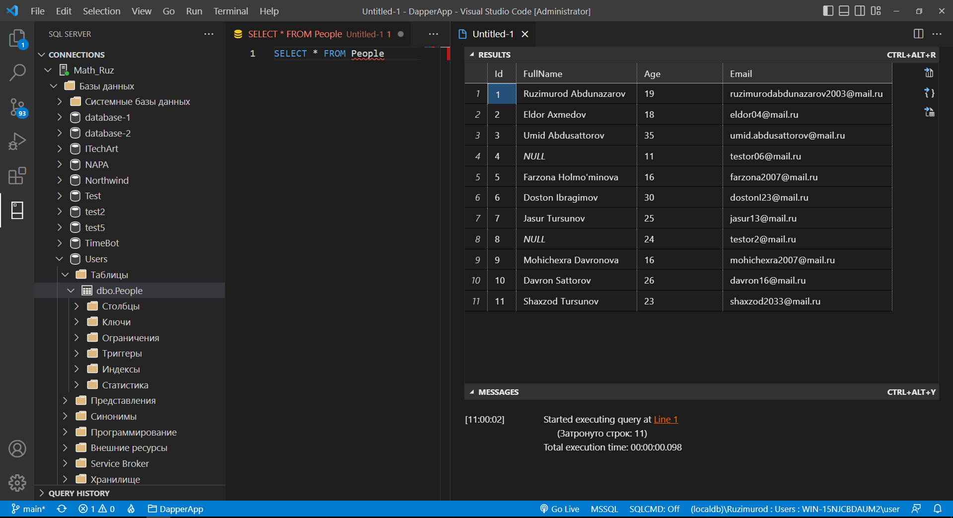

Bu malumotlar asosida yangi model tuzib olamiz.

public class User

{

    public int Id { get; set; }

    [DisplayName("Ф.И.О")]

    public string? FullName { get; set; }

    [DisplayName("Возраст")]

    public int Age { get; set; }

    [DisplayName("Электронная почта")]

    [Required]

    public string? Email { get; set; }

}

Keyingi bosqichda malumotlar bazasidan malumot olib kelish uchun Dapper ORM(Object Relation Mapper) dan foydalanamiz.

public interface IUserRepository

{

    int MaxId { get; }

    void Create(User user);

    void Delete(int id);

    User Get(int id);

    List<User> GetAll();

    void Update(User user);

    int Count { get; }

}

Birinchi ***IUserRepository*** interfeysini qurib olamiz.

Endi ***UserRepository*** ni yozamiz,kodlar asosan SQL ni o’zidagi Query da yoziladi,

Shuning uchun ham Dapper EfCore ga qaraganda tezroq ishlaydi,

1] Umumiy barcha User larni olib kelish uchun quyidagicha qilamiz.

public List<User> GetAll()

{

    using (IDbConnection db = new SqlConnection(_connectionString))

    {

        return db.Query<User>("SELECT * FROM People").ToList();

    }

}

Shu yerda bir narsaga e’tibor bering, ***SELECT * FROM People*** umumiy malumotlarni olib kelsa ***Query()*** buyruqi buni object ga aylantirayapti,

2] Aynan qaysidir Userni olib kelish uchun (SQL da SELECT buyruqi yordamida)

public User Get(int id)

{

    using (IDbConnection db = new SqlConnection(_connectionString))

    {

        return db.QuerySingleOrDefault<User>("SELECT * FROM People WHERE Id = @id", new { id }) ?? new User { };

    }

}

Bu yerda ***QuerySingleOrDefault()*** metodi bitta id parametrini Id ga tenglayapti.

3] Yangi User qo’shish uchun (SQL da INSERT buyruqi yordamida)

public void Create(User user)

{

    using (IDbConnection db = new SqlConnection(_connectionString))

    {

        var sqlQuery = "INSERT INTO People VALUES(@Id, @FullName, @Age, @Email)";

        db.Execute(sqlQuery, user);

    }

}

Bu yerda ko’rinib turibdiki kodimiz dasturga ***Execute()*** qilinayapti.

4] Malum bir Userni o’zgartirish uchun (SQL da UPDATE buyruqi yordamida)

public void Update(User user)

{

    using (IDbConnection db = new SqlConnection(_connectionString))

    {

        var sqlQuery = "UPDATE People SET FullName = @FullName, Age = @Age, Email = @Email WHERE Id = @Id";

        db.Execute(sqlQuery, user);

    }

}

5] Malum bir Userni o’chirish uchun (SQL da DELETE buyruqi yordamida)

public void Delete(int id)

{

    using (IDbConnection db = new SqlConnection(_connectionString))

    {

        var sqlQuery = "DELETE FROM People WHERE Id = @id";

        db.Execute(sqlQuery, new { id });

    }

}

6] Ma’lum bir prodsedureni chaqirish uchun (SQL da EXEC buyruqi yordamida)

Eng avvalo bitta prodsedura yaratib olaman,string DateTime ni Full qilib beradigan.

CREATE PROCEDURE ToFullDateTime @dateTime nvarchar(30)

AS

    DECLARE @date DATETIME;

    SET @date = CONVERT(DATETIME, @dateTime, 121)

    SELECT DATENAME(YEAR, @date) AS 'Year',

    DATENAME(QUARTER, @date)     AS 'Quarter',

    DATENAME(MONTH, @date)       AS 'MonthName',

    DATENAME(DAYOFYEAR, @date)   AS 'DayOfYear',

    DATENAME(DAY, @date)         AS 'Day',

    DATENAME(WEEK, @date)        AS 'Week',

    DATENAME(WEEKDAY, @date)     AS 'DayOfTheWeek',

    DATENAME(HOUR, @date)        AS 'Hour',

    DATENAME(MINUTE, @date)      AS 'Minute',

    DATENAME(SECOND, @date)      AS 'Second',

    DATENAME(MILLISECOND, @date) AS 'MilliSecond',

    DATENAME(MICROSECOND, @date) AS 'MicroSecond',

    DATENAME(NANOSECOND, @date)  AS 'NanoSecond',

    DATENAME(ISO_WEEK, @date)    AS 'ISO_WEEK'

a] ***CommandType.Text*** bilan

using (IDbConnection db = new SqlConnection(_connectionString))

{

    var sqlQuery = "EXEC ToFullDateTime @dateTime";

    FullTime result = db.QuerySingleOrDefault<FullTime>(sqlQuery, new { dateTime = DateTime.Now.ToString("yyyy-MM-dd HH:mm:ss") });

    return $"Год - {result.Year}, Четверть - {result.Quarter}, Месяц название - {result.MonthName}, День года - {result.DayOfYear}, День - {result.Day}, День недели - {result.DayOfTheWeek}, Час - {result.Hour}, Минута - {result.Minute}, Секунд - {result.Second}";

}

b] ***CommandType.StoredProcedure*** bilan

using (IDbConnection db = new SqlConnection(_connectionString))

{

    var prodsedure = "[ToFullDateTime]";

    var values = new { dateTime = DateTime.Now.ToString("yyyy-MM-dd HH:mm:ss") };

    FullTime result = db.QuerySingleOrDefault<FullTime>(prodsedure, values,commandType: CommandType.StoredProcedure);

    return $"Год - {result.Year}, Четверть - {result.Quarter}, Месяц название - {result.MonthName}, День года - {result.DayOfYear}, День - {result.Day}, День недели - {result.DayOfTheWeek}, Час - {result.Hour}, Минута - {result.Minute}, Секунд - {result.Second}";

}

Demak yana bitta takrorlash qilib olamiz, boshi esingizdan chiqib ketgan bo’lsa {smile} {smile} {smile}

a) Sql bilan bog’lanish hosil qilish

using (IDbConnection db = new SqlConnection(_connectionString))

{

//qanaqadir kod

}

b) Sql kodlarini shunchaki yozish

SELECT * FROM People

c) Yangi model tuzish (biz qaytarayotgan malumot obyekt ko’rinishida chiroyli bo’lishi uchun)

public class Class_Nomi

{

    //Proporties

}

d) Dapper bilan ko’nikma: Agar nimanidir bazada yangilamoqchi bo’lsangiz ***Execute()***

using (IDbConnection db = new SqlConnection(_connectionString))

{

    var sqlQuery = "INSERT INTO People VALUES(@Id, @FullName, @Age, @Email)";

    db.Execute(sqlQuery, user);

}

e) Dapper bilan ko’nikma: Agar nimanidir bazadan olmoqchi bo’lsangiz ***Query()***

using (IDbConnection db = new SqlConnection(_connectionString))

{

    return db.Query<User>("SELECT * FROM People").ToList();

}

f) Dapper bilan ko’nikma: Agar bazadan kelayotgan malumot bir qator bo’lsa ***QuerySingleOrDefault()***

using (IDbConnection db = new SqlConnection(_connectionString))

{

    return db.QuerySingleOrDefault<User>("SELECT * FROM People WHERE Id = @id", new { id }) ?? new User { };

}

g) Dapper bilan ko’nikma: Agar bazadan bitta prodsedureni ishlamoqchi bo’lsangiz

***CommandType.StoredProcedure*** yoki ***CommandType.Text*** bilan qilamiz.

Proyektning github dagi kodlarini <https://github.com/Ruzimurod2003/dapper-mvc> ga joylab qo’ydim.

Agar nimanidir o’rgangan bo’lsangiz bundan juda ham hursandman.