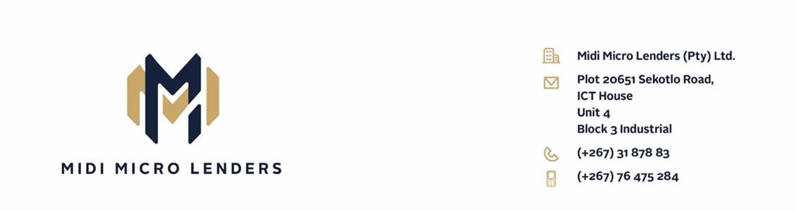 QUOTATION

PERSONAL DETAILS

Applicant Name & Surname Edward Kemmonye
Omang/Passport No 794 417 411

LOAN DETAILS

Loan Amount Requested BWP 30 000.00
Loan Term 48 months
Monthly Instalments BWP 1 305.04

Total Amount Payable BWP 62 641 .92
(all costs and interest Included)

Deduction will be done through LESAKA.

Signed by ________________________________

Date: ___________________________

