An attempt is made to describe the minimum level that could be reached in the real world with global cooperation against the epidemic, the range of problems that must be addressed at present, and any circumstances that might accelerate or hinder the achievement of the goal.

Introducing a variant of the May-Leonard model, the SEIR model, we fit data to the global epidemic population, find the minimum level that can be reached in the future by linear regression, try to show the problems that exist in each country during an epidemic outbreak, and give the corresponding solutions that can accelerate the fight against the epidemic and the mistakes that can accelerate its deterioration.

尝试描述在现实世界中，在全球防疫合作下可能达到的最低水平、目前必须解决的一系列问题、以及任何可能加速或阻碍目标实现的情况。

引入MayLeonard模型的变种SEIR模型，对于全球疫情感染人口做数据拟合，通过线性回归的方式寻找在未来可能达到的最低水平，尝试陈列出在疫情爆发期间各国存在的问题，分别给出相应能够加速抗击疫情的解决方式与加速疫情恶化的错误举措。

* **COVID-19 Infection Dynamics.**

In the face of an epidemic outbreak, it is easy to think of using the SEIR model [36]. After observing and studying the SEIR model, this paper found that the SEIR model is very similar to the extended May-Leonard model mentioned earlier. The different populations are divided into susceptible, exposed, infected and recured, corresponding to the four-dimensional May-Leonard model. We only need to modify the competition coefficients of different populations against other populations to transform the SEIR model into a simple and clear reflection of the changes in the proportions of various populations during the outbreak, and after fitting it with actual data, we can infer the current situation and future trends of the outbreak in reverse.

面对疫情的爆发，人们很容易想到采用SEIR模型[36]。经过对SEIR模型的观察和研究，本文发现SEIR模型与前面提到的扩展的MayLeonard模型非常相似。不同的人群被分为易感人群、暴露人群、感染人群和恢复人群，对应于四维的MayLeonard模型。我们只需修改不同人群对其他人群的竞争系数，就可以转化为SEIR模型，简单明了地反映出疫情爆发期间各种人群比例的变化，用实际数据拟合后，就可以反向推断出疫情的发展现状和未来趋势。

The graph below shows the change in the number of people in various categories within the city of Wuhan between the beginning of the new crown outbreak and the closure of the city. The differentiation of the different types of patients will enable us to quantify and predict trends in the epidemic and the increase in infections, which will be very useful in our subsequent data analysis.

下图展示的是新冠疫情爆发初期到封城之间，武汉城市内的各类人群数量的变化情况。将不同类型的患者进行区分能够有效地定量分析并预测疫情发展趋势和感染者增长情况，这将十分有助于我们接下来的数据分析。

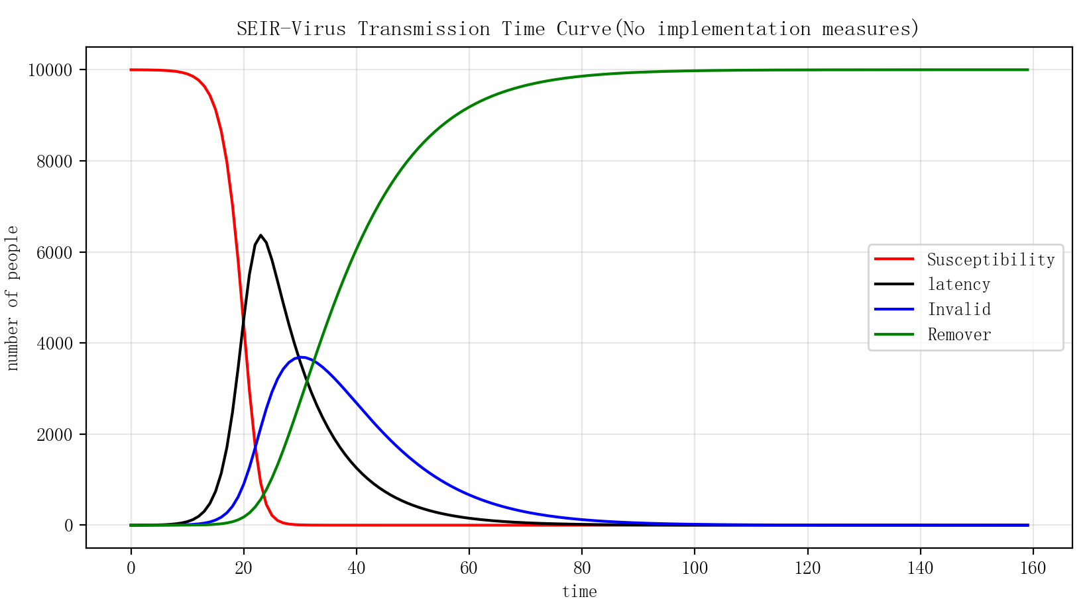

Figure 3-5： Virus spread chart (Wuhan)

首先假设城市的总人数不变，即不考虑出生率和死亡率，则有N = S(t) + E(t) + I(t) + R(t)，N是城市总人数，为一个常数，S(t)、E(t)、I(t)、R(t)分别表示t时刻网络中处于易感态、潜伏态、感染态和移除态的个体数目。其次，如果一个易感者与一个感染者发生物理接触，易感者成为潜伏者的概率（传染率）是 $β_{1}$；一个处于潜伏期的个体单位时间内感染他人的概率为 $β_{2}$，同时他将以概率 $γ_{1}$ 迁入感染者，同样，感染者以概率 $γ_{2}$ 成为移出者。

Firstly, assuming that the total number of people in the city remains constant, i.e. without considering birth and death rates, we have N = S(t) + E(t) + I(t) + R(t), where N is the total number of people in the city and is a constant, and S(t), E(t), I(t) and R(t) denote the number of individuals in the network who are in the susceptible, latent, infected and removed states at time t respectively. Second, if a susceptible individual comes into physical contact with an infected individual, the probability of the susceptible individual becoming a latent individual (contagion rate) is $β_{1}$; the probability of an individual in the latent state infecting others per unit time is $β_{2}$, while he will move into the infected state with probability $γ_{1}$, and similarly, the infected individual becomes a remover with probability $γ_{2}$.

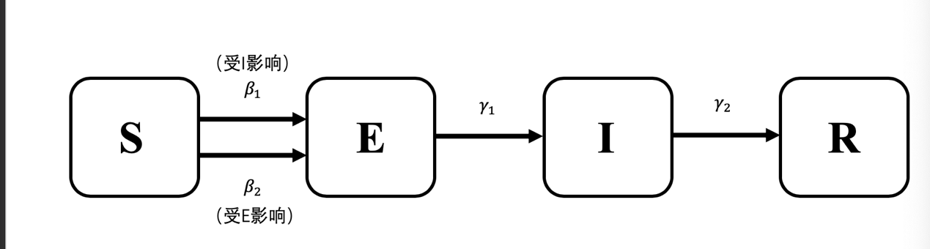

图3-6：Schematic diagram of SEIR model

In the SEIR model, the individual transition processes between the various states can be described by the following four differential equations:

在SEIR模型中，各种状态之间的个体转换过程可以用以下四个微分方程来描述：

|  |  |  |
| --- | --- | --- |
|  | $$\frac{dS\left(t\right)}{dt}=-β_{1}\frac{I\left(t\right)}{N}S\left(t\right)r_{i}-β_{2}\frac{E\left(t\right)}{N}S\left(t\right)r_{e}$$ | (1.1) |
|  | $$\frac{dE\left(t\right)}{dt}=β_{1}\frac{I\left(t\right)}{N}S\left(t\right)r_{i}+β_{2}\frac{E\left(t\right)}{N}S\left(t\right)r_{e}-γ_{1}E(t)$$ |
|  | $$\frac{dI\left(t\right)}{dt}=γ_{1}E\left(t\right)-γ_{2}I(t)$$ |
|  | $$\frac{dR\left(t\right)}{dt}=γ_{2}I(t)$$ $$r_{i}=\left\{\begin{aligned}C_{1} t<t_{free} \\ C_{2} t≥t_{free}\end{aligned}\right. ,$$ $$r_{e}=\left\{\begin{aligned}C_{1} t<t_{free} \\ C_{3} t≥t_{free}\end{aligned}\right.$$ |

$r_{i}$ is the number of people who are in contact with the infected each day, $r_{e}$ is the number of people who are in contact each day, and $t_{free}$ is the time point when the government takes effective measures. $C_{1}$, $C_{2}$, and $C_{3}$ are constants, and $C_{1}$ ＞ $C_{2}$, $C_{1}$ ＞ $C_{3}$. As the government takes active countermeasures, the sick people will be quarantined and effectively treated in time, and the number of people in contact with the sick will decrease. At the same time, because people actively reduce the frequency of going out, stay away from crowded places, and wear masks to protect themselves from the virus, the number of people that susceptible people come in contact with has also decreased a lot.

$r_{i}$ 为感染者每天接触的人数， $r_{e}$ 为潜伏者每天接触的人数， $t_{free}$ 为政府采取有效措施的时间点。 $C_{1}$， $C_{2}$ 和 $C_{3}$ 是常数，且 $C_{1}$ ＞ $C_{2}$， $C_{1}$ ＞ $C_{3}$。由于政府采取积极的应对措施，使得病的人被及时隔离和受到有效治疗，感病人接触的人数将减少。同时，因为人们也主动地减少外出次数、远离人群密集的地方、戴口罩等来保护自己避免感染病毒，所以易感类的人们日常接触的人的数量也减少了很多。

* **SEIR模型的解决方案**

众所周知，疫情防控的最佳时机在疫情爆发的初期，本文选取了新加坡、中国、美国和日本四个代表性国家截至2020年6月5日的疫情数据作为初始爆发指标。作为四个防疫策略差异较大的国家，对他们的分析能够更加直观地凸显防疫策略对于新冠疫情发展的影响，受疾病影响的总人数如下图片所示：

As it is well known that the best time to prevent and control an outbreak is at the beginning of the outbreak, this paper selects four representative countries, Singapore, China, the United States and Japan, as the initial outbreak indicators as of 5 June 2020. As four countries with widely varying epidemic control strategies, their analysis can more visually highlight the impact of epidemic control strategies on the development of the new crown epidemic, with the total number of people affected by the disease shown in the images below.

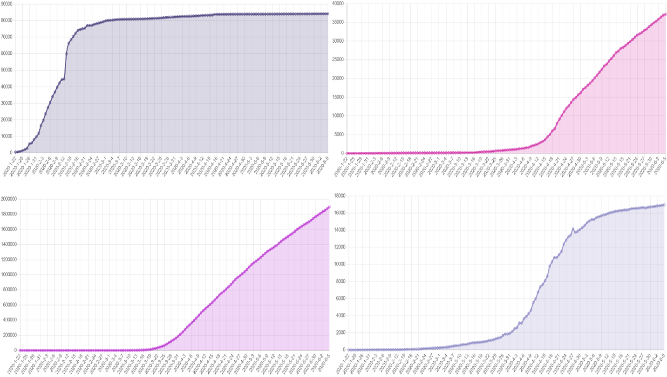

Figure 3-7 total cases in China, Singapore, US, Japan

下面是这四个国家的病人总数在拟合SEIR模型后的曲线图：

The following is a graph of the total number of patients in these four countries after fitting the SEIR model:

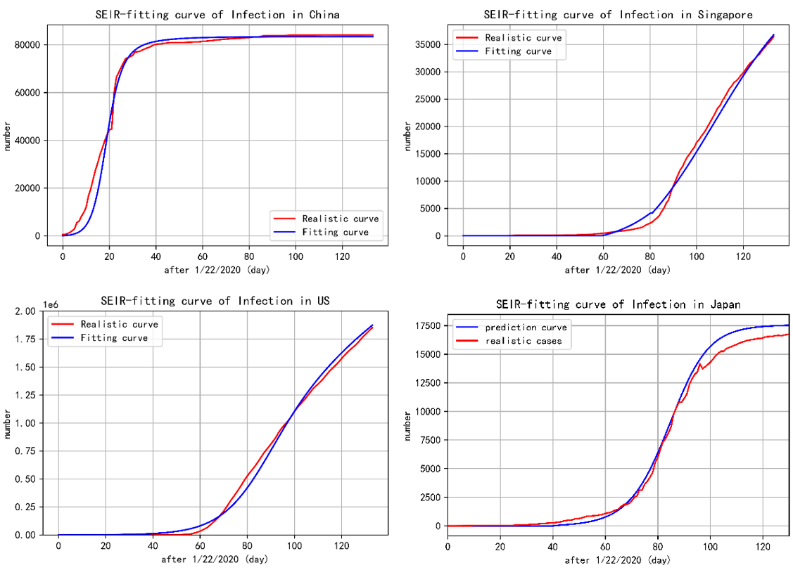Figure 3-8 Fitting Curve for each country

根据2020年6月5日以后各国患病总人数的统计，以及新闻报道中的真实数据，可以发现在疫情爆发后的60天左右，各国已经开始为更好地抗击疫情进行物资交流和运输，中国在疫情爆发的最早阶段接收了各国的大量医疗物资，并在较早稳定国内局势后向其他国家输送物资。因此，纯SEIR模型在60天后并不适用。本文 在疫情爆发后的前60天，用SEIR模型来分析这个时间段，外部干扰影响较小。

Based on the statistics of the total number of people sickened in each country after 5 June 2020, as well as the real data from news reports, it can be seen that around 60 days after the outbreak, countries had already started to exchange and transport supplies to better fight the epidemic, with China receiving large amounts of medical supplies from various countries in the earliest stages of the outbreak and sending supplies to other countries after stabilising the situation at home earlier. Therefore, the pure SEIR model does not apply after 60 days. In this paper, the SEIR model is used to analyse this time period in the first 60 days after the outbreak, when external disturbances are less influential.

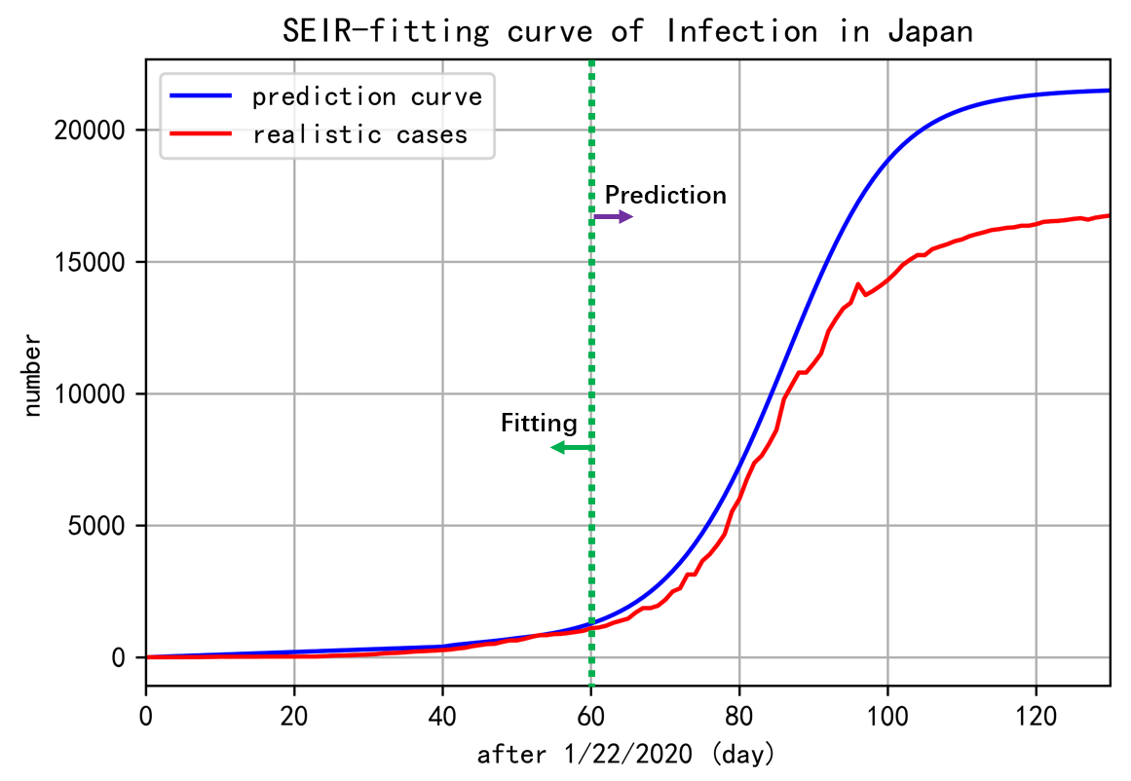

图3-9 Trend chart of predicted development after the first 60 days of fitting

在上图中，我们确保模型在前60天可以很好地拟合，并在不改变参数的情况下继续模拟疫情的发展。可以看到，60天后，由于疫情材料的帮助或在其他干预措施下，无论是增长率还是累计总量都低于之前情况下预测的曲线。这反映出各国在疫情发生时采取了强有力的相应政策进行防治。其中，国际间医疗物资的运送和各国共同抗击疫情的努力。

In the above picture, we ensure that the model can be well fitted in the first 60 days, and continue to simulate the development of the epidemic without changing the parameters. As you can see, after 60 days, due to the help of epidemic materials or Under other interventions, both the growth rate and the cumulative total are lower than the curve predicted by the previous situation. This reflects that countries have adopted strong corresponding policies to fight the epidemic in the middle of the epidemic. Among them, the international The delivery of medical supplies between countries and the efforts of various countries to work together to fight the epidemic.

* **What if others be like China**

我们首先构建了SEIR模型。数据来源是2020年12月4日全球疫情的累计确诊病例数，以世界为联盟人口。首先，我们将模型曲线与现实数据进行拟合，并试图推导出全球疫情的后续发展趋势。之后，为了找到有效控制疫情所能达到的最低目标，我们假设，如果世界各国都意识到疫情的严重性，对疫情控制较好的中国无疑是一个值得学习的对象。2020年12月4日以后，我们将以前拟合中国国内病例累积情况的曲线参数引入模型，代表世界各国都像中国一样采取了严格的控制和预防措施。得到的结果如下。

We first constructed the SEIR model. The data source was the cumulative number of confirmed cases of the global epidemic as of 4 December 2020, with the world as the union population. First, we fitted the model curves to realistic data and tried to derive the subsequent trend of the global epidemic. Afterwards, in order to find the minimum target that can be achieved to effectively control the epidemic, we assume that if all countries in the world are aware of the seriousness of the epidemic, China, which has a better control of the epidemic, is undoubtedly a worthy candidate for study. after 4 December 2020, we introduce into the model the parameters of the curve that previously fitted the accumulation of cases within China, representing the fact that all countries in the world, like China, have adopted strict control and preventive measures as China has done. The results obtained are as follows.

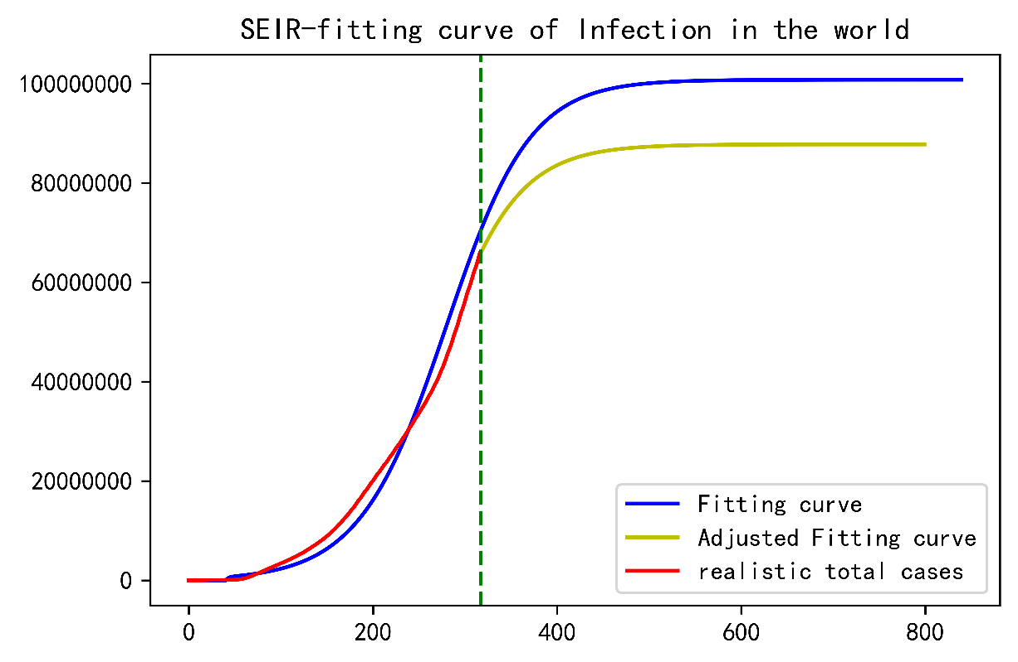

Figure 4-1：Comparison between taking strict measures or not

从上图可以看出，根据我们模型的模拟结果，按照目前的疫情发展速度，全球疫情可能还需要300多天才能稳定下来，如果按照今天中国的严格控制策略，可能在200天左右疫情就会稳定。当然，还有很多实际因素是我们没有考虑到的。例如，由于患病人口基数大，各国限制人们的旅行越来越困难。但是，考虑到各国之间医疗用品的运送和疫苗药物的研究越来越深入，我们仍然认为，像中国这样减少人与人之间的接触或者佩戴合格的医用口罩的策略是最好的，可以有非常好的效果。为了保证疫情能够如模型所示得到有效控制，我们列出了一些措施供参考。

As you can see from the graph above, based on the simulation results of our model, at the current rate of development of the epidemic, it may take more than 300 days for the global epidemic to stabilise, and if China's strict control strategy is followed today, the epidemic may be stabilised in around 200 days. There are, of course, many practical factors that we have not taken into account. For example, it is becoming increasingly difficult for countries to restrict people's travel due to the large base of sick people. However, given the increasing research into the delivery of medical supplies and vaccine drugs between countries, we still believe that a strategy such as the one used in China to reduce person-to-person contact or the wearing of qualified medical masks would be the best and could have very good results. To ensure that the outbreak can be effectively controlled as the model suggests, we have listed some measures for reference.

基于对所提模型的深入分析，我们强调了以下见解。

建议的模型细化了全球抗击流行病合作的最低可实现水平的全球目标。也就是说。

达到全球抗疫合作最低可实现水平的全球目标的时间表如下。

Based on an in-depth analysis of the proposed model, we have highlighted the following insights.

The proposed model refines global targets for the minimum achievable level of global cooperation in the fight against epidemics. In other words.

The timeline for reaching the global target of the minimum achievable level of global cooperation against the epidemic is as follows.

可能加速实现全球抗击流行病合作的情况有以下几点

一些共同抗疫的组织建立或相关协议被提出，可能会加大区域之间的合作交流。有效的疫苗被研制出来可能会大大降低健康人被感染的概率。更多的医疗物资和医务人员送向有需要的人。

相比之下，可能阻碍实现全球抗击流行病合作的情况如下：

如果有新闻或者媒体传播不当言论，比如谣言，可能会导致民众不信任政府，自暴自弃，选择不戴口罩上街等不理智行为。政府机关直接合作效率低下。国家之间不合作。

最后我们撰写了一篇memo希望能够在现实世界里对于抗击疫情做出贡献。我们同样使用了SEIR模型，并且将地球看做一个整体。通过收集截止到2020年12月4号的数据，我们对现实数据进行拟合，得到了未来疫情的发展走势。我们发现按照目前趋势或许仍然需要300多天疫情才能趋于稳定。但是当各国都从开始采取和中国一样的治理策略时，或许只需要200天左右疫情就会被压制，并且全球累积的患病个例也会有显著下降。在此之前，仍然存在一些必须克服的问题，包括了。。。。我们由此也提出了一些措施，能够对于全球抗击疫情做出贡献，例如。。。。实际上，还存在着一些阻碍人们抗击疫情的因素，包括。。。。

The following scenarios may accelerate the achievement of global cooperation in the fight against epidemics

A number of organisations working together against the epidemic are established or relevant agreements are proposed, which may increase the exchange of cooperation between regions. The development of effective vaccines may significantly reduce the probability of healthy people being infected. More medical supplies and medical personnel are sent to those in need.

In contrast, situations that may prevent the achievement of global cooperation in the fight against pandemics are as follows.

If there is news or media spreading inappropriate statements, such as rumours, this may lead to people distrusting their government, giving up on themselves, choosing not to wear masks on the streets and other irrational behaviour. Inefficient direct cooperation between government agencies. There is no cooperation between countries.

Finally we have written a memo that we hope will contribute to the fight against the epidemic in the real world. We also used the SEIR model and looked at the planet as a whole. By collecting data up to December 4, 2020, we fitted realistic data to the future course of the epidemic. We found that it may still take more than 300 days for the epidemic to stabilise on current trends. But when countries start to adopt the same management strategy as China, it may only take around 200 days for the epidemic to be suppressed and for the cumulative number of cases worldwide to fall significantly. Until then, there are still issues that must be overcome, including 。。。。 We have thus proposed some measures that could contribute to the global fight against the epidemic, such as 。。。。 In fact, there are still some barriers to the fight against the epidemic, including 。。。。

[36] Berger, David W., Kyle F. Herkenhoff, and Simon Mongey. An seir infectious disease model with testing and conditional quarantine. No. w26901. National Bureau of Economic Research, 2020.