

NOVAC TECHNOLOGY SOLUTIONS

Specification Document

Document Version No.: 1.00

Revision History
Version No | Date | Reason For Changes | Author | Reviewer | Approver
0.01 | 24-04-2025 | Draft | VENKATALAKSHMI
0.02 | 05-05-2025 | Reviewed | VENKATALAKSHMI | M.DHANALAKSHMI | SANKAR GANESH
1.00 | 05-05-2025 | Baselined | VENKATALAKSHMI | M.DHANALAKSHMI | SANKAR GANESH

Table of Contents
1. Introduction 4
1.1 Purpose 4
1.2 Scope of the Document 4
1.3 Roles and Responsibilities 4
1.4 Field Types Used in this FS Document 4
2. Functions of the Application 4
2.1 Changes in Claim Paid and Claim Payment Info Report_INC-61350 4
2.1.1 Purpose of the Requirement 4
2.1.2 Accessibility 5
2.1.3 Usage and Validation 5
2.1.4 Action Flow 5
2.2 Assumptions and Dependencies 6
2.3 Requirements Validation 6
3. Appendix A 6
3.1 Appendix 1 6

Introduction

Purpose
The purpose of this requirement, to change the report filter criteria for the Claim Paid Report and Claim Payment Info Report in the ZIVA application:
  - Guidelines, circulars, instructions and directions released from time to time by Philippines Insurance council.

Scope of the Document
To change the report filter criteria in the Claim Paid Report and Claim Payment Info Report.

Roles and Responsibilities
Refer RACI document

Field Types Used in this FS Document

Field Type | Description
Varchar | Stores Variable Length of any Character Set.
BigInt | Stores Numeric Values from 0 to 255.
Integer | Stores Numeric Values without Decimals.
Date | Stores Date and Time value.
Pkid | User-defined data type to hold unique numbers without null values

Functions of the Application
The requirements are described below in detail will be implemented in system.
- Changes in Claim Paid and Claim Payment Info Report_INC-61350

Changes in Claim Paid and Claim Payment Info Report_INC-61350

Purpose of the Requirement
This document will elaborate us about the Claim Paid Report and the Claim Payment Info Report based on the Claim Paid Date (Instrument/Transaction Date) for each claim, ensuring accurate reporting of actual payment transactions.

Accessibility
This screen can be access in the given Menu path which is menu >> Claim Intimation Interface
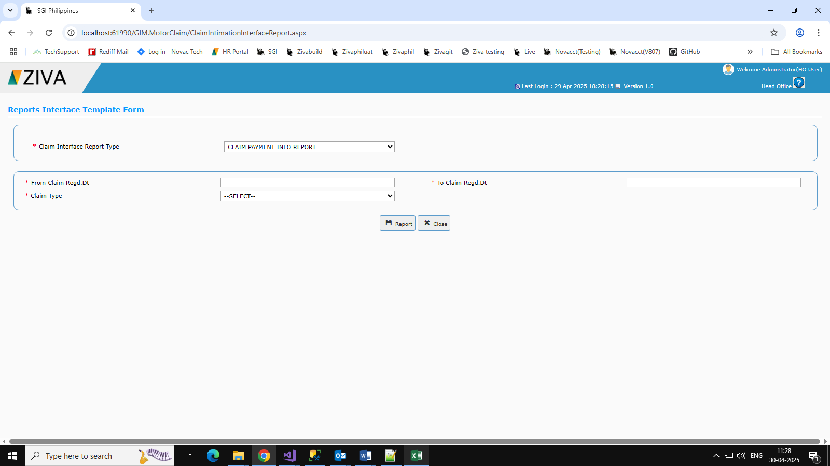

Usage and Validation
Table ID | Table Name | Table Description
A | GIM_Policy | To Store the motor policy details
B | GIM_Receipt_h | To Store the motor receipt details
C | Gim_MTCLM_Registration | To Store the motor claim registration details
D | GNM_T_PHIL_POLICY | To Store the non-motor details
E | GNM_PHIL_Receipt_h | To Store the non-motor receipt details
F | Gnm_CLM_Registration | To Store the non-motor claim registration details

Action Flow

Affected Screen/ Component/Control | Event | Method/JS Function/Procedure Block | Operation | Validation / Error Message / Raising Error Events
btnSave | btnGenerate_Click | If(!(generate)) | Based On the Given data it should populate the same | It throws mandatory Validation
btnClear |  | clearAll() | Based On the Given data it should populate the same | It throws mandatory Validation
btnClose | btnClose_Click | protected void btnCLose_Click(object sender, EventArgs e) | Based On the Given data it should populate the same | It throws mandatory Validation

Assumptions and Dependencies
NA

Requirements Validation
NA

Appendix A
NA

Appendix 1
NA

