# **Practical :1**

**Aim:** Introduction to Android Studio Steps**:**

1. Open Android Studio -> Click on New Project -> Select Empty Activity -> Click Next

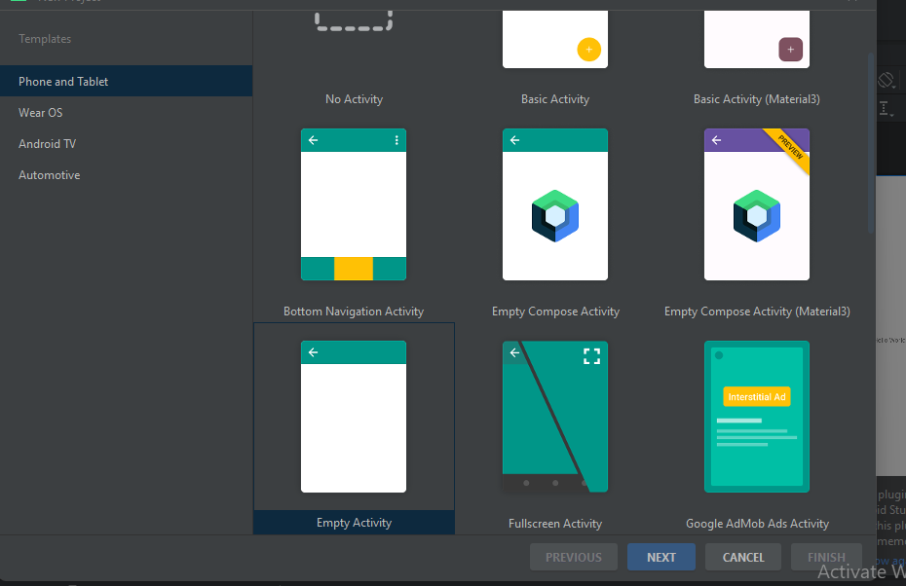

1. Add a Project Name and Select Language as Kotlin -> Click Finish

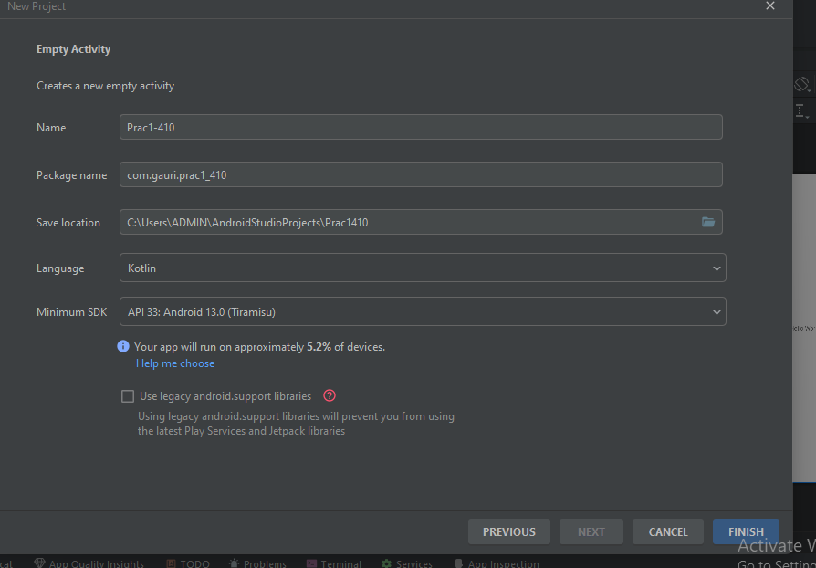

1. Steps to create an AVD: a) Click on the Device manager icon on the right hand side
2. b) Go to Virtual tab -> Create a device

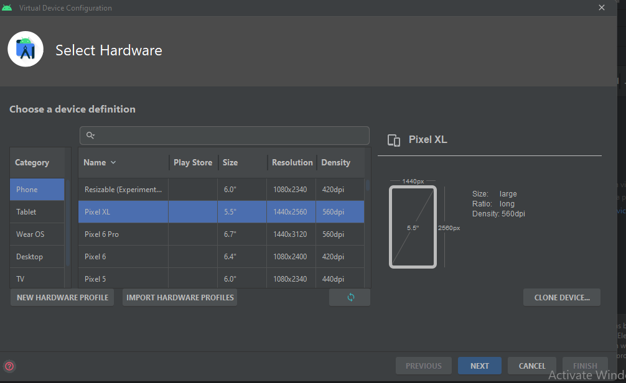

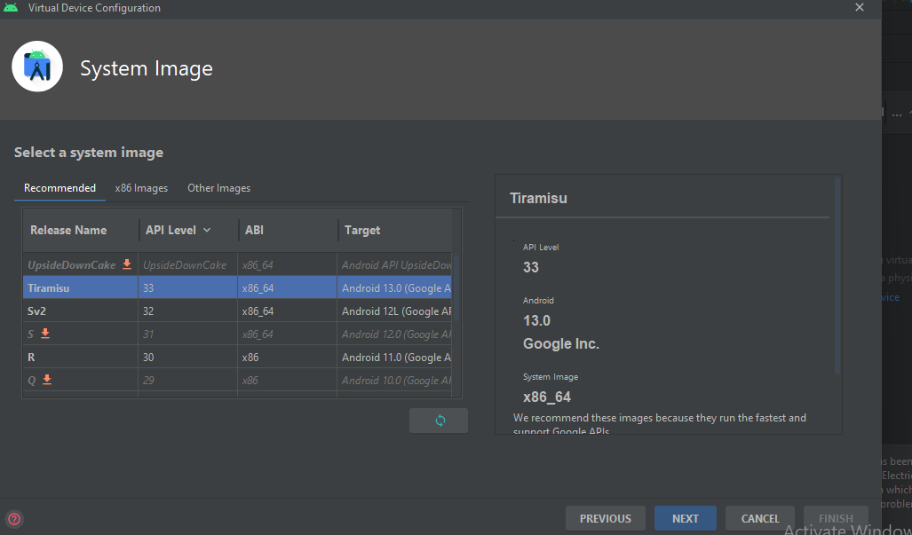

**Activity main.xml:**

<?xml version="1.0" encoding="utf-8"?>  
<androidx.constraintlayout.widget.ConstraintLayout xmlns:android="http://schemas.android.com/apk/res/android"  
 xmlns:app="http://schemas.android.com/apk/res-auto"  
 xmlns:tools="http://schemas.android.com/tools"  
 android:layout_width="match_parent"  
 android:layout_height="match_parent"  
 tools:context=".MainActivity">  
  
 <TextView  
 android:layout_width="112dp"  
 android:layout_height="24dp"  
 android:text="Hello World!"  
 android:textSize="24sp"  
 app:layout_constraintBottom_toBottomOf="parent"  
 app:layout_constraintLeft_toLeftOf="parent"  
 app:layout_constraintRight_toRightOf="parent"  
 app:layout_constraintTop_toTopOf="parent" />  
  
</androidx.constraintlayout.widget.ConstraintLayout>

**OUTPUT:-**

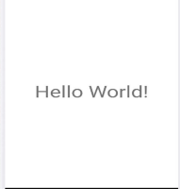

# **Practical No2 Aim: Create a Signup Page using Linear Layout**

# **activity_main.xml**

?xml version="1.0" encoding="utf-8"?>  
<LinearLayout  
 xmlns:android="<http://schemas.android.com/apk/res/android>"  
 android:layout_height="match_parent"  
 android:layout_width="match_parent"  
 android:layout_margin="10dp"  
android:orientation="vertical">  
  
 <TextView  
 android:layout_width="wrap_content"  
 android:layout_height="wrap_content"  
 android:text="Facebook"  
 android:textStyle="bold"  
 android:textSize="40sp"  
 android:layout_gravity="center"  
 android:textColor="@color/black"/>  
  
 <EditText  
 android:layout_width="wrap_content"  
 android:layout_height="wrap_content"  
 android:text="Create a Neww account"  
 android:textSize="25sp"  
 android:layout_gravity="center"/>  
  
 <EditText  
 android:layout_width="363dp"  
 android:layout_height="wrap_content"  
 android:layout_margin="10dp"  
 android:hint="Username"  
 android:textSize="25sp"/>  
  
 <EditText  
 android:layout_width="363dp"  
 android:layout_height="wrap_content"  
 android:layout_margin="10dp"  
 android:hint="Email"  
 android:textSize="25sp"/> <EditText  
 android:layout_width="363dp"  
 android:layout_height="wrap_content"  
 android:layout_margin="10dp"  
 android:hint="password"android:textSize="25sp"android:inputType="textPassword"/>

<EditText  
 android:layout_width="363dp"  
 android:layout_height="wrap_content"  
 android:layout_margin="10dp"  
 android:hint="confirm password"  
 android:textSize="25sp"/>  
 <CheckBox  
 android:layout_width="wrap_content"  
 android:layout_height="wrap_content"  
 android:text="I accept the terms and conditions"  
 android:layout_margin="10dp"  
 android:textSize="25sp"/>  
 <Button  
 android:layout_width="wrap_content"  
 android:layout_height="wrap_content"  
 android:layout_margin="10dp"  
 android:text="sign up"  
 android:layout_gravity="center"  
 />  
 <TextView  
 android:layout_width="match_parent"  
 android:layout_height="match_parent"  
 android:text="Already have an account? Login here"  
 android:layout_margin="10dp"  
 android:textSize="20sp"  
 android:textAlignment="center"/>  
</LinearLayout>

**OUTPUT:-**

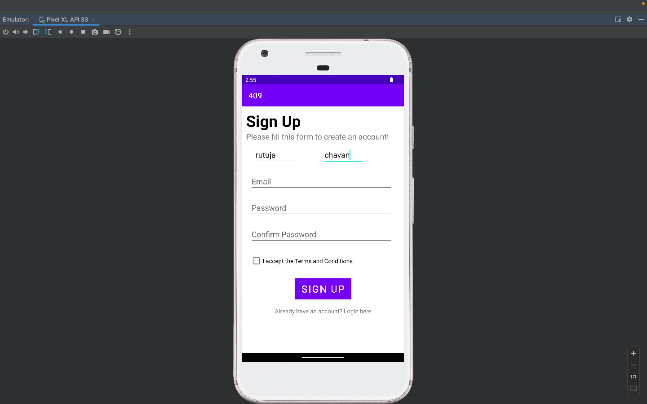

# **Practical No 3**

**Aim: Create a Signup Page using Relative Layout activity_main.xml :**

<?xml version="1.0" encoding="utf-8"?>

<RelativeLayout

xmlns:android="http://schemas.android.com/apk/res/android"

android:layout_width="match_parent"

android:layout_height="match_parent"

android:layout_margin="10dp" >

<TextView

android:id="@+id/text1"

android:layout_width="wrap_content"

android:layout_height="wrap_content"

android:text="Sign up now to start your free sales trial."

android:textSize="20sp"

android:layout_margin="10dp"

/>

<TextView

android:id="@+id/text2"

android:layout_width="wrap_content"

android:layout_height="wrap_content"

android:text="First name"

android:textSize="15sp"

android:layout_below="@id/text1"

android:layout_alignLeft="@id/text1"

/>

<EditText

android:id="@+id/et1"

android:layout_width="100dp"

android:layout_height="wrap_content"

android:textSize="12dp"

android:layout_below="@id/text2"

android:layout_alignLeft="@id/text2"

/>

<TextView

android:id="@+id/text3"

android:layout_width="wrap_content"

android:layout_height="wrap_content"

android:layout_below="@id/text1"

android:layout_alignRight="@id/text1"

android:text="Last name"

android:layout_marginRight="10dp"

android:textSize="15sp" />

<EditText

android:id="@+id/et2"

android:layout_width="100dp"

android:layout_height="wrap_content"

android:layout_below="@id/text3"

android:layout_alignRight="@id/text3"

android:layout_marginRight="10dp"

android:textSize="12dp" />

<TextView

android:id="@+id/text4"

android:layout_width="wrap_content"

android:layout_height="wrap_content"

android:text="Work email"

android:textSize="15sp"

android:layout_below="@id/et1"

android:layout_alignLeft="@id/et1" />

<EditText

android:id="@+id/et3"

android:layout_width="100dp"

android:layout_height="wrap_content"

android:textSize="12dp"

android:layout_below="@id/text4"

android:layout_alignLeft="@id/text4" />

<TextView

android:id="@+id/text5"

android:layout_width="match_parent"

android:layout_height="wrap_content"

android:layout_below="@id/et2"

android:layout_alignLeft="@id/et2"

android:text="Job Title"

android:layout_marginRight="10dp"

android:textSize="15sp" />

<EditText

android:id="@+id/et4"

android:layout_width="150dp"

android:layout_height="wrap_content"

android:layout_below="@id/text5"

android:layout_alignRight="@id/text5"

android:layout_marginRight="10dp"

android:textSize="12dp" />

<TextView

android:id="@+id/text6"

android:layout_width="wrap_content"

android:layout_height="wrap_content"

android:text="Company"

android:textSize="15sp"

android:layout_below="@id/et3"

android:layout_alignLeft="@id/et3" />

<EditText

android:id="@+id/et5"

android:layout_width="150dp"

android:layout_height="wrap_content"

android:textSize="12dp"

android:layout_below="@id/text6"

android:layout_alignLeft="@id/text6" />

<TextView

android:id="@+id/text7"

android:layout_width="match_parent"

android:layout_height="wrap_content"

android:text="Employees"

android:textSize="15sp"

android:layout_below="@id/et4"

android:layout_alignLeft="@id/et4"

android:layout_marginRight="10dp" />

<EditText

android:id="@+id/et6"

android:layout_width="150dp"

android:layout_height="wrap_content"

android:layout_below="@id/text7"

android:layout_alignRight="@id/text7"

android:textSize="12dp"

android:layout_marginRight="10dp"/>

<TextView

android:id="@+id/text8"

android:layout_width="match_parent"

android:layout_height="wrap_content"

android:text="Phone"

android:textSize="15sp"

android:layout_below="@id/et5"

android:layout_alignLeft="@id/et5" />

<EditText

android:id="@+id/et7"

android:layout_width="150dp"

android:layout_height="wrap_content"

android:layout_below="@id/text8"

android:layout_alignLeft="@id/text8"

android:textSize="12dp" />

<TextView

android:id="@+id/text9"

android:layout_width="match_parent"

android:layout_height="wrap_content"

android:layout_below="@id/et6"

android:layout_alignLeft="@id/et6"

android:text="Country/Region"

android:layout_marginRight="10dp"

android:textSize="15sp" />

<EditText

android:id="@+id/et8"

android:layout_width="150dp"

android:layout_height="wrap_content"

android:layout_below="@id/text9"

android:layout_alignRight="@id/text9"

android:layout_marginRight="10dp"

android:textSize="12dp" />

<CheckBox

android:id="@+id/checkbox"

android:layout_width="380dp"

android:layout_height="wrap_content"

android:layout_below="@id/et7"

android:text="I agree to the Main Services Agreement."

android:textSize="10sp"

android:layout_margin="10dp"/>

<TextView

android:id="@+id/text10"

android:layout_width="wrap_content"

android:layout_height="wrap_content"

android:layout_below="@id/checkbox"

android:text="By registering, you confirm that you agree to the storing and processing of your personal data by Salesforce as described in the Privacy Statement."

android:textSize="8sp"

android:layout_margin="10dp"/>

<Button

android:layout_width="match_parent"

android:layout_height="wrap_content"

android:layout_below="@id/text10"

android:layout_marginLeft="10dp"

android:layout_marginRight="10dp"

android:text="Start my free trial"

android:layout_marginTop="10dp"

android:textSize="20sp" />

</RelativeLayout>

**OUTPUT:-**

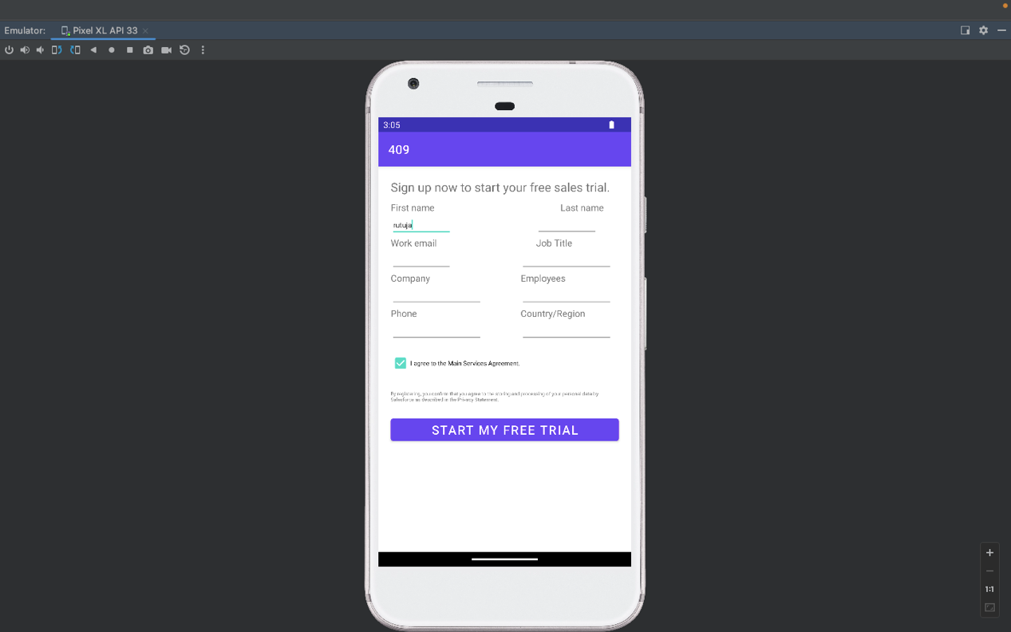

# **Practical No 4**

**Aim: Create a Signup page using Absolute layout activity_main.xml**

<?xml version="1.0" encoding="utf-8"?>  
<AbsoluteLayout  
 xmlns:android="http://schemas.android.com/apk/res/android"  
 android:layout_width="match_parent"  
 android:layout_height="match_parent" >  
 <TextView  
 android:layout_width="wrap_content"  
 android:layout_height="wrap_content"  
 android:layout_x="100dp"  
 android:layout_y="50dp"  
 android:text="FACEBOOK"  
 android:textStyle="bold"  
 android:textSize="40sp"  
 android:gravity="center"  
 />  
 <TextView android:id="@+id/text1"  
 android:layout_width="wrap_content"  
 android:layout_height="wrap_content"  
 android:layout_x="100dp"  
 android:layout_y="100dp"  
 android:text=" create a new account"  
 android:textSize="20sp"  
 android:textStyle="bold"  
 />  
 <TextView android:id="@+id/text2"  
 android:layout_width="wrap_content"  
 android:layout_height="wrap_content"  
 android:layout_x="100dp"  
 android:layout_y="150dp"  
 android:text="its quick and easy "  
 android:textSize="15sp"  
 />  
 <EditText  
 android:layout_width="wrap_content"  
 android:layout_height="wrap_content"  
 android:layout_x="30dp"  
 android:layout_y="200dp"  
 android:hint="Firstname"  
 android:textSize="15sp"  
 />  
 <EditText  
 android:layout_width="wrap_content"  
 android:layout_height="wrap_content"  
 android:layout_x="250dp"  
 android:layout_y="200dp"  
 android:hint="last name"  
 android:textSize="15sp"  
 />  
 <EditText  
 android:layout_width="324dp"  
  
 android:layout_height="wrap_content"  
 android:layout_x="30dp"  
 android:layout_y="250dp"  
 android:hint="Enter email address"  
 android:inputType="textEmailAddress"  
 />  
 <EditText  
 android:layout_width="324dp"  
 android:layout_height="wrap_content"  
 android:layout_x="30dp"  
 android:layout_y="300dp"  
 android:hint="New password"  
 android:inputType="textPassword"  
 />  
 <TextView android:id="@+id/text3"  
 android:layout_width="wrap_content"  
 android:layout_height="wrap_content" android:layout_x="30dp"  
 android:layout_y="370dp"  
 android:text="Date of Birth"  
 android:hint="Enter date of birth"  
 android:textSize="15sp"  
  
 />  
 <Button  
 android:layout_width="wrap_content"  
 android:layout_height="wrap_content"  
 android:layout_x="114dp"  
 android:layout_y="400dp"  
 android:text="Sign Up"  
 android:textSize="25sp"  
 />  
</AbsoluteLayout>

**OUTPUT:-**

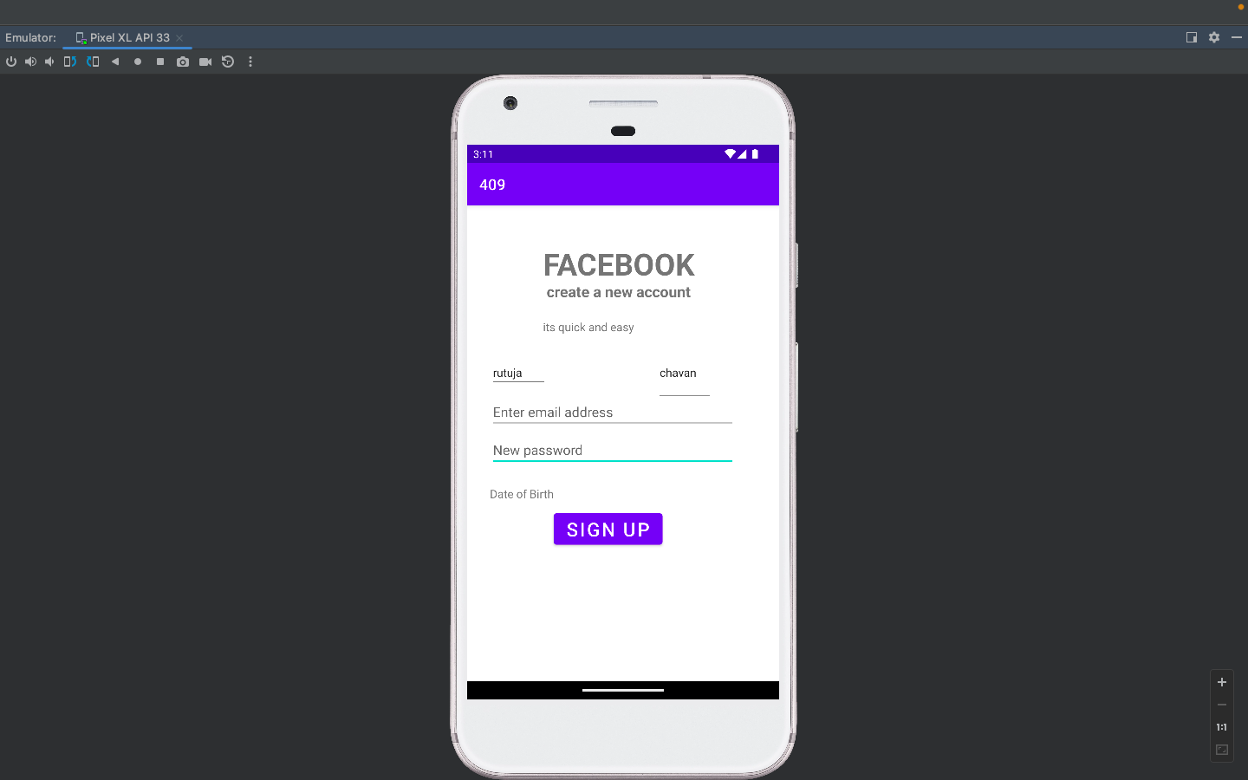

# **Practical No 5**

**Aim:- Create a Signup Page using Table Layout** **activity_main.xml**

<?xml version="1.0" encoding="utf-8"?>  
<TableLayout xmlns:android="http://schemas.android.com/apk/res/android" xmlns:app="http://schemas.android.com/apk/res-auto" android:layout_height="match_parent" android:layout_width="match_parent" android:layout_margin="10dp">  
 <TextView android:id="@+id/text"  
 android:layout_width="wrap_content"  
 android:layout_height="wrap_content"  
 android:layout_centerHorizontal="true"  
 android:layout_marginTop="30dp"  
 android:text="Registration Form for sports"  
 android:textSize="30sp"  
 android:textStyle="bold"  
 android:layout_margin="10dp">  
 </TextView>  
 <TextView android:id="@+id/text1"  
 android:layout_width="wrap_content"  
 android:layout_height="wrap_content"  
 android:text="it's easy to do"  
 android:layout_centerHorizontal="true"  
 android:layout_below="@+id/text"  
 android:textSize="20sp"  
 android:layout_margin="10dp"  
 >  
</TextView>  
 <TableRow  
 android:layout_marginTop="20dp">  
 <TextView android:id="@+id/text2"  
 android:layout_width="wrap_content"  
 android:layout_height="wrap_content"  
 android:text="Username"  
 android:textSize="20sp"  
 android:layout_centerVertical="true"  
 android:layout_below="@+id/text1"  
 android:layout_marginLeft="20dp"  
 >  
 </TextView>  
 <EditText android:id="@+id/edit1"  
 android:layout_width="wrap_content"  
 android:layout_height="wrap_content"  
 android:layout_below="@+id/text2"  
 android:layout_marginLeft="20dp"  
 android:layout_marginRight="20dp"  
 android:inputType="textPersonName"  
 android:hint="Username"  
 /></TableRow>  
 <TableRow>  
 <TextView android:id="@+id/text3"  
 android:layout_width="wrap_content"  
 android:layout_height="wrap_content"  
 android:text="Email Address"  
 android:textSize="20sp"  
 android:layout_centerVertical="true"  
 android:layout_below="@+id/edit1"  
 android:layout_marginLeft="20dp"  
 >  
 </TextView>  
 <EditText android:id="@+id/edit2"  
 android:layout_marginRight="20dp"  
 android:layout_width="wrap_content"  
 android:layout_height="wrap_content"  
 android:layout_below="@id/text3"  
 android:layout_marginLeft="20dp"  
 android:ems="10"  
 android:hint="Email"  
 android:inputType="textEmailAddress" /></TableRow>  
 <TableRow>  
 <TextView android:id="@+id/text4"  
 android:layout_width="wrap_content"  
 android:layout_height="wrap_content"  
 android:text="Password"  
 android:textSize="20sp"  
 android:layout_centerVertical="true"  
 android:layout_below="@+id/edit2"  
 android:layout_marginLeft="20dp"  
 >  
 </TextView>  
 <EditText android:id="@+id/edit3"  
 android:layout_width="wrap_content"  
 android:layout_height="wrap_content"  
 android:ems="10"  
 android:inputType="textPassword"  
 android:hint="Password"  
 android:layout_marginRight="20dp"  
 android:layout_below="@+id/text4"  
 android:layout_marginLeft="20dp"  
 />  
 </TableRow>  
 <TableRow>  
 <TextView android:id="@+id/text5"  
 android:layout_width="wrap_content"  
 android:layout_height="wrap_content"  
 android:text="Confirm Password"  
 android:textSize="20sp"  
 android:layout_centerVertical="true"  
 android:layout_below="@+id/edit3"  
 android:layout_marginLeft="20dp"  
 >  
 </TextView>  
  
 <EditText android:id="@+id/edit4"  
 android:layout_width="148dp"  
 android:layout_height="wrap_content"  
 android:layout_below="@+id/text5"  
 android:layout_marginLeft="20dp"  
 android:ems="10"  
 android:hint="Confirm Password"  
 android:inputType="textPassword" />  
  
 </TableRow>  
 <TableRow>  
 <TextView android:id="@+id/text6"  
 android:layout_width="wrap_content"  
 android:layout_height="wrap_content"  
 android:text="Address"  
 android:textSize="20sp"  
 android:layout_centerVertical="true"  
 android:layout_below="@+id/edit3"  
 android:layout_marginLeft="20dp"  
 >  
 </TextView>  
 <EditText android:id="@+id/edit5"  
 android:layout_width="148dp"  
 android:layout_height="wrap_content"  
 android:layout_below="@+id/text5"  
 android:layout_marginLeft="20dp"  
 android:ems="10"  
 android:hint="address"  
  
 android:inputType="text" />  
 </TableRow>  
 <Button android:id="@+id/btn1"  
 android:layout_width="match_parent"  
 android:layout_height="wrap_content"  
 android:layout_below="@id/edit4"  
 android:layout_margin="10dp"  
 android:text="Register"  
 app:cornerRadius="5dp"  
 android:textSize="20dp"  
 android:background="@color/teal_700"  
 >  
</Button>  
  
 <TextView  
 android:id="@+id/text7"  
 android:layout_width="wrap_content"  
 android:layout_height="wrap_content"  
 android:text="Terms and Conditions and Privacy Policy."  
 android:textSize="18sp"  
 android:layout_below="@id/text6"  
 android:layout_centerInParent="true"  
 android:layout_margin="10dp"  
 />  
</TableLayout>

**OUTPUT:-**

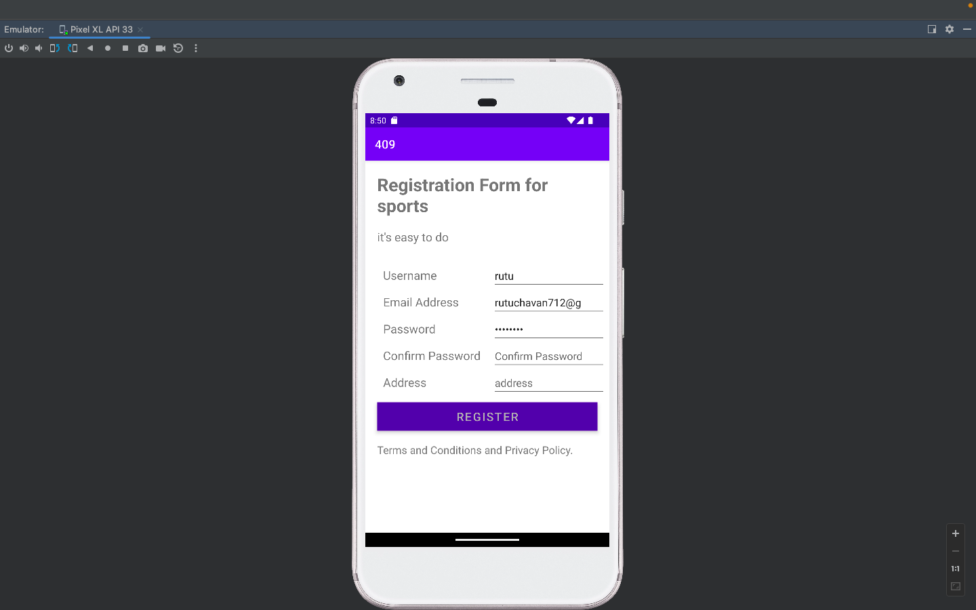

# **Practical No 6**

**Aim:- Create a Signup page using Constraint Layout** **activity_main.xml** :

<?xml version="1.0" encoding="utf-8"?> <androidx.constraintlayout.widget.ConstraintLayout xmlns:android="http://schemas.android.com/apk/res/android" xmlns:app="http://schemas.android.com/apk/res-auto" android:layout_width="match_parent" android:layout_height="match_parent"  
 android:layout_margin="10dp">  
  
  
  
  
 <TextView  
 android:id="@+id/txt1"  
 android:layout_width="wrap_content"  
 android:layout_height="wrap_content"  
 android:layout_margin="20dp"  
 android:text="Create An Account"  
 android:textSize="25sp"  
 app:layout_constraintEnd_toEndOf="parent"  
 app:layout_constraintStart_toStartOf="parent"  
 app:layout_constraintTop_toTopOf="parent" />  
  
 <EditText  
 android:id="@+id/edt1"  
 android:layout_width="0dp"  
 android:layout_height="wrap_content"  
 android:layout_margin="20dp"  
 android:hint="Full Name"  
 android:textSize="20sp"  
 app:layout_constraintLeft_toLeftOf="@id/guideline"  
 app:layout_constraintRight_toRightOf="@id/guideline2"  
 app:layout_constraintTop_toBottomOf="@id/txt1" />  
  
 <EditText  
 android:id="@+id/edt2"  
 android:layout_width="0dp"  
 android:layout_height="wrap_content"  
 android:layout_margin="20dp"  
 android:hint="Age"  
 android:textSize="20sp"  
 app:layout_constraintLeft_toLeftOf="@id/guideline"  
 app:layout_constraintRight_toRightOf="@id/guideline2"  
 app:layout_constraintTop_toBottomOf="@id/edt1" />  
  
 <EditText  
 android:id="@+id/edt3"  
 android:layout_width="0dp"  
 android:layout_height="wrap_content"  
 android:layout_margin="20dp"  
 android:hint="Mobile Number"  
 android:inputType="phone"  
 android:textSize="20sp"  
 app:layout_constraintLeft_toLeftOf="@id/guideline"  
 app:layout_constraintRight_toRightOf="@id/guideline2"  
 app:layout_constraintTop_toBottomOf="@id/edt2" />  
  
 <EditText android:id="@+id/edt4"  
 android:layout_width="0dp"  
 android:layout_height="wrap_content"  
 android:layout_margin="20dp"  
 android:hint="Email Address"  
 android:inputType="textEmailAddress"  
 android:textSize="20sp"  
 app:layout_constraintLeft_toLeftOf="@id/guideline"  
 app:layout_constraintRight_toRightOf="@id/guideline2"  
 app:layout_constraintTop_toBottomOf="@id/edt3" />  
  
 <EditText  
 android:id="@+id/edt5"  
 android:layout_width="0dp"  
 android:layout_height="wrap_content"  
 android:layout_margin="20dp"  
 android:hint="Password"  
 android:textSize="20sp"  
 app:layout_constraintLeft_toLeftOf="@id/guideline"  
 app:layout_constraintRight_toRightOf="@id/guideline2"  
 app:layout_constraintTop_toBottomOf="@id/edt4" />  
  
 <TextView  
 android:id="@+id/txt2"  
 android:layout_width="wrap_content"  
 android:layout_height="wrap_content"  
 android:layout_margin="20dp"  
 android:text="Got A Refereal Code?(Optional)"  
 android:textSize="15sp"  
 app:layout_constraintStart_toStartOf="@id/guideline"  
 app:layout_constraintTop_toBottomOf="@id/edt5" />  
  
 <CheckBox  
 android:id="@+id/chk1"  
 android:layout_width="wrap_content"  
 android:layout_height="wrap_content"  
 android:layout_margin="20dp"  
 android:text="Get Updates on Whatsapp"  
 android:textSize="15sp"  
 app:layout_constraintLeft_toLeftOf="@id/guideline"  
 app:layout_constraintTop_toBottomOf="@id/txt2" />  
  
 <TextView  
 android:id="@+id/txt3"  
 android:layout_width="wrap_content"  
 android:layout_height="wrap_content"  
 android:layout_margin="10dp"  
 android:text="By creating this account, you agree to our Privacy Policy"  
 android:textSize="13sp"  
 app:layout_constraintEnd_toEndOf="@id/guideline2"  
 app:layout_constraintStart_toStartOf="@id/guideline"  
 app:layout_constraintTop_toBottomOf="@id/chk1" />  
  
 <Button  
 android:id="@+id/btn1"  
 android:layout_width="wrap_content"  
 android:layout_height="wrap_content"  
 android:layout_margin="20dp"  
 android:text="Create an Account"  
 android:textSize="15sp"  
 app:layout_constraintEnd_toEndOf="@id/guideline2"  
 app:layout_constraintStart_toStartOf="@id/guideline"  
 app:layout_constraintTop_toBottomOf="@id/txt3" />  
  
 <TextView  
 android:id="@+id/txt4"  
 android:layout_width="wrap_content"  
 android:layout_height="wrap_content"  
 android:layout_margin="10dp"  
 android:text="Have an account ?Sign In"  
 android:textSize="15sp"  
 app:layout_constraintEnd_toEndOf="@id/guideline2"  
 app:layout_constraintStart_toStartOf="@id/guideline"  
 app:layout_constraintTop_toBottomOf="@id/btn1" />  
  
 <androidx.constraintlayout.widget.Guideline  
 android:id="@+id/guideline"  
 android:layout_width="wrap_content"  
 android:layout_height="wrap_content"  
 android:orientation="vertical"  
 app:layout_constraintGuide_percent="0.05" />  
  
 <androidx.constraintlayout.widget.Guideline  
 android:id="@+id/guideline2"  
 android:layout_width="wrap_content"  
 android:layout_height="wrap_content"  
 android:orientation="vertical"  
 app:layout_constraintGuide_percent="0.95" />  
</androidx.constraintlayout.widget.ConstraintLayout>  
  
  
**OUTPUT :-**

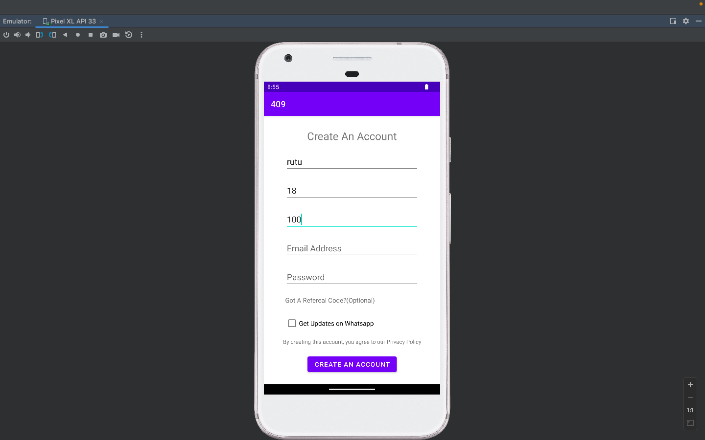

**Practical No 7**

**Aim:-** Explore Resource Folder(strings,colors,themes,drawlables) strings.xml

**Strings.xml:**

<resources>  
 <string name="app_name">Prac7-409 </string>  
 <string name="my_name"> Rutuja </string>  
 <string name="roll_no">TYIT409 </string>  
</resources>

Colors.xml:

<?xml version="1.0" encoding="utf-8"?>  
<resources>  
 <color name="pink">#FFBB86FC</color>  
 <color name="purple">#FF6200EE</color>  
 <color name="dark_blue">#FF3700B3</color>  
  
</resources>

**Night/theme.xml:**

<resources xmlns:tools="http://schemas.android.com/tools">  
 <!-- Base application theme. -->  
 <style name="Theme.R409" parent="Theme.AppCompat.Light.DarkActionBar">  
 <!-- Primary brand color. -->  
 <item name="colorPrimary">@color/purple_200</item>  
 <item name="colorPrimaryDark">@color/purple_700</item>  
 <item name="colorAccent">@color/teal_200</item>  
 <!-- Customize your theme here. -->  
 </style>  
</resources>

**Values/theme.xml:-**

<resources xmlns:tools="http://schemas.android.com/tools">  
 <!-- Base application theme. -->  
 <style name="Theme.R409" parent="Theme.AppCompat.Light.DarkActionBar">  
 <!-- Primary brand color. -->  
 <item name="colorPrimary">@color/purple_500</item>  
 <item name="colorPrimaryDark">@color/purple_700</item>  
 <item name="colorAccent">@color/teal_200</item>  
 <!-- Customize your theme here. -->  
 </style>  
</resources>

**Manifest.xml:**

<?xml version="1.0" encoding="utf-8"?>  
<manifest xmlns:android="http://schemas.android.com/apk/res/android"  
 xmlns:tools="http://schemas.android.com/tools">  
  
 <application  
 android:allowBackup="true"  
 android:dataExtractionRules="@xml/data_extraction_rules"  
 android:fullBackupContent="@xml/backup_rules"  
 android:icon="@mipmap/ic_launcher"  
 android:label="@string/app_name"  
 android:supportsRtl="true"  
 android:theme="@style/Theme.R409"  
 tools:targetApi="31">  
 <activity  
 android:name=".MainActivity"  
 android:exported="true">  
 <intent-filter>  
 <action android:name="android.intent.action.MAIN" />  
  
 <category android:name="android.intent.category.LAUNCHER" />  
 </intent-filter>  
 </activity>  
 </application>  
  
</manifest>

**//Activity.xml:-**

<?xml version="1.0" encoding="utf-8"?>  
<androidx.constraintlayout.widget.ConstraintLayout xmlns:android="http://schemas.android.com/apk/res/android"  
 xmlns:app="http://schemas.android.com/apk/res-auto"  
 xmlns:tools="http://schemas.android.com/tools"  
 android:layout_width="match_parent"  
 android:layout_height="match_parent"  
 tools:context=".MainActivity">  
  
 <TextView android:id="@+id/txt1"  
 android:layout_width="wrap_content"  
 android:layout_height="wrap_content"  
 android:text="@string/my_name"  
 android:textColor="@color/orange"  
 android:textSize="30sp"  
 app:layout_constraintBottom_toBottomOf="parent"  
 app:layout_constraintEnd_toEndOf="parent"  
 app:layout_constraintStart_toStartOf="parent"  
 app:layout_constraintTop_toTopOf="parent"  
 app:layout_constraintVertical_bias="0.15" />  
  
 <TextView android:id="@+id/txt2"  
 android:layout_width="wrap_content"  
 android:layout_height="wrap_content"  
 android:text="@string/roll_no"  
 android:textColor="@color/green"  
 android:textSize="30sp"  
 app:layout_constraintBottom_toBottomOf="parent"  
 app:layout_constraintEnd_toEndOf="parent"  
 app:layout_constraintHorizontal_bias="0.498"  
 app:layout_constraintStart_toStartOf="parent"  
 app:layout_constraintTop_toBottomOf="@+id/txt1"  
 app:layout_constraintVertical_bias="0.096" />  
  
 <ImageView  
 android:id="@+id/img1"  
 android:layout_width="185dp"  
 android:layout_height="148dp"  
 android:src="@drawable/img"  
 app:layout_constraintBottom_toBottomOf="parent"  
 app:layout_constraintEnd_toEndOf="parent"  
 app:layout_constraintStart_toStartOf="parent"  
 app:layout_constraintTop_toBottomOf="@id/txt2"  
 app:layout_constraintVertical_bias="0.200" /></androidx.constraintlayout.widget.ConstraintLayout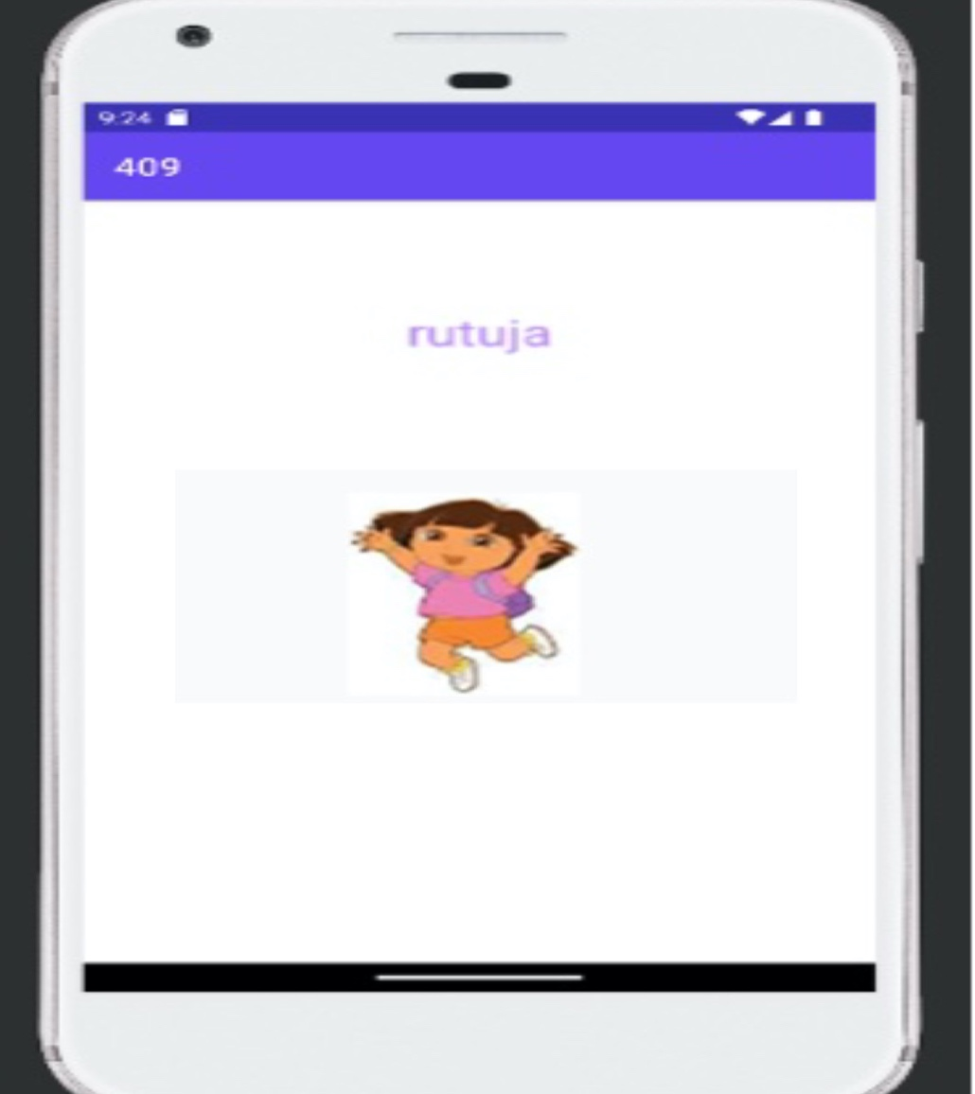

# **Practical No - 8A**

**//activitymain.xml:**

<?xml version="1.0" encoding="utf-8"?>  
<LinearLayout  
 xmlns:android="http://schemas.android.com/apk/res/android" android:layout_height="match_parent" android:layout_width="match_parent" android:orientation="vertical" android:gravity="center"> <TextView android:id="@+id/txt1" android:layout_width="wrap_content" android:layout_height="wrap_content" android:text="Mutiple activities" android:textSize="25sp"/>  
 <TextView android:id="@+id/txt2" android:layout_width="wrap_content" android:layout_height="wrap_content" android:text="This is Second Activity" android:textSize="25sp"/>  
</LinearLayout>

**//Activitymain.kt:**

package com.example.rc409  
  
import android.content.Intent  
import androidx.appcompat.app.AppCompatActivity  
import android.os.Bundle  
import android.widget.Button  
  
  
class MainActivity : AppCompatActivity() {  
 override fun onCreate(savedInstanceState: Bundle?) {  
 super.onCreate(savedInstanceState)  
 setContentView(R.layout.*activity_main*)  
  
 val btn1=findViewById<Button>(R.id.*btn1*)  
 btn1.setOnClickListener**{** val intent=  
 Intent(this,ActivitySecond::class.*java*)  
 startActivity(intent)  
 **}** }

}

**//second activity.xml:**

<?xml version="1.0" encoding="utf-8"?>  
<LinearLayout  
 xmlns:android="http://schemas.android.com/apk/res/android" android:layout_height="match_parent" android:layout_width="match_parent" android:orientation="vertical" android:gravity="center"> <TextView android:id="@+id/txt1" android:layout_width="wrap_content" android:layout_height="wrap_content" android:text="Mutiple activities" android:textSize="25sp"/>  
 <TextView android:id="@+id/txt2" android:layout_width="wrap_content" android:layout_height="wrap_content" android:text="This is Second Activity" android:textSize="25sp"/>  
</LinearLayout>

**//Second activity.kt :**

package com.example.rc409   
  
import androidx.appcompat.app.AppCompatActivity  
import android.os.Bundle  
  
class ActivitySecond : AppCompatActivity() {  
 override fun onCreate(savedInstanceState: Bundle?) {  
 super.onCreate(savedInstanceState)  
 setContentView(R.layout.*activity_second*)  
 }  
}

**//manifest file:**

<?xml version="1.0" encoding="utf-8"?>  
<manifest xmlns:android="http://schemas.android.com/apk/res/android"  
 xmlns:tools="http://schemas.android.com/tools">  
  
 <application  
 android:allowBackup="true"  
 android:dataExtractionRules="@xml/data_extraction_rules"  
 android:fullBackupContent="@xml/backup_rules"  
 android:icon="@mipmap/ic_launcher"  
 android:label="@string/app_name"  
 android:supportsRtl="true"  
 android:theme="@style/Theme.Rc409"  
 tools:targetApi="31">  
 <activity android:name=".ActivitySecond" android:exported="false" />  
 <activity  
 android:name=".MainActivity" android:exported="true">  
 <intent-filter>  
 <action android:name="android.intent.action.MAIN" />  
  
 <category android:name="android.intent.category.LAUNCHER" />  
 </intent-filter>  
 </activity>  
 </application>  
  
</manifest>

**OUTPUT:**

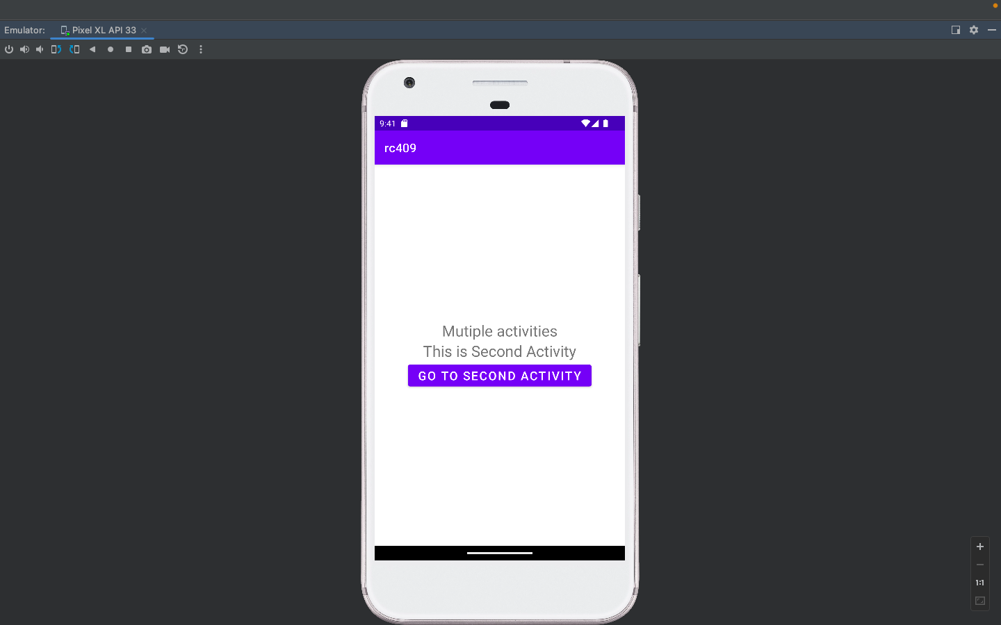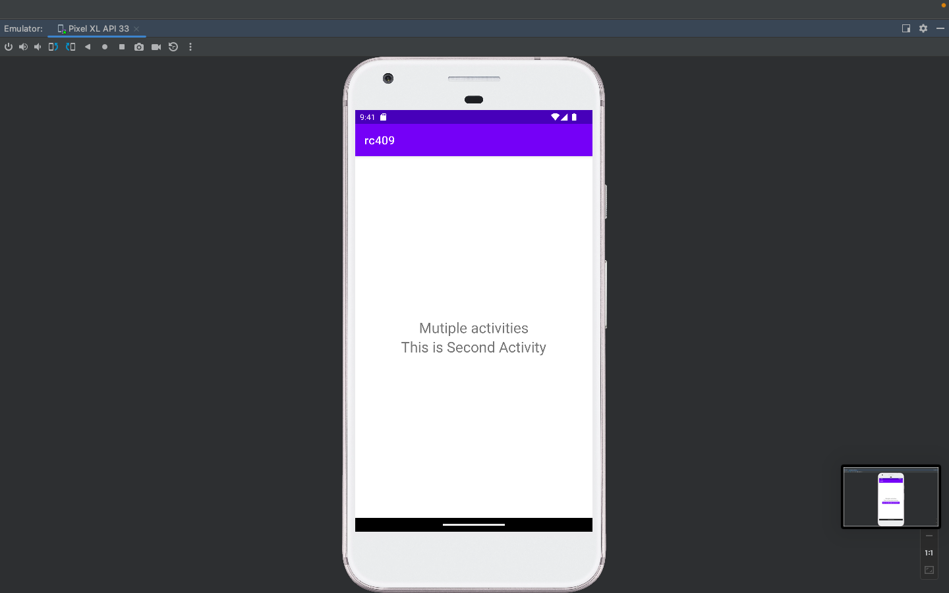

Practical No 8b

## //**Activity_main.xml :-**

<?xml version="1.0" encoding="utf-8"?>  
<LinearLayout  
 xmlns:android="http://schemas.android.com/apk/res/android" android:layout_width="match_parent" android:layout_height="match_parent" android:orientation="vertical"  
 android:gravity="center"  
 >  
 <TextView android:id="@+id/txt2" android:layout_width="wrap_content" android:layout_height="wrap_content" android:text="This is First Activity" android:textSize="25sp"/>  
 <EditText android:id="@+id/edt1" android:layout_width="wrap_content" android:layout_height="wrap_content" android:hint="Enter Your Name"  
 android:textSize="20sp"  
 />  
 <Button android:id="@+id/btn1" android:layout_width="wrap_content" android:layout_height="wrap_content"  
 android:text="Next" android:textSize="20sp"/>  
</LinearLayout>

**//Activitymain.kt:-**

package com.example.rc409  
  
import android.content.Intent  
import androidx.appcompat.app.AppCompatActivity  
import android.os.Bundle  
import android.widget.Button  
import android.widget.EditText  
  
class MainActivity : AppCompatActivity() {  
 override fun onCreate(savedInstanceState: Bundle?) {  
 super.onCreate(savedInstanceState)  
 setContentView(R.layout.*activity_main*)  
 val btn1=findViewById<Button>(R.id.*btn1*)  
 val edt1=findViewById<EditText>(R.id.*edt1*)  
 btn1.setOnClickListener**{** val message:String=edt1.*text*.toString()  
 val intent= Intent(this,SecondActivity::class.*java*)  
 intent.putExtra("key1",message)  
 startActivity(intent)  
 **}** }  
}

**//secondactivity.kt:-**

<?xml version="1.0" encoding="utf-8"?>  
<LinearLayout  
 xmlns:android="http://schemas.android.com/apk/res/android" android:layout_width="match_parent" android:layout_height="match_parent" android:orientation="vertical"  
 android:gravity="center"  
 >  
 <TextView android:id="@+id/txt2" android:layout_width="wrap_content" android:layout_height="wrap_content" android:text="This is Second Activity" android:textSize="25sp"/>  
 <TextView android:id="@+id/txt3" android:layout_width="wrap_content" android:layout_height="wrap_content"  
 android:text="Hello" android:textSize="25sp"/>  
</LinearLayout>

**//Secondactivity.kt :-**

package com.example.rc409  
  
import androidx.appcompat.app.AppCompatActivity  
import android.os.Bundle  
import android.widget.TextView  
  
class SecondActivity :  
 AppCompatActivity() {  
 override fun onCreate(savedInstanceState: Bundle?) {  
 super.onCreate(savedInstanceState)  
 setContentView(R.layout.*activity_second*)  
 val txt3=findViewById<TextView>(R.id.*txt3*)  
 val bundle:Bundle?=*intent*.*extras* val grabmsg=bundle!!.getString("key1")  
 txt3.*text*="Welcome "+grabmsg  
  
}  
}

**//manifest file:**

<?xml version="1.0" encoding="utf-8"?>  
<manifest xmlns:android="http://schemas.android.com/apk/res/android"  
 xmlns:tools="http://schemas.android.com/tools">  
  
 <application  
 android:allowBackup="true"  
 android:dataExtractionRules="@xml/data_extraction_rules"  
 android:fullBackupContent="@xml/backup_rules"  
 android:icon="@mipmap/ic_launcher"  
 android:label="@string/app_name"  
 android:supportsRtl="true"  
 android:theme="@style/Theme.Rc409"  
 tools:targetApi="31">  
 <activity  
 android:name=".SecondActivity"  
 android:exported="false" />  
 <activity  
 android:name=".MainActivity"  
 android:exported="true">  
 <intent-filter>  
 <action android:name="android.intent.action.MAIN" />  
  
 <category android:name="android.intent.category.LAUNCHER" />  
 </intent-filter>  
 </activity></application>  
</manifest>

**OUTPUT:-**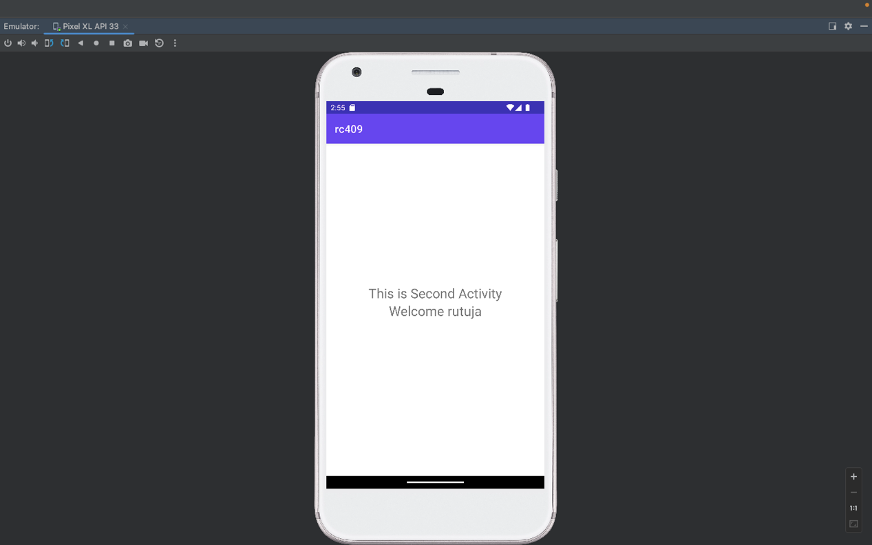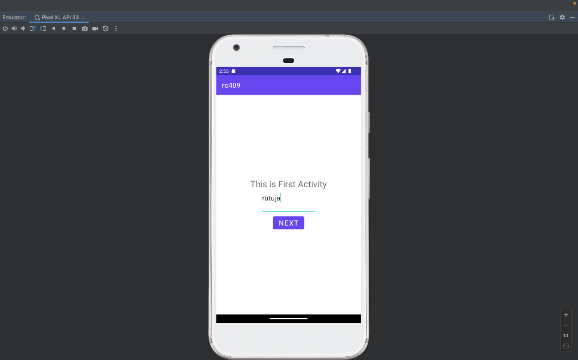

**Practical No 8c**

## **Activity_main.xml :**

?xml version="1.0" encoding="utf-8"?>  
  
<LinearLayout  
 xmlns:android="http://schemas.android.com/apk/res/android" android:layout_width="match_parent" android:layout_height="match_parent" android:gravity="center"  
 android:orientation="vertical"  
 >  
 <TextView android:id="@+id/txt1"  
 android:layout_width="wrap_content"  
 android:layout_height="wrap_content"  
 android:text="Send File"  
 android:textSize="25sp"/>  
 <EditText android:id="@+id/edt1"  
 android:layout_width="wrap_content"  
 android:layout_height="wrap_content"  
 android:hint="Enter Your name"  
 android:textSize="25sp"/>  
 <Button android:id="@+id/btn1"  
 android:layout_width="wrap_content"  
 android:layout_height="wrap_content"  
 android:text="Next"  
 android:textSize="20sp"/>  
  
</LinearLayout>

**//MainActivity.kt:**

class MainActivity : AppCompatActivity() {  
 override fun onCreate(savedInstanceState: Bundle?) {  
 super.onCreate(savedInstanceState)  
 setContentView(R.layout.*activity_main*)  
  
 val btn1=findViewById<Button>(R.id.*btn1*)  
 val edit1=findViewById<EditText>(R.id.*edt1*)  
 btn1.setOnClickListener**{** val message:String=edit1.*text*.toString()  
 val intent= Intent()  
 intent.*action*=Intent.*ACTION_SEND* intent.putExtra(Intent.*EXTRA_TEXT*,message)  
 intent.*type*="text/plain"  
 startActivity(Intent.createChooser(intent,"Send my data too: "))  
 **}**}  
}

**//manifest file:**

<?xml version="1.0" encoding="utf-8"?>  
<manifest xmlns:android="http://schemas.android.com/apk/res/android"  
 xmlns:tools="http://schemas.android.com/tools">  
  
 <application  
 android:allowBackup="true"  
 android:dataExtractionRules="@xml/data_extraction_rules"  
 android:fullBackupContent="@xml/backup_rules"  
 android:icon="@mipmap/ic_launcher"  
 android:label="@string/app_name"  
 android:supportsRtl="true"  
 android:theme="@style/Theme.rc409"  
 tools:targetApi="31">  
 <activity android:name=".MainActivity" android:exported="true">  
 <intent-filter>  
 <action android:name="android.intent.action.MAIN" />  
  
 <category android:name="android.intent.category.LAUNCHER" />  
 </intent-filter>  
 </activity>  
  
  
 </application>  
  
</manifest>

**OUTPUT:-**

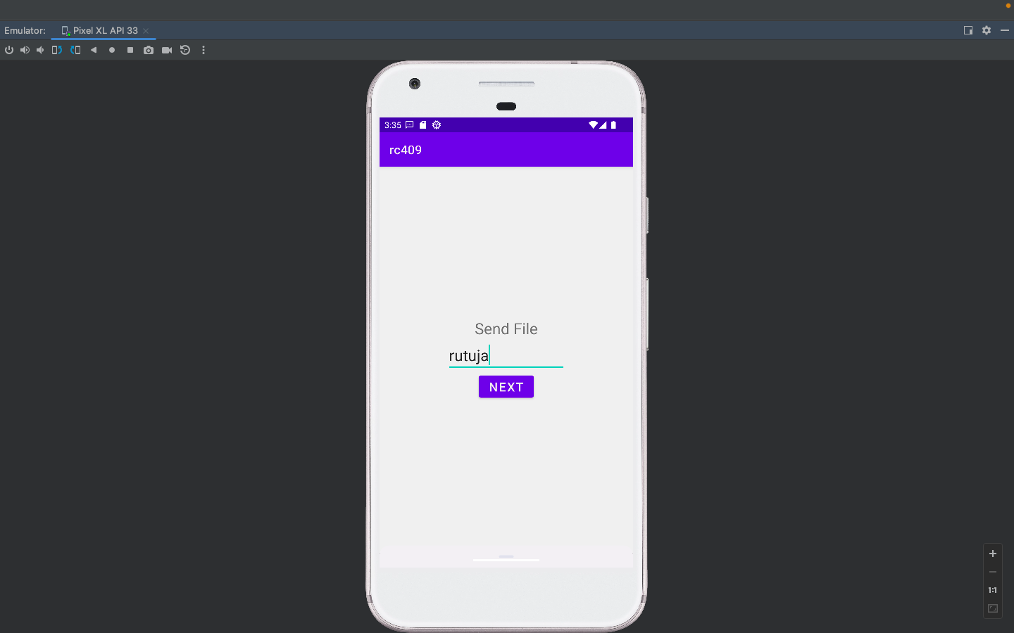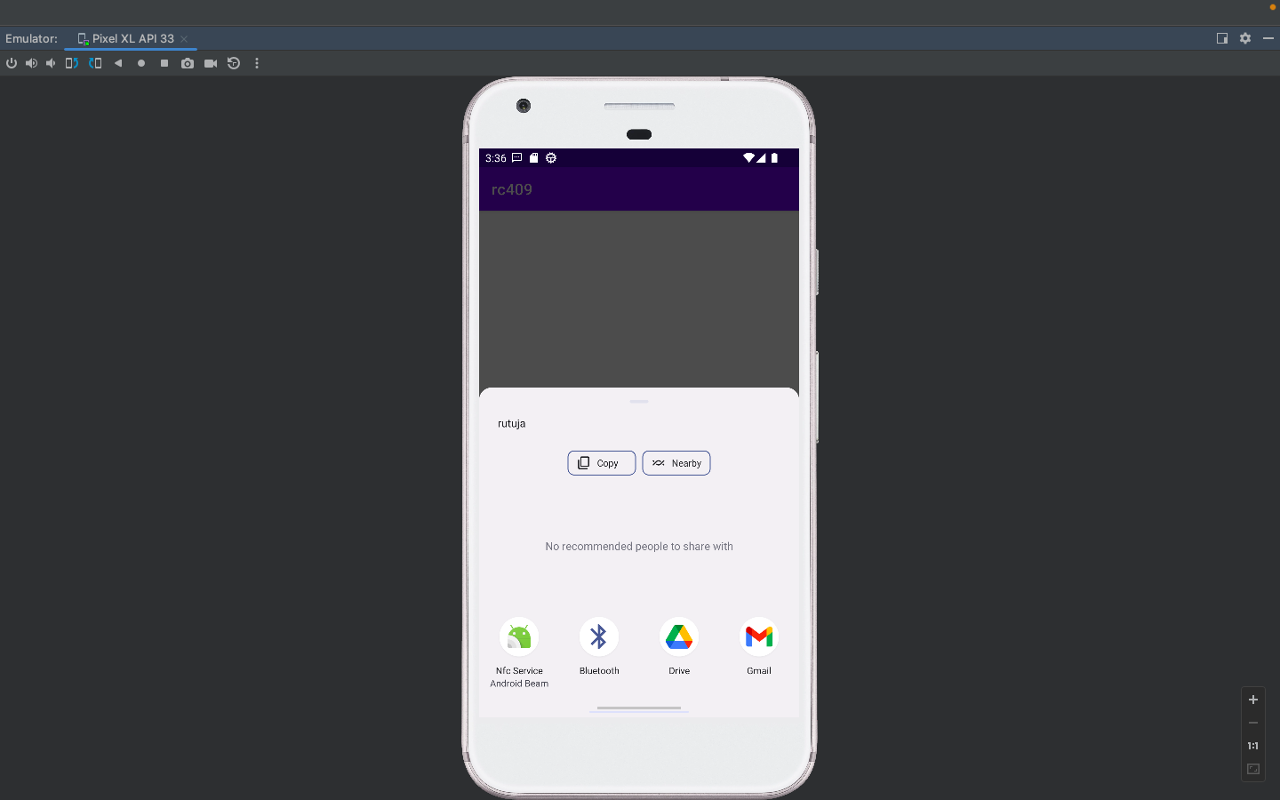

# **Practical No 8d**

## **Activity_main.xml**

<?xml version="1.0" encoding="utf-8"?>

<LinearLayout

xmlns:android="http://schemas.android.com/apk/res/android" android:layout_width="match_parent" android:layout_height="match_parent" android:gravity="center"

android:orientation="vertical"

>

<TextView android:id="@+id/txt1" android:layout_width="wrap_content" android:layout_height="wrap_content"

android:text="409" android:textSize="25sp"/>

<Button android:id="@+id/btn1" android:layout_width="wrap_content" android:layout_height="wrap_content"

android:text="Click"

android:textSize="20sp"/>

</LinearLayout>

**MainActivity.kt** package com.example.rc409

import android.content.Intent import android.net.Uri import androidx.appcompat.app.AppCompatActivity

import android.os.Bundle

import android.widget.Button

class MainActivity : AppCompatActivity() { override fun onCreate(savedInstanceState: Bundle?) { super.onCreate(savedInstanceState) setContentView(R.layout.activity_main) val btn1=findViewById<Button>(R.id.btn1)

btn1.setOnClickListener{

val intent=Intent() intent.action=Intent.ACTION_VIEW intent.data= Uri.parse("https://www.google.com/")

startActivity(intent)

}

}

}

## **Manifest file :-**

<activity android:name=".MainActivity" android:exported="true">

<intent-filter>

<action android:name="android.intent.action.MAIN" />

<category android:name="android.intent.category.LAUNCHER" />

</intent-filter>

</activity>

Output:

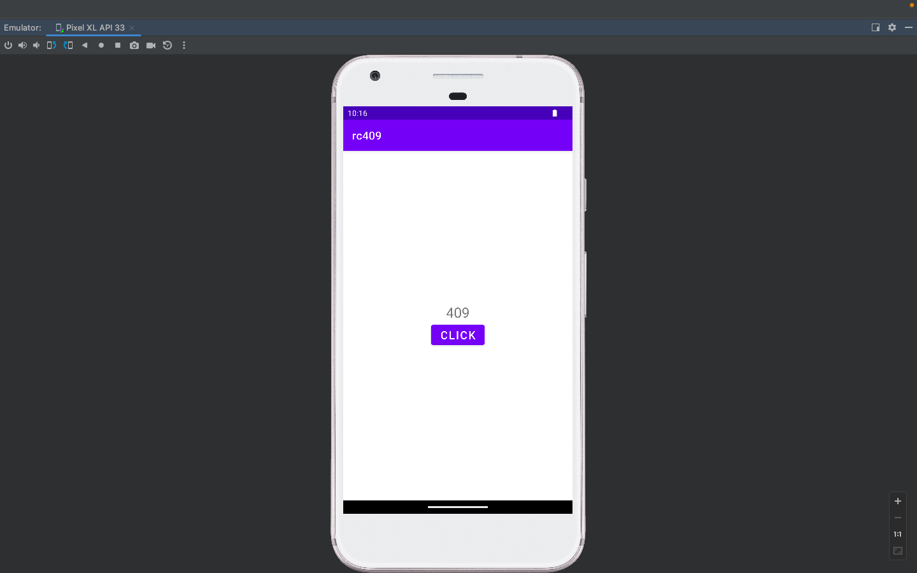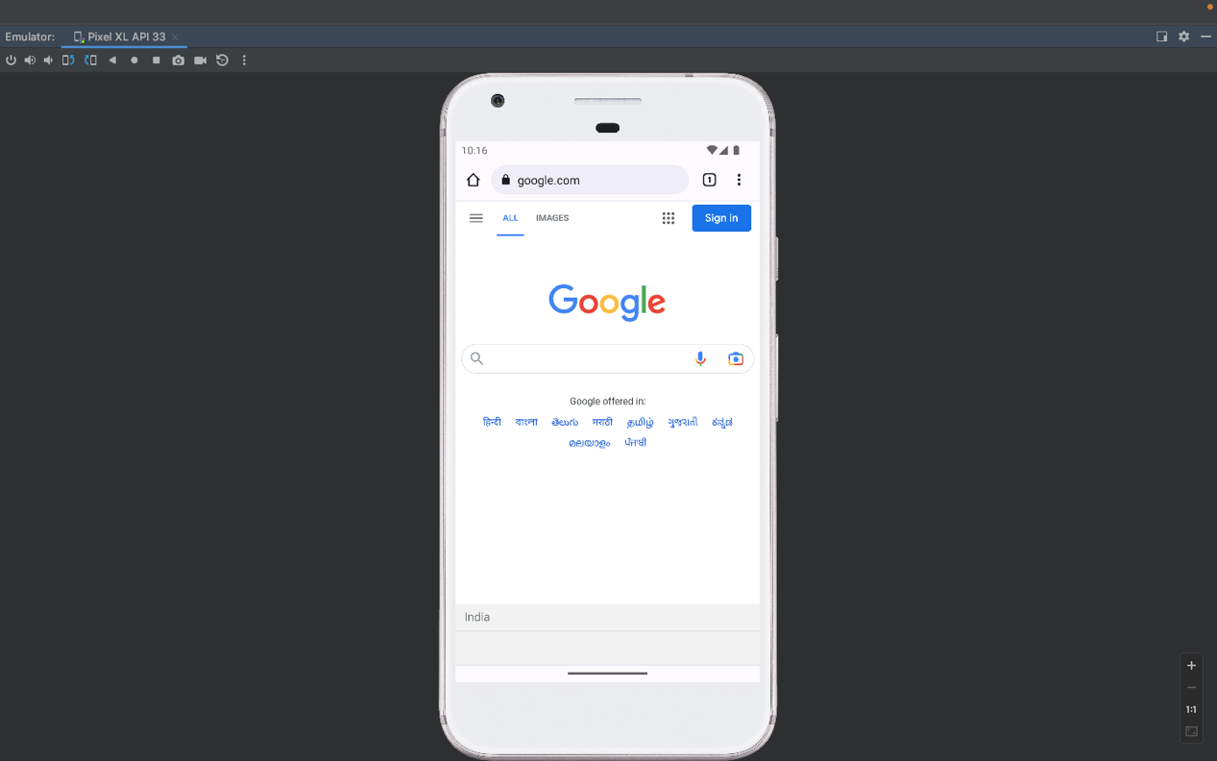

**Practical 9**

**Activity lifecycle**

**AIM:** Activity lifecycle

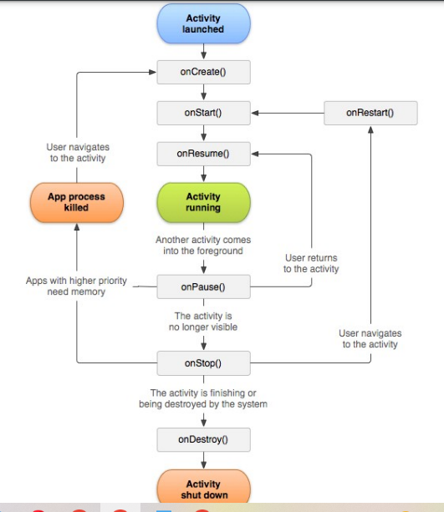

**//activity_main.xml :-**

<?xml version="1.0" encoding="utf-8"?> <androidx.constraintlayout.widget.ConstraintLayout xmlns:android="http://schemas.android.com/apk/res/android" xmlns:app="http://schemas.android.com/apk/res-auto" xmlns:tools="http://schemas.android.com/tools" android:layout_width="match_parent" android:layout_height="match_parent"

tools:context=".MainActivity">

<TextView android:id="@+id/txt1" android:layout_width="wrap_content" android:layout_height="wrap_content" android:text="Practical 9" android:textSize="25sp"

app:layout_constraintBottom_toBottomOf="parent" app:layout_constraintEnd_toEndOf="parent" app:layout_constraintStart_toStartOf="parent" app:layout_constraintTop_toTopOf="parent"

app:layout_constraintVertical_bias="0.271" />

<TextView android:id="@+id/txt2" android:layout_width="wrap_content" android:layout_height="wrap_content" android:text="Activity Lifecycle" android:textSize="25sp" app:layout_constraintBottom_toBottomOf="parent" app:layout_constraintEnd_toEndOf="parent" app:layout_constraintHorizontal_bias="0.497" app:layout_constraintStart_toStartOf="parent" app:layout_constraintTop_toBottomOf="@+id/txt1" app:layout_constraintVertical_bias="0.061" />

<TextView android:id="@+id/txt3" android:layout_width="wrap_content" android:layout_height="wrap_content" android:text="RUTUja TYIT 409"

android:textSize="25sp" app:layout_constraintBottom_toBottomOf="parent" app:layout_constraintEnd_toEndOf="parent" app:layout_constraintHorizontal_bias="0.497" app:layout_constraintStart_toStartOf="parent" app:layout_constraintTop_toBottomOf="@+id/txt2"

app:layout_constraintVertical_bias="0.061" />

</androidx.constraintlayout.widget.ConstraintLayout>

**// MainActivity.kt :**

package com.example.rc409  
import androidx.appcompat.app.AppCompatActivity  
import android.os.Bundle  
import android.util.Log  
  
class MainActivity : AppCompatActivity() {  
 val tag="Activity Lifecycle"  
 override fun onCreate(savedInstanceState: Bundle?) { super.onCreate(savedInstanceState)  
 setContentView(R.layout.activity_main)  
 Log.d(tag,"onCreate_409")  
 }  
 override fun onStart() { super.onStart()  
 Log.d(tag,"onStart_409")  
 }  
 override fun onResume() { super.onResume()  
 Log.d(tag,"onResume_409")  
 }  
 override fun onPause() { super.onPause()  
 Log.d(tag,"onPause_409")  
 }  
 override fun onStop() { super.onStop()  
 Log.d(tag,"onStop_409")  
 }  
 override fun onDestroy() { super.onDestroy()  
 Log.d(tag,"onDestroy_409")  
 }  
}

**//Manifest file:-**

<activity

android:name=".MainActivity" android:exported="true">

<intent-filter>

<action android:name="android.intent.action.MAIN" />

<category android:name="android.intent.category.LAUNCHER" />

</intent-filter>

</activity>

**Logcat** 