Computer Networks
ASSIGNMENT 1
Make the Data of a Smart Manufacturing Plant Arrive Correctly and On Time
Name | R. Vishwa
Register Number | 1911260146
Course code | CSA07 – Computer Networks
Nature | Individual – Total marks 50
GitHub repository | CSA07-1911260146-Assignment1 – link: https://github.com/Rvishwa28/CSA0707-COMPUTER-NETWORK.git
Python version used | Python 3 (confirm installed version after running the programs)

Task 1 – Size the Traffic Before Choosing Anything

1.1 Total traffic
Source | Working | Traffic
Robot controllers | 40 × (200 B × 8 bits) ÷ 2 ms = 40 × 0.8 Mbps | 32.00 Mbps
Vibration sensors | 600 × 50 B/s × 8 = 240,000 bit/s | 0.24 Mbps
CCTV cameras | 24 × 4 Mbps (continuous) | 96.00 Mbps
Office users | 150 × 10 % = 15 active × 2 Mbps | 30.00 Mbps
Total, one line | 32 + 0.24 + 96 + 30 | 158.24 Mbps
Plant, 8 lines | 8 × 158.24 | 1,265.92 Mbps (≈ 1.266 Gbps)

1.2 Most data vs strictest delay
The CCTV cameras send the most data (96 Mbps = 60.7 % of the line’s traffic). The robot controllers have the strictest delay requirement (commands within 10 ms) even though they send only 32 Mbps. They are not the same source – volume and urgency are different properties, so a design sized only on bandwidth would ignore the robots.

1.3 Is a single 1 Gbps uplink enough?
- One line: 158.24 Mbps = 15.8 % of 1 Gbps – enough.
- Whole plant (8 lines): 1,265.92 Mbps = 126.6 % of 1 Gbps – not enough; the uplink is overloaded by 265.92 Mbps.
- Shared queue with CCTV: if robot commands wait in the same FIFO queue as CCTV, each command may sit behind a burst of camera frames. A single 1,500-byte frame takes 12 µs to send, but a filled 1 MB buffer takes 1 MB × 8 ÷ 1 Gbps = 8 ms to drain – 80 % of the robots’ 10 ms budget in one queue. Once the offered load exceeds 1 Gbps the buffer overflows and commands are dropped. Fix: separate VLAN and strict-priority queue (802.1p / DSCP EF) for robot traffic, and a 10 Gbps uplink.

1.4 Ranking by harm of a 100 ms delay
Rank | Traffic | Reason
1 (worst) | Robot commands | 100 ms is 10× the 10 ms deadline; robots act on stale commands – collisions, scrap parts or a safety stop.
2 | CCTV | Live view lags and jitter breaks video playback; frames are lost if buffers are small – but recording is not safety-critical.
3 | Office / ERP / e-mail | Interactive use notices 100 ms but remains usable; TCP absorbs it.
4 (least) | Vibration sensors | Report once per second, so 100 ms is only 10 % of the reporting period; trend data, not control.

Alternative Concept Analysis – motion-triggered CCTV (5 % of the time)
- CCTV traffic = 96 × 0.05 = 4.8 Mbps (saves 91.2 Mbps per line, 95 %).
- One line = 32 + 0.24 + 4.8 + 30 = 67.04 Mbps; 8 lines = 536.32 Mbps = 53.6 % of 1 Gbps.
- Decision: on average the 1 Gbps uplink is no longer the bottleneck. Remaining risk is queueing delay when many cameras trigger together (all 24 triggered = back to 96 Mbps per line) – still handled by priority queues. Cost: cameras need local storage, and live viewing/forensic delay increase.

complete calculations with units, delay-versus-volume comparison and a justified ranking.

Task 2 – Count the Domains in the Contractor’s Drawing
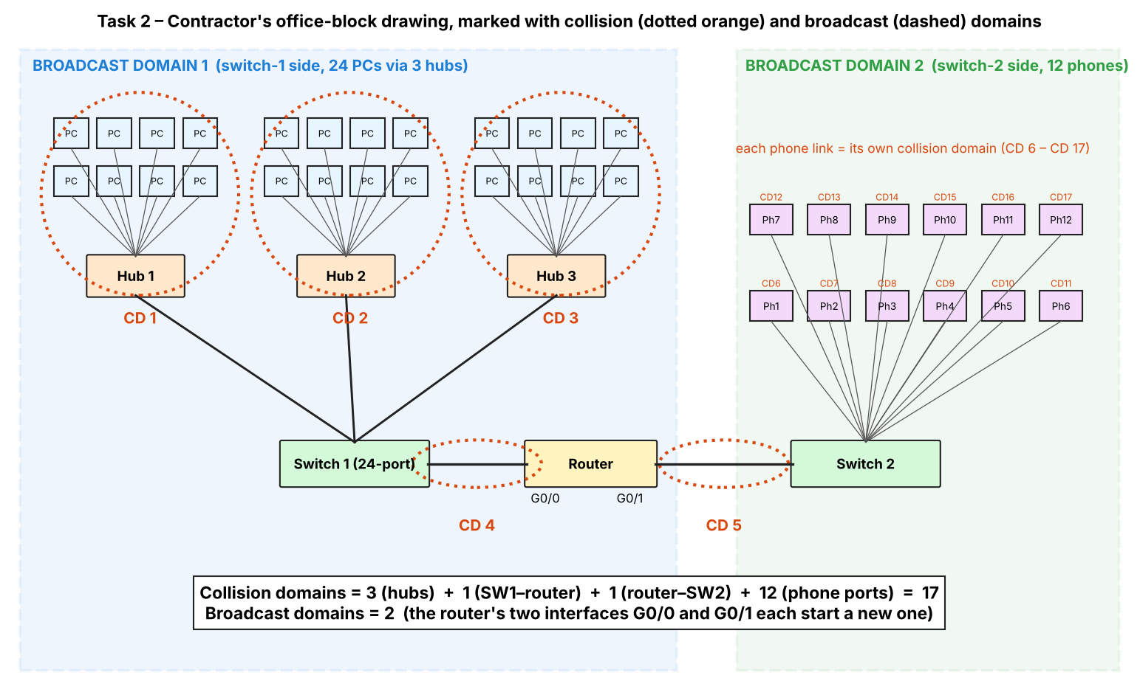

2.1 Domain counts
Part of the network | Collision domains | Why
Hub 1, Hub 2, Hub 3 (8 PCs each + uplink to switch) | 3 | A hub repeats every signal to all ports, so each hub with its 8 PCs and its switch port is one shared segment.
Switch 1 ↔ router G0/0 | 1 | One link between two devices.
Router G0/1 ↔ Switch 2 | 1 | One link between two devices.
12 IP phones on Switch 2 | 12 | Each switch port is its own collision domain.
Total | 17 | 3 + 1 + 1 + 12

Broadcast domains = 2. Switches and hubs forward broadcasts; the router does not. Interface G0/0 (switch 1, the three hubs and 24 PCs) is one broadcast domain and G0/1 (switch 2 and 12 phones) is the other.

2.2 OSI layer of each device and why a hub cannot stop collisions
Device | OSI layer | What it does
Hub | 1 – Physical | Regenerates and repeats electrical bits to every port; does not read addresses.
Switch | 2 – Data link | Reads the destination MAC, learns addresses and forwards only to the right port.
Router | 3 – Network | Reads IP addresses, routes between networks and blocks broadcasts.
PC / IP phone | All layers (7 down to 1) | End systems that run applications.
A hub works only at layer 1: it has no memory of frames or MAC addresses, so it cannot buffer or separate traffic. Two PCs sending at the same time put overlapping signals on the shared wire – a collision – and the hub passes that on to every port. (Shared Ethernet therefore needs CSMA/CD.)

2.3 Point-to-point vs multipoint
- Point-to-point (two devices only): Switch 1 ↔ router G0/0; router G0/1 ↔ Switch 2; each IP phone ↔ Switch 2 port; each hub ↔ switch uplink as a cable.
- Multipoint (shared by many devices): each hub segment – 8 PCs plus the uplink share one medium.

2.4 Standards and bodies
Technology | Standard | Body
Ethernet | IEEE 802.3 | IEEE
Wi-Fi | IEEE 802.11 | IEEE
IPv4 | RFC 791 | IETF
OSI model | ISO 7498 | ISO
5G | 3GPP specifications (IMT-2020) | 3GPP / ITU
Why buy only standard-compliant equipment: devices from different vendors interoperate; the plant is not locked to one supplier; equipment can be replaced or extended later (the network will grow to 5 plants); and conformance testing/certification (e.g. Wi-Fi Alliance, Ethernet) reduces risk.

Alternative Concept Analysis – replace the three hubs with three unmanaged switches
 | With hubs | With 3 switches
Collision domains | 17 | 41 (24 PC links + 3 switch uplinks + 1 + 1 + 12 phones)
Broadcast domains | 2 | 2 (unchanged)
What it fixes: collisions disappear (every link is full-duplex and CSMA/CD is not needed); each PC gets its own 100 Mbps/1 Gbps instead of sharing a segment.
What it does not fix: the 24 PCs are still in one broadcast domain; unmanaged switches have no VLANs, QoS, security or monitoring; no layer-3 separation; and without spanning tree, a mistaken loop can bring the network down.
correct domain counts on a marked drawing, device-layer reasoning and a standards table.

Task 3 – Read a Captured Frame Layer by Layer

3.1 Layer and PDU of each line
Line of capture | OSI layer | PDU
Ethernet II (MACs, Type 0x0800) | 2 – Data link | Frame
IPv4 (10.10.1.25 → 10.10.9.4, TTL 61, Protocol 6) | 3 – Network | Packet
TCP (port 51522 → 502, Seq 1201, Ack 88) | 4 – Transport | Segment
Data (12-byte Modbus write-register command) | 7 – Application (5–7) | Data / message

3.2 Routers crossed
The controller set TTL = 64; the packet shows TTL = 61. Each router subtracts 1, so 64 − 61 = 3 routers were crossed before the capture point.

3.3 Bytes on the wire and overhead
 | 12-byte command | 1,400-byte camera packet
Data | 12 | 1,400
TCP header | 20 | 20
IPv4 header | 20 | 20
Ethernet header (6 + 6 + 2) | 14 | 14
FCS | 4 | 4
Total on the wire | 70 bytes | 1,458 bytes
Overhead | 58 B = 82.86 % | 58 B = 3.98 %

3.4 Which layer handles each fault
Fault | Layer | What happens
(a) MAC address wrong | 2 – Data link | NIC/switch does not accept the frame; it is dropped.
(b) TTL reaches 0 | 3 – Network | The router discards the packet and returns ICMP “Time Exceeded”.
(c) Destination port closed | 4 – Transport | The host replies with a TCP RST (connection refused).

3.5 TCP/IP model mapped onto the seven layers
OSI layers | TCP/IP layer
7 Application, 6 Presentation, 5 Session | Application
4 Transport | Transport
3 Network | Internet
2 Data link, 1 Physical | Link (Network access)

3.6 Complete the Code – Task03/layers.py
def send(message):
pdu = message
for layer, tag in LAYERS:
head = "[" + tag + "|"
tail = "|FCS]" if tag == "ETH" else "]"
pdu = head + pdu + tail
print(f"{layer:<13}adds {tag:<4} -> {len(pdu):>3} bytes")
return pdu
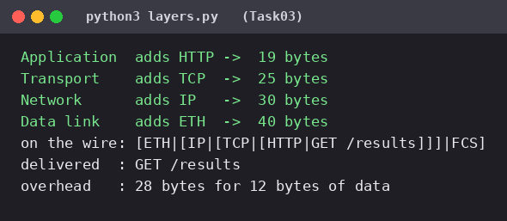
1,400-byte message: the toy headers add 28 bytes in both cases, but 28 ÷ 40 = 70 % overhead for the 12-byte message against 28 ÷ 1,428 = 1.96 % for 1,400 bytes – the same lesson as the real capture.
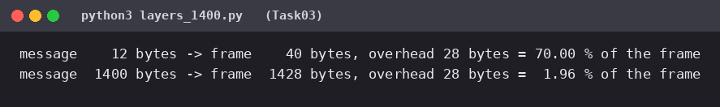

Alternative Concept Analysis – command directly in an Ethernet frame (EtherType 0x8892)
 | Modbus/TCP/IP/Ethernet | Direct in Ethernet (0x8892)
Bytes per command (nominal) | 12 + 20 + 20 + 14 + 4 = 70 | 12 + 14 + 4 = 30
Bytes saved | – | 40 bytes (57 %)
Commands per second on 100 Mbps | 100 Mbps ÷ (70 × 8) = 178,571 | 100 Mbps ÷ (30 × 8) = 416,667
Extra commands freed | – | ≈ 238,096 per second
Practical note: Ethernet’s minimum frame is 64 bytes, so a 30-byte frame is padded to 64; the real saving is then 70 → 64 bytes (6 bytes, 195,312 commands/s). The main gain is lower processing time, not bandwidth.
What the plant loses by giving up IP: routing – frames cannot leave the local layer-2 network, so no link to other lines/plants or the head office; no TTL and no IP firewalling/addressing; no TCP – so no ordering, retransmission or flow control (the application protocol must provide reliability itself); and the traffic is limited to one broadcast domain.
A layer-by-layer reading of the capture, overhead calculations (70 B/82.86 % and 1,458 B/3.98 %) and a fault-to-layer map.

Task 4 – Choose a Medium for Each Run

4.1 Medium for each run
Run | Chosen medium | Deciding reason
(a) Robot cell next to arc-welding, 85 m | Cat6A S/FTP (shielded) – or multimode fibre if the noise is severe | 85 m is inside the 100 m twisted-pair limit; shielding resists welding EMI. Fibre is completely immune to EMI.
(b) Office floor → shop-floor switch, 140 m | Multimode fibre (OM3/OM4) | The trap: 140 m looks short, but is over the 100 m limit of any twisted-pair Ethernet cable.
(c) Shop floor → data centre, 550 m | Single-mode fibre (OS2) | 550 m is the very edge of 1000BASE-SX on multimode and beyond 10G multimode reach (OM4 ≈ 400 m); single-mode covers up to 10 km with room to grow.
(d) Plant → head office, 400 km | Leased line (carrier fibre) or carrier WAN service | No private cable can be run 400 km; the carrier’s long-haul fibre with amplifiers provides an SLA.

Which run cannot use copper Ethernet at all: (d) 400 km – no copper Ethernet exists at that distance (attenuation; Ethernet copper is limited to 100 m). Runs (b) 140 m and (c) 550 m also exceed the 100 m limit, so copper is out for them too unless an extra switch is inserted; the trap is (b).

4.2 Shannon capacity of a 250 MHz cable
SNR | Working | Capacity
40 dB (normal) | 250 MHz × log₂(1 + 10 000) = 250 × 13.288 | 3,321.96 Mbps
15 dB (near welders) | 250 MHz × log₂(1 + 31.62) = 250 × 5.028 | 1,256.95 Mbps

Why measured speed is always below the Shannon limit: Shannon is a theoretical upper bound that needs ideal coding and infinite complexity; real links use finite modulation and coding, non-ideal noise (not white), headers, preamble/inter-frame gaps, protocol overhead, retransmissions and equipment losses.

4.3 Complete the Code – Task04/media_limits.py
def nyquist(bandwidth_hz, levels):
return 2 * bandwidth_hz * math.log2(levels)

def shannon(bandwidth_hz, snr_db):
snr = 10 ** (snr_db / 10)
return bandwidth_hz * math.log2(1 + snr)
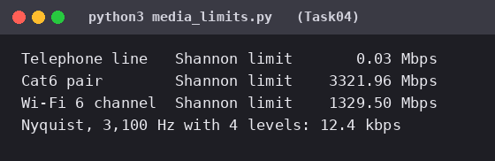

4.4 SNR needed for 56 kbps on a 3,100 Hz line
C = B log₂(1 + S/N) → S/N = 2^(56,000 ÷ 3,100) − 1 = 2^18.06 − 1 = 274,132 → 54.4 dB. A real analogue telephone line gives about 30–35 dB, which limits it to roughly 33.6 kbps. 54.4 dB is not realistic on an analogue line; 56k modems worked only because the telephone company’s end was digital (no analogue-to-digital quantisation noise).
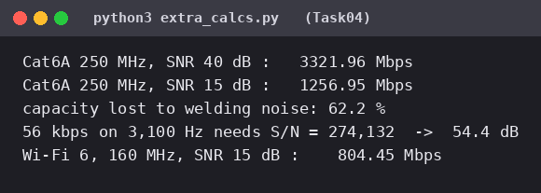

Alternative Concept Analysis – Wi-Fi 6 for the robot cell
160 MHz × log₂(1 + 31.62) = 804.45 Mbps at 15 dB – enough bandwidth for the 32 Mbps of robot traffic. But a wireless link is not acceptable for 10 ms robot commands: Wi-Fi uses CSMA/CA contention, so latency is not guaranteed; welding interference lowers the SNR randomly and causes retries; and delay/jitter can reach tens of milliseconds. Capacity is not the issue – determinism is. Keep shielded wired links for the robots; use Wi-Fi only for non-critical devices.
A justified medium for each run, trapped run (b) identified, and Shannon calculations with interpretation.

Task 5 – Wi-Fi 6 or 5G for Moving Equipment?

5.1 Hand-overs per trip
 | Wi-Fi 6 | Private 5G
Coverage per access point/cell | 30 m | 300 m
Hand-overs on the 1.2 km route | 1,200 ÷ 30 = 40 | 1,200 ÷ 300 = 4
Time per hand-over | 150 ms | 20 ms
Unreachable time per trip (600 s at 2 m/s) | 40 × 150 ms = 6.0 s (1.0 % of trip) | 4 × 20 ms = 80 ms (0.013 %)
One hand-over every | 15 s | 150 s
2-ms commands lost per hand-over | 75 | 10

5.2 5G service types
Traffic | 5G service type | Why
AGVs (10 ms commands) | URLLC – ultra-reliable low-latency | Hard deadline and reliability.
CCTV cameras (96 Mbps per line) | eMBB – enhanced mobile broadband | High bandwidth video.
Vibration/temperature sensors (600 per line) | mMTC – massive machine-type communication | Many small, low-power devices.

5.3 Where Bluetooth, Zigbee or LoRa beat Wi-Fi/5G
- Bluetooth (BLE): short range – tool/handheld pairing, wearables, asset tags; very low power.
- Zigbee: low-power mesh for battery sensors, lighting and environment monitoring; many nodes at low cost.
- LoRa: kilometres of range and years on battery for slow sensors (temperature, tank levels, yard/outdoor assets).
None is suitable for robot or AGV control or video – data rates are too low and latency too high.

5.4 Could Wi-Fi 6 with fast roaming (802.11r) meet the deadline?
802.11r cuts hand-over time from about 150 ms to roughly 50 ms or less (typical vendor figures), but even 50 ms is far above the 10 ms deadline: the AGV is still unreachable for 40 × 50 ms = 2 s per trip (about 1,000 missed 2-ms commands). Remaining risks: contention/jitter on a shared channel, interference from welding, AP overload and coverage holes – and 40 hand-over events per trip. 5G with only 4 hand-overs per trip is the better choice.

Alternative Concept Analysis – LoRaWAN for the sensors
600 sensors × 50 B/s × 8 = 240 kbps, against a LoRa gateway capacity of about 5 kbps → 48 gateways needed (one gateway carries only 5,000 ÷ 400 = 12.5 such sensors). It does not fit. Decision: keep the 50 B/s vibration sensors on Wi-Fi (or wired); use LoRa only for slow sensors – e.g. 50 B every 60 s = 6.7 bps each, so one gateway serves about 750 sensors.
hand-over calculations, mapping of traffic to 5G service types and a justified wireless decision.

Task 6 – Interpret an Ethernet Port Report

6.1 Meaning of the errors
- Late collision: a collision detected after the first 512 bits (64 bytes) of a frame were sent. On a correct half-duplex link collisions happen in that first 64-byte window; a late one means the other end transmitted while this end was already well into its frame – the other end is not following CSMA/CD (or the cable is too long).
- CRC error: the frame check sequence does not match – the frame was damaged; fragments cut short by late collisions are typical.
- Combination: the two ends disagree about duplex. The PC is forced to half-duplex (auto-negotiation off) while the gigabit switch port is operating full-duplex, so the switch transmits whenever it wants (no carrier sense) → the PC sees late collisions, CRC and receive errors; the switch sees runt/CRC errors. Result: very slow, retransmitted traffic.

6.2 Likely cause and exact fix
Cause: duplex mismatch – PC forced to 100 Mb/s half-duplex with auto-negotiation off, switch port set to auto/full.
Linux: sudo ethtool -s eth0 autoneg on (check with ethtool eth0; to force: sudo ethtool -s eth0 speed 100 duplex full autoneg off – then the switch port must be forced the same). Windows: Device Manager → Network adapter → Properties → Advanced → *Speed & Duplex* → Auto Negotiation (or PowerShell: Set-NetAdapterAdvancedProperty -Name "Ethernet" -DisplayName "Speed & Duplex" -DisplayValue "Auto Negotiation"). Best practice: auto-negotiation on at both ends (it is required for gigabit).

6.3 Addresses
- 01:00:5e:0a:01:02 – the first octet 0x01 has its least-significant bit (I/G) = 1, so it is a group (multicast) address, not a single device. The prefix 01:00:5e is the IPv4 multicast range; the low 23 bits map to a 224–239.10.1.2 group.
- 3c:52:82:4e:11:07 – the first three bytes 3c:52:82 are the OUI (organisationally unique identifier) – the NIC manufacturer’s IEEE-assigned ID; it is registered to Hewlett Packard. The last three bytes are the device-specific number.

6.4 Jumbo frames (9,000 bytes) for the CCTV storage server
Yes, they help: per-frame overhead (38 bytes including preamble and inter-frame gap) falls from 38 ÷ 1,538 = 2.47 % to 38 ÷ 9,038 = 0.42 %, and the server handles ~6 times fewer frames/interrupts. What must also change: the MTU must be raised on every device in the path – storage server, cameras/recorders, every switch port and VLAN end to end – otherwise frames are fragmented or dropped. Jumbo frames also stay inside one layer-2/MTU domain (not across the WAN).

Alternative Concept Analysis – ring of industrial switches vs star
 | Ring with fast ring recovery | Star of switches
Recovery after one cable cut | Typically ≈ 10–50 ms (e.g. ERPS/MRP; classic RSTP 1–2 s) – traffic re-routes the other way round the ring | None – no alternate path; stays down until the cable is repaired (or needs a manual/redundant link)
Devices that lose connection | None after recovery (frames lost only during the brief switch-over) | The device(s) behind the cut cable – one device if an access link; all devices below a switch if an uplink
Cost | Fewer cables, but ring-capable (managed) switches | Simple, more cable to a central point
(Recovery times are typical vendor figures for the protocols named.) For robots with a 10 ms deadline even a 30–50 ms recovery causes a few missed commands – so a ring is better than a star for availability, but robot cells should still fail safe.
reasoned interpretation of the report, corrective configuration, and correct answers on addressing and frame size.

Task 7 – Will the Receiver Notice the Error?

7.1 CRC for data 1101011011, generator 1011
Append 3 zeros (degree of generator): 1101011011000, then divide modulo-2 (XOR):
1101 XOR 1011 = 0110 -> 0110011011000
1100 XOR 1011 = 0111 -> 0011111011000
1111 XOR 1011 = 0100 -> 0001001011000
1001 XOR 1011 = 0010 -> 0000010011000
(leading 0: shift)
1001 XOR 1011 = 0010 -> 0000000101000
(leading 0: shift)
1010 XOR 1011 = 0001 -> 0000000000100
(remaining leading 0s: shift) remainder = 100
CRC bits = 100; transmitted frame = 1101011011100.

7.2 Received frame 1101011011101
Dividing 1101011011101 by 1011 leaves remainder 001 (not 000) → the frame is rejected – an error was detected (the last bit differs from the transmitted 100).

7.3 Burst errors
- The generator has degree 3, so every burst of length ≤ 3 bits is certain to be detected (confirmed by program for every position in the frame).
- Undetected pattern: any error pattern that is itself a multiple of 1011, e.g. 0000000001011 (flips the three bits 1011, a 4-bit burst) or 0000000011101 (4 bits). The corrupted frame is still divisible by G, so the receiver accepts it.

7.4 Two-dimensional parity (4 × 4 block)
1 0 1 1 | 1
0 1 1 0 | 0
1 1 0 0 | 0
0 1 0 1 | 0
--------+--
0 1 0 0 | 1 (row parities on the right, column parities below)
A 4-bit error that 2-D parity misses: flip the four corners of a rectangle – rows 1 and 3, columns 1 and 3. Each affected row and column has two flipped bits, so all row and column parities stay the same (verified by the program).

7.5 Internet checksum of 4500, 0073, 0000, 4000
Sum = 0x4500 + 0x0073 + 0x0000 + 0x4000 = 0x8573; no carry; one’s complement = 0x7A8C.

7.6 Complete the Code – Task07/crc.py
for i in range(len(dividend) - len(divisor) + 1):
if rem[i] == "1":
for j in range(len(divisor)):
rem[i + j] = "0" if rem[i + j] == divisor[j] else "1"
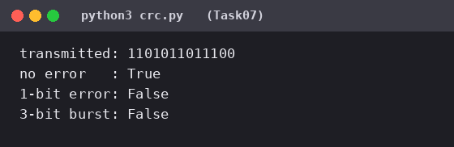
Error pattern that generator 1011 cannot detect (found with the program): 0000000001011. Reason: the receiver’s check is “remainder of frame ÷ G = 0”; when the XOR of the error pattern with the frame is divisible by G, the remainder of the error is 0, so it is invisible. Any multiple of x³ + x + 1 works.
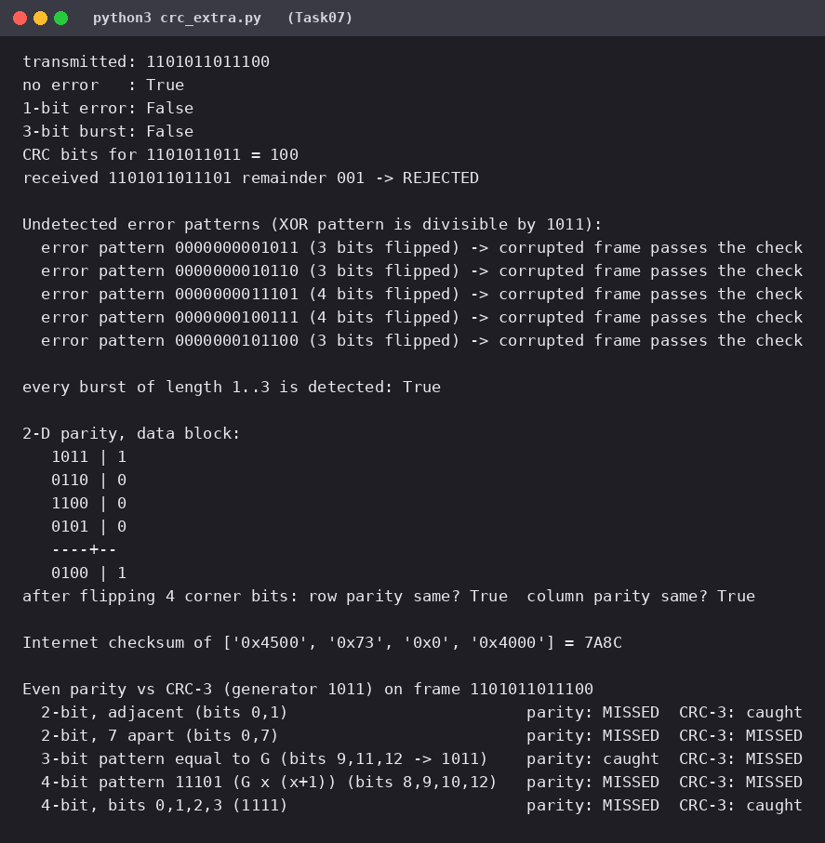

Alternative Concept Analysis – even parity vs CRC-3 (1011)
Error | Even parity | CRC-3 (1011)
2-bit, adjacent (bits 0,1) | MISSED | caught
2-bit, 7 apart (bits 0,7) | MISSED | MISSED (x⁷+1 is divisible by G)
3-bit pattern 1011 (any odd number of errors) | caught | MISSED
4-bit 1111 (bits 0–3) | MISSED | caught
4-bit pattern 11101 (multiple of G) | MISSED | MISSED
Even parity catches every odd-numbered error – including 3-bit pattern 1011 that CRC-3 misses – but misses every even-numbered error (all 2-bit and 4-bit patterns). CRC-3 catches all bursts ≤ 3 bits and most 2-bit and 4-bit errors that parity misses, but cannot catch some multiples of 1011. CRC is much stronger overall (and real Ethernet uses CRC-32); parity is cheap (1 bit).
hand calculations with working, an undetected-error example for each method and a comparison of their strength.

Task 8 – Correct the Error or Ask Again?

8.1 Hamming check bits for a 16-bit word
2^r ≥ m + r + 1: r = 4 → 16 ≥ 21 ✗; r = 5 → 32 ≥ 22 ✓. 5 check bits. Overhead = 5/16 = 31.25 % of the data (5/21 = 23.8 % of the 21-bit codeword).

8.2 Minimum Hamming distance of {00000, 01011, 10101, 11110}
Pairwise distances: 3, 3, 4, 4, 3, 3 → d_min = 3. It can detect d − 1 = 2 errors and correct ⌊(d − 1)/2⌋ = 1 error.

8.3 Hamming(7,4) – codeword 0110011 arrives as 0110111
Syndrome = 5 → bit 5 is wrong. Flip it: 0110011; data bits (positions 3, 5, 6, 7) = 1011.

8.4 FEC or ARQ?
On this noisy radio link a retransmission takes 40 ms, which is long compared with the sensor’s reporting interval, so forward error correction is better when errors are frequent – the receiver repairs the reading immediately. ARQ is better when errors are rare (no overhead until needed). Video streaming and 5G use FEC because retransmitting is too slow for real-time data, there may be no return channel (broadcast/multicast), and the channel is lossy.

8.5 Complete the Code – Task08/hamming.py
def decode(c):
s1 = c[0] ^ c[2] ^ c[4] ^ c[6]
s2 = c[1] ^ c[2] ^ c[5] ^ c[6]
s3 = c[3] ^ c[4] ^ c[5] ^ c[6]
pos = s1 + 2 * s2 + 4 * s3
if pos:
c[pos - 1] ^= 1
return pos, [c[2], c[4], c[5], c[6]]
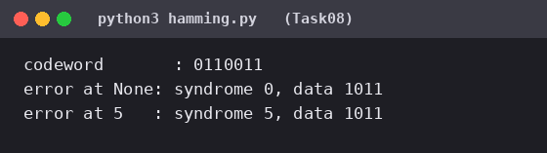
Two flipped bits: flipping bits 1 and 5 of the codeword gives syndrome 4, so the decoder “corrects” bit 4 – the wrong bit – and returns data 1111 instead of 1011, silently. Hamming(7,4) can correct one error but a second error cannot be detected (a SECDED extra parity bit is needed).
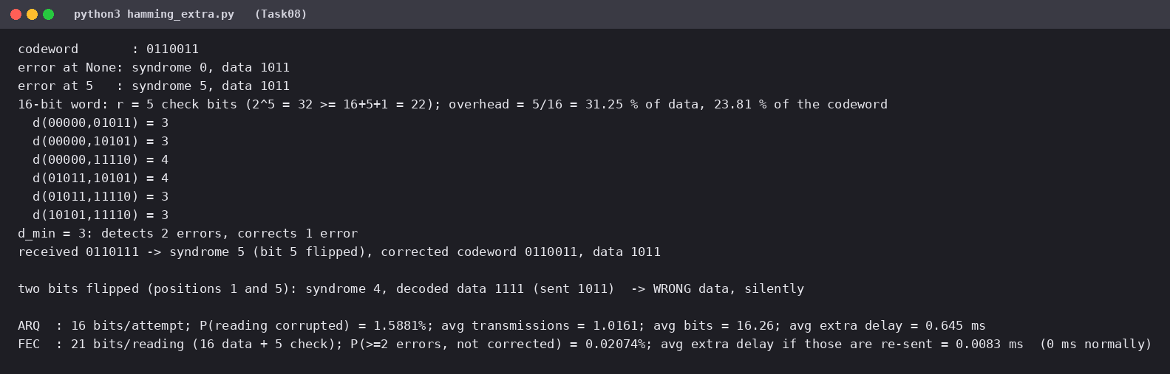

Alternative Concept Analysis – BER = 10⁻³, 16-bit readings
 | Hamming FEC | Retransmit on error (ARQ)
Bits per reading | 21 (16 + 5 check) | 16 (+ error-detection bits not counted)
P(reading needs action) | P(≥ 2 errors in 21 bits) = 0.0207 % | 1 − 0.999¹⁶ = 1.588 %
Average transmissions | ≈ 1 | 1/(1 − 0.01588) = 1.0161
Average bits sent | 21 | 16 × 1.0161 = 16.26
Average extra delay | 0 ms (0.0083 ms if the rare uncorrectable ones are re-sent) | 0.0161 × 40 ms = 0.645 ms
Choice: at this error rate ARQ uses fewer bits (16.3 vs 21) and adds an average 0.65 ms delay, but each error costs a 40 ms stall – a sensor needing predictable timing prefers FEC (fixed 21 bits, essentially no added delay). Since the plain Hamming code cannot detect double errors, use a SECDED code plus ARQ fallback.
correct calculations, a corrected codeword and a justified choice between FEC and ARQ.

Task 9 – How Big Must the Window Be?

9.1 Head-office link: 400 km, 1 Gbps, 1,500-byte frames
Quantity | Working | Result
Transmission time | 12,000 bits ÷ 10⁹ bit/s | 12 µs
Propagation time | 400,000 m ÷ 2 × 10⁸ m/s | 2 ms (RTT 4 ms)
a = prop ÷ tx | 2 ms ÷ 12 µs | 166.67
Stop-and-wait utilisation | 1 ÷ (1 + 2a) = 1 ÷ 334.33 | 0.299 % → 2.99 Mbps of 1,000 Mbps
Smallest window for full use | W ≥ 1 + 2a = 334.33 | W = 335 frames
Go-Back-N sequence numbers | W + 1 = 336 → 2⁹ = 512 | 9 bits
Selective Repeat sequence numbers | 2W = 670 → 2¹⁰ = 1,024 | 10 bits

Fewer resends after one loss: Selective Repeat resends only the lost frame; Go-Back-N resends the lost frame and everything after it (up to 335 frames). Cost: the SR receiver must buffer out-of-order frames (up to 335 × 1,500 B ≈ 502.5 kB) and keep a window of its own; the GBN receiver just discards out-of-order frames (no buffer).
Frame delimiting: HDLC and PPP mark the start and end of a frame with the flag byte 01111110 (0x7E). HDLC uses bit stuffing (insert a 0 after five consecutive 1s); PPP uses byte stuffing (0x7E or 0x7D inside data is replaced by 0x7D followed by the byte XOR 0x20).

9.2 Complete the Code – Task09/utilisation.py
a = prop / tx
u = min(1.0, window / (1 + 2 * a))
return u, a
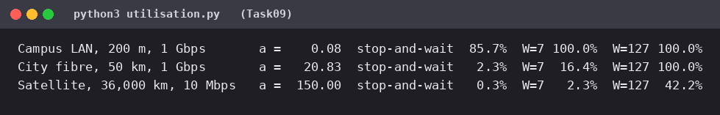
Satellite link, 100 % utilisation: tx = 12,000 ÷ 10⁷ = 1.2 ms; prop = 36 × 10⁶ ÷ 2 × 10⁸ = 180 ms; a = 150; W ≥ 1 + 2a = 301 frames (consistent with W = 127 giving 127/301 = 42.2 %).
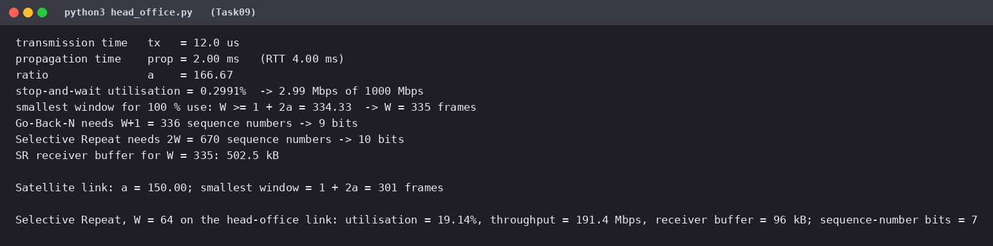

Alternative Concept Analysis – Selective Repeat with window 64
- Utilisation = 64 ÷ 334.33 = 19.14 %; throughput = 0.1914 × 1 Gbps = 191.4 Mbps.
- Receiver buffer = 64 × 1,500 B = 96,000 B ≈ 96 kB; sequence numbers needed = 2 × 64 = 128 → 7 bits.
- Window 64 is 5.2 times smaller than the 335 needed, so the link is ~80 % idle. TCP window scaling is needed on the real link: bandwidth-delay product = 1 Gbps × 4 ms = 500 kB.
correct timing, utilisation and window calculations, sequence-number sizes and a justified protocol choice (Selective Repeat).

Task 10 – Find Where the Delay Comes From

10.1 Propagation delay check
400 km ÷ 2 × 10⁸ m/s = 2 ms one-way, 4 ms round trip. The traceroute RTT to hop 6 is ≈ 12.6 ms, so propagation explains 4 ÷ 12.6 = 32 %; the remaining ≈ 8.6 ms is router processing, queueing, serialisation and the fact that the real fibre route is longer than the straight line.

10.2 Hop 3 (38.2 ms) and hop 5 (stars)
- Hop 3, one value of 38.2 ms: traceroute measures the time of the router’s ICMP “time exceeded” reply, which the router generates on its low-priority control plane; a momentary CPU spike or ICMP rate-limit makes one probe slow. It is not a fault: the other two probes are 4.0/4.2 ms and later hops (11–12 ms) show no 38 ms delay – real forwarding delay would appear at every following hop.
- Hop 5, * * *: the router does not answer TTL-expired probes (ICMP filtered by a firewall or policy) but still forwards traffic – hop 6 replies normally. It is not a fault.

10.3 Which hop adds the most delay
Hop | Median RTT | Increase over previous hop
1 10.10.1.1 | 0.6 ms | –
2 100.64.0.1 | 3.1 ms | +2.5 ms
3 172.31.4.9 | 4.2 ms (38.2 ms outlier ignored) | +1.1 ms
4 103.21.8.17 | 11.8 ms | +7.6 ms (largest)
6 10.200.0.10 | 12.6 ms | +0.8 ms (over hop 4)
Hop 3 → 4 (172.31.4.9 → 103.21.8.17) adds the most delay – ≈ 7.6 ms, the jump from a private address to a public one: most probably the long-distance carrier link, which also contains the 2 ms of propagation.

10.4 Your own traceroute, ping and Wireshark capture
This part must be done on your own computer – the sandbox I used for the other tasks has no access to real networks, so I could not produce a genuine measurement, and the assignment asks for your own evidence. Steps:
- Windows: tracert -d <server> and ping -n 20 <server>; Linux/macOS: traceroute -n <server> and ping -c 20 <server>.
- Start Wireshark on your active interface, then visit a website. Stop and filter e.g. tcp.port == 443 || dns.
- Screenshot one packet and expand the layers: Frame (layer 1) → Ethernet II (layer 2: MACs) → Internet Protocol (layer 3: IP addresses, TTL) → TCP/UDP (layer 4: ports, flags) → Application (layer 7: DNS/HTTP/TLS) and label each header.

Alternative Concept Analysis – monitoring methods
Problem in the traceroute | SNMP counters (continuous) | NetFlow/flow records (continuous) | Occasional ping/traceroute
Hop 3 spike (38.2 ms) | Would not show it – counters track bytes/errors, not single ICMP delays (unless IP-SLA probes) | No | Only if run at that moment; re-runs show it was transient
Hop 5 stars | Not detected; not a real problem | No – traffic is seen flowing through | Shows stars but cannot tell filtering from a fault
Large delay on hop 3→4 link | Shows utilisation/drops/errors on the interface within the polling interval (1–5 min) | Shows which flows fill the link, within ~1–5 min of export | Shows the delay at that moment and where it starts
Summary: SNMP + flow records give continuous history and trends (minutes) and show why a link is busy; ping/traceroute give an instant end-to-end view and locate the hop, but only when someone runs them. Best practice: combine them – continuous SNMP/NetFlow for detection, traceroute to locate the cause.
A reasoned reading of the traceroute and a propagation-delay check (done); your own measured evidence (to be inserted).

Task 11 – Defend the Network Design

11.1 Recommended design (numbers from Tasks 1–10)
Area | Medium / technology | Ethernet settings | Justification (task)
Robot cell by welders (85 m) | Cat6A S/FTP shielded, 1 Gbps (fibre if the noise worsens) | Full-duplex, auto-negotiation ON, own VLAN, strict-priority queue (DSCP EF) | T4: 85 m < 100 m; SNR 15 dB still gives 1,257 Mbps vs the 32 Mbps need; T6: avoid duplex mismatch.
Office floor → shop-floor switch (140 m) | Multimode fibre OM3/OM4 | Full-duplex 1 Gbps | T4: 140 m > 100 m copper limit.
Shop floor → data centre (550 m) | Single-mode fibre, 10 Gbps uplink | Full-duplex, jumbo frames only on the CCTV/storage VLAN | T1: 8 lines = 1,265.92 Mbps > 1 Gbps; T4: 550 m; T6: jumbo cuts overhead 2.47 → 0.42 %.
Plant → head office (400 km) | Leased line (carrier fibre) ≥ 1 Gbps, with backup | TCP window scaling | T4: only option at 400 km; T9/T10: 4 ms RTT, 500 kB bandwidth-delay product.
Offices, handhelds | Wi-Fi 6 (802.11r) | WPA3, separate VLAN | T5: fine for non-critical traffic (30 Mbps per line).
Sensors | Wired/Wi-Fi 6; LoRa only for slow sensors | – | T5: 600 sensors = 240 kbps > one LoRa gateway (5 kbps).
CCTV | Wired PoE, motion-triggered recording | Own VLAN, lowest priority | T1: 96 → 4.8 Mbps per line.

11.2 Error control and flow control
- Wired links: Ethernet CRC-32 FCS on every frame (T7: CRC detects all short bursts); TCP (selective repeat/SACK) for reliable transfer; robot commands over TCP/UDP in a prioritised VLAN with no pause frames.
- WAN to head office: sliding window with W ≥ 335 frames needed for full use (T9) – 10-bit sequence numbers for Selective Repeat; stop-and-wait would give only 2.99 Mbps.
- Wireless sensor links: forward error correction (T8: Hamming adds 5 check bits = 31.25 % but avoids a 40 ms retransmission); upgrade to SECDED codes since plain Hamming miscorrects double errors.

11.3 The two biggest remaining risks
- Congestion or failure of the shared uplink: at 126.6 % load (T1) robot commands queue behind video → mitigated by 10 Gbps, QoS priority and a redundant ring/second uplink (recovery ≈ tens of ms, T6).
- Wireless mobility and noise: Wi-Fi hand-overs of 150 ms (40 per trip = 6 s unreachable, T5) and welding interference cannot meet 10 ms – mitigated by keeping robots wired and (Task 12) moving mobile equipment to private 5G.

11.4 Does it work for five plants?
Per plant (8 lines) the traffic is 1,265.92 Mbps; five plants = 6,330 Mbps in total, but robot control (256 Mbps per plant) and CCTV (768 Mbps per plant, 38 Mbps with motion triggering) stay local. Only office traffic (30 Mbps × 8 = 240 Mbps) and sensor data (1.92 Mbps) cross the WAN: ≈ 242 Mbps per plant, ≈ 1.21 Gbps for five plants worst case – workable with a ≥ 1 Gbps leased line per plant and a 10 Gbps head-office aggregation. Use VLANs per line (≈ 40 devices per /26) to keep broadcast domains small as the plant grows to 1,500 devices.

Alternative Concept Analysis – everything on private 5G instead of wired backbone + Wi-Fi
Traffic (8 lines) | Rate | Carry on 5G? | Reason
Robot control | 256 Mbps | Fixed robots: cable; mobile/reconfigurable ones: 5G URLLC | Deterministic, EMI-free on cable; 5G URLLC is for equipment that moves.
AGVs | 40 Mbps (50 AGVs) | 5G (URLLC) | 4 hand-overs × 20 ms vs Wi-Fi 6 s per trip.
Sensors | 1.92 Mbps | 5G (mMTC) | Many small devices, tiny load.
Office | 240 Mbps | Wi-Fi 6 / cable | Cheap capacity, not latency-critical.
CCTV | 768 Mbps | Cable (fibre/PoE) | A 5G cell shares a few hundred Mbps (assumed); 768 Mbps video would starve control traffic.
A recommendation supported by calculations from Tasks 1–10 (measured evidence from Task 10.4 to be added by you).

Task 12 – Re-evaluate and Adapt the Design
Decision: MODIFY – keep the wired backbone, fibre/shielded cabling, error-control settings and Wi-Fi 6 for offices; move AGVs and mobile equipment to a private 5G URLLC network and upgrade the uplink to 10 Gbps.

A. Impact analysis (2 marks)
Affected element | Impact of private 5G + 50 AGVs
Wireless choice | AGVs cannot rely on Wi-Fi 6 – 40 hand-overs of 150 ms each per 1.2 km trip (T5).
Media | 5G radio units/small cells need fibre backhaul (single-mode, 550 m run already planned) and PoE/power; the 1 Gbps uplink must grow.
Error control | 5G uses LDPC/polar coding with HARQ (FEC + fast retransmission) on the air link; wired CRC-32/TCP unchanged.
Traffic | See table below.

Assumption (AGV traffic was not given): each AGV sends control/telemetry like a robot controller – 200 bytes every 2 ms = 0.8 Mbps; optional on-board camera 4 Mbps.
Scenario | Calculation | Plant traffic | Load on 1 Gbps / 10 Gbps
Original (8 lines) | 8 × 158.24 | 1,265.92 Mbps | 126.6 % / 12.7 %
+ 50 AGVs, control only | 1,265.92 + 50 × 0.8 | 1,305.92 Mbps | 130.6 % / 13.1 %
+ 50 AGVs with cameras | 1,305.92 + 50 × 4 | 1,505.92 Mbps | 150.6 % / 15.1 %

B. Test the original design
Test | Original design (Wi-Fi 6 for mobile) | 5G
Hand-overs per AGV trip (1.2 km at 2 m/s = 600 s) | 40 | 4
Unreachable time per trip | 40 × 150 ms = 6.0 s (1.0 % of time) | 4 × 20 ms = 80 ms (0.013 %)
With 802.11r (~50 ms) | 40 × 50 ms = 2.0 s | –
Hand-overs for 50 AGVs per cycle | 2,000 (3.3 per second across the fleet) | 200
2-ms commands lost per hand-over | 75 | 10
Meets 10 ms deadline during hand-over? | No – 150 ms is 15× the deadline | Not quite (20 ms) – needs dual connectivity/make-before-break
Result: the original design cannot serve 50 moving AGVs – every hand-over exceeds the 10 ms deadline by 15× and happens 3.3 times per second somewhere in the fleet. 5G cuts blind time 75-fold (6 s → 80 ms per trip). Also, the 1 Gbps uplink is already overloaded (126.6 %) and goes to 130.6 % with AGVs.

C. Adaptation or redesign
- Private 5G (URLLC slice): AGVs, mobile robots, handhelds; overlapping cells of 300 m (4 cells on the 1.2 km route) with dual connectivity so the AGV stays attached during hand-over; AGVs must also stop safely on loss of command.
- Wi-Fi 6: offices only (30 Mbps per line); mMTC / LoRa: sensors.
- Fibre backbone: 10 Gbps single-mode uplink (13.1 % loaded with AGVs); backup uplink in a ring; 5G core on-premises so commands never leave the plant.
- Unchanged: shielded Cat6A in the robot cell, multimode fibre for the 140 m run, leased line for the 400 km head-office link, CRC-32/TCP, QoS priority for robot and AGV control.

D. Evidence-based defence (2 marks)
- Why not RETAIN: Wi-Fi gives 6 s unreachable per trip against the “never miss a command” rule; the uplink is at 130.6 %.
- Why not REDESIGN completely: the wired design is sound – 5G cannot carry 768 Mbps of CCTV plus 256 Mbps of robot control, and cable is immune to RF problems near the welders; the original numbers (robot cell 32 Mbps within 1,257 Mbps capacity at 15 dB; 85 m < 100 m) still hold. Rebuilding would add cost without benefit.
- Why MODIFY works: 5G reduces hand-over time 75× (6 s → 80 ms per trip) and the AGVs’ 40 Mbps is a tiny load on a 10 Gbps backbone (13.1 %).
- Trade-offs: extra cost of the 5G core, radios and spectrum/licence; 5G’s 20 ms hand-over still needs mitigation; two technologies to operate (5G + Wi-Fi) – accepted because each is used where it is strongest.
A quantified impact analysis, a calculation-based test of the original design, a clear modify-decision and a defence with numbers and trade-offs.

