**Software Requirement Specification (SRS)**

**For**

**Monitoring Software**

Version 1.3

**Submitted to**



Deputy Police Commissioner (Logistics)

Dhaka Metropolitan Police

Dhaka-1217

**Prepared By:**



15th Floor, 52/1 Hasan Holdings Limited

New Eskaton Road, Dhaka 1000.

Email: [info@soft-bd.com](mailto:info@soft-bd.com)

Corporate website: [www.soft-bd.com](http://www.soft-bd.com)



# The Procurement of Goods Monitoring Software SRS Approval Letter

I ……………………..…. understand that this SRS contains all the Software Requirement Analysis that has been precisely documented for understanding how The Procurement of Goods Monitoring Software will operate in the real world. I also understand that by approving this SRS, I will not be able to add further requirements to The Procurement of Goods Monitoring Software. I am hereby providing my authorization for SoftBD Ltd. to proceed with the design and development phase.

Name:

Designation:

Signature:

Date:

Contents

The Procurement of Goods Monitoring Software SRS Approval Letter 2

Document Revision History 4

1 Executive Summary 5

2 Introduction 6

2.1 Purpose 6

2.2 Document Conventions 6

2.3 Intended Audience and Reading Suggestions 7

2.4 Scope of Work 8

2.4.1 Technology Specification 10

Definition, Acronyms & Abbreviation 10

Audience 11

User Interface 11

Hardware Interface 11

Software Interface 11

3. Specific Requirements 12

3.1. Development Technology: 13

3.2 Functional Requirement 14

Detail understanding of Component 14

Use Cases 16

5. Non Functional Requirements/ Software Attributes 66

5. Monitoring Strategy 67

6 Risk Management 68

7 Change Management Process 69

# Document Revision History

|  |  |  |  |  |
| --- | --- | --- | --- | --- |
| **Version No.** | **Date of Release** | **Prepared By** | **Reviewed By** | **Activity** |
| V0.1 | July 01, 2019 | Mahmud Hasan | Mohammed Yasir | Initial Draft |
| V0.2 | July 03, 2019 | Mahmud Hasan | Mohammed Yasir | Added Executive Summary & Introduction |
| V0.3 | July 04, 2019 | Mahmud Hasan | Mohammed Yasir | Added Purpose, Document  Conventions |
| V0.4 | July 07, 2019 | Mahmud Hasan | Mohammed Yasir | Added Intended Audience  Reading Suggestions |
| V0.5 | July 07, 2019 | Mahmud Hasan | Mohammed Yasir | Added Scope of Work, Added Definition, Acronyms  Abbreviation |
| V1.0 | July 08, 2019 | Mahmud Hasan | Mohammed Yasir | Add Use cases |
| V1.1 | August 18, 2019 | Mahmud Hasan | Mohammed Yasir | Update Functional Requirement & Use case |
| V1.2 | August 19, 2019 | Mahmud Hasan | Mohammed Yasir | Update Use case |
| V1.3 | August 20, 2019 | Mahmud Hasan | Mohammed Yasir | Update Use case |

# 1 Executive Summary

The development of The Procurement of Goods Monitoring Software and provide Support & Maintenance, has a one-month timeframe to conduct all necessary requirement analysis, planning, development, testing, operational activities for country wide rollout and arrangements prior to implementation at full swing. The Procurement of Goods Monitoring Software also has a provision for providing 12 months support & maintenance of the newly implemented system.

To initiate the project we have conducted few inception meeting and submitted the inception report as per the deliverable requirement of the project. The project deliverables also demands a comprehensive System Requirement Specification (SRS) to clearly understand, how we are going to develop the software. This SRS fully describes what the software will do and how it will be expected to perform.

This software requirements specification document enlists all necessary requirements that are required for the project development. To derive the requirements we need to have clear and thorough understanding of the products to be developed. This SRS has been prepared after detailed communications with the Project Implementation Unit (PIU) and all other stakeholders.

This SRS will minimize the time and effort required by SoftBD Ltd. to achieve desired goals and also minimize the development cost. This SRS defines how the application will interact with system hardware, other programs and human users in a wide variety of real-world situations. Parameters such as operating speed, response time, availability, portability, maintainability, scalability, extensibility, security and speed of recovery from adverse events.

This SRS details the activities undertaken and the achievement that needs to be obtained during the different phase of the project life cycle. This is a self-contained document and once approved, it will guide the project personnel to understand the project and management structure more clearly. The processes and strategies one has to adopt in order for achieving certain results, tracking the progress and maintaining the quality. It also describes the impending risks and challenges the project has to overcome to maintain the work schedule.

# 2 Introduction

This document describes in substantial detail, the software requirements of IM, an online instant messaging application. This document will describe the functional requirements and non-functional requirements of the proposed system. This document is intended for the stakeholders of the application, to assist in the development process of IM as well as to serve a reference to clarify any future issues that the stakeholders may run into.

IM aims at providing a seamlessly integrated, web based, mobile messaging application, that identifies the contacts on a user’s mobile device and enables free text messaging services. For better interaction and user experience, IM intends to provide support for different media types such as audio, video and emoticons.

## 2.1 Purpose

The purpose if this Software Requirement Specification (SRS) is:

* To gain agreement with stakeholders and Project Implementation Unit (PIU).
* To describe what the development of The Procurement of Goods Monitoring Software will look like for a business perspective and IT perspective. This document will also describe how the system will work and how each functionality will behave.
* To provide IT specialist the information needed to develop the Procurement of Goods Monitoring Software for system designing and developing the application.

## 2.2 Document Conventions

When writing this SRS for The Procurement of Goods Monitoring Software, the following terminologies are used:

* Software Requirement Specification (SRS): A software requirements specification (SRS) is a description of a software system to be developed. It lays out functional and non-functional requirements, and may include a set of use cases that describe user interactions that the software must provide.

Project Implementation Unit (PIU): Project Implementation Unit (PIU) team is a team whose members usually belong to different groups, functions and are assigned to activities for the same project. A team can be divided into sub-teams according to need. Usually project teams are only used for a defined period of time. They are disbanded after the project is deemed complete. Due to the nature of the specific formation and disbandment, PIU are usually in organizations.

* Terms of Reference (ToR): Terms of reference (ToR) defines the purpose and structures of a project, committee, meeting, negotiation, or any similar collection of people who have agreed to work together to accomplish a shared goal.

## 2.3 Intended Audience and Reading Suggestions

This document is to be read by the development team, the project managers, QA Engineers, supporting staff, testers, documentation writers, and all other stakeholders of The Procurement of Goods Monitoring Software. The SRS has been organized approximately in order of increasing user specificity requirements. The developers and project managers need to become intimately familiar with the SRS.

## 2.4 Scope of Work

**Functional Requirements**

1. **User Registration**

Admin User will be adding user name, valid unique mobile number and Designation on the online web application.

User must be able to register for the application through a valid phone number. On installing the application, user must be prompted to register their phone number. If Phone number is already added into the system user can be login into the system. If user skips this step, application should close.

1. **Adding New Contacts**

Admin User will be add user name, valid unique mobile number and Designation on the online web application for add new contact.

1. **Send Message**

User should be able to send instant message to any contact on his/her IM contact list. User should be notified when message is successfully delivered to the recipient by displaying a tick sign next to the message sent.

1. **Send Attachments & Live Streaming**

User should be able to send audio, video and images as attachments as well as Live Streaming of audio & video, providing inline document viewer that lets users view pdf and word attachments .

Audio formats that the application should support : mp3 wav Video formats that the application should support : avi mp4 flv gif Image formats that the application should support: jpg png . System will be able to send all files but only mobile supported files will be viewed in specific mobile.

1. **Broadcast Message**

User should be able to create groups of contacts. User should be able to broadcast messages to these groups.

1. **Message Status**

User must be able to get information on whether the message sent has been read by the intended recipient. If recipient reads the message, 2 ticks must appear next to the message read.

1. **Location Services**

Admin must be able to get information on user location (GPS coordinator in the IM app.) Admin should be able to view location history of any user up to last 6 months.

**Enhancement Requests**

1. **Last Seen**

Client has requested that user be able to see the date and time when his/her contact was last using the application.

1. **User Profile**

User should be able to set their profile picture and a status.

**Support & Maintenance:**

* 1. The vendor needs to provide 12 (twelve) months support & maintenance services of the developed system after the implementation phase. It includes (but not limited to) the following, as part of the SLA:
     + - 24x7 online technical support.
       - Response, Restoration and Remedy at the time of an incident.
       - Incident shall be categorized based on their severity level.
       - Problem Management Procedure.
       - Escalation Matrix.
  2. Support & Maintenance will cover fixing all bugs and system errors, as and when identified by the system users.
  3. Priority operations in Support & Maintenance to fix an error that result in the application not operating or performing other than as it should be.
  4. The vendor shall undertake timely backup of the entire database to meet the challenges of system recovery, in case of any disaster or missing data.
  5. The vendor needs to assign permanent support engineers who will work closely with the clients/designated officials to ensure proper delivery of any required services during the support and maintenance phase.
  6. The vendor company cannot assign programmers to other projects till the completion of the assignment, and will ensure the continuity of the scheduled work by other programmers in case of his/her absence.
  7. The hired and assigned IT personals for support & maintenance must be regular employees of the vendor company.
  8. The vendor needs to provide a monthly support & maintenance log report.

### 2.4.1 Technology Specification

1. Need to use Open Source Development Platform.
2. PHP based platform with tool architecture like Bootstrap, framework like Cake PHP/Laravel/codeigniter and MySQL database can be used.
3. Android will be used for Android mobile app.
4. Future technology Change, iterative prototyping and agility in product design are the generic expectation.
5. Technology and all related design/data will be open to DMP.
6. Need to work in IDE with DMP Tech Team.

**2.4.2 System Testing:**

Vendor Company will ensure system to be tested at module integration and load level. All necessary security at application level architecture needs to be followed.

## Definition, Acronyms & Abbreviation

|  |  |
| --- | --- |
| **Acronyms** | **Abbreviations** |
| **API** | Application Program Interface |
| **CSV** | Comma Separated Values |
| **DCP** | Dhaka Metropolitan Police |
| **IM** | Instance Message |
| **ToR** | Terms of Reference |
| **GUI** | Graphical User Interface |
| **SRS** | Software Requirement Specification |
| **SLA** | Service Level Agreement |
| **PIU** | Project Implementation Unit |
| **PHP** | Hypertext Pre-Processor |
| **HTML 5** | Hypertext Markup Language |
| **CSS 3** | Cascading Style Sheet |
| **IDE** | Integrated Development Environment |
| **XML** | Extensible Markup Language |
| **XHTML** | Extensible Hypertext Markup Language |

## Audience

The audience for this document includes anyone seeking an understanding for how the applications works to support the business needs within the context of the technological framework supported by the Bangladesh Government.

## User Interface

This section describes the logical characteristics of each interface between the intended software product and the users. For user interface design, common GUI standards will be followed along with the presence of keyboard shortcuts, error message display standards etc., and standard buttons, uniform color combination in all UI, uniform font and font size and functions (i.e. help) will appear on every screen or whenever needed. Details of the user interface design are documented in the Use case Section of this document.

## Hardware Interface

Since the application must run over the internet, all the hardware shall require to connect internet will be hardware interface for the proposed system. As for e.g. Modem, WAN – LAN, Ethernet Cross-Cable. The system will be compatible with all well-known browsers of Desktop, Laptop, and smart devices.

## Software Interface

The provision here is the keep the external software commination interface as seamless as possible. User experience is the most priority concern in this regards when the Procurement of Goods Monitoring Software is interfacing with other 3rd party software such as 3rd party services that will be integrated into the system, payment gateway, database management system, server OS, web services etc. In particular the system will be interfacing/communication with the following external system:

# 3. Specific Requirements

The Procurement of Goods Monitoring Software Architecture Overview

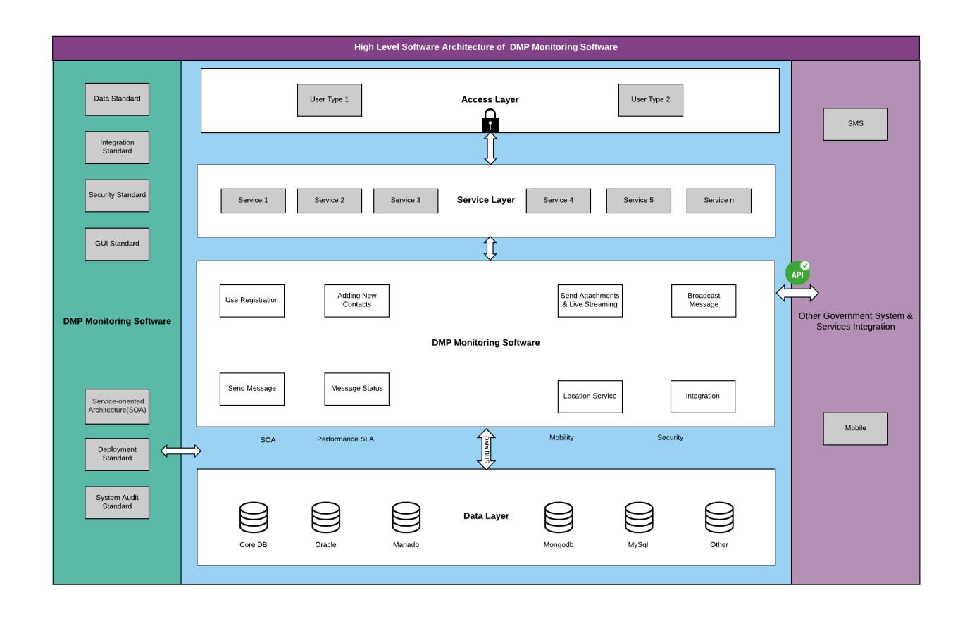

We are fully complied with the objectives of the assignment and scope of work described in the Technical Specification. In accordance to our understanding we have proposed a high level application architecture design strategy in the image above which explains the software architecture of THE PROCUREMENT OF GOODS MONITORING SOFTWARE.

We will adopt the microservice architecture approach while designing the systems. Microservice architecture is a method of developing software applications as a suite of independently deployable, small, modular services in which each service runs a unique process and communicates through a well-defined, lightweight mechanism to serve a business goal.

We will use Microservice Architecture for the following reasons:

* Enables the continuous delivery and deployment of large, complex applications.
  + Better testability - services are smaller and faster to test
  + Better deploy ability - services can be deployed independently
  + It enables you to organize the development effort around multiple, auto teams. It enables you to organize the development effort around multiple teams. Each (two pizza) team is owns and is responsible for one or more single service. Each team can develop, deploy and scale their services independently of all of the other teams.
* Each microservice is relatively small.
  + Easier for a developer to understand.
  + The IDE is faster making developers more productive.
  + The application starts faster, which makes developers more productive, and speeds up deployments.
* Improved fault isolation. For example, if there is a memory leak in one service then only that service will be affected. The other services will continue to handle requests. In comparison, one misbehaving component of a monolithic architecture can bring down the entire system.
* Eliminates any long-term commitment to a technology stack. When developing a new service you can pick a new technology stack. Similarly, when making major changes to an existing service you can rewrite it using a new technology stack.

## 3.1. Development Technology:

Development technology was defined to save time and making the architecture robust in respective of front-end and back-end. The selection of right technology, tools and platform is very important and challenging especially in case of large enterprise application or platform. In fact, depending on the nature, size and business practices of the enterprises the technology tools and platform may varies from application to application. Even tools may vary within the same application for different interfaces. For this project of The Procurement of Goods Monitoring Software considering the size, security requirement, nature of business practices, volume of data and frequency of transaction, we can obviously consider it as a large-scale enterprise application. As per your requirements see the description of the technology to be used for development in the below section:

* Server OS : Linux
* Workstation : Windows
* Front End Tools : Android Studio
* Language : PHP, HTML5, JavaScript, CSS3, JS, Jquery, ArgoUML.JAVA
* Architectural Pattern : MVC
* Framework : Cake PHP 3, Bootstrap, AngularJS
* Database Engine : MySQL
* Diagram Application : MS Visio
* Source Code Management : Gitlab

## 3.2 Functional Requirement

### Detail understanding of Component

As per our understand and previous experience in working with similar project below is the proposed component diagram of THE PROCUREMENT OF GOODS MONITORING SOFTWARE

**Component Diagram of DMP Monitoring System**

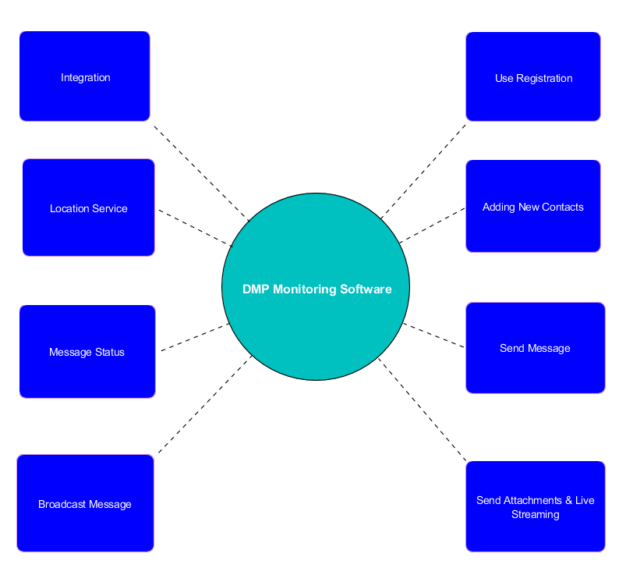

Core Component for THE PROCUREMENT OF GOODS MONITORING SOFTWARE:

1. Use Registration

2. Adding New Contacts

3. Send Message

4. Send Attachments & Live Streaming

5. Broadcast Message

6. Message Status

7. Location Service

8. Integration

### Use Cases

**User Registration**

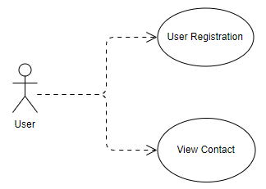

**User Registration**

|  |  |
| --- | --- |
| Action Name | User Registration |
| Actors | User |
| Use Case Diagram |  |
| Trigger | When a user wants to register into the system. |
| Process Flow Diagram |  |
| https://documents.lucidchart.com/documents/b083312d-a595-4336-a741-622dc414721a/pages/Cq8vzdw823T2?a=9655&x=6&y=184&w=1546&h=414&store=1&accept=image%2F*&auth=LCA%20192a8530683c2e16c17cb7c614e5d7205e8951da-ts%3D1562211634 | |
| Brief Description | The process of user registration. |
| Initial Step-By-Step Description | Before this use case can be initiated, the user has already connected to the Online Monitoring Software Mobile App.     1. Assuming on successfully install Monitoring Software into the mobile. 2. User will provide Phone Number. 3. Click “Registration”. 4. System will check if the number is added in the system in contact list. 5. If the number is added into the system by the admin, user registration successful completed and System will provide OTP. Otherwise the application should closed |
| Task Dependencies | User Login |
| Goal | To register into the system. |
| Post Conditions | A new user will be registered. |
| Platform | Mobile Application |
| Proposed Module | User Registration |
| User Interface | |

**View Contact**

|  |  |
| --- | --- |
| Action Name | View Contact |
| Actors | User |
| Use Case Diagram |  |
| Trigger | When a user wants to view contact list. |
| Process Flow Diagram |  |
| https://documents.lucidchart.com/documents/a3962fd8-8b92-41e2-be3c-3a3ccf48fef2/pages/nvZw2KhnYcui?a=11101&x=-28&y=230&w=1326&h=186&store=1&accept=image%2F*&auth=LCA%2042d86d928cf0f5efd039a771c7c56e404caf8de0-ts%3D1562476589 | |
| Brief Description | The process of view contact list. |
| Initial Step-By-Step Description | Before this use case can be initiated, the user has already connected to the Online Monitoring Software Mobile App.     1. Assuming on successfully install Monitoring Software into the mobile. 2. After successfully Registration in the system, User will enter into the Application. 3. Press chat icon for view contact list. |
| Task Dependencies | User Login |
| Goal | To view contact list. |
| Post Conditions | Contact list viewed. |
| Platform | Mobile Application |
| Proposed Module | User Registration |
| User Interface | |

**User Profile Management**

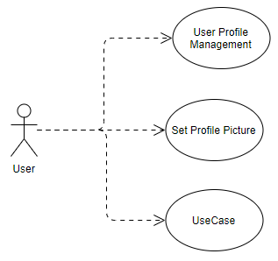

**Update User Profile**

|  |  |
| --- | --- |
| Action Name | Update User Profile |
| Actors | User |
| Use Case Diagram |  |
| Trigger | When a user wants to update profile. |
| Process Flow Diagram |  |
| https://documents.lucidchart.com/documents/a3962fd8-8b92-41e2-be3c-3a3ccf48fef2/pages/IZXl3te_NNdm?a=9849&x=-288&y=232&w=1493&h=186&store=1&accept=image%2F*&auth=LCA%20f7f66afc50fc6b0179bd1c38afded9582ae8d650-ts%3D1562476589 | |
| Brief Description | The process of update profile. |
| Initial Step-By-Step Description | Before this use case can be initiated, the user has already connected to the Online Monitoring Software Mobile App.     1. Assuming on successfully install Monitoring Software into the mobile. 2. Press drawer icon from top-left corner 3. User press on profile icon. 4. Press Edit icon 5. Change information where required. User cannot change Name, Phone Number, and Designation 6. Press right arrow icon for update information. |
| Task Dependencies | User Login |
| Goal | To update user information. |
| Post Conditions | User Information Updated. |
| Platform | Mobile Application |
| Proposed Module | User Profile Management |
| User Interface | |

**Set Profile Picture**

|  |  |
| --- | --- |
| Action Name | Set Profile Picture |
| Actors | User |
| Use Case Diagram |  |
| Trigger | When a user wants to set profile Picture. |
| Process Flow Diagram |  |
| https://documents.lucidchart.com/documents/a3962fd8-8b92-41e2-be3c-3a3ccf48fef2/pages/LPZwDZ7-OURj?a=9949&x=-288&y=232&w=1493&h=186&store=1&accept=image%2F*&auth=LCA%204a4716bc773e279f2c2f8cd3084d0a3cfafd155e-ts%3D1562476589 | |
| Brief Description | The process of set profile Picture. |
| Initial Step-By-Step Description | Before this use case can be initiated, the user has already connected to the Online Monitoring Software Mobile App.     1. Assuming on successfully install Monitoring Software into the mobile. 2. Press drawer icon from top-left corner 3. User press on profile icon. 4. Press user profile picture. 5. Select Picture 6. Upload Picture 7. Click Set Picture set profile picture. |
| Task Dependencies | User Login |
| Goal | To set profile Picture. |
| Post Conditions | User Profile Picture added. |
| Platform | Mobile Application |
| Proposed Module | User Profile Management |
| User Interface | |

**Set Status**

|  |  |
| --- | --- |
| Action Name | Set Status |
| Actors | User |
| Use Case Diagram |  |
| Trigger | When a user wants to set Status. |
| Process Flow Diagram |  |
| https://documents.lucidchart.com/documents/a3962fd8-8b92-41e2-be3c-3a3ccf48fef2/pages/LPZwDZ7-OURj?a=9949&x=-288&y=232&w=1493&h=186&store=1&accept=image%2F*&auth=LCA%204a4716bc773e279f2c2f8cd3084d0a3cfafd155e-ts%3D1562476589 | |
| Brief Description | The process of set Status. |
| Initial Step-By-Step Description | Before this use case can be initiated, the user has already connected to the Online Monitoring Software Mobile App.     1. Assuming on successfully install Monitoring Software into the mobile. 2. Press drawer icon from top-left corner 3. User press on profile icon. 4. Press Account Setting. 5. Press Privacy 6. Press Last seen 7. Select last seen status Everyone/ My Contacts/ Nobody for setup user online presence status |
| Task Dependencies | User Login |
| Goal | To set Status. |
| Post Conditions | User Profile Status updated. |
| Platform | Mobile Application |
| Proposed Module | User Profile Management |
| User Interface | |

**Broadcast Message**

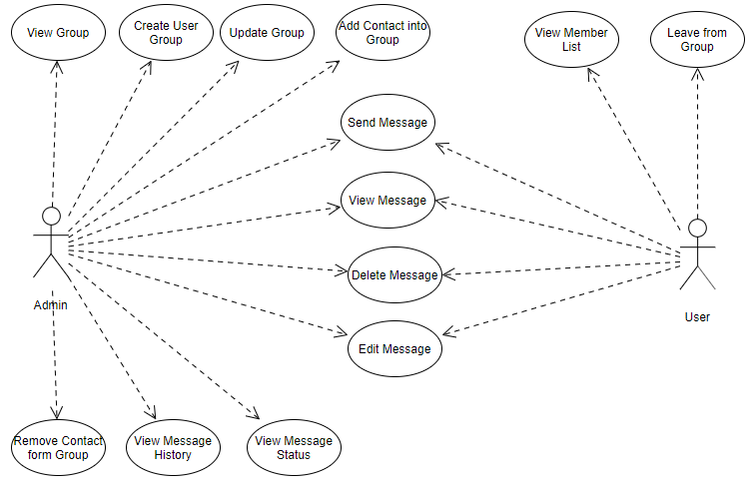

**Create User Group**

|  |  |
| --- | --- |
| Action Name | Create User Group |
| Actors | Admin |
| Use Case Diagram |  |
| Trigger | When admin wants to create user group. |
| Process Flow Diagram |  |
| https://documents.lucidchart.com/documents/a3962fd8-8b92-41e2-be3c-3a3ccf48fef2/pages/iMU-knxk0pS4?a=9993&x=-73&y=444&w=1496&h=418&store=1&accept=image%2F*&auth=LCA%20c5fee62a3c0a13ad9dc3b79f6ca0d0cab782d6b3-ts%3D1562476589 | |
| Brief Description | The process of create user group. |
| Initial Step-By-Step Description | Before this use case can be initiated, the user has already connected to the Online Monitoring Software Mobile App.     1. Assuming on successfully install Monitoring Software into the mobile. 2. Press Chat Icon and press Create Group or 3. User Press group tab. 4. Press Group Icon. 5. Select at least one contact for create group. 6. Press Next icon. 7. Type Group Name. 8. Press OK to create group. |
| Task Dependencies | Admin Login |
| Goal | To create user group. |
| Post Conditions | A new user group will be created. |
| Platform | Mobile Application |
| Proposed Module | Broadcast Message |
| User Interface | |

**View Group**

|  |  |
| --- | --- |
| Action Name | View Group |
| Actors | Admin |
| Use Case Diagram |  |
| Trigger | When admin wants to view group. |
| Process Flow Diagram |  |
| https://documents.lucidchart.com/documents/a3962fd8-8b92-41e2-be3c-3a3ccf48fef2/pages/Ekzs2.cgC7vM?a=10079&x=61&y=232&w=1297&h=186&store=1&accept=image%2F*&auth=LCA%20a182826ec650ece70405940393f1db3fae1d7f94-ts%3D1562476589 | |
| Brief Description | The process of view user group. |
| Initial Step-By-Step Description | Before this use case can be initiated, the user has already connected to the Online Monitoring Software Mobile App.     1. Assuming on successfully install Monitoring Software into the mobile. 2. User Press group tab. 3. Group will be view under the group tab. |
| Task Dependencies | Admin Login |
| Goal | To view group. |
| Post Conditions | User group information will be viewed. |
| Platform | Mobile Application |
| Proposed Module | Broadcast Message |
| User Interface | |

**Update Group**

|  |  |
| --- | --- |
| Action Name | Update Group |
| Actors | Admin |
| Use Case Diagram |  |
| Trigger | When admin wants to update group. |
| Process Flow Diagram |  |
| https://documents.lucidchart.com/documents/a3962fd8-8b92-41e2-be3c-3a3ccf48fef2/pages/oP.d3NDVeG~8?a=10248&x=-2&y=25&w=1767&h=420&store=1&accept=image%2F*&auth=LCA%20b89d7df119a3275a952a4840fbe5741d46556c64-ts%3D1562476589 | |
| Brief Description | The process of update user group. |
| Initial Step-By-Step Description | Before this use case can be initiated, the user has already connected to the Online Monitoring Software Mobile App.     1. Assuming on successfully install Monitoring Software into the mobile. 2. User Press Chat Icon. 3. Search / Select Group. 4. Update information. 5. Click Update. |
| Task Dependencies | Admin Login |
| Goal | To update group. |
| Post Conditions | User group information will be updated. |
| Platform | Mobile Application |
| Proposed Module | Broadcast Message |
| User Interface | |

**Add Contact into Group**

|  |  |
| --- | --- |
| Action Name | Add Contact into Group |
| Actors | Admin |
| Use Case Diagram |  |
| Trigger | When admin wants to Add Contact into Group. |
| Process Flow Diagram |  |
| https://documents.lucidchart.com/documents/a3962fd8-8b92-41e2-be3c-3a3ccf48fef2/pages/gN1wJrZxjvVE?a=10469&x=10&y=225&w=1456&h=176&store=1&accept=image%2F*&auth=LCA%206bc4f6202bf7db360760272019c338173d9b3512-ts%3D1562476589 | |
| Brief Description | The process of Add Contact into Group. |
| Initial Step-By-Step Description | Before this use case can be initiated, the user has already connected to the Online Monitoring Software Mobile App.     1. Assuming on successfully install Monitoring Software into the mobile. 2. User Press group tab 3. Select Group. 4. Press head of the group page 5. Press add people icon or press Add button 6. Select member for add into the group. 7. Click OK icon for add contact into the group. |
| Task Dependencies | Admin Login |
| Goal | To Add Contact into Group. |
| Post Conditions | Contact Added into Group. |
| Platform | Mobile Application |
| Proposed Module | Broadcast Message |
| User Interface | |

**Leave from Group**

|  |  |
| --- | --- |
| Action Name | Leave from Group |
| Actors | User |
| Use Case Diagram |  |
| Trigger | When user wants to leave from Group. |
| Process Flow Diagram |  |
| https://documents.lucidchart.com/documents/a3962fd8-8b92-41e2-be3c-3a3ccf48fef2/pages/Qe2wy7YX-9O0?a=10564&x=10&y=225&w=1454&h=176&store=1&accept=image%2F*&auth=LCA%20e5379236b7370c7af7f6d80abeefa49865d4dd7e-ts%3D1562476589 | |
| Brief Description | The process of leave form Group. |
| Initial Step-By-Step Description | Before this use case can be initiated, the user has already connected to the Online Monitoring Software Mobile App.     1. Assuming on successfully install Monitoring Software into the mobile. 2. User Press group tab 3. Select Group. Press icon form top-right side and select Exit Group. 4. User will be leave from the group. |
| Task Dependencies | User Login |
| Goal | To leave form group. |
| Post Conditions | User will be leaved form Group. |
| Platform | Mobile Application |
| Proposed Module | Broadcast Message |
| User Interface | |

**View Member List**

|  |  |
| --- | --- |
| Action Name | View Member List |
| Actors | User |
| Use Case Diagram |  |
| Trigger | When user wants to view group member. |
| Process Flow Diagram |  |
| https://documents.lucidchart.com/documents/a3962fd8-8b92-41e2-be3c-3a3ccf48fef2/pages/Ho2wvS_vw4XY?a=11070&x=-39&y=230&w=1568&h=187&store=1&accept=image%2F*&auth=LCA%2097a73896c75479d5a383e29a69f58551237ddb74-ts%3D1562476589 | |
| Brief Description | The process of view Group Members. |
| Initial Step-By-Step Description | Before this use case can be initiated, the user has already connected to the Online Monitoring Software Mobile App.     1. Assuming on successfully install Monitoring Software into the mobile. 2. User Press group tab. 3. Select Group. 4. Press head of the group page. 5. Member list will be viewed in the group information page. |
| Task Dependencies | User Login |
| Goal | To view group members. |
| Post Conditions | Group members will be viewed. |
| Platform | Mobile Application |
| Proposed Module | Broadcast Message |
| User Interface | |

**Send Message**

|  |  |
| --- | --- |
| Action Name | Send Message |
| Actors | User / Admin |
| Use Case Diagram |  |
| Trigger | When user / admin wants to send message. |
| Process Flow Diagram |  |
| https://documents.lucidchart.com/documents/a3962fd8-8b92-41e2-be3c-3a3ccf48fef2/pages/nG2w9utN2TYs?a=11054&x=-9&y=231&w=1509&h=187&store=1&accept=image%2F*&auth=LCA%202638659b9d8f58bde05d18773a6869fd024f3823-ts%3D1562476589 | |
| Brief Description | The process of send message. |
| Initial Step-By-Step Description | Before this use case can be initiated, the user has already connected to the Online Monitoring Software Mobile App.     1. Assuming on successfully install Monitoring Software into the mobile. 2. User Press group tab. 3. Select Group. 4. Type Message. 5. Press send icon for send message into the group. |
| Task Dependencies | User/ Admin Login |
| Goal | To send message. |
| Post Conditions | Message will be send. |
| Platform | Mobile Application |
| Proposed Module | Broadcast Message |
| User Interface | |

**View Message**

|  |  |
| --- | --- |
| Action Name | View Message |
| Actors | User / Admin |
| Use Case Diagram |  |
| Trigger | When user/ admin wants to view message. |
| Process Flow Diagram |  |
| https://documents.lucidchart.com/documents/a3962fd8-8b92-41e2-be3c-3a3ccf48fef2/pages/4O2wsqCVduDz?a=11037&x=4&y=231&w=1234&h=187&store=1&accept=image%2F*&auth=LCA%20c91629d35cd1c2891d9cdad1e2cc68b8c03c7c03-ts%3D1562476589 | |
| Brief Description | The process of view message. |
| Initial Step-By-Step Description | Before this use case can be initiated, the user has already connected to the Online Monitoring Software Mobile App.     1. Assuming on successfully install Monitoring Software into the mobile. 2. User Press group tab. 3. Select Group. 4. Message will be viewed into the message page. |
| Task Dependencies | User / admin Login |
| Goal | To view message. |
| Post Conditions | Message will be viewed. |
| Platform | Mobile Application |
| Proposed Module | Broadcast Message |
| User Interface | |

**View Message History**

|  |  |
| --- | --- |
| Action Name | View Message History |
| Actors | Admin |
| Use Case Diagram |  |
| Trigger | When admin wants view message history. |
| Process Flow Diagram |  |
| https://documents.lucidchart.com/documents/a3962fd8-8b92-41e2-be3c-3a3ccf48fef2/pages/459vmzmKDOqm?a=11425&x=20&y=225&w=1232&h=176&store=1&accept=image%2F*&auth=LCA%206a2daf8f91909eccc3ab6aa3485c6d5d49e824fc-ts%3D1562476589 | |
| Brief Description | The process of view message history. |
| Initial Step-By-Step Description | Before this use case can be initiated, the user has already connected to the Online Monitoring Software Mobile App.     1. Assuming on successfully install Monitoring Software into the mobile. 2. User Press group tab. 3. Select Group. 4. View Message. 5. Message history will be viewed for a period of time. |
| Task Dependencies | Admin Login |
| Goal | To view message history. |
| Post Conditions | Message will be viewed for a period of time. |
| Platform | Mobile Application |
| Proposed Module | Broadcast Message |
| User Interface | |

**Remove Contact form Group**

|  |  |
| --- | --- |
| Action Name | Remove Contact form Group |
| Actors | Admin |
| Use Case Diagram |  |
| Trigger | When admin wants remove Contact form Group. |
| Process Flow Diagram |  |
| https://documents.lucidchart.com/documents/a3962fd8-8b92-41e2-be3c-3a3ccf48fef2/pages/Y13wdhu8wg5O?a=11563&x=79&y=225&w=1342&h=176&store=1&accept=image%2F*&auth=LCA%2088839cf1fc865826d270d72e62e27341a2a6bbf5-ts%3D1562496356 | |
| Brief Description | The process of Remove Contact form Group. |
| Initial Step-By-Step Description | Before this use case can be initiated, the user has already connected to the Online Monitoring Software Mobile App.     1. Assuming on successfully install Monitoring Software into the mobile. 2. User Press group tab. 3. Select Group. 4. Press hold on specific contact. 5. Select remove from list 6. Contact will be removed from the list. |
| Task Dependencies | Admin Login |
| Goal | To Remove Contact form Group. |
| Post Conditions | Contact will be removed from group. |
| Platform | Mobile Application |
| Proposed Module | Broadcast Message |
| User Interface | |

**View Message Status**

|  |  |
| --- | --- |
| Action Name | View Message Status |
| Actors | Admin |
| Use Case Diagram |  |
| Trigger | When admin wants to View Message Status. |
| Process Flow Diagram |  |
| https://documents.lucidchart.com/documents/a3962fd8-8b92-41e2-be3c-3a3ccf48fef2/pages/n83wUsOa4lWS?a=11767&x=74&y=225&w=1612&h=176&store=1&accept=image%2F*&auth=LCA%20f3ffdf5345ae6a6bf60b66e4293aedc527c93fba-ts%3D1562496356 | |
| Brief Description | The process of View Message Status. |
| Initial Step-By-Step Description | Before this use case can be initiated, the user has already connected to the Online Monitoring Software Mobile App.     1. Assuming on successfully install Monitoring Software into the mobile. 2. User Press group tab. 3. Select Group. 4. View message 5. Message status will be shown besides the message. |
| Task Dependencies | Admin Login |
| Goal | To View Message Status. |
| Post Conditions | Message Status will be viewed. |
| Platform | Mobile Application |
| Proposed Module | Broadcast Message |
| User Interface | |

**Send Message**

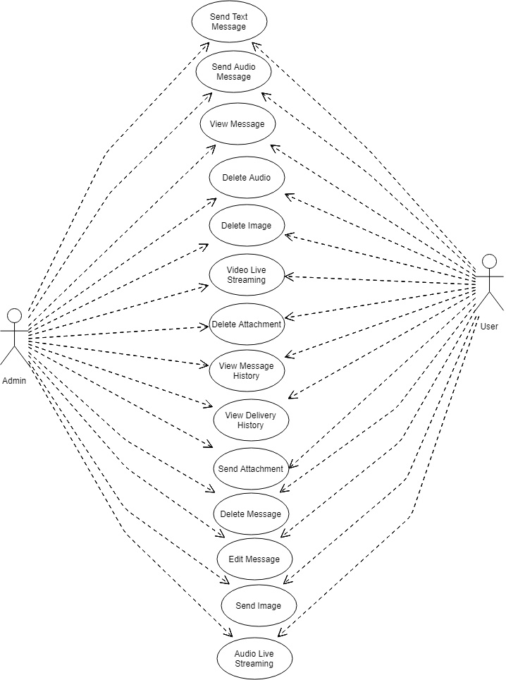

**Send Text Message**

|  |  |
| --- | --- |
| Action Name | Send Text Message |
| Actors | User / Admin |
| Use Case Diagram |  |
| Trigger | When user / admin wants to send text message. |
| Process Flow Diagram |  |
| https://documents.lucidchart.com/documents/a3962fd8-8b92-41e2-be3c-3a3ccf48fef2/pages/xe4wSdQO.O_t?a=11809&x=-9&y=231&w=1509&h=187&store=1&accept=image%2F*&auth=LCA%204f5682bd6bff38defe018b76d724ce235ac7931c-ts%3D1562496356 | |
| Brief Description | The process of send text message. |
| Initial Step-By-Step Description | Before this use case can be initiated, the user has already connected to the Online Monitoring Software Mobile App.     1. Assuming on successfully install Monitoring Software into the mobile. 2. User Press Chat Icon. 3. Select a Contact. 4. Type Message. 5. Press send icon for sending message. |
| Task Dependencies | User/ Admin Login |
| Goal | To send Text message. |
| Post Conditions | Text Message will be send. |
| Platform | Mobile Application |
| Proposed Module | Send Message |
| User Interface | |

**Send Audio Message**

|  |  |
| --- | --- |
| Action Name | Send Audio Message |
| Actors | User / Admin |
| Use Case Diagram |  |
| Trigger | When user / admin wants to send Audio message. |
| Process Flow Diagram |  |
| https://documents.lucidchart.com/documents/a3962fd8-8b92-41e2-be3c-3a3ccf48fef2/pages/yi4wXOmUI0VU?a=11858&x=-9&y=231&w=1509&h=187&store=1&accept=image%2F*&auth=LCA%20f3910addc25be44025946a555ca6bac0895506bd-ts%3D1562496356 | |
| Brief Description | The process of send audio message. |
| Initial Step-By-Step Description | Before this use case can be initiated, the user has already connected to the Online Monitoring Software Mobile App.     1. Assuming on successfully install Monitoring Software into the mobile. 2. User Press Chat Icon. 3. Select a Contact. 4. Press attachment icon. 5. Press audio message icon 6. Select audio message 7. Press send icon for send audio message. |
| Task Dependencies | User/ Admin Login |
| Goal | To send audio message. |
| Post Conditions | Audio Message will be send. |
| Platform | Mobile Application |
| Proposed Module | Send Message |
| User Interface | |

**View Message**

|  |  |
| --- | --- |
| Action Name | View Message |
| Actors | User / Admin |
| Use Case Diagram |  |
| Trigger | When user/ admin wants to view message. |
| Process Flow Diagram |  |
| https://documents.lucidchart.com/documents/a3962fd8-8b92-41e2-be3c-3a3ccf48fef2/pages/UE4wioaw~5SE?a=11893&x=4&y=231&w=1234&h=187&store=1&accept=image%2F*&auth=LCA%20a49e8171d647e864f676864e70252ad5c1a67fd7-ts%3D1562496356 | |
| Brief Description | The process of view message. |
| Initial Step-By-Step Description | Before this use case can be initiated, the user has already connected to the Online Monitoring Software Mobile App.     1. Assuming on successfully install Monitoring Software into the mobile. 2. User Press Chat Icon. 3. Select contact. 4. Specific Contact message will be viewed . |
| Task Dependencies | User / admin Login |
| Goal | To view message. |
| Post Conditions | Message will be viewed. |
| Platform | Mobile Application |
| Proposed Module | Send Message |
| User Interface | |

**Edit Message**

|  |  |
| --- | --- |
| Action Name | Edit Message |
| Actors | User / Admin |
| Use Case Diagram |  |
| Trigger | When user/ admin wants to edit message. |
| Process Flow Diagram |  |
| https://documents.lucidchart.com/documents/a3962fd8-8b92-41e2-be3c-3a3ccf48fef2/pages/BfzsMRCHPKez?a=11902&x=-34&y=210&w=1628&h=178&store=1&accept=image%2F*&auth=LCA%2010e8bcaacf2acac0fea734fa43fc09446aeec7ae-ts%3D1562496356 | |
| Brief Description | The process of edit message. |
| Initial Step-By-Step Description | Before this use case can be initiated, the user has already connected to the Online Monitoring Software Mobile App.     1. Assuming on successfully install Monitoring Software into the mobile. 2. User Press Chat Icon. 3. Select Contact. 4. Select Message. 5. Press edit icon. 6. Type updated message. 7. Press Send. |
| Task Dependencies | User/ Admin Login |
| Goal | To edit message. |
| Post Conditions | Message will be edited. |
| Platform | Mobile Application |
| Proposed Module | Send Message |
| User Interface | |

**Delete Message**

|  |  |
| --- | --- |
| Action Name | Delete Message |
| Actors | User / Admin |
| Use Case Diagram |  |
| Trigger | When user/ admin wants to delete message. |
| Process Flow Diagram |  |
| https://documents.lucidchart.com/documents/a3962fd8-8b92-41e2-be3c-3a3ccf48fef2/pages/Kp3wp.G9uC2y?a=11911&x=-23&y=210&w=1386&h=178&store=1&accept=image%2F*&auth=LCA%2005ea2db18d935c30be31003f30454499bb2e4047-ts%3D1562496356 | |
| Brief Description | The process of delete message. |
| Initial Step-By-Step Description | Before this use case can be initiated, the user has already connected to the Online Monitoring Software Mobile App.     1. Assuming on successfully install Monitoring Software into the mobile. 2. User Press Chat Icon. 3. Select Contact. 4. Select Message. 5. Press delete icon. 6. Message will be Deleted |
| Task Dependencies | User/ Admin Login |
| Goal | To delete message. |
| Post Conditions | Message will be deleted. |
| Platform | Mobile Application |
| Proposed Module | Send Message |
| User Interface | |

**Delete Audio**

|  |  |
| --- | --- |
| Action Name | Delete Audio |
| Actors | User / Admin |
| Use Case Diagram |  |
| Trigger | When user/ admin wants to delete Audio. |
| Process Flow Diagram |  |
| https://documents.lucidchart.com/documents/a3962fd8-8b92-41e2-be3c-3a3ccf48fef2/pages/IQ4wHmG5_~Xy?a=11960&x=-23&y=210&w=1386&h=178&store=1&accept=image%2F*&auth=LCA%200c1b2130edad1a9fedaecc7f77bb12a000f8b2d6-ts%3D1562496356 | |
| Brief Description | The process of delete Audio. |
| Initial Step-By-Step Description | Before this use case can be initiated, the user has already connected to the Online Monitoring Software Mobile App.     1. Assuming on successfully install Monitoring Software into the mobile. 2. User Press Chat Icon. 3. Select Contact. 4. Select the Audio. 5. Press delete icon. 6. Audio Message will be deleted. |
| Task Dependencies | User/ Admin Login |
| Goal | To delete audio message. |
| Post Conditions | Audio Message will be deleted. |
| Platform | Mobile Application |
| Proposed Module | Send Message |
| User Interface | |

**Send Image**

|  |  |
| --- | --- |
| Action Name | Send Image |
| Actors | User / Admin |
| Use Case Diagram |  |
| Trigger | When user / admin wants to send image. |
| Process Flow Diagram |  |
| https://documents.lucidchart.com/documents/a3962fd8-8b92-41e2-be3c-3a3ccf48fef2/pages/7V4wrJFRyKbp?a=12128&x=-9&y=210&w=1522&h=178&store=1&accept=image%2F*&auth=LCA%2069a956bb5d7599af2cc621c26fab5ec7f332c850-ts%3D1562496356 | |
| Brief Description | The process of send image. |
| Initial Step-By-Step Description | Before this use case can be initiated, the user has already connected to the Online Monitoring Software Mobile App.     1. Assuming on successfully install Monitoring Software into the mobile. 2. User Press Chat Icon. 3. Select a Contact. 4. Press Image Icon. 5. Select Image 6. Press send icon for sending image. |
| Task Dependencies | User/ Admin Login |
| Goal | To send image. |
| Post Conditions | Image will be send. |
| Platform | Mobile Application |
| Proposed Module | Send Message |
| User Interface | |

**Delete Image**

|  |  |
| --- | --- |
| Action Name | Delete Image |
| Actors | User / Admin |
| Use Case Diagram |  |
| Trigger | When user/ admin wants to delete image. |
| Process Flow Diagram |  |
| https://documents.lucidchart.com/documents/a3962fd8-8b92-41e2-be3c-3a3ccf48fef2/pages/714wPcdnnbKJ?a=12207&x=-23&y=210&w=1386&h=178&store=1&accept=image%2F*&auth=LCA%2014e4ffcf7867bd70b40e2082f7c7f0662f6f7676-ts%3D1562496356 | |
| Brief Description | The process of delete image. |
| Initial Step-By-Step Description | Before this use case can be initiated, the user has already connected to the Online Monitoring Software Mobile App.     1. Assuming on successfully install Monitoring Software into the mobile. 2. User Press Chat Icon. 3. Select Contact. 4. Select the image. 5. Press delete icon. 6. Image will be deleted. |
| Task Dependencies | User/ Admin Login |
| Goal | To delete image. |
| Post Conditions | Image will be deleted. |
| Platform | Mobile Application |
| Proposed Module | Send Message |
| User Interface | |

**Audio Live Streaming**

|  |  |
| --- | --- |
| Action Name | Audio Live Streaming |
| Actors | User / Admin |
| Use Case Diagram |  |
| Trigger | When user / admin wants to Audio Live Streaming. |
| Process Flow Diagram |  |
| https://documents.lucidchart.com/documents/a3962fd8-8b92-41e2-be3c-3a3ccf48fef2/pages/yi4wXOmUI0VU?a=12242&x=-8&y=231&w=1487&h=187&store=1&accept=image%2F*&auth=LCA%202177b01f3deee0e45fc4fa49d58d73d1eb086daa-ts%3D1562496356 | |
| Brief Description | The process of Audio Live Streaming. |
| Initial Step-By-Step Description | Before this use case can be initiated, the user has already connected to the Online Monitoring Software Mobile App.     1. Assuming on successfully install Monitoring Software into the mobile. 2. User Press Chat Icon. 3. Select a Contact. 4. Press Audio Call Icon. 5. Audio will be Recording and Sending. |
| Task Dependencies | User/ Admin Login |
| Goal | To Audio Live Streaming. |
| Post Conditions | Audio Live Streaming will be send. |
| Platform | Mobile Application |
| Proposed Module | Send Message |
| User Interface | |

**Video Live Streaming**

|  |  |
| --- | --- |
| Action Name | Video Live Streaming |
| Actors | User / Admin |
| Use Case Diagram |  |
| Trigger | When user / admin wants to Video Live Streaming. |
| Process Flow Diagram |  |
| https://documents.lucidchart.com/documents/a3962fd8-8b92-41e2-be3c-3a3ccf48fef2/pages/wc5wRw1ozSfx?a=12567&x=16&y=231&w=1413&h=187&store=1&accept=image%2F*&auth=LCA%2009569bbd0c61daf7a2c70e3275e4ad222dc3b794-ts%3D1562496356 | |
| Brief Description | The process of Video Live Streaming. |
| Initial Step-By-Step Description | Before this use case can be initiated, the user has already connected to the Online Monitoring Software Mobile App.     1. Assuming on successfully install Monitoring Software into the mobile. 2. User Press Chat Icon. 3. Select a Contact. 4. Press Video Call Icon. 5. Video will be Recording and Sending. |
| Task Dependencies | User/ Admin Login |
| Goal | To Video Live Streaming. |
| Post Conditions | Video Live Streaming will be send. |
| Platform | Mobile Application |
| Proposed Module | Send Message |
| User Interface | |

**Send Attachment**

|  |  |
| --- | --- |
| Action Name | Send Attachment |
| Actors | User / Admin |
| Use Case Diagram |  |
| Trigger | When user / admin wants to send Attachment and view these file using inline document viewer. |
| Process Flow Diagram |  |
| https://documents.lucidchart.com/documents/a3962fd8-8b92-41e2-be3c-3a3ccf48fef2/pages/ui5wusbzeSN_?a=12639&x=-9&y=210&w=1522&h=178&store=1&accept=image%2F*&auth=LCA%206659ee2abb789ea3aa046e81653c1c1f1f7b272b-ts%3D1562496356 | |
| Brief Description | The process of send Attachment and view these file using inline document viewer. |
| Initial Step-By-Step Description | Before this use case can be initiated, the user has already connected to the Online Monitoring Software Mobile App.     1. Assuming on successfully install Monitoring Software into the mobile. 2. User Press Chat Icon. 3. Select a Contact. 4. Press Attachment Icon. 5. Press file icon 6. Select word /PDF file 7. Upload file. 8. Press send icon for send file. Receiver can view these file in their supported mobile using inline document viewer. |
| Task Dependencies | User/ Admin Login |
| Goal | To send Attachment and view these file using inline document viewer. |
| Post Conditions | Attachment will be send. |
| Platform | Mobile Application |
| Proposed Module | Send Message |
| User Interface | |

**Delete Attachment**

|  |  |
| --- | --- |
| Action Name | Delete Attachment |
| Actors | User / Admin |
| Use Case Diagram |  |
| Trigger | When user/ admin wants to delete Attachment. |
| Process Flow Diagram |  |
| https://documents.lucidchart.com/documents/a3962fd8-8b92-41e2-be3c-3a3ccf48fef2/pages/el5whV7V3w.y?a=12687&x=-23&y=210&w=1386&h=178&store=1&accept=image%2F*&auth=LCA%20b50cde1bbd0c48214e76d92af3ed0aa3b0438b00-ts%3D1562496356 | |
| Brief Description | The process of delete Attachment. |
| Initial Step-By-Step Description | Before this use case can be initiated, the user has already connected to the Online Monitoring Software Mobile App.     1. Assuming on successfully install Monitoring Software into the mobile. 2. User Press Chat Icon. 3. Select Contact. 4. Select the Attachment. 5. Press delete icon. 6. Attachment will be deleted. |
| Task Dependencies | User/ Admin Login |
| Goal | To delete Attachment. |
| Post Conditions | Attachment will be deleted. |
| Platform | Mobile Application |
| Proposed Module | Send Message |
| User Interface | |

**View Message History**

|  |  |
| --- | --- |
| Action Name | View Message History |
| Actors | Admin, User |
| Use Case Diagram |  |
| Trigger | When Admin/ User wants view message history. |
| Process Flow Diagram |  |
| https://documents.lucidchart.com/documents/a3962fd8-8b92-41e2-be3c-3a3ccf48fef2/pages/459vmzmKDOqm?a=12706&x=20&y=225&w=1232&h=176&store=1&accept=image%2F*&auth=LCA%203681a4ced0f32efeb2da60f293979355e13958dc-ts%3D1562496356 | |
| Brief Description | The process of view message history. |
| Initial Step-By-Step Description | Before this use case can be initiated, the user has already connected to the Online Monitoring Software Mobile App.     1. Assuming on successfully install Monitoring Software into the mobile. 2. User Press Chat Icon. 3. Select a Contact. 4. View Message. 5. Message will be viewed besides the message for a period of time. |
| Task Dependencies | Admin/ User Login |
| Goal | To view message history. |
| Post Conditions | Message will be viewed for a period of time. |
| Platform | Mobile Application |
| Proposed Module | Send Message |
| User Interface | |

**View Delivery History**

|  |  |
| --- | --- |
| Action Name | View Delivery History |
| Actors | Admin/ User |
| Use Case Diagram |  |
| Trigger | When Admin/ User wants to View Delivery History. |
| Process Flow Diagram |  |
| https://documents.lucidchart.com/documents/a3962fd8-8b92-41e2-be3c-3a3ccf48fef2/pages/xv5wgyflHCcn?a=12846&x=56&y=225&w=1860&h=176&store=1&accept=image%2F*&auth=LCA%204346bd3c3869412b95c607aa594ef2c7d68e3e09-ts%3D1562496356 | |
| Brief Description | The process of View Delivery History. |
| Initial Step-By-Step Description | Before this use case can be initiated, the user has already connected to the Online Monitoring Software Mobile App.     1. Assuming on successfully install Monitoring Software into the mobile. 2. User Press Chat Icon. 3. Select a Contact. 4. Send a Message. 5. If message is delivered, 1 tick must appear next to the message. If Recipient reads the message, 2 ticks must appear next to the message. |
| Task Dependencies | Admin/ User Login |
| Goal | To View Delivery History. |
| Post Conditions | Delivery History will be viewed. |
| Platform | Mobile Application |
| Proposed Module | Send Message |
| User Interface | |

**Message Status**

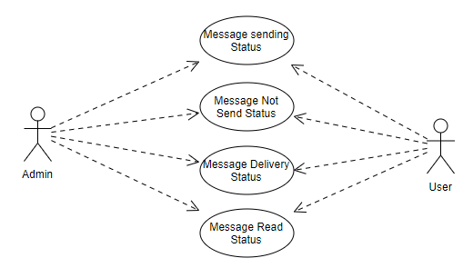

**Message sending Status**

|  |  |
| --- | --- |
| Action Name | Message sending Status |
| Actors | Admin/ User |
| Use Case Diagram |  |
| Trigger | When Admin/ User wants to View Message sending Status. |
| Process Flow Diagram |  |
| https://documents.lucidchart.com/documents/a3962fd8-8b92-41e2-be3c-3a3ccf48fef2/pages/eC5wv2Po.7g7?a=12950&x=67&y=209&w=1618&h=208&store=1&accept=image%2F*&auth=LCA%209ba7b58a10aa3dcf271a2eed1035cdfd3e393da4-ts%3D1562496356 | |
| Brief Description | The process of View Message sending Status. |
| Initial Step-By-Step Description | Before this use case can be initiated, the user has already connected to the Online Monitoring Software Mobile App.     1. Assuming on successfully install Monitoring Software into the mobile. 2. User Press Chat Icon. 3. Select a Contact/ a group. 4. Send a Message. 5. Sending must appear next to the message. |
| Task Dependencies | Admin/ User Login |
| Goal | To View Message sending Status. |
| Post Conditions | Message sending Status will be viewed. |
| Platform | Mobile Application |
| Proposed Module | Message Status |
| User Interface | |

**Message Not Send Status**

|  |  |
| --- | --- |
| Action Name | Message Not Send Status |
| Actors | Admin/ User |
| Use Case Diagram |  |
| Trigger | When Admin/ User wants to View Message Not Send Status. |
| Process Flow Diagram |  |
| https://documents.lucidchart.com/documents/a3962fd8-8b92-41e2-be3c-3a3ccf48fef2/pages/BH5wA1VzdLNV?a=13037&x=67&y=221&w=1618&h=184&store=1&accept=image%2F*&auth=LCA%2011215318f49a9c4f8792b13acce99219c0cfa6b3-ts%3D1562496356 | |
| Brief Description | The process of View Message Not Send Status. |
| Initial Step-By-Step Description | Before this use case can be initiated, the user has already connected to the Online Monitoring Software Mobile App.     1. Assuming on successfully install Monitoring Software into the mobile. 2. User Press Chat Icon. 3. Select a Contact/ a group. 4. Send a Message. 5. Not Sending warning Message must appear next to the message. |
| Task Dependencies | Admin/ User Login |
| Goal | To View Message Not Send Status. |
| Post Conditions | Message Not Send Status will be viewed. |
| Platform | Mobile Application |
| Proposed Module | Message Status |
| User Interface | |

**Message Delivery Status**

|  |  |
| --- | --- |
| Action Name | Message Delivery Status |
| Actors | Admin/ User |
| Use Case Diagram |  |
| Trigger | When Admin/ User wants to View Message Delivery Status. |
| Process Flow Diagram |  |
| https://documents.lucidchart.com/documents/a3962fd8-8b92-41e2-be3c-3a3ccf48fef2/pages/4L5wvQgQ1R60?a=13113&x=67&y=209&w=1618&h=208&store=1&accept=image%2F*&auth=LCA%2012a56618a89126ea711459ab137749cab5b54133-ts%3D1562496356 | |
| Brief Description | The process of View Message Delivery Status. |
| Initial Step-By-Step Description | Before this use case can be initiated, the user has already connected to the Online Monitoring Software Mobile App.     1. Assuming on successfully install Monitoring Software into the mobile. 2. User Press Chat Icon. 3. Select a Contact/ a group. 4. Send a Message. 5. 1 tick must appear next to the message. |
| Task Dependencies | Admin/ User Login |
| Goal | To View Message Delivery Status. |
| Post Conditions | Message Delivery Status will be viewed. |
| Platform | Mobile Application |
| Proposed Module | Message Status |
| User Interface | |

**Message Read Status**

|  |  |
| --- | --- |
| Action Name | Message Read Status |
| Actors | Admin/ User |
| Use Case Diagram |  |
| Trigger | When Admin/ User wants to View Message Read Status. |
| Process Flow Diagram |  |
| https://documents.lucidchart.com/documents/a3962fd8-8b92-41e2-be3c-3a3ccf48fef2/pages/4d6wGIxgJUFQ?a=13203&x=67&y=223&w=1618&h=180&store=1&accept=image%2F*&auth=LCA%2038de517966a686b26387486992a3e503b73b9d5a-ts%3D1562496356 | |
| Brief Description | The process of View Message Read Status. |
| Initial Step-By-Step Description | Before this use case can be initiated, the user has already connected to the Online Monitoring Software Mobile App.     1. Assuming on successfully install Monitoring Software into the mobile. 2. User Press Chat Icon. 3. Select a Contact/ a group. 4. Send a Message. 5. 2 ticks must appear next to the message. |
| Task Dependencies | Admin/ User Login |
| Goal | To View Message Read Status. |
| Post Conditions | Message Read Status will be viewed. |
| Platform | Mobile Application |
| Proposed Module | Message Status |
| User Interface | |

**Last Seen**

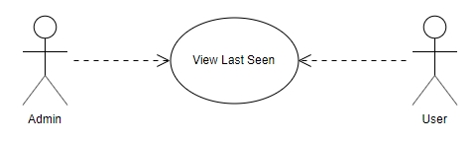

**View Last Seen**

|  |  |
| --- | --- |
| Action Name | View Last Seen |
| Actors | Admin/ User |
| Use Case Diagram |  |
| Trigger | When Admin/ User wants to View user when last seen the system. |
| Process Flow Diagram |  |
| https://documents.lucidchart.com/documents/a3962fd8-8b92-41e2-be3c-3a3ccf48fef2/pages/13~sU0f2Nav6?a=13332&x=26&y=236&w=1191&h=176&store=1&accept=image%2F*&auth=LCA%2056aec89412fb68105b75295408200341c61b29e2-ts%3D1562557289 | |
| Brief Description | The process of View user when last seen the system. |
| Initial Step-By-Step Description | Before this use case can be initiated, the user has already connected to the Online Monitoring Software Mobile App.     1. Assuming on successfully install Monitoring Software into the mobile. 2. User Press Chat Icon. 3. Select a Contact. 4. In below user name, User can see last seen time of the system. User can set up this status. |
| Task Dependencies | Admin/ User Login |
| Goal | To View user when last seen the system. |
| Post Conditions | User when last seen the system will be viewed. |
| Platform | Mobile Application |
| Proposed Module | Last Seen |
| User Interface | |

**Location Service**

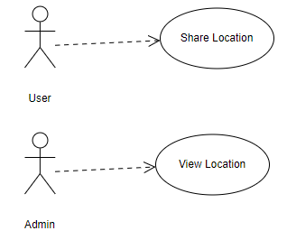

**Share Location**

|  |  |
| --- | --- |
| Action Name | Share Location |
| Actors | User |
| Use Case Diagram |  |
| Trigger | When User wants to Share Location. |
| Process Flow Diagram |  |
| https://documents.lucidchart.com/documents/a3962fd8-8b92-41e2-be3c-3a3ccf48fef2/pages/wWEfmD7GGG2d?a=13473&x=74&y=225&w=1346&h=176&store=1&accept=image%2F*&auth=LCA%206d220c239a2d7bf3c3f857111e5a478384da6cec-ts%3D1562557289 | |
| Brief Description | The process of Share Location. |
| Initial Step-By-Step Description | Before this use case can be initiated, the user has already connected to the Online Monitoring Software Mobile App.     1. Assuming on successfully install Monitoring Software into the mobile. 2. User Press Chat Icon. 3. Select a Contact. 4. Press Attachment icon 5. Press location icon. 6. Select Location. 7. Press Share Location. 8. Location will be shared. |
| Task Dependencies | User Login |
| Goal | To Share Location. |
| Post Conditions | Location will be shared. |
| Platform | Mobile Application |
| Proposed Module | Last Seen |
| User Interface | |

**View Location**

|  |  |
| --- | --- |
| Action Name | View Location |
| Actors | Admin |
| Use Case Diagram |  |
| Trigger | When Admin wants to View Location. |
| Process Flow Diagram |  |
| https://documents.lucidchart.com/documents/a3962fd8-8b92-41e2-be3c-3a3ccf48fef2/pages/Yxex-8bPOZ7d?a=13566&x=74&y=225&w=1346&h=176&store=1&accept=image%2F*&auth=LCA%20e1036c325e34a79d099ed3eb740c142597cb61b8-ts%3D1562557289 | |
| Brief Description | The process of View Location. |
| Initial Step-By-Step Description | Before this use case can be initiated, the user has already connected to the Online Monitoring Software Mobile App.     1. Assuming on successfully install Monitoring Software into the mobile. 2. User Press Chat Icon. 3. Select a Contact. 4. Admin user can be Select view location option. 5. Specific user location will be viewed. |
| Task Dependencies | Admin Login |
| Goal | To view Location. |
| Post Conditions | Last active location will be viewed. |
| Platform | Mobile Application |
| Proposed Module | Last Seen |
| User Interface | |

**Contacts**

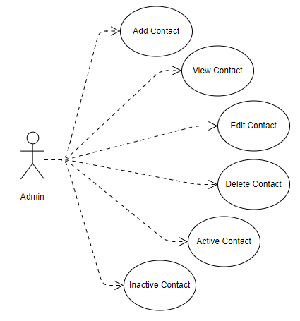

**Add Contact**

|  |  |
| --- | --- |
| Action Name | Add Contact |
| Actors | Admin |
| Use Case Diagram |  |
| Trigger | When an Admin wants to add contact into the system. |
| Process Flow Diagram |  |
| https://documents.lucidchart.com/documents/a3962fd8-8b92-41e2-be3c-3a3ccf48fef2/pages/t9NgX66ZvEFr?a=8239&x=8&y=214&w=1496&h=418&store=1&accept=image%2F*&auth=LCA%20c356ca8d9020fdf7bfba57833345b5504977a611-ts%3D1562234557 | |
| Brief Description | The process of adding contact. |
| Initial Step-By-Step Description | Before this use case can be initiated, the user has already connected to the Online Monitoring Software website and logged in successfully.     1. Assuming on successfully logging into Monitoring Software, User will be navigated to the system by default. 2. User wills Add Phone Number, Name and Designation. 3. Click “Add” or add contact into the contact list. |
| Task Dependencies | Admin Login |
| Goal | To add contact into the system. |
| Post Conditions | New Contact will be added. |
| Platform | Web Application |
| Proposed Module | Contact |
| User Interface | |

**View Contact List**

|  |  |
| --- | --- |
| Action Name | View Contact List |
| Actors | Admin |
| Use Case Diagram |  |
| Trigger | When an Admin wants to view contact list into the system. |
| Process Flow Diagram |  |
| https://documents.lucidchart.com/documents/a3962fd8-8b92-41e2-be3c-3a3ccf48fef2/pages/pFtkJxONj4lf?a=11084&x=-28&y=230&w=1326&h=186&store=1&accept=image%2F*&auth=LCA%20636c8786d06050a94a3f253f441354128e4e7144-ts%3D1562476589 | |
| Brief Description | The process of viewing contact list. |
| Initial Step-By-Step Description | Before this use case can be initiated, the user has already connected to the Online Monitoring Software website and logged in successfully.     1. Assuming on successfully logging into Monitoring Software, User will be navigated to the system by default. 2. User will click view contact List to view all contact. |
| Task Dependencies | Admin Login |
| Goal | To view contact List into the system. |
| Post Conditions | Contact list will be viewed. |
| Platform | Web Application |
| Proposed Module | Contact |
| User Interface | |

**Update Contact**

|  |  |
| --- | --- |
| Action Name | Update Contact |
| Actors | Admin |
| Use Case Diagram |  |
| Trigger | When an Admin wants to update contact into the system. |
| Process Flow Diagram |  |
| https://documents.lucidchart.com/documents/a3962fd8-8b92-41e2-be3c-3a3ccf48fef2/pages/xIDf.EY9brEb?a=8919&x=12&y=16&w=1503&h=615&store=1&accept=image%2F*&auth=LCA%209f570b051ab7b129883326fe90ed4b1ed102968a-ts%3D1562234557 | |
| Brief Description | The process of updating contact. |
| Initial Step-By-Step Description | Before this use case can be initiated, the user has already connected to the Online Monitoring Software website and logged in successfully.     1. Assuming on successfully logging into Monitoring Software, User will be navigated to the system by default. 2. User will view contact List. 3. User will select Specific Contact for update. 4. Click updates option. 5. Update contact information such as mobile number, designation etc . 6. Click Update for update the contact. |
| Task Dependencies | Admin Login |
| Goal | To update contact into the system. |
| Post Conditions | Contact will be updated. |
| Platform | Web Application |
| Proposed Module | Contact |
| User Interface | |

**Inactive Contact**

|  |  |
| --- | --- |
| Action Name | Inactive Contact |
| Actors | Admin |
| Use Case Diagram |  |
| Trigger | When an Admin wants to inactive contact into the system. |
| Process Flow Diagram |  |
| https://documents.lucidchart.com/documents/a3962fd8-8b92-41e2-be3c-3a3ccf48fef2/pages/pgFfH03D9MEu?a=8978&x=11&y=236&w=1490&h=176&store=1&accept=image%2F*&auth=LCA%208e83abe4c6bb4796885b34add108b30f8e8d7c09-ts%3D1562234557 | |
| Brief Description | The process of inactivation contact. |
| Initial Step-By-Step Description | Before this use case can be initiated, the user has already connected to the Online Monitoring Software website and logged in successfully.     1. Assuming on successfully logging into Monitoring Software, User will be navigated to the system by default. 2. User will view contact List. 3. User will select Specific Contact for inactivation. 4. Clicks inactivate option for inactive the contact. |
| Task Dependencies | Admin Login |
| Goal | To inactivate contact into the system. |
| Post Conditions | Contact will be inactivated. |
| Platform | Web Application |
| Proposed Module | Contact |
| User Interface | |

**Activate Contact**

|  |  |
| --- | --- |
| Action Name | Activate Contact |
| Actors | Admin |
| Use Case Diagram |  |
| Trigger | When an Admin wants to Activate contact into the system. |
| Process Flow Diagram |  |
| https://documents.lucidchart.com/documents/a3962fd8-8b92-41e2-be3c-3a3ccf48fef2/pages/KI-vc.yS_0.F?a=9181&x=7&y=236&w=1494&h=176&store=1&accept=image%2F*&auth=LCA%20c748c68194528c63068244961a2fd3429c885801-ts%3D1562234557 | |
| Brief Description | The process of Activation contact. |
| Initial Step-By-Step Description | Before this use case can be initiated, the user has already connected to the Online Monitoring Software website and logged in successfully.     1. Assuming on successfully logging into Monitoring Software, User will be navigated to the system by default. 2. User will view contact List. 3. User will select Specific Contact for activation. 4. Clicks activate option activate the contact. |
| Task Dependencies | Admin Login |
| Goal | To activate contact into the system. |
| Post Conditions | Contact will be activated. |
| Platform | Web Application |
| Proposed Module | Contact |
| User Interface | |

# Non Functional Requirements/ Software Attributes

1. **Scalability**

IM should be able to provide instant messaging services to 1 billion users at any given time.

1. **Privacy**

Messages shared between users should be encrypted to maintain privacy.

1. **Robustness**

In case user’s device crashes, a backup of their chat history must be stored on remote database servers to enable recoverability.

1. **Performance**

Application must be lightweight and must send messages instantly.

# 5. Monitoring Strategy

Project coordinator will update the Project Manager and all other Stakeholder through schedule meeting and emails on starting and ending of each phase mentioned in the work schedule.

To ensure the implementation of project in time with quality, the Project Manager will monitor all activities of the projects closely so that all the module/tasks of the project are completed properly in time. We will prepare an extensive project monitoring and evaluation plan and distribute the monitoring responsibility to designated person with a predefined schedule so that monitoring and evaluation processes are accomplished without any fail.

# Risk Management

Risk management describes strategies and methods used to identify and avoid risks throughout the life cycle of the project. All kinds of risks are identified here, most common risk factors that has been the main cause of a project failure are mentioned below:

* Personnel shortfalls
* Unrealistic schedules
* Developing the wrong functions and properties
* Developing the wrong user interface
* Gold plating (adding more functionality/features than is unnecessary)
* Continuing stream of requirements changes
* Shortfalls in externally furnished components
* Shortfalls in externally performed tasks
* Real-time performance shortfalls

These are the major risk factor that is associated with the nature of the work done or the client and the target environment, risks within the project and the team environment and finally technical risks involved with the system or other aspects of the technology of the software. To prevent this type of common risks we have been monitoring all our projects very closely.

# 7 Change Management Process

Requirement change management process defines the set of activities that need to be performed when there are some new requirements or changes to existing requirements (we will call both of these as changes in the requirements). Requirement changes can occur at any point during the project execution stage. The basic goal of requirement change management process is to control requirement changes and minimize the impact of changes on the project. This involves understanding the full impact of a requirement change request, as well as the cumulative impact of changes, on the project. It also requires making the customer fully aware of the impact of the changes on the project so that changes in the negotiated terms can be done amicably. The requirements change management process, in a sense, tries to ensure that a project succeeds despite requirement changes.

There will be two aspects to requirements change management – agreement with the customer about how the changes will be dealt with, and the process of actually making the changes. The overall approach for handling changes will be agreed by DMP and SoftBD Ltd, and is frequently a part of the proposal as well as the project management plan. Generally, this specifies how the change requests will be made, when formal approvals are needed, building a buffer in the estimates for handling changes etc. In the context of the overall approach, when a request for a requirement change comes in, the requirements change management process has to be executed. The project team leader/manager is primarily responsible for executing the process to incorporate the change in the project. However, DMP and the business manager to whom the project leader reports, and the development team will also participate in this process. The entry criterion for this process is that a change request has been received, and the inputs are the change request and the work products that have already been produced in the project. The main outputs are the impact analysis report for the change request, revised project plan, and changed work products, and the exit criterion is that the change has been incorporated.

The major steps in the process are:

1. Log changes
2. Perform impact analysis on the work products
3. Estimate effort needed for this change requests
4. Re-estimate delivery schedule
5. Perform cumulative cost impact analysis
6. Review impact with senior management, if thresholds are exceeded
7. Obtain customer sign off
8. Rework work products

A change request log will be maintained to keep track of the change requests. Each entry in the log contains a change request number, a brief description of the change, the impact of the change, the status of the change request and key dates. The effect of a change request is assessed by performing impact analysis. Impact analysis involves identifying work products that need to be changed, and evaluating the quantum of change to each; reassessing the project‘s risks by revisiting the risk management plan; and evaluating the overall impact of the changes on the effort and schedule estimates. The outcome of the analysis is reviewed and approved by the project leader and DMP. The change request itself is incorporated in the requirement specification document, usually as appendices. Sometimes the relevant portions of the document may also be modified to reflect the changes. Monitoring of approved change requests and ensuring proper implementation of change request is handled by the configuration management process.

We will keep note of the change management during the entire project phase and update the SRS as and when necessary. We will assure delivery of the project in timeliness by tracking the change management and monitoring the project closely and prepare further work schedule whenever there is a change.