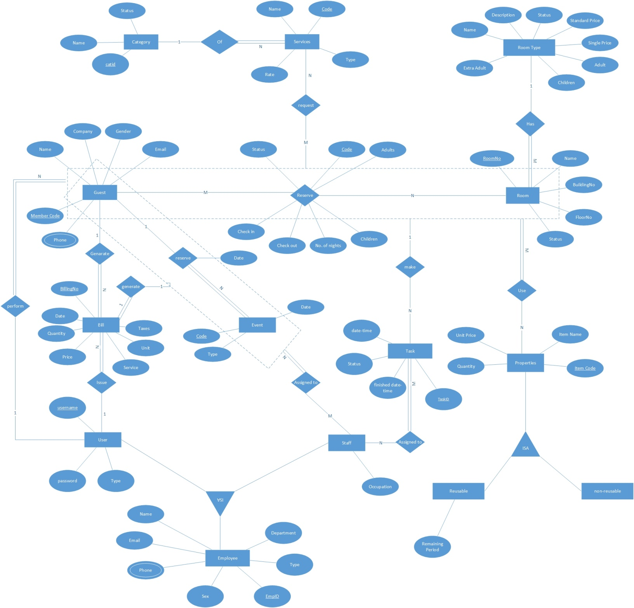**E R Diagram**

**Use Case Diagram**

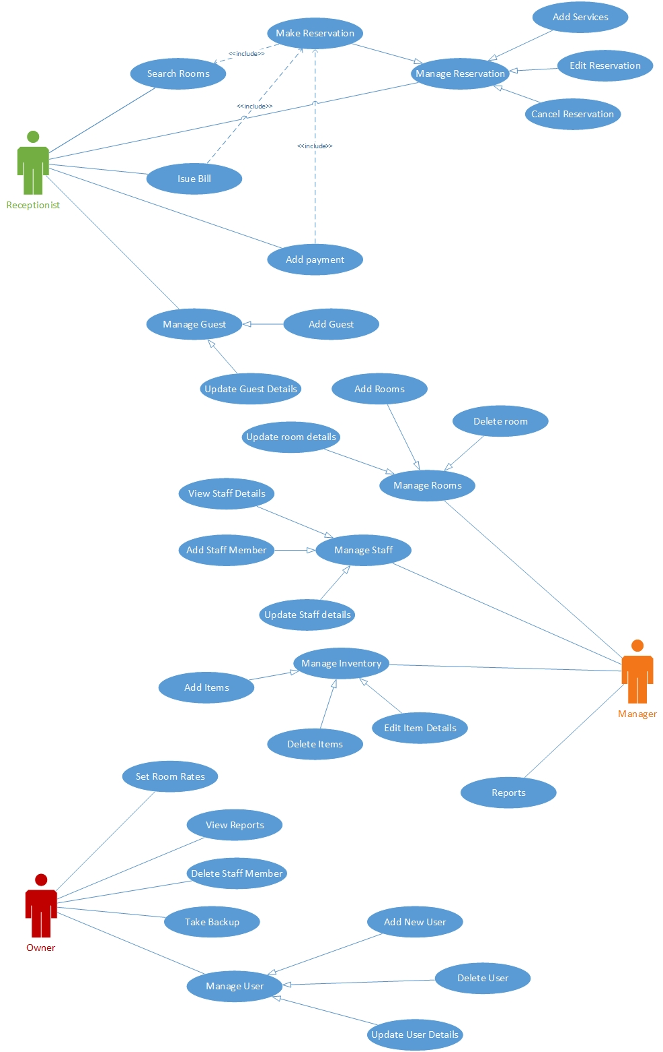 **Find Dev** is a creative network where user can share projects, message other developers, rate other’s work and search other developers.

This document describes in substantial detail, the software requirements of Find Dev, which is a creative network. This document will describe the features of the project. This document is intended for the stakeholders of the application, to assist in the development process of IM as well as to serve a reference to clarify any future issues that the stakeholders may run into.

Purpose

The purpose if this Software Requirement Specification (SRS) is:

• To gain agreement with stakeholders and Project Implementation Unit (PIU).

• To describe what the development of The Procurement of Goods Monitoring Software will look like for a business perspective and IT perspective. This document will also describe how the system will work and how each functionality will behave.

• To provide IT specialist the information needed to develop the Procurement of Goods Monitoring Software for system designing and developing the application.

Scope of Work

1. User Registration
2. Add new Projects
3. Send message
4. User profile

**Audience:**

The audience for this document includes anyone seeking an understanding for how to share his/her projects online and connect with developers around the world.