Simplebank.sol

contract SimpleBank {

// Mapping to store balance of each user
mapping(address => uint256) public balances;

// Address of contract owner
address public owner;

constructor() {
owner = msg.sender; // owner = account who deployed contract
}

// Deposit money into your own wallet
function deposit() public payable {
require(msg.value > 0, "Deposit amount must be greater than 0");
balances[msg.sender] += msg.value;
}

// Withdraw money from your wallet
function withdraw(uint256 amount) public {
require(balances[msg.sender] >= amount, "Insufficient balance");

// Update balance BEFORE transfer
balances[msg.sender] -= amount;

// Transfer ETH to user
payable(msg.sender).transfer(amount);
}

// Check your balance
function getBalance() public view returns (uint256) {
return balances[msg.sender];
}

// Only owner can check total contract balance
function getContractBalance() public view returns (uint256) {
require(msg.sender == owner, "Only owner can check this");
return address(this).balance;
}
}

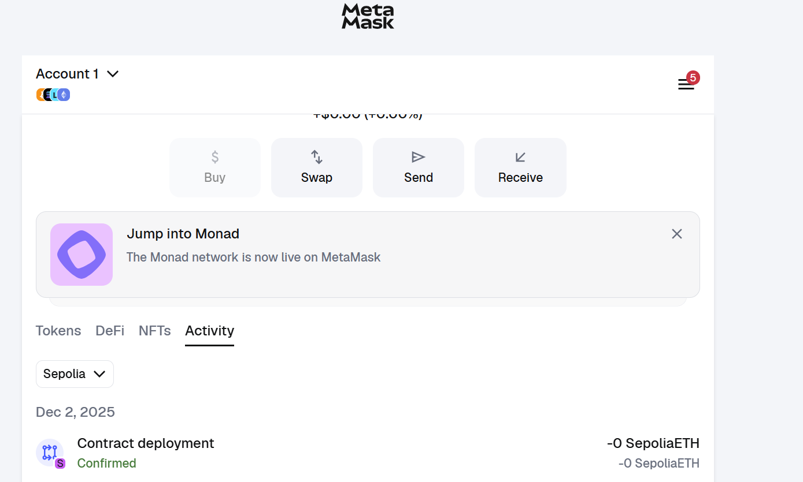

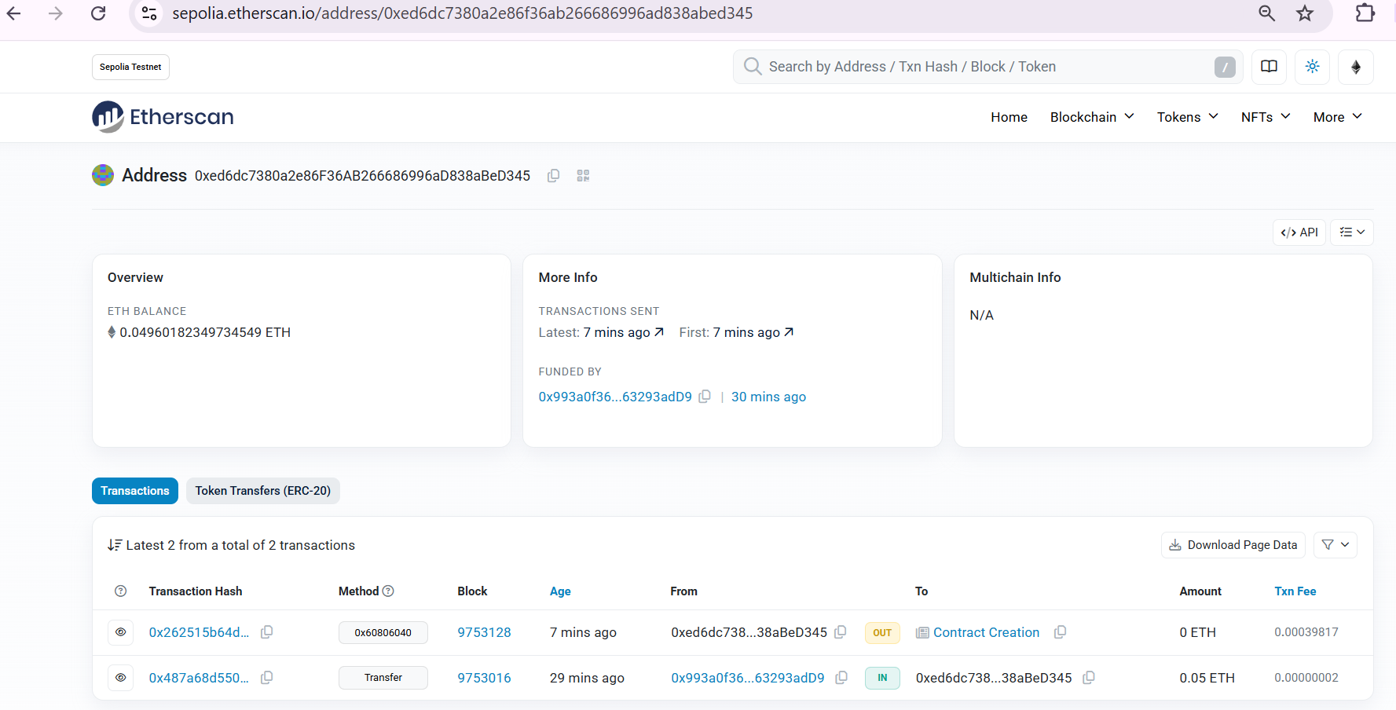

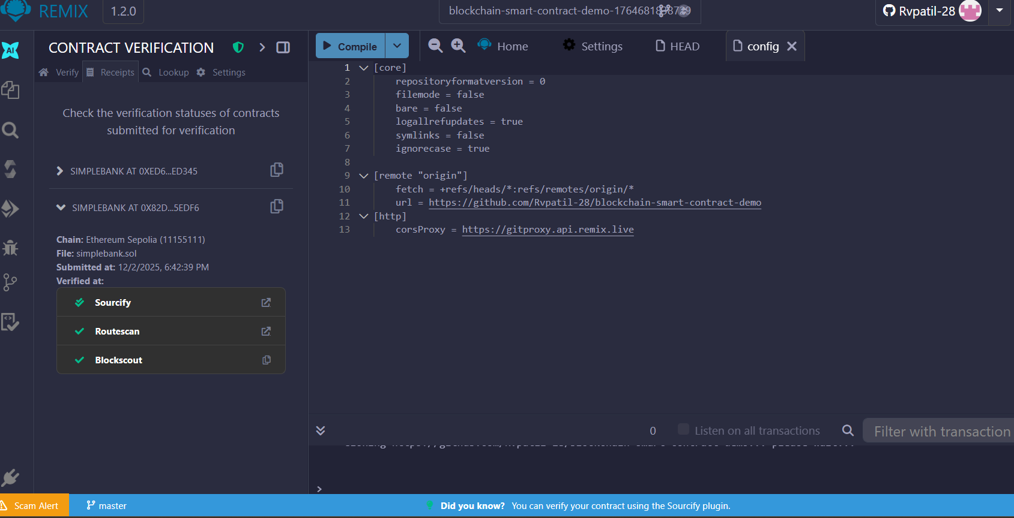

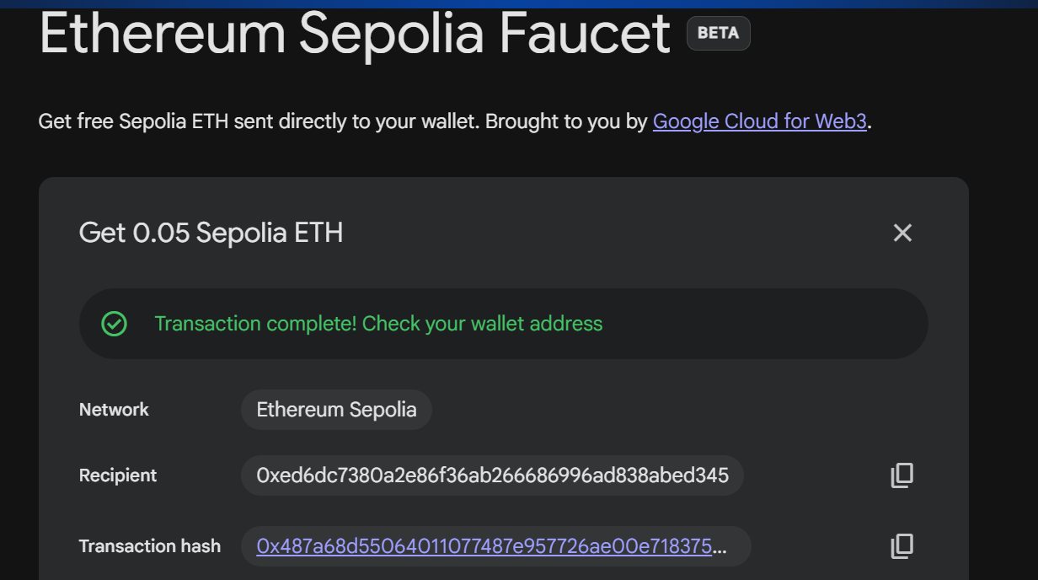

https://remix.ethereum.org/#

https://sepolia.etherscan.io/address/0xed6dc7380a2e86f36ab266686996ad838abed345

