MedAI: a Retrieval Augmented Generation Framework
1st Satya Deekshita Valavala
U01111339
2nd Veda Sai Preethi Radarapu
U01125565
3rd Charitha Ravuru
U01106375
Abstract:
In general any Language Model only based medical question answering systems have been shown to hallucinate and provide unreliable answers because they do not have access to domain-specific evidence when generating answers. In this project, we are introducing MedAI, a framework for evidence-based medical question answering by Retrieval-Augmented Generation (RAG). MedAI integrates the semantic retrieval with vector embeddings and generation powered by a Large Language Model to answer medical questions with retrieved context as evidence. We have used the datasets such as MedQuAD and PubMedQA consisting of around 200k medical questions, answers, and biomedical passages. Sentence-transformer embeddings along with FAISS vector similarity search and OpenAI language generation powers MedAI's response retrieval and generation. Results show that retrieval augmented answers contain more relevant information and less hallucinated answers when compared to generation-only based models.
Key words:
machine learning, retrieval augmented generation, medical question answering, large language model, embeddings, vector database, semantic search, healthcare AI, neural networks, dataset, evaluation.
Github Lin:
https://github.com/RvsPreethi/medai
Introduction:
Medical professionals and patients expect accurate and evidence-based responses from a Medical Question Answering system as incorrect medical advice can be decisive. Large Language Models are trained on internet-scale data which might not contain the latest medical findings, and might be missing domain-specific expertise. Additionally, generative models are not inherently explainable, and it is impossible to verify if the generated response was grounded on trusted medical literature.
In the recent years, AI has been applied successfully to various healthcare tasks like disease diagnosis and prediction, medical imaging understanding, clinical decision making, and virtual health assistants. One popular application of AI in healthcare is Medical Question Answering, as this empowers medical practitioners and patients to access medical knowledge quickly. Retrieval-Augmented Generation or RAG provides a solution to some of these limitations. Retrieval-Augmented Generation models first retrieve documents from a knowledge base and then provide them as context to the language model prior to generating an answer. This has been shown to increase factual correctness, reduce hallucinations and allow for easy ground-truthing of responses using the retrieved documents as evidence.
In our Retrieval-Augmented Medical Question Answering System the system leverages trusted biomedical datasets to return evidence-based healthcare responses. MedAI combines Semantic Embedding Models, FAISS Vector Similarity Search, and OpenAI’s language models to ground medical answers in trusted data. MedQuAD and PubMedQA datasets were used which consist of around 200k medical questions, answers, and clinical context.
Related Work:
Retrieval-Augmented Generation (RAG) based answer retrieng models have been explored on open domain datasets where models are trained on internet crawl data. Such general-purpose models can answer questions conversationally and exhibit strong language understanding. However, using these as a whole pretrained models can lead to unreliability for usecases that are sensitive in our current domain such as healthcare related conversations. Past QA generation models tend to answer questions with freely generated text that is not necessarily medically grounded. These models risk producing hallucinated answers, misleading information or even medically inaccurate advice. Therefore, such models lack trustworthiness for providing medical advice or support. These issues motivate our need for a medical question answering (QA) system with a constrained scope rather than an open generative model.

There should always be a boundary that an AI can help. As at the certain extent a professional is more useful than the AI for diagnosing or providing accurate information. Hence we used such features in our application. The dataset MedQA and PubMedQA will help in curating such answers and ghelp the patient to a certain extend by avoiding false results. In this paper, we present a domain specific medical AI assistant which we train and test on the biomedical datasets MedQA and PubMedQA. Our model retrieves evidence prior to generating an answer to a question. We want to ensure AI only provides users with support within a safe operating scope. Our model is not a substitute for a real medical professional who should be consulted for diagnosis, treatment, and other decisions. We hope to allow patients to gain helpful information about their questions, to a limited extent.
We used lightweight embedding models, FAISS based vector retrieval, and OpenAI’s language generation into a scalable and efficient healthcare assistant system.
Methodology:
The first step in our developed system is including preprocessing of MedQuAD and PubMedQA dataset. We modified all the data in both the datasets into a JSON array comprising of medical question, answer and source as well as context medical text. We also removed out duplicate and incomplete records during preprocessing. These records are now transformed into text chunks that will be used for semantic retrieval. Then these records will form the knowledge base for our implementation system. These datasets contain medical symptoms/treatments/causes/biomedical explanations which makes them a trusted source of context for medical question answering tasks.
The preprocessed data from the earlier data is then sed to generate semantic embeddings using the SentenceTransformer model called all-MiniLM-L6-v2. Now we index these embeddings using facebook AI similarity search (FAISS). When a medical question is asked by the user, the query is passed through the embedder to convert it into an embedding. This embedding is then used to search through the entire vector database from our index file to retrieve the top K medical documents. These nearest medical neighbors are ranked by similarity scores and passed on to the LM as evidence.
For answer generation, we integrated OpenAI Large language Model into our RAG pipeline. WWhen we pass the retrieved medical text as well as the users question to the model using a prompt. Using the input passed to it, the LLM will generate a related medical answer that takes the evidence into account. We use other instructions in the prompt to limit the output to only the information in the evidence and prevent hallucinations. We then append a disclaimer to note that the generated response should not be taken as legitimate medical advice.
Retrieved context is passed to GPT-4.1-mini to generate evidence-based medical answers. The retrieval and generation pipeline has temperature set at 0.2 to yield more deterministic answers and limit hallucinations. Experiments were run on a Windows workstation with Python 3.11. GPUs were used if available to speed up embedding creation/inference.
Lastly, we built a Streamlit dashboard for visualization and qualitative analysis of our results. We showcased the dataset statisticss, retrieval score plots, samples of retrieved medical documents. Inference from this app can allow us to better visualize the behavior of our system. The entire MedAI pipeline includes the following stages:
- Semantic Retrieval,
- Vector Database,
- Embedding generation,
- Generative AI

Experimental Setup:
In this project, we have used two public biomedical question answering datasets were used which are, MedQuAD and PubMedQA. Each dataset was chosen based on reliable healthcare information and popularity throughout medical NLP fields.
MedQuAD is a mixture of medical question and answer pairs obtained through many healthcare companies and organizations such as the National Institutes of Health. Questions within this dataset ranged from inquiries about symptoms to diseases, treatment, diagnosis, prevention, and medical conditions. PubMedQA is a biomedical research question answering dataset created through PubMed abstracts and scientific literature. Questions within this dataset focused on evidence-based biomedical reasoning and clinical research oriented inquiries.
After preprocessing both the datasets into a single schema which is consisting of question, answer, context, source, and focus fields of data; duplicates and partial entries were dropped. All text data was cleaned before the data is sent to generating semantic embeddings. Overall both datasets contained around 200,000 medical inquiries and document retrieval data we used for retrieval as well as evaluation of our system.
TABLE I. Summary of Datasets
Dataset | Train | Domain | Data Type
MedQuAD | 47,000 approx | Medical QA | Question & Answer Pairs
PubMedQA | 150,000 approx | Healthcare and Bio medical | Retrieval Corpus

Retrieval-based and qualitative performance metrics were used to benchmark the Retrieval-Augmented Generation pipeline of our proposed MedAI framework. Because retrieved medical evidence contributes directly to the final output generation, performance metrics such as top-1 accuracy and recall of K documents were calculated. Mean Reciprocal Rank (MRR) was also calculated based on ranked retrieval results to determine the quality of retrieval. Generated responses were qualitatively analyzed to determine context relevance, and reductions in hallucinated information. Generated outputs are then compared against the reference medical answers to determine how well the retrieved evidence allowed the underlying GPT-4.1-mini model to create medically-grounded healthcare responses.
Results:
We observe that the combined medical corpus is over 227K records sourced from MedQuAD and PubMedQA datasets. We an also see that PubMedQA contains most of the data coming to biomedical research-focused entries. On the other hand, MedQuAD consists of formatted medical Q&A pairs coming from reliable healthcare websites. We see that the dataset represents questions from a high number of medical fields such as cancer, cardiovascualr diseases, neurological disorders, biomedical research etc. These visuals help us understand that the knowledge base from which we retrieve information during semantic search covers enough ground to answer a variety of user questions about healthcare. Sample record inspection. We can also interactively inspect sample records from our dataset. This allows us to view medical questions, answers and metadata through the Streamlit dashboard.
We ran the evaluation on retrieval on 200 randomly chosen test questions. We achieved a Top-1 Accuracy of 0.935. This means that for the majority of test questions, which has the correct medical answer was able to be retrieved first from the dataset. We also have a Recall for 5 is of 0.995. This means that the correct evidence was able to be found within the top 5 documents retrieved for nearly all input questions. We can also see that the MRR score was 0.961 which demonstrates that relevant documents are ranked very highly by our FAISS retriever. These scores demonstrate that our embedding-based retrieval pipeline is quite effective at retrieving relevant medical context prior to generating an answer.
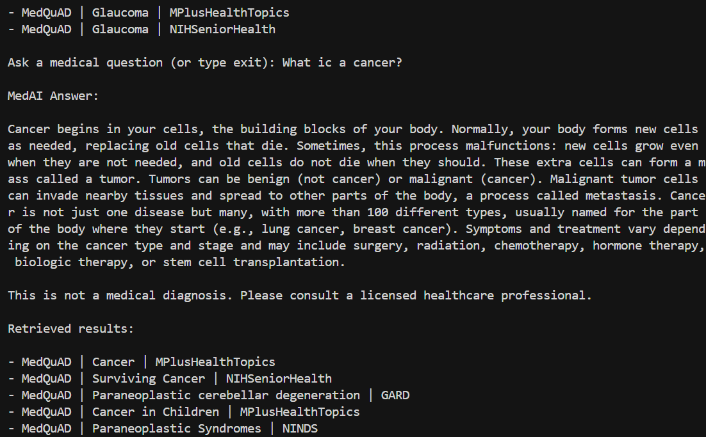

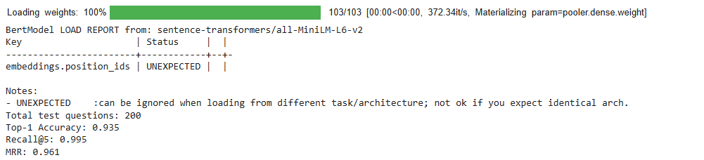

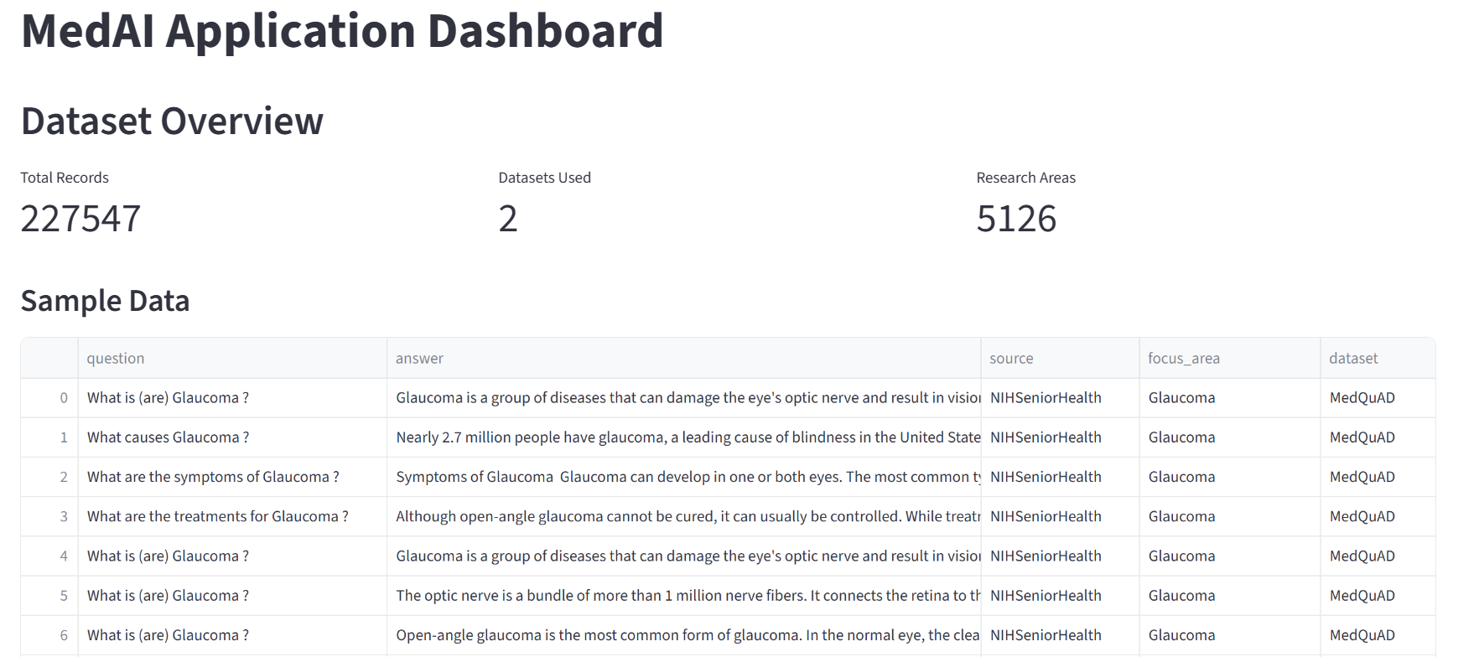

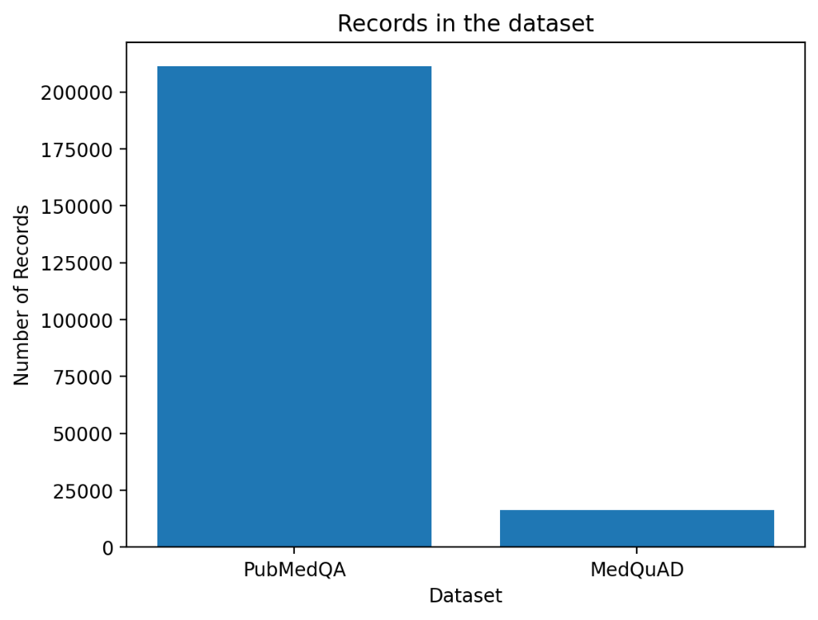
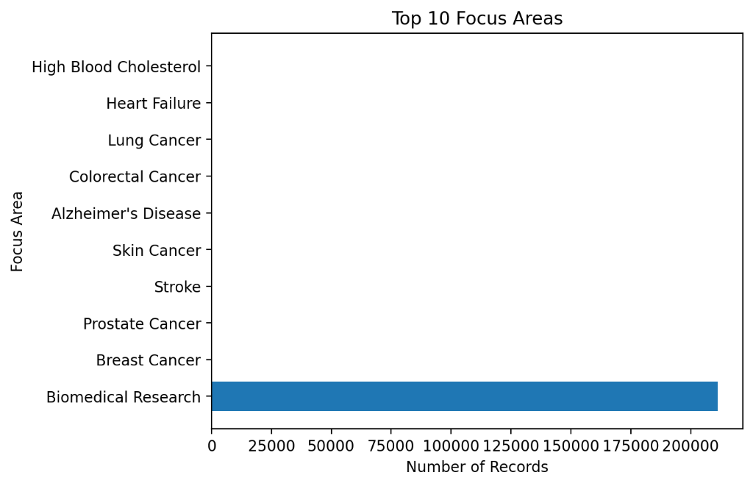

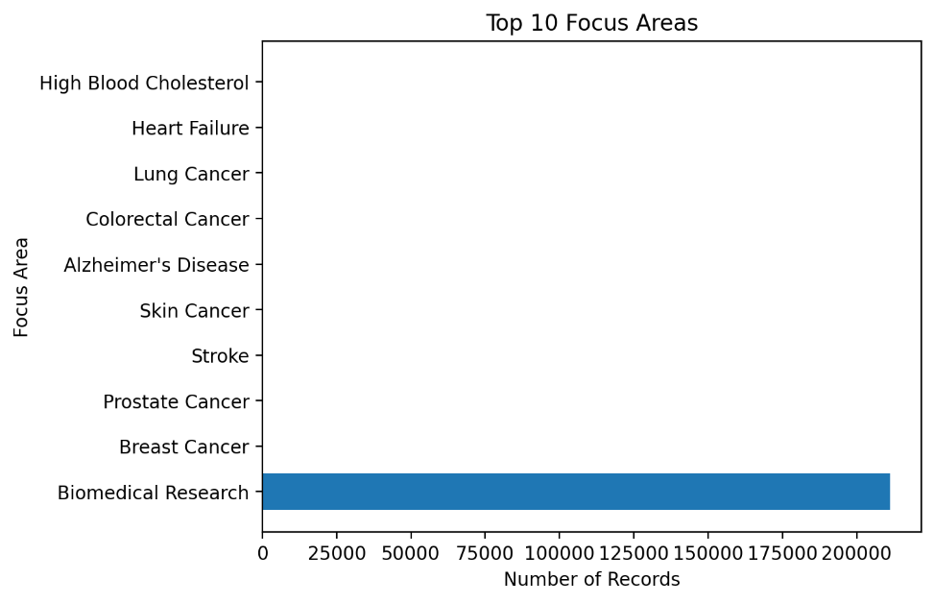

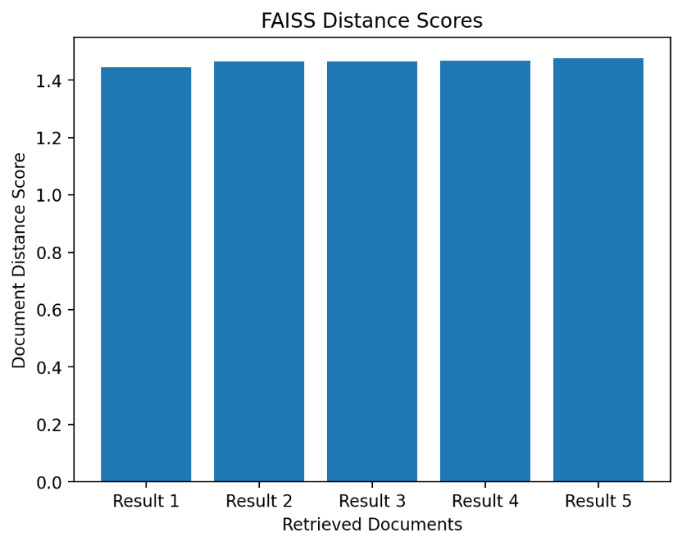
Conclusion:
In conclusion, we introduced MedAI, a Retrieval Augmented Generation Framework for Medical Question Answering to the research community. We implemented this MedAI using most reliable and trusted biomedical datasets, semantic embedding retrieval and similarity search powered by FAISS, and Large Language Models to power our evidence-based, contextual medical responses. We retrieved relevant medical evidence prior to answer generation to ensure robust responses and decrease the amount of hallucinated responses generated by naive generative AI frameworks alone. Our results from the experiment showed promising retrieval results with high Top-1 Accuracy, Recall@5, and Mean Reciprocal Rank showcasing our retrieval pipeline’s effectiveness. We also showcased the improved evaluation metrics with the development of our Streamlit dashboard with dataset analytics as well as retrieval bar plots. Finally, we can also say that MedAI can serve as an efficient and scalable healthcare assistant framework that can be extended in the future with larger-scale biomedical datasets, fine-tuned medical foundation models, multimodal healthcare inputs, and real-time integration of clinical knowledge.
Author Contributions:
1st Author (Satya Deekshita Valavala):
- collected and analyzed MedQuAD and PubMedQA datasets
- performed dataset preprocessing and data cleaning
- worked along with teammates in retrieval pipeline implementation
- conducted experimental evaluation and testing
2nd Author (Veda Sai Preethi Radarapu):
- designed RAG architecture
- implemented FAISS vector database and semantic retrieval pipeline
- integrated OpenAI Large Language Model response API
3rd (Charitha Ravuru):
Developed and implemented the streamlit api and also the metrics evaluation. Worked on the report for results and the implementation sections.

