**MATURI VENKATA SUBBA RAO (M.V.S.R) ENGINEERING COLLEGE**

**(An Autonomous Institution)**

Department of Information technology

TEXTXPERT

Team no:14

**TEAM DETAILS**

T VINEETHYA

2451-21-737-066

S NAVNEET KUMAR

2451-21-737-073

S LOKESH

2451-21-737-080

**DETAILS OF INTERNSHIP**

### **Name**: AICTE-Eduskills Academy

**Domain:** AI-ML

**Duration:** 3 months

# ABSTRACT

# There have been difficulties in information communication between the countries over the years. In modern times, language interpreters must understand and speak both the language that is being translated and translated to. Language translation plays a crucial role in bridging communication gaps across diverse linguistic communities. In this project, we to present a comprehensive text translator implemented using the Python programming language. The Text Translation project represents a comprehensive initiative aimed at addressing the challenges of multilingual communication through the development of an efficient and accurate text translation system. In this case study we work on this problem by developing a Graphical User Interface(GUI) and also with all the effectiveness of Python programming language. Our TranslateXpert will solve all the problems of multilingual communcation with accurate, easy and user-friendly translation.

**INTRODUCTION**

TextExpert project specializes in seamlessly translating messages from one language to another, facilitating effective communication across borders and cultures.

## PROBLEM STATEMENT

## TextXpert build bridges between languages , to effectively communicate between languages.This project helps in translating the text by automatically recognzing the sourcetext.It involves implementing a multi-step process such As User Input Processing, Learning and Adaptation, Response Generation,AIML Pattern Matching.

## EXISTING SYSTEM

In the existing system, we have google translator which utilizes internet connectivity wheras there are also many translators in which interface may not be proper.

## PROPOSED SYSTEM

## TextXpert build bridges between languages , to effectively communicate between languages.This project helps in translating the text by automatically recognzing the sourcetext.It involves implementing a multi-step process such As User Input Processing, Learning and Adaptation, Response Generation,AIML Pattern Matching.

## SCOPE

## Scope of our project describes it is user-friendly system for multilingual communication and includes natural language processing through AIML, adaptable translation for diverse languages, context-awareness, robust error handling, scalability for future expansion, and a seamless user interface. The project focuses on continuous learning and improvement, integration with various platforms, user customization, and security measures.

# SYSTEM REQUIREMENTS

## SOFTWARE REQUIRED:

## ➢ Operating System : Windows OS

## ➢ IDE : Any Python IDE

## ➢ Libraries used : googletrans,tkinter

## ➢ Technology : Python 3.10

## ➢ Translator package

## HARDWARE REQUIRED:

## ➢ Processor : Intel i3/i4/i5/i7➢ Hard disk : Any SSD➢ RAM:8GB

# SYSTEM ARCHITECTURE

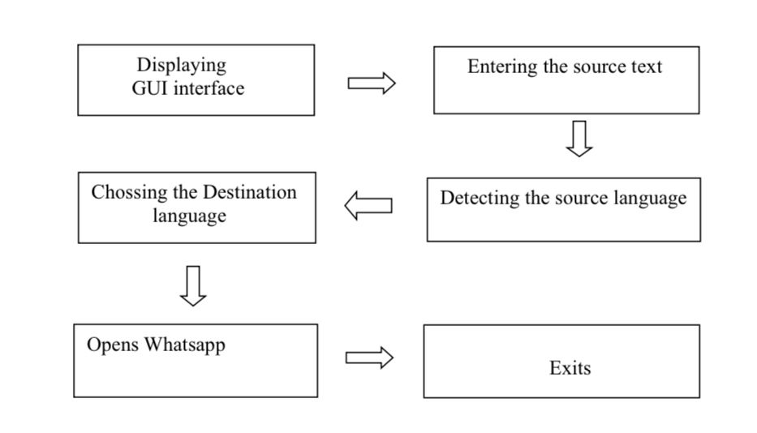

**DESIGN AND IMPLEMENTATION**

**Features:**

A translation is a process that involves the conversion of the text from one language to another. It has the following official features.

➢ Accuracy

➢ Natural

➢ Clarity

HOME PAGE

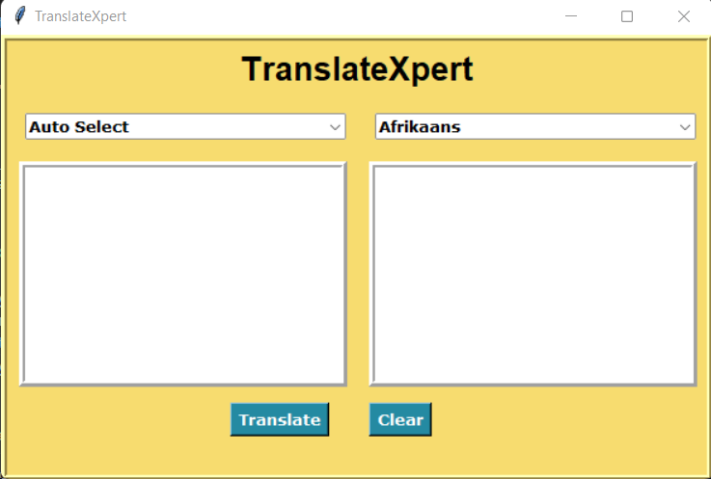

# CONCLUSION

Translation is an activity to convert a message or written statement into same message or statement in one language. The ability to translate texts from foreign language becomes important to the text and book translation that is needed because people have to get the information. The system achieves accurate and context-aware translations. The user-friendly interface, adaptability to new languages, and continuous learning mechanisms contribute to a dynamic and efficient translation experience. With a focus on security, user customization, and rigorous testing, the TextTranslator using AIML project stands as an intelligent, reliable, and comprehensive solution, paving the way for enhanced cross-cultural communication and understanding in a globalized world.