**DAY 2: PLANNING THE TECHNICAL FOUNDATION**

**"Marketplace Technical Foundation – Pak-Chair"**

* **Frontend Requirements**:
  + User-friendly interface for browsing products.
  + Responsive design for mobile and desktop users.
  + Essential pages: Home, Product Listing, Product Details, Cart, Checkout, and Order Confirmation.
* **Sanity CMS as Backend**:
  + Use Sanity CMS to manage product data, customer details, and order records.
  + Design schemas in Sanity to align with business goals.
* **Third-Party APIs**:
  + Integrate APIs for shipment tracking, payment gateways, and other backend services.
* **Design System Architecture**

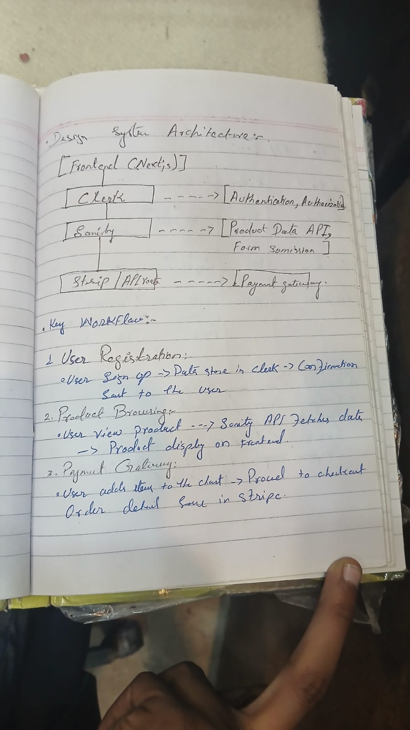

### ****Plan API Requirements:****

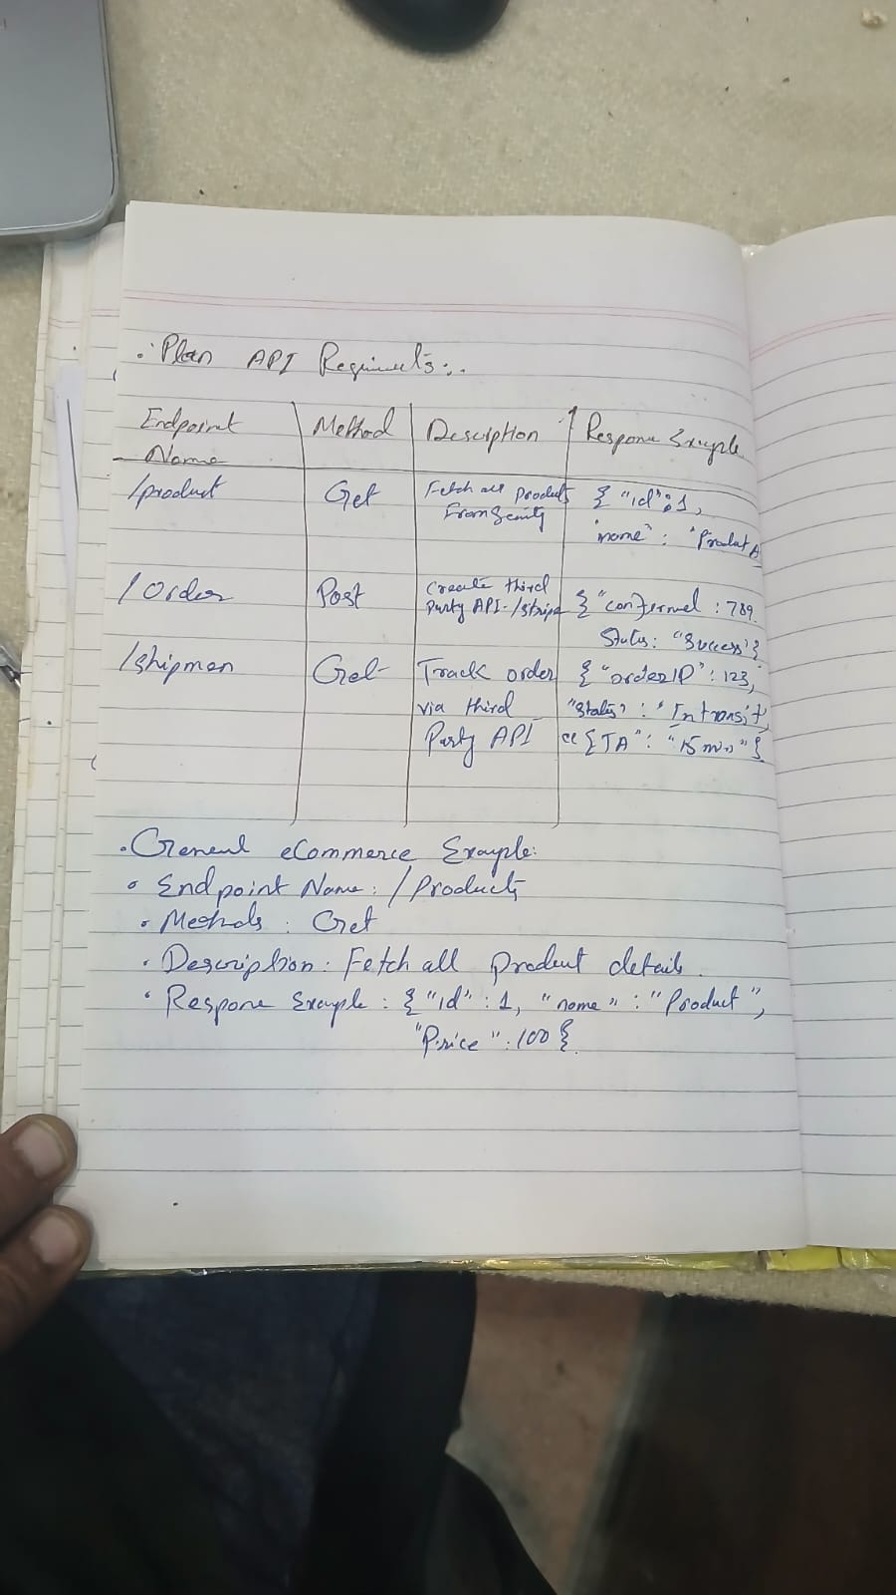

**Technical Documentation:**

User can visit website without account creation .For buy some thing user create account.User signin and account create in **Clerk.** All the prouduct detail,price,tag data coming from **sanity**. For payment gateway **stripe** isused and third party api use.Contact forms and post data save in **sanity**.