**Day:4**

**Functional Deliverables:**

**Steps for Implementation:**

**1.Setup:**

Nextjs installled and link with CMS Sanity.

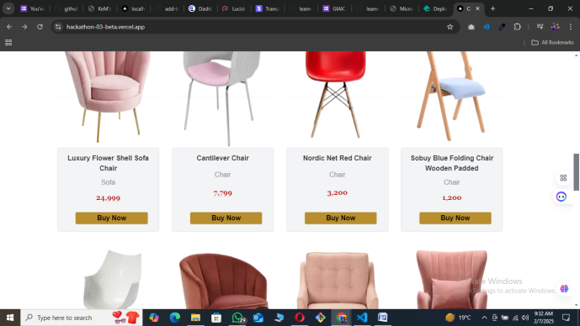

**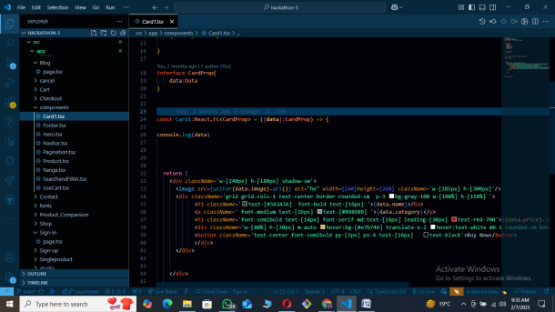  
2.component Building:**

Reuseable component are used with tailwind css.

**3.State Managemnt:**

useState,useEffect and localStorage are used in project.

**Key Component:**

* Product Card
* Product Listing
* Pagination
* Search and Filter

**Steps For development front end and backend:**

**Frontend:**

* Website with Homepage, ShopPage ,Blogpage, Contactpage Singleproductpage ,signin in page,Cart page and payment page.
* Nextjs and react used in Frontend.
* For styleing Tailwindcss is being using.

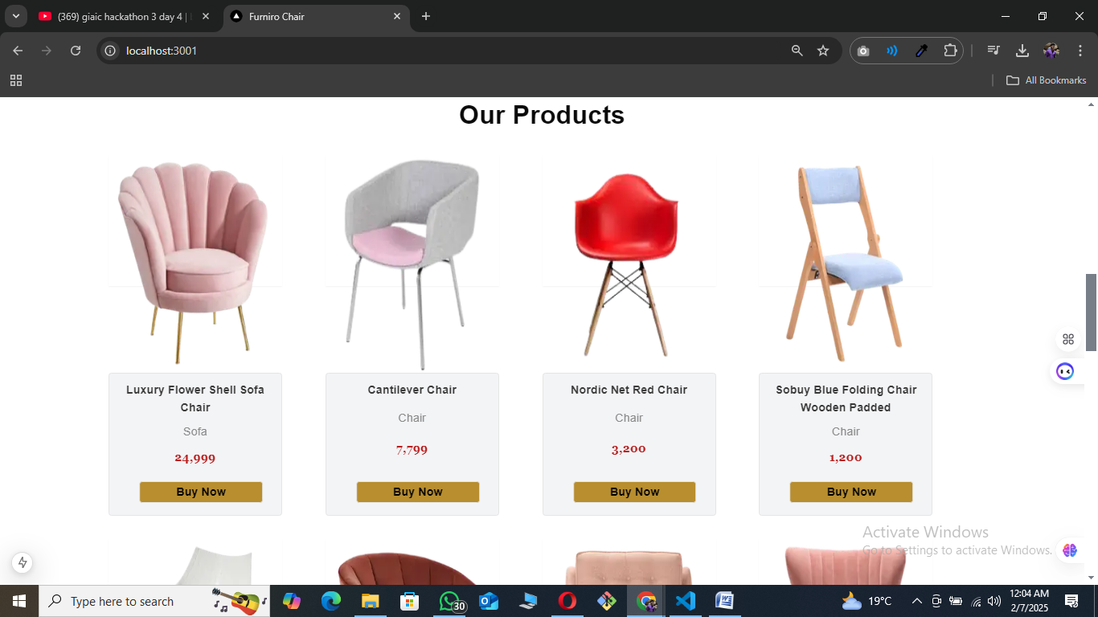

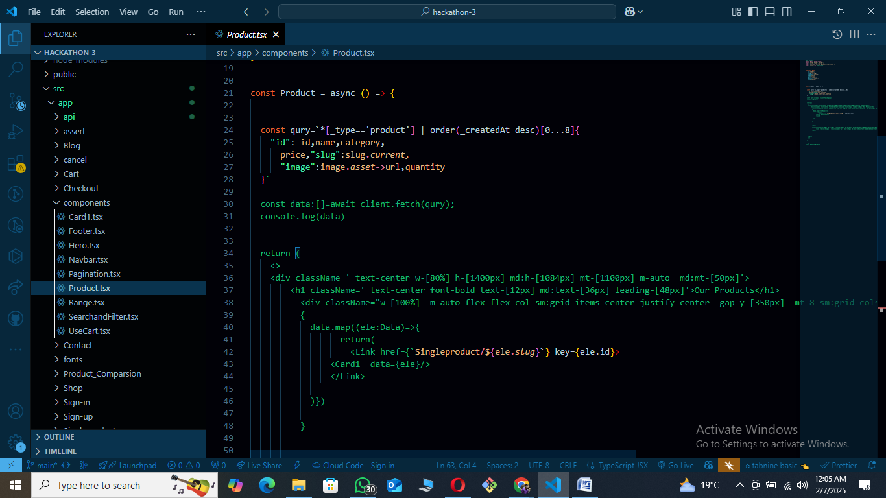

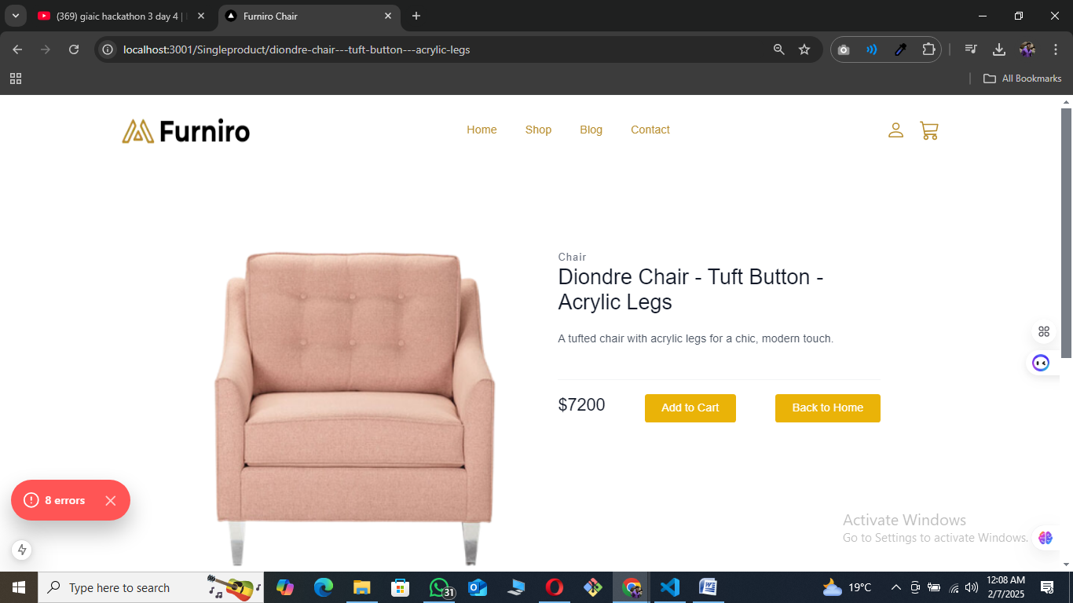

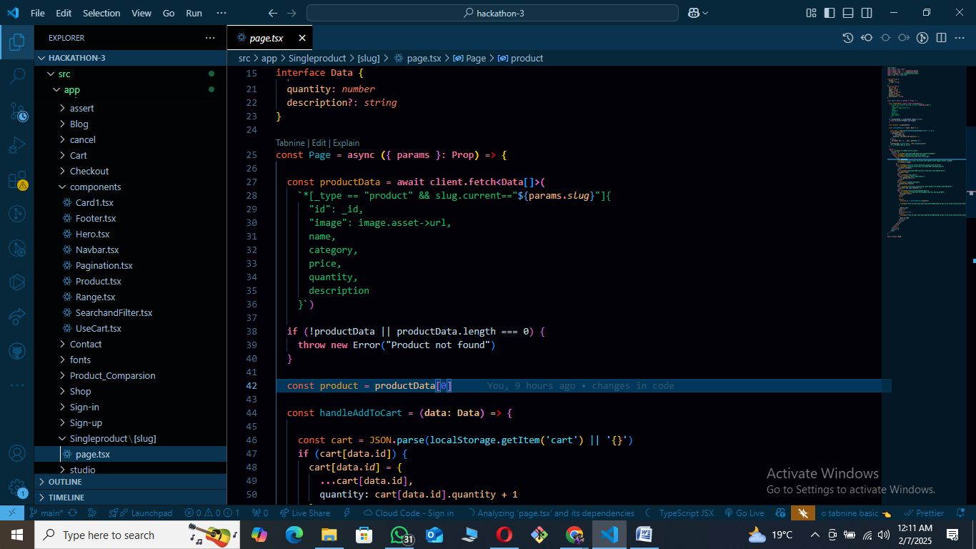

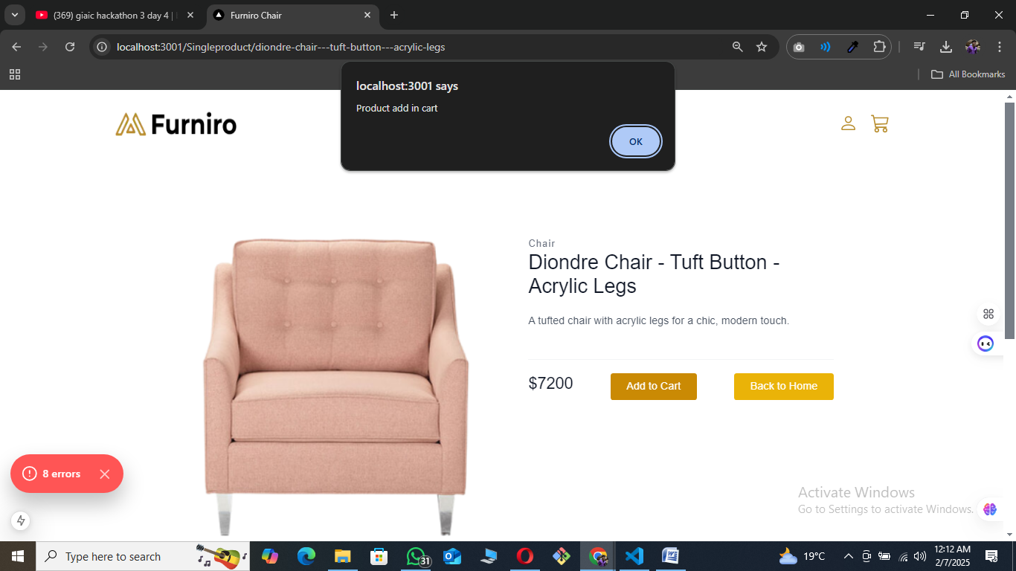

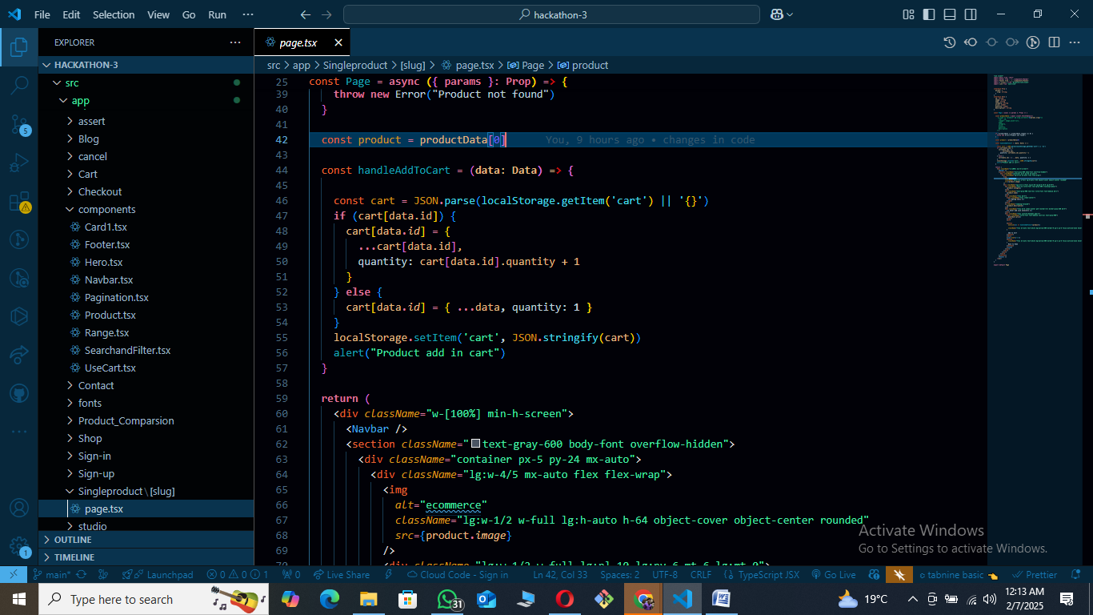

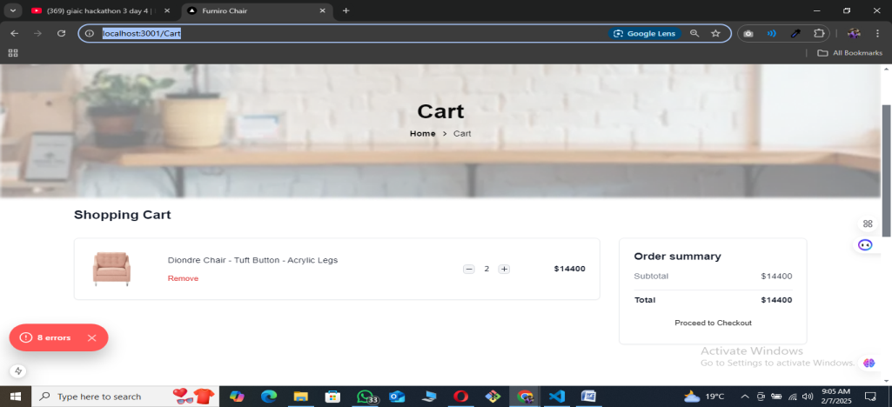

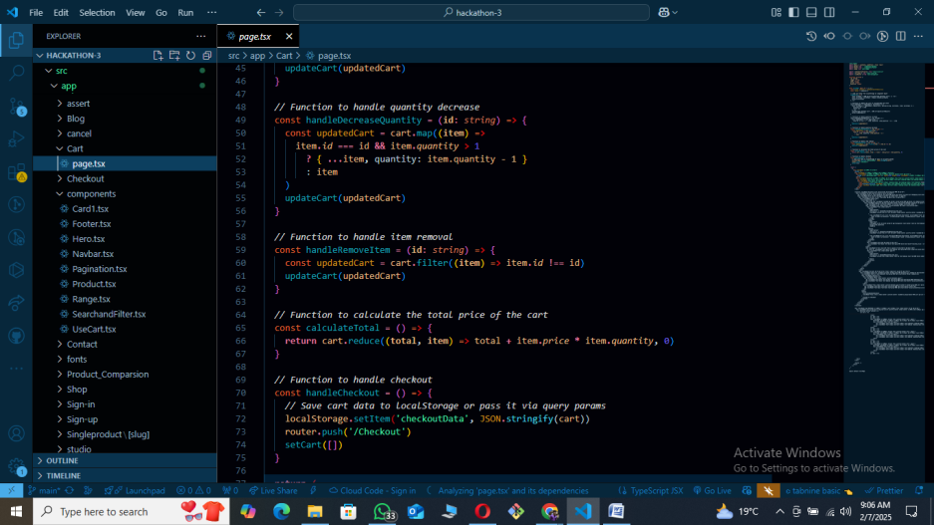

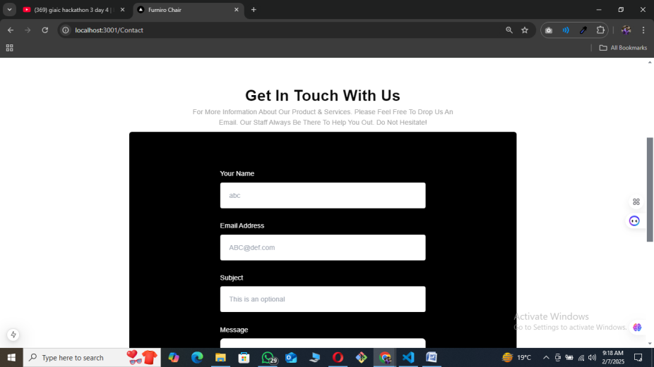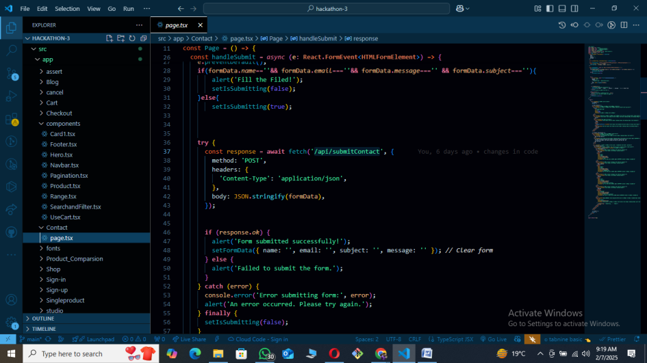

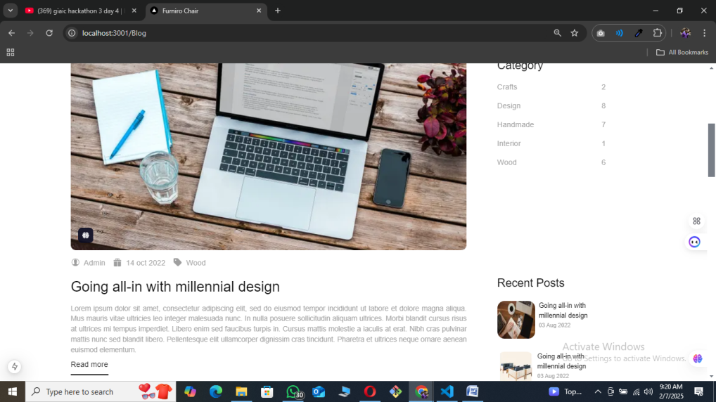

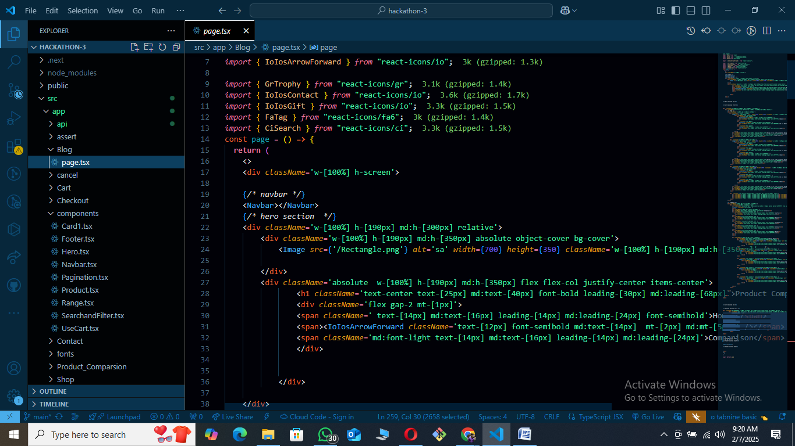

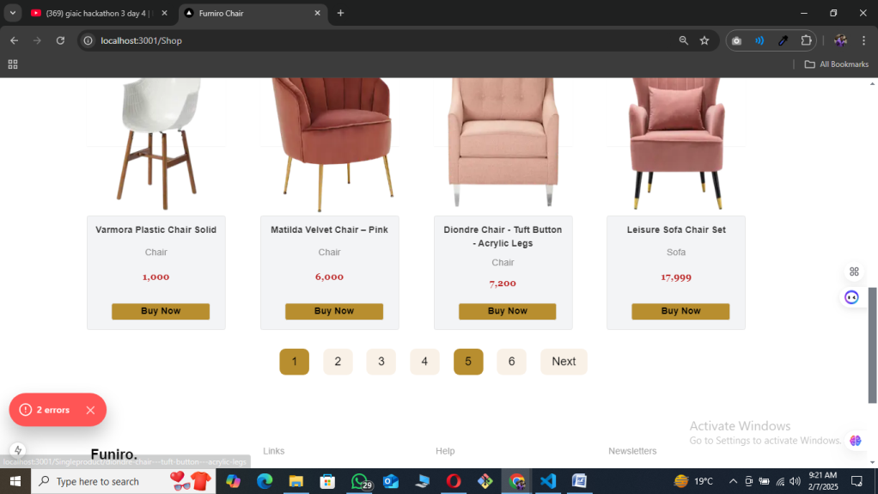

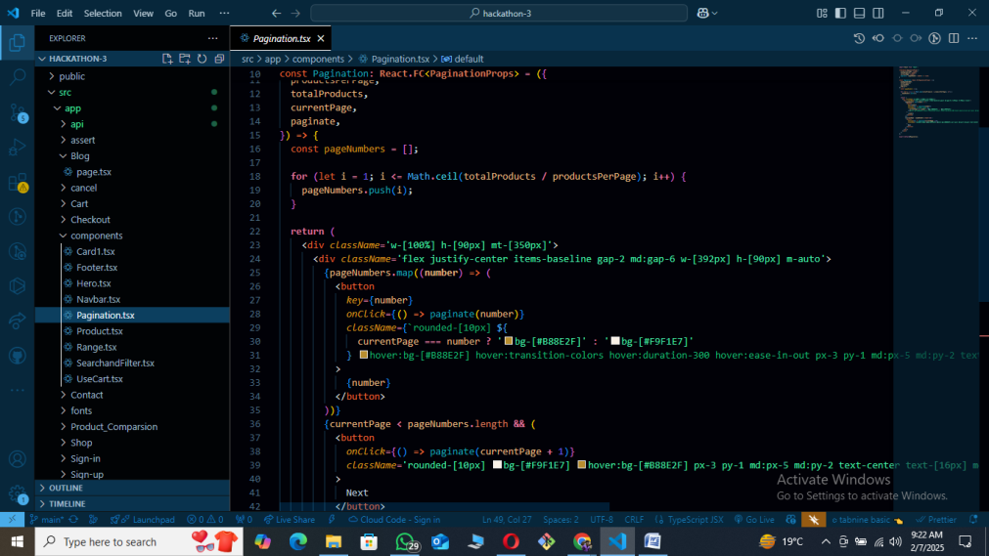

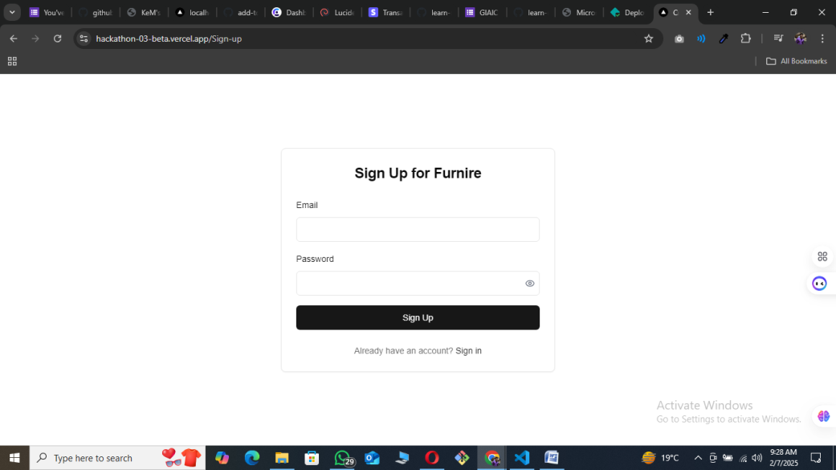

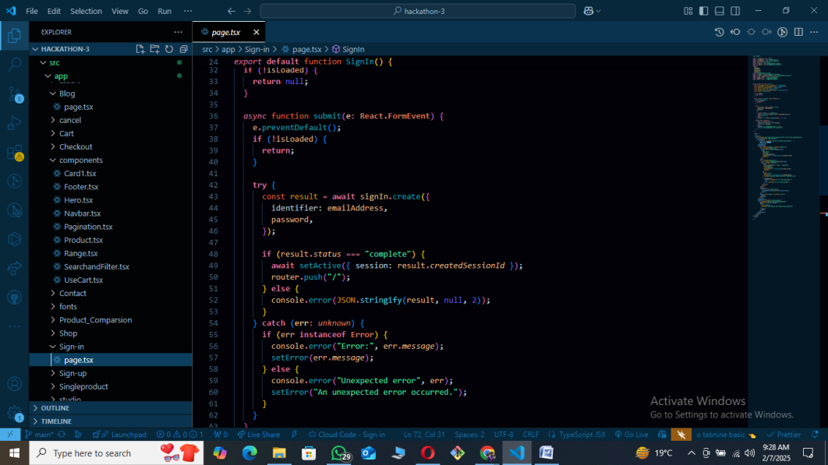

**Backend Developmet:**

**For Signin and Signup:**

* For user authentication and authorization Clerk is use.

**Payment Gateway Integration:**

* User can pay through Stripe Payment gateway.

**Data Flow API:**

* All card data and contact form summit data to sanity.

**Conclusion:**

For my website, card data comes from Sanity, and the contact form's POST request also saves data in Sanity. For payments, I use Stripe, but the data goes through an API instead of being sent directly to Stripe. For authentication and authorization, I use Clerk, and my Clerk setup is customized