Class assignment

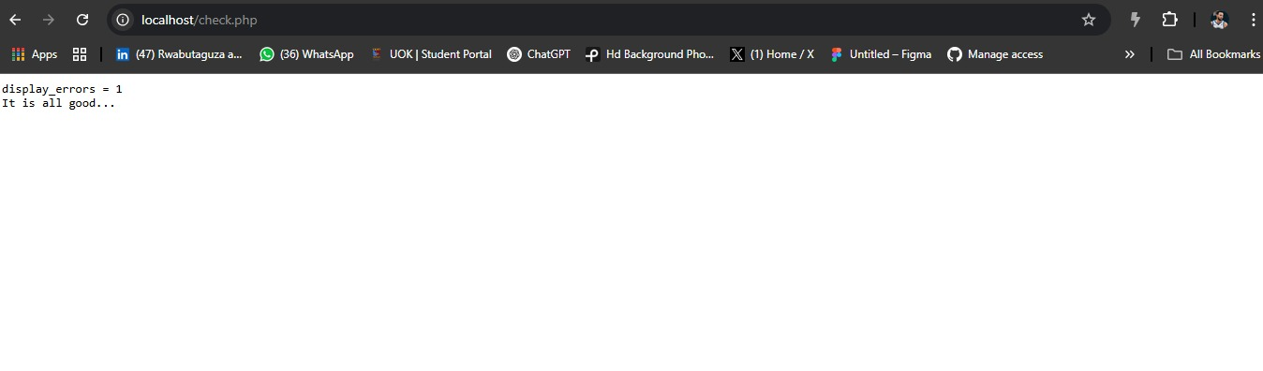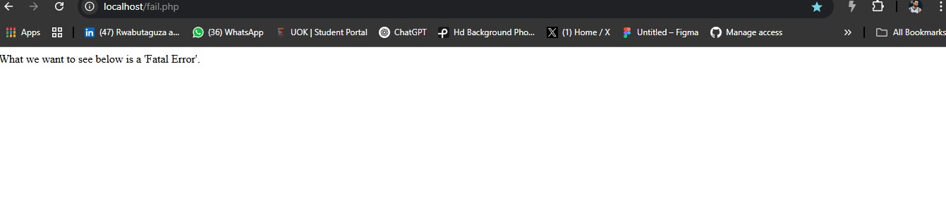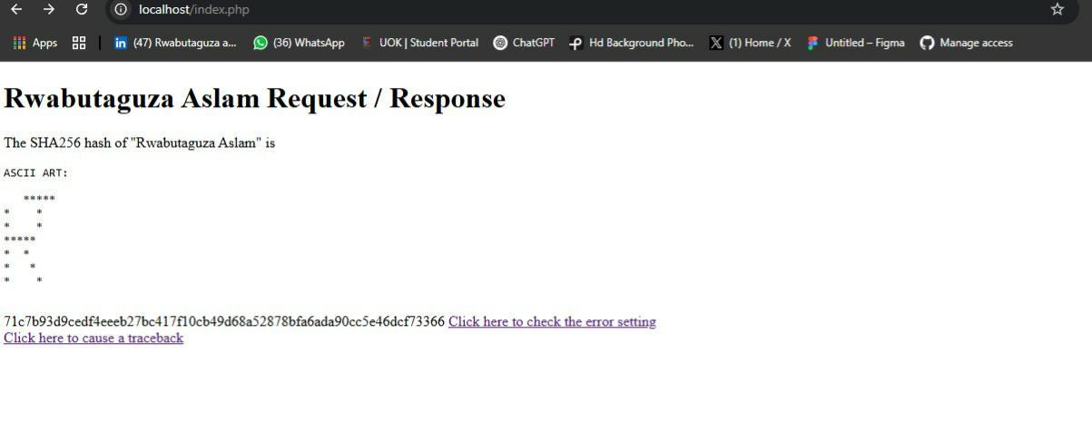**ID:25012112.** Index page

Fail page link

Check page link