LLD OF CONNECTX
BACKEND

Name(s) : Neel Pritesh Khambhata (7167380), Nitish Bhardwaj (7201791)

Overview

ConnectX is an advanced automation software designed to enhance social media engagement for businesses. By utilizing cutting-edge AI technologies, ConnectX enables dynamic, personalized interactions with customers across various social media platforms. This platform empowers businesses to streamline their social media operations, improve customer engagement, and gain valuable insights through data analytics

Class Diagram

CLASSES

User
- Attributes:
  - + user Id: String
  - + name: String
  - + email: String
  - + password: String
  - + subscription Plan: Subscription
  - - Accounts: List<Account>
- Methods:
  - + signup (): void
  - + login (): Boolean
  - + view Dashboard (): void
  - + logout (): void

2. Account
- Attributes:
  - + accountId: String
  - +username:String
  - + linked Date: Date
  - + status: String
  - - posts: List<Post>
- Methods:
  - + logout (): void
  - + disconnect (): void
  - + fetch Posts (): List<Post>
  - + login (): Boolean

3. Dm Handler
- Attributes:
  - + automationId: String
  - + triggerKeyword: String
  - + responseMessage: String
- Methods:
  - + setAutomation(triggerKeyword: String, response: String): void
  - + triggerDM(message: String): boolean
  - + handleError(error: DMError): void

4. Subscription
- Attributes:
  - + plan_Id: String
  - + plan_name: String
  - + price: Double
  - + features: List<String>
- Methods:
  - + upgrade Plan (planId: String): void
  - + Cancel Subscription (): void

5.AIResponse
- Attributes:
  - + responseId: String
  - + contextData: String
  - - trainingData: List<String>
- Methods:
  - + generateResponse(message: String): String
  - + trainModel(data: List<String>): void

6. Analytics Dashboard
- Attributes:
  - + dashboard_id: String
- Methods:
  - + displayDashboard(): void

7. Notification Manager
- Attributes:
  - + notification_Id: String
  - + type: String
  - + message: String
- Methods:
  - + sendNotification(type: String, message: String): void
  - + logNotification(): void

8. Post Automation
- Attributes:
  - + postId: String
  - + automationEnabled: boolean
  - + associatedTriggers: List<DMHandler>
- Methods:
  - + attachAutomation(): void
  - + detach Automation(): void

CLASS DIAGRAM

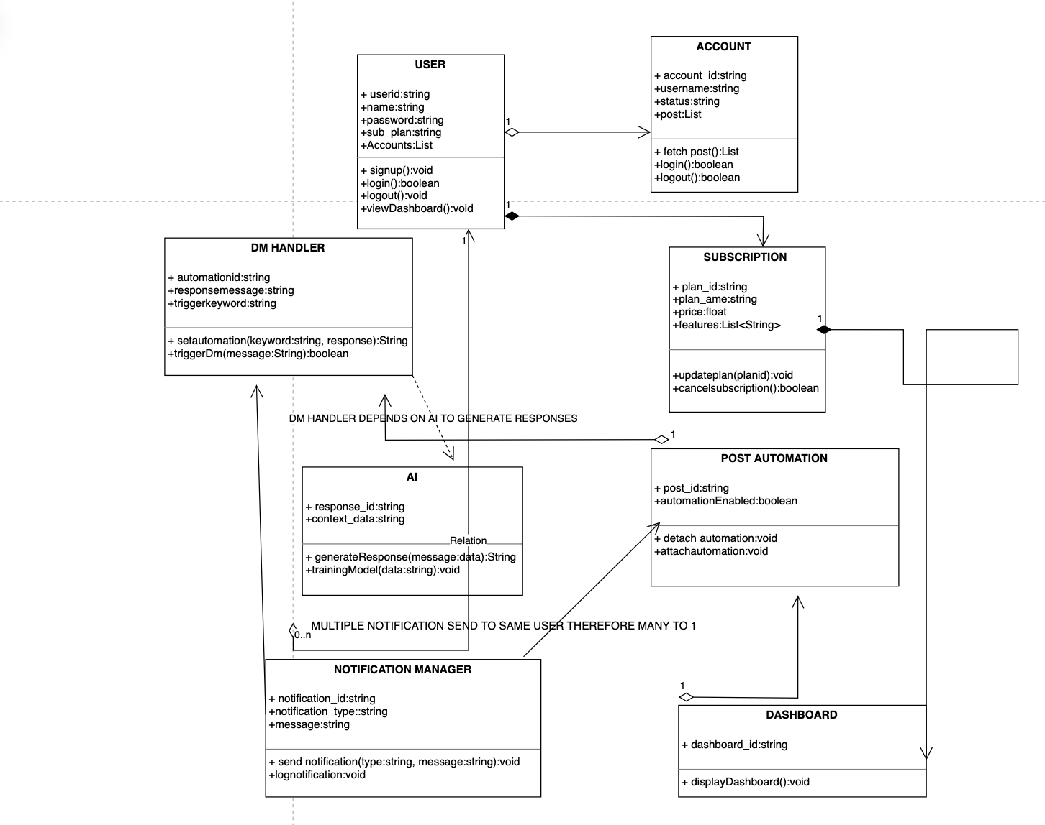

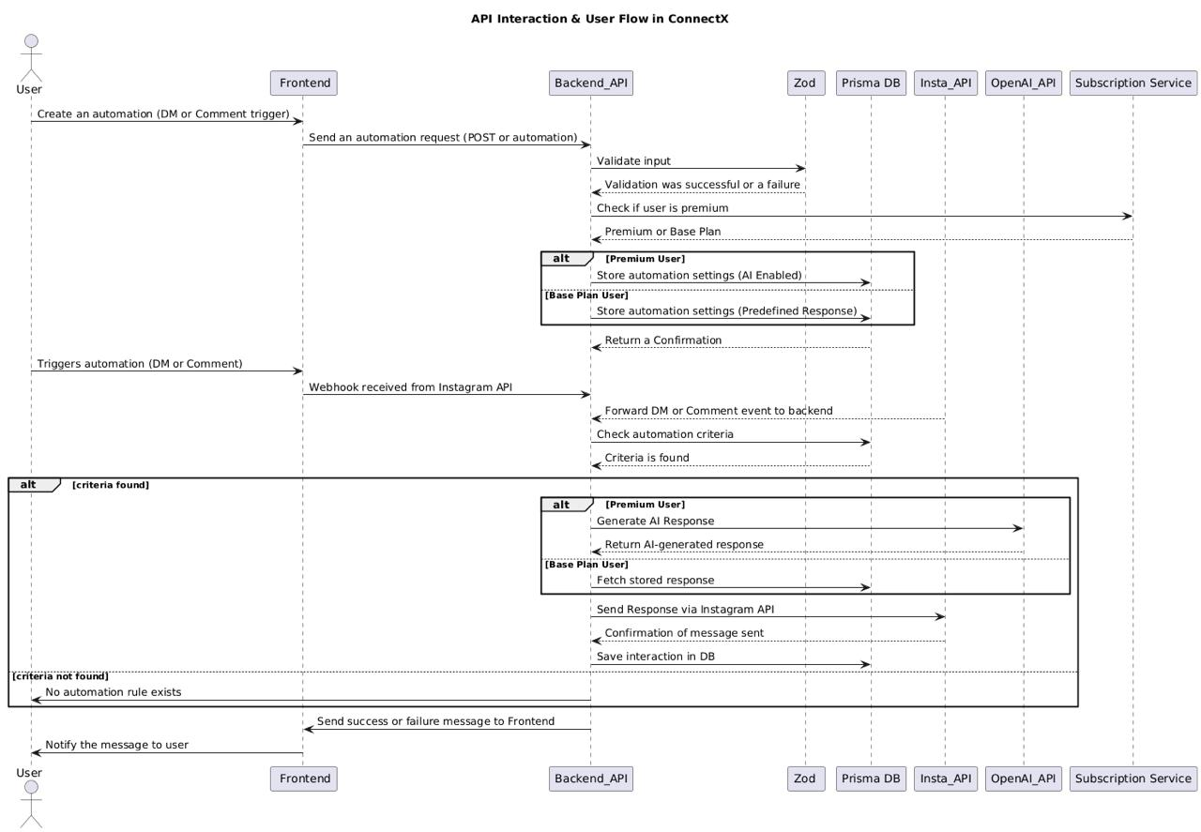

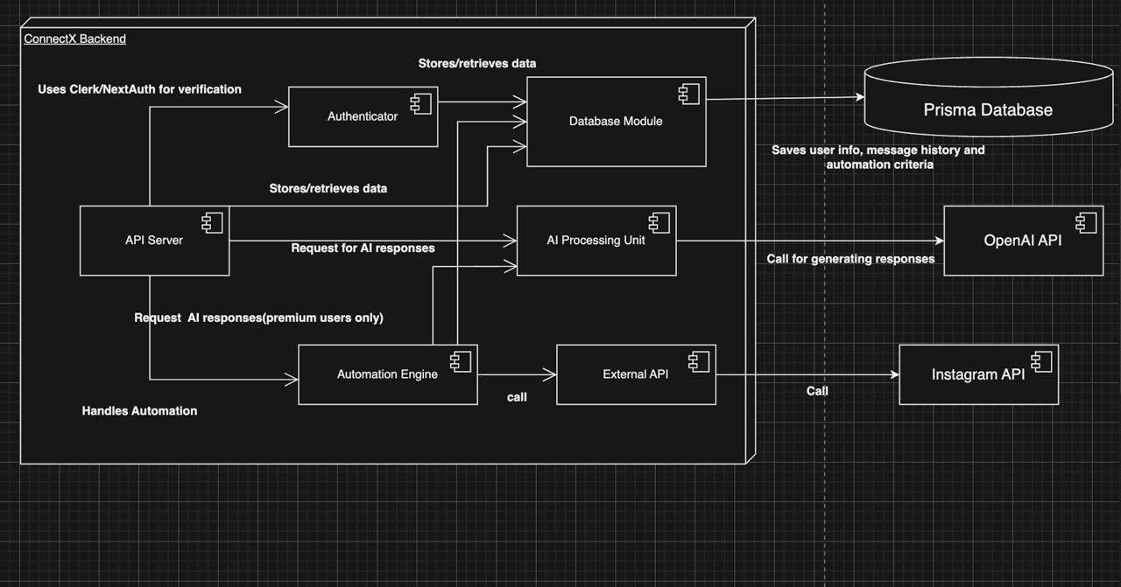

STRATEGIES TO HANDLE ERRORS AND EXCEPTIONS

Exception Type | SCENARIO | HOW WE WILL HANDLE
Network error | API failure when connecting social accounts | Retry request with exponential backoff; Show user-friendly error message
Validation Error | Invalid user input during automation | Display inline validation messages
Authentic Error | Invalid login credentials | Show "Incorrect credentials" message
DataNotfound |  | No data available with responsive UI
Timeout Exception | Long running request to APIS | Notify user to try later

API ENDPOINTS

User Management
Endpoint | Method | Description | Request Body | Response | Error Codes
/api/auth/login | POST | Authenticates user | {username, password } | {token } | 401, 500
/api/auth/register | POST | Registers a new user | {name, email, password } | { userId, token } | 400, 500
/api/auth/logout | POST | Logs user out | {token } | {success: true } | 401, 500

Account Management
Endpoint | Method | Description | Request Body | Response | Error Codes
/api/account/connect | POST | Connects Instagram account | { accountType, accessToken } | { success: true, accountId } | 400, 403, 500
/api/account/disconnect | DELETE | Disconnects an account | { accountId } | { success: true } | 404, 500
/api/account/details | GET | Fetches account details | { accountId } | { accountData } | 404, 500

DM Handler
Endpoint | Method | Description | Request Body | Response | Error Codes
/api/dms/send | POST | Sends an automated DM | { recipientId, message } | { messageId } | 404, 500
/api/dms/list | GET | Fetches DM history | { accountId, dateRange } | { messages } | 404, 500
/api/dms/delete | DELETE | Deletes a DM | { messageId } | { success: true } | 404, 500

Subscription Management
/api/subscription/create | POST | Creates subscription plan | { userId, planType, paymentInfo } | {subscriptionId } | 400, 402, 500

/api/subscription/cancel | POST | Cancels subscription | { subscriptionId } | { success: true } | 404, 500

/api/subscription/status | GET | Fetches subscription status | { userId } | {subscriptionDetails } | 404, 500

Post Automation
Endpoint | Method | Description | Request Body | Response | Error Codes
/api/posts/schedule | POST | Schedules a post | { accountId, content, scheduleTime } | { postId } | 400, 500
/api/posts/delete | DELETE | Deletes a scheduled post | { postId } | { success: true } | 404, 500
/api/posts/list | GET | Fetches scheduled posts | { accountId } | { posts } | 400, 500

AI Response Manager
Endpoint | Method | Description | Request Body | Response | Error Codes
/api/ai/generate-response | POST | Generates DM response | { messageContext } | { aiResponse } | 400, 500
/api/ai/feedback | POST | Sends feedback to AI | { responseId, feedback } | { success: true } | 400, 500

