OPENMRS
Handover Module User Guide
Installation Administration and User Workflows
Version 1.1.0
This guide explains how to deploy and use the Handover module for patient, pharmacy, emergency trolley, and equipment handovers. It covers team assignment and signatures, operational reports, CSV and PDF exports, privileges, and troubleshooting.

Module implementations

1 Upgrade first
Important upgrade instruction: stop Tomcat and remove the previously deployed Patient Handover or Handover OMOD before copying version 1.1.0. Do not keep two versions in the OpenMRS modules directory. Removing the old OMOD does not remove handover database records.
Guide information | Current value
Module display name | Handover
Module ID and URL namespace | patienthandover
Current package | handover-1.1.0.omod
OpenMRS module directory | /var/lib/OpenMRS/modules
Hospital name on PDF reports | Global property billing.healthFacilityName
Required pharmacy dependency | Rwanda Pharmacy Management module providing InventoryService

Safe replacement sequence
1. Notify users and stop Tomcat. Do not replace an OMOD while OpenMRS is running.
2. Back up the OpenMRS database and module directory according to facility policy.
3. Remove all older patienthandover or handover OMOD files from the modules directory. Keep only the new version.
4. If an expanded module cache exists, remove only the cache folder belonging to patienthandover. Never remove the whole OpenMRS application-data directory.
5. Copy handover-1.1.0.omod into /var/lib/OpenMRS/modules and set ownership to the Tomcat service account.
6. Start Tomcat and monitor the log until Liquibase and the Spring application context complete successfully.
sudo systemctl stop tomcat9
# Remove only older Handover module OMOD files from /var/lib/OpenMRS/modules
sudo cp handover-1.1.0.omod /var/lib/OpenMRS/modules/
sudo chown tomcat9:tomcat9 /var/lib/OpenMRS/modules/handover-1.1.0.omod
sudo systemctl start tomcat9
sudo journalctl -u tomcat9 -f

Verification: open Administration > Manage Modules and confirm that only one Handover module is installed and started. Then open each navigation page once to confirm that its UI Framework view loads.

2 Roles and privileges
Assign privileges through OpenMRS Administration > Manage Roles. Team membership controls who may sign a particular handover; a privilege alone does not make a user a member of every team.
Privilege | Purpose | Typical assignment
Patient Handover: View | Open dashboards, pending and saved handovers | All handover users
Patient Handover: Create | Create and sign outgoing handovers | Clinical, pharmacy and support staff
Patient Handover: Receive | Sign as a receiving team member | Receiving staff
Patient Handover: Complete Tasks | Complete assigned patient follow-up tasks | Receiving clinical staff
Patient Handover: Edit | Edit eligible pending handovers | Creators and authorized supervisors
Patient Handover: Cancel | Cancel eligible pending handovers with a reason | Creators and authorized supervisors
Patient Handover: Manage | Manage catalogues and handovers across permitted location | Managers
Patient Handover: View Reports | Open report pages | Supervisors and auditors
Patient Handover: Export Reports | Download CSV and PDF files | Authorized supervisors and auditors
Patient Handover: View All Providers | Select providers beyond the normal restricted list | Administrators or designated managers

Editing authority: team changes, handover editing, and cancellation are available only when the user has the required privilege and is either the handover creator or a manager. Received or cancelled handovers remain historical records and are not edited as pending work.

3 Shared team workflow
All handover types use outgoing and receiving teams. The authenticated user who creates the handover is included in the outgoing team and signed automatically at submission time.
1. Select the shift.
2. Choose Add sender for every additional outgoing team member. Type the provider name and select the matching suggestion; user IDs are not displayed.
3. Choose Add receiver and select each receiving provider in the same way. At least one receiver is required.
4. Submit after reviewing the selected patients or items. Each member signs individually, and the signature time is retained.
5. Receiving signatures become available after all required outgoing signatures are complete. The handover becomes Received only after every active receiving team member has signed.
Team progress uses signed/total notation. For example, Senders 1/1 and Receivers 0/2 means the sender has completed signing and both receivers are still required. View members separates Sending Team and Receiving Team and shows who signed, who remains, and each signature time.
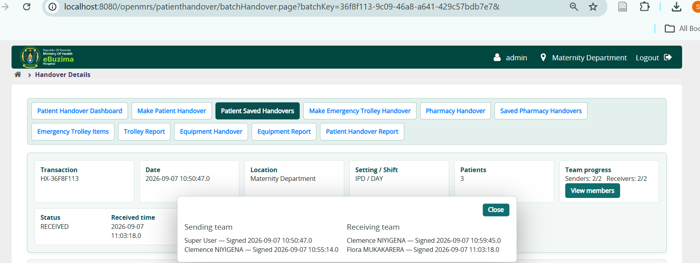
Figure 1 Patient handover detail showing complete sending and receiving teams and signature progress

4 Patient handover

Automatic patient worklist
The automatic worklist is designed for active, admitted patients at the current login location. The module evaluates admission or visit activity and the latest relevant encounter, and excludes patients whose qualifying presence at the location is older than two months. Manual Add remains available without this automatic worklist condition; the user must verify clinical relevance before adding a patient manually.
- Choose IPD or OPD, then load patients for the current login location.
- Use Select All to select all currently displayed eligible patients.
- Use search by name or identifier to find a patient within the worklist.
- Use manual patient search when an appropriate patient is not returned automatically.

Create the transaction
1. Open Make Patient Handover and confirm the login location.
2. Select the patients. Enter priority and SBAR: Situation, Background, Assessment, and Recommendation.
3. Add individual follow-up tasks where required. Tasks are assigned to all active receiving team members.
4. Select shift, add outgoing team members, and add receiving team members.
5. Review all records and submit the handover as one transaction.

Receive and manage
- Open Patient Saved Handovers or the patient dashboard. Pagination limits long result sets.
- Use View members to inspect both teams and signature progress.
- A member signs only their own assignment. Signature times are preserved independently.
- Before completion, an authorized creator or manager can edit the handover, edit team members, or cancel it with a reason.
- The Age column uses hours below 24 hours and days after 24 hours.

5 Pharmacy handover
Pharmacy locations and available stock are loaded from the locally installed Rwanda Pharmacy Management module. The integration uses InventoryService.getAvailableInventoryForPharmacy(Integer), which returns InventoryBalance records. Pharmacy stock quantities are read-only; the handover records a snapshot and does not permit users to type or alter the source available quantity.
1. Open Pharmacy Handover and select the pharmacy location.
2. Choose Load Items to view paginated available stock. Use View all items when the full location list is needed.
3. Select only the stock lines being handed over, or choose the option to submit all available items.
4. For each selected line, verify Item, Code, Batch, Expiry date, and Available quantity.
5. Select shift, add sending and receiving team members, and submit.
6. Assigned members sign in order. Pending handovers appear only to relevant team members, the creator, and authorized managers.
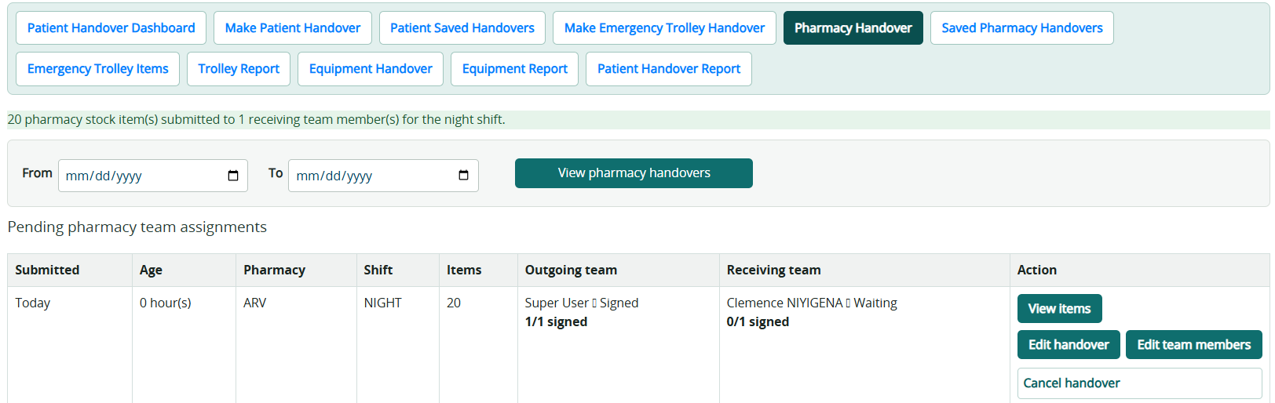
Figure 2 Pharmacy page with pending team assignments and pharmacy location controls

Pharmacy reports
Saved Pharmacy Handovers provides From and To date filters, pharmacy, shift, and status filters. View items displays the handed snapshot. View history shows amendments and signature events. Export CSV downloads one filtered dataset; Download PDF produces a readable report, and each handover can be exported individually.
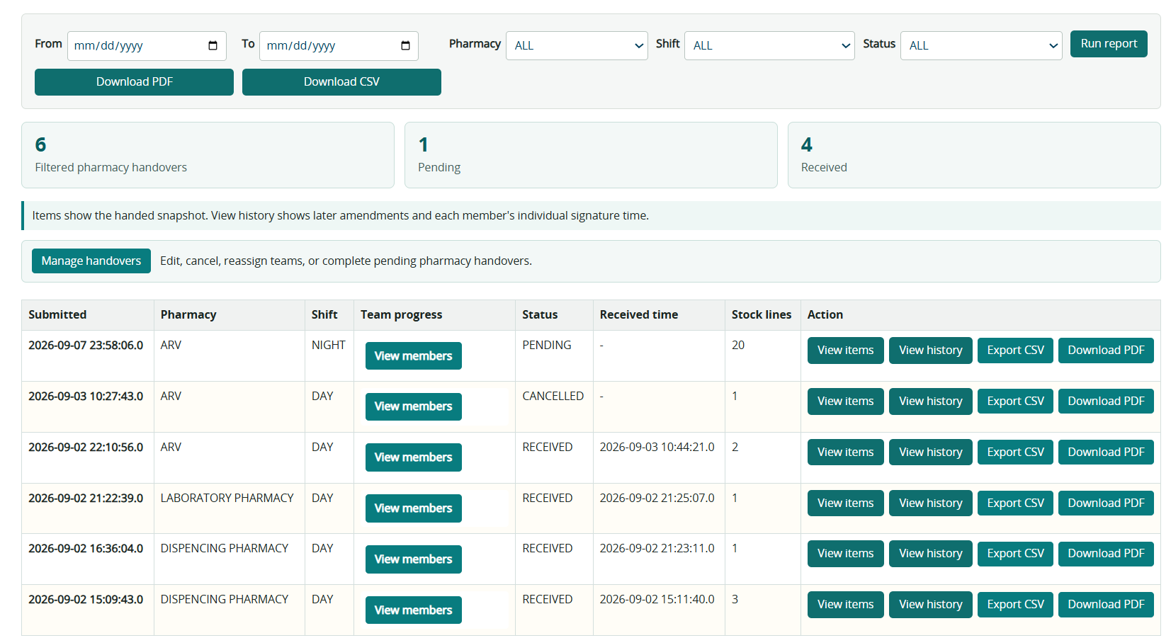
Figure 3 Pharmacy report filters, summary, team progress and handover actions

6 Emergency trolley handover

Maintain the trolley catalogue
- Open Emergency Trolley Items to add a permanent item manually or import a CSV or XLSX template.
- Use pagination for normal viewing and View All Items when a complete inventory review is required.
- Retiring an item removes it from future transactions without deleting historical handovers.

Create and receive
1. Open Make Emergency Trolley Handover and select shift.
2. Type provider names to add any number of outgoing and receiving team members.
3. Review the item list. Set the handed quantity and observation. A zero quantity is valid and remains visible for safety review; negative quantities are rejected.
4. Submit the handover. Quantities and notes remain part of the transaction snapshot.
5. Each team member signs. When all outgoing and receiving members have signed, the handover becomes Received.
Trolley Report supports date, shift, and status filters, pagination, CSV export, full filtered PDF download, and individual handover PDF download.

7 Equipment handover

Create the equipment catalogue
Users with management permission may add equipment manually or upload the supplied CSV template. The template columns are Equipment name, Quantity, Status, and Observation. Typical statuses include FUNCTIONAL, NEEDS MAINTENANCE, and OUT OF SERVICE.
- Use Download template before preparing a bulk upload.
- Quantity must be numeric and cannot be negative.
- Observation records condition details that do not fit the status value.

Make an equipment handover
1. Open Equipment Handover and select Day or Night shift.
2. Type provider names to add the sending and receiving teams.
3. Select individual equipment lines or Select All.
4. Enter the Handed quantity for every selected line. It must be greater than zero and cannot exceed Available quantity. The catalogue quantity is not overwritten by this entry.
5. Submit selected items or submit all equipment items.
6. Review pending team progress and sign when the action is available to the current member.

Equipment report
Open Equipment Report. Filter by From date, To date, shift, and status. Results are paginated. View items expands the equipment name, handed quantity, status, and observation. Download CSV exports the filtered rows. Download PDF exports the full filtered report, while the row action downloads one handover with both teams and signature times.

8 Reports and exports
Report | Filters | Screen details | Downloads
Patient Handover Report | From, To, care setting, shift, status | Batch, patients, SBAR, tasks, teams and status | Filtered PDF, individual PDF, CSV
Saved Pharmacy Handovers | From, To, pharmacy, shift, status | Stock snapshot, history, teams and progress | Filtered PDF, individual PDF, CSV
Trolley Report | From, To, shift, status | Transaction, quantities, notes, teams and progress | Filtered PDF, individual PDF, CSV
Equipment Report | From, To, shift, status | Equipment, handed quantity, condition, teams and progress | Filtered PDF, individual PDF, CSV

PDF header: reports use the facility name stored in the global property billing.healthFacilityName. If this property is empty, the PDF displays Hospital. PDF files include the filtered handover content rather than only a title page.
Batch separation: full PDF and CSV reports preserve handover-by-handover grouping. Individual PDF actions export only the selected handover. On-screen pagination does not restrict the full filtered download.
Confidentiality: exported files may contain patient, staff, pharmacy, or operational data. Store, transmit, and dispose of them according to facility policy.

9 Administration and technical reference

Core data concepts
Term | Meaning
Transaction key | Stable identifier linking a handover to its teams and history
Snapshot | The patients or items and values saved at submission time
Team member | A sending or receiving person with an independent signature state and time
Pending | At least one required signature is not complete
Received | All active sending and receiving signatures are complete
Cancelled | A pending transaction was cancelled with an audit reason
Pagination | A screen displays a limited page while exports can include the complete filtered set

Database and service integration
The module stores patient, pharmacy, trolley, equipment, team-member, and audit records in indexed handover tables. Indexes support common location, status, transaction-key, and date lookups. Liquibase applies schema changes when the module starts.
Pharmacy inventory is obtained through the Rwanda Pharmacy Management API. If startup or page loading reports Service not found for org.openmrs.module.rwandapharmacymanagement.api.InventoryService, verify that the correct Rwanda Pharmacy Management module version is installed and started before Handover.

Useful diagnostic queries
Run read-only queries only against a backup or under database-administrator supervision. Table names should be confirmed against the deployed Liquibase schema.
SELECT module_id, started FROM openmrs_module WHERE module_id IN ('patienthandover','rwandapharmacymanagement');
SELECT handover_type, role, signed, COUNT(*) AS members
FROM handover_team_member
WHERE voided = 0
GROUP BY handover_type, role, signed;

Do not update status or signature fields directly in SQL. Use the application workflow so audit history, signer identity, and completion rules remain consistent.

10 Verification checklist
- Only handover-1.1.0.omod is deployed; all earlier Patient Handover or Handover OMOD versions were removed first.
- Handover starts without Liquibase or WebApplicationContext errors.
- The login location is displayed and controls the work context.
- Patient Select All works and the automatic list contains active admitted patients with a recent qualifying encounter.
- Additional senders and receivers can be selected by typing provider names on every handover type.
- Team progress shows correct signed/total values and View members separates both teams.
- Pharmacy items show code, batch, expiry date, and read-only available quantity.
- Trolley and equipment item lists paginate and provide a View All option where applicable.
- Equipment handed quantity is editable but cannot exceed available quantity.
- Patient, pharmacy, trolley, and equipment reports filter correctly and download populated CSV and PDF files.
- billing.healthFacilityName appears as the facility name on PDFs.

11 Troubleshooting
Symptom | Likely cause | Action
Unable to update data model using liquibase.xml | Old duplicate OMOD, partial earlier schema, or database permission issue | Stop Tomcat, keep only one OMOD, back up the database, and inspect the first Liquibase cause in the log.
Unable to refresh WebApplicationContext | A required module, class, or service did not load | Review the first nested exception and verify required modules are started.
InventoryService not found | Wrong or inactive Rwanda Pharmacy Management module | Install and start the module that exposes the expected API before starting Handover.
No viewProvider named patienthandover | Module did not start or URL points to an unavailable page | Confirm module status and inspect startup logs before reloading.
A team remains Pending | An active team member has not signed or team membership changed | Open View members and review each active member and signature time.
PDF returns 404 for a full report | Old controller or malformed report URL still deployed | Remove the old OMOD, deploy 1.1.0, restart Tomcat, and use the report page Download PDF action.
Styles appear unchanged | Browser or OpenMRS resource cache | Deploy only the new OMOD, restart, then perform a hard browser refresh.
Patient missing from automatic list | No active recent admission/location evidence | Check the latest encounter and admission state, or use manual add after clinical verification.

Appendix A Database tables
The Handover module creates or manages the following 15 tables. Most operational tables also contain standard OpenMRS audit fields: creator, date_created, changed_by, date_changed, voided, voided_by, date_voided, void_reason, and uuid.
Area | Table | Purpose | Main stored contents
Patient | patient_handover | One patient record within a handover transaction | patient_handover_id; patient_id; batch_uuid; priority; situation; background; assessment; recommendation; shift; care_setting; location_id; legacy receiving and acknowledgement fields; legacy task fields; cancellation fields.
Patient | patient_handover_task | Individual follow-up task for a handed-over patient | patient_handover_task_id; patient_handover_id; description; due_date; assignee_provider_id; completed; completed_by; date_completed.
Patient | patient_handover_audit_event | Audit event for patient handover and task activity | event ID; event_type; batch_key; handover_uuid; task_uuid; user_id; location_id; event_date; successful; details.
Shared teams | handover_team_member | Sending and receiving teams for patient, trolley, and equipment handovers | handover_type; transaction_key; person_id; participant_role; signed; signed_by; date_signed. Supports multiple members and independent signature times.
Pharmacy | pharmacy_handover | Pharmacy handover transaction header | pharmacy_handover_id; pharmacy_location_id; pharmacy_name; location_id; shift; legacy receiving provider; date_submitted; acknowledgement fields; cancellation fields.
Pharmacy | pharmacy_handover_item | Stock snapshot included in a pharmacy handover | pharmacy_handover_item_id; pharmacy_handover_id; inventory_balance_id; item_name; item_code; batch_number; expiry_date; available_quantity. One physical table; the later change set only repairs a partially applied installation when this table is missing.
Pharmacy | pharmacy_handover_participant | Pharmacy sending and receiving team signatures | pharmacy_handover_id; person_id; participant_role; signed; signed_by; date_signed.
Trolley | emergency_trolley_item | Permanent emergency trolley catalogue by location | item_id; location_id; item_name; current_quantity; standard_note; active.
Trolley | emergency_trolley_handover | Emergency trolley handover transaction header | handover_id; location_id; shift; legacy receiving provider; status; date_submitted; date_received; received_by; cancellation fields.
Trolley | emergency_trolley_handover_item | Trolley item snapshot for one handover | handover_item_id; handover_id; item_id; item_name_snapshot; previous_quantity; handed_quantity; note.
Trolley | emergency_trolley_import | Audit summary for trolley catalogue imports | import_id; location_id; file_name; total_rows; items_added; items_skipped; items_failed; status; error_summary.
Legacy trolley | patient_handover_trolley_item | Original trolley item storage retained for compatibility | record ID; batch_uuid; item_name; remaining_quantity; unit; expiry_date; remarks. The current workflow uses the emergency_trolley tables.
Equipment | handover_equipment_item | Permanent equipment catalogue by location | equipment_item_id; location_id; equipment_name; available quantity; equipment_status; observation; active.
Equipment | equipment_handover | Equipment handover transaction header | equipment_handover_id; location_id; shift; status; date_submitted; date_received; received_by.
Equipment | equipment_handover_line | Equipment snapshot included in one handover | equipment_handover_line_id; equipment_handover_id; equipment_item_id; equipment_name; handed quantity; equipment_status; observation.

