OPENMRS

Handover Module User Guide
Installation Administration and User Workflows
Version 1.5.2
This guide explains how to deploy and use the Handover module for patient, laboratory, pharmacy, emergency trolley, and equipment handovers. It covers team assignment and signatures, operational reports, CSV and PDF exports, privileges, and troubleshooting.

Prepared for Ministry of Health supported OpenMRS implementations

1 Upgrade first
Important upgrade instruction: stop Tomcat and remove the previously deployed Patient Handover or Handover OMOD before copying version 1.5.2. Do not keep two versions in the OpenMRS modules directory. Removing the old OMOD does not remove handover database records.
Guide information | Current value
Module display name | Handover
Module ID and URL namespace | patienthandover
Current package | handover-1.5.2.omod
OpenMRS module directory | /var/lib/OpenMRS/modules
PDF report identity header | billing.healthFacilityCountryHeading, billing.healthFacilityName, billing.healthFacilityAddress, billing.healthFacilityEmail, and billing.healthFacilityLogo
Required pharmacy dependency | Rwanda Pharmacy Management module providing InventoryService
Laboratory order type | Global property laboratorymanagement.orderType.labOrderTypeId identifies laboratory orders for Laboratory Handover
Make Patient Handover drafts | Saved per user, location and care setting in patient_handover_draft (created automatically on first start of 1.5.x)

Safe replacement sequence
1. Notify users and stop Tomcat. Do not replace an OMOD while OpenMRS is running.
2. Back up the OpenMRS database and module directory according to facility policy.
3. Remove all older patienthandover or handover OMOD files from the modules directory. Keep only the new version.
4. If an expanded module cache exists, remove only the cache folder belonging to patienthandover. Never remove the whole OpenMRS application-data directory.
5. Copy handover-1.5.2.omod into /var/lib/OpenMRS/modules and set ownership to the Tomcat service account.
6. Start Tomcat and monitor the log until Liquibase and the Spring application context complete successfully.
sudo systemctl stop tomcat9
# Remove only older Handover module OMOD files from /var/lib/OpenMRS/modules
sudo cp handover-1.5.2.omod /var/lib/OpenMRS/modules/
sudo chown tomcat:tomcat /var/lib/OpenMRS/modules/handover-1.5.2.omod
sudo systemctl start tomcat9
sudo journalctl -u tomcat9 -f

Verification: open Administration > Manage Modules and confirm that only one Handover module is installed and started. Then open each navigation page once to confirm that its UI Framework view loads.
Upgrading from 1.4 or 1.5.x: Version 1.5 creates the patient_handover_draft table automatically during the first start. No manual SQL is required. After deploying, ask users to refresh the browser with Ctrl+F5 so the new page scripts and styles are loaded.

2 Roles and privileges
Assign privileges through OpenMRS Administration > Manage Roles. Team membership controls who may sign a particular handover; a privilege alone does not make a user a member of every team.
Privilege | Purpose | Typical assignment
Patient Handover: View | Open dashboards, pending and saved handovers | All handover users
Patient Handover: Create | Create and sign outgoing handovers | Clinical, pharmacy and support staff
Patient Handover: Receive | Sign as a receiving team member | Receiving staff
Patient Handover: Complete Tasks | Complete assigned patient follow-up tasks | Receiving clinical staff
Patient Handover: Edit | Edit eligible pending handovers | Creators and authorized supervisors
Patient Handover: Cancel | Cancel eligible pending handovers with a reason | Creators and authorized supervisors
Patient Handover: Manage | Manage catalogues and handovers across permitted location | Managers
Patient Handover: View Reports | Open report pages | Supervisors and auditors
Patient Handover: Export Reports | Download CSV and PDF files | Authorized supervisors and auditors
Patient Handover: View All Providers | Select providers beyond the normal restricted list | Administrators or designated managers

Editing authority: team changes, handover editing, and cancellation are available only when the user has the required privilege and is either the handover creator or a manager. Received or cancelled handovers remain historical records and are not edited as pending work.

3 Shared team workflow
All handover types use outgoing and receiving teams. The authenticated user who creates the handover is included in the outgoing team and signed automatically at submission time.
1. Select the shift.
2. Choose Add sender for every additional outgoing team member. Type the provider name and select the matching suggestion; user IDs are not displayed.
3. Choose Add receiver and select each receiving provider in the same way. At least one receiver is required.
4. Submit after reviewing the selected patients or items. Each member signs individually, and the signature time is retained.
5. Receiving signatures become available after all required outgoing signatures are complete. The handover becomes Received only after every active receiving team member has signed.
Team progress uses signed/total notation. For example, Senders 1/1 and Receivers 0/2 means the sender has completed signing and both receivers are still required. View members separates Sending Team and Receiving Team and shows who signed, who remains, and each signature time.
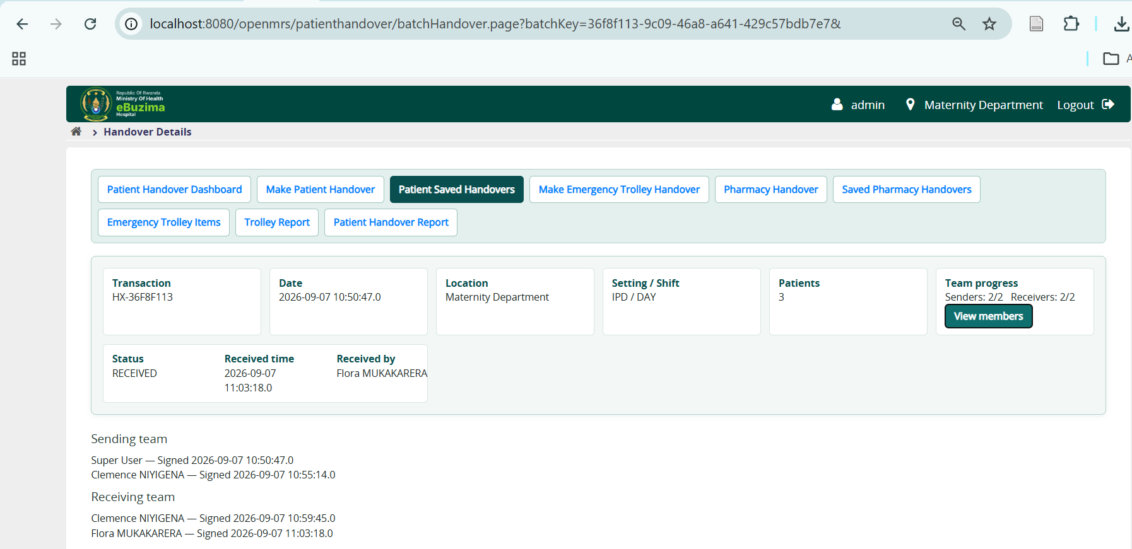
Figure 1 Patient handover detail showing complete sending and receiving teams and signature progress

4 Patient handover

Load the worklist
Make Patient Handover lists patients who have an active visit at the current login location or one of its departments and whose visit (admission) started in the selected period.
1. Open Make Patient Handover and confirm the login location shown under the page title.
2. Choose the Care setting: IPD or OPD.
3. Set Admitted from and Admitted to. Both days are included. By default the period runs from two days before today until today. If the dates are entered in the wrong order they are swapped automatically.
4. Choose Load patients.
- Use Find patient in worklist to filter the list by name or identifier.
- Use + Add patient to search the whole database when a patient is not listed. Add patients one at a time to the temporary list, then choose Add patient(s) to worklist.
- Remove on a patient card, or Remove selected, hides patients from this worklist for your session.
- View all shows every patient on one page; otherwise the worklist is shown in pages.

Fill in the handover
The page has two numbered steps and a bar fixed to the bottom of the screen that always shows the number of selected patients, the draft status and the Submit handover button.
1. Step 1, Shift and teams: select the shift and the destination. You are included in the sending team and signed automatically. Add other senders, and add at least one receiver, by typing a name and choosing the provider suggestion.
2. Step 2, Patients: every patient is shown as a card with name, identifier, sex and age. Tick the box at the left of a card to include the patient, or use Select all on this page. Selected cards are highlighted.
3. Choose the patient Status. Cards of Urgent patients get an amber edge and Critical patients a red edge.
4. Complete Situation, Background, Assessment and Recommendation. Each box accepts up to 1000 characters.
5. Open task(s) for the receiving team to add follow-up tasks with a due date and time. Each task is assigned to every receiving team member.
6. Check the bottom bar, choose Submit handover and confirm. All selected patients are saved as one transaction.

SBAR filled in from the patient’s records
When the worklist opens, empty SBAR boxes are filled in from information already recorded for that patient in OpenMRS forms. This saves typing; it does not replace clinical review.
SBAR box | Filled from (default configuration)
Situation | Final diagnosis, other presumptive diagnosis, chief complaints, progress-note subjective
Background | Clinical summary, history of present illness, past medical history, clinical history, known allergies
Assessment | Progress-note assessment and objective findings, investigation summary, other diagnosis, latest vital signs (pulse, blood pressure, temperature, respiratory rate, oxygen saturation)
Recommendation | Plan, treatment/action taken, identified health education needs

- Each line shows the field, its latest recorded value and the date and time it was recorded, for example “Final diagnosis: Malaria (03 Nov 10:15)”. Always check the date: an old value may no longer be correct.
- Entries that contain only a placeholder such as “.” or “-” are ignored, and the most recent meaningful value is used instead.
- If nothing is recorded for a box, the same box from the patient’s last handover (within 30 days) is offered.
- Filled-in boxes have a yellow background and a REVIEW badge. Point at the badge to see where the text came from. The badge disappears as soon as you edit the text.
- Use records puts the text from the records back after you have changed it.
- When you submit, the confirmation warns if a selected patient still contains filled-in text that nobody edited.
Clinical responsibility: The person who submits remains responsible for the handover content. Correct or delete any filled-in text that is out of date before submitting.

Drafts: continue where you stopped
Everything entered on Make Patient Handover is saved automatically as a draft: immediately in the browser and, a few seconds later, in your user account. A draft is kept for each user, login location and care setting.
- You may leave the page, log out or close the browser at any time. When you open Make Patient Handover again with the same location and care setting, the shift, teams, selected patients, statuses, SBAR text and tasks are restored, also on another computer.
- Draft status: the bar shows Saving draft to your account, Draft saved to your account at a given time, Continuing your draft from a given time, or Saved on this device only — will retry when the server cannot be reached (the browser copy is kept and saving is retried).
- Text entered for patients on other pages of the worklist is kept in the draft.
- After a successful submission the draft is deleted automatically.
- Discard draft, in the bottom bar, deletes the draft from the browser and from your account and clears the form.

Receive and manage
- Open Patient Saved Handovers or the patient dashboard. Pagination limits long result sets.
- Use View members to inspect both teams and signature progress.
- A member signs only their own assignment. Signature times are preserved independently, and a signature cannot be recorded twice. When several members sign at the same moment, the handover still completes correctly.
- Before completion, an authorized creator or manager can edit the handover, edit team members, or cancel it with a reason.
- The Age column uses hours below 24 hours and days after 24 hours.

5 Pharmacy handover
Pharmacy locations and available stock are loaded from the locally installed Rwanda Pharmacy Management module. The integration uses InventoryService.getAvailableInventoryForPharmacy(Integer), which returns InventoryBalance records. Pharmacy stock quantities are read-only; the handover records a snapshot and does not permit users to type or alter the source available quantity.
1. Open Pharmacy Handover and select the pharmacy location.
2. Choose Load Items to view paginated available stock. Use View all items when the full location list is needed.
3. Select only the stock lines being handed over, or choose the option to submit all available items.
4. For each selected line, verify Item, Code, Batch, Expiry date, and Available quantity.
5. Select shift, add sending and receiving team members, and submit.
6. Assigned members sign in order. Pending handovers appear only to relevant team members, the creator, and authorized managers.
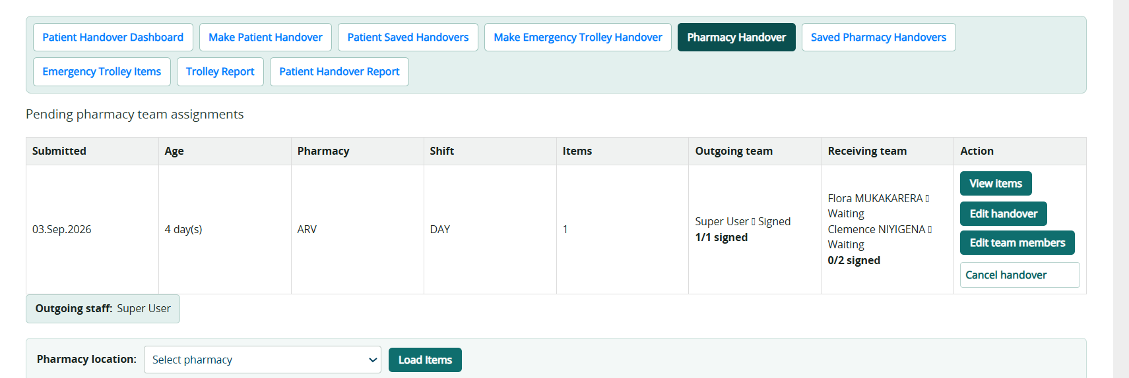
Figure 2 Pharmacy page with pending team assignments and pharmacy location controls

Pharmacy reports
Saved Pharmacy Handovers provides From and To date filters, pharmacy, shift, and status filters. View items displays the handed snapshot. View history shows amendments and signature events. Export CSV downloads one filtered dataset; Download PDF produces a readable report, and each handover can be exported individually.
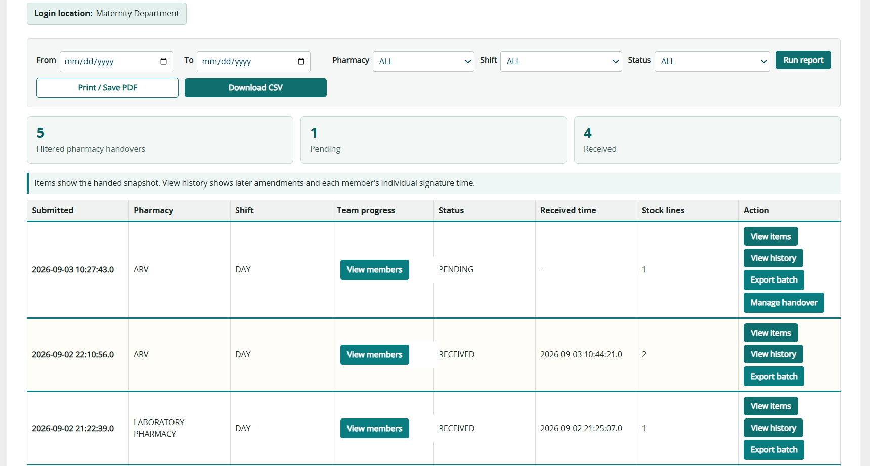
Figure 3 Pharmacy report filters, summary, team progress and handover actions

6 Emergency trolley handover

Configure trolley types and stock thresholds
- Open Emergency Trolley Items with the Patient Handover: Manage privilege. Add each trolley type with a name, a code, and an optional description. Trolley types belong to the current login location.
- Select the trolley before maintaining its catalogue. Add items manually or import the CSV or XLSX template. The current template columns are Item Name, Starting Quantity, Minimum Quantity, and Standard Note.
- Set a non-negative minimum quantity when adding an item, or edit it later in the trolley item list. The Stock Status column shows LOW STOCK and highlights the row when Current Quantity is below Minimum Quantity; a quantity equal to the minimum shows OK.
- Low-stock status is evaluated as current quantity less than minimum quantity. Zero is valid for both starting and handover quantities; negative values are rejected.
- Retiring an item removes it from future transactions without deleting historical handovers. Existing item names in an import are skipped, and an upload never removes catalogue items.

Create and receive
1. Open Make Emergency Trolley Handover, select the trolley type, and select the shift.
2. Type provider names to add any number of outgoing and receiving team members.
3. Review the item list. Set the handed quantity and observation. A zero quantity is valid and remains visible for safety review; negative quantities are rejected.
4. Submit the handover. Quantities and notes remain part of the transaction snapshot.
5. Each team member signs. When all outgoing and receiving members have signed, the handover becomes Received.
Trolley Report supports From and To dates, shift, and status filters. The results identify the trolley type, transaction, team progress, status, item count, and completion or cancellation time. Users with export permission can download filtered CSV and PDF reports or an individual handover PDF; PDF details include the trolley type.

7 Equipment handover

Create the equipment catalogue
Users with management permission may add equipment manually or upload the supplied CSV template. The template columns are Equipment name, Quantity, Status, and Observation. Typical statuses include FUNCTIONAL, NEEDS MAINTENANCE, and OUT OF SERVICE.
- Use Download template before preparing a bulk upload.
- Quantity must be numeric and cannot be negative.
- Observation records condition details that do not fit the status value.

Make an equipment handover
1. Open Equipment Handover and select Day or Night shift.
2. Type provider names to add the sending and receiving teams.
3. Select individual equipment lines or Select All.
4. Enter the Handed quantity for every selected line. It must be greater than zero and cannot exceed Available quantity. The catalogue quantity is not overwritten by this entry.
5. Submit selected items or submit all equipment items.
6. Review pending team progress and sign when the action is available to the current member.

Equipment report
Open Equipment Report. Filter by From date, To date, shift, and status. Results are paginated. View items expands the equipment name, handed quantity, status, and observation. Download CSV exports the filtered rows. Download PDF exports the full filtered report, while the row action downloads one handover with both teams and signature times.

8 Laboratory handover
Laboratory Handover lists patients who have a laboratory order with a lab code (accession number) but no result yet, so that the outgoing laboratory team can hand pending work over to the next shift.

Requirements
- Sign in at a laboratory location: a location whose name, or whose parent location’s name, contains “Laboratory” or “Lab”. Administrators can allow other locations by listing their IDs in patienthandover.laboratoryLocationIds.
- The global property laboratorymanagement.orderType.labOrderTypeId must contain the laboratory order type ID; otherwise the page reports that the worklist is unavailable.
- Creating and signing as a sender requires Patient Handover: Create; signing as a receiver requires Patient Handover: Receive.

Make a laboratory handover
1. Open Laboratory Handover. Set the Laboratory worklist period (From and To; by default the last two days) and choose Load worklist. The worklist covers the facility of the current login location.
2. Review Patients with a lab code and no result. Use Remove to hide a row that should not be handed over.
3. To add a patient who is not listed, use Find and add a patient: search by patient name, identifier or lab code and choose Add to worklist. Patients whose results are already recorded cannot be added.
4. Tick the patients to hand over and enter a comment for each where useful (up to 2000 characters).
5. Select the shift, add the sending and receiving team members from the provider suggestions, and choose Submit selected patients.
Note: Orders whose results were recorded after the worklist was loaded are skipped at submission. If the page reports that the selected orders are no longer available, reload the worklist.

Sign and complete
- Pending laboratory handovers are shown to their team members, the creator and managers. View patients shows the handed patients, lab codes, order dates and comments.
- Senders sign with Sign as sender. Receivers use Mark my receipt after every sender has signed. The handover becomes Received when all team members have signed.
- While the handover is pending, the creator or a manager can use Edit to correct the comments.

Laboratory Handover Report
Open Laboratory Handover Report, filter by From, To, shift and status, and choose Run report. View patients expands each handover. Download CSV and Download PDF export the filtered handovers and require Patient Handover: Export Reports; each handover also has its own Download PDF action.

9 Reports and exports
Report | Filters | Screen details | Downloads
Patient Handover Report | From, To, care setting, shift, status | Batch, patients, SBAR, tasks, teams and status | Filtered PDF, individual PDF, CSV
Saved Pharmacy Handovers | From, To, pharmacy, shift, status | Stock snapshot, history, teams and progress | Filtered PDF, individual PDF, CSV
Trolley Report | From, To, shift, status | Transaction, trolley type, quantities, notes, teams and progress | Filtered PDF, individual PDF, CSV
Equipment Report | From, To, shift, status | Equipment, handed quantity, condition, teams and progress | Filtered PDF, individual PDF, CSV
Laboratory Handover Report | From, To, shift, status | Patients, lab codes, order dates, comments, teams and progress | Filtered PDF, individual PDF, CSV

PDF identity header: configure billing.healthFacilityCountryHeading, billing.healthFacilityName, billing.healthFacilityAddress, billing.healthFacilityEmail, and billing.healthFacilityLogo. The country falls back to hospital.country and registrationcore.country, then REPUBLIC OF RWANDA. The facility name falls back to hospital.name and facility.name, then Hospital. Address, email, and logo also accept the corresponding hospital.* and facility.* fallback properties. The logo value must resolve to an image that the server can load.
Batch separation: full PDF and CSV reports preserve handover-by-handover grouping. Individual PDF actions export only the selected handover. On-screen pagination does not restrict the full filtered download.
Confidentiality: exported files may contain patient, staff, pharmacy, or operational data. Store, transmit, and dispose of them according to facility policy.

10 Administration and technical reference

Core data concepts
Term | Meaning
Transaction key | Stable identifier linking a handover to its teams and history
Snapshot | The patients or items and values saved at submission time
Team member | A sending or receiving person with an independent signature state and time
Pending | At least one required signature is not complete
Received | All active sending and receiving signatures are complete
Cancelled | A pending transaction was cancelled with an audit reason
Pagination | A screen displays a limited page while exports can include the complete filtered set

Global properties
Change these values in Administration > Settings (or Advanced Settings). Changes take effect the next time a page is opened; no restart is required.
Property | Default | Purpose
patienthandover.overdueHours | 2 | Hours after which a pending patient handover is shown as overdue
patienthandover.laboratoryLocationIds | (empty) | Comma-separated location IDs allowed to use Laboratory Handover in addition to locations named Laboratory or Lab
laboratorymanagement.orderType.labOrderTypeId | (site specific) | Order type of laboratory orders used by the laboratory worklist
patienthandover.sbar.prefillEnabled | true | Fill in empty SBAR boxes from the patient’s records
patienthandover.sbar.maxAgeDays | 0 | 0 uses the latest value of any age; a number of days ignores older values
patienthandover.sbar.situationConcepts | see section 4 | Concepts used for Situation, in display order
patienthandover.sbar.backgroundConcepts | see section 4 | Concepts used for Background
patienthandover.sbar.assessmentConcepts | see section 4 | Concepts used for Assessment
patienthandover.sbar.recommendationConcepts | see section 4 | Concepts used for Recommendation

Each SBAR concept list is comma-separated. An entry may be a concept UUID, a numeric concept ID or a SOURCE:CODE mapping such as CIEL:1284. Concepts that do not exist are skipped and reported in the OpenMRS log with the text “SBAR pre-fill”. Several defaults are numeric concept IDs taken from the facility forms; check them when moving to another server. The setting patienthandover.sbar.lookbackDays from version 1.5.0 is no longer used and may be deleted.

Database and service integration
The module stores patient, pharmacy, trolley, equipment, team-member, and audit records in indexed handover tables. Version 1.2.6 added named emergency trolley units, associates trolley catalogue items and trolley handovers with a trolley, and stores a minimum quantity for each trolley item. Liquibase creates a default trolley for existing catalogue records and links legacy trolley handovers without changing their saved item snapshots.
Version 1.4 adds laboratory_handover and laboratory_handover_item for laboratory handovers. Version 1.5 adds patient_handover_draft, which keeps one unsubmitted Make Patient Handover form per user, location and care setting. Signing locks the team rows of the transaction so that simultaneous signatures are recorded safely.
Pharmacy inventory is obtained through the Rwanda Pharmacy Management API. If startup or page loading reports Service not found for org.openmrs.module.rwandapharmacymanagement.api.InventoryService, verify that the correct Rwanda Pharmacy Management module version is installed and started before Handover.

Useful diagnostic queries
Run read-only queries only against a backup or under database-administrator supervision. Table names should be confirmed against the deployed Liquibase schema.
SELECT module_id, started FROM openmrs_module WHERE module_id IN ('patienthandover','rwandapharmacymanagement');
SELECT handover_type, role, signed, COUNT(*) AS members
FROM handover_team_member
WHERE voided = 0
GROUP BY handover_type, role, signed;
SELECT t.trolley_name, i.item_name, i.current_quantity, i.minimum_quantity
FROM emergency_trolley_item i
JOIN emergency_trolley_unit t ON t.trolley_id = i.trolley_id
WHERE i.active = 1 AND i.voided = 0
AND i.current_quantity < i.minimum_quantity
ORDER BY t.trolley_name, i.item_name;

Do not update status or signature fields directly in SQL. Use the application workflow so audit history, signer identity, and completion rules remain consistent.

11 Verification checklist
- Only handover-1.5.2.omod is deployed; all earlier Patient Handover or Handover OMOD versions were removed first.
- Handover starts without Liquibase or WebApplicationContext errors.
- The login location is displayed and controls the work context.
- On Make Patient Handover, Select all on this page and Remove selected work, and Admitted from/to returns the active patients admitted in that period.
- For a patient with recorded notes or vital signs, SBAR boxes show text marked REVIEW with the source date.
- A draft started on one computer is restored on another for the same user, location and care setting, and disappears after the handover is submitted.
- At a laboratory location, Laboratory Handover loads pending laboratory orders and a submitted laboratory handover can be signed by both teams.
- Additional senders and receivers can be selected by typing provider names on every handover type.
- Team progress shows correct signed/total values and View members separates both teams.
- Pharmacy items show code, batch, expiry date, and read-only available quantity.
- Each location can maintain named trolley types, each trolley has its own item catalogue, and trolley item lists paginate with a View All option.
- Equipment handed quantity is editable but cannot exceed available quantity.
- Patient, pharmacy, trolley, and equipment reports filter correctly and download populated CSV and PDF files.
- The configured country heading, facility name, address, email, and logo appear in PDF report headers, with documented fallback properties and defaults.

12 Troubleshooting
Symptom | Likely cause | Action
Unable to update data model using liquibase.xml | Old duplicate OMOD, partial earlier schema, or database permission issue | Stop Tomcat, keep only one OMOD, back up the database, and inspect the first Liquibase cause in the log.
Unable to refresh WebApplicationContext | A required module, class, or service did not load | Review the first nested exception and verify required modules are started.
InventoryService not found | Wrong or inactive Rwanda Pharmacy Management module | Install and start the module that exposes the expected API before starting Handover.
No viewProvider named patienthandover | Module did not start or URL points to an unavailable page | Confirm module status and inspect startup logs before reloading.
A team remains Pending | An active team member has not signed or team membership changed | Open View members and review each active member and signature time.
PDF returns 404 for a full report | Old controller or malformed report URL still deployed | Remove the old OMOD, deploy 1.5.2, restart Tomcat, and use the report page Download PDF action.
Styles appear unchanged | Browser or OpenMRS resource cache | Deploy only the new OMOD, restart, then perform a hard browser refresh.
Patient missing from automatic list | No active recent admission/location evidence | Widen Admitted from/to, check the latest encounter and admission state, or use manual add after clinical verification.
SBAR boxes stay empty | Nothing recorded for the configured concepts, pre-fill disabled, or concept IDs differ on this server | Check the patienthandover.sbar settings, search the OpenMRS log for “SBAR pre-fill”, and confirm that the ward’s forms record the configured concepts.
SBAR shows an old value | The latest recorded value is old; by default there is no age limit | Check the date in brackets and edit the text. Optionally set patienthandover.sbar.maxAgeDays.
Draft status shows Saved on this device only | The server could not be reached or the session expired | Keep the page open; saving is retried. If the session expired, log in again; the browser copy is kept.
Select all, Remove selected or Use records do nothing | An older page script is cached by the browser | Refresh with Ctrl+F5 and confirm that version 1.5.2 or later is deployed.
Laboratory Handover is available only at a laboratory location | The login location is not recognised as a laboratory | Log in at the laboratory location or add its ID to patienthandover.laboratoryLocationIds.
Laboratory worklist is unavailable | laboratorymanagement.orderType.labOrderTypeId is not configured | Set the property to the laboratory order type ID.

Appendix A Database tables
The Handover module creates or manages the following 19 tables. Most operational tables also contain standard OpenMRS audit fields: creator, date_created, changed_by, date_changed, voided, voided_by, date_voided, void_reason, and uuid.
Area | Table | Purpose | Main stored contents
Patient | patient_handover | One patient record within a handover transaction | patient_handover_id; patient_id; batch_uuid; priority; situation; background; assessment; recommendation; shift; care_setting; location_id; legacy receiving and acknowledgement fields; legacy task fields; cancellation fields.
Patient | patient_handover_task | Individual follow-up task for a handed-over patient | patient_handover_task_id; patient_handover_id; description; due_date; assignee_provider_id; completed; completed_by; date_completed.
Patient | patient_handover_audit_event | Audit event for patient handover and task activity | event ID; event_type; batch_key; handover_uuid; task_uuid; user_id; location_id; event_date; successful; details.
Shared teams | handover_team_member | Sending and receiving teams for patient, trolley, and equipment handovers | handover_type; transaction_key; person_id; participant_role; signed; signed_by; date_signed. Supports multiple members and independent signature times.
Pharmacy | pharmacy_handover | Pharmacy handover transaction header | pharmacy_handover_id; pharmacy_location_id; pharmacy_name; location_id; shift; legacy receiving provider; date_submitted; acknowledgement fields; cancellation fields.
Pharmacy | pharmacy_handover_item | Stock snapshot included in a pharmacy handover | pharmacy_handover_item_id; pharmacy_handover_id; inventory_balance_id; item_name; item_code; batch_number; expiry_date; available_quantity. One physical table; the later change set only repairs a partially applied installation when this table is missing.
Pharmacy | pharmacy_handover_participant | Pharmacy sending and receiving team signatures | pharmacy_handover_id; person_id; participant_role; signed; signed_by; date_signed.
Trolley | emergency_trolley_unit | Named physical trolley configured for one OpenMRS location | trolley_id; location_id; trolley_name; trolley_code; description; active. Version 1.2.6 creates a Default Emergency Trolley for existing trolley data during upgrade.
Trolley | emergency_trolley_item | Permanent emergency trolley catalogue for a named trolley at a location | item_id; location_id; trolley_id; item_name; current_quantity; minimum_quantity; standard_note; active. LOW STOCK applies when current_quantity is below minimum_quantity.
Trolley | emergency_trolley_handover | Emergency trolley handover transaction header | handover_id; location_id; trolley_id; shift; legacy receiving provider; status; date_submitted; date_received; received_by; cancellation fields.
Trolley | emergency_trolley_handover_item | Trolley item snapshot for one handover | handover_item_id; handover_id; item_id; item_name_snapshot; previous_quantity; handed_quantity; note.
Trolley | emergency_trolley_import | Audit summary for trolley catalogue imports | import_id; location_id; file_name; total_rows; items_added; items_skipped; items_failed; status; error_summary.
Legacy trolley | patient_handover_trolley_item | Original trolley item storage retained for compatibility | record ID; batch_uuid; item_name; remaining_quantity; unit; expiry_date; remarks. The current workflow uses the emergency_trolley tables.
Equipment | handover_equipment_item | Permanent equipment catalogue by location | equipment_item_id; location_id; equipment_name; available quantity; equipment_status; observation; active.
Equipment | equipment_handover | Equipment handover transaction header | equipment_handover_id; location_id; shift; status; date_submitted; date_received; received_by.
Equipment | equipment_handover_line | Equipment snapshot included in one handover | equipment_handover_line_id; equipment_handover_id; equipment_item_id; equipment_name; handed quantity; equipment_status; observation.
Patient | patient_handover_draft | Unsubmitted Make Patient Handover form of one user | draft_id; user_id; location_id; care_setting; draft_data (form values as JSON); date_created; date_changed; uuid
Laboratory | laboratory_handover | Laboratory handover transaction header | laboratory_handover_id; location_id; shift; status; date_submitted; date_received; received_by; audit fields
Laboratory | laboratory_handover_item | Pending laboratory order snapshot included in one handover | laboratory_handover_item_id; laboratory_handover_id; patient_id; patient_name; patient_identifier; lab_code; order_ids; ordered_on; comment

13 What’s new in version 1.5
This section summarises the changes since version 1.2.6. The instructions in the earlier sections already describe the current behaviour.
Update | How it works
Drafts in the user account | Make Patient Handover saves the form to the user account as well as the browser, restores the newer copy, and deletes it after submission. See section 4.
SBAR from patient records | Empty SBAR boxes are filled in from the latest recorded observations, or from the last handover, and marked REVIEW until edited. See section 4.
New patient layout | Patients are shown as cards with labelled SBAR boxes, status colours and a fixed bottom bar with the draft status and Submit handover.
Admission date range | Admitted from and Admitted to replace the Admitted within (days) list.
Laboratory handover | Team-based handover of pending laboratory orders, with report, CSV and PDF. See section 8.
Safer signing | Simultaneous signatures complete the handover correctly, a signature cannot be recorded twice, and a trolley handover cannot be received twice.
Input limits | SBAR boxes stop at 1000 characters and the server explains which patient’s text is too long.

Earlier updates in version 1.2.6
Update | How it works
Patient eligibility | The automatic IPD worklist uses active, admitted patients with a qualifying encounter in the previous two days. OPD uses current-day activity. A clinically appropriate patient absent from the automatic list may be added manually without this automatic-list condition.
One-by-one manual addition | Search for one patient, choose Add, then repeat for each additional patient. The temporary list is committed only when Add patients to worklist is selected.
Manual-only worklist | View manually added patients displays those patients in the main handover table, where they can be selected and given status, SBAR and tasks like automatically listed patients.
Validation recovery | Before server validation, patient selections, statuses, SBAR and task values are saved in the user session. If a required value is missing, the same worklist context and entered values are restored.
Patient statuses | Available values are STABLE, URGENT, CRITICAL, DIED, CURED/RECOVERED, DEFAULTED/LEFT CARE and TRANSFERRED. Reports summarize these statuses per handover.
Draft behavior | The browser draft protects work in progress. Server-backed rejected-form recovery adds protection after validation redirect. Successful submission clears rejected-form recovery.

Upgrade note
Remove every older patienthandover or handover OMOD before deploying handover-1.5.2.omod. Stop Tomcat, back up the database and module directory, deploy only one Handover OMOD, start Tomcat, and monitor the log until the module has started. Then refresh the browser with Ctrl+F5.

Appendix B Illustrated module workflows
The following screenshots were taken with version 1.2.6. From version 1.5, Make Patient Handover (Figures B3, B8, B11, B12 and B26) uses the patient cards, the Admitted from and Admitted to dates, the REVIEW markers and the bottom bar described in section 4; the steps are otherwise unchanged. Screen content varies with privileges, login location, available data and configuration.

Figure B1. OpenMRS home page and Handover entry point
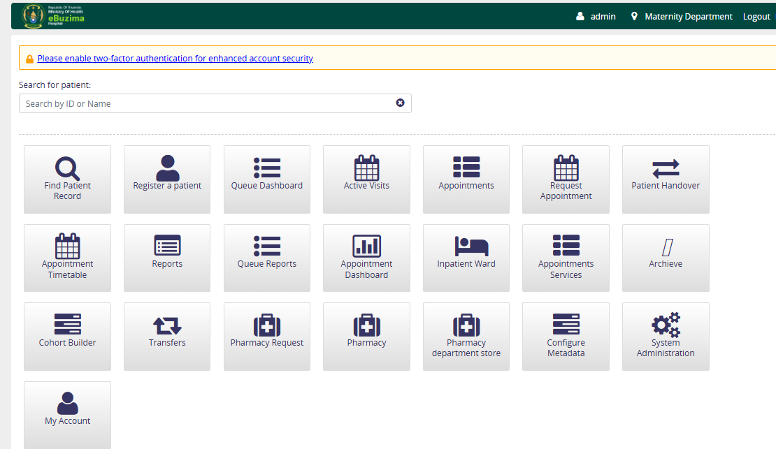
Figure B1: OpenMRS home page and Handover entry point
Confirm the login location shown in the upper-right corner before opening the module. The location determines which patients, trolley catalogues, equipment and pending assignments are shown. Select the Handover application tile to begin.

Figure B2. Patient Handover Dashboard
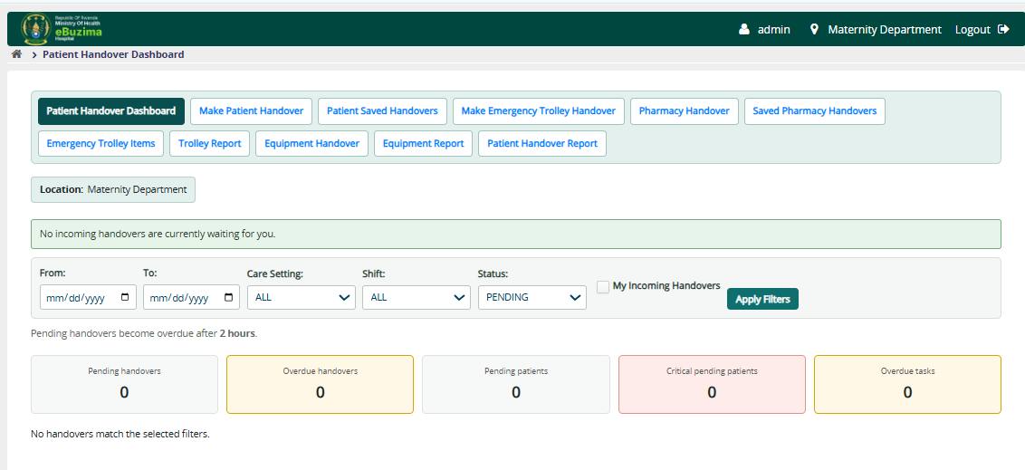
Figure B2: Patient Handover Dashboard
Use the dashboard to review handover activity for the current location. Filter by date range, care setting, shift and status. The summary boxes distinguish pending, completed and cancelled work so a supervisor can quickly identify incomplete transactions.

Figure B3. Opening Make Patient Handover
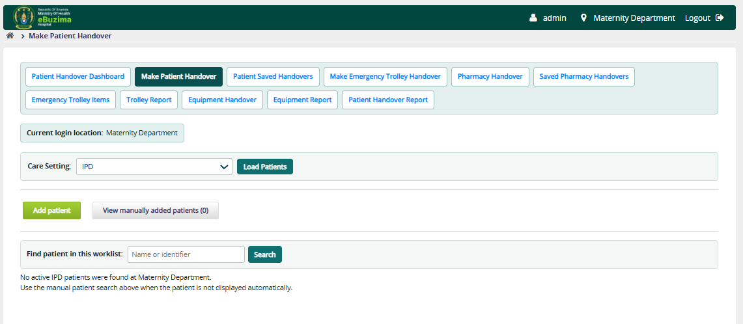
Figure B3: Opening Make Patient Handover
Select IPD or OPD and choose Load Patients. The automatic worklist contains eligible active patients for the current login location. IPD considers recent qualifying activity; manual addition remains available when an appropriate patient is not listed.

Figure B4. Opening the Add patient panel
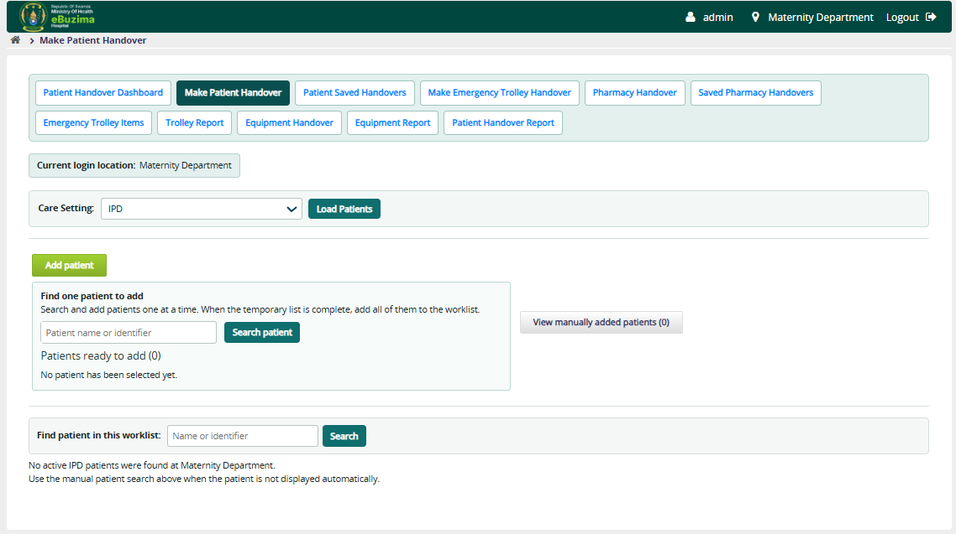
Figure B4: Opening the Add patient panel
Choose Add patient to open database search. Search by a patient name or identifier. This search does not immediately alter the worklist; it is used to find one patient for the temporary selection list.

Figure B5. Searching for one patient
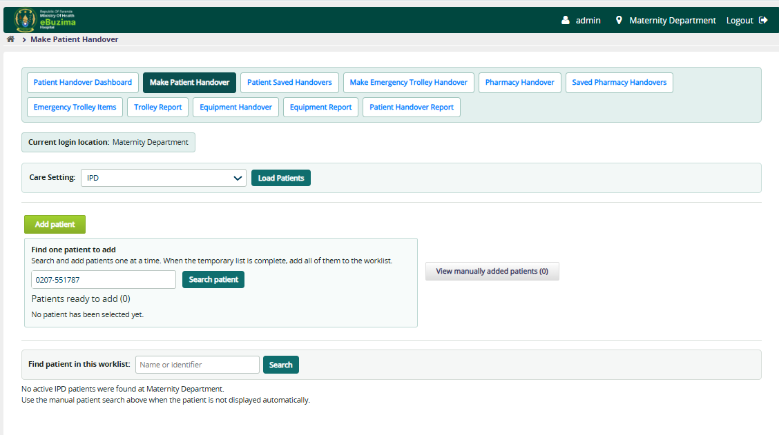
Figure B5: Searching for one patient
Enter enough of the name or identifier to identify the correct record, then choose Search patient. Verify both the patient name and identifier before selecting Add, especially where patients have similar names.

Figure B6. Adding a search result to the temporary list
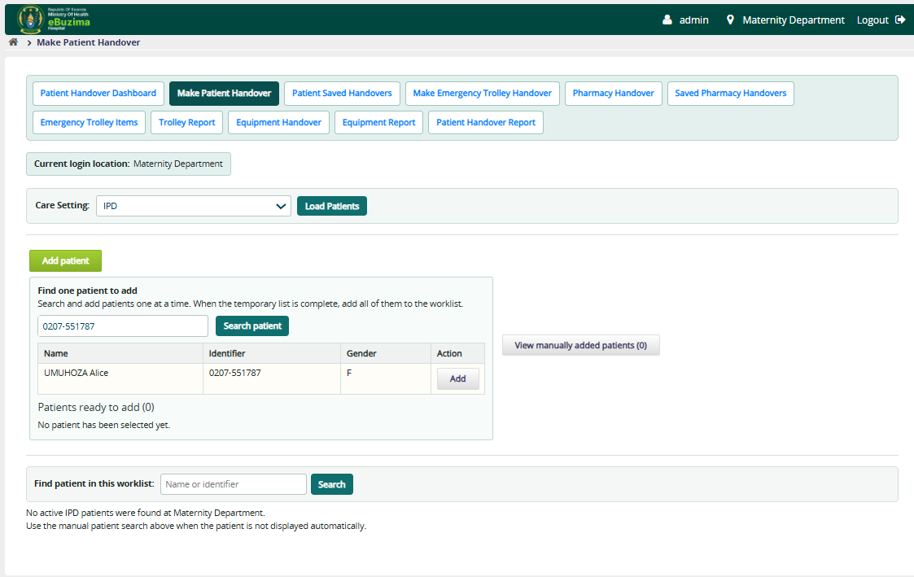
Figure B6: Adding a search result to the temporary list
Choose Add beside the correct search result. The patient is held in the temporary list. Search again to find another patient; repeat the same process until every required patient has been collected.

Figure B7. Completing the temporary patient list
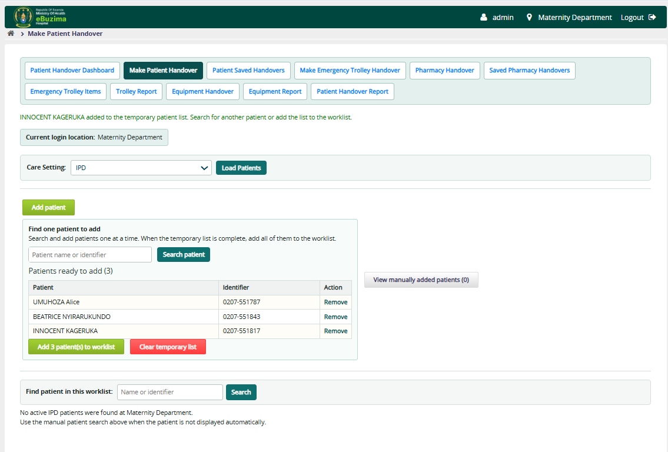
Figure B7: Completing the temporary patient list
Review Patients ready to add. Remove an incorrect entry if necessary. When the list is complete, choose Add patients to worklist once. View manually added patients then displays these records in the normal handover table.

Figure B8. Patient worklist and handover controls
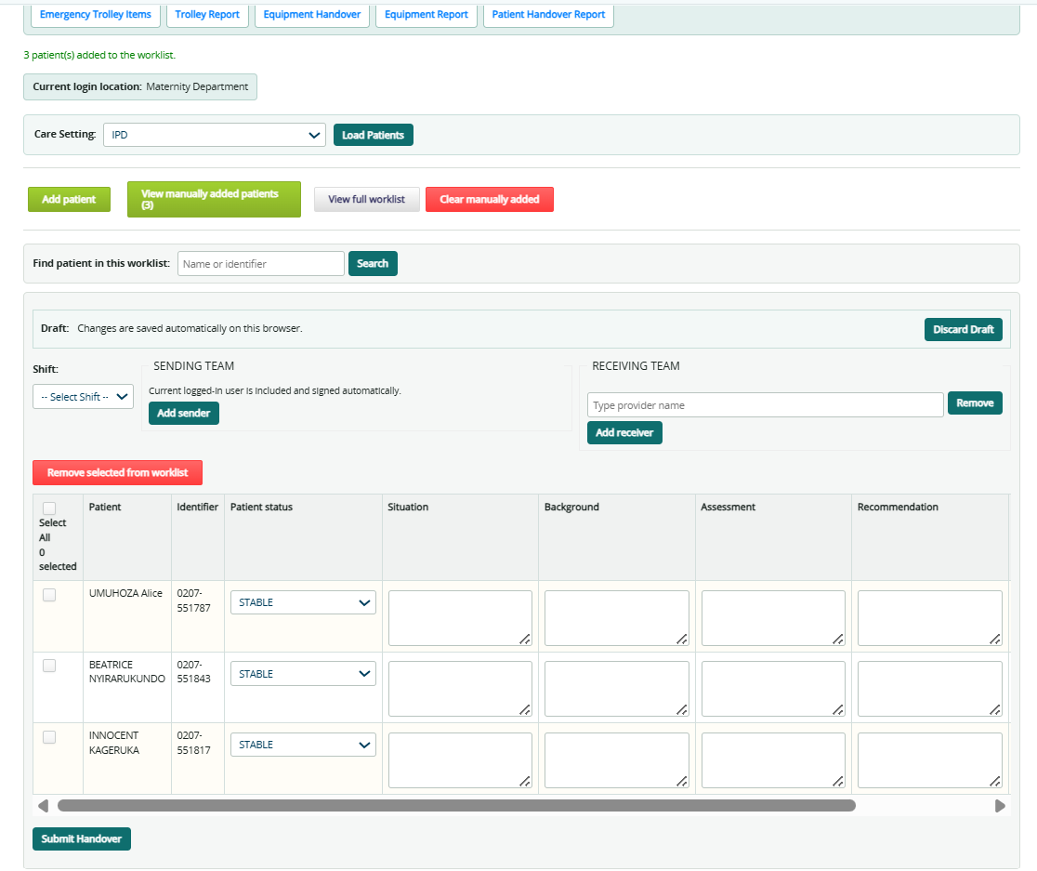
Figure B8: Patient worklist and handover controls
Select the shift, build the sending and receiving teams, and select the patients to hand over. View All is useful when selecting across the entire eligible list. Remove selected from worklist hides records that should not be included in the current work context.

Figure B9. Adding sending and receiving team members
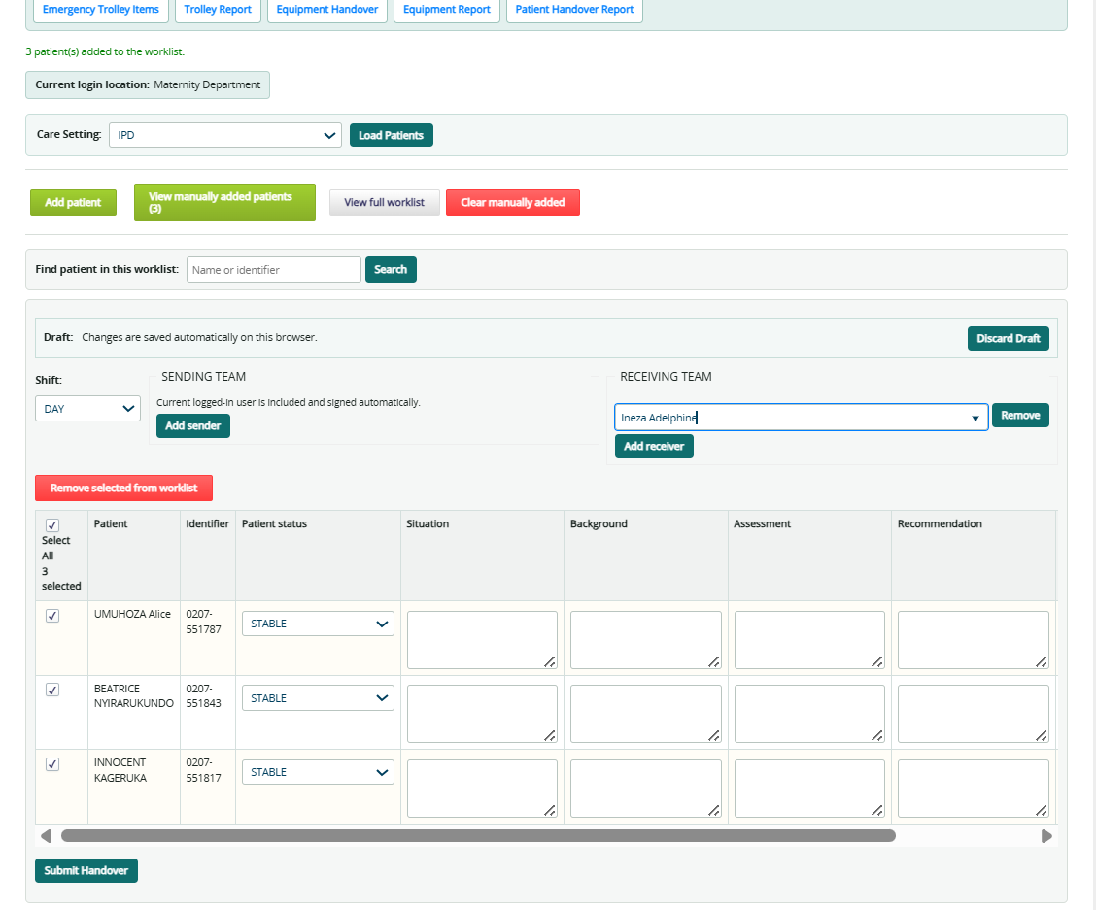
Figure B9: Adding sending and receiving team members
The authenticated creator is automatically included in the sending team and signs at submission. Use Add sender or Add receiver, type a provider name, and choose a suggestion from the list. At least one valid receiving provider is required.

Figure B10. Selecting a provider from suggestions
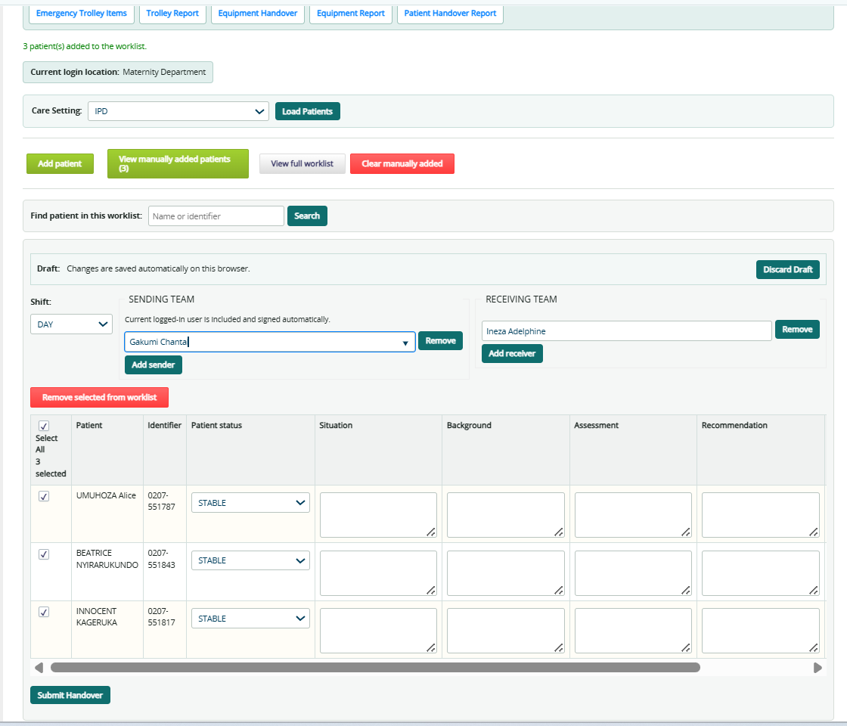
Figure B10: Selecting a provider from suggestions
A typed name is not sufficient by itself. Choose the matching provider suggestion so the provider ID is recorded. If a name remains unresolved, select the correct suggestion or remove that incomplete team row before submission.

Figure B11. Completing patient status and SBAR
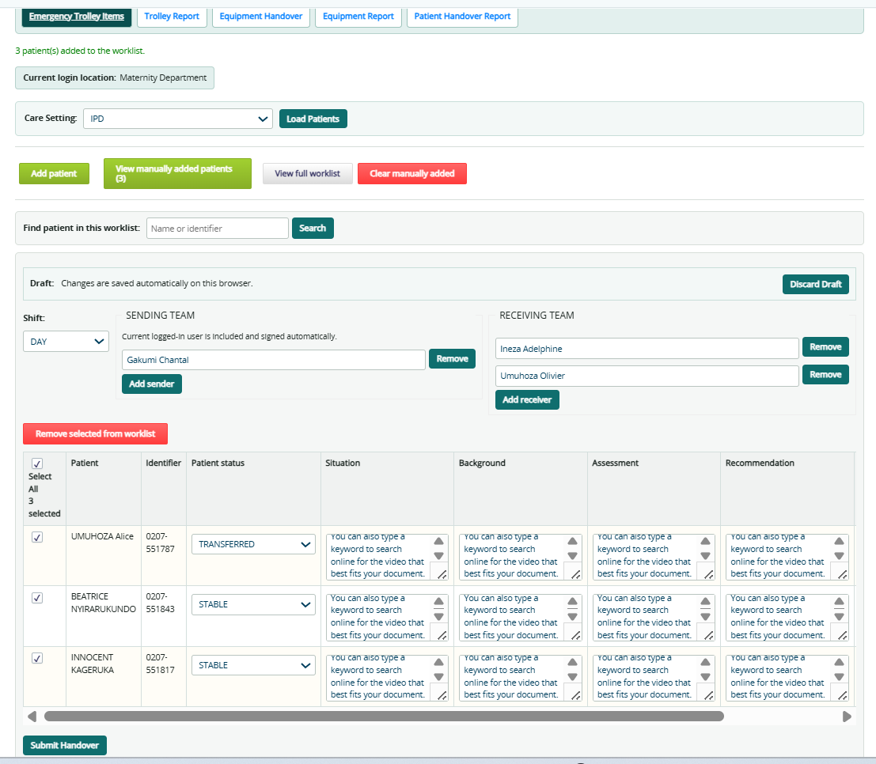
Figure B11: Completing patient status and SBAR
For each selected patient, choose the clinical status and record Situation, Background, Assessment and Recommendation as appropriate. SBAR is not mandatory, but meaningful entries improve continuity and should be concise, current and clinically relevant.

Figure B12. Adding individual follow-up tasks
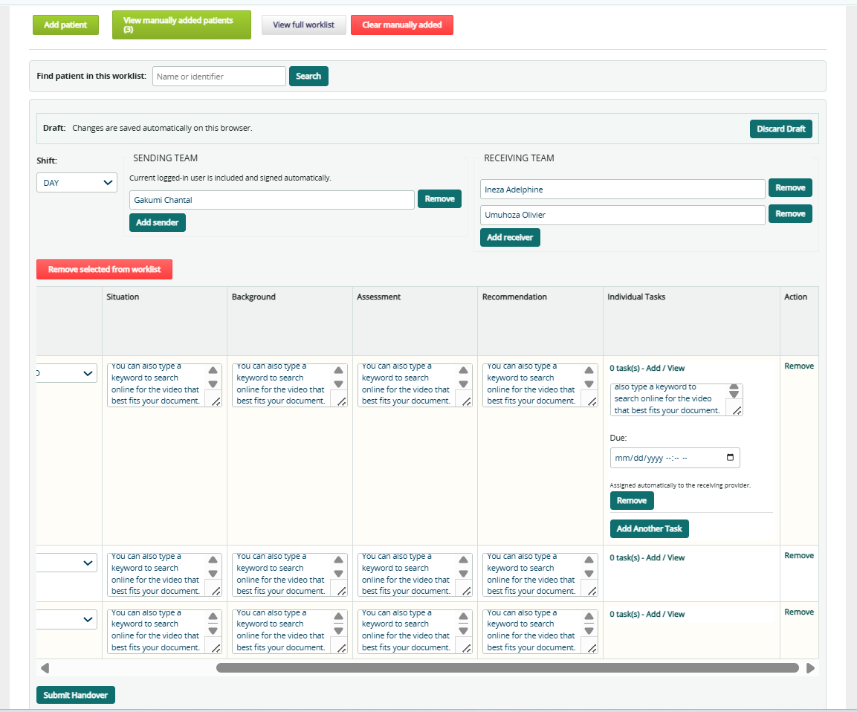
Figure B12: Adding individual follow-up tasks
Use Add/View tasks for patient-specific actions. Enter a clear task and due date/time. Each task is assigned to every active receiving team member, allowing the receiving team to see and complete follow-up responsibilities.

Figure B13. Monitoring a pending patient handover
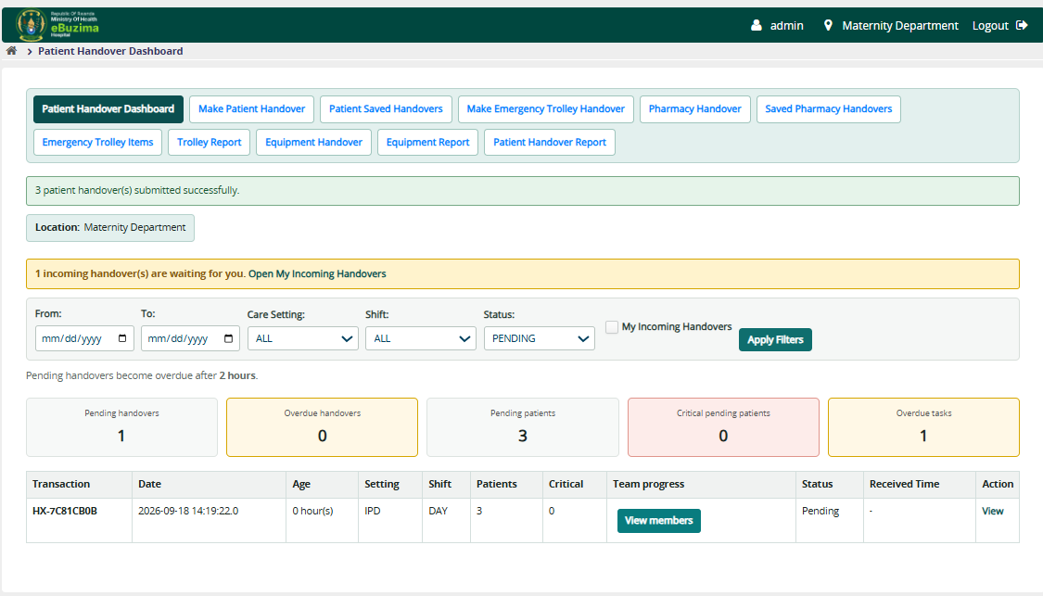
Figure B13: Monitoring a pending patient handover
Pending rows show transaction details and team progress. A handover remains pending until required senders and receivers have signed. Use View members to determine exactly who has signed and who remains.

Figure B14. Viewing team signature progress
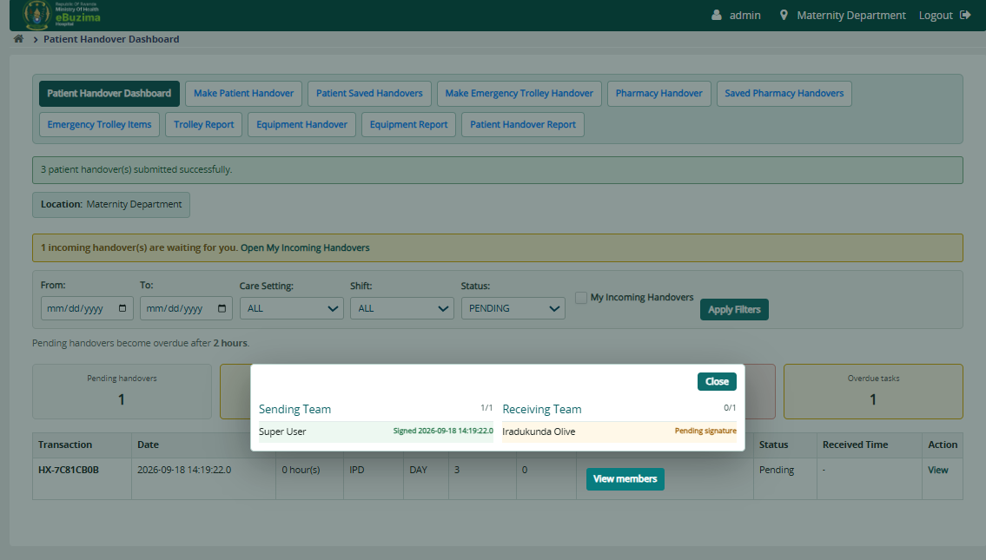
Figure B14: Viewing team signature progress
The members window separates Sending Team and Receiving Team. Signed/total counts provide a quick summary, while each member row shows signature state and time. Close the window after review.

Figure B15. Patient Saved Handovers
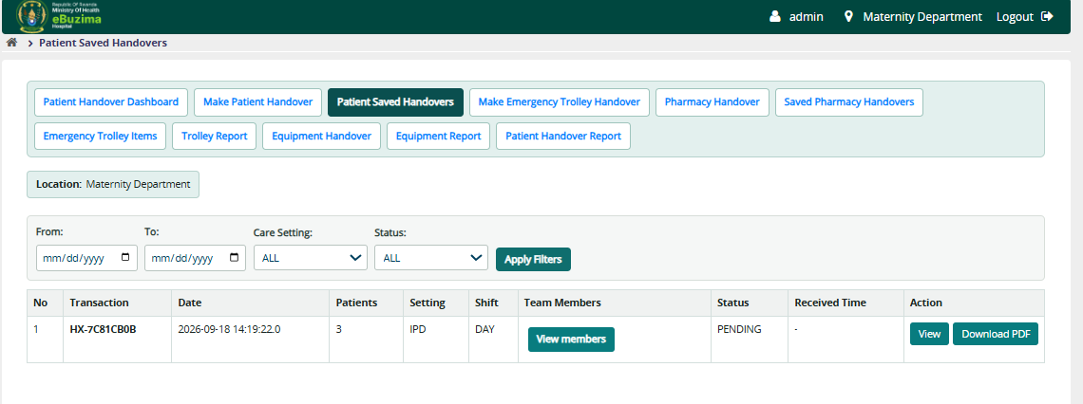
Figure B15: Patient Saved Handovers
Use filters to retrieve saved patient transactions. View opens clinical details and SBAR, View members opens team progress, and report actions export the filtered range or an individual transaction according to the selected action.

Figure B16. Emergency trolley type and item administration
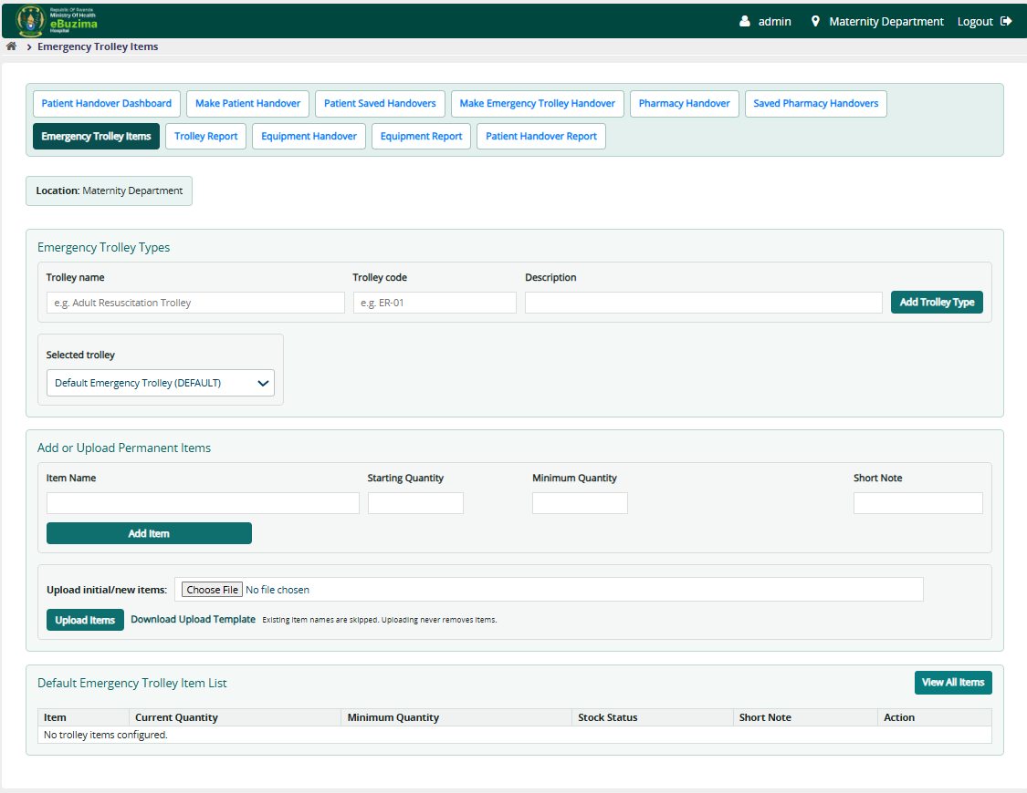
Figure B16: Emergency trolley type and item administration
Create named trolley types for locations that operate more than one trolley. Select the trolley before maintaining its catalogue. Add items manually or use the supplied import template.

Figure B17. Maintaining trolley quantities and minimum levels
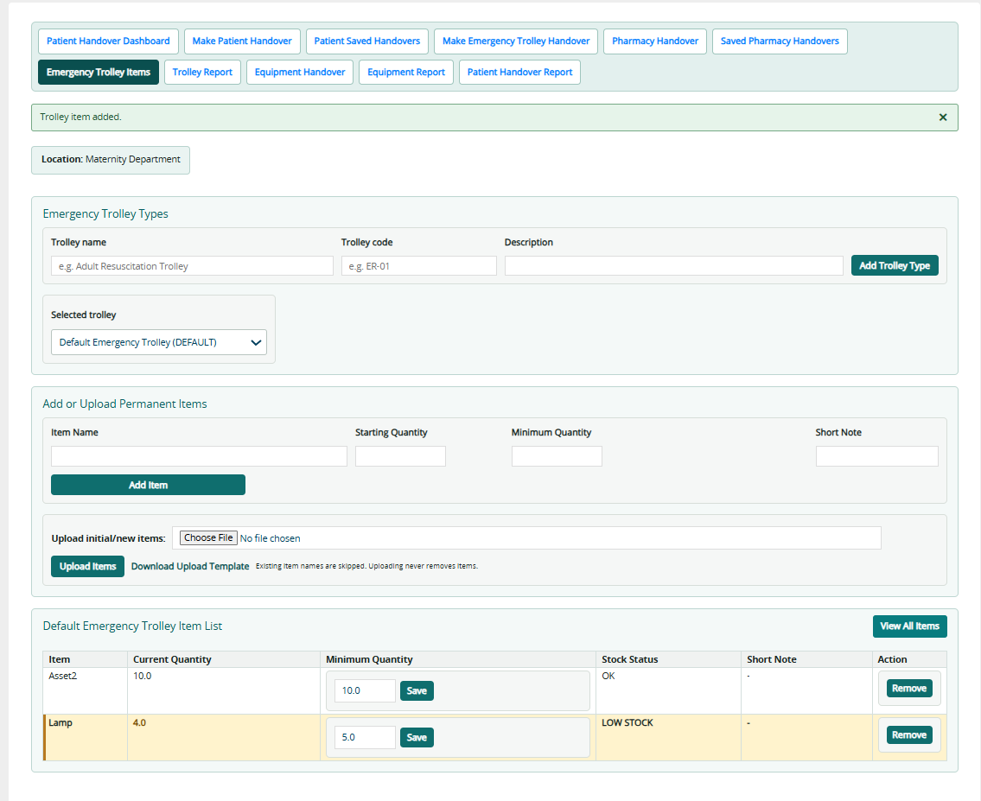
Figure B17: Maintaining trolley quantities and minimum levels
Each trolley item records starting/current quantity and minimum quantity. Edit minimum quantity when stock policy changes. A LOW STOCK warning appears when current quantity is below the configured minimum; existing items remain available unless explicitly retired.

Figure B18. Adding or editing a trolley type
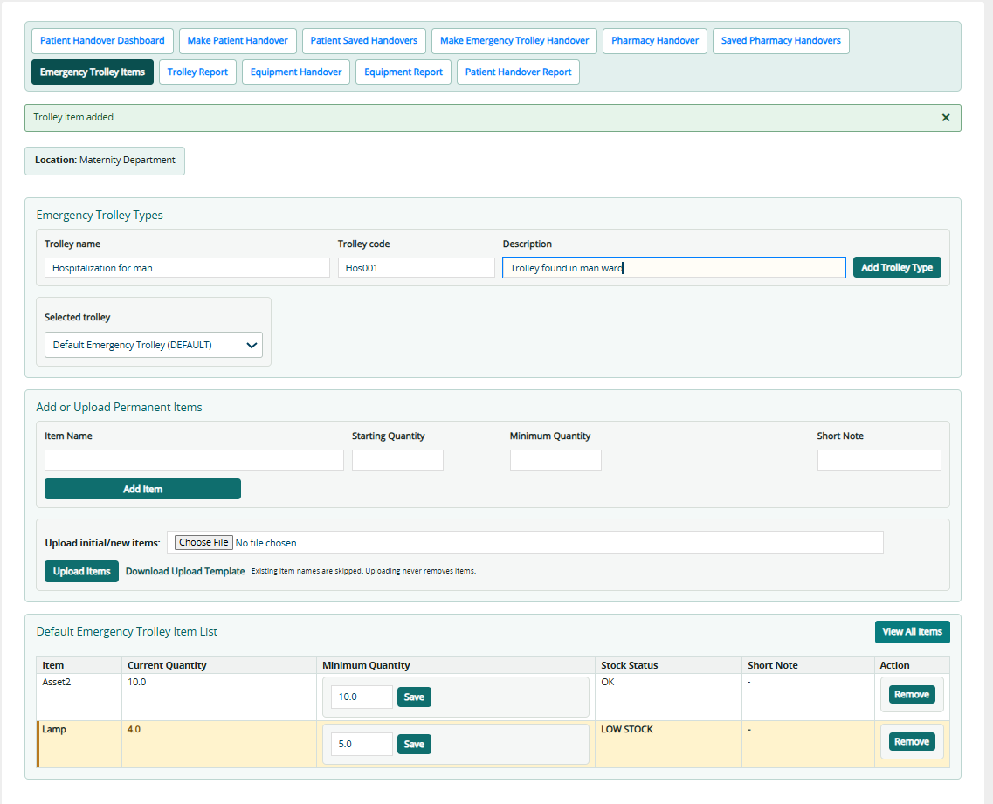
Figure B18: Adding or editing a trolley type
Provide a meaningful trolley name, a unique code and an optional description. The code helps distinguish similar units in reports. After saving, select that trolley before adding its item catalogue.

Figure B19. Making an emergency trolley handover
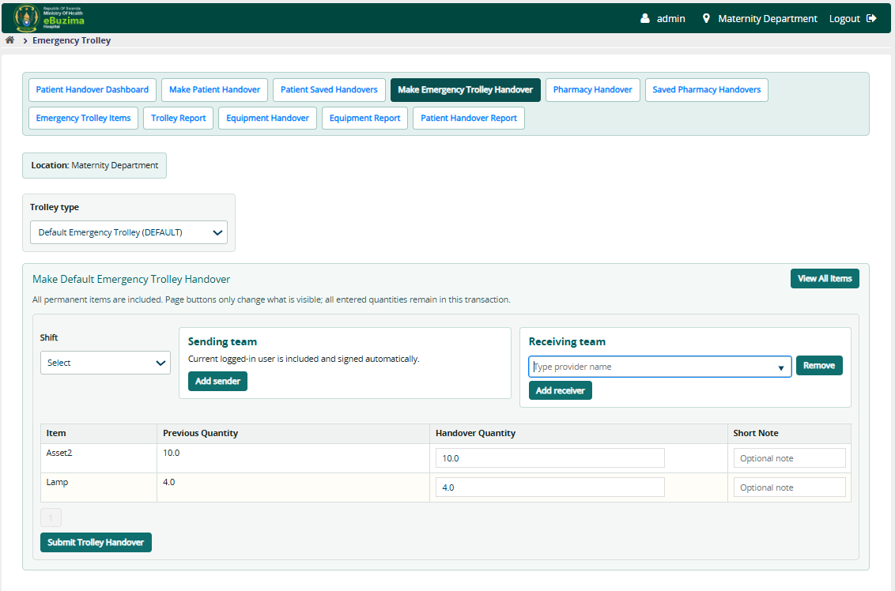
Figure B19: Making an emergency trolley handover
Choose the trolley type and shift, build both teams, and review every permanent trolley item. Enter handed quantity and a useful note where required. Submit only after comparing the physical trolley with the displayed catalogue.

Figure B20. Pending emergency trolley transaction
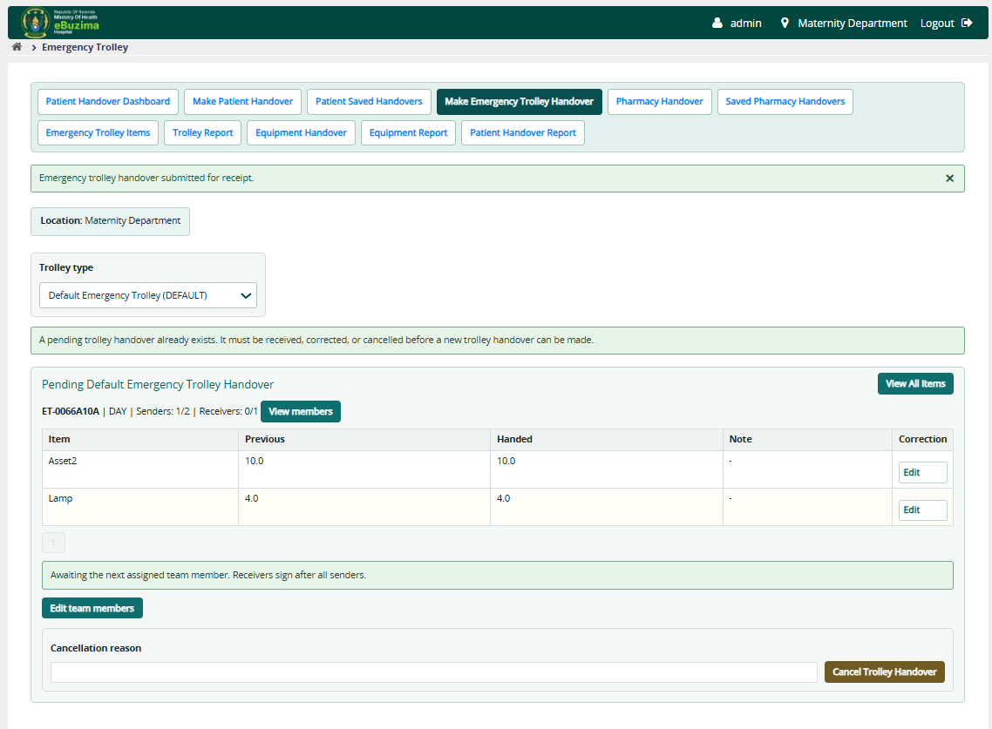
Figure B20: Pending emergency trolley transaction
The pending section identifies trolley type, shift, items and team progress. Assigned members use View members and the available signing action. Managers or the creator can manage the handover before completion where privileges permit.

Figure B21. Editing trolley teams or transaction details
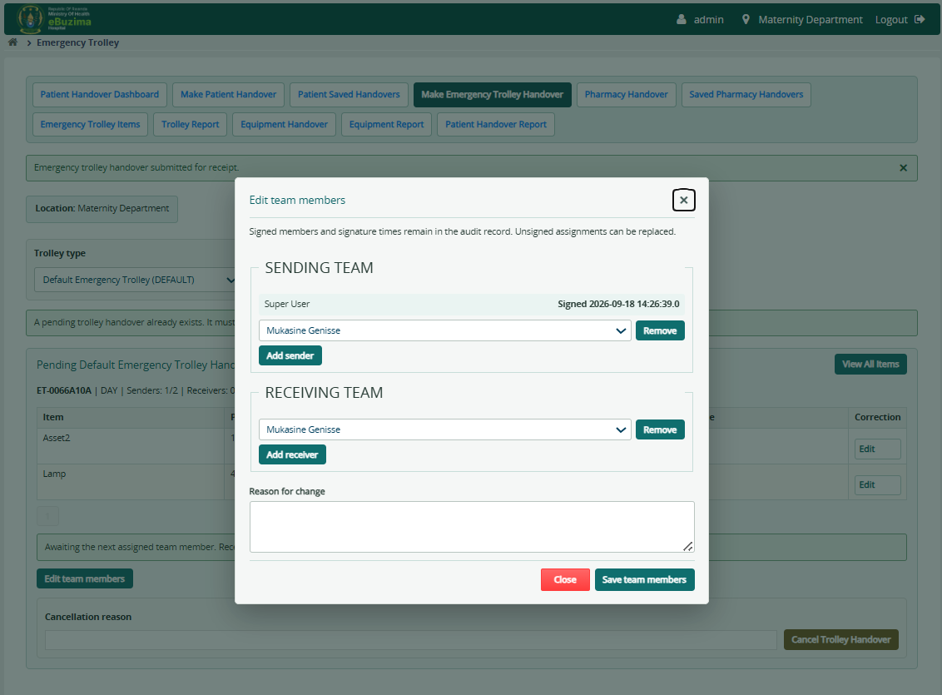
Figure B21: Editing trolley teams or transaction details
The management dialog separates sending and receiving teams and records a reason for change. Preserve already valid signers, remove only incorrect assignments and add replacement providers carefully because team changes affect completion status.

Figure B22. Equipment catalogue administration
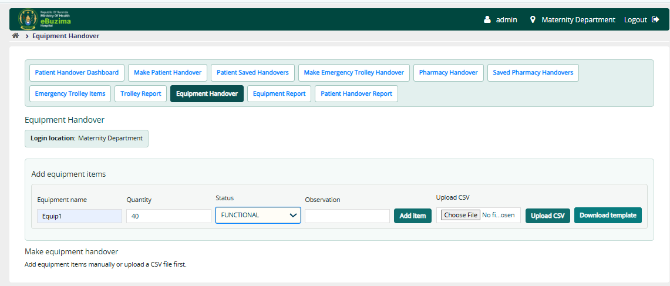
Figure B22: Equipment catalogue administration
Add equipment name, quantity, status and observation manually, or download and populate the CSV template. Upload validates the rows before creating catalogue entries. Use observations for condition details that are not represented by the status value.

Figure B23. Making an equipment handover
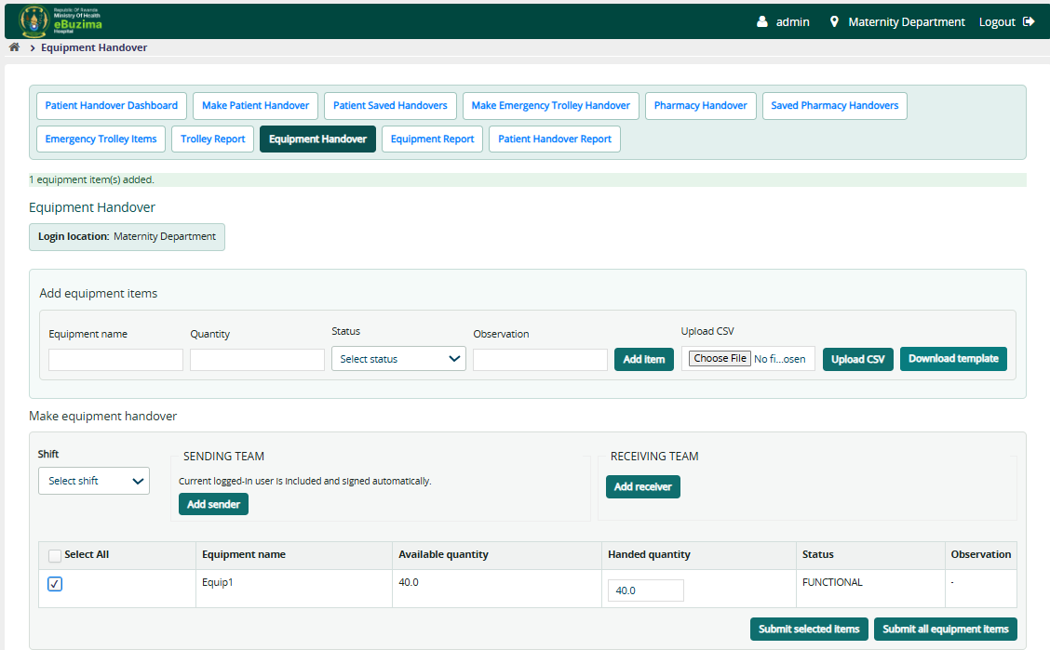
Figure B23: Making an equipment handover
Select the shift and teams, then select individual equipment or Select All. Enter the handed quantity for each selected line; it must be greater than zero and cannot exceed available quantity. Submit selected items or all catalogue items as appropriate.

Figure B24. Pending equipment handover
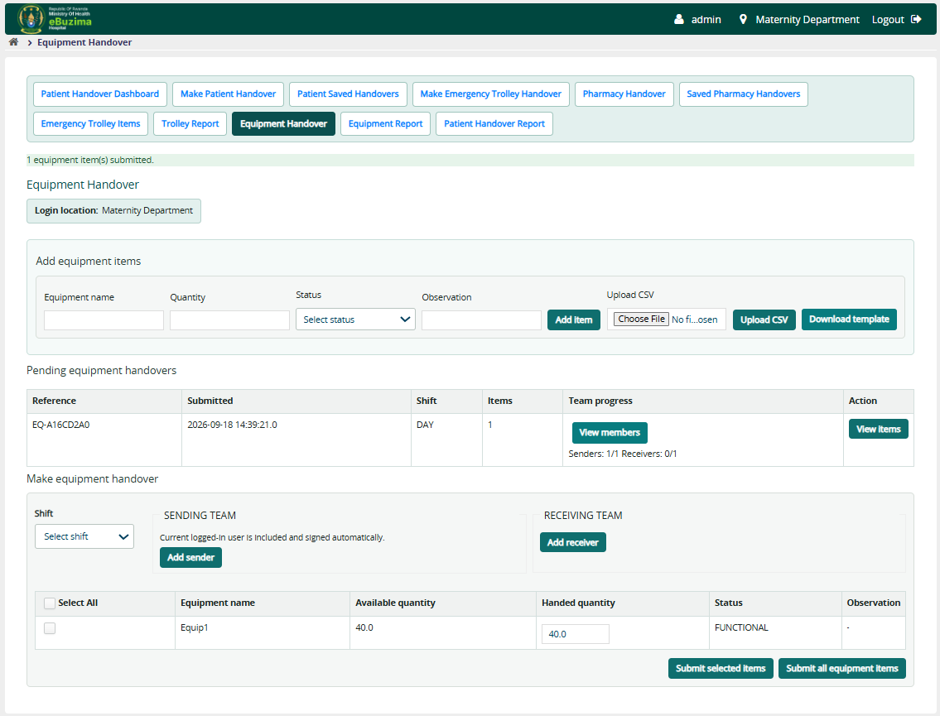
Figure B24: Pending equipment handover
The pending transaction row displays reference, date, shift, item count and team progress. View items verifies the handed snapshot. Assigned members sign individually; the transaction is complete only when required signatures are present.

Figure B25. Selecting a pharmacy and reporting period
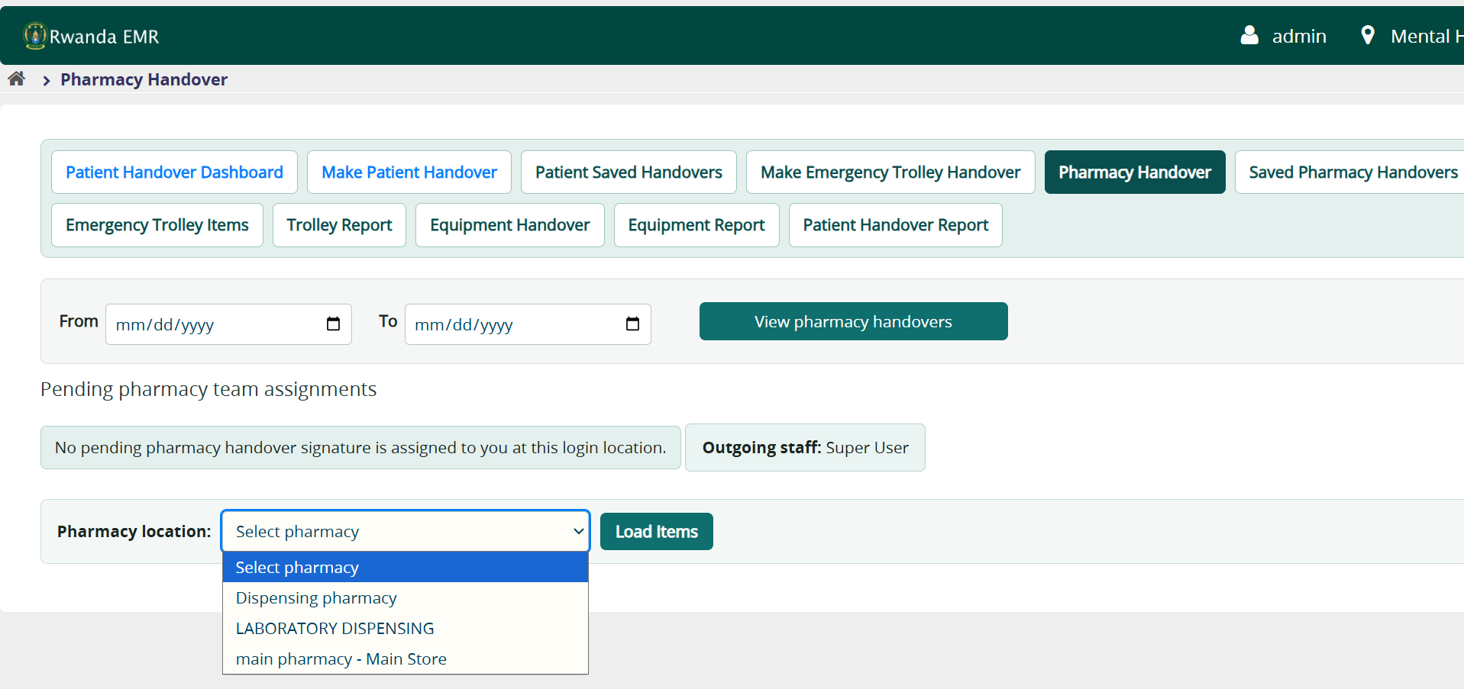
Figure B25: Selecting a pharmacy and reporting period
On Pharmacy Handover, choose From and To dates when reviewing activity, then select the pharmacy location and Load Items. Available stock is read from the Rwanda Pharmacy Management inventory service for the selected pharmacy.

Figure B26. Using patient status values
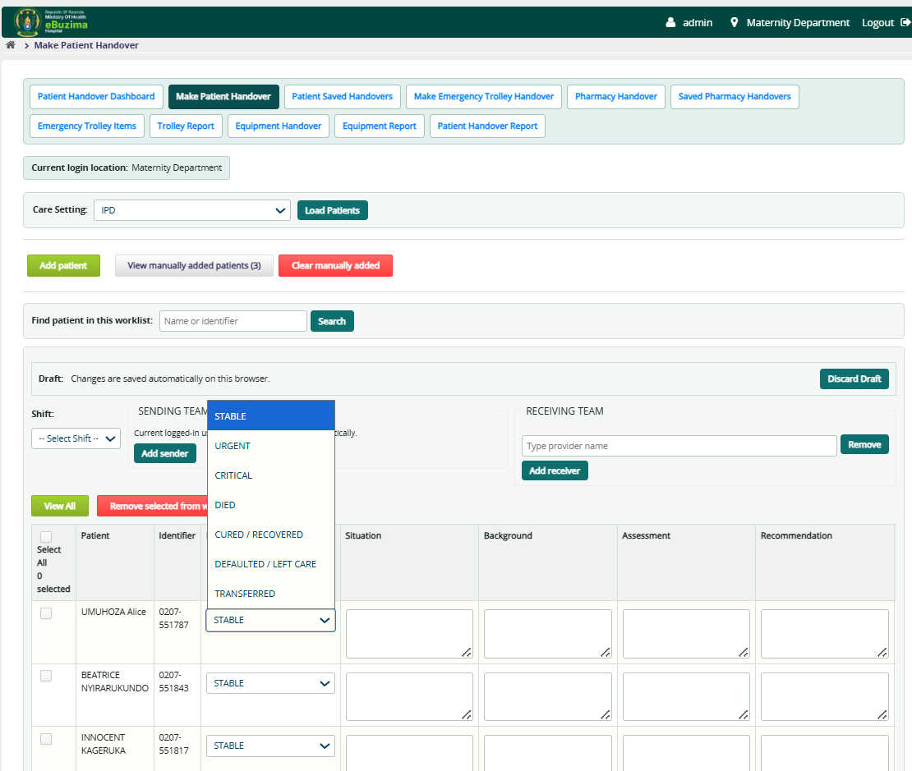
Figure B26: Using patient status values
Choose the status that represents the patient at handover: STABLE, URGENT, CRITICAL, DIED, CURED/RECOVERED, DEFAULTED/LEFT CARE or TRANSFERRED. The chosen status is retained in transaction details and summarized in patient reports.

Figure B27. Emergency trolley PDF report
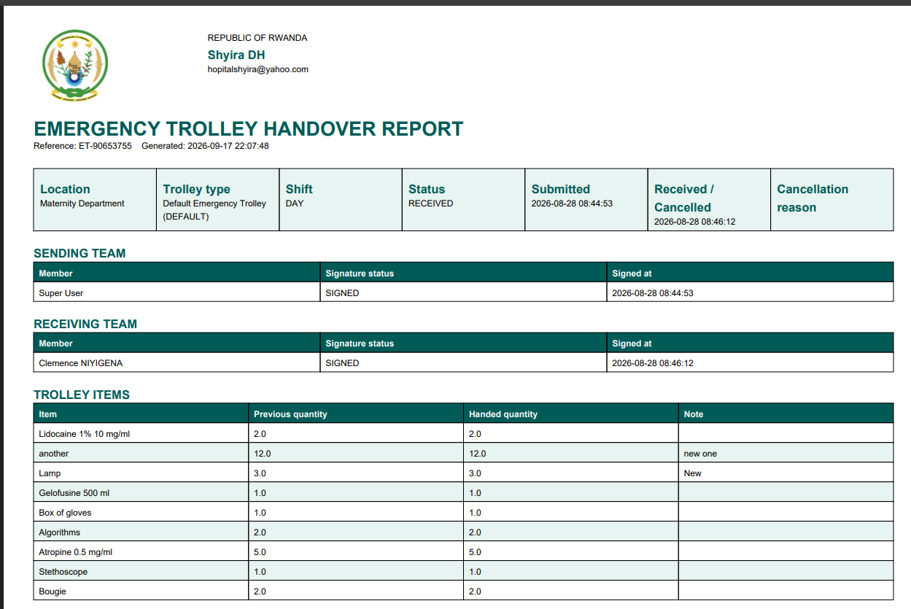
Figure B27: Emergency trolley PDF report
The PDF identifies the facility, trolley type, location, shift, status, submission/completion times, both teams and the handed item snapshot. Use it for an auditable printable record, subject to facility confidentiality and retention policy.

Figure B28. Pharmacy PDF report
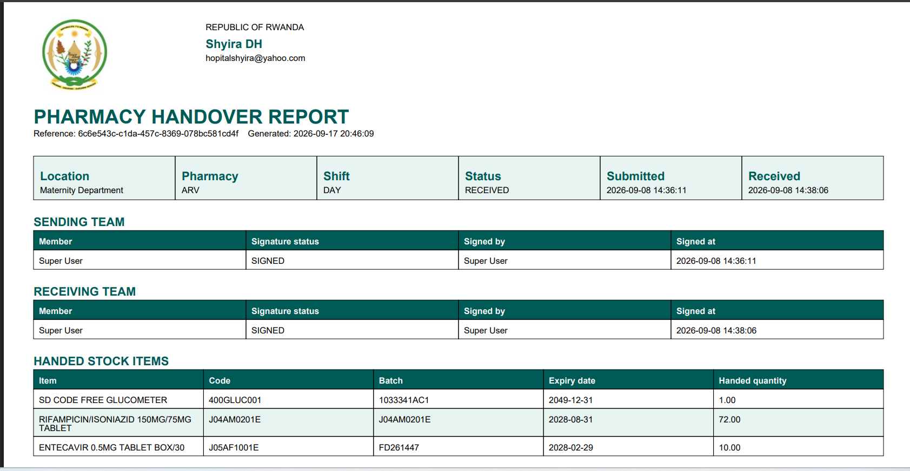
Figure B28: Pharmacy PDF report
The pharmacy report records facility identity, pharmacy, shift, status, sending and receiving signatures, and handed stock details including item, code, batch, expiry date and handed quantity.

Figure B29. Patient summarized PDF report
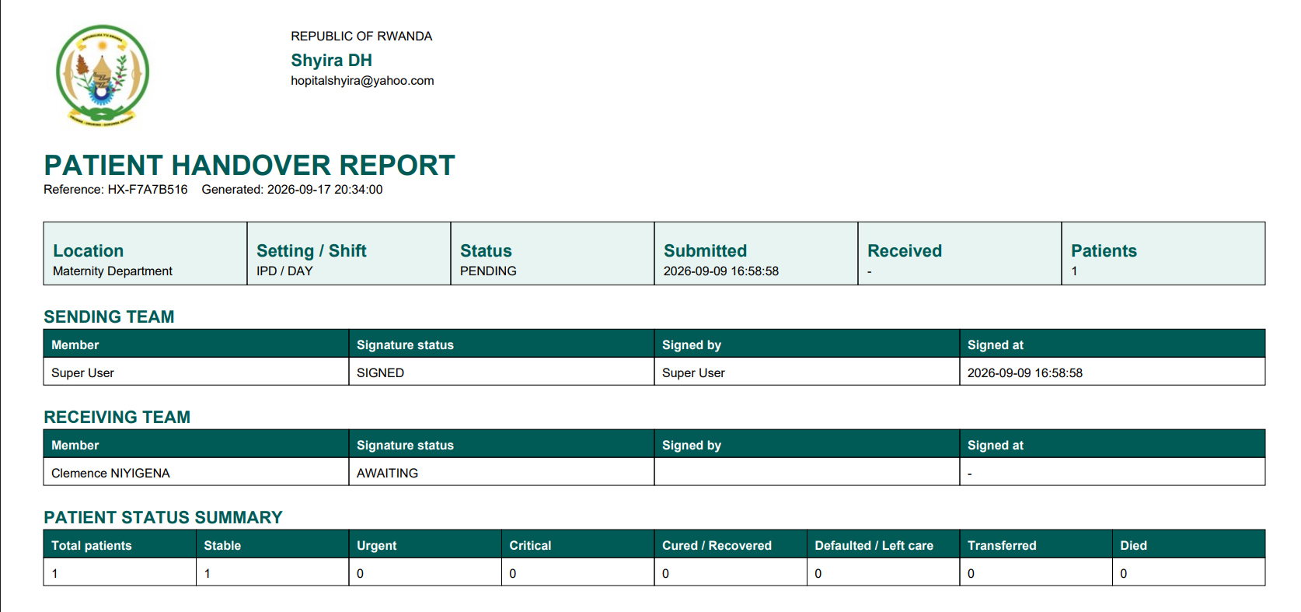
Figure B29: Patient summarized PDF report
The summarized patient report keeps each handover separate and shows facility identity, location, care setting/shift, status, timestamps, both teams and counts by patient status. Use the detailed export when SBAR-level information is required.

Figure B30. Detailed pharmacy handover export
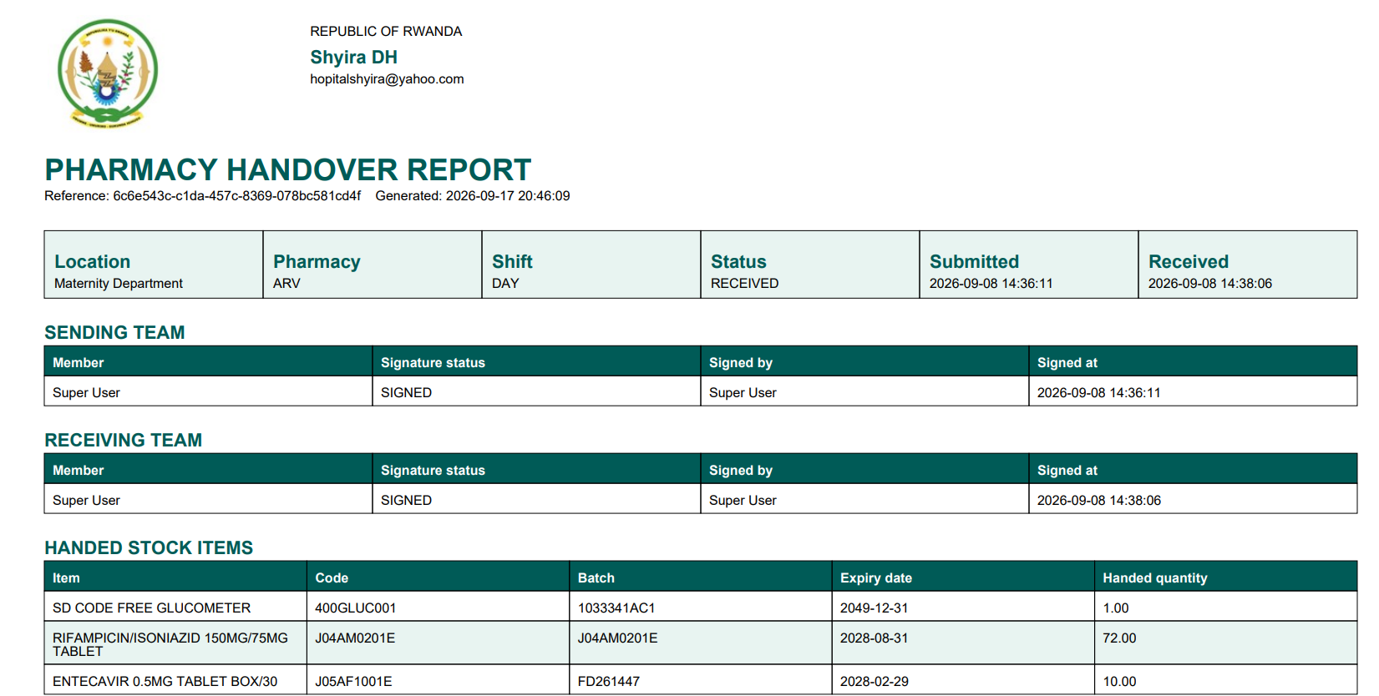
Figure B30: Detailed pharmacy handover export
A single-handover export shows the exact stock snapshot and team signature times for that transaction. It is different from a filtered multi-handover report, in which every handover begins on a new page.

Quick start for a new user
- Confirm the login location before opening Handover.
- Open the required handover type and select the shift.
- Select the patients or items that are physically and clinically being handed over.
- Add all outgoing and receiving providers by choosing names from provider suggestions.
- Review quantities, patient status, SBAR and tasks before submitting.
- Check every SBAR box marked REVIEW: correct or delete filled-in text that is out of date.
- Use View members to monitor signatures; do not share another member's account or sign on their behalf.
- Use the relevant report page and filters for operational review, then export PDF or CSV only when authorized.

