Whole Pharmacy Connection Diagram
Rwanda Pharmacy Management module overview
This document shows how OpenMRS clinical records, pharmacy master data, dispensing, inventory, supplier/RMS integration, HIE, SMS, reporting, and settings connect.
Whole Module View
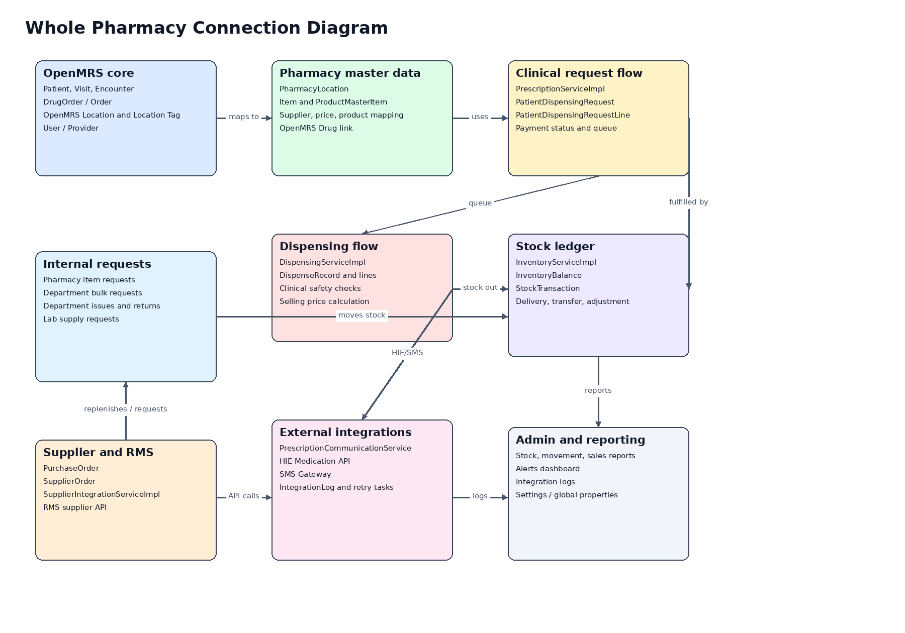

Prescription to Dispensing Flow
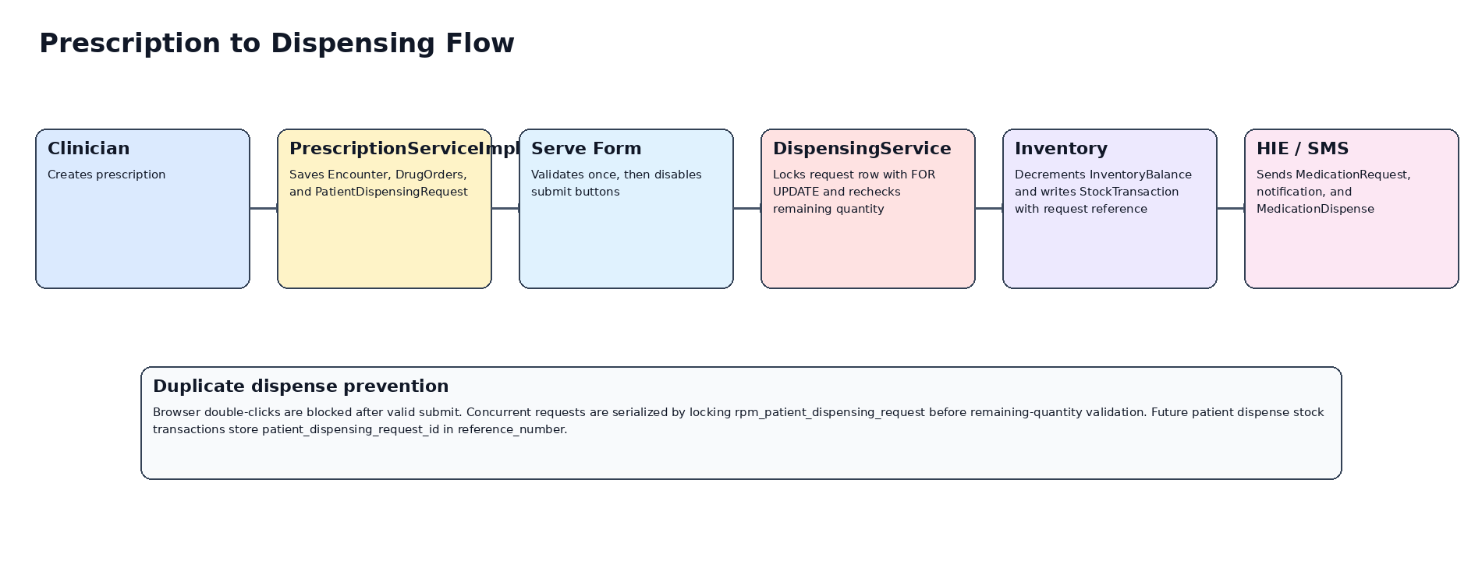

Stock Movement Summary
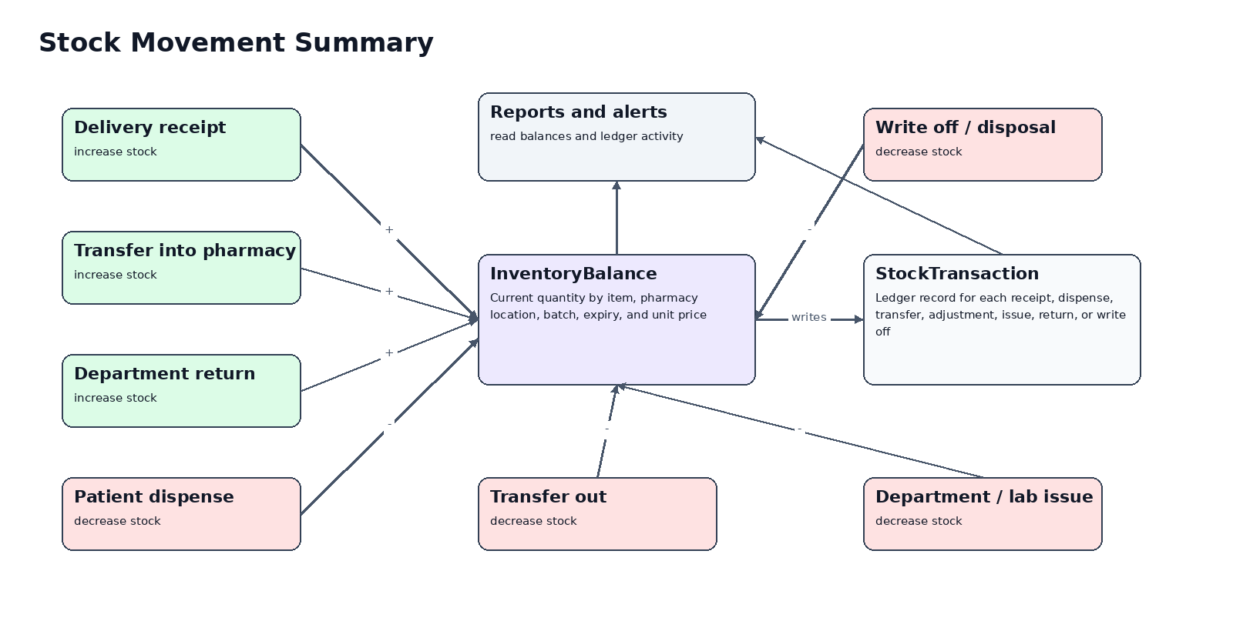
Duplicate Dispense Prevention
- The serve form disables submit buttons after client-side validation passes to prevent accidental double-click submits from the same browser page.
- Patient-request dispensing reloads the request with a database FOR UPDATE lock before checking already-dispensed quantities.
- Future patient dispense stock transactions store the request id in rpm_stock_transaction.reference_number and include it in remarks, for example Dispensed against request #123.
Key Code Anchors
- PrescriptionServiceImpl creates OpenMRS encounters/orders and module dispensing requests.
- DispensingServiceImpl validates dispensing, applies safety/pricing, reduces stock, records dispense transactions, and guards patient-request dispensing with a row lock.
- InventoryServiceImpl receives deliveries, transfers stock, adjusts stock, and maintains InventoryBalance plus StockTransaction.
- SupplierIntegrationServiceImpl submits purchase orders and delivery confirmations to RMS.
- PrescriptionCommunicationService sends HIE and SMS messages and records integration logs.

