**Mohr’s Circle Documentation**

**Rwik Rana | Yash Meshram | Shreyas Sonawane | Manish Alriya**

**18110146 | | |**

This is a detailed documentation of the theory related to Mohr Circle and the Mohr Circle App. This is a final term project for the Course of ME 321 - Mechanics of Deformable bodies under the guidance of Prof. Ravi Shastri Ayyagari. To use the app, go to ([Rwik2000/MohrCircleGame (github.com)](https://github.com/Rwik2000/MohrCircleGame))

# **THEORY**

## **What is Mohr’s Circle, and why is it used?**

Mohr’s circle is a useful graphical technique for finding principal stresses and strains in a material. Mohr’s circle helps in calculating the principal angles (orientations) corresponding to the principal stresses or principal strains without using the stress or strain transformation equations. It also helps in finding out the value of normal and shear stresses at any specified angle.

## **How to Draw a Mohr’s Circle?**

There are four different types of Mohr’s Circle for four different cases.

1. Mohr’s Circle for 2 Dimensional Stresses
2. Mohr’s Circle for 3 Dimensional Stresses
3. Mohr’s Circle for 2 Dimensional Strains
4. Mohr’s Circle for 3 Dimensional Strains

### **Mohr’s Circle for 2 Dimensional Stress**

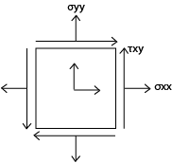For stresses that act on a body in a 2-D manner, 2-D Mohr’s Circle is a simple and effective way to find out the principal stresses and their respective principal angles. This method also helps us find out the Normal and Shear stresses at any given angle with which the plane is rotated.

**STEPS**

1. Starting with a stress or strain element in the XY plane, construct a grid with normal stress on the horizontal axis and shear stress on the vertical. (Positive shear stress plots at the bottom.)
2. Plot the vertical face coordinates V(*σxx, -τxy*).
3. 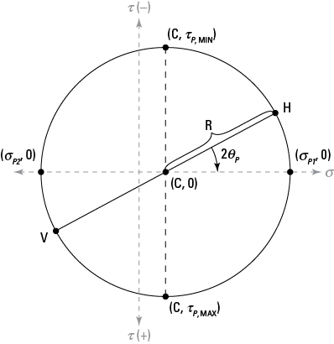Plot the horizontal coordinates H(*σyy, τxy*). The sign of *τxy* is very essential in finding out the correct mohr circle. It should be noted that the sign of *τxy* with *σxx* is negative because the shear stresses on the horizontal faces are creating a couple. This balances (or acts in the opposite direction of) the shear stresses on the vertical faces.
4. Draw a diameter line connecting Points V (from Step 1) and H (from Step 2).
5. Sketch the circle around the diameter from Step 3.  
   The circle should pass through Points V and H, as shown here.
6. Compute the normal stress position for the circle’s center point (*C*).
$$C= \frac{σ_{xx}+ σ_{yy}}{2}$$

7. Calculate the radius (*R*)for the circle.
$$R= \sqrt{\left(\frac{σ_{xx}- σ_{yy}}{2}\right)+{\left(τ_{xy}\right)}^{2}}$$

8. Determine the principal stresses *σP1* and *σP2.*
$$σ_{P1,P2}= C±R$$

9. Compute the principal angles *ΘP1* and *ΘP2*.

$${2θ}_{P1}=\tan^{-1}\left(\frac{2τ_{xy}}{σ_{xx}-σ_{yy}}\right)$$

$${2θ}_{P2}={{2θ}_{P2}+ 180}^{o}$$

One could also use equations directly (instead of Mohr’s circle) to determine transformed stresses at any angle:

$σ_{x'}= \left(\frac{σ_{xx}+ σ_{yy}}{2}\right)+ \left(\frac{σ_{xx}- σ_{yy}}{2}\right)cos2θ+ τ_{xy}sin2θ$

$$σ_{xy'}= -\left(\frac{σ_{xx}- σ_{yy}}{2}\right)sin2θ+ τ_{xy}cos2θ$$

### **Mohr’s Circle for 3 Dimensional Stress**

Let us take a small cube of dimension (*dx, dy, dz*) from a large 3-D solid. Normal and shear stress will act on each face of the cube. ‘*σii’* is the normal stress and *σij* is the shear stress on each face (*i,j = x, y, z*). All total there are nine components, and these will describe the state of stress at a point. These nine components are shown in the figure below :

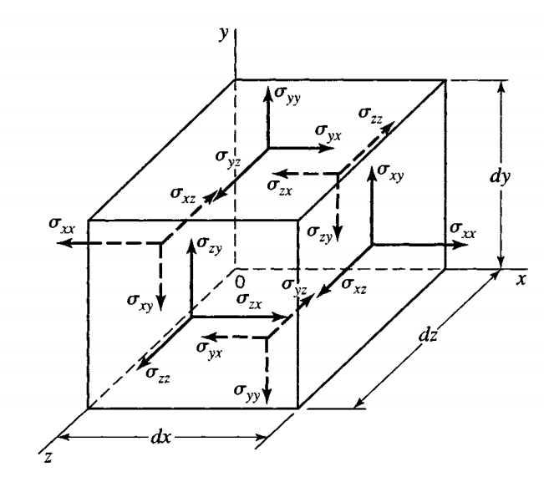

**STEPS :**

1. For the calculator purpose, we will be using the stress tensor (T)
$$T= \left[\begin{matrix}σ_{xx} & σ_{xy} & σ_{zx} \\ σ_{xy} & σ_{yy} & σ_{yz} \\ σ_{zx} & σ_{xy} & σ_{zz}\end{matrix}\right]$$

2. Assuming only surface force and body forces are acting on the body. Thus summing of the moment will give us the following result:
$$σ_{yz}=σ_{zy} , σ_{zx}=σ_{xz}, σ_{xy}=σ_{yx}$$

$$σ_{y'}= \left(\frac{σ_{xx}+ σ_{yy}}{2}\right)- \left(\frac{σ_{xx}- σ_{yy}}{2}\right)cos2θ- τ_{xy}sin2θ$$

3. The next steps involve finding the characteristic equation of the stress tensor and the corresponding eigen values.

|T - σI| = 0

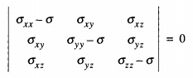

1. Solving the determination,  we get



This is the characteristic equation of the Stress tensor where the solution for σ gives the corresponding eigenvalues and thus the principal stresses. In the above equation, I1, I2, I3 are :

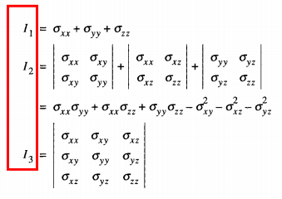

If principal stresses are known, then I1, I2, I3 can be expressed in terms of the principal stresses.

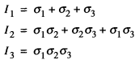

1. Putting the value of I1, I2 and I3 on the above cubic equation, we can find the principal stresses.

The roots the cubic equation will be σ1, σ2 and σ3 such that

**σ1 ≥ σ2 ≥ σ3**

1. Once we find out the principal stresses, we plot the corresponding circles. The centres and radii of the circle are found out using :

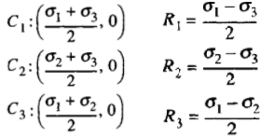

1. 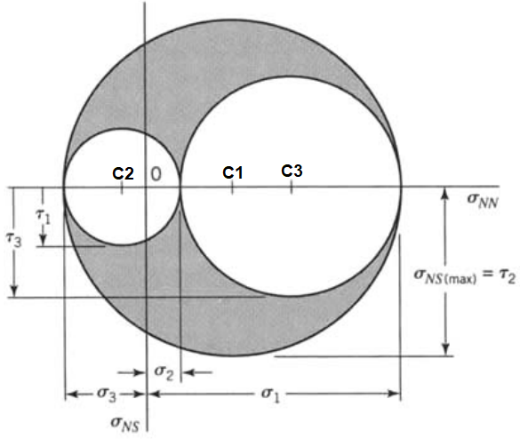Plot C1, C2, C3 on the principal stress axis, i.e. on the σNN axis. Now using these centres, draw circles using the found radii. The shaded area show in the figure is the permissible area (including the perimeters), i.e. only combinations of normal and shear stresses that lie in this region are possible.
2. To find the Normal and shear stresses on a plane, find out the direction cosines

(l, m, n) of the normal of the planes

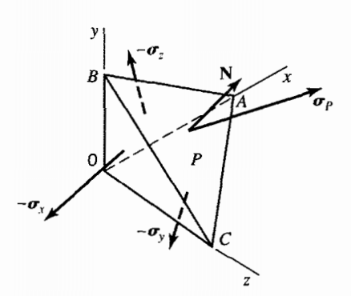

l = cos(α)

m = cos(β)

n = cos(y)

Such that

l2 + m2 + n2 = 1

here, α, β, y are the angles made by the Normal to to x, y and z-axes respectively.

1. The Normal Stress σNN on plane P is given by :



1. Thus, the Shear stress σNS on the plane is



Maximum Shear stress is

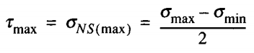

1. It should be noted that the direction of the shear stress cannot be found out using this method, and hence, by default, the out app takes the direction as positive. Plot the points (σNN , σNS ). As the direction cosines satisfy l2 + m2 + n2 = 1, the resulting point is ensured to be within the permissible region.

Thus finally, we get :



σNN , σNS

### 

### **Mohr’s Circle for strains**

Mohr’s Circle for strains has exactly the same procedure as that of Mohr’s circle for stresses with the only difference being :

1. 2-Dimension - Instead of plotting (*εxx, - εxy*), (just like (*σxx, -τxy*)), we plot (*εxx, -* γ *xy/2*), and follow the same procedure as that Stresses.
2. 3-Dimension – Similar to the above point, instead of putting the valu of *τxy, τyz, τzx,* directly in the stress tensor, one has to divide the shear strains respectively by 2 and then put these values in the stress tensor. All the other steps are just the same as that of 3-Dimensional Mohr Circle.