**System Documentation**

for

**Campus Event Check-in System with Student ID and Payment Integration**

**Task 3**

**Tutorial Section: TT1L**

**Group No.: Group 6**

|  |  |  |  |  |
| --- | --- | --- | --- | --- |
| HAZIQ IZZUDDIN BIN AHMAD TARMIDZI | | 1211112293 |  | |
| WAN AMIRUL AMIR BIN WAN ROMZI | | 1211112289 |  | |
| MUHAMMAD ARIF BIN ABDUL JALEEL | | 1231303334 |  | |
| LIM XIAO QI | | 1211108212 |  | |
|  |  | | |
|  |  | | |
|  |  | | |
|  |  | | |
| **Date:** | 1. **MAY 2025** | | |

# **Requirements Elicitation Plans Using the Kano Model**

#### **Project Title:**

Campus Event Check-in System with Student ID and Payment Integration

#### **Vision (System Overview):**

This project aims to build a digital platform for campus event check-ins. It will integrate with the university's student ID database and payment system, making event attendance and ticket purchases smoother for students. The goal is to improve how events are managed and ensure an easy and secure experience for all users.

### **Requirements Elicitation Plan**

The elicitation process is designed to classify requirements into **Dissatisfiers**, **Satisfiers**, and **Delighters** using the Kano Model. This model helps ensure the platform meets basic needs, fulfills expected functionalities, and introduces features that exceed user expectations.

### **Stakeholders Involved**

Identifying the right stakeholders is crucial for gathering meaningful requirements. Key stakeholders include the university administration, event organizers, and students, as they directly use or influence the system. Technical teams like the university IT department and database managers ensure proper system integration. Payment gateway providers are also involved to guarantee secure and efficient payment processes.

|  |  |
| --- | --- |
| Stakeholder | Role in the Project |
| Administration Officer | Ensures integration with student databases and event policies. |
| Event Organizers | Defines event-specific requirements and operations. |
| Students | End-users who interact with the system for check-ins and payments. |
| University Database Team | Provide technical support for integration. |
| Payment Gateway Providers | Ensure seamless payment processing. |

### **Kano Model Categories**

Using the Kano Model, requirements are grouped into Dissatisfiers, Satisfiers, and Delighters. Dissatisfiers are basic needs that must be met to avoid dissatisfaction. Satisfiers are the features that increase user satisfaction as they improve. Delighters are unexpected features that bring joy to users and make the system stand out.

#### **Dissatisfiers (Must-Haves)**

These are basic requirements that, if unmet, result in dissatisfaction but do not create excitement when fulfilled.

|  |  |  |
| --- | --- | --- |
| Feature | Requirement | Elicitation Method |
| Accurate Integration with Student ID Database | The system must verify student identities using the university database. | Interviews with IT and database teams to ensure alignment. |
| Secure Payment Processing | Ensure PCI-compliant, secure, and reliable payment methods. | Meetings with payment gateway providers to confirm protocols. |
| Basic Check-in Functionality | Allow students to check in digitally using their student ID. | Surveys to identify common user expectations for check-in systems. |

#### **Satisfiers (Performance Features)**

These are explicitly desired requirements that increase satisfaction proportionally to their fulfillment.

|  |  |  |
| --- | --- | --- |
| Feature | Requirement | Elicitation Method |
| Real-Time Attendance Tracking | The system should update attendance records in real time for event organizers. | Workshops with event organizers to define data accuracy needs. |
| Multi-Payment Options | Support for credit/debit cards, digital wallets, and campus currency. | User group discussions to identify preferred payment methods. |
| Ticket Purchase Integration | Integrate with the university's ticketing system for seamless event access. | Meetings with the ticketing system team to align functionalities. |

**Delighters (Excitement Features)**

These are unexpected features that delight users and exceed their expectations.

|  |  |  |
| --- | --- | --- |
| Feature | Requirement | Elicitation Method |
| Gamification for Attendance | Reward frequent event attendees with points or badges. | Brainstorming sessions with students to explore creative motivators. |
| Personalized Event Recommendations | Suggest events based on students’ past attendance or preferences. | Focus groups to understand user preferences and feasibility. |
| Mobile Wallet Integration | Allow students to save payment methods for faster transactions. | Prototype testing to evaluate user interest. |

## **Kano Model**

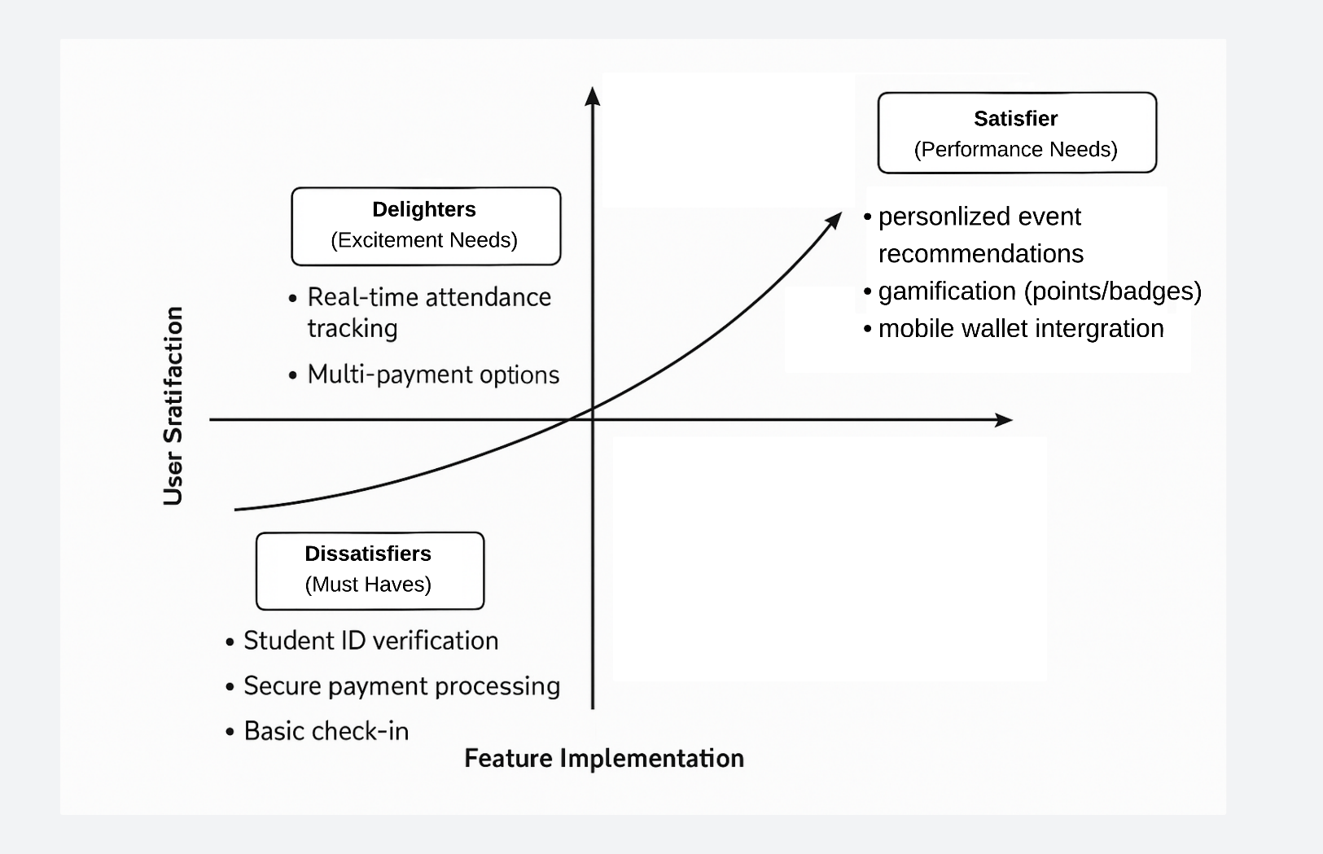

### **Elicitation Techniques**

Selecting the right techniques for gathering requirements is important to make the system effective and user-friendly. These techniques help understand user needs and prioritize them correctly.

These are planned method to be used for elicitation:

* **Interviews:** Direct conversations with stakeholders like IT teams, event organizers, and payment providers.
* **Observation:** Monitor current event check-in processes to identify inefficiencies and improvement opportunities.

### **Steps to Implementation**

Implementing the plan requires a clear process to ensure all requirements are captured, analyzed, and prioritized. First, all stakeholders must be prepared with materials to guide the discussions. Then, structured elicitation sessions are conducted to collect inputs. Requirements are classified into Dissatisfiers, Satisfiers, and Delighters. Finally, findings are documented and used to prioritize development.

1. **Prepare Stakeholder Materials:**
   * Draft clear questions and discussion points based on the Kano categories.
2. **Conduct Stakeholder Sessions:**
   * Use structured interviews, surveys, and focus groups for requirement gathering.
3. **Categorize Requirements:**
   * Classify inputs into Dissatisfiers, Satisfiers, and Delighters using Kano analysis.
4. **Prioritize Features:**
   * Rank features based on stakeholder importance and feasibility.
5. **Document Findings:**
   * Summarize results for alignment with project objectives.

### **Expected Outcomes**

By following this elicitation plan, we expect to gain a complete understanding of the system's requirements. Users will have their basic needs met, desired features addressed, and some delightful surprises included. This ensures that the system is both functional and appealing, creating a valuable tool for event management on campus.