FunMirrors

The Funny Mirror is a modern computational geometry project that uses advanced mathematical methods to dynamically change and deform mesh grids in three dimensions. This project blends computational rigor and creative expression by deliberately manipulating the z-coordinate through the use of square root calculations, exponential functions, sinusoidal waves, and scaling factors. The result is a dizzying, funhouse-like panorama that transforms calm landscapes. By enabling users to inhabit an altered, dreamlike world where the laws of reality no longer apply, the Funny Mirror challenges preconceived notions and is useful for immersive art exhibits, interactive data visualizations, and lighthearted entertainment.

general overview of the parameters in those expressions:
1. plane.Z: The Z-coordinate of the 3D mesh grid, which is being modified.
2. Scaling factors: The constants 20, -10, and -100 that scale the Z-coordinate.
3. Exponential function parameters:
- (plane.X*1.0/plane.W)/0.1 and (plane.Y*1.0/plane.H)/0.1: The ratios of the X/Y coordinates to the width/height, divided by 0.1.
- -0.5: The constant that controls the rate of decay of the exponential function.
- 0.1*np.sqrt(2*np.pi): The normalizing factor.
4. Sine wave parameters:
- 2*np.pi: The angular frequency of the sine waves.
- (plane.X-plane.W/4.0)/plane.W and (plane.Y-plane.H/4.0)/plane.H: The normalized X/Y coordinates with a phase shift of 1/4 of the period.
5. Square root parameters:
- (plane.X*1.0/plane.W) and (plane.Y*1.0/plane.H): The ratios of the X/Y coordinates to the width/height.


Mirror 1 : Z = 20*exp^((x/w)^2 / 2*0.1*sqrt(2*pi))

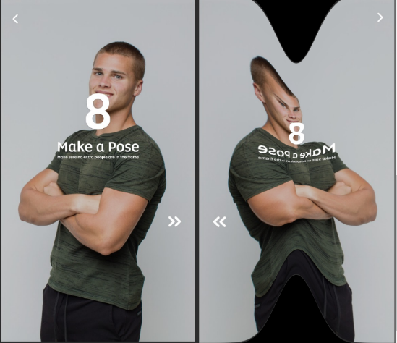
Mirror 2 : Z = -10*exp^[(x/w)^2 / (2*0.1*sqrt(2*pi))]


Mirror 3 : Z = -10*exp^[(y/h)^2 / (2*0.1*sqrt(2*pi))]

Mirror 4 : Z = 20*[sin(2pi(x/w - 1/4)) + sin(2pi(y/ - 1/4))]
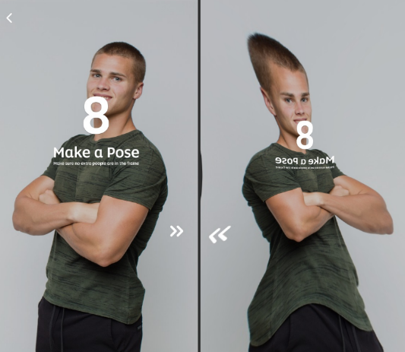

Mirror 5: Z = -20*[sin(2pi(x/w - 1/4)) + sin(2pi(y/ - 1/4))]
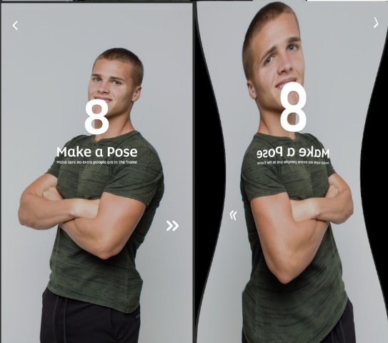

Mirror 6 : Z = -100*sqrt[(x/w)^2 + (y/h)^2]
