- Which of the following is true about Oracle Views?
a) Views store data permanently
b) Views improve performance by storing indexed data
c) Views are virtual tables that do not store data permanently
d) Views allow DML operations even if they contain aggregate functions
- What happens when you drop a view in Oracle?
a) The underlying table is also deleted
b) The underlying table remains intact
c) All dependent objects are automatically dropped
d) The data in the underlying table is deleted
- Which command is used to create a read-only view?
a) CREATE READ-ONLY VIEW view_name AS ...
b) CREATE VIEW view_name AS ...
c) CREATE VIEW view_name AS ... WITH CHECK OPTION;
d) CREATE OR REPLACE VIEW view_name AS ...
- You are given an EMPLOYEES table with the following structure:
EMP_ID | EMP_NAME | DEPT_ID | SALARY | HIRE_DATE
101 | John | 10 | 5000 | 2018-06-15
102 | Alice | 20 | 7000 | 2019-09-22
103 | Bob | 10 | NULL | 2021-01-10
104 | Emma | 30 | 9000 | 2017-03-12
You need to create a VIEW named EMP_SALARY that meets the following conditions:
- Displays only active employees (employees hired after January 1, 2015).
- Includes employee names (EMP_NAME) and salaries , but if the SALARY is NULL, replace it with 'Not Disclosed'.
- Sort the results in descending order of salary.
Ans) create view emp_salary as select emp_name, nvl(to_char(salary),'not disclosed') as salary_info from employees where hire_date> date '2015-01-01' order by salary ;
select * from emp_salary;
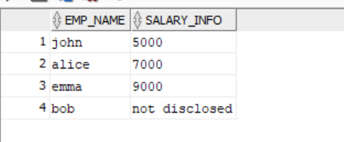

- Which of the following is not a valid sequence operation?
a) NEXTVAL
b) CURRVAL
c) SETVAL
d) PREVVAL
- If a sequence is created as:
- CREATE SEQUENCE emp_seq START WITH 100 INCREMENT BY 5;
What will be the value returned by emp_seq.NEXTVAL on its third call?
a) 100
b) 105
c) 110
d) 115
- Write a SQL query to create a sequence that starts at 5000 and increments by 10 and use it to insert a new employee record in the EMPLOYEES table.
- Which of the following statements is true about GROUP BY?
a) It must always be used with ORDER BY
b) It can be used with aggregate functions like SUM () and AVG()
c) It is used to filter rows before aggregation
d) It allows HAVING to replace WHERE
- Which aggregate function is not allowed in a GROUP BY clause?
a) COUNT()
b) SUM()
c) AVG()
d) RANK()
- Write a SQL query to display department-wise total salaries from the EMPLOYEES table, sorted by department ID.
- What is the default sorting order of ORDER BY in Oracle?
a) Ascending (ASC)
b) Descending (DESC)
c) Random
d) Based on index
- What will happen if you run the following query?
SELECT employee_name, salary FROM employees ORDER BY 2 DESC;
a) It will sort by employee_name
b) It will sort by salary in descending order
c) It will cause a syntax error
d) It will sort by employee_id
- Write a SQL query to display employee names and salaries, sorted by highest salary first.
Ans) SELECT emp_name, salary FROM employees ORDER BY 2 DESC;
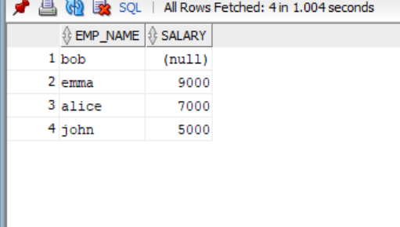

- What does SELECT DISTINCT do in Oracle?
a) Removes all NULL values from the result set
b) Removes duplicate rows from the result set
c) Groups data based on distinct values
d) Works only with numeric columns
- Which of the following queries will return unique job titles from the EMPLOYEES table?
a) SELECT DISTINCT job_id FROM employees;
b) SELECT UNIQUE job_id FROM employees;
c) SELECT DISTINCT * FROM employees;
d) SELECT ALL job_id FROM employees;
- Write a SQL query to retrieve unique department IDs from the EMPLOYEES table.
select distinct(dept_id) from employees;
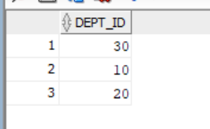
- Write a query to retrieve the top 3 highest-paid employees from each department.
select emp_name, dept_id, salary
from (select emp_name, dept_id, salary,
dense_rank() OVER (partition by dept_id order by salary desc) as rank from employees)
where rank <= 3 order by dept_id, rank;
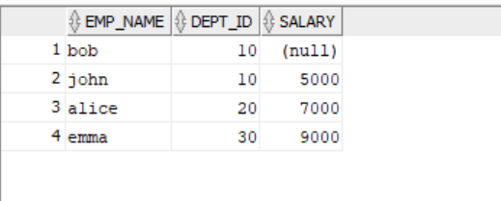
- Retrieve employees sorted first by department in ascending order, then by salary in descending order, and finally by employee name alphabetically.
select * from
(select * from (select * from employees order by dept_id asc) order by salary desc)
order by emp_name;
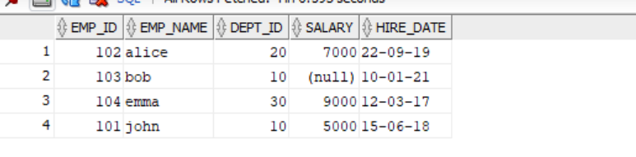
- There is a Materialized View MV_ORDERS is based on the ORDERS table.
After creating the Materialized View, you execute the following:

ALTER TABLE ORDERS ADD COLUMN order_priority VARCHAR2(10);

Now when we execute the below query:
SELECT * FROM MV_ORDERS;
Will this query execute successfully? Why or why not?
No, it will not execute as when a view is instantiated it captures the structure of table and the view does not automatically update from the table . Also there would be a mismatch between table and the view.

