Q1: Write a query to display employee names, their department names, and their bonus amounts. If the BONUS is NULL, display the average bonus of that department instead.
Tables:
EMPLOYEES
EMP_ID | EMP_NAME | DEPT_ID | BONUS
101 | John Doe | 10 | NULL
102 | Jane Smith | 10 | 400
103 | Mark Taylor | 20 | NULL
DEPARTMENTS
DEPT_ID | DEPT_NAME
10 | IT
20 | HR
Expected Output:
EMP_NAME | DEPT_NAME | BONUS
John Doe | IT | 400
Jane Smith | IT | 400
Mark Taylor | HR | NULL
 | Ans)
Select a.emp_name, b.dept_name,
nvl( a.bonus ,(select avg(bonus) from employees where dept_id=a.dept_id) ) as bonus
from employees a left join departments b on a.dept_id=b.dept_id;
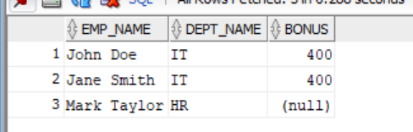

Q2: Write a query that calculates the total salary payout. Include active employees' salaries directly, and for inactive employees, add half of their salary as a severance payout.
Table:
EMPLOYEES
EMP_ID | EMP_NAME | STATUS | SALARY
201 | Alex Johnson | ACTIVE | 5000
202 | Chris Martin | INACTIVE | 4000
203 | Taylor Swift | ACTIVE | 6000
Expected Output:
TOTAL_PAYOUT
12000
Ans) select sum(decode(status, ’INACTIVE’, salary/2, ’ACTIVE’, salary)) as total_payout from employees;
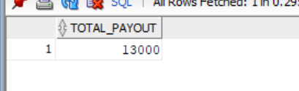
Q3: Write a query to classify employees' performance ratings based on their salary as follows:
- SALARY > 7000 ➔ "Excellent"
- SALARY BETWEEN 5000 AND 7000 ➔ "Good"
- SALARY < 5000 ➔ "Average"
- If SALARY is NULL, assign "Not Evaluated"
Table:
EMPLOYEES
EMP_ID | EMP_NAME | SALARY
301 | Sam Wilson | 8000
302 | Bruce Wayne | 6000
303 | Clark Kent | NULL
Expected Output:
EMP_NAME | RATING
Sam Wilson | Excellent
Bruce Wayne | Good
Clark Kent | Not Evaluated
Select emp_name, case when salary>7000 then ‘Excellent’
When salary>5000 and salary < 7000 then ‘Good’
When salary <5000 then ‘average’
Else ‘not evaluated’
End as Rating from employees;
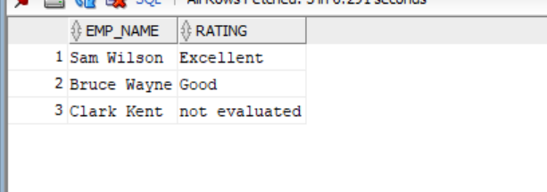
Q4: Write a query that lists active employees grouped by department in a comma-separated format, sorted in descending order of salary.
Table:
EMPLOYEES
EMP_NAME | DEPT_ID | STATUS | SALARY
Alex Johnson | 10 | ACTIVE | 5000
Chris Martin | 10 | INACTIVE | 4000
Taylor Swift | 20 | ACTIVE | 6000
Expected Output:
DEPT_ID | EMPLOYEES
10 | Alex Johnson
20 | Taylor Swift

Ans) select dept_id, listagg(emp_name, ', ') within group (order by salary) as employees from employees where status = 'ACTIVE' group by dept_id;
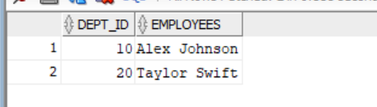
Q5: Write a query that extracts the last 4 digits from each PHONE_NUMBER column.
Table:
CUSTOMERS
CUSTOMER_ID | PHONE_NUMBER
401 | +1-202-555-0190
402 | +44-208-123-4567
403 | +91-98765-43210
Expected Output:
CUSTOMER_ID | LAST_4_DIGITS
401 | 0190
402 | 4567
403 | 3210

select customer_id , substr(phone_number,-4,4)as last4_digits from customers
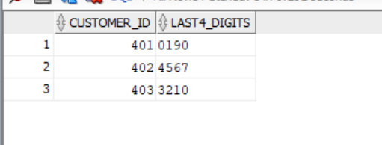
Q6: Write a query to extract the email domain (e.g., gmail.com, yahoo.com) from the following table.
Table:
USERS
USER_ID | EMAIL
501 | john.doe@gmail.com
502 | jane.smith@yahoo.com
503 | mark.taylor@outlook.com
Expected Output:
EMAIL | DOMAIN
john.doe@gmail.com | gmail.com
jane.smith@yahoo.com | yahoo.com
mark.taylor@outlook.com | outlook.com
select email, substr(email,instr(email,'@')+1) as domain from users;
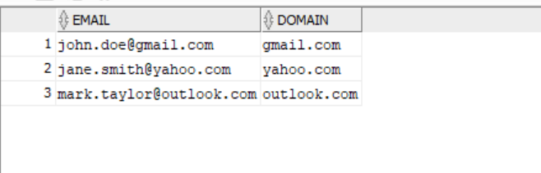
Q7: Write a query that displays:
- Employee names in uppercase
- Extracts the first three characters of each employee's name
- If the SALARY is NULL, display "Salary Not Available" instead
Expected Output:
EMP_NAME | NAME_SHORT | SALARY_INFO
JOHN DOE | JOH | 5000
JANE SMITH | JAN | Salary Not Available
select upper(emp_name) as emp_name, upper(substr(emp_name,1,3)) as short_name, nvl(to_char(salary),'salary not available') as salary_info from employees;
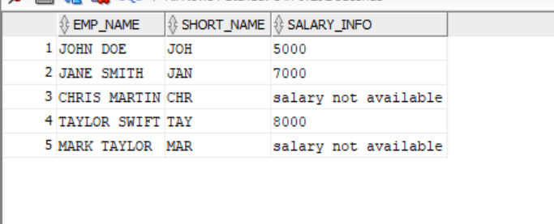
Sample Table: EMPLOYEES
EMP_ID | EMP_NAME | DEPT_ID | SALARY | BONUS | JOIN_DATE | MANAGER_ID
101 | John Doe | 10 | 5000 | NULL | 12-JAN-2021 | NULL
102 | Jane Smith | 20 | 7000 | 500 | 15-MAR-2022 | 101
103 | Chris Martin | 10 | NULL | NULL | 20-MAY-2020 | 101
104 | Taylor Swift | 30 | 8000 | 1000 | 10-DEC-2022 | 102
105 | Mark Taylor | 30 | NULL | NULL | 05-JUL-2019 | NULL
Q8: Show employee details with calculated total compensation and list employees per department (sorted by salary)
select EMP_ID, EMP_NAME, DEPT_ID, SALARY, BONUS, JOIN_DATE, MANAGER_ID , nvl(BONUS,0)+SALARY as total_compensation from employees order by dept_id,salary;
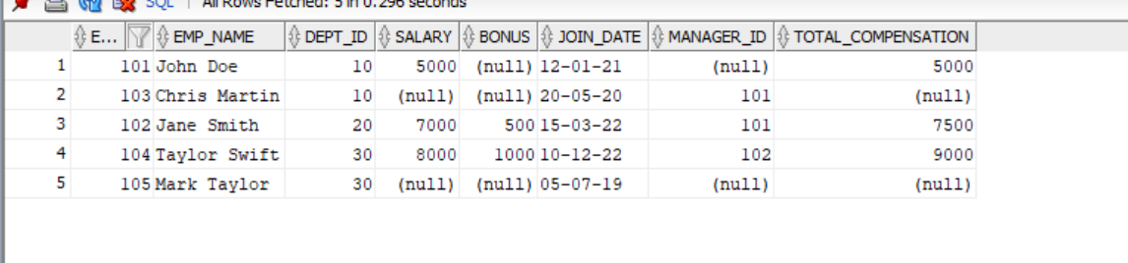
Q9: Extract the first name from EMP_NAME and replace NULL salaries with "N/A"
select substr(emp_name,1,instr(emp_name,' ')) as first_name, nvl(to_char(salary),'N/A') from employees ;
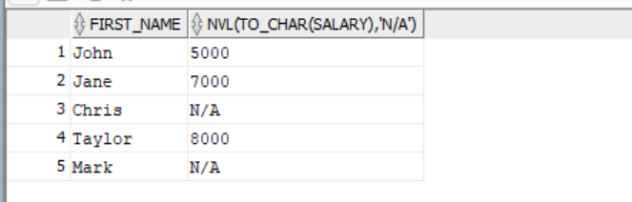

Q10: Display employee names grouped by manager ID with names truncated after 5 characters and list their salary details.
Select nvl(to_char(manager_id),'NA') , listagg('('||substr(emp_name,1,5)|| ' '|| nvl(to_char(salary),'NA')|| ')') as employees_and_salary from employees group by manager_id;
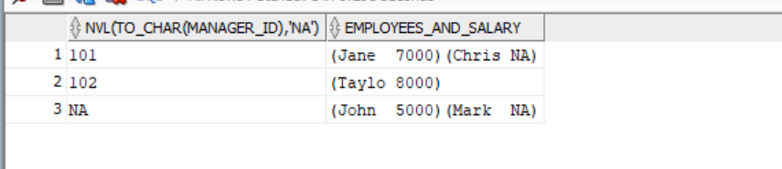

Q11: Write a SQL query to categorize employees based on their salary:
- High Salary: Salary ≥ 8000
- Medium Salary: Salary between 5000 and 7999
- Low Salary: Salary < 5000 or NULL
Display the salary category along with employee names listed in alphabetical order, separated by “ |”.
select status_salary,listagg(emp_name, ' | ') within group(order by emp_name) as employees from
(Select emp_name, case when salary>=8000 then 'High salary'
when salary between 5000 and 7999 then 'Medium salary'
else 'Low salary' end as status_salary
from employees)
group by status_salary;
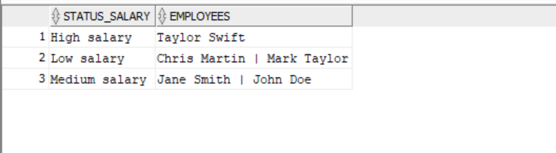

Q12: Write a SQL query to display employee names along with their experience category based on the number of years they have worked in the company. The categories are defined as follows:
- Senior: Employees who have been with the company for 4 or more years.
- Mid-Level: Employees who have been with the company for 2 to 3 years.
- Junior: Employees who have been with the company for less than 2 years.
The query should:
- Calculate the employee's experience in years based on their JOIN_DATE.
- Assign the appropriate experience category using conditions.
- List employee names grouped by experience category in alphabetical order, separated by “|”.
select status,listagg(emp_name, ' | ') within group(order by emp_name) as employees from
(Select emp_name, case when round(months_between(sysdate,join_date)/12)>=4 then 'Senior'
when round(months_between(sysdate,join_date)/12) between 2 and 3 then 'Med-Level'
else 'Junior' end as status
from employees)
group by status;
