- Create and insert data in tables using the above tables.
create table employees (employee_id int primary key, first_name varchar(50), last_name varchar(50), salary int, job_id varchar(10), department_id int, manager_id int);
create table departments (department_id int primary key, department_name varchar(50), location_id int);
create table jobs (job_id varchar(10) primary key, job_title varchar(50));
create table locations122 (location_id int primary key, city varchar(50), country_id varchar(10));
create table countries (country_id varchar(10) primary key, country_name varchar(50));
create table projects (project_id int primary key, project_name varchar(50));

insert into employees values (101, 'John', 'Doe', 60000, 'IT_PROG', 10, NULL);
insert into employees values (102, 'Jane', 'Smith', 70000, 'IT_PROG', 10, 101);
insert into employees values (103, 'Michael', 'Johnson', 80000, 'HR_REP', 20, NULL);
insert into employees values (104, 'Emily', 'Davis', 55000, 'HR_REP', 20, 103);
insert into employees values (105, 'Robert', 'Brown', 50000, 'SA_REP', 30, 106);
insert into employees values (106, 'Linda', 'Wilson', 90000, 'SA_MAN', 30, NULL);

insert into departments values (10, 'IT', 100);
insert into departments values (20, 'HR', 200);
insert into departments values (30, 'Sales', 300);
insert into departments values (40, 'Marketing', 400);

insert into jobs values ('IT_PROG', 'Programmer');
insert into jobs values ('HR_REP', 'HR Representative');
insert into jobs values ('SA_REP', 'Sales Representative');
insert into jobs values ('SA_MAN', 'Sales Manager');

insert into locations122 values (100, 'New York', 'US');
insert into locations122 values (200, 'London', 'UK');
insert into locations122 values (300, 'Tokyo', 'JP');
insert into locations122 values (400, 'Paris', 'FR');

insert into countries values ('US', 'United States');
insert into countries values ('UK', 'United Kingdom');
insert into countries values ('JP', 'Japan');
insert into countries values ('FR', 'France');

insert into projects values (1, 'Project Alpha');
insert into projects values (2, 'Project Beta');
insert into projects values (3, 'Project Gamma');

3) write a query to select all columns from the "employees" table.
select * from employees;
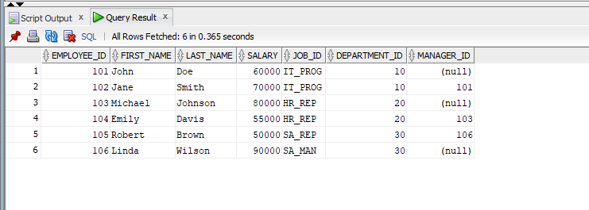
4. Write a query to select only "first_name" and "salary" from the "employees" table.
select first_name,salary from employees;
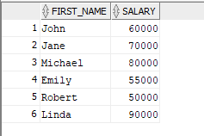
5. Write a query to retrieve unique job titles from the "employees" table.
select b.job_title from jobs b where job_id in (select distinct(job_id) from employees);

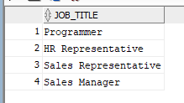
6. Write a query to fetch employees whose salary is greater than 50000.
select * from employees where salary>50000;
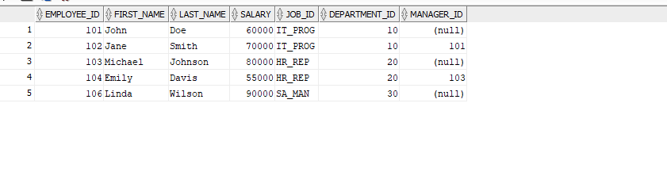
7. Write a query to find employees working in department 10.
select * from employees where department=10;
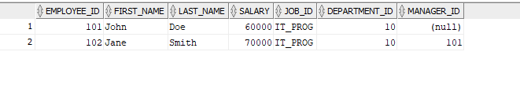
8. Write a query using INNER JOIN to get employee names along with their department names.
select a.first_name||' '||a.last_name as employee_name, b.department_name from employees a inner join departments b on a.department_id=b.department_id;
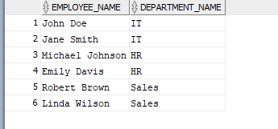

9. Write a query using LEFT JOIN to retrieve all employees and their department names (including employees who don't belong to any department).
select a.first_name||' '||a.last_name as employee_name, b.department_name from employees a inner join departments b on a.department_id=b.department_id;
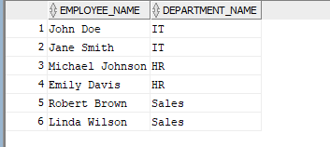

10. Write a query using RIGHT JOIN to retrieve all departments and their employees (including departments without employees).
select b.department_name,a.first_name||' '||a.last_name as employee_name from employees a right join departments b on a.department_id=b.department_id;
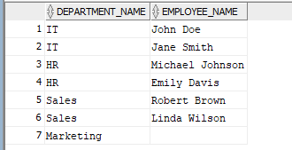

11. Write a query using FULL OUTER JOIN to get all employees and departments, even if there is no matching record in one of them.
select a.first_name||' '||a.last_name as employee_name, b.department_name from employees a full outer join departments b on a.department_id=b.department_id;
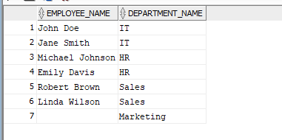
12. Write a query to fetch employees along with their manager's name using SELF JOIN.
select a.* , b.first_name||' '||b.last_name as manager_name from employees a inner join employees b on a.manager_id=b.employee_id;
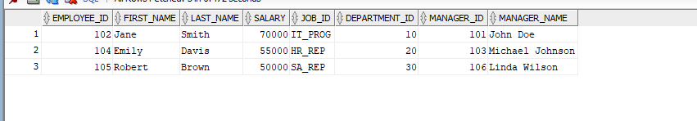
13. Retrieve employee names and their job titles from the "employees" and "jobs" tables.
select a.first_name||' '||a.last_name as employee_name, b.job_title from employees a inner join jobs b on a.job_id=b.job_id;
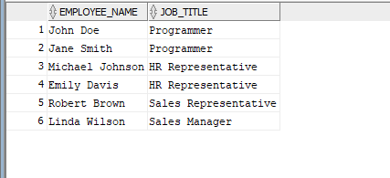
14. Get a list of employees along with their department names, including employees who do not belong to any department.
select a.first_name||' '||a.last_name as employee_name, b.department_name from employees a left join departments b on a.department_id=b.department_id;
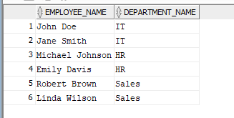
15. Retrieve department names along with the names of employees working in each department, including departments that have no employees.
select b.department_name,a.first_name||' '||a.last_name as employee_name from employees a right join departments b on a.department_id=b.department_id;

16. Get the names of all employees and the city where their department is located.
select a.first_name||' '||a.last_name as employee_name,c.city from employees a inner join departments b on a.department_id=b.department_id inner join locations122 c on b.location_id=c.location_id;
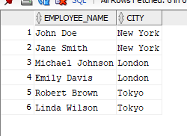
17. Retrieve a list of employees along with their manager’s name.
select a.* , b.first_name||' '||b.last_name as manager_name from employees a left join employees b on a.manager_id=b.employee_id;
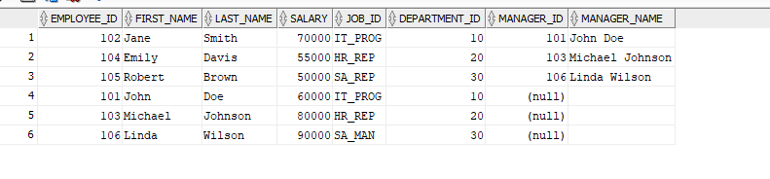
18. Get all employees and their department names, including those who do not have a department and departments that have no employees.
select a.*, b.department_name from employees a full outer join departments b on a.department_id=b.department_id;
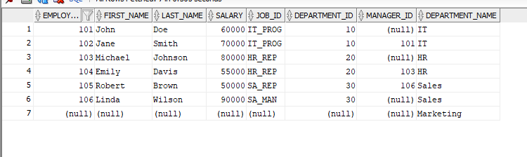
19. Retrieve a list of employees who work in the same department as "John Doe" (assuming John Doe is an employee).
select * from employees where department_id=(select department_id from employees where first_name='John' and last_name='Doe');
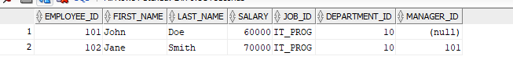
20. Find all employees who have the same job title as "Jane Smith".
select * from employees where job_id=(select job_id from employees where first_name='Jane' and last_name='Smith');
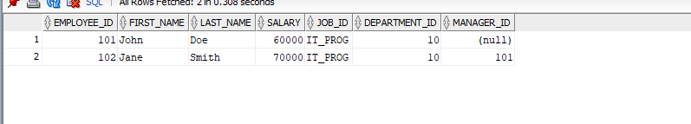
21. Get a list of employees and the name of the country where they work.
select a.* , d.country_name from employees a join departments b on a.department_id = b.department_id join locations c on b.location_id=c.location_id join countries d on c.country_id=d.country_id ;
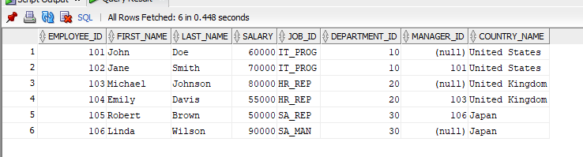
22. Find all employees who do not have a manager.
select * from employees where manager_id is null;
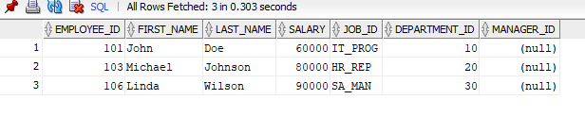
23. Perform a Cartesian product between the "employees" and "departments" tables.
select * from employees cross join departments ;
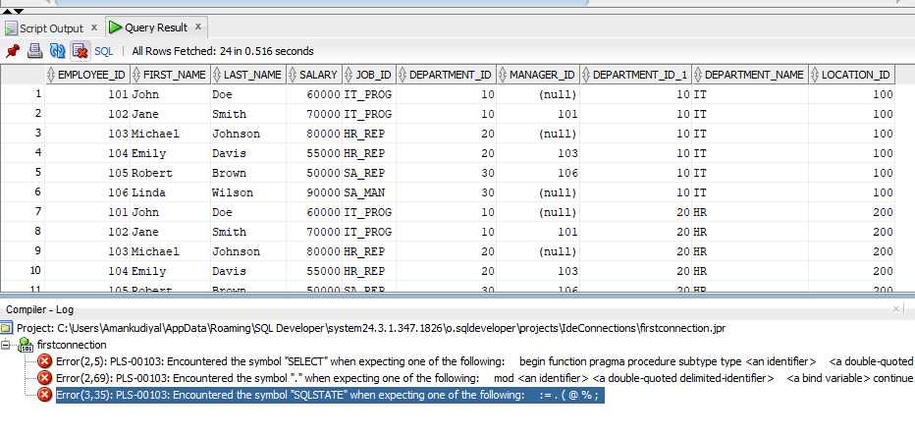
24. Retrieve a Cartesian product of all job titles and all department names.
select a.job_title , b.department_name from jobs a cross join departments b;
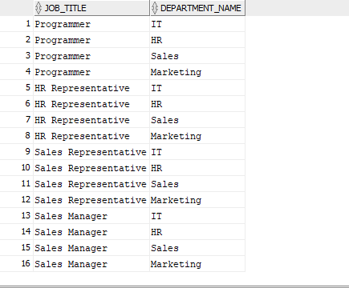

25. Generate all possible pairings of employees (excluding self-pairings).
select a.* ,b.* from employees a cross join employees b where a.employee_id!=b.employee_id;
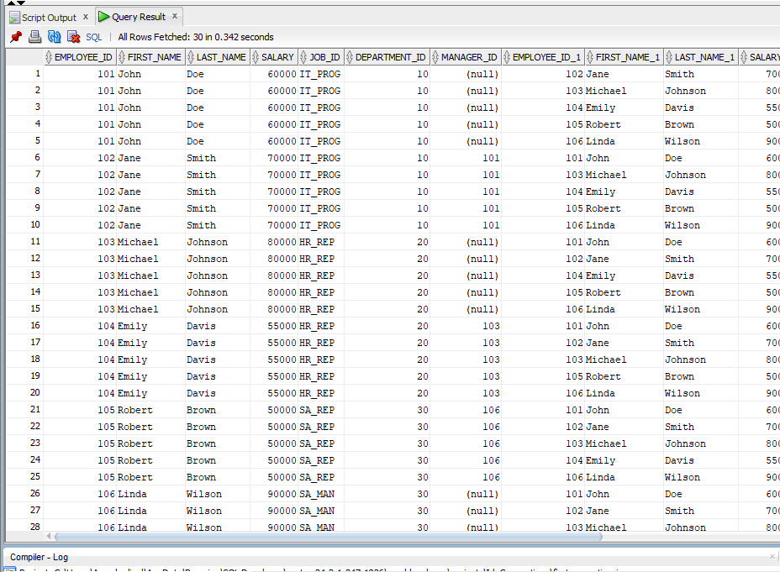

26. Show a combination of all employees and all locations (even if they are not working there).
select a.*,b.* from employees a cross join locations122 b ;
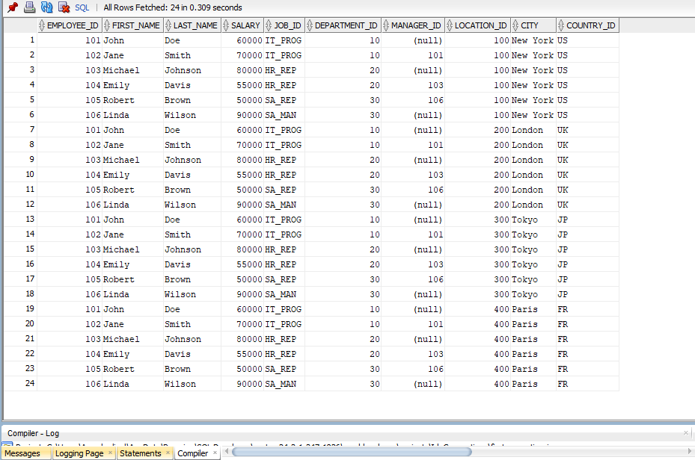
27. Find all possible pairings of employees and job titles (even if they don’t have that job).
select a.*,b.job_title from employees a cross join jobs b ;
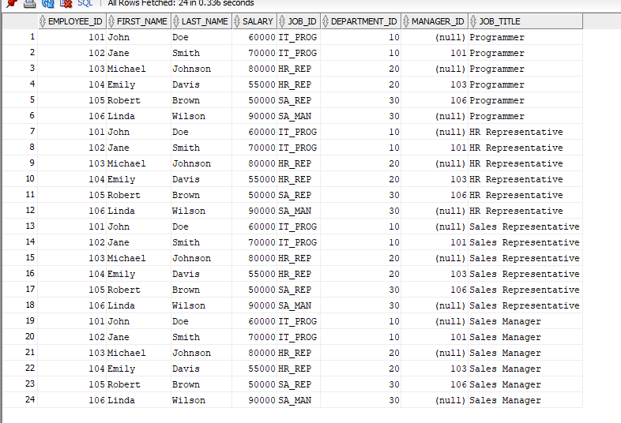
28. Compare CROSS JOIN with INNER JOIN by retrieving employees and their department names.
select a.* , b.department_name from employees a cross join departments b;
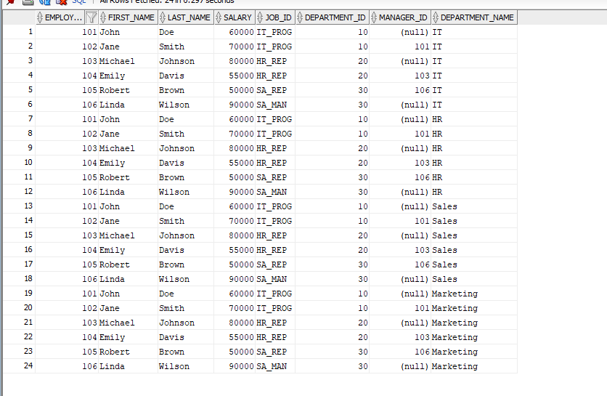
select a.* , b.department_name from employees a inner join departments b on a.department_id=b.department_id;
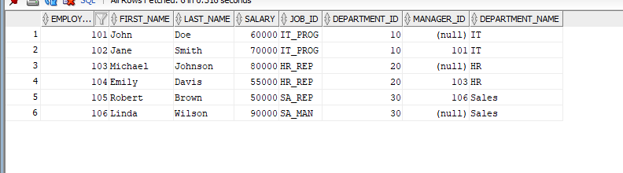
29. Find all possible project-employee assignments using CROSS JOIN.
select a.*,b.* from projects a cross join employees b ;
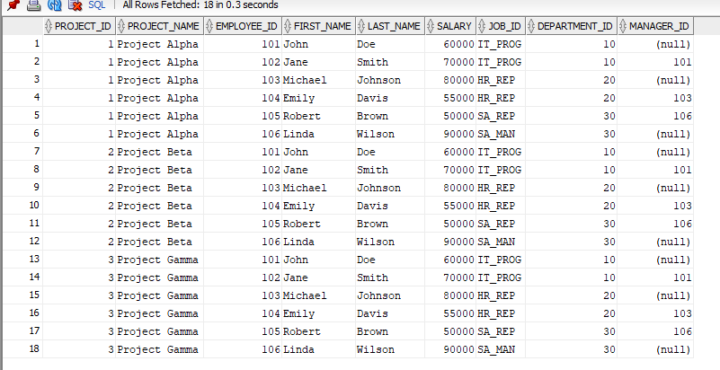

30. List all possible pairs of job titles and department locations.
select a.job_title , d.* from jobs a cross join locations122 d;
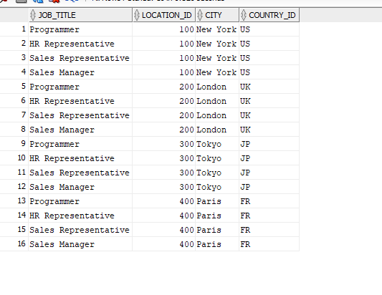

31. Generate a combination of all managers and all employees (even if they don’t report to each other).
select a.first_name||' '||a.last_name , b.first_name||' '||b.last_name from employees a cross join employees b where a.employee_id!=b.employee_id;

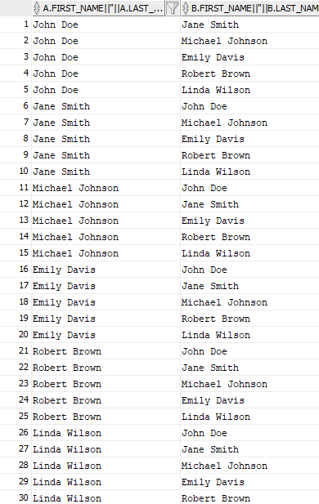

32. Find all possible country-department combinations.
select a.*,b.* from countries a cross join departments b ;
