1. Create a directory

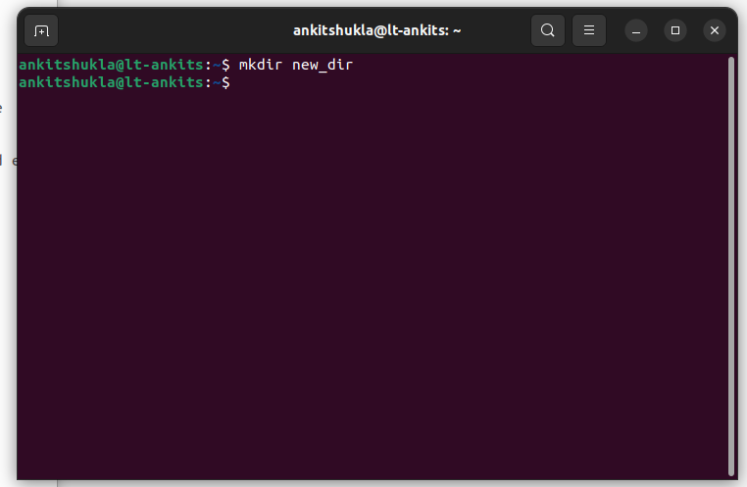

2. Switch to this directory

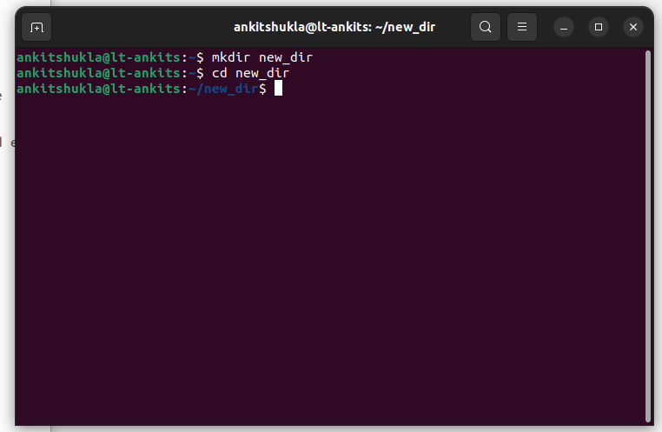

3. Create a normal text file

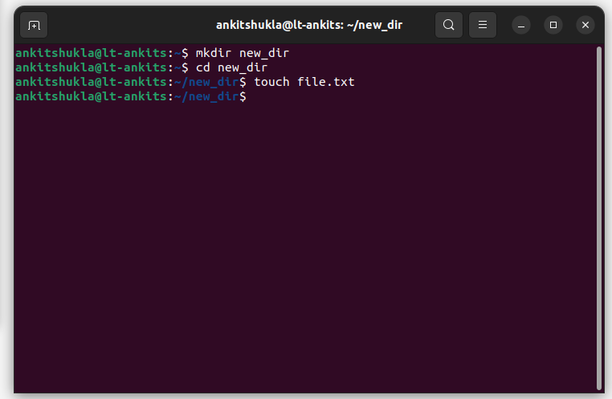

4. Create a hidden text file

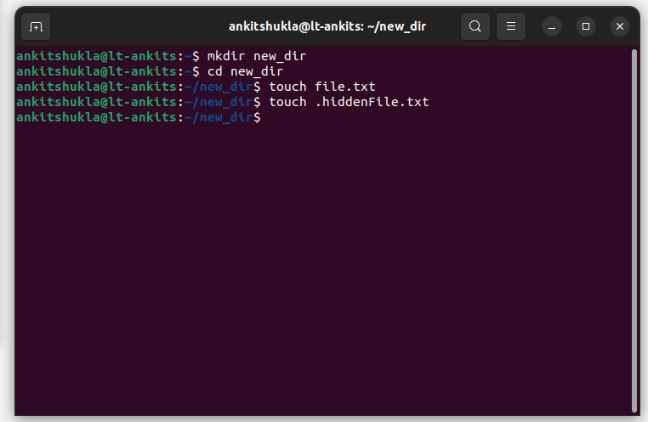

5. Modify the access of the hidden text file so that it can be edited only by root user.

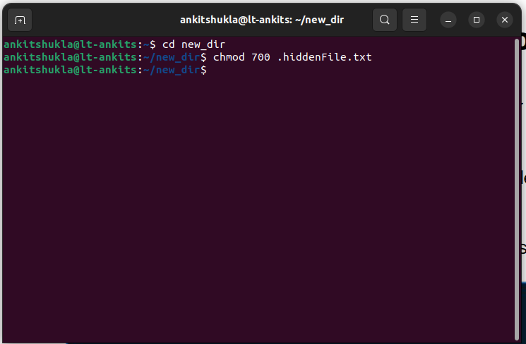

6. Move the hidden file to a your desktop.

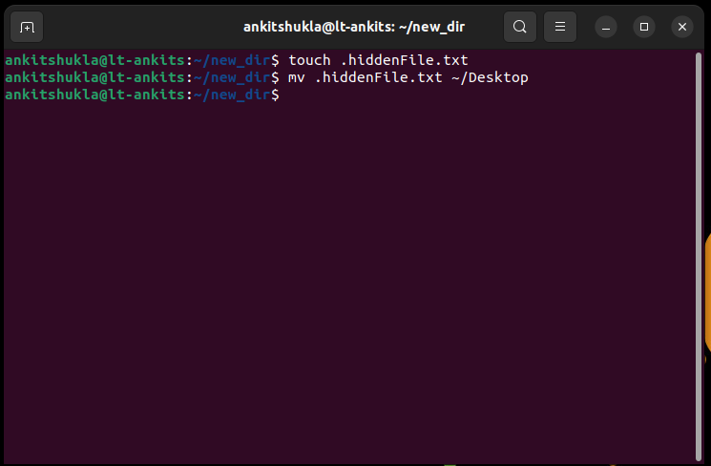

7. Create a directory, add 3 files into it and then remove the whole directory.

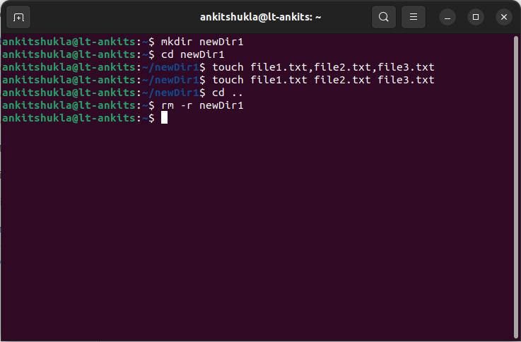

8. Create a new user group.

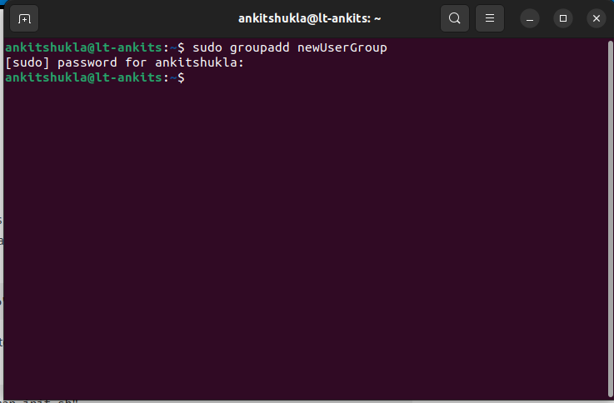

9. Create a new user and assign a new user home and the previously created usergroup to the user.

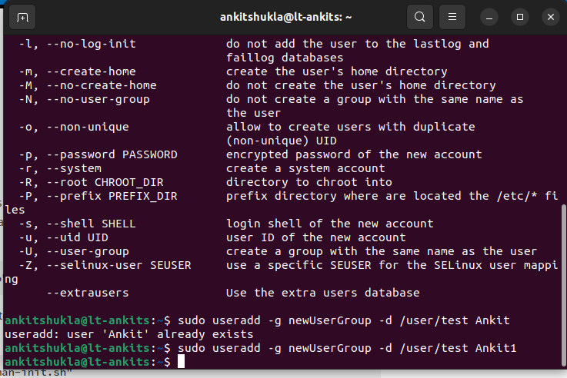

10. Create a symbolic link in a different location for the file created in step 3.

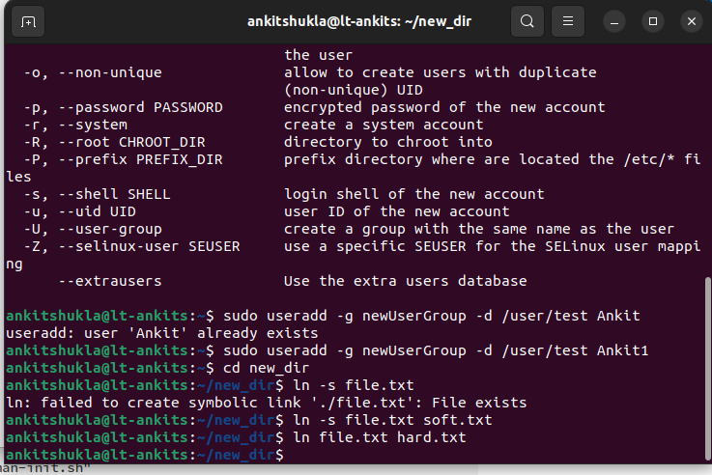

11. Open google chrome or any other web browser, see its memory usage using top command and end the process using the ps and grep commands.

