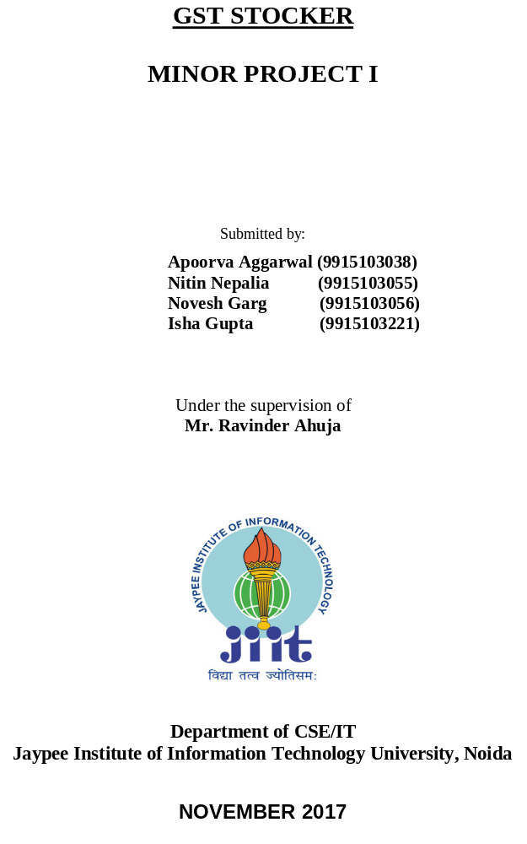

ACKNOWLEDGEMENT

We would like to place on record our deep sense of gratitude to Mr. Ravinder Ahuja, Assistant Professor (Grade II), Jaypee Institute of Information Technology, India for his generous guidance, help and useful suggestions.

We express our sincere gratitude to Ms. Bindu Verma, for her stimulating guidance, continuous encouragement and supervision throughout the course of present work.

We also wish to extend thanks to our classmates for their insightful comments and constructive suggestions to improve the quality of this project work.

Apoorva Aggarwal (9915103038)
Nitin Nepalia (9915103055)
Novesh Garg (9915103056)
Isha Gupta (9915103221)

ABSTRACT

The Goods and Services Tax has revolutionized the Indian taxation system since its first introduction in the Lok Sabha on 29th March, 2017, and came into effect from 1st July, 2017. Goods & Services Tax Law in India is a comprehensive, multi-stage, destination-based tax that will be levied on every value addition.
Our product GST Stocker provides them a convenient and efficient way to handle their stocks, managing previous records and calculating GST for their goods and services. It provides the C&F/C&A, Distributors, Stockist, Super-Stockist and anyone who is a Trader of anything, a convenient and efficient way to handle their stocks, managing previous records and calculating GST for their goods and services. The users will have a handful of techniques for their business management such as Sales, Purchase, Inventory, Financial Accounting, invoice, Claims and Returns.
Our aim is to develop a Product which can be used by a Shopkeeper and an MNC at the same time. Handling GST Stocker is as easy as learning typing or browsing on computer. With very basic knowledge of accounts (credit and debit), one can start to manage their financial activities almost immediately.

TABLE OF CONTENTS

Acknowledgement
Abstract
Gantt Chart
List of Tables
List of Figures
List of Abbreviations
Introduction
Background Study
Research papers and conclusion
Requirement Analysis
Software & Hardware Requirements
Functional Requirements
Non – Functional Requirements
UML Diagrams
Implementation
Testing and Analysis
References
Conclusion

GANTT CHART

Month-> AUGUST  Tasks |  |  | SEPTEMBER |  | OCTOBER |  | NOVEMBER
Communication with mentor
Planning
Implementation of working model
Discussion with mentor
Mid-term Evaluation

Adding non-functional requirements
Testing and analysis
Final project evaluation

LIST OF TABLES

Table Title Page

1 GST returns table..................................................................................... 55
2 Requirements............................................................................................ 57

‘LIST OF FIGURES

Figure Title Page

1 Flow Diagram for the application............................................................... 70
2 Use Case Diagram ........................................................................................ 95
3 ER Diagram for the database..................................................................... 95
ABBREVIATIONS

GST Goods & Services Tax
CGST Central Goods & Services Tax
IGST Integrated Goods & Services Tax
SGST State Goods & Services Tax
GSTR Goods & Services Tax Returns

INTRODUCTION

Motivation behind the choice of topic:
GST is an emerging topic in the present era. After the Constitutional Amendment Bill for roll out of GST was passed by the Parliament, the IT sectors are working on solutions to provide traders a convenient software to handle GST operations related to their business. Hence, we are looking to contribute something similar in functioning yet different in handling application which might make things even more convenient for businessmen. Moreover, due to the originality and freshness of the idea, executing it as a minor project was a perfect platform.

Purpose of Project:
The GST (Goods and Services Tax) is a common comprehensive nationwide tax based on the VAT (Value Added Tax) principle which replaces several taxes levied by the Central and State governments upon the products and services. GST calculator is thus used to calculate how much your product or service would cost after the application of GST. This project aims to covers all major operations like Sales, Purchase, Inventory, Financial Accounting, invoice, Claims and Returns.

Scope of Project:
GST Stocker is designed to address the challenges of Small & Independent Aspirants, Retailers and large multi-store Retail Chains. The software can be used in many fields like pharmacy, jewelry, restaurants, garments, supermarkets, retails and subscription software.
Our current scope of the application provides the user with following functional components:-

LEDGERS
A ledger is the actual account head to identify the transactions and are used in all accounting vouchers. The ledger function in our application manages the creation, alteration and display of a particular entity or an organization with all its details regarding the taxation process.

INVENTORY
Inventory management helps you track your orders to completion, helps you see through your current stock, evaluate your orders, both sales and purchases and tells you exactly what your stock requirement is. Maintain shelf space efficiently by giving fast selling goods the priority they deserve on the shelf.

VOUCHER
Generate your sales invoices quickly and easily, with instant impact on your inventory, accounts, and taxation. Use our POS invoices for your retail needs, simplifying all over-the-counter cash sales. Moreover, take charge of credit management and staying on top of your game by simply defining credit limits. It instinctively warns you when the credit limit is crossed.

BALANCE SHEET
It generates your balance sheet which is a statement of the assets, liabilities and capital of a business or other organization at a particular point of time, detailing the balance if income and expenditure over the preceding period.

GSTR
It generate your GST return files which is maintained monthly and yearly. It generate GSTR-1,GSTR-2, GSTR-3B forms which are filed monthly and GSTR-9 which is filed

INVOICE GENERATION
As a GST registered dealer, you are required to provide GST invoices, also known as bills to your clients. GST stocker provides a feature to generate invoice or bill which is basically a list of goods sent or services provided, along with amount due for payment.
GST
It manages the details of GSTR forms which are of three types:
Return Form | Particulars | Frequency | Due Date
GSTR-1 | Details of outward supplies of taxable goods and/or services effected | Monthly | 10th of the next month***
GSTR-2 | Details of inward supplies of taxable goods and/or services effected claiming input tax credit. | Monthly | 15th of the next month***
GSTR-3B | Simple return for Jul – Dec 2017  [Not applicable from Jan 2018 onwards] | Monthly | 20th of the next month
GSTR-9 | Annual Return | Annually | 31st December of next financial year
Table 1: GST returns table

BACKGROUND STUDY

Conceptual study:
Apart from the technical studies for building the main project, the planning session required a lot knowledge about the core and working of taxation in our country. We had to read an insight about the different types of taxes and their values over particular amount.
CGST is a tax levied on Intra State supplies of both goods and services by the Central Government and will be governed by the CGST Act.
SGST is a tax levied on Intra State supplies of both goods and services by the State Government and will be governed by the SGST Act.
IGST is a tax levied on all Inter-State supplies of goods and/or services and will be governed by the IGST Act. IGST will be applicable on any supply of goods and/or services in both cases of import into India and export from India.
CESS imposed by the central government is a tax on tax, levied by the government for a specific purpose. Generally, cess is expected to be levied till the time the government gets enough money for that purpose.

Technical study:
The core project language used is Java, front-end design has been built in JavaFX. Database used is MYSQL and connected through Java Database Connectivity with the main console.
Java is a general-purpose computer programming language that is concurrent, class-based, object-oriented, and specifically designed to have as few implementation dependencies as possible. It is intended to let application developers "write once, run anywhere" (WORA), meaning that compiled Java code can run on all platforms that support Java without the need for recompilation. Java applications are typically compiled to bytecode that can run on any Java virtual machine (JVM) regardless of computer architecture. As of 2016, Java is one of the most popular programming languages in use, particularly for client-server web applications, with a reported 9 million developers.

JavaFX is a software platform for creating and delivering desktop applications, as well as rich internet applications (RIAs) that can run across a wide variety of devices. JavaFX is intended to replace Swing as the standard GUI library for Java SE, but both will be included for the foreseeable future. JavaFX has support for desktop computers and web browsers on Microsoft Windows, Linux, and macOS.

Java Database Connectivity (JDBC) is an application programming interface (API) for the programming language Java, which defines how a client may access a database. It is Java based data access technology and used for Java database connectivity. It is part of the Java Standard Edition platform, from Oracle Corporation. It provides methods to query and update data in a database, and is oriented towards relational databases.

MySQL is an open-source relational database management system (RDBMS). Its name is a combination of "My", the name of co-founder Michael Wideness’s daughter, and "SQL", the abbreviation for Structured Query Language. The MySQL development project has made its source code available under the terms of the GNU General Public License, as well as under a variety of proprietary agreements.
Research papers:
[1] (a) Title : ROLE OF GOOD AND SERVICE TAX IN THE GROWTH OF INDIAN ECONOMY
(b) Author : Dr. Pradeep Chaurasia , Shweta Singh , Prakash Kumar Sen
(c) Year of publication : 20 Feburary 2016
(d) Published by : ICRTESM-16
(e) URL: http://data.conferenceworld.in/ICRTESM2/P240-245.pdf

[2] (a) Title : A Study On Goods And Services Tax In India

(b) Author : Neha kanojia
(c) Year of publication : 23 March 2016
(d) Published by : TIJRP
(e) Journal name : The international journal research publication
(f) URL: http://www.theinternationaljournal.org/ojs/index.php?journal=tij&page=article&op=view&path%5B%5D=2569

[3] (a) Title : GOODS AND SERVICES TAX IN INDIA: A WAY FORWARD

(b) Author : Nitin kumar
(c) Year of publication : 13 May 2013
(d) Published by : IEEE
(e) Journal name : GJMS
(f) URL: http://gjms.co.in/index.php/gjms2016/article/view/213

Summary: The goods and services tax (GST) is projected at creating a single, unified market that will benefit both corporate and the economy. It is an indirect tax that will lead to the abolition of all other taxes such as central sales tax, state-level sales tax, excise duty, service tax, and value-added tax (VAT). Both the state and the central governments will impose GST on almost all goods and services produced in India or imported into the country. Direct taxes, such as income tax, corporate tax and capital gains tax will not be affected by GST. It will simplify India's tax structure, broaden the tax base, and create a common market across states. This will lead to increased compliance and increase India's tax-to-gross domestic product ratio. According to a report by the National Council of Applied Economic Research, GST is expected to increase economic growth by between 0.9 per cent and 1.7 per cent. Exports are expected to increase by between 3.2 per cent and 6.3 percent, while imports will likely raise 2.4-4.7 per cent, the study found.
A unified GST is an economically efficient solution even for the multinationals, which have to compete with the companies in the unorganized sector, as it simplifies the indirect tax structure to one general rate that can be paid by all companies. 243 | P a g e Under the GST structure, every company gets a deduction on the taxes already paid by its suppliers. That results in every buyer ensuring that his supplier has paid his part to claim his deductions. With the introduction of the bill, the signal that the Modi government seems keen to send is that all the key decisions could well be in the hands of the GST Council. With both representatives from the Centre and states in place, the latter would likely have a say in the implementation of tax laws in their territories.
Data collection The data are collected from many sources like government reports, news papers, magazines and websites. The data are secondary and collected on the basis of convenient types of research. The data collected and shorted started from the year 2000 to the year 2015. Research design There are many of variability found in-between the data collected from the year 2000 to 2015. There are direct variable and indirect variable affect the result of the study. Direct variable The direct variables are basically the indirect taxes like sales tax, service tax, VAT tax, and excise duty are going to directly affected by the GST. Indirect Variable In this study the constitution of India, GDP of India and planning commission are term as indirect variables. The constitutional amendment is required for the government to pass the GST bill in India. For the constitutional amendment it is necessary for the government to at least get the two thirst support from both of the houses.

REQUIREMENT ANALYSIS

Hardware and Software Requirements

Particulars | Recommended Configuration
Processor | Intel Pentium IV Processor with 1.7-3.0 GHz/Dual Core Processor with 1.86-3.2 GHz/Core2 Duo Processor 1.86-3.6 GHz is the minimum recommended processor.
RAM | 1 GB or more*
Hard Disk | 150 MB Free Space to install the application (Excluding Data).
Monitor Resolution | 1024 x 768 or Higher*
Operating System | Windows 7 or later

Table 2: Requirements

Functional Requirements
1. Trading
a) Processing of demand/supply,
b) Maintenance and processing of stocks,
c) Processing of sales,
d) Processing of purchase,
e) Control of orders and supply from ledgers,
f) Processing of invoices,
g) Availability of items,
h) Credits/debits,
i) Management of price lists,
j) Analysis of sales (customers, materials, trade groups, etc.).

2. Retail Management:
a) Invoicing
b) Discount Schemes
c) Inventory Stock Transfer (Issue and Receipt)
d) Balance Sheet
i. Inventory Stock transfer Reporting
ii.Sales Reporting

3. Management and Financials
a) General Ledger
b) Accounts Payable
c) Accounts Receivables
d) Management Accounting and Cost
e) Asset Management
f) Bills

4. Sales and Distribution
a) Purchase and Sales Order Management
b) Inventory Management System

Non-Functional Requirements
- The solution architecture should be platform independent.
- The solution architecture should be vendor independent.
3. The solution should provide for multi-tiered architectures.
4. System architecture should allow infrastructure simplicity and standardization.

UML DIAGRAMS
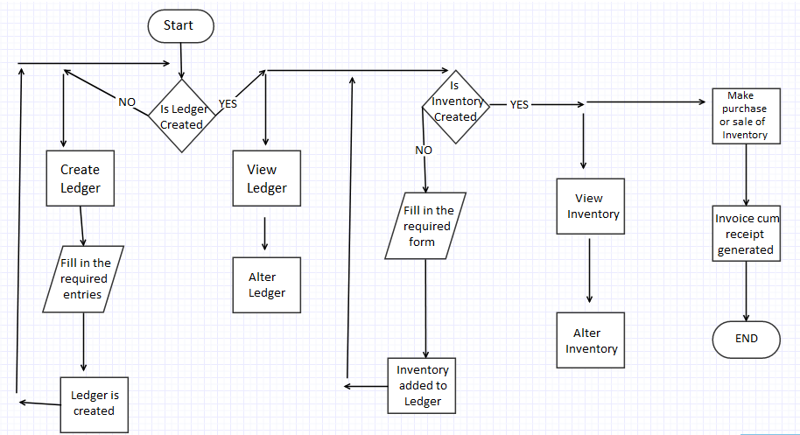

Figure 1: Flow Diagram for the application
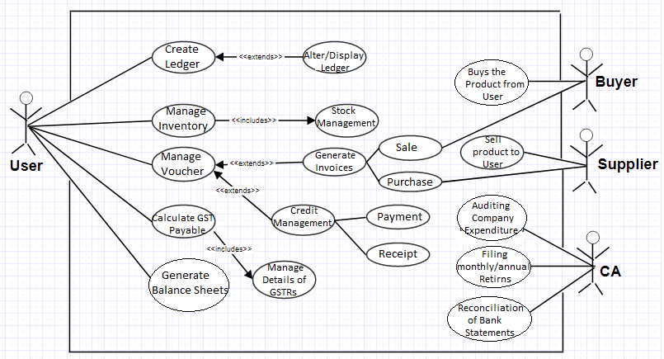 Figure 2: Use Case Diagram
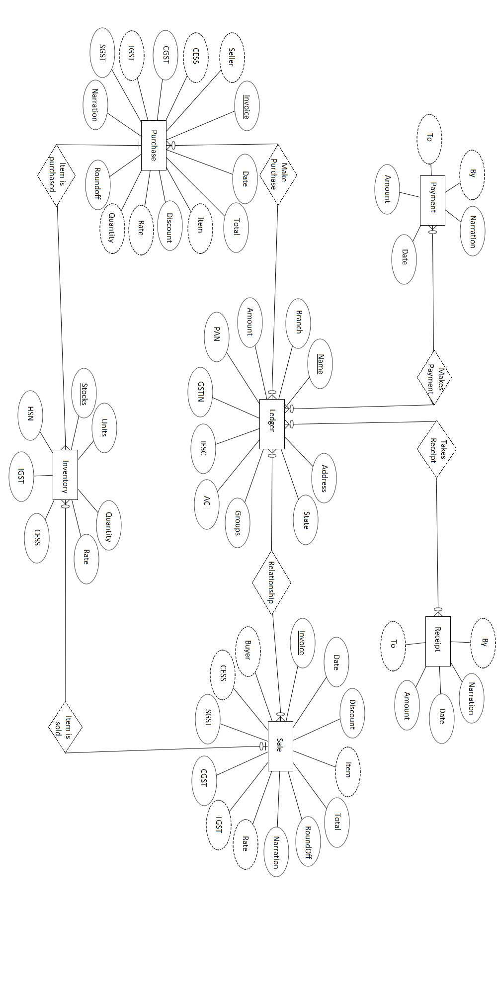
Figure3: ER diagram
IMPLEMENTATION

Our application is a complete product that retains its original simplicity yet offers comprehensive business functionalities such as Accounting, Inventory, Sales, Purchase and Point of Sales along with compliance capabilities for GST.

The Application starts off with the home page with its basic functionalities being displayed.
In order to access each of theirs’ functions, the user can press the respective button and head on to next pages.

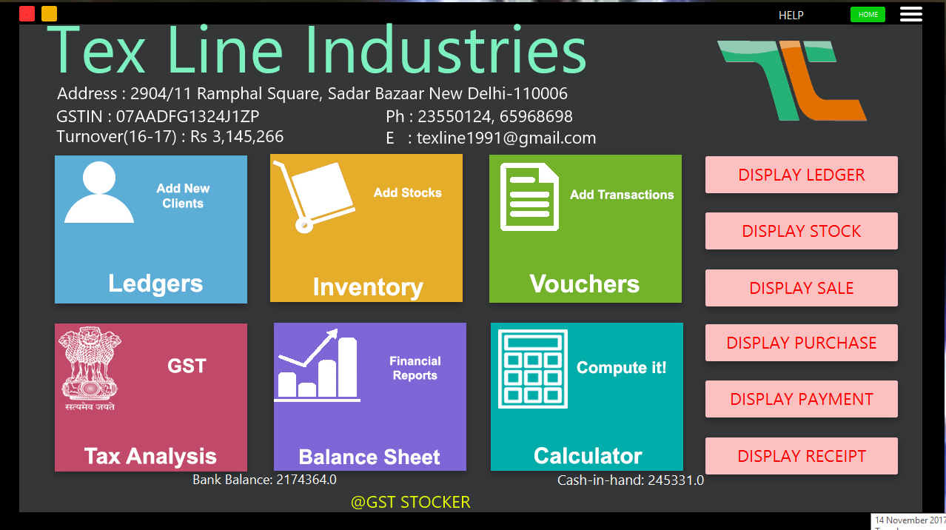

For instance the user selects the option of ledger will be now directed to a page containing a form to create ledger. Also, on the right hand side top corner comes a menu option from where the user can do various other tasks on the ledgers.

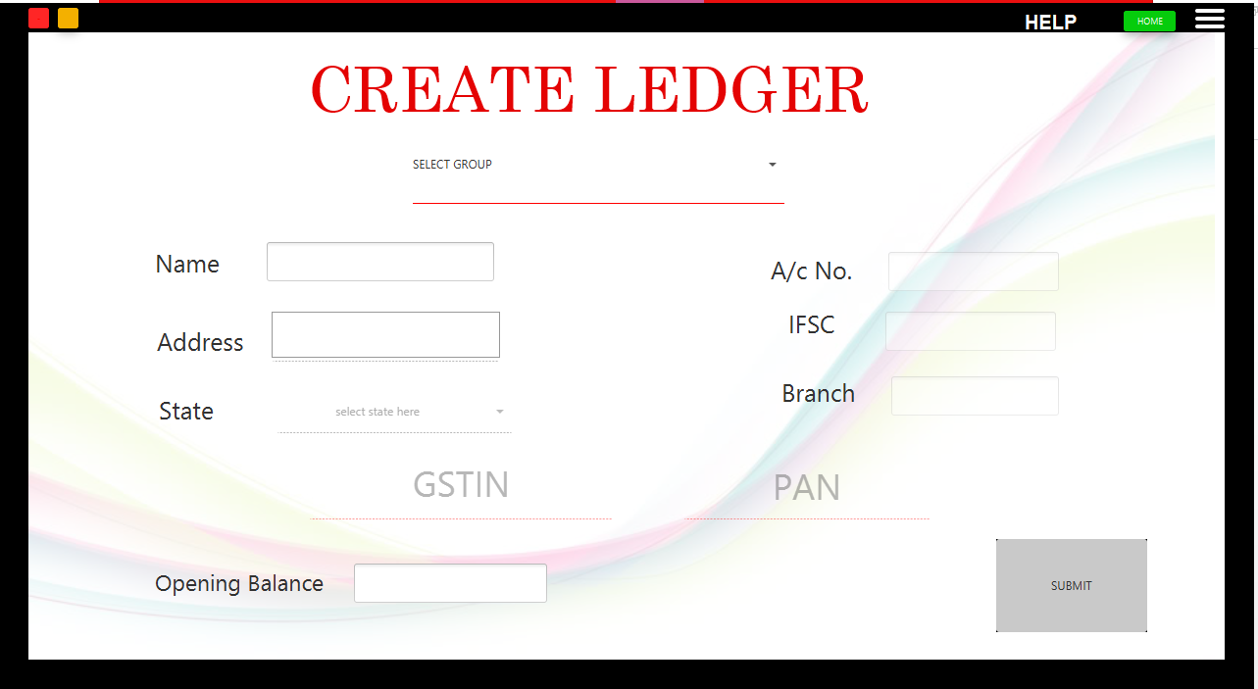

As the submit button is pressed the form is submitted to the databse and accordingly a ledger is created.Left side panel shows the other various functions that can be performed over the already created ledgers such as dsiplaying them and altering the required ones.

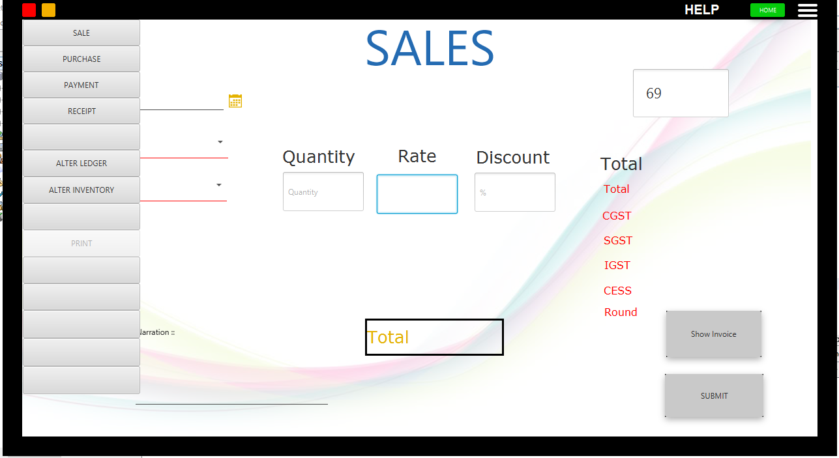

Same as above, selecting the inventory option will take the user to the page of creating inventory with all their details and manage stocks. The inventory created is then added to the database of items along with its quantity.

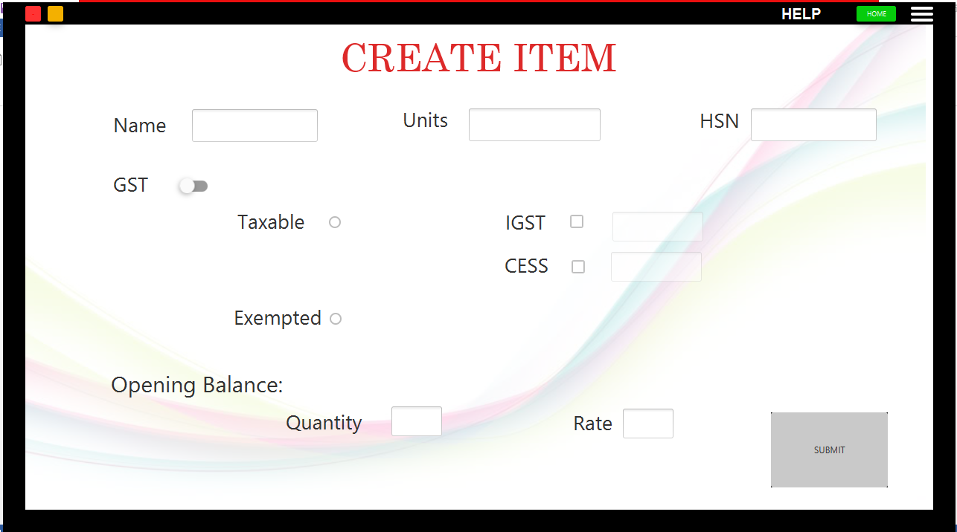

The third functionality of voucher consists of multiple functions such as

To make Sales

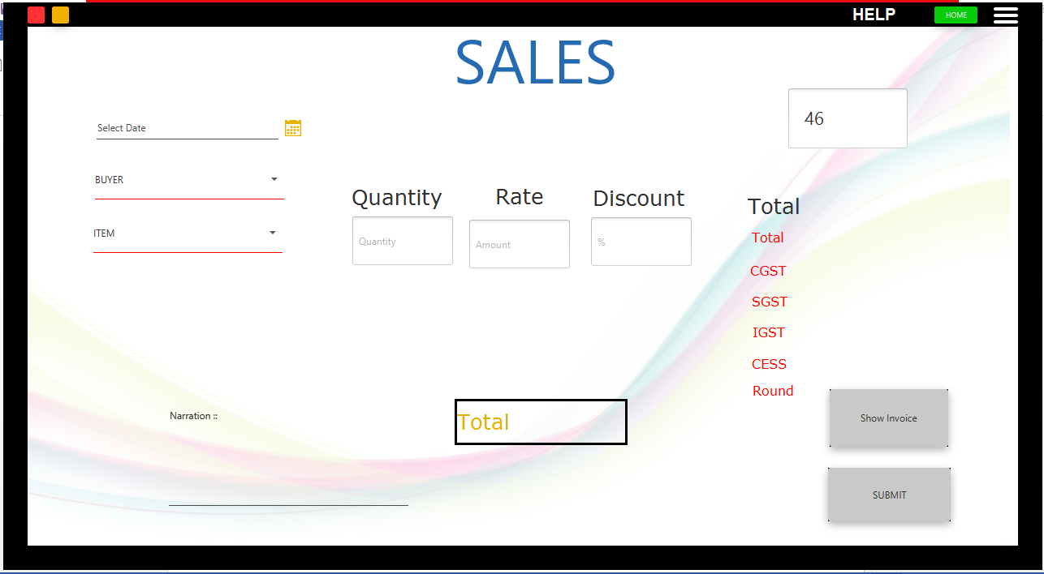

To make Purchase.

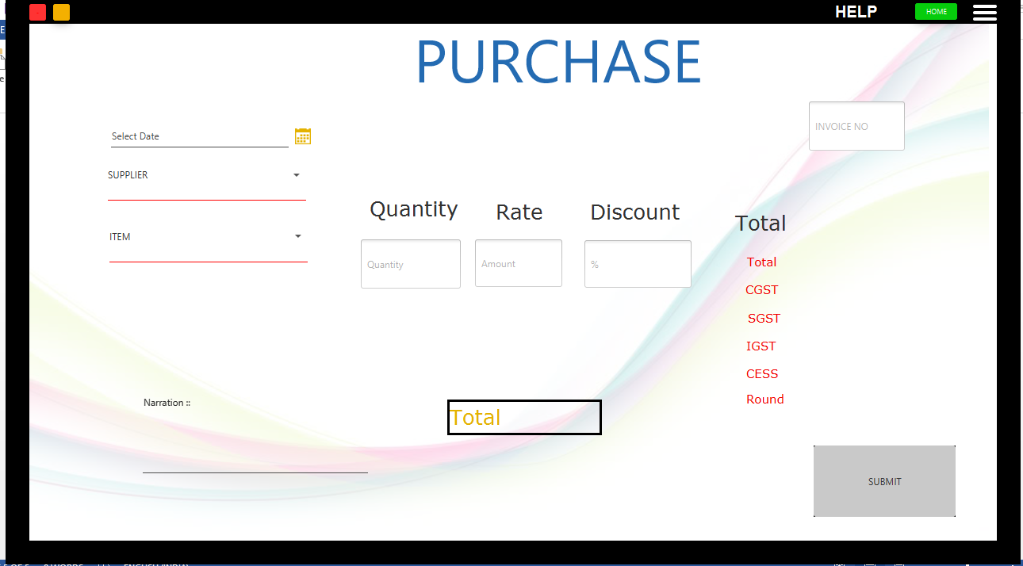

Payment details by the user

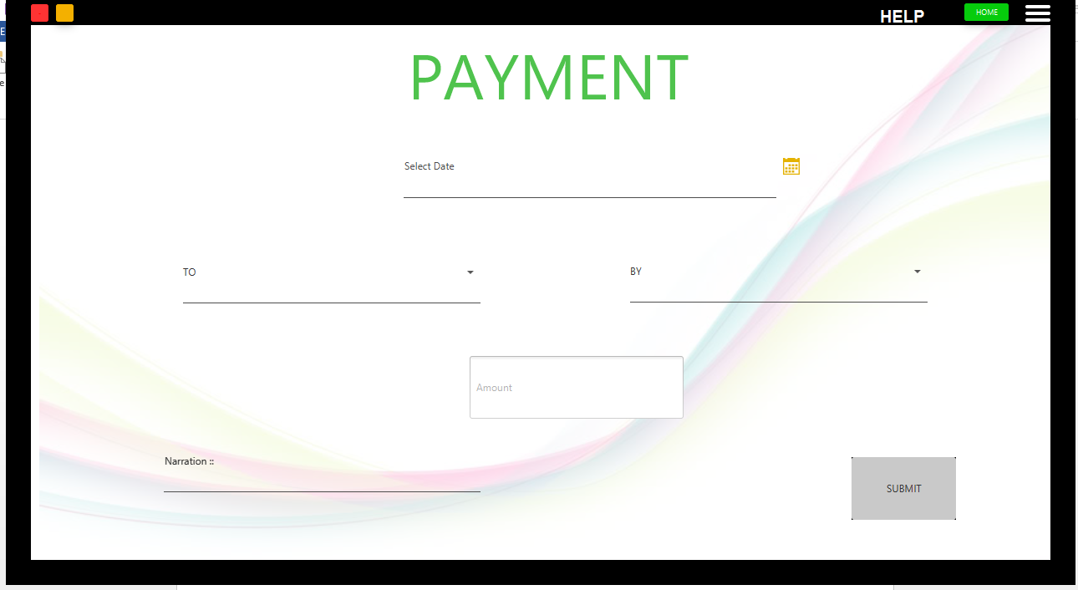

Receipt of payment to the user

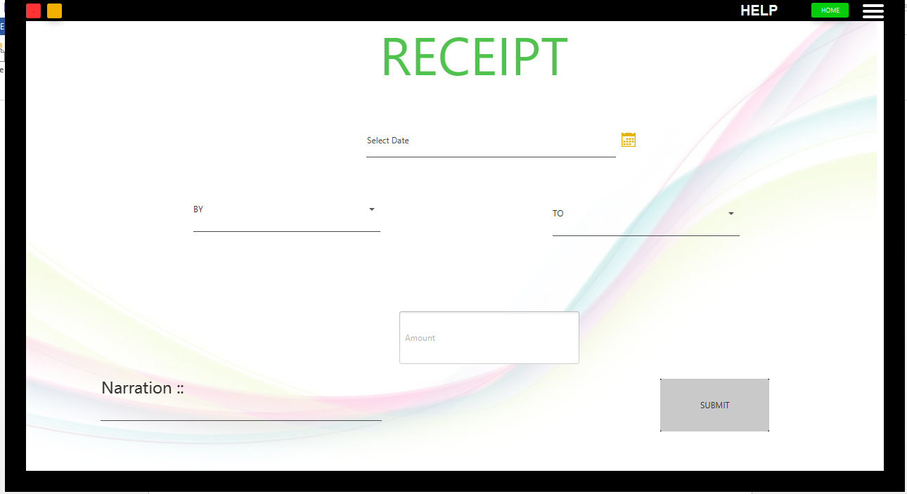

Then comes the GSTR forms which are generated by selecting desired month and year.

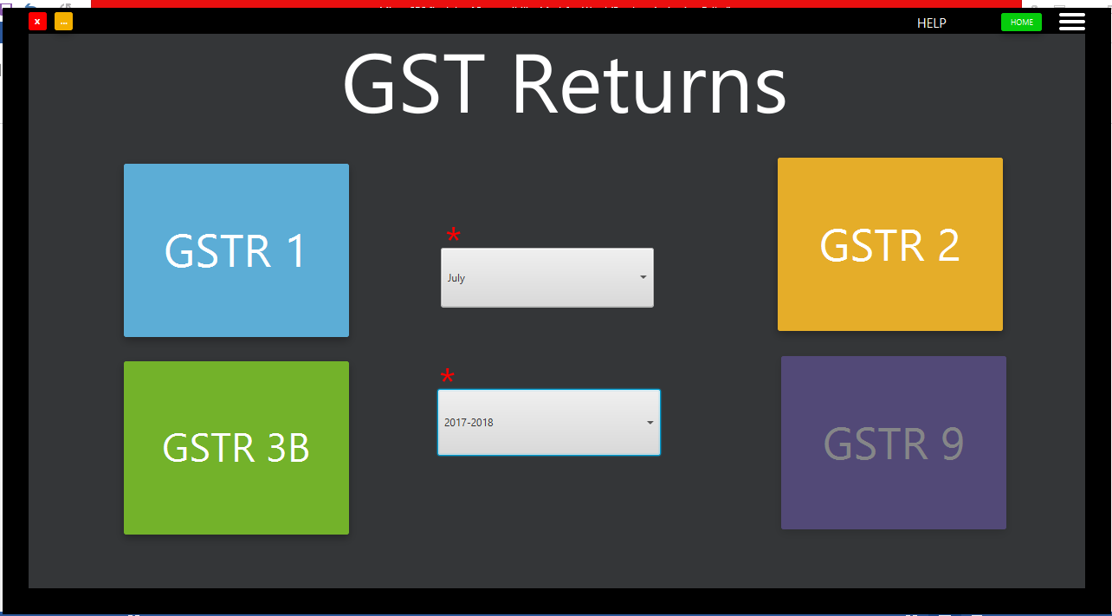

You can also view the previous records by “Display” function. Similarly like ledger you can display all the tables available in GST stocker.

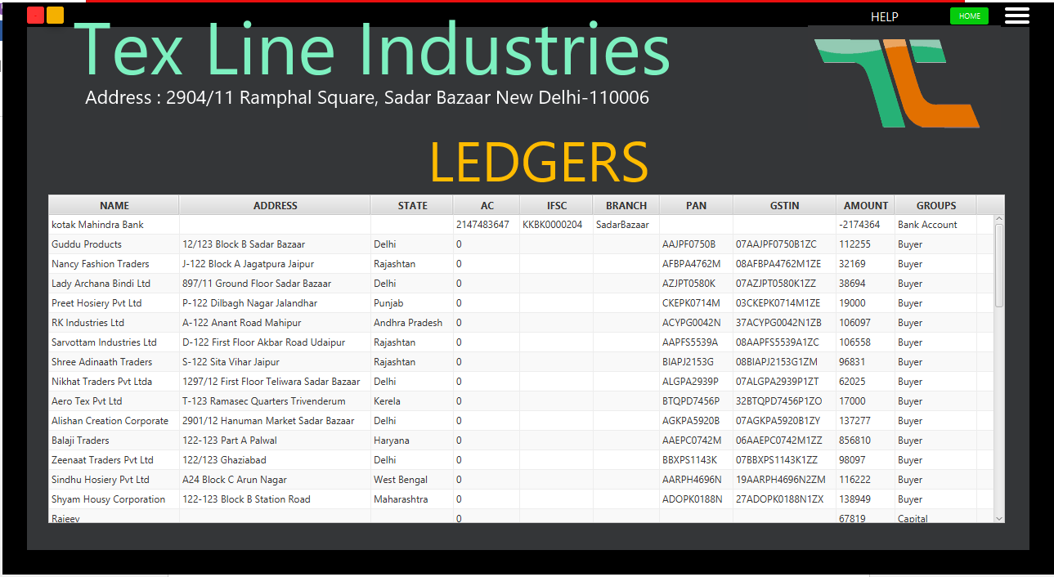

The final functionality this app is providing is the balance sheet which helps us in maintaining our assets and liabilities and thus tell the user about his losses and profits.

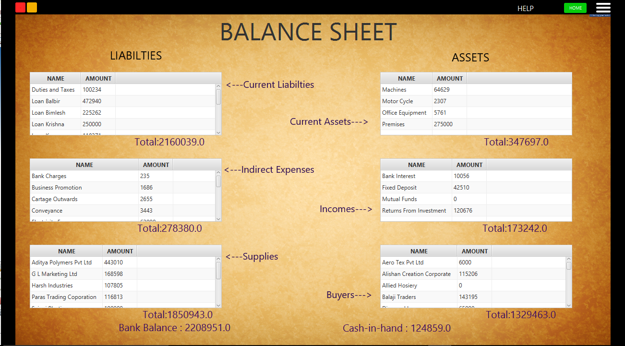

Testing and Analysis

Test case | Description | Expected Outcome | Actual Outcome | Status
1. Submit button | Inserting ledger info in sql | One row addition in sql | One row addition in sql | True
2. Group combo box | Activating desired fields | Desired fields activation | Desired fields activated | True
3. PAN and GSTIN field | Validating their format | Alert box for wrong input | Alert box appear if input is wrong | True
Test case for ledger form
Test case | Description | Expected Outcome | Actual Outcome | Status
1. Submit button | Inserting stock info in sql | One row addition in sql | One row addition in sql | True
2. GST toggle button | Activating desired fields | Desired fields activation | Desired fields activated | True
3. HSN field | Validating its format | Alert box for wrong input | Alert box appear if input is wrong | True
Test case for inventory
Test case | Description | Expected Outcome | Actual Outcome | Status
1. Submit button | Inserting stock info in sql | One row addition in sql | One row addition in sql | True
2. Show invoice button | Generation of invoice | Invoice generates | Invoice generates | True
3. Quantity field | Quantity<=stock available | Alert if quantity demanded is more | Alert if quantity demanded is more | True
4. Invoice no field | Invoice no increments after every transaction | Invoice no increments | Invoice no increments | True
Test case for sale
Test case | Description | Expected Outcome | Actual Outcome | Status
1. Submit button | Inserting purchase info in sql | One row addition in sql | One row addition in sql | True
2. GST toggle button | Activating desired fields | Desired fields activation | Desired fields activated | True
3. HSN field | Validating its format | Alert box for wrong input | Alert box appear if input is wrong | True
3. Quantity field | Quantity update in sql | Quantity updation | Quantity updation | True
Test case for purchase

Test case | Description | Expected Outcome | Actual Outcome | Status
1. Submit button | Inserting receipt info in sql | One row addition in sql | One row addition in sql | True
2.ledger updation | Info updates the ledger | Ledger updates | Ledger updates | True
Test case for receipt
Test case | Description | Expected Outcome | Actual Outcome | Status
1. Submit button | Inserting payment info in sql | One row addition in sql | One row addition in sql | True
2.ledger updation | Info updates the ledger | Ledger updates | Ledger updates | True
Test case for payment

Test case | Description | Expected Outcome | Actual Outcome | Status
1.Retrieving data | Data is retrieve from sql | Cells value is filled automatically | Cells value is filled automatically | True
2. Excel sheet | Generation of excel sheet on clicking button | Excel sheet generates | Excel sheet generated | True
Test case for GSTR forms
Test case | Description | Expected Outcome | Actual Outcome | Status
1. Retrieving data | Data is retrieve from sql | Cells value is filled automatically | Cells value is filled automatically | True
2. Excel sheet | Generation of excel sheet on clicking button | Excel sheet generates | Excel sheet generated | True
3. Analysis | Loss-profit analysis | Showing whether company is facing loss or profit | Showing whether company is facing loss or profit | True
Test case for balance sheet
Test case | Description | Expected Outcome | Actual Outcome | Status
1. Data insertion | Inserting info in sql | One row addition in sql | One row addition in sql | True
2. Data alteration | Altering data fileds in sql | Fields altered | Fields altered | True
3. Data retrieval | Retrieval of data by various forms | Successful data retrieval | Succesful data retrieval | True
Test case for sql database

CONCLUSION & FUTURE SCOPE

The present study has been made to suggest and develop some tools which will eventually be useful to the governments, financial institutions, owners and/or contractors for timely completion of large infrastructure projects at reasonable cost and of a specified quality. GST projects are targeting towards financing, designing, implementing and operating infrastructure facilities and services that were traditionally provided by the public sector. The government of India is leading the process of promoting GST projects in India to create a success story. However, the overall financing gaps in infrastructure are quite high as per the estimates of planning commission of India. The investment needs for infrastructure is enormous. India faces a very large financing gap which needs to be bridged by domestic as well as foreign and private sector investment

References

Kumar, N. (2014). Goods and Services Tax in India: A Way Forward. Global Journal of Multidisciplinary Studies, 3(6).

Beniwal, Vrishti (2013, Dec 23), Years of wait before DTC, GST are roll out, Business Standard .Retrieved from http://www.business-standard.com

CA Rajkumar S Adukia, A Study On Proposed Goods And Services Tax [GST] Framework In India, available at http://taxclubindia.com/simple/rajkumar.pdf

