**SQL EXERCISE**

**#TASK 1**

**Creating Employee DB**

*1. create employee(emp_id,employee_name,department_name,dept_id,location_id,salary)department(dept_id,department_name),locations (location_id, location_name) tables with relevant attributes.*

Ans:-

CREATE TABLE employee(

emp_id int,

employee_name varchar(30),

department_name varchar(30),

location varchar(30),

salary int

);

CREATE TABLE department(

dept_id int,

department_name char

);

CREATE TABLE locations(

location_id int,

location_name char

);

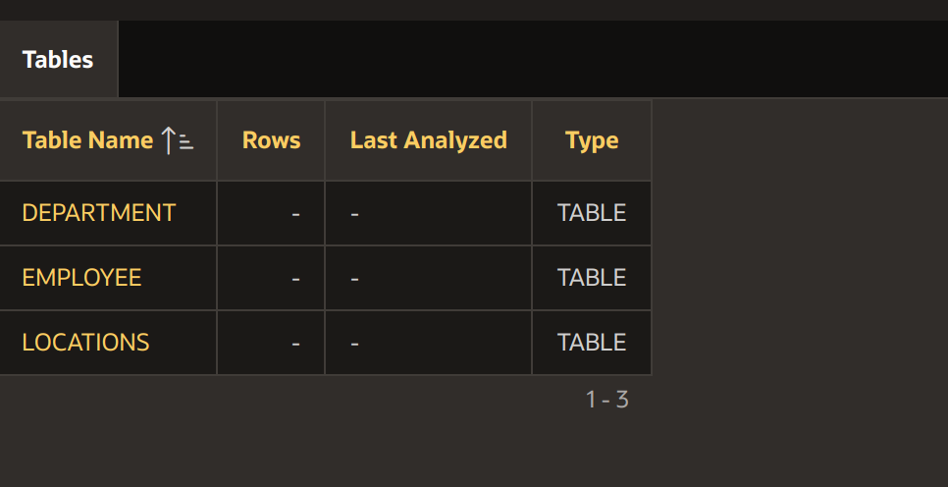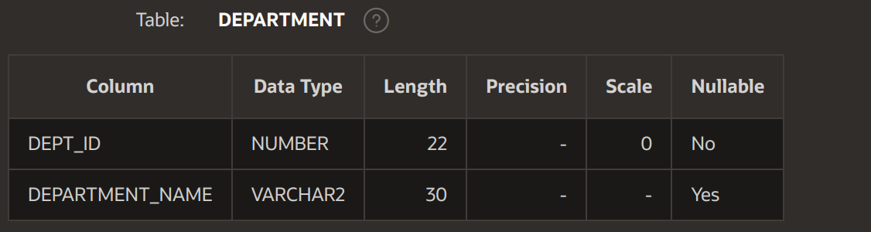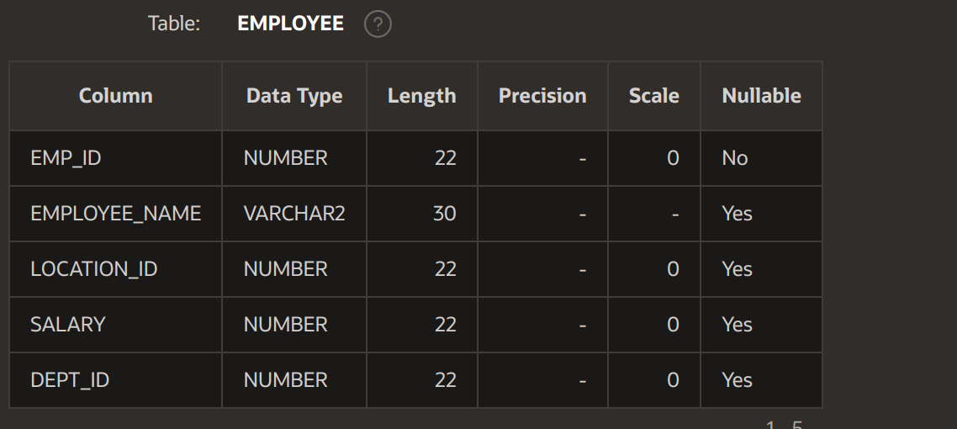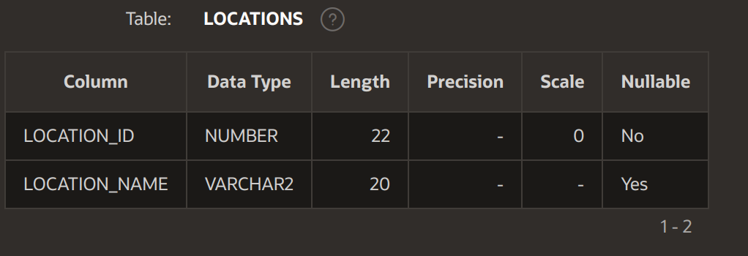

*2. create primary key on each table and foreign keys (location->department, department->employee)*

Ans:-

ALTER TABLE employee

ADD CONSTRAINT emp_id

PRIMARY KEY(emp_id);

ALTER TABLE department

ADD CONSTRAINT dept_id

PRIMARY KEY(dept_id);

ALTER TABLE locations

ADD CONSTRAINT location_id

PRIMARY KEY(location_id);

ALTER TABLE employee

ADD FOREIGN KEY (dept_id) REFERENCES department(dept_id);

ALTER TABLE employee

ADD FOREIGN KEY (location_id) REFERENCES locations(location_id);



*3. insert 20 employees data, 4 departments data, 2 locations data.*

Ans:-

INSERT INTO locations

VALUES (1, 'Noida');

INSERT INTO Department

VALUES (101, 'Engineering');

INSERT INTO employee

VALUES (1001 , 'A1' , 'Engineeering' , 1 , 20000 , 101) ;

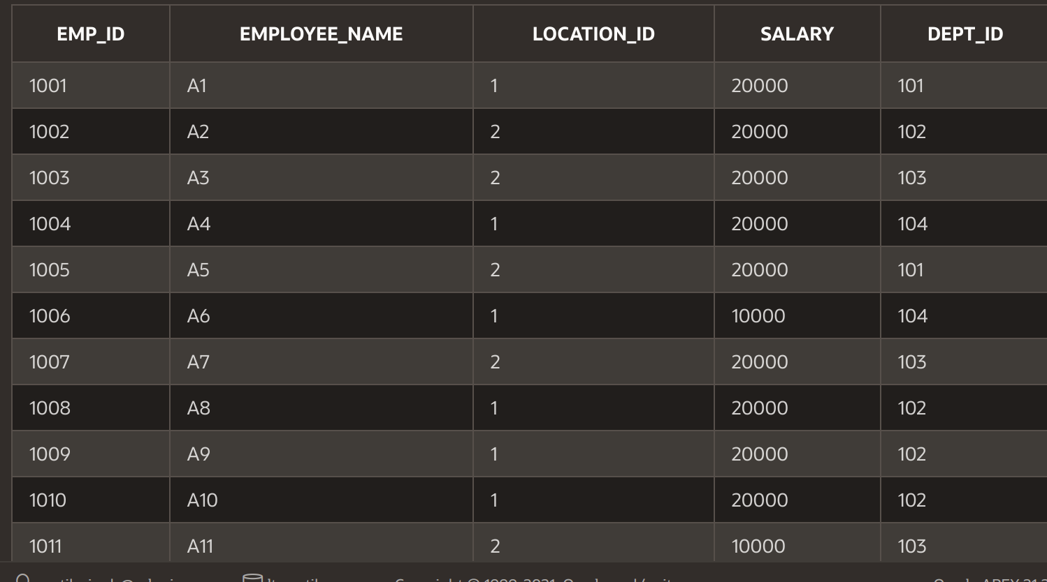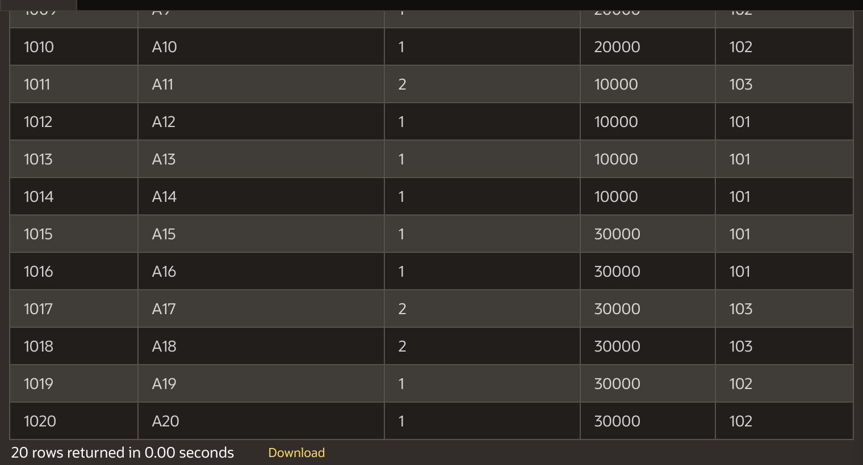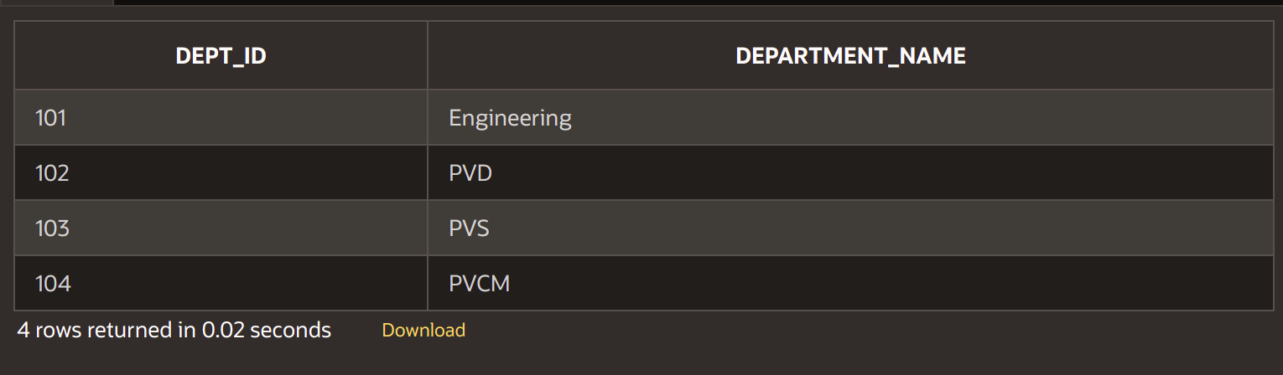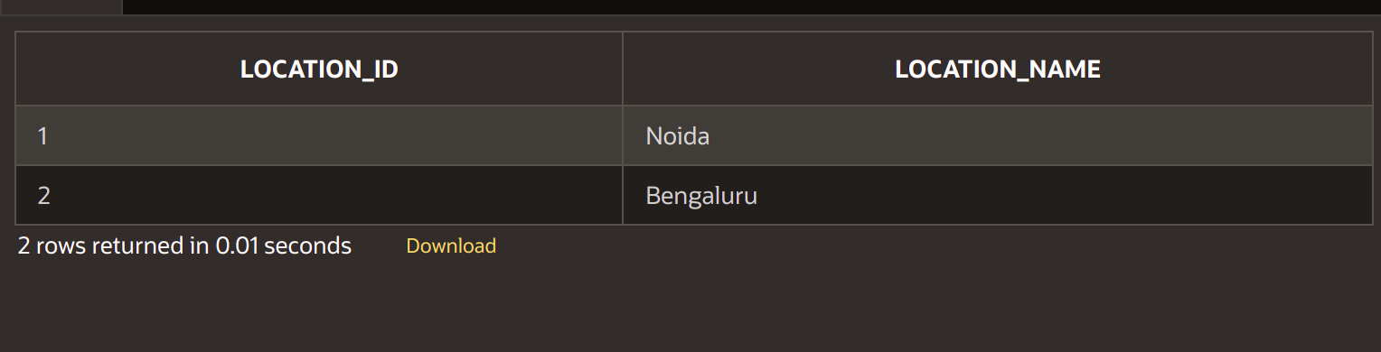

*4. write below queries:*

*a) display all employees names and their department names*

Ans:-

SELECT employee.employee_name, department.department_name

FROM employee

INNER JOIN department

ON employee.dept_id = department.dept_id

ORDER BY employee.employee_name;

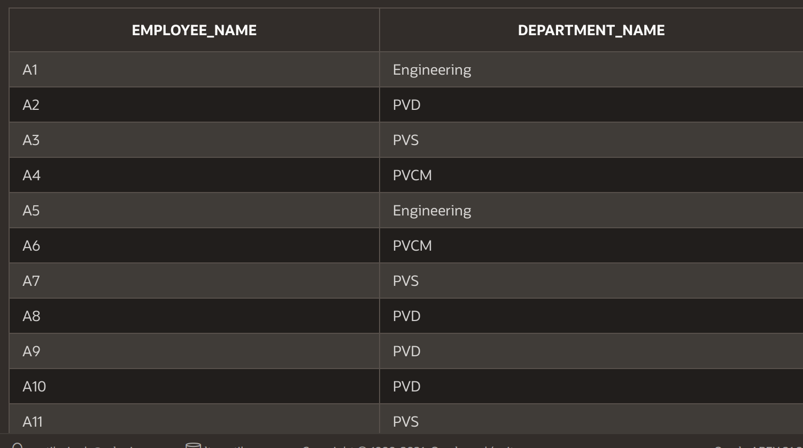

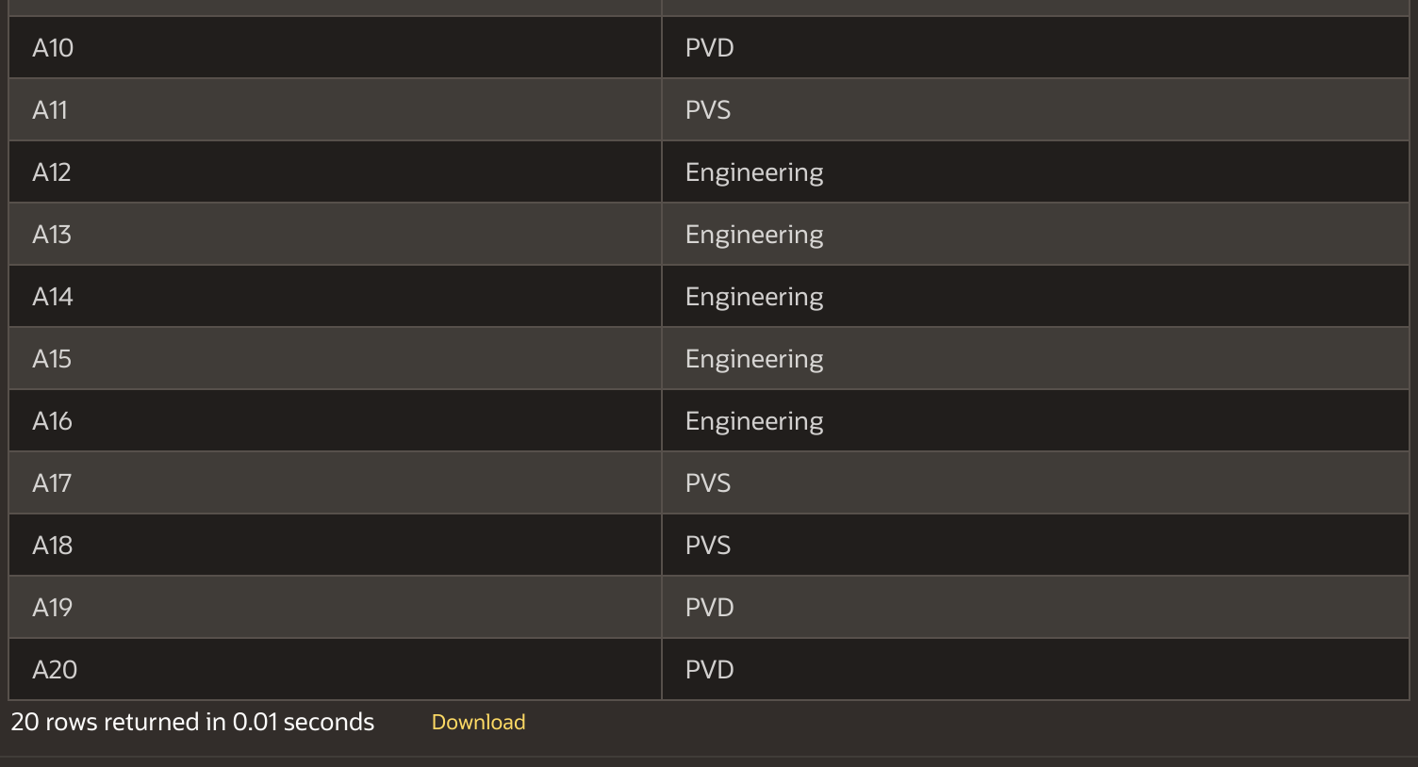

*b) display all location_name, department_name, employee_name, salary for all matching rows from 3 tables.*

Ans:-

SELECT locations.location_name, department.department_name, employee.employee_name, employee.salary

FROM ((employee

INNER JOIN department ON employee.dept_id = department.dept_id )

INNER JOIN locations ON employee.location_id = locations.location_id)

ORDER BY emp_id;

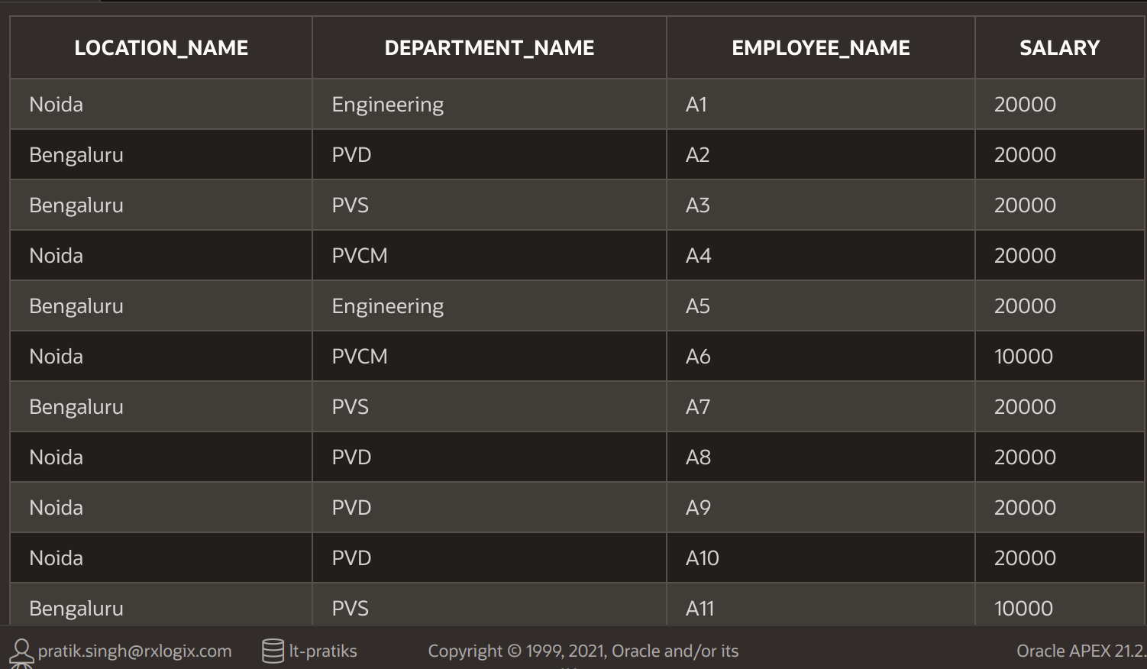

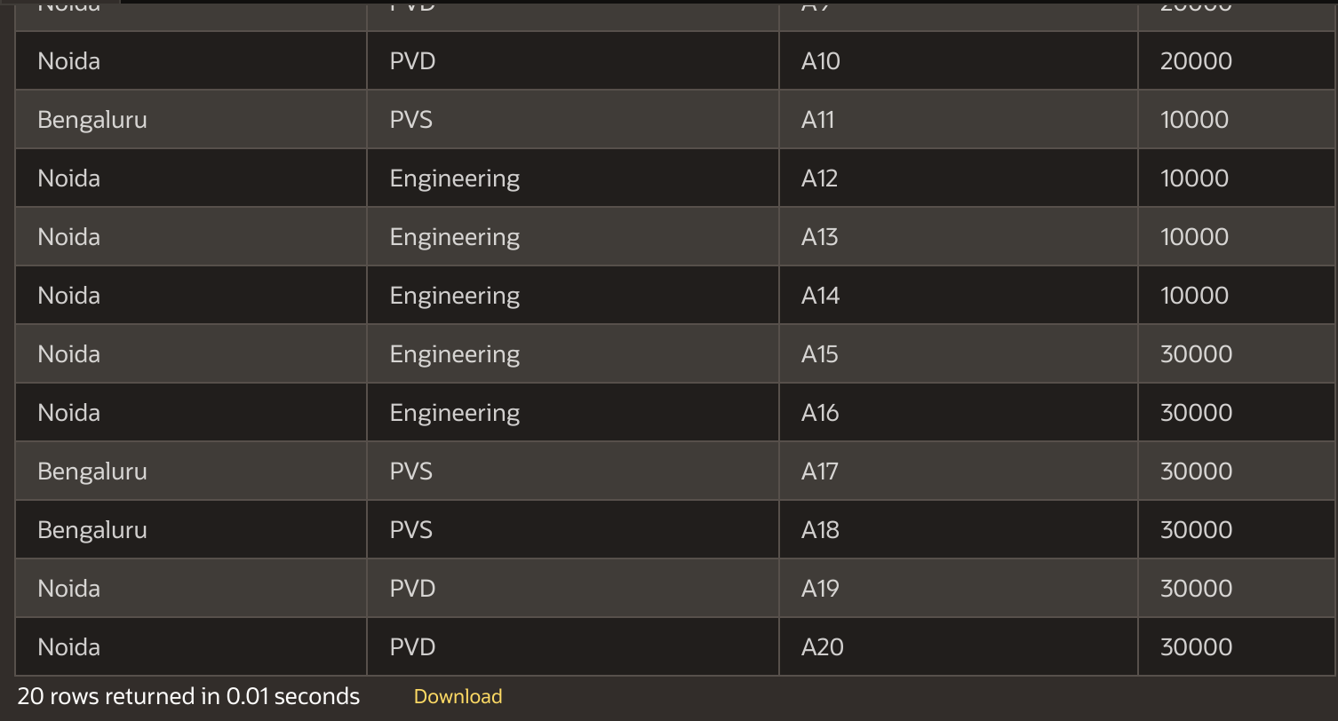

*c) select maximum salary earned from each department*

Ans:-

SELECT max(employee.salary), department.department_name

FROM employee

INNER JOIN department

ON employee.dept_id = department.dept_id

GROUP BY department.department_name;

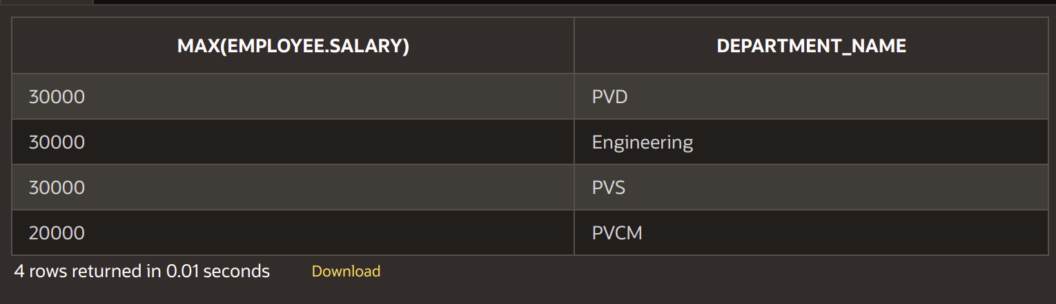

*d) select 2nd highest salary from each department.*

SELECT max(salary), department.department_name

FROM employee a

Join department

ON a.dept_id = department.dept_id

WHERE 1 = (SELECT count(distinct salary)

FROM employee b

where b.salary > a.salary and a.dept_id = b.dept_id

group by dept_id)

group by department.department_name;

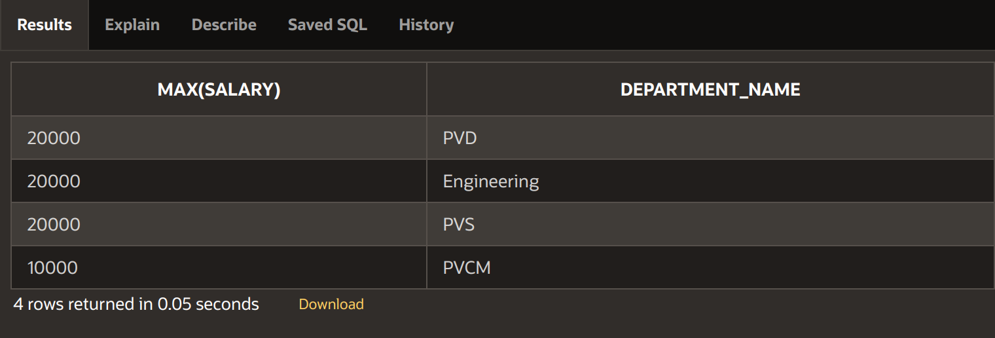

*e) select location_name, department_name, average_salary(of each location)*

Ans:

SELECT location_name,department_name,avg(salary)

FROM employee

JOIN department

ON employee.dept_id = department.dept_id

JOIN locations

ON employee.location_id = locations.location_id

GROUP BY location_name,department_name;

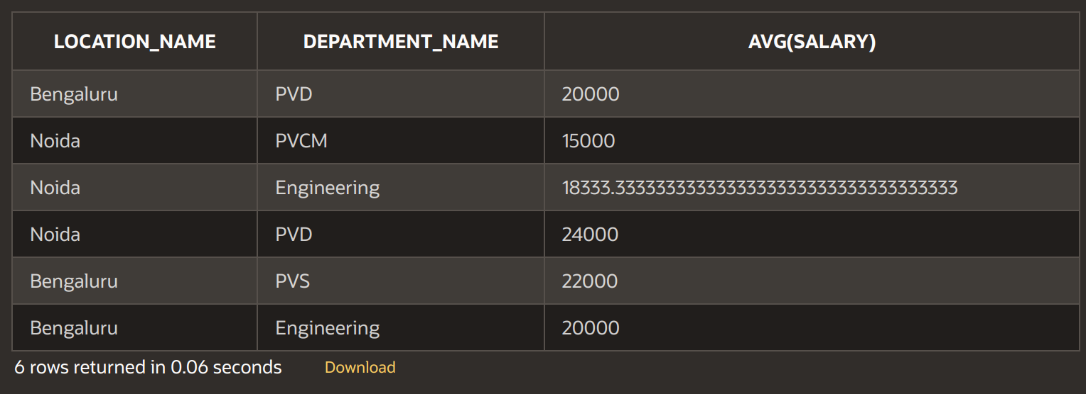

*f) Show locations with no of department where no of department is 2*

Ans:-

SELECT location_name,count(DISTINCT employee.dept_id)

FROM employee

JOIN locations

ON employee.location_id = locations.location_id

HAVING count(DISTINCT employee.dept_id) = 2

GROUP BY locations.location_name;



