Map for Panimalar Engineering College with an AI Chatbot

Pallavi S  
Department of Computer Science and Engineering  
*Panimalar Engineering College*Chennai, India  
pallavisriram2602@gmail.com

Rajeshwari C  
Department of Computer Scienceand Engineering  
*Panimalar Engineering College*Chennai, India  
rajeshwarichakra06@gmail.com

*Abstract*—**Navigating large college campuses can be a daunting task, especially for new students and visitors. This project aims to develop a user-friendly digital platform integrating an interactive campus map with an AI chatbot called “The PEC Map with an AI Chatbot”. Users can engage in real-time, conversational interactions with the chatbot to receive accurate and instant guidance. The integration of the AI chatbot with the map enhances the user experience by providing dynamic, personalized responses based on location and specific queries. The college map will also provide a detailed layout of buildings, departments, facilities, and services, allowing users to easily locate their desired destinations. Through machine learning and natural language processing (NLP), the chatbot interprets user intents and dynamically updates the map to display relevant information**

Keywords—AI Chatbot, machine learning, natural language processing(nlp).

# Introduction

The goal of the project is to develop a Map interface integrated with an artificial intelligence(AI) chatbot for seamless communication with the user interface. The Map is intended for navigating inside Panimalar Engineering College(PEC) Campus. This Map also offers the option of viewing a specific building, real-time location inside the campus, navigation in the campus in the including the shortest distance between the starting point and destination. The AI chatbot in the Map assists the user in making decisions regarding navigation. Apart from that, it also offers customizedrecommendations to an user for reaching a specific destination.

Our project “The PEC Map” focuses on creating a customized map for PEC with all the features to make the Map user interface user-friendly. The AI chatbot offers a conversational interface making it easier for the user to understand the instructions and recommendations. The Map offers spatial visualization and processes user query using natural language processing(NLP) This Map reduces the stress and hassle for the visitors thereby saving time and energy.

The platform is designed to be user-friendly, regardless of the skill level, ensuring that students, faculty, and visitors can easily navigate the campus. Additionally, the AI chatbot can provide valuable information beyond directions, such as details about ongoing campus events, department contacts, and administrative services.

# literature survey

AI Chatbot Development and Navigation: Research by Palanivel & Sujatha (2021) discusses the role of AI in creating intelligent chatbots that use natural language processing (NLP) to interpret user queries and provide campus-related information. These chatbots offer personalized assistance for way finding, enhancing accessibility and ease of navigation for students and visitors.

Human-Computer Interaction (HCI): Studies such as by Gulliksen et al. (2020) investigate the design and usability aspects of AI-powered chatbots, ensuring that the interaction is intuitive. Literature emphasizes integrating user feedback and design thinking into the creation of chatbot systems to improve their utility and user satisfaction.

Location-Based Services (LBS): AI chatbots use advanced geospatial technologies, such as GPS and indoor positioning systems, to offer real-time directions. The study by Kaasinen et al. (2022) highlights how AI and LBS can work together to provide highly accurate navigation within dynamic and complex environments like a college campus.

Data-Driven Personalization: Research in AI personalization techniques, such as by Walker & Singh (2019), explores how chatbots leverage student data to offer tailored responses. For instance, chatbots can recommend study spaces or events based on a student’s schedule or preferences, enhancing the map's relevance.

# PROPOSED METHODOLOGY

##### **Interactive Digital Campus Map**

The system will feature a detailed, interactive map of the entire college campus, accessible on any device.

##### **AI-Powered Chatbot**

The AI chatbot, integrated with the map, will provide real-time, conversational assistance to users.

##### **USER-FRIENDLY INTERFACE**

A simple and intuitive interface for both the map and chatbot, allowing users of all skill levels to navigate the system easily.

##### **Customized Maps for College**

Our project aims to create a custom and tailor-made college map for the visitors to reduce their daily hassle.

##### **MAP INTERFACE SYSTEM**

The user interface system involving the Map interface is displayed onto the user. “The PEC Map” contains a lot of features and actions present in it to ensure the smooth workflow of the system. Let’s delve deeply into the components of the Map Interface System and their specific functions.Key Components:

### Open Map:

The system starts with the user or system triggering the opening of a map interface. This is the most important step of a GIS-based application or website service system that provides geographical or navigational services.

### Display Map Interface:

After the map is opened, the interface presents various controls such as zoom, pan, search, and other navigation tools for the user to interact with the map. It shows the geographical data and locations.

### Navigation of Map:

The user can navigate through the map using various controls such as zooming, dragging, or clicking. This component provides the core interaction tools for moving through and exploring the map.

### Map action:

Once the user has navigated to a specific area, there are multiple actions available, such as:

**Zoom:** Allows the user to zoom in and out of specific areas.

**Click:** The user can click on a location, and it will trigger further actions, such as identifying a point of interest (POI).

**Search:** Users can input specific queries, like addresses, and the map will locate those places.

### Close the Map:

This component closes the map interface once the user is done navigating, thus ending their session with the map system.

**AI CHATBOT SYSTEM:**

“The PEC Map” also has a built-in feature of an AI Chatbot. This chatbot is used to give directions and recommendations to the user.

KEY COMPONENTS:

### AI Chatbot System:

The user initiates interaction with an AI chatbot. This happens via a dedicated chatbot interface or by clicking on an AI assistant icon.

### Input Query:

The user types or speaks a query into the chatbot. This could be a specific request such as asking for directions, information about a place, or even questions about geographic data.

### Query Processing:

The AI processes the input, parsing the natural language query, interpreting what the user is asking, and possibly interacting with back- end systems (like the map database or other external data sources) to retrieve relevant information.

### AI Chatbot Response:

Based on the processed query, the AI provides a response. This could include text-based answers, suggestions or recommendations, or additional queries for clarification.

### Map Visualization of the Response:

If the chatbot’s response includes spatial or location-based information, it can display the results directly on the map interface. For instance, if a user asks for directions or places of interest, the chatbot will return results as markers or paths on the map.

An illustration of the userflow interaction diagram is explained in the form of a flowchart given below.

This flowchart explains the sequence of actions taking place starting from the opening of the Map to navigation till the closing of the Map.

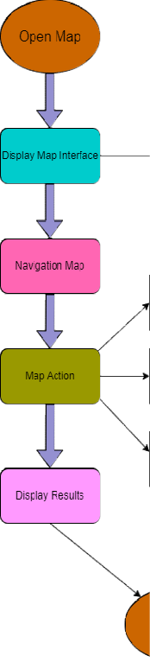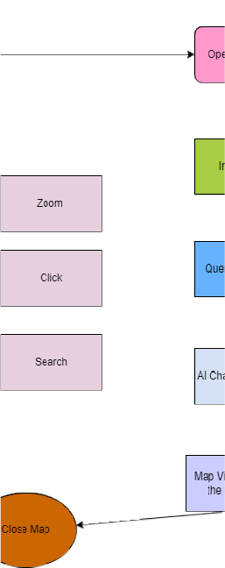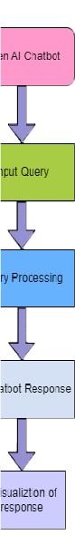

figure 1: flowchart describing the userflow interaction

# RESULTS

**MAP PERFORMANCE:**

Key Metrics:

Time to First Paint (TTFP): Time it takes for the first elements of the map (such as tiles or markers) to appear.

Time taken to Interact (TTI): Time for the map to become fully interactive for users (i.e., users can zoom, pan, click on markers).

Tile Loading Time: Time taken to load all the map tiles, especially as users pan or zoom.

Interaction Latency: Measure the delay between user actions (e.g., clicks, zooms) and the system's response.

FPS (Frames per Second): Higher FPS ensures smooth map interactions, especially during animations (e.g., moving between locations).

**AI CHATBOT PERFORMANCE:**

. Key Metrics:

Average Response Time: Time taken for the chatbot to understand the user query and provide a response.

Response Latency Under Load: Analyze chatbot performance under heavy traffic or multiple concurrent queries.

Intent Recognition Accuracy: Percentage of queries where the chatbot correctly identifies the user's intent (e.g., asking for directions).

Entity Recognition Accuracy: Ability of the chatbot to accurately identify campus-specific entities (e.g., names of buildings, classrooms).

Scalability: Ensure the NLU model can handle an increasing number of users without significant drops in performance

# V.REFERENCES

Palanivel and Sujatha(2021): AI Chatbot and Development

Gulliksen et. al (2021): Human-Computer Interaction

Kaasinen et. Al.(2022): Location-based services

Walker&Singh(2019): Data-driven personalization