Project 5: Smart Image Analysis Application
Platform: AWS Academy Learner Lab (us-east-1)
Author: Ramsha | Date: July 5, 2026

1. Problem Statement
A company wants to automatically understand the content of images it receives — identifying objects, scenes, facial expressions, and whether people in the photo are smiling — without manual review. This application analyzes uploaded images and stores the analysis results for later retrieval.

2. Solution Architecture
Image Upload → Amazon S3 → AWS Lambda (trigger) → Amazon Rekognition → Amazon DynamoDB

AWS Services Used
- Amazon S3 — image storage and event trigger source
- AWS Lambda — event-driven compute, orchestrates the analysis
- Amazon Rekognition — DetectLabels (objects/scenes) + DetectFaces (emotion/smile)
- Amazon DynamoDB — persists combined analysis results

Environment Note
Built entirely on AWS Academy Learner Lab, which restricts custom IAM role creation. All services (Lambda, S3, Rekognition, DynamoDB) were configured to use the pre-provisioned LabRole execution role instead of a custom IAM policy.

3. Implementation Steps

3.1 S3 Bucket Setup
- Created bucket: ramsha-smart-img-analysis (us-east-1)
- Created folder: images-input/
- Configured event notification for s3:ObjectCreated:* events, prefix images-input/, targeting the Lambda function
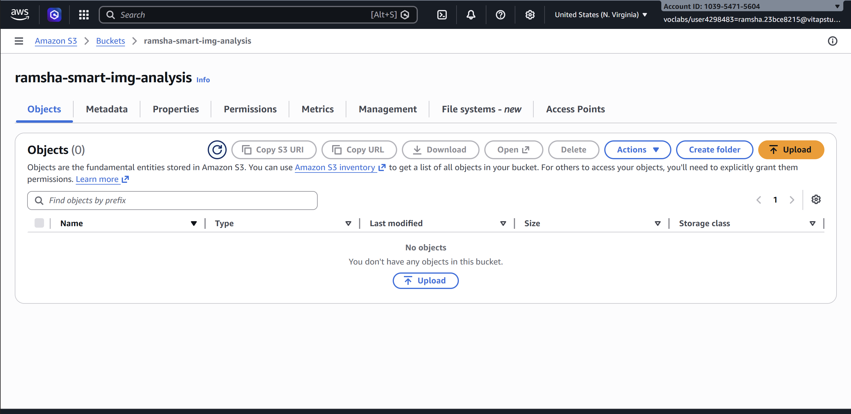

3.2 DynamoDB Table
- Table name: ImageAnalysisResults
- Partition key: image_id (String) — uses the S3 object key as unique identifier
- Capacity mode: On-demand (default settings)

3.3 Lambda Function
- Function name: ImageAnalysisFunction
- Runtime: Python 3.12
- Execution role: LabRole (existing role, via Custom execution role toggle)
- Timeout increased: 3s → 30s
- Memory increased: 128MB → 256MB
- Trigger: S3 bucket ramsha-smart-img-analysis, prefix images-input/, all object create events
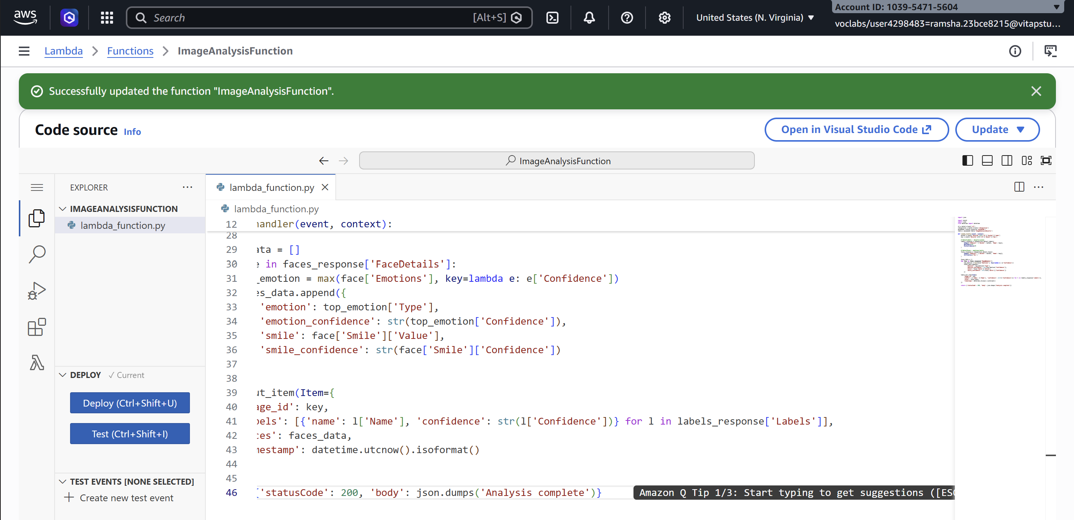

3.4 Verification
Confirmed successful execution via CloudWatch Logs — clean START → END → REPORT sequence with no errors, ~731ms duration:
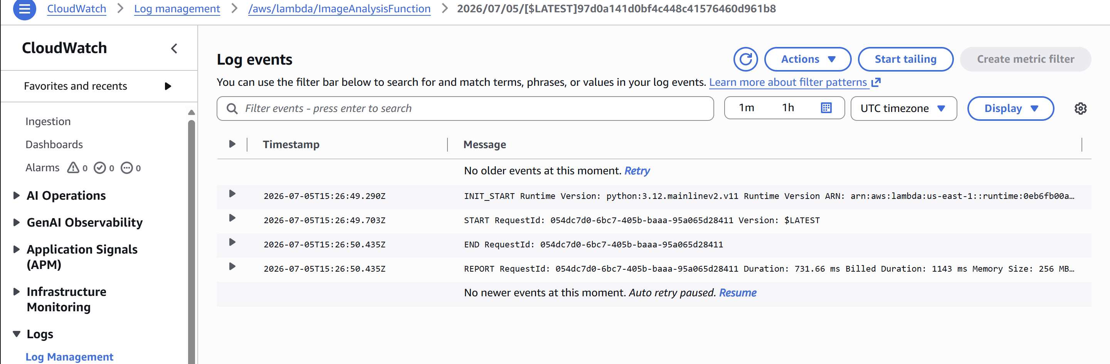

4. Test Results
Five images were uploaded to validate the pipeline across different scenarios:
# | Image | Faces | Notable Result
1 | images.jpg | 1 | HAPPY 100%; smile=true (99.96%)
2 | 215441473_e1.jpeg | 0 | No people — labels: Teddy Bear, Toy, Plush, Remote Control; faces returned cleanly empty
3 | emotions.jpeg | 9 | Varied emotions correctly distinguished: Happy, Surprised, Sad, Angry, Calm, Confused
4 | common-emotions.jpg | 24 | Large multi-face collage handled without timeout/error; mixed emotions accurate
5 | 360_F_215952710...jpg | 1 | SAD 99.3%; smile=false — correctly not flagged happy

Key Observations
- The pipeline correctly returns an empty faces list when no people are present, rather than erroring.
- Emotion classification remained accurate even with a large number of simultaneous faces (24 in one image).
- Smile detection correctly differentiated true/false with high confidence — did not default to "true."

DynamoDB Scan Results
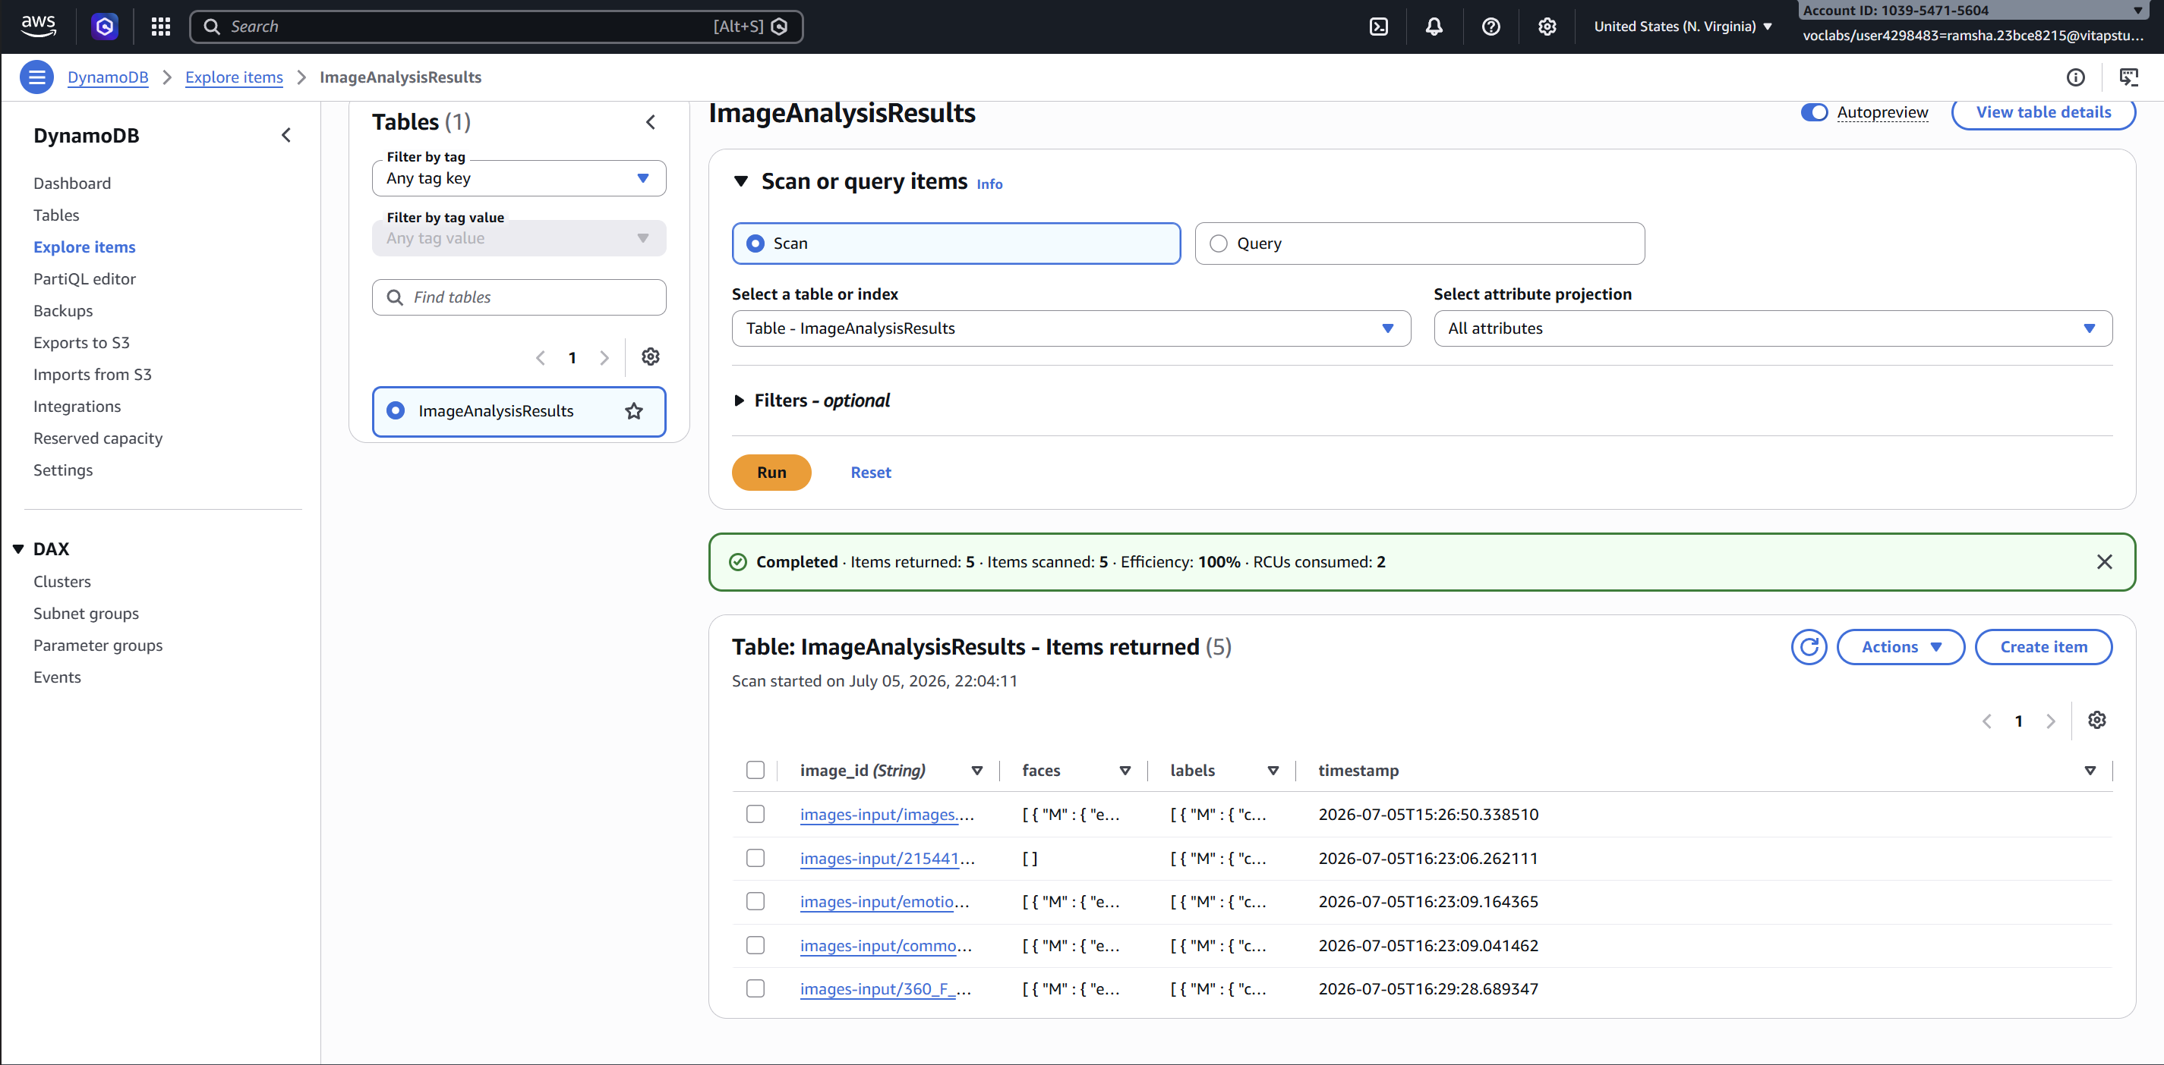

Sample Stored Record
{
"image_id": "images-input/images.jpg",
"faces": [
{
"emotion": "HAPPY",
"emotion_confidence": "100.0",
"smile": true,
"smile_confidence": "99.9570541381836"
}
],
"labels": [
{"confidence": "99.99464416503906", "name": "Head"},
{"confidence": "99.99464416503906", "name": "Person"},
{"confidence": "99.96414184570312", "name": "Happy"},
{"confidence": "99.96414184570312", "name": "Smile"}
],
"timestamp": "2026-07-05T15:26:50.338510"
}

5. Expected Output / Deliverables Mapping
Expected Output | Description | Status
Detected objects/labels | List of objects/scenes with confidence scores | Delivered
Facial analysis | Emotion classification with confidence scores | Delivered
Smile detection | True/false smile result with confidence score | Delivered
DynamoDB records | One record per analyzed image, combining all results | Delivered

6. Challenges & Resolutions
- IAM restrictions in Learner Lab: custom IAM roles could not be created. Resolved by using the pre-provisioned LabRole for Lambda's execution role.
- Default Lambda timeout too short: caused early failures. Resolved by increasing timeout to 30s and memory to 256MB.
- Region lock: Learner Lab restricts access to us-east-1/us-west-2. All resources created in us-east-1.

7. Conclusion
The Smart Image Analysis Application successfully demonstrates an event-driven, serverless architecture on AWS. Uploading an image to S3 automatically triggers analysis via Rekognition (label and face detection), with combined results persisted to DynamoDB for later retrieval — fulfilling all requirements of the project brief with no manual intervention required at any step.

