Automated Liquid Handler
Technical Design Document
An autonomous robotic liquid handling system for lab environments

System Overview

An automated liquid handler built on a repurposed Sovol SV08 3D printer as the XYZ motion platform. A pipette assembly driven by a stepper linear actuator replaces the print head, enabling precise aspiration and dispensing of liquid samples. An Atlas Scientific EZO pH circuit provides real-time pH monitoring. A Raspberry Pi 5 runs a SILA2 server that coordinates instrument operation and communicates with a desktop client over the local network. An onboard camera provides live monitoring and computer vision feedback.
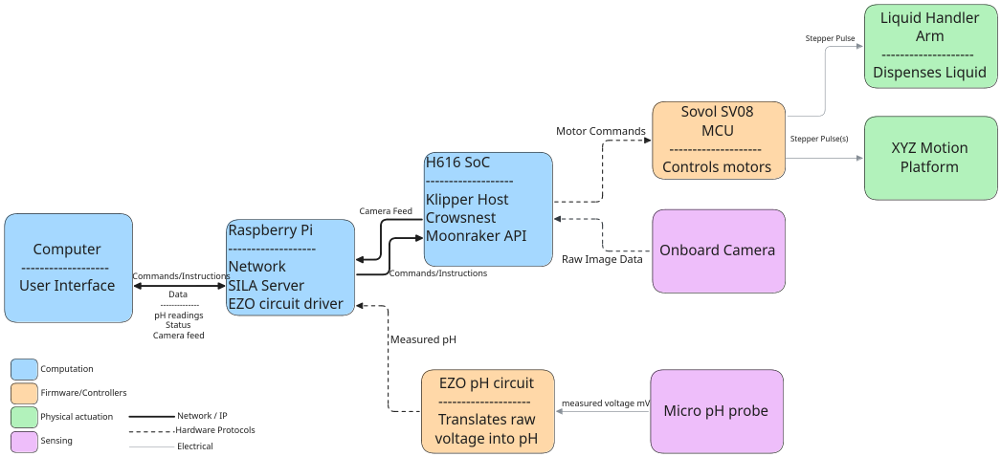

Component | Role
Sovol SV08 | XYZ motion platform, onboard H616 SoC runs Klipper and Moonraker API
SV08 MCU | Real-time stepper pulse generation for X, Y, Z, and pipette axes
Raspberry Pi 5 | Lab controller, runs SILA2 server, EZO driver, camera CV processing
Stepper Linear Actuator | Drives pipette plunger for aspiration and dispensing
Pipette Cone Assembly | Liquid displacement mechanism
Atlas Scientific EZO pH Circuit | Converts analog probe voltage to digital pH reading over I2C
Micro pH Probe | Measures pH of liquid samples
Onboard Camera | Live feed and CV-based arm monitoring via Crowsnest
Desktop Computer | User interface, connects to SILA2 server on Raspberry Pi

Wiring and Pin Out Diagrams
Hardware Overview

XYZ Motion Platform

Overview

The Sovol SV08 CoreXY 3D printer serves as the XYZ motion platform. The CoreXY gantry handles X and Y movement, and the Z axis raises and lowers the pipette assembly over the workspace. Motion is controlled by Klipper firmware. The H616 SoC on the SV08 mainboard runs the Klipper host and exposes the Moonraker REST/WebSocket API for external control. A separate MCU on the same board handles real-time stepper pulse generation.
Components
Sovol SV08
The base motion platform. Modified by replacing the print head with the pipette assembly. Klipper config files are updated to define the liquid handler workspace, safe acceleration limits, and pipette axis.
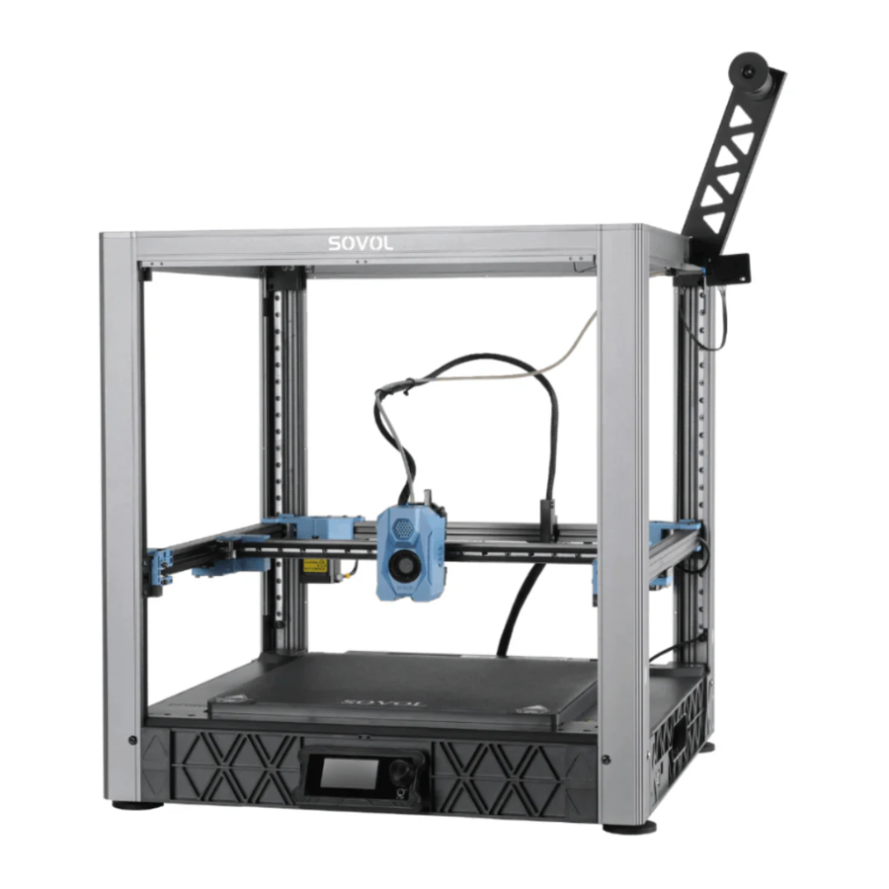

Parameter | Value
Motion system | CoreXY
Build volume | 350 x 350 x 345 mm
Onboard computer | Allwinner H616 ARM SoC
Firmware | Klipper (Sovol fork)
API | Moonraker (port 7125)
Camera software | Crowsnest (port 8080)
Z axes | 4 independent stepper motors
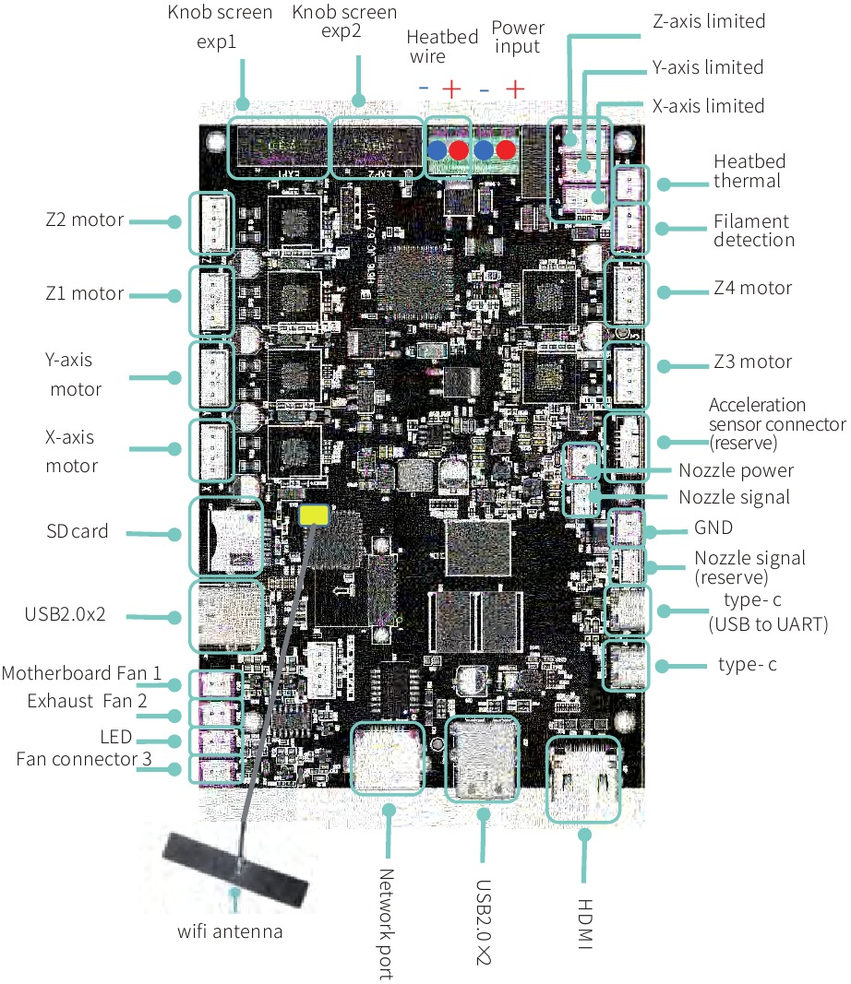
Raspberry Pi 5
Main lab controller. Connects to the SV08 H616 over the local network via the Moonraker API. Hosts the SILA2 server and drives the Atlas EZO pH circuit over I2C.
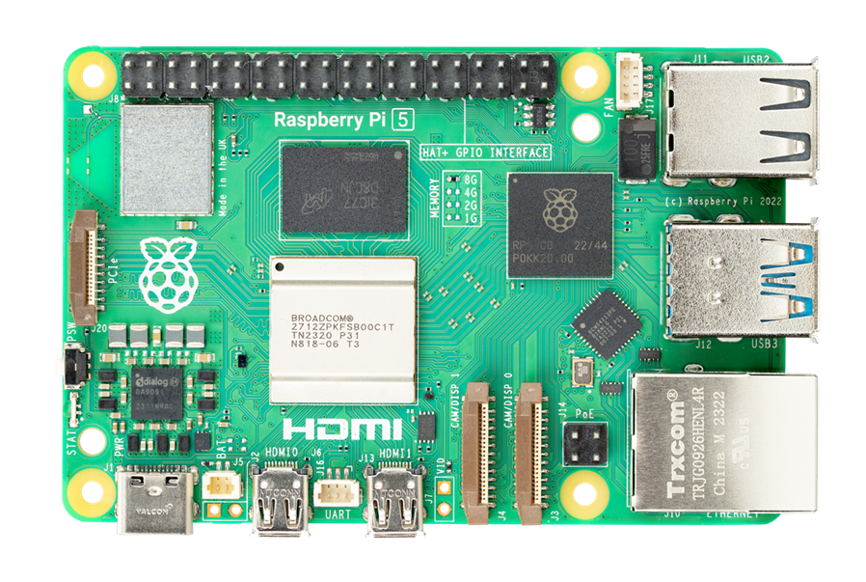
Parameter | Value
Model | Raspberry Pi 5
RAM | 8 GB
OS | Raspberry Pi OS (64-bit)
Connection to SV08 | Ethernet, local network
Moonraker API port | 7125
Crowsnest stream port | 8080
pH sensor interface | I2C (GPIO pins)

Liquid Handler

Overview

The print head of the SV08 is replaced with a pipette assembly. A stepper linear actuator drives the pipette plunger to aspirate and dispense liquid. The actuator is controlled as an additional stepper axis through the SV08 firmware. An Atlas Scientific EZO pH circuit connected to the Raspberry Pi provides real-time pH feedback during operation.
Components
Stepper Linear Actuator
Drives the pipette plunger. Controlled via the SV08 stepper driver as an additional axis in Klipper config.

Parameter | Value
Manufacturer | Haydon Kerk Pittman
Type | Can-stack stepper linear actuator
Control path | SV08 stepper driver via Klipper

Pipette Cone Assembly
Parameter | Value
Manufacturer | Pipette Supplies
Model | E1 ClipTip single-channel
Max volume | 1250 uL

Atlas Scientific EZO pH Circuit
Converts the analog millivolt signal from the pH probe into a digital pH reading. Communicates with the Raspberry Pi over I2C. An electrically isolated carrier board is used to prevent noise from the stepper motors interfering with readings.
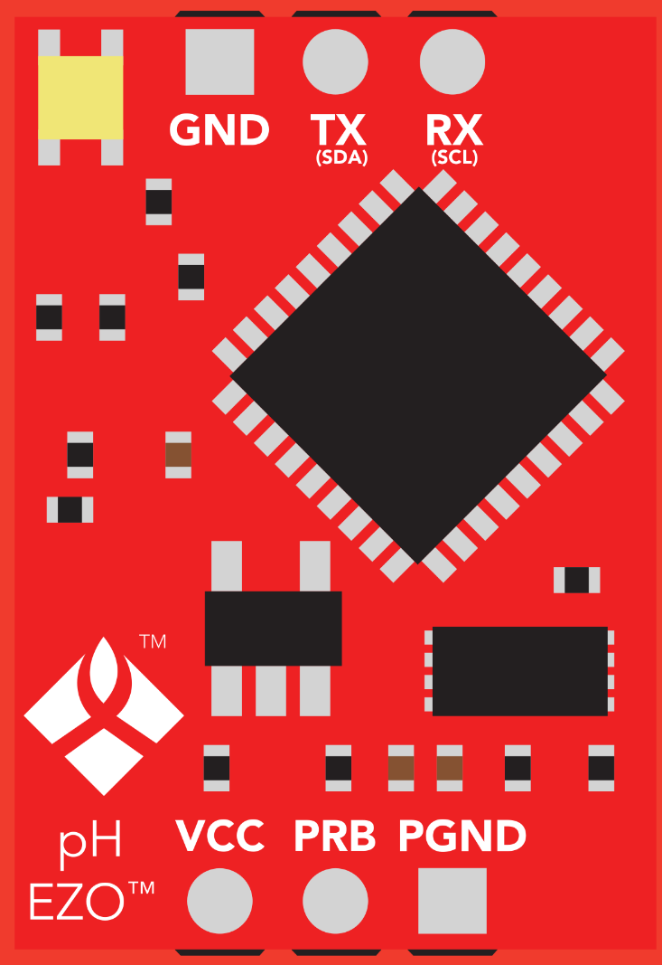

Parameter | Value
Manufacturer | Atlas Scientific
Model | EZO pH Circuit
Interface | I2C
I2C address | 0x63 (default)
Carrier board | Electrically Isolated EZO Carrier Board Gen 2
Input | Analog mV from pH probe
Output | pH value over I2C

Micro pH Probe
Parameter | Value
Model | TBD
Type | Micro pH probe

Software Overview

Layer | Deployment | Description
Klipper firmware | SV08 H616 SoC | Motion planning and G-code execution
Moonraker | SV08 H616 SoC | REST/WebSocket API exposing Klipper to the network
Crowsnest | SV08 H616 SoC | MJPEG camera stream over HTTP
Motion driver | Raspberry Pi | Moonraker API client for sending motion and pipette commands
pH driver | Raspberry Pi | Atlas EZO I2C driver for reading pH values
Camera CV | Raspberry Pi | Consumes Crowsnest stream for arm monitoring
SILA2 server | Raspberry Pi | Exposes instrument as a SILA2-compliant lab device
Desktop client | Desktop computer | SILA2 client providing user interface and protocol control

References

[1] Sovol, “SV08 3D Printer,” GitHub. [Online]. Available: https://github.com/Sovol3d/SV08. [Accessed: Apr. 2026].
[2] K. Van and contributors, “Klipper 3D Printer Firmware,” klipper3d.org. [Online]. Available: https://www.klipper3d.org. [Accessed: Apr. 2026].
[3] A. Chacon and contributors, “Moonraker — Klipper API Server,” moonraker.readthedocs.io. [Online]. Available: https://moonraker.readthedocs.io. [Accessed: Apr. 2026].
[4] SiLA Consortium, “SiLA 2 Standard for Lab Automation,” sila-standard.com. [Online]. Available: https://sila-standard.com/standards/. [Accessed: Apr. 2026].
[5] Atlas Scientific, “EZO pH Circuit,” atlas-scientific.com. [Online]. Available: https://atlas-scientific.com/embedded-solutions/ezo-ph-circuit/. [Accessed: Apr. 2026].
[6] M. D. Mikolajczyk et al., “How to convert a 3D printer into a personal automated liquid handler,” SLAS Technology, 2024, doi: 10.1016/j.slast.2024.100173. [Online]. Available: https://www.sciencedirect.com/science/article/pii/S2472630324001213. [Accessed: Apr. 2026].

