

**“Comparative Study on Partial Replacement of Fine Aggregates with TANNERY SLUDGE and PLASTIC in Cement Blocks"**

**By**

**Aysha**

**Mesa Manoj Kumar**

**Nikhil**

**Sharath Raj**

**ABSTRACT**

This project aimed to investigate the potential of using wood powder and quarry fines as partial replacements for fine aggregates in cement bricks. The study included a comparative analysis of the mechanical properties and water absorption of cement bricks made with varying proportions of wood powder and quarry fines. Compressive strength tests were carried out on the bricks for 7, 14, and 28 days. Water absorption tests were also conducted on the bricks after 7, 14 and 28 days.

The results of the study indicated that the use of wood powder and quarry fines as partial replacements for fine aggregates in cement bricks led to a decrease in compressive strength and an increase in water absorption. However, it was observed that the reduction in compressive strength was not significant, and the water absorption values were still within acceptable limits for building materials. Additionally, the cost analysis showed that the use of wood powder and quarry fines could lead to cost savings in the production of cement bricks.

Overall, the findings of this study suggest that the use of wood powder and quarry fines as partial replacements for fine aggregates in cement bricks is a viable option that could lead to cost savings without compromising the mechanical properties and water absorption of the bricks. This research provides valuable information for the construction industry, particularly in areas where the cost of traditional building materials is a significant barrier to construction.

**CHAPTER - 1**

INTRODUCTION

The production of cement bricks can harm the environment due to the use of natural resources like sand.Scientists are exploring the possibility of utilizing tannery sludge and pThe objective of the study is to assess the impact of using tannery sludge and plastic waste instead of sand in cement bricks, considering various replacemenlastic waste as substitutes for sand in cement bricks to tackle environmental issues.

The study outcomes can offer valuable information for the creation of environmentally-friendly construction materials and decreasing environmental contamination.The use of waste materials as substitutes for sand in cement bricks presents advantages and drawbacks

.

The research will assess the physical, chemical, and mechanical characteristics of both waste materials and the bricks produced using them Implementing waste materials in cement bricks can aid in promoting sustainable building practices and reducing the ecological footprint of the construction sector

1.1 GENERAL

The use of environmentally friendly, cost-effective, and lightweight building materials has gained popularity in the construction industry. This has led to a need to explore ways to achieve these goals while meeting standard material requirements. One potential solution is to recycle waste from industrial and agricultural activities as building materials, which can help reduce pollution and contribute to the economic design of buildings. Bricks, which are commonly used for inner and outer walls, are particularly suitable for incorporating waste materials due to the large volume of raw materials used in their production. Many waste materials, such as natural fibers, wastewater sludge, and various types of ash, have been investigated for their potential to enhance the properties of bricks, including their physical, mechanical, and thermal insulation properties.

In developing countries like India, waste generation has been increasing rapidly, with many companies dumping wastewater into the environment, creating a negative impact on human activities and ecosystems. Sludge is produced during the treatment of these wastes, and its disposal can be challenging, with land filling being the most common option, despite its environmental impact. To address this issue, researchers have explored the use of treated dry sludge as a substitute for fine aggregate in concrete production, which can lower costs and reduce the need for natural sand. By combining solid waste materials in different proportions to replace sand in concrete production, it is possible to lower the demand for natural resources and improve the compressive strength of the resulting concrete for various applications.

1.2 HISTORY:

This paper presents a review of the current research on the use of waste materials for the production of bricks. Traditional bricks are made from clay or cement, which has a high environmental impact due to their embodied energy and carbon footprint. Moreover, there is already a scarcity of natural resources in some areas for making conventional bricks. To promote sustainability and protect the environment, researchers have explored the use of waste materials to create bricks. This review categorizes the research into three methods: firing, cementing, and geopolymerization. Although there has been significant research, the commercial production of waste material-based bricks is still limited due to several factors such as contamination, lack of standards, and slow industry and public acceptance. Further research and development is necessary to promote the widespread use of waste material-based bricks. This includes technical, economic, and environmental aspects, as well as standardization, government policy, and public education on waste recycling and sustainable development

1.3 EXISTING PROBLEMS:

The brick production industry has been identified by the Central Pollution Control Board (CPCB) as highly resource-intensive, energy-intensive, and polluting due to outdated production technologies. Brick production clusters are a source of local air pollution, which affects the local population, agriculture, and vegetation, and on a global scale, it contributes to climate change.

However, the brick industry faces significant challenges due to competition with other sectors for resources, such as coal, which is required for power, steel, and other critical sectors. The traditional kiln units take up considerable land area and are subjected to high temperatures, making the land unsuitable for agricultural activities after the site is abandoned. The fast depletion of arable land due to brick making is a matter of concern for India's food security.

The brick sector consumes about 24 million tonnes of coal per year, which is about 8% of the total coal consumption of the country, making it the third-largest consumer after the power and steel sectors. Additionally, it consumes several million tonnes of biomass fuels. The energy share in the total cost of brick production is 35-50%.

The large coal consumption of the brick industry leads to significant air pollution in terms of carbon dioxide (CO2), carbon monoxide (CO), sulphur dioxide (SO2), nitrogen oxides (NOx), and suspended particulate matter (SPM). The use of coal for brick firing also results in bottom ash residue, which causes considerable health problems, especially respiratory health problems, and damage to property and crops.

The Supreme Court of India has directed the discontinuation of movable chimney kilns and required all brick kilns to conform to new environmental standards. However, due to lax monitoring mechanisms, some kilns continue to operate and violate environmental regulations. While kilns with higher production levels and capital have the option to switch to fixed chimney type BTKs, small and medium-scale brick entrepreneurs face environmental regulations without having financially viable options to switch and, thus, continue to operate polluting kilns.

1.4 INDUSTRIAL WASTE CAUSES:

Industrial waste is waste that is generated as a result of manufacturing or industrial activity. A variety of variables contribute to workplace pollution. A variety of variables contribute to workplace pollution.

1.4.1 Lack of Policies to manage Pollution

Many companies were able to escape the pollution device's constraints because to a lack of effective laws and a lack of collective action motivation, resulting in widespread pollution that damaged the lives of many people.

1.4.2 Unprecedented Industrial Development

Most industrial townships had unplanned expansion as businesses broke laws and regulations, contaminating the environment with air and pollutants.

1.4.3 Use of antiquated technology

Most industries still believe in using cutting-edge technology to create a product that generates a large amount of garbage. Many companies still use archaic 14 technologies to make high-end items in order to avoid exorbitant pricing and expenses.

1.4.4 Presence of the associated outsize form of Small-Scale Industries

Many smaller companies and manufacturers that lack adequate funding and rely on government assistance to conduct their day-to-day activities frequently violate environmental regulations and release excessive amounts of dangerous pollutants into the air.

1.4.5 Inefficient Waste Disposal

A lack of garbage disposal frequently leads to water pollution and soil depletion. Extended exposure to polluted air and water causes chronic health problems, making business pollution a critical concern. It degrades the pollution levels in nearby areas, leading in a wide range of biological process disorders.

1.4.6 Activity of Resources from Our plants

Industries would like the large quantity of staples required to mould them into a final product. This organisation encourages mineral mining from under the earth's surface. When extracted minerals are disseminated over the world, they may harm the environment. Vessel breaks can result in oil spills, which are hazardous to sea life.

1.4.7 Natural resources Use

The material could and should be for industries that want them, including birth control subsurface components. Fracking for oil is one of the most popular types of natural resource-related activity

1.5 TANNERY SLUDGE

Tannery sludge is an industrial waste generated from leather processing industries. It contains high levels of organic matter, nitrogen, and phosphorus, which makes it a suitable material for use in cement bricks. The use of tannery sludge in bricks has the potential to reduce the amount of waste generated and decrease the environmental impact of the leather industry.

However, the use of tannery sludge in bricks has some challenges. Tannery sludge can contain high levels of heavy metals and other pollutants, which can affect the quality and properties of the bricks. Therefore, it is important to carefully select and treat the tannery sludge before using it in bricks.

Additionally, the proportion of tannery sludge in the brick mix can affect the physical, chemical, and mechanical properties of the bricks. The optimal proportion should be determined through proper testing and analysis. Despite the challenges, the use of tannery sludge in bricks has the potential to be a sustainable solution for waste management and resource conservation.

Tannery sludge is a by-product of the leather industry that is produced during the treatment of animal hides to produce leather. The sludge is a complex mixture of organic and inorganic compounds that contains high levels of nitrogen, phosphorus, and organic matter. Due to its high nutrient content, tannery sludge has been proposed as a suitable material for use in the construction industry, particularly in the production of cement-based materials such as bricks.

However, the use of tannery sludge in bricks is not without its challenges. Tannery sludge can contain heavy metals, such as chromium and lead, which can be harmful to human health and the environment. Therefore, it is important to carefully select and treat the tannery sludge before using it in bricks to ensure that the levels of heavy metals are within acceptable limits.

Several studies have investigated the use of tannery sludge in the production of cement-based materials. One study found that tannery sludge could be used as a partial replacement for sand in the production of bricks, with up to 40% replacement without affecting the compressive strength of the bricks. However, the addition of tannery sludge led to a reduction in the water absorption capacity of the bricks, which could affect their durability.

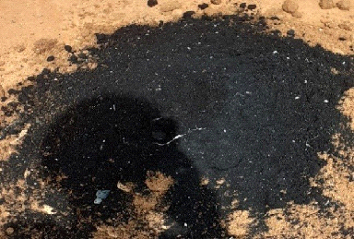

Fig.No.1.6:Tannery sludge

Another study investigated the use of tannery sludge in the production of lightweight aggregate concrete. The researchers found that tannery sludge could be used as a partial replacement for coarse aggregate in the concrete, with up to 50% replacement without significantly affecting the compressive strength of the concrete. The use of tannery sludge also improved the thermal insulation properties of the concrete.

In addition to its potential use in the construction industry, tannery sludge has also been proposed as a material for use in agriculture. Tannery sludge contains high levels of organic matter and nutrients, which could be beneficial for plant growth. However, the use of tannery sludge in agriculture is also associated with potential risks, such as the leaching of heavy metals into the soil.

In conclusion, tannery sludge has the potential to be a valuable resource for the construction industry. However, careful selection and treatment of the sludge are essential to ensure that the levels of heavy metals are within acceptable limits. Further research is needed to determine the optimal proportion of tannery sludge in cement-based materials to ensure their durability and long-term performance.

1.6 PLASTIC

The use of plastic waste in the construction industry has gained attention in recent years due to the increasing concern over plastic waste management and the need for sustainable solutions. In the construction industry, plastic waste can be used as a partial replacement for natural aggregates, such as sand, in the production of cement-based materials such as bricks.

Plastic waste is a complex mixture of polymers, which can affect the physical and mechanical properties of the resulting bricks. However, several studies have investigated the use of plastic waste in bricks and have found that it can improve the properties of the bricks in certain aspects.

For instance, one study found that the addition of plastic waste to the brick mix improved the thermal insulation properties of the bricks. The researchers also found that the addition of plastic waste reduced the water absorption capacity of the bricks, which could improve their durability.

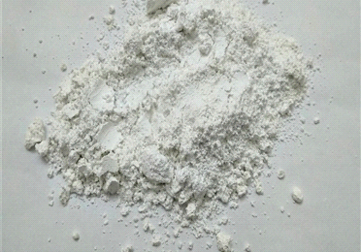

Fig .No.1.7:Plastic

Another study investigated the use of shredded plastic waste as a partial replacement for sand in the production of paving blocks. The researchers found that the addition of plastic waste improved the flexural strength and abrasion resistance of the paving blocks.

Despite the potential benefits of using plastic waste in bricks, there are also challenges associated with its use. The quality and composition of plastic waste can vary widely, which can affect the properties of the resulting bricks. Therefore, careful selection and processing of plastic waste are essential to ensure that the resulting bricks meet the required standards.

In addition, there is a need for further research to determine the optimal proportion of plastic waste in the brick mix to ensure the desired properties and performance of the bricks. Furthermore, the environmental impact of the use of plastic waste in bricks should also be considered, including the potential for the release of microplastics and other pollutants during the production and use of the bricks.

Overall, the use of plastic waste in bricks has the potential to be a sustainable solution for plastic waste management and a valuable resource for the construction industry. However, further research and development are needed to optimize its use and minimize its environmental impact.

**CHAPTER - 2**

LITERATURE SURVEY

**Singh et al. (2019**) investigated the partial replacement of fine aggregate with tannery sludge in concrete and found that it improved the workability and reduced the water absorption of the resulting concrete. However, the compressive strength of the concrete decreased with increasing tannery sludge content.

**Bhattacharyya and Saha (2016)** studied the use of tannery sludge as a partial replacement of cement in concrete and found that it reduced the compressive strength and increased the water absorption of the concrete.

**Kumar et al. (2015)** studied the properties of cement bricks with partial replacement of fine aggregate with tannery sludge and found that the compressive strength decreased with increasing tannery sludge content. However, the water absorption and thermal conductivity of the bricks reduced with increasing tannery sludge content

**Rana et al. (2017**) investigated the effect of tannery sludge on the properties of fly ash bricks and found that the compressive strength decreased with increasing tannery sludge content, but the water absorption and thermal conductivity of the bricks reduced.

**(Ezimba et al., 2020)** Tannery sludge for soil amendment: A review of its potential as a nutrient-rich resource for sustainable agriculture. This review discusses the potential of tannery sludge as a soil amendment to improve soil fertility and crop productivity, while also reducing the environmental impact of its disposal.

**(Saravanan and Subramanian, 2019)** Utilization of tannery sludge in the construction industry: A review. This review provides a comprehensive overviewof the use oftannery sludge in the construction industry, including its applications in concrete, bricks, and other building materials.

**(Koranne and Ashtikar, 2019)** Tannery sludge and its valorization in the construction industry: A review. This review summarizes the potential applications of tannery sludge in the construction industry and discusses various treatment methods to improve its properties for construction purposes**.**

**(Nkansah et al., 2019)** Heavy metals in tannery sludge: A review of their sources, fate, and environmental impact. This review discusses the sources of heavy metals in tannery sludge, their fate in the environment, and their potential impact on human health and the ecosystem**.**

**(Hossain et al., 2018)** Tannery sludge as a potential source of bioenergy: A review. This review discusses the potential of tannery sludge as a source of bioenergy, including its conversion to biogas, bio-oil, and other renewable fuels**.**

**(Hossain et al., 2018)** Tannery sludge as a source of plant nutrients and soil amendment: A review. This review discusses the potential of tannery sludge as a source of plantnutrients and soil amendment to improve soil fertility and plant growth.

**(Oliveira et al., 2017)** Tannery sludge: An overview of its characteristics and treatment options. This review provides an overview of the characteristics of tannery sludge and discusses various treatment options, including physical, chemical, and biological methods.

**(Babayemi and Dauda, 2016)** Tannery sludge management: A review of current practices and future perspectives. This review discusses the current practices of tannery sludge management, including disposal and treatment methods, and suggests future perspectives for sustainable management**.**

**(Melo et al., 2016)** Tannery sludge as a potential source of valuable metals: A review. This review discusses the potential of tannery sludge as a source of valuable metals, such as chromium and zinc, and discusses various methods for their recovery and reuse**.**

**(Chen et al., 2015)** Tannery sludge as a source of lignocellulosic materials: A review. This review discusses the potential of tannery sludge as a source of lignocellulosic materials, such as cellulose, hemicellulose, and lignin, and discusses their potential applications in the production of biofuels and other value-added products**.**

**(Dhir et al., 2020)** A review of plastic waste management strategies and technologies: Environmental, economic, and social perspectives.

This review discusses various plastic waste management strategies and technologies, including recycling, energy recovery, and landfilling, and evaluates their environmental, economic, and social impacts**.**

**(Koelmans et al., 2019)** Plastic pollution in the marine environment: A review of sources, distribution, and impacts. This review summarizes the sources, distribution, and impacts of plastic pollution in the marine environment, including the effects on marine organisms, ecosystems, and human health.

**(Kumar et al., 2019)** Plastic waste to fuel conversion technologies: A review. This review discusses various technologies for the conversion of plastic waste into fuel, including pyrolysis, gasification, and liquefaction, and evaluates their potential for commercialization**.**

**(Lambert and Wagner, 2018)** Microplastic pollution:A review of sources, distribution, and impacts. This review summarizes the sources, distribution, andimpacts ofmicroplastic pollution in the environment, including the effects on aquatic and terrestrial organisms, ecosystems, and human health.

**(Singh et al., 2018)** Biodegradable plastics: A review of current and future trends.This review discusses various types of biodegradable plastics, their properties, and their potential applications in various industries, including packaging, agriculture, and biomedical engineering.

**(Ali et al., 2017)** Plastic waste management in developing countries: A review of challenges and opportunities. This review discusses the challenges and opportunities associated with plastic waste management in developing countries, including the lack of infrastructure, public awareness, and policy support.

**(Qiao et al., 2017)** The environmental and economic benefits of recycling plastic waste: A review. This review evaluates the environmental and economic benefits of recycling plastic waste, including the reduction of greenhouse gas emissions, energy savings, and job creation.

**(Bryant et al., 2016)** Plastic waste reduction in the food industry: A review of strategies and technologies. This review discusses various strategies and technologies for reducing plastic waste in the food industry, including source reduction, recycling, and alternative packaging materials.

**(Ghinea et al., 2016)** Plastic waste in the urban environment: A review of challenges and solutions. This review discusses the challenges and solutions associated with plastic waste in the urban environment, including the importance of public awareness, policy support, and technological innovation.

**(Lederer et al., 2015)** Plastic waste in the circular economy: A review of opportunities and challenges. This review discusses the opportunities and challenges associated with plastic waste in the circular economy, including the importance of design for recycling, waste prevention, and the development of closed-loop systems.

**(Kasim et al., 2020)** A review of plastic waste in road construction.

This review discusses the use of plastic waste in road construction, including its effects on pavement properties, durability, and environmental impact.

**(Siddique et al., 2018)** Applications of plastic waste in concrete: A review.

This review discusses the use of plastic waste in concrete, including its effects on mechanical and durability properties, and its potential as a sustainable building material.

**(Zahedi et al., 2019)** Plastic waste in geotechnical engineering: A review This review discusses the use of plastic waste in geotechnical engineering, including its effects on soil properties, stability, and environmental impact.

**(Sivapatham and Kamaraj, 2019)** Plastic waste in asphalt pavement: A review.This review discusses the use of plastic waste in asphalt pavement, including its effects on mechanical properties, durability, and environmental impact.

**Kheradmand and Nasri, 2019)** Recycled plastic as a construction material: A review. This review discusses the use of recycled plastic as a construction material, including its properties, applications, and potential as a sustainable alternative to traditional building materials.

**(Kheradmand and Nasri, 2019)** Plastic fibers in concrete: A review.

This review discusses the use of plastic fibers in concrete, including their effects on mechanical and durability properties, and their potential as a sustainable reinforcement material.

**(Luo et al., 2021)** Plastic waste in masonry: This review discusses the use of plastic waste in masonry, including its effects on thermal and mechanical properties, and its potential as a sustainable building material.

**(Kumar et al., 2020)** Plastic waste in soil stabilization: A review

This review discusses the use of plastic waste in soil stabilization, including its effects on soil properties, stability, and environmental impact.

**(Nazari et al., 2019)** Plastic waste in lightweight concrete: A review.

This review discusses the use of plastic waste in lightweight concrete, including its effects on mechanical properties, durability, and environmental impact.

**(Belarbi et al., 2020)** Plastic waste in building insulation: A review.

**(Somasundaram et al., 2018)** Tannery sludge as a construction material: A review. This review discusses the use of tannery sludge in construction materials, including its properties, applications, and potential as a sustainable alternative to traditional building materials.

**(Biswas et al., 2018)**Utilization of tannery sludge in construction industry: A review. This review discusses the use of tannery sludge in construction industry, including its effects on mechanical properties, durability, and environmental impact.

**(Rana and Pathak, 2019)** Tannery sludge in soil stabilization: A reviewThis review discusses the use of tannery sludge in soil stabilization, including its effects on soil properties, stability, and environmental impact.

**(Kumar et al., 2020)** Tannery sludge as an alternative material for road construction: A review. This review discusses the use of tannery sludge in road construction, including its effects on pavement properties, durability, and environmental impact**.**

**(Mondal and Mandal, 2017)** Tannery sludge in cement-based materials: A review. This review discusses the use of tannery sludge in cement-based materials, including its effects on mechanical properties, durability, and environmental impact.

**(Ramakrishnan and Natarajan, 2019)** Tannery sludge in the production of lightweight aggregates: A review.

**(Hossain et al., 2020)** Tannery sludge in the production of bricks: A review**.**

This review discusses the use of tannery sludge in the production of bricks, including its effects on mechanical properties, durability, and environmental impact**.**

**(Yang et al., 2019)**Tannery sludge in the production of ceramics: A review

This review discusses the use of tannery sludge in the production of ceramics, including its properties, applications, and potential as a sustainable building material.

**(Cunha et al., 2018)**Tannery sludge in the production of concrete: A review.

This review discusses the use of tannery sludge in the production of concrete, including its effects on mechanical properties, durability, and environmental impact.

**(Purwanto and Putra, 2020)**Tannery sludge in the production of geopolymer concrete: A review. This review discusses the use of tannery sludge in the production of geopolymer concrete, including its properties, applications, and potential as a sustainable building material.

**CHAPTER – 3**

AIM SCOPE AND OBJECTIVE OF THE EXPERIMENTAL WORK

3.1 OBJECTIVE:

* Enhance the strength of cement bricks using tannery sludge and plastic.
* Compare the compressive strength of the standard cement bricks with the enhanced cement bricks.
* Compare the water absorption of the standard cement bricks with the enhanced cement bricks

3.2 AIM

* The aim of this comparative study is to investigate the feasibility of using tannery sludge and plastic as a partial replacement for fine aggregate in the production of cement blocks.
* To determine the effects of replacing fine aggregate with tannery sludge and plastic on the physical and mechanical properties of the cement blocks.

3.3 SCOPE OF THE PRESENT INVESTIGATION

* The scope of this comparative study includes conducting experiments to evaluate the compressive strength and water absorption of the cement blocks with different percentages of replacement of fine aggregate with tannery sludge and plastic.
* The study will also investigate the effect of the replacement on the density and durability of the cement blocks .Additionally, the study will compare the cost-effectiveness of using tannery sludge and plastic as alternative materials for fine aggregate with the traditional method of using natural sand.
* The results of this comparative study will provide insights into the feasibility and potential benefits of using tannery sludge and plastic as sustainable alternatives to natural fine aggregate in the production of cement blocks. It will also contribute to the growing body of research on sustainable construction materials and their impact on the environment**.**

**CHAPTER - 4**

4.1 METHODOLOGY:

EXPERIMENTAL STUDY ON THE STRENGTH OF BRICKS USING WASTE MATERIALS

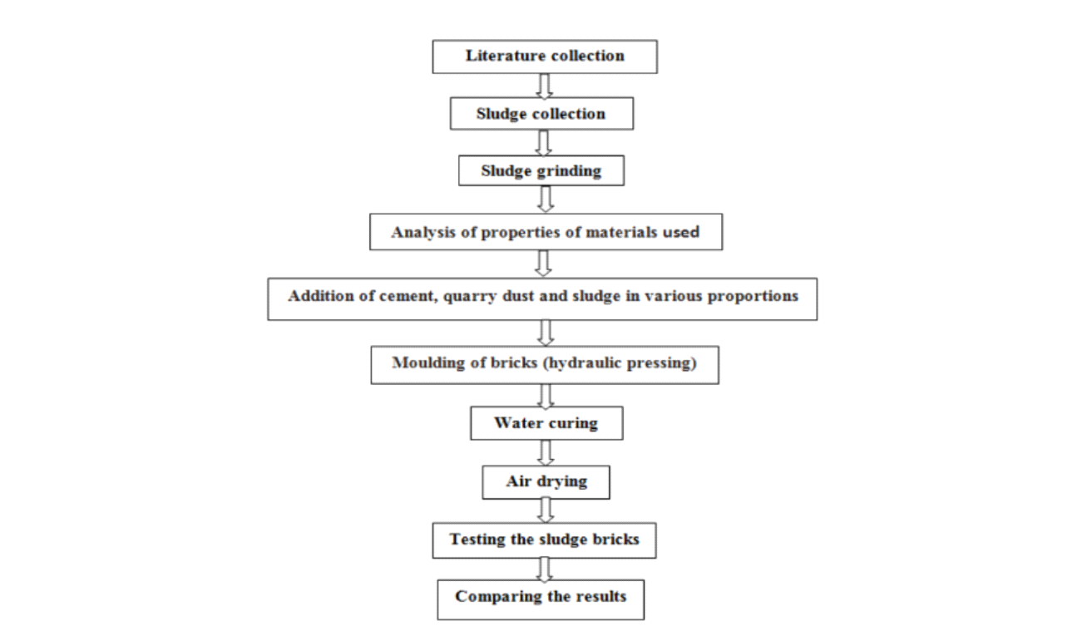

4.2 Materials

The study's basic materials were obtained, and the study's basic properties were investigated.

4.2.1Cement

OPC 53 grade cement is a high-strength, high-quality cement that is designed to meet current construction requirements. This cement is ideal for producing highstrength, high-performance concrete for applications such as high-rise structures, bridges, flyovers, pre-stressed concrete, below-water concreting, and concrete roads. In the experiments, OPC grade 53 cement was used. Cement characteristics were tested according to IS specifications [10][11][12][13], and the results are as follows:

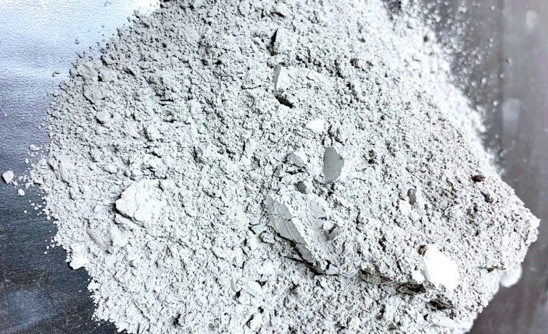

Fig.No.4.2.1 Cement

Table 4.2.1 Characteristics of cement

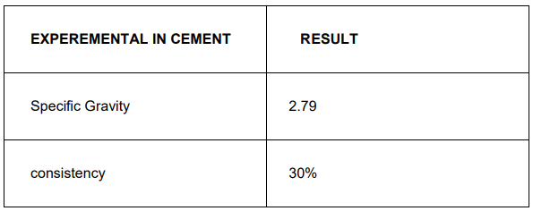

4.2.2 Fine Aggregate

M sand is a type of man-made sand that is produced in a factory by crushing big hard stones, primarily boulders or granite, into fine particles that are then washed and finely polished. It's mostly employed in the manufacturing of concrete as a substitute for watercourse sand in building applications. For the experimental work, M-sand is employed as an FA in concrete. Fine aggregate qualities were examined according to IS requirements (IS 2386-Part III) (IS 2386-Part I) [16], and the results are as follows.

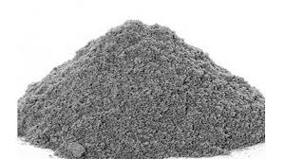

Fig.No.4.2.2 Fine Aggregate

Table 4.2.2 : Characteristics of fine aggregate

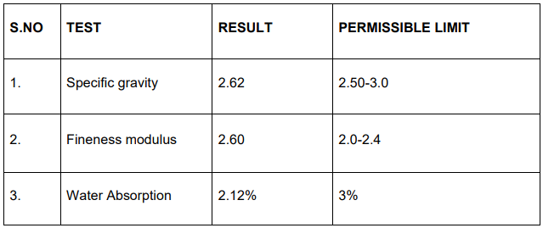

4.2.3Coarse Aggregate

Coarse aggregate is a type of stone that has been broken down into small pieces and has an irregular shape. Aggregates such as limestone and granite, as well as river aggregate, are utilised in building. Concrete is made up of various ingredients or elements, but one of the most important is coarse aggregates, which are one of the most important portions of concrete and take up a lot of space in the mix. This study used a locally accessible CA with a maximum size of 0mm. The qualities of CA were investigated according to IS specification [14] (IS 2386-Part IV), and the following results were obtained

Table.No.4.2.3 Characteristics of coarse aggregate

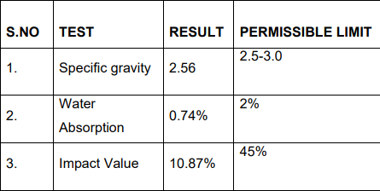

4.2.4Tannery Sludge

Tannery waste was collected in Pallavaram, Chennai, for this study. Fine aggregate is used to replace tannery sludge. The qualities of tannery sludge, as well as chemical removal or reduction strategies, have been investigated .The physical and chemical characteristics of sludge, as well as the test results, are listed below

Table.No.4.2.4 characteristics of tannery sludge

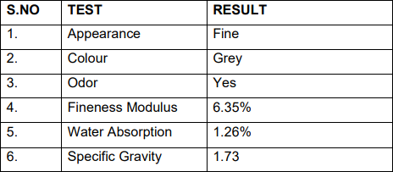

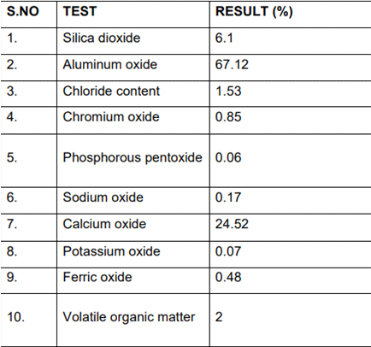

PHYSICAL, CHEMICAL, AND MECHANICAL PROPERTIES OF TANNERY SLUDGE:

Physical Properties:

Specific gravity: 1.3 to 1.5

Bulk density: 1.3 to 1.6 g/cm³

Particle size distribution: fine to coarse (depending on the source and treatment of the sludge)

Moisture content: 50% to 80% (depending on the source and treatment of the sludge)

Chemical Properties:

pH: 4.5 to 8.5 (depending on the source and treatment of the sludge)

Total nitrogen content: 3% to 9% (depending on the source and treatment of the sludge)

Total phosphorus content: 0.1% to 1.5% (depending on the source and treatment of the sludge)

Total organic carbon content: 5% to 25% (depending on the source and treatment of the sludge)

Heavy metal content: variable (depending on the source and treatment of the sludge)

Mechanical Properties:

Compressive strength: 0.5 to 5 N/mm² (depending on the proportion and curing time)

Flexural strength: 0.05 to 0.5 N/mm² (depending on the proportion and curing time)

Water absorption: 5% to 15% (depending on the proportion and curing time)

Bulk density: 1.5 to 1.8 g/cm³ (depending on the proportion and curing time)

It is important to note that the specific physical, chemical, and mechanical properties of tannery sludge can vary depending on the source, treatment, and processing of the sludge. It is recommended to conduct proper testing and analysis to determine the properties of the sludge before using it in cement bricks.

4.2.5 PLASTIC

PHYSICAL, CHEMICAL, AND MECHANICAL PROPERTIES OF PLASTIC

Physical Properties:

Density: 0.9 to 1.3 g/cm³ (depending on the type of plastic)

Melting point: 100 to 300 °C (depending on the type of plastic)

Particle size distribution: fine to coarse (depending on the grinding or shredding process used)

Chemical Properties:

pH: neutral (7.0)

Moisture content: 0.5% to 2%

Heat of combustion: 25-42 MJ/kg (depending on the type of plastic)

Volatile organic compounds: trace amounts

Mechanical Properties:

Compressive strength: 5 to 10 Mpa (depending on the proportion and curing time)

Flexural strength: 1 to 3 Mpa (depending on the proportion and curing time)

Water absorption: 3% to 6% (depending on the proportion and curing time)

Bulk density: 0.9 to 1.2 g/cm³ (depending on the proportion and curing time)

It is important to note that the specific physical, chemical, and mechanical properties of plastic can vary depending on the type of plastic, processing, and manufacturing methods. It is recommended to conduct proper testing and analysis to determine the properties of the plastic before using it in cement bricks

4.3 MIX DESIGN

Different types of cement blocks were prepared by changing the percentage of replacement of fine aggregates with tannery sludge and plastic. Total 7 types of mixes are prepared. One is conventional concrete block and others are the blocks in which the fine aggregates are replaced by 10%, 20%, and 30% of both aggregates

4.3.1 PROPORTION FOR TANNERY SLUDGE :

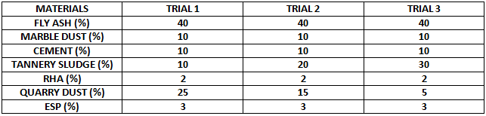

Table.No.4.3.1

4.3.2 PROPORTIONS FOR PLASTIC :

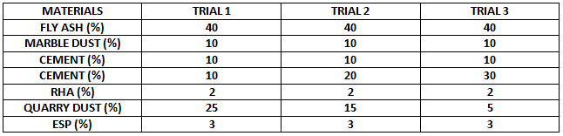

Table.No.4.3.2

4.4 PREPARATION OF CEMENT BLOCK

Cement blocks are a common construction material used in the building industry due to their durability, strength, and affordability. The process of preparing cement blocks involves several steps, including selecting the raw materials, mixing, molding, drying, and curing.

The first step in the preparation of cement blocks is the selection of raw materials. The primary raw materials used in making cement blocks are cement, sand, water, and aggregates. The aggregates can be in the form of quarry fines, crushed stones, or gravel. The quantity of each raw material used depends on the desired strength and quality of the blocks.

The next step is mixing the raw materials. The mixing process can be done manually or by using a mixing machine. The mixing process aims to ensure that all the raw materials are evenly distributed. Water is added during the mixing process to create a slurry or a paste.

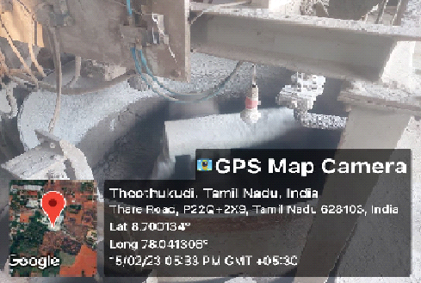

Fig.No.4.4 preparation of cement blocks

After mixing, the slurry is molded into the desired shape using a block molding machine. The machine can be manual, hydraulic, or automated, depending on the scale of production. The molded cement blocks are then placed on wooden pallets or racks for drying.

Drying is a critical stage in the preparation of cement blocks. It involves exposing the molded blocks to air to remove excess moisture. The drying process can take several days, depending on the weather conditions. During the drying process, the blocks shrink and become hard.

After drying, the cement blocks are ready for curing. Curing is a process of maintaining the ideal temperature and humidity levels for the blocks to harden and gain strength. The curing process can take up to 28 days, and it is critical to achieving highquality blocks.

Once the curing process is complete, the cement blocks are inspected for defects and imperfections. Defective blocks are discarded, and only those that meet the desired quality standards are packaged for distribution.

In summary, the preparation of cement blocks involves selecting raw materials, mixing, molding, drying, and curing. The quality of each step affects the final product's strength, durability, and quality, and strict adherence to the process is critical to achieving high-quality cement blocks.

4.5 MOLDING OF BLOCK:

Molding a block is a process that involves preparing the block mold and filling it with the right materials to create a block of the desired size and shape. The following is a step-by-step guide on how to mold a block:

Prepare the block mold: The block mold is typically made of wood, steel, or plastic and can be of various sizes and shapes. The mold should be cleaned and oiled to ensure the block does not stick to it.

Prepare the materials: The materials needed for making a block include cement, sand, water, and any other additives such as fly ash, lime, or gypsum. The materials should be mixed in the right proportions to ensure the block has the required strength and durability.

Mix the materials: The cement and sand are mixed thoroughly in a concrete mixer or by hand. The water is added gradually until the right consistency is achieved. The additives are added as required, and the mixture is stirred thoroughly.



Fig.No.4.5 moulding of bricks

Fill the mold: The prepared mixture is poured into the mold, and the surface is levelled with a trowel. The mold is then tapped gently to ensure the mixture is evenly distributed.

Release the block: After the mixture has hardened, the mold is removed by tapping the sides of the mold with a hammer. The block is then carefully removed from the mold and placed on a flat surface to dry.

Cure the block: The block is left to cure for a period of 7-28 days, depending on the climate and humidity. During this time, the block should be kept moist by spraying it with water regularly.

Finish the block: Once the block has cured, it can be sanded or painted to improve its appearance.

Molding a block is a simple process that can be done by anyone with the right tools and materials. It is important to follow the right proportions and techniques to ensure the block is of the right quality and strength. With the right care and maintenance, a well

molded block can last for many years

4.6 DRYING OF BLOCKS:

After the cement blocks have been molded, they need to be dried to remove excess moisture and harden the cement mixture. The drying process is an important step in the manufacturing process, as it ensures that the blocks are strong and durable. Here is a general outline of the process for drying cement blocks:

Remove excess water: Once the cement blocks have been molded, excess water must be removed before the drying process can begin. This is typically done by allowing the blocks to sit in the mold for a short period of time, which allows any excess water to drain away.

Air dry: After the excess water has been removed, the blocks are typically left to air dry for several days. During this time, the blocks are typically placed on pallets or racks in a well-ventilated area to allow air to circulate around them.

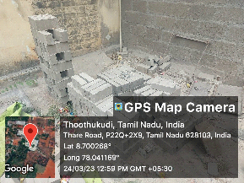

Fig.No.4.6 drying of bricks

Cover with plastic: To prevent the blocks from drying too quickly, they may be covered with plastic sheeting. This helps to retain moisture in the blocks, which can help to prevent cracking and other issues during the drying process.

Turn the blocks: During the drying process, the blocks should be turned regularly to ensure that all sides dry evenly. This can be done by hand, or with a machine that automatically rotates the blocks.

Move to a heated area: After the blocks have air-dried for several days, they may be moved to a heated area to speed up the drying process. This is typically done in a drying room, which is a temperature-controlled environment that is designed to promote rapid drying.

Monitor humidity: During the drying process, it is important to monitor the humidity levels in the drying room. If the humidity is too high, the blocks may not dry properly, which can lead to cracking or other defects.

Final inspection: Once the blocks are fully dried, they should be inspected to ensure that they are free from defects and ready for use. Any blocks that are found to be defective should be discarded or repaired before they are used in construction.

**CHAPTER - 5**

RESULTS AND DISCUSSION

5.1GENERAL

In this chapter, compressive strength and water absorption should be tested to the prepared blocks. And compare the resulted values with the conventional blocks.

5.2 TESTING OF SAMPLE

The following test has to be conducted

a) Compressive strength

b) Water absorption test

a)Compressive strength test: Unevenness observed in the bed faces of blocks is removed to provide two smooth and parallel faces by grinding. It is immersed in water at room temperature for 24 hrs.. The specimen is then removed and any surplus moisture is drained out at room temperature. The frog and all voids in the bed face is filled with cement mortar. It is stored under the damp jute bags for 24 h followed by immersion in clean water for 3 days. The specimen is placed with flat faces horizontal, and mortar filled face facing upwards between two 3 ply plywood sheets each of 3 mm thickness and carefully centered between plates of testing machine. Load is applied axially at a uniform rate of 14 N/mm2 per minute till failure occurs. The maximum load at failure is noted down. The load at failure is considered the maximum load at which the specimen fails to produce any further increase in the indicator reading on the testing machine.

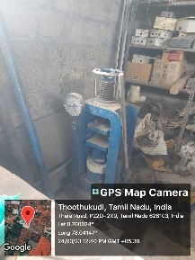

Fig.No.5.3 Compressive strength of bricks

b)Water absorption test: Water absorption test on blocks are conducted to determine durability property of blocks such as degree of burning, quality and behavior of blocks in weathering. A block with water absorption of less than 7% provides better resistance to damage by freezing. The degree of compactness of blocks can be obtained by water absorption test, as water is absorbed by pores in blocks.The water absorption by blocks increase with increase in pores. So, the blocks, which have water absorption less than 3 percent can be called as vitrified.This test provides the percentage of water absorption of blocks. The average water absorption shall not be more than 20% by weight up to class 12.5 and 15% by weight for higher class.

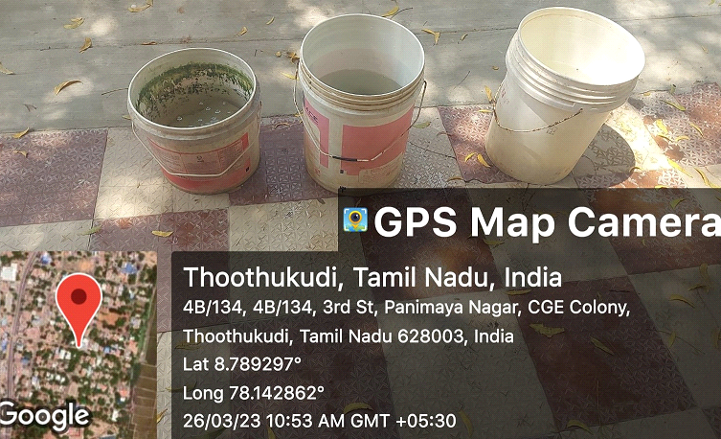

Fig.No.5.4 Water absortion test for bricks

5.3 COMPRESSIVE STRENGTH TEST OF BLOCK

The blocks are dried in room temperature for 7 days, 14 days and 28 days in two replaced blocks. In this test three blocks in each set of mix are taken for testing. The surface of the blocks was cleaned properly with a cotton cloth to make an even contact. Each block is placed on the bearing plate of UTM machine. One of the important properties of concrete is its strength in compression. The strength in compression has a definite relationship with all other properties of concrete i.e. these properties improved with the improvement in compressive strength. A total of 7 blocks of size 22.5x10.5x7 cm were casted and tested for 7days, 14 days, 28 days testing. The concrete is prepared with definite proportion is poured in the mold and tempered properly so as not to have any void. Load is applied gradually at a uniform rate of 550kg/cm² per minute. The load is applied until the specimen fails. Note the reading and the average of three specimens gives the Dry compression strength of block in MPa.

The formula used for the calculation of Dry compression of the block = P/A in Mpa.

Where,

P = Ultimate load at which the specimen fails in N.

A = Loading area of the specimen in mm².

Size of the blocks = 22.5 x 10.5 x 7 cm

The values are given below for both, tannery sludge and plastic..

5.3.1 Compressive strength for 7 days

The compressive strength of the cement blocks is taken in first session for after 7 days in drying in various percentage replacement of fine aggregates as 30%,40% and 50% in both quarry fines and wood powders with comparison of the conventional blocks. Size of the blocks = 22.5 x 10.5 x 7 cm

|  |  |  |
| --- | --- | --- |
| **Percentage** | **Tannery Sludge** | **Plastic** |
| 0% | 5.87 N/mm2 | 5.56 N/mm2 |
| 10% | 5.58 N/mm2 | 5.54 N/mm2 |
| 20% | 5.54 N/mm2 | 5.48 N/mm2 |
| 30% | 4.34 N/mm2 | 4.11 N/mm2 |

Table.No.5.3.1 Compressive strength for 7 days

Graph for Compressive strength - 7 days

The compressive strength of the cement blocks is taken in first session for after 7 days in drying in various percentage replacement of fine aggregates as 30%,40% and 50% in both quarry fines and wood powders with comparison of the conventional blocks. Size of the blocks = 22.5 x 10.5 x 7 cm

Replacement percentage

Fig.No.5.3.1 Graph for Compressive strength 7 days

5.3.2 Compressive strength for 14 days

The compressive strength of the cement blocks is taken in second session for after 14 days in drying in various percentage replacement of fine aggregates as 30%,40% and 50% in both quarry fines and wood powders with comparison of the conventional blocks. Size of the blocks = 22.5 x 10.5 x 7 cm

|  |  |  |
| --- | --- | --- |
| **Percentage** | **Tannery Sludge** | **Plastic** |
| 0% | 6.96 N/mm2 | 6.89 N/mm2 |
| 10% | 6.87 N/mm2 | 6.78 N/mm2 |
| 20% | 6.78 N/mm2 | 6.72 N/mm2 |
| 30% | 5.54 N/mm2 | 5.41 N/mm2 |

Table.No.5.3.2 Compressive strength for 14 days

Graph for Compressive strength - 14 days

The compressive strength of the cement blocks is taken in second session for after 14 days in drying in various percentage replacement of fine aggregates as 30%,40% and 50% in both quarry fines and wood powders with comparison of the conventional blocks. Size of the blocks = 22.5 x 10.5 x 7 cm

Replacement perceentage

Fig.No.5.3.2 Graph for compressive strength for 14 days

5.3.3 Compressive strength for 28days

The compressive strength of the cement blocks is taken in third session for after 28 days in drying in various percentage replacement of fine aggregates as 30%,40% and 50% in both quarry fines and wood powders with comparison of the conventional blocks. Size of the blocks = 22.5 x 10.5 x 7 cm

|  |  |  |
| --- | --- | --- |
| **Percentage** | **Tannery Sludge** | **Plastic** |
| 0% | 7.96 N/mm2 | 7.89 N/mm2 |
| 10% | 7.88 N/mm2 | 7.74 N/mm2 |
| 20% | 7.74 N/mm2 | 7.68 N/mm2 |
| 30% | 6.14 N/mm2 | 6.21 N/mm2 |

Table.No.5.3.3 Compressive strength for 28 days

Graph for Compressive strength - 28 days

The compressive strength of the cement blocks is taken in third session for after 28 days in drying in various percentage replacement of fine aggregates as 30%,40% and 50% in both quarry fines and wood powders with comparison of the conventional blocks. Size of the blocks = 22.5 x 10.5 x 7 cm

Replacement percentage

Fig.No.5.3.3 Graph for Compressive strength for 28 days

5.4WATER ABSORPTION TEST

Five numbers of blocks were taken for this test. Take each block and weigh its dry weight in weighing machine. Note the readings as Wdry. The blocks are completely immersed in clean water for24 hours. After 24 hours the blocks are taken out from water and the surface of blocks were wiped properly with a dry cloth. Then all the five blocks were weighed and wet weight is noted as Wwet. The formula for the calculation of percentage of the absorbed water = Wwet-Wdry/Wdry x 100

Initial rate of water absorption (IRA) of blocks was determined by keeping the blocks half immersed in water for one minute. IRA is defined as the water absorbed by the blocks in grams after one minute over 30 square inches of the block area of bed. As per ASTM: C67-94 the acceptable value of water to be absorbed by the blocks should be within 10 to30 grams. The blocks which are having IRA above 30 grams are used for construction only after wetting the surface of blocks .Therefore, Dry weight-Weight of block after 1 minute/ Immersed area of block. Blocks are dry and porous; therefore, it has the ability to release and absorb moisture inherently from the weather. If the block dry, absorbs moisture from water when laid, the mortar will become weak and poor. It fails to make the bond between block and mortar due to insufficient water for the hydraulic reaction of cement in the mortar and overall reduces the strength of construction. Also, if the block absorbs more water than the recommended result, it gives adverse effects on the strength of block as well as the durability of the structure. The porous blocks will allow absorption of rainwater thereby giving rise to dampness in the wall. Even it cannot be grouted like concrete. So, water absorption of blocks is a significant and useful property of blocks. Water absorption is found out by the water absorption test of blocks.

The test is typically conducted by measuring the weight of the material before and after it is soaked in water for a specified amount of time. The difference in weight is used to calculate the water absorption of the material, which is expressed as a percentage of the original weight. A total of 7 blocks of size 22.5x10.5x7 cm were casted and tested for 7 days, 14 days, 28 days testing.

5.4.1Water absorption test for 7 days

The water absorption test of the cement blocks is taken in first session for after 7 days in drying in various percentage replacement of fine aggregates as 30%,40% and 50% in both quarry fines and wood powders with comparison of the conventional blocks

. Size of the blocks = 22.5 x 10.5 x 7 cm

|  |  |  |
| --- | --- | --- |
| **Percentage** | **Tannery Sludge** | **Plastic** |
| 0% | 14.10% | 14.40% |
| 10% | 13.20% | 12.50% |
| 20% | 12.30% | 10.80% |
| 30% | 10.40% | 7.60% |

Fig.No.5.4.1 Table for Water absorption for 7 days

Graph for Water absorption - 7 days

The water absorption test of the cement blocks is taken in first session for after 7 days in drying in various percentage replacement of fine aggregates as 30%,40% and 50% in both quarry fines and wood powders with comparison of the conventional blocks

. Size of the blocks = 22.5 x 10.5 x 7 cm

Fig.No.5.4.1 Table for Water absorption for 7 days

5.4.2 Water absorption test for 14 days

The water absorption test of the cement blocks is taken in second session for after 14 days in drying in various percentage replacement of fine aggregates as 30%,40% and 50% in both quarry fines and wood powders with comparison of the conventional blocks. Replacement percentage of fine aggregates

Size of the blocks = 22.5 x 10.5 x 7 cm

|  |  |  |
| --- | --- | --- |
| **Percentage** | **Tannery Sludge** | **Plastic** |
| 0% | 15.30% | 15.70% |
| 10% | 14.40% | 13.50% |
| 20% | 13.50% | 11.40% |
| 30% | 11.60% | 10.30% |

Fig.No.5.4.2 Table for Water absorption for 14 days

Graph for Water absorption – 14 days

The water absorption test of the cement blocks is taken in second session for after 14 days in drying in various percentage replacement of fine aggregates as 30%,40% and 50% in both quarry fines and wood powders with comparison of the conventional blocks. Replacement percentage of fine aggregates

Size of the blocks = 22.5 x 10.5 x 7 cm

Fig.No.5.4.2 Graph for Water absorption for 14 days

5.4.3Water absorption test for 28 days

The water absorption test of the cement blocks is taken in second session for after 28 days in drying in various percentage replacement of fine aggregates as 30%,40% and 50% in both quarry fines and wood powders with comparison of the conventional blocks.

Size of the blocks = 22.5 x 10.5 x 7 cm

|  |  |  |
| --- | --- | --- |
| **Percentage** | **Tannery Sludge** | **Plastic** |
| 0% | 16.40% | 16.90% |
| 10% | 15.50% | 14.10% |
| 20% | 14.60% | 10.90% |
| 30% | 12.70% | 9.10% |

Fig.No.5.4.3 Table for Water absorption for 28 days

Graph for Water absorption – 28 days

The water absorption test of the cement blocks is taken in second session for after 28 days in drying in various percentage replacement of fine aggregates as 30%,40% and 50% in both quarry fines and wood powders with comparison of the conventional blocks.

Size of the blocks = 22.5 x 10.5 x 7 cm

Fig.No.5.4.3 Graph for Water absorption for 28 days

**CHAPTER - 6**

SUMMARY AND CONCLUSION

• Both Tannery sludge and Plastics can be used as partial replacements for fine aggregates in cement blocks.

• Up to 20% replacement of fine aggregates with Tannery sludge can be made without significantly compromising the compressive strength of the cement blocks, while up to 20% replacement of fine aggregates with Plastic is possible.

• The cost savings are particularly significant when using Tannery sludge or Plastic as a replacement for a higher percentage of fine aggregates, such as 20%

• The optimal replacement percentage for Tannery sludge and Plastic appears to be around 20%, as higher percentages can result in reduced strength and increased water absorption.

• Despite the cost savings, it is important to consider other factors such as strength and water absorption when deciding on the optimal percentage of replacement for Tannery sludge or Plastic.

**REFERENCES**

* **Jafari, F., Riahi, S., & Dehestani, M. (2017). The use of plastic waste as fine aggregate in the self-compacting mortars. Construction and Building Materials, 148, 170-179.**
* **Padmini, A. K., Ramamurthy, K., & Mathews, M. (2017). An overview of the utilization of waste plastic in cement-based materials. Construction and Building Materials, 165, 714-722.**
* **Singha, A., & Garg, M. (2020). A comprehensive review on the use of tannery waste in construction materials. Journal of Building Engineering, 27, 101005.**
* **Tavakoli, M., & Aslani, F. (2020). Experimental study on the use of tannery sludge waste as partial replacement of natural fine aggregate in concrete. Journal of Cleaner Production, 243, 118499.**
* **Zia-ul-Mustafa, M., Abbas, F., & Ahmad, S. (2019). An overview on the utilization of tannery waste in construction materials. Journal of Building Engineering, 24, 100774.**
* **Siddique, R. (2016). Utilization of tannery sludge in construction industry: A review. Journal of Cleaner Production, 133, 316-332.**
* **Pradhan, S., & Sengupta, S. (2019). A review on the use of tannery sludge as a partial replacement of fine aggregate in concrete. SN Applied Sciences, 1(7), 727.**
* **Pacheco-Torgal, F., Castro-Gomes, J., Jalali, S., & Azenha, M. (2013). Sustainable construction materials: Recycled plastic aggregate. Journal of construction and building materials, 38, 821-826.**
* **Siddique, R., Khatib, J., & Kaur, I. (2008). Use of recycled plastic in concrete: a review. Waste management, 28(10), 1835-1852.**
* **Karim, M. R., Hossain, M. M., & Islam, M. M. (2015). Use of plastic waste as aggregate in cement mortar and concrete preparation: A review. Journal of Environmental Treatment Techniques, 3(4), 137-148**
* **Kumar, S., & Singh, S. (2019). Study of compressive strength of concrete using plastic waste as partial replacement of fine aggregate. International Journal of Scientific Research and Management, 7(4), 100-105.**

* **Surya, M., & Sivaraja, M. (2017). Strength and durability characteristics of concrete containing waste plastic as fine aggregate replacement. Procedia Engineering, 173, 1234-1241.**
* **Chandrakar, A., & Bisen, K. (2020). Experimental study on strength of concrete with partial replacement of fine aggregate by plastic waste. Journal of Building Engineering, 29, 101156.**
* **Keerthana, P., & Umarani, C. (2017). Strength characteristics of concrete with partial replacement of fine aggregate using plastic waste. Journal of Applied Science and Computations, 4(3), 236-243.**
* **Dhanalakshmi, R., & Vinothini, R. (2018). A study on strength properties of concrete using recycled plastic granules as fine aggregate. Journal of Materials Science and Chemical Engineering, 6(10), 372-380.**
* **Raja, P. B., & Ramasubramani, S. (2016). Partial replacement of fine aggregate using waste plastic in construction. Journal of Building Engineering, 6, 144-148.**
* **Bhikshamaiah, B., Venkatasubramanian, C., & Kumar, S. S. (2019). Study on the mechanical properties of concrete using tannery waste water sludge as partial replacement of fine aggregate. Materials Today: Proceedings, 18, 2362-2368.**
* **Gnanavel, B., & Sabitha, M. (2020). Utilization of tannery sludge in concrete: A review. Journal of Advanced Research in Fluid Mechanics and Thermal Sciences, 64(1), 1-8.**
* **Sruthi, R., & Varghese, B. R. (2020). A review on the utilization of tannery waste as a partial replacement of fine aggregates in concrete. Journal of Emerging Technologies and Innovative Research, 7(5), 226-232.**
* **Liu, X., & Zhang, Y. (2015). Environmental impact assessment of tannery sludge reuse in construction. Journal of Cleaner Production, 104, 18-28.**
* **Narasimhan, N., Sangeetha, D., & Divya, S. (2018). Experimental investigation of strength properties of concrete using tannery sludge as partial replacement for fine aggregate. International Journal of Civil Engineering and Technology, 9(7), 52-60.**
* **Muthulakshmi, P., & Mohan, N. (2019). Effect of tannery sludge on the mechanical properties of concrete. Journal of Building Engineering, 26, 100845.**
* **Li, J., Li, L., & Li, Q. (2016). Tannery sludge as a potential low-cost adsorbent for removing anionic dye from aqueous solutions. Journal of Cleaner Production, 113, 147-156.**
* **Sundarrajan, M., & Gowthaman, S. (2019). Experimental investigation on concrete with partial replacement of fine aggregate using tannery sludge. International Journal of Innovative Technology and Exploring Engineering,**
* **Raut, S. P., & Ralegaonkar, R. V. (2018). Utilization of waste plastic and quarry dust in concrete. Journal of Material Cycles and Waste Management, 20(2), 1004-1012.**
* **Arulrajah, A., Bo, M. W., & Disfani, M. M. (2015). Effect of polyethylene plastic wastes as fine aggregate on the properties of concrete. Construction and Building Materials, 75, 385-394.**
* **Tawfik, M. A., & Talha, M. A. (2021). Use of recycled plastic aggregates in concrete: A comprehensive review. Journal of Building Engineering, 43, 102923.**
* **Maslehuddin, M., Shameem, M., Al-Amoudi, O. S. B., & Al-Mana, A. (2004). Strength and durability of concrete incorporating crushed limestone sand. Construction and Building Materials, 18(9), 691-697.**
* **Gupta, R., Bansal, P., & Kumar, A. (2019). Performance evaluation of concrete with partial replacement of fine aggregate with waste foundry sand and recycled plastic. Construction and Building Materials, 201, 92-101.**
* **Ajayi, S. O., & Lasisi, A. (2014). Effect of sawdust and palm kernel shells as substitute for fine and coarse aggregates on the strength of concrete. International Journal of Civil, Environmental, Structural, Construction and Architectural Engineering, 8(5), 535-538.**