Integrated Computational Framework for the Accelerated Discovery of Perovskite Materials in Radiation Dosimetry

Abstract
Traditional methods for discovering perovskite materials are often limited by the high computational costs associated with Density Functional Theory (DFT). This research presents a hybrid computational approach that replaces exhaustive first-principles screening with a high-efficiency predictive pipeline. By integrating a Multitask Deep Learning model, a Random Forest classifier, and a Crystal Graph Neural Network (CGNN), the framework predicts critical material properties such as bandgap, formation energy, and structural stability. The system successfully screened over 37000 hypothetical compounds, identifying 27000 physically valid perovskites. This provides a scalable, cost-effective library of alternative materials for the next generation of radiation dosimeters.

1. Introduction
1.1 Background
Perovskite materials, characterized by the general formula ABX₃, represent a highly versatile class of materials. Their utility stems from a massive chemical space formed by varying the A-site cation, B-site metal cation, and X-site anion. These materials have gained significant attention due to their exceptional optoelectronic and radiation-related properties.
1.2 Problem Statement
Identifying optimal compositions for specific operating conditions remains resource-intensive. Traditional DFT-based screening is computationally expensive and scales poorly when exploring thousands of structures. This limitation necessitates a robust, predictive framework capable of modelling multiple physical fields efficiently.
1.3 Proposed Solution
This project proposes a hybrid framework integrating machine learning models with mathematical optimization. By using the Materials Project database for training, the system classifies properties of generated compounds to provide cost-effective alternatives to current dosimetry materials.

2. Literature Survey
2.1 Overview of Perovskite Properties
Perovskites allow for precise control over electronic band structures. While hybrid organic-inorganic perovskites (HOIPs) expand tunability, they face challenges regarding long-term stability and environmental degradation.
2.2 Computational and ML Trends
- DFT Studies: Previous research used large-scale DFT screening to reveal vast compositional spaces but noted the prohibitive costs.
- Machine Learning: Studies by Sadhu et al. and Tian et al. have demonstrated that regression-based models and Broad Learning Systems can predict bandgaps with high accuracy and reduced cost.
2.3 Structural Stability Criteria
Stability is governed by three primary physical constraints used in this study:
- Charge Neutrality: For ABX₃, the condition $q_A + q_B + 3q_X = 0$ must be met.
- Goldschmidt Tolerance Factor (t): Defined as $t=\frac{r_A + r_X}{\sqrt{2}(r_B + r_X)}$ stable structures typically fall between 0.8 < t <1.0.
- Octahedral Factor (mu): Defined as $mu=\frac{r_B}{r_X}$ with stable structures generally satisfying $0.414 <mu < 0.732.

3. System Design and Architecture
The system is designed as a modular pipeline where data extraction leads to feature engineering, followed by a multi-model predictive phase.
3.1 Data Extraction
The foundation leverages the Materials Project API (mp-api). The system targets 14,000 compounds matching specific stoichiometry.
3.2 Feature Engineering
Crystallographic Information Files (CIF) are processed to extract spatial coordinates and chemical identities. A "Chemical Intelligence Layer" incorporates a knowledge base of atomic properties, including ionic radii and electronegativity.

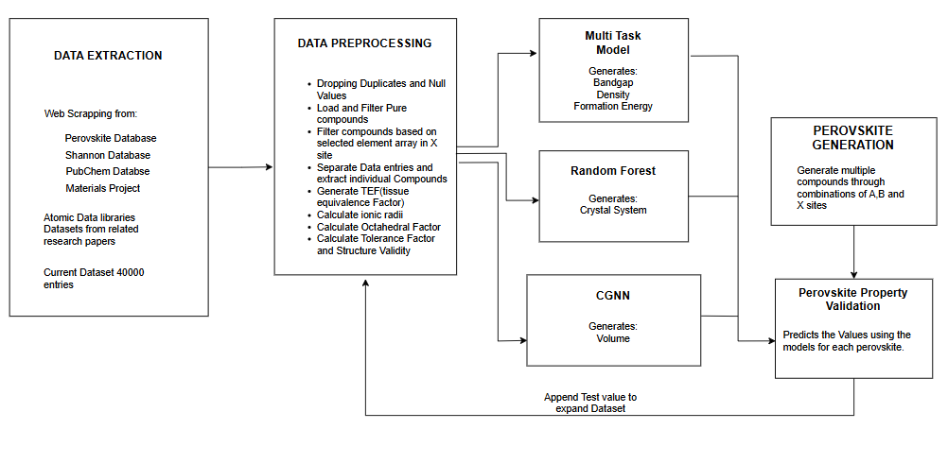

4. Implementation: The Bagging Model Approach
The core predictive capability relies on three distinct models, each specialized for specific material attributes.
4.1 Multitask Deep Learning Model
This PyTorch-based model handles complex inorganic hybrid formulas.
- Architecture: Utilizes linear layers and Residual Blocks to allow better gradient flow during deeper learning.
- Outputs: Predicts Bandgap, Formation Energy, Volume, and Density simultaneously.
- Standardization: Uses Standard Scaler to prevent high volume values from disrupting training.
4.2 Random Forest Classification
While the deep learning model handles regression, the Random Forest provides superior metrics for categorical data.
- Target: Predicts the Crystal System.
- Inputs: Uses the tolerance factor, octahedral factor, and bandgap as vectors.
- Split: Trained on an 80-20 data split.
4.3 Crystal Graph Neural Network (CGNN)
To capture the intricate spatial relationships of atoms, CGNN treats the material as a mathematical graph.
- Nodes/Edges: Atoms are nodes; chemical bonds are edges.
- Focus: Primarily used to refine the prediction of material Volume.

5. Data Generation and Optimization
5.1 High-Throughput Generation
Using known elements for A, B, and X sites, the system generated 39,670 chemically stable perovskite candidates.
- Filtering: After applying Tolerance and Octahedral factor tests, 21,769 valid compounds remained.
- TEF: The Tissue Equivalence Factor was calculated for these candidates to assess their suitability for medical/radiation dosimetry.
5.2 Constraint-Based Screening
Optimization is performed through three specific "Performance Windows":
- Stability: Filters for the "Perovskite Window" (0.8 to 1.1).
- Performance: Targets specific bandgap ranges required for measurable electrical signals in dosimetry.
- Economics: Eliminates combinations exceeding a user-defined "Budget" threshold to ensure commercial scalability.
- Abundance: Only considers compounds where the elements in the site are considered to be “Abundant”, i.e. the least occurring element in the compound has to have more that 2.3 p.p.m found in the earth’s crust.

6. Results and Analysis
The performance of the models demonstrates high reliability for materials discovery.
Target Property MAE R2 Score Accuracy

Bandgap 0.36 0.8641 -
Formation Energy 0.0687 0.9710 -
Density 0.1744 0.9618 -
Volume 0.4475 0.9929 -
Crystal System - - 79.28%

The system ultimately produced 21,769 highly optimized perovskite structures with predicted attributes ready for experimental consideration.

7. Conclusion
This research successfully integrated multi-task learning, graph networks, and ensemble classification to bypass the limitations of DFT. By generating a dataset of over 21,000 valid perovskites, the study provides a significant foundation for discovering sustainable, high-performance materials for radiation dosimetry. Future work may extend this framework to other crystal systems and property domains.

