Test on C# code.

Test case 1:
To test if this Removes Duplicates & replaces $ with £
Current Code:
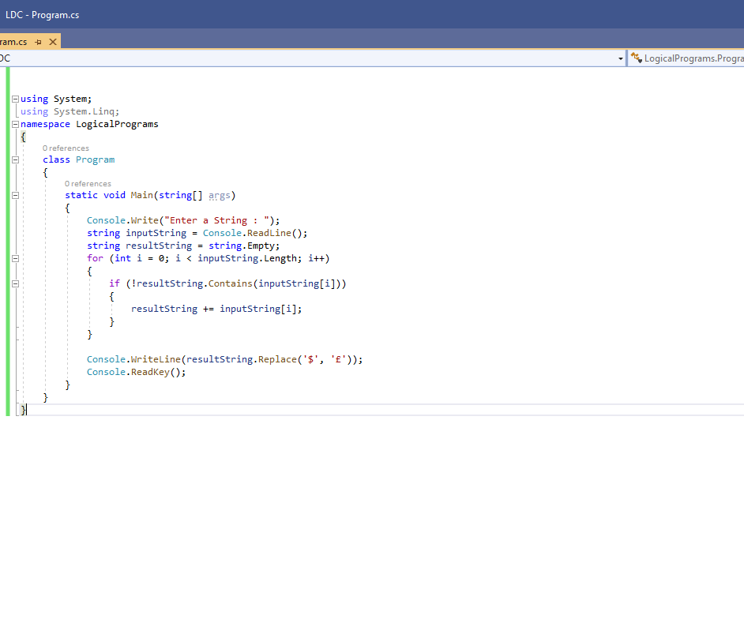
Result:
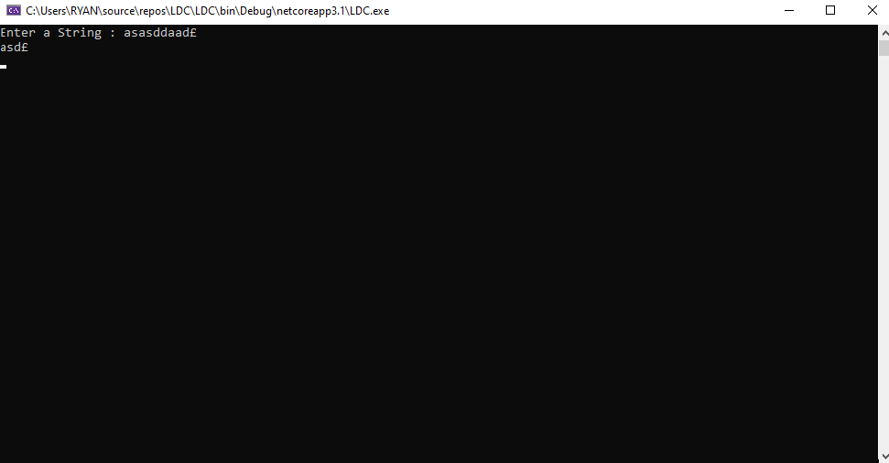
Code currently replaces $ with £ and removes any duplicate character.

Test case 2:
To test if this Removes Duplicates, replaces $ with £ & removes the characters 4 & _ from the output string.
Current code:
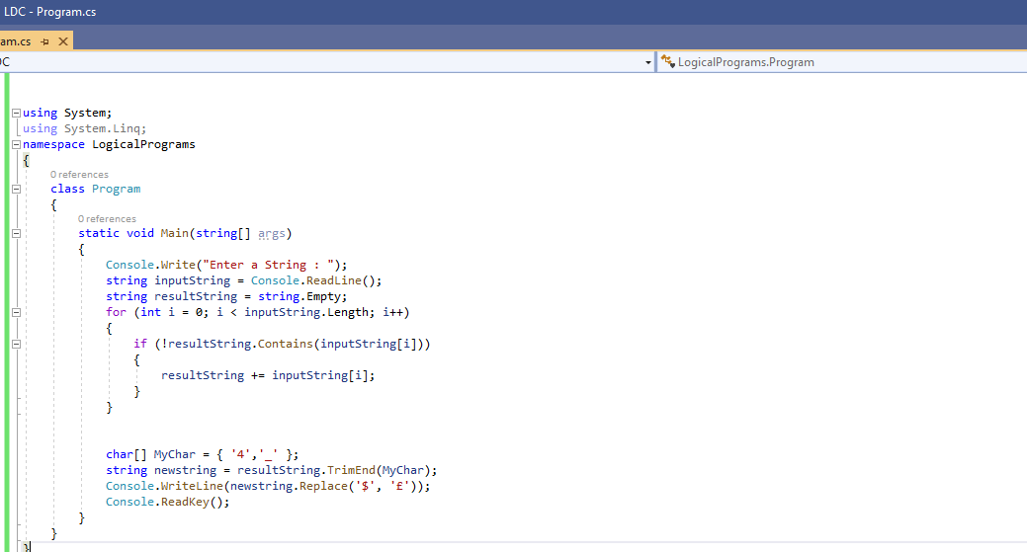

Result: Failed only removes from the end of the string as using the function trimmed

Test case 3: amended code and used just trim function in C#
To test if this Removes Duplicates, replaces $ with £ & removes the characters 4 & _ from the output string.

Current code
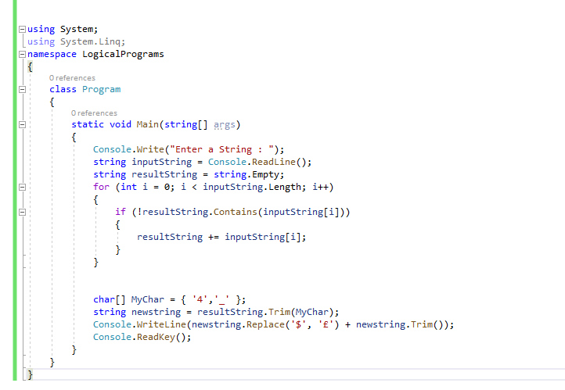

Result: Removes Duplicates, replaces $ with £ & removes the characters 4 & _ from the output string. Failed trim only seems to remove from the start of the line or end.

Test case 4
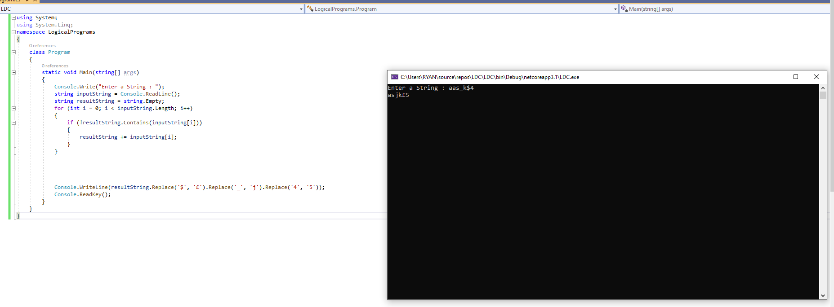
Used the replace function to remove 4 & _ instead these characters become j & 5, duplicates continue to be removed and $ becomes £.

Test case 5:
Tired to implement IF statement to remove truncate after 15 chars test failed
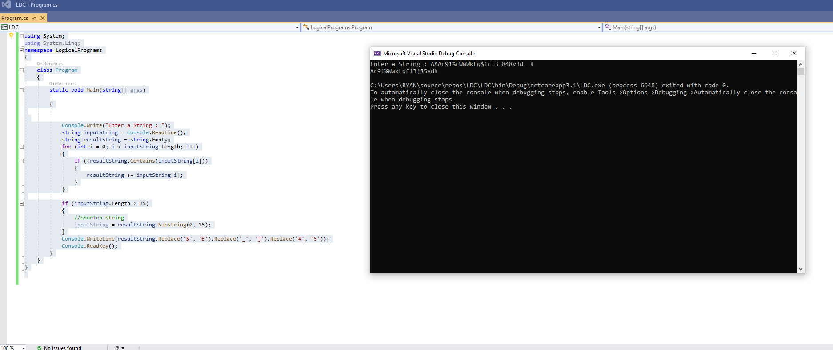

Test case 6.
Used the replace function to remove 4 & _ instead these characters become j & 5, duplicates continue to be removed and $ becomes £. And only selects the first 15 characters of the output string.

