**Perbandingan THRESH\_GAUSSIAN kernel 3x3 dengan 5x5**

**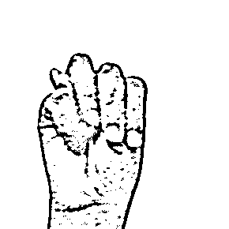**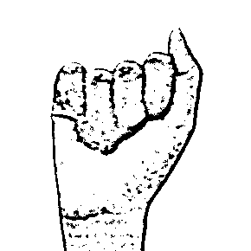

Bagan 2 THRESH\_GAUSSIAN

Bagan 1 THRESH\_GAUSSIAN

|  |  |  |  |
| --- | --- | --- | --- |
| A dengan kernel **5X5** | A dengan kernel **3X3** | M dengan kernel **5x5** | M dengan kernel **3x3** |
| C:\Users\Randi\Documents\Bisindo\OpenCV-Bisindo-Alphabets-Sign-Detection\train_data\erosi_5.png  Bagan erosi 5x5  C:\Users\Randi\Documents\Bisindo\OpenCV-Bisindo-Alphabets-Sign-Detection\train_data\dilasi_5.png  Bagan dilasi 5x5  C:\Users\Randi\Documents\Bisindo\OpenCV-Bisindo-Alphabets-Sign-Detection\train_data\morfo_closing_5.png  Bagan morfologi closing 5x5  C:\Users\Randi\Documents\Bisindo\OpenCV-Bisindo-Alphabets-Sign-Detection\train_data\morfo_opening_5.png  Bagan morfologi opening 5x5 | C:\Users\Randi\Documents\Bisindo\OpenCV-Bisindo-Alphabets-Sign-Detection\train_data\erosi_3.png  Bagan 7 erosi 3x3  C:\Users\Randi\Documents\Bisindo\OpenCV-Bisindo-Alphabets-Sign-Detection\train_data\dilasi_3.png  Bagan 8 dilasi 3x3  C:\Users\Randi\Documents\Bisindo\OpenCV-Bisindo-Alphabets-Sign-Detection\train_data\morfo_closing_3.png  Bagan 9 morfologi closing 3x3  C:\Users\Randi\Documents\Bisindo\OpenCV-Bisindo-Alphabets-Sign-Detection\train_data\morfo_opening_3.png  Bagan 10 morfologi 3x3 | C:\Users\Randi\Documents\Bisindo\OpenCV-Bisindo-Alphabets-Sign-Detection\train_data\erosi_5.png  Bagan 11 erosi 5x5.  C:\Users\Randi\Documents\Bisindo\OpenCV-Bisindo-Alphabets-Sign-Detection\train_data\dilasi_5.png  Bagan 12 dilasi 5x5  C:\Users\Randi\Documents\Bisindo\OpenCV-Bisindo-Alphabets-Sign-Detection\train_data\morfo_closing_5.png  Bagan 13 morfologi closing 5x5  C:\Users\Randi\Documents\Bisindo\OpenCV-Bisindo-Alphabets-Sign-Detection\train_data\morfo_opening_5.png  Bagan 14morfologi opening 5x5 | C:\Users\Randi\Documents\Bisindo\OpenCV-Bisindo-Alphabets-Sign-Detection\train_data\erosi_3.png  Bagan 15 erosi 3X3  C:\Users\Randi\Documents\Bisindo\OpenCV-Bisindo-Alphabets-Sign-Detection\train_data\dilasi_3.png  Bagan 16 dilasi 3x3  C:\Users\Randi\Documents\Bisindo\OpenCV-Bisindo-Alphabets-Sign-Detection\train_data\morfo_closing_3.png  Bagan 17 morfologi closing 3x3  C:\Users\Randi\Documents\Bisindo\OpenCV-Bisindo-Alphabets-Sign-Detection\train_data\morfo_opening_3.png  Bagan 18 morfologi opening 3x3 |

**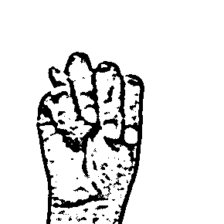Perbandingan ADAPTIVE\_THRESH\_MEAN\_C dengan Kernel 3x3**

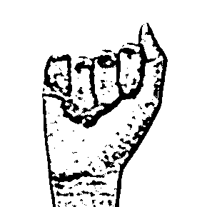

Bagan 20 ADAPTIVE\_THRESH\_MEAN\_C

Bagan 19 ADAPTIVE\_THRESH\_MEAN\_C

|  |  |  |  |
| --- | --- | --- | --- |
| A dengan kernel **3X3** | M dengan kernel **3x3** |  |  |
| C:\Users\Randi\Documents\Bisindo\OpenCV-Bisindo-Alphabets-Sign-Detection\train_data\erosi_5.png  Bagan erosi 3x3  C:\Users\Randi\Documents\Bisindo\OpenCV-Bisindo-Alphabets-Sign-Detection\train_data\dilasi_5.png  Bagan dilasi 3x3  C:\Users\Randi\Documents\Bisindo\OpenCV-Bisindo-Alphabets-Sign-Detection\train_data\morfo_closing_5.png  Bagan morfologi closing 3x3  C:\Users\Randi\Documents\Bisindo\OpenCV-Bisindo-Alphabets-Sign-Detection\train_data\morfo_opening_5.png  Bagan morfologi opening 3x3 | C:\Users\Randi\Documents\Bisindo\OpenCV-Bisindo-Alphabets-Sign-Detection\train_data\erosi_3.png  Bagan erosi 3x3  C:\Users\Randi\Documents\Bisindo\OpenCV-Bisindo-Alphabets-Sign-Detection\train_data\dilasi_3.png  Bagan dilasi 3x3  C:\Users\Randi\Documents\Bisindo\OpenCV-Bisindo-Alphabets-Sign-Detection\train_data\morfo_closing_3.png  Bagan morfologi closing 3x3  C:\Users\Randi\Documents\Bisindo\OpenCV-Bisindo-Alphabets-Sign-Detection\train_data\morfo_opening_3.png  Bagan morfologi opening 3x3 |  |  |

**Perbandingan THRESH\_GAUSSIAN ADAPTIVE\_THRESH\_MEAN\_C dan dengan Kernel 3x3 pada Negative Image**

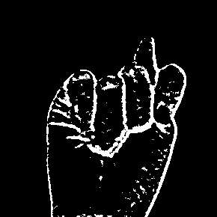

Bagan 30THRESH\_GAUSSIAN negative

Bagan ADAPTIVE\_THRESH\_MEAN Negative

|  |  |  |  |
| --- | --- | --- | --- |
| A dengan kernel **3X3** | M dengan kernel **3x3** |  |  |
| H:\Bisindo\OpenCV-Bisindo-Alphabets-Sign-Detection\train_data\_THRESH_GAUSSIAN\negative.png  Bagan 31 erosi 3x3  H:\Bisindo\OpenCV-Bisindo-Alphabets-Sign-Detection\train_data\_THRESH_GAUSSIAN\dilasi_negative.png  Bagan 32 dilasi 3x3  H:\Bisindo\OpenCV-Bisindo-Alphabets-Sign-Detection\train_data\_THRESH_GAUSSIAN\morfo_closing_3.png  Bagan 33 morfologi closing 3x3  H:\Bisindo\OpenCV-Bisindo-Alphabets-Sign-Detection\train_data\_THRESH_GAUSSIAN\morfo_opening_3.png  Bagan 34 morfologi opening 3x3 | H:\Bisindo\OpenCV-Bisindo-Alphabets-Sign-Detection\train_data\_ADAPTIVE_THRESH_MEAN_C\erosi_3.png  Bagan 35 erosi 3x3  H:\Bisindo\OpenCV-Bisindo-Alphabets-Sign-Detection\train_data\_ADAPTIVE_THRESH_MEAN_C\dilasi_negative.png  Bagan 36 dilasi 3x3  H:\Bisindo\OpenCV-Bisindo-Alphabets-Sign-Detection\train_data\_ADAPTIVE_THRESH_MEAN_C\morfo_closing_3.png  Bagan 37 morfologi closing 3x3  H:\Bisindo\OpenCV-Bisindo-Alphabets-Sign-Detection\train_data\_ADAPTIVE_THRESH_MEAN_C\morfo_opening_3.png  Bagan 38 morfologi opening 3x3 |  |  |