Dbo.class

select * from dbo.Class

INSERT INTO dbo.Class(Id, ClassName, ClassId)

values(1, 'English', 1)

INSERT INTO dbo.Class(Id, ClassName, ClassId)

values(2, 'Russian', 2)

INSERT INTO dbo.Class(Id, ClassName, ClassId)

values(3, 'French', 3)

INSERT INTO dbo.Class(Id, ClassName, ClassId)

values(4, 'Databases', 4)

INSERT INTO dbo.Class(Id, ClassName, ClassId)

values(5, 'Programming', 5)

INSERT INTO dbo.Class(Id, ClassName, ClassId)

values(6, 'Programming Basics', 6)

INSERT INTO dbo.Class(Id, ClassName, ClassId)

values(7, 'Web App Development', 7)

INSERT INTO dbo.Class(Id, ClassName, ClassId)

values(8, 'History', 8)

INSERT INTO dbo.Class(Id, ClassName, ClassId)

values(9, 'P.E', 9)

INSERT INTO dbo.Class(Id, ClassName, ClassId)

values(10, 'Math', 10)

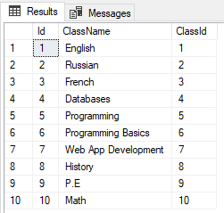

# Dbo.coupons

select * from dbo.Coupons

set identity_insert dbo.Coupons off

INSERT INTO dbo.Coupons(StudentId)

values(1)

INSERT INTO dbo.Coupons(StudentId)

values(2)

INSERT INTO dbo.Coupons(StudentId)

values(3)

INSERT INTO dbo.Coupons(StudentId)

values(4)

INSERT INTO dbo.Coupons(StudentId)

values(5)

INSERT INTO dbo.Coupons(StudentId)

values(6)

INSERT INTO dbo.Coupons(StudentId)

values(7)

INSERT INTO dbo.Coupons(StudentId)

values(8)

INSERT INTO dbo.Coupons(StudentId)

values(9)

INSERT INTO dbo.Coupons(StudentId)

values(10)

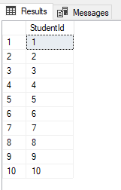

# Dbo.groups

select * from dbo.Groups

INSERT INTO dbo.Groups(FirstName, LastName, Email, Phone, ClassId)

values('tom', 'Tomavoch', 'tomavoch@gmail.com', 55511112, '1')

INSERT INTO dbo.Groups(FirstName, LastName, Email, Phone, ClassId)

values('Dan', 'Daningel', 'Danin@gmail.com', 2222222, '2')

INSERT INTO dbo.Groups(FirstName, LastName, Email, Phone, ClassId)

values('Kalvar', 'Kukk', 'kukk@gmail.com', 215136, '3')

INSERT INTO dbo.Groups(FirstName, LastName, Email, Phone, ClassId)

values('Deez', 'Nuttington', 'nit@gmail.com', 72137213, '4')

INSERT INTO dbo.Groups(FirstName, LastName, Email, Phone, ClassId)

values('mikk', 'mar', 'mikmar@gmail.com', 12651326, '5')

INSERT INTO dbo.Groups(FirstName, LastName, Email, Phone, ClassId)

values('hunt', 'hunter', 'hunter@gmail.com', 215125136, '6')

INSERT INTO dbo.Groups(FirstName, LastName, Email, Phone, ClassId)

values('tolm', 'tolmune', 'tolmune@gmail.com', 136136, '7')

INSERT INTO dbo.Groups(FirstName, LastName, Email, Phone, ClassId)

values('genrt', 'brab', 'barb@gmail.com', 1326136, '8')

INSERT INTO dbo.Groups(FirstName, LastName, Email, Phone, ClassId)

values('henry', 'pärt', 'pärt@gmail.com', 125136, '9')

INSERT INTO dbo.Groups(FirstName, LastName, Email, Phone, ClassId)

values('sandra', 'sar', 'sandra@gmail.com', 15136, '10')

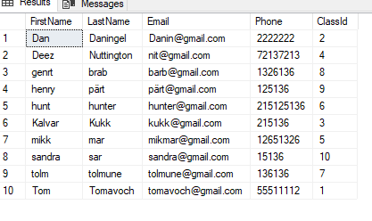

# Dbo.kitchen

select * from dbo.Kitchen

INSERT INTO dbo.Kitchen(MenuDate, Food, CouponId)

values('2000-09-02', 'Burger', 1)

INSERT INTO dbo.Kitchen(MenuDate, Food, CouponId)

values('2000-09-03','Cheese', 2)

INSERT INTO dbo.Kitchen(MenuDate, Food, CouponId)

values('2000-09-04','Fish', 3)

INSERT INTO dbo.Kitchen(MenuDate, Food, CouponId)

values('2000-09-05','Sand', 4)

INSERT INTO dbo.Kitchen(MenuDate, Food, CouponId)

values('2000-09-06','Stones', 5)

INSERT INTO dbo.Kitchen(MenuDate, Food, CouponId)

values('2000-09-07','Cement', 6)

INSERT INTO dbo.Kitchen(MenuDate, Food, CouponId)

values('2000-09-08','Lettuce', 7)

INSERT INTO dbo.Kitchen(MenuDate, Food, CouponId)

values('2000-09-09','Fries', 8)

INSERT INTO dbo.Kitchen(MenuDate, Food, CouponId)

values('2000-09-10','Potatoes', 9)

INSERT INTO dbo.Kitchen(MenuDate, Food, CouponId)

values('2000-09-11','Fish', 10)

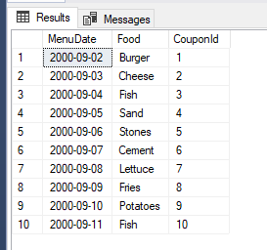

# Dbo.school

select * from dbo.School

INSERT INTO dbo.School(SchoolName,SchoolAddress)

values('1.Kool','123street')

INSERT INTO dbo.School(SchoolName,SchoolAddress)

values('2.Kool','13street')

INSERT INTO dbo.School(SchoolName,SchoolAddress)

values('3.Kool','823street')

INSERT INTO dbo.School(SchoolName,SchoolAddress)

values('4.Kool','1street')

INSERT INTO dbo.School(SchoolName,SchoolAddress)

values('5.Kool','23street')

INSERT INTO dbo.School(SchoolName,SchoolAddress)

values('6.Kool','73street')

INSERT INTO dbo.School(SchoolName,SchoolAddress)

values('7.Kool','97street')

INSERT INTO dbo.School(SchoolName,SchoolAddress)

values('8.Kool','12street')

INSERT INTO dbo.School(SchoolName,SchoolAddress)

values('9.Kool','1123street')

INSERT INTO dbo.School(SchoolName,SchoolAddress)

values('154.Kool','9street')

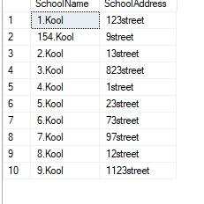

# Dbo.student

set identity_insert dbo.Student on

select * from Student

INSERT INTO dbo.Student(StudentId,ClassId, FirstName, LastName, ParentPhone)

VALUES (1, 1, 'Tomas', 'Selbi', '5554')

INSERT INTO dbo.Student(StudentId,ClassId, FirstName, LastName, ParentPhone)

VALUES (2, 2, 'Male', 'Selbi', '55556')

INSERT INTO dbo.Student(StudentId,ClassId, FirstName, LastName, ParentPhone)

VALUES (3, 3, 'Mann', 'Selbi', '55557')

INSERT INTO dbo.Student(StudentId,ClassId, FirstName, LastName, ParentPhone)

VALUES (4, 4, 'Sig', 'Selbi', '55558')

INSERT INTO dbo.Student(StudentId,ClassId, FirstName, LastName, ParentPhone)

VALUES (5, 5, 'Stig', 'Selbi', '5554')

INSERT INTO dbo.Student(StudentId,ClassId, FirstName, LastName, ParentPhone)

VALUES (6, 6, 'Ruth', 'Selbi', '5553')

INSERT INTO dbo.Student(StudentId,ClassId, FirstName, LastName, ParentPhone)

VALUES (7, 7, 'Luke', 'Selbi', '5552')

INSERT INTO dbo.Student(StudentId,ClassId, FirstName, LastName, ParentPhone)

VALUES (8, 8, 'Mike', 'Majers', '5551')

INSERT INTO dbo.Student(StudentId,ClassId, FirstName, LastName, ParentPhone)

VALUES (9, 9, 'Tommy', 'Tomats', '5545')

INSERT INTO dbo.Student(StudentId,ClassId, FirstName, LastName, ParentPhone)

VALUES (10, 10, 'Jane', 'Jane', '5255')

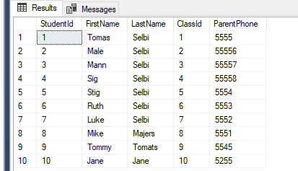

# Store proc

CREATE PROCEDURE StudentParentNumbers

AS

Select ParentPhone, LastName

FROM dbo.Student

GO;

EXEC StudentParentNumbers

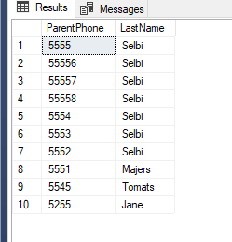

# JOINS

SELECT * from dbo.Student

right join dbo.Groups on dbo.Student.FirstName = dbo.Groups.FirstName

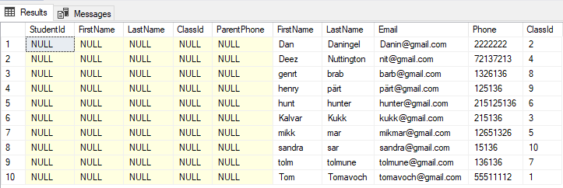

SELECT * from dbo.Student

left join dbo.Groups on dbo.Student.FirstName = dbo.Groups.FirstName

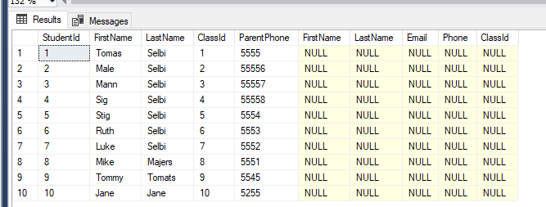

SELECT * from dbo.Student

full join dbo.Groups on dbo.Student.FirstName = dbo.Groups.FirstName

