Riley Stadel

HW 1

Feb-13-2019

I feel like I did not do it correctly, but I was able to get the perceptron learning algorithm working for linearly separable data and was able to return the number of iterations it took to find a solution.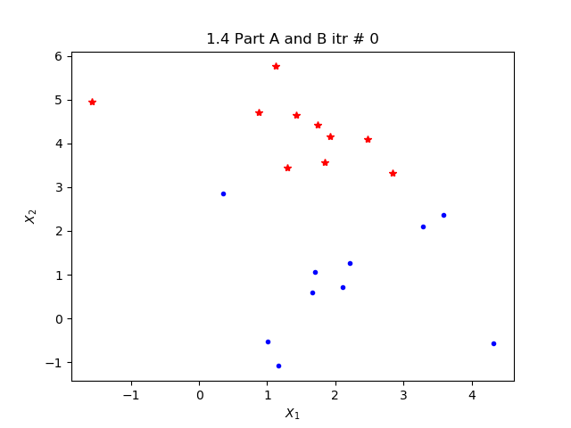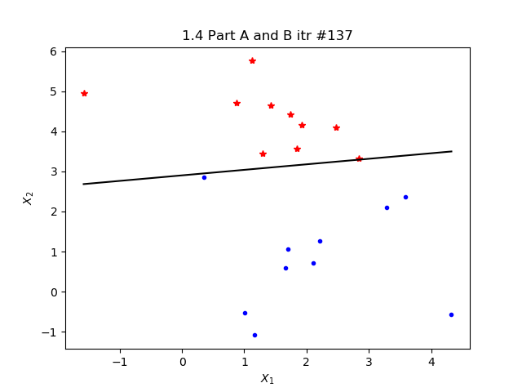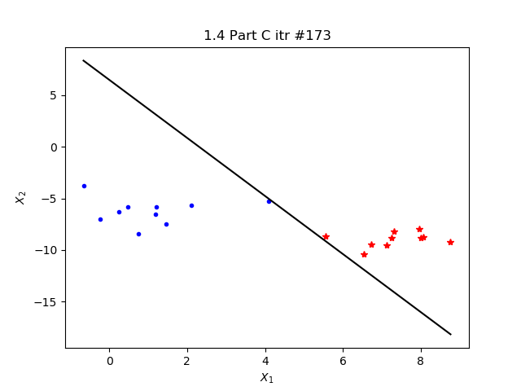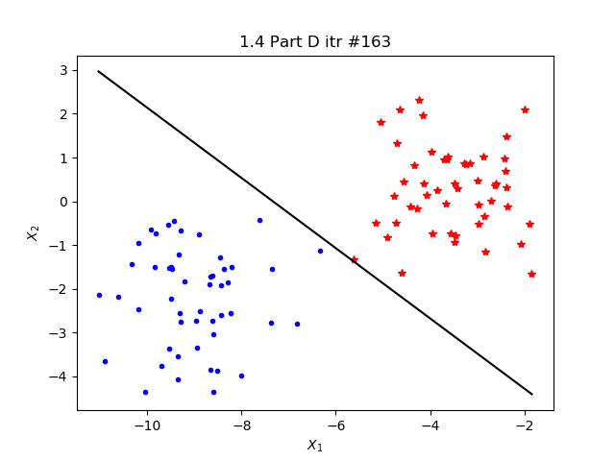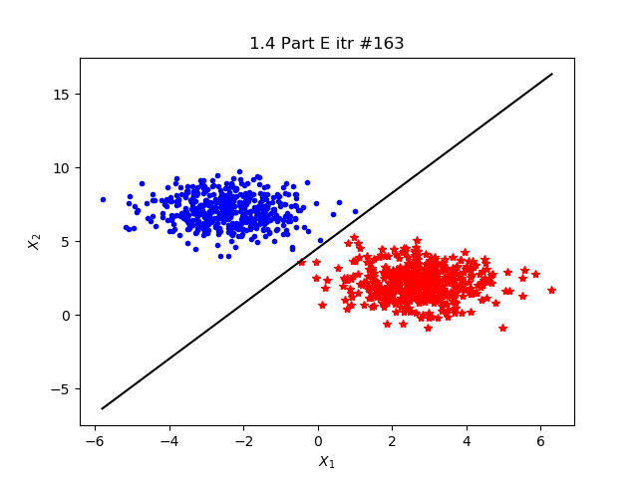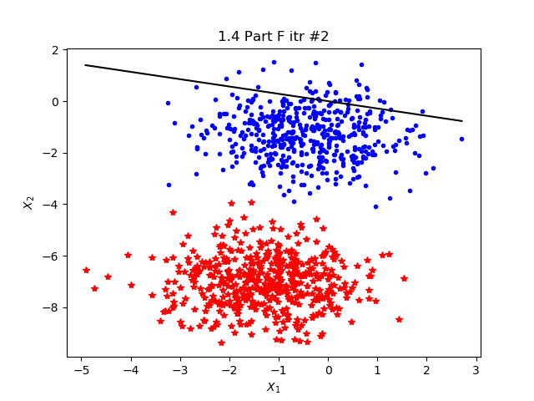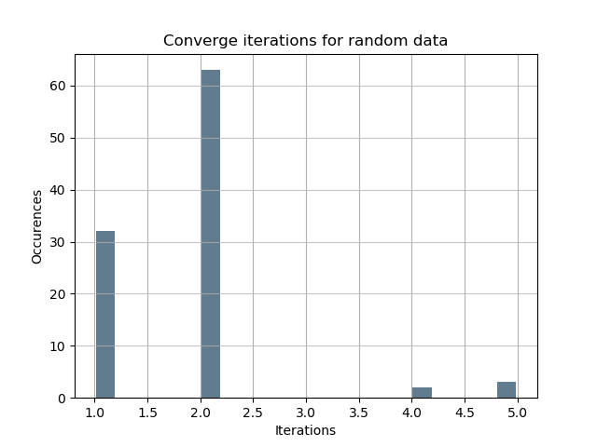

H)

Once again, I feel I did not do it correctly because each of the data sets was either around 2 or 150 iterations based on the amount of noise in the data.