HW3

Riley. E. Stadel

Report

1a.

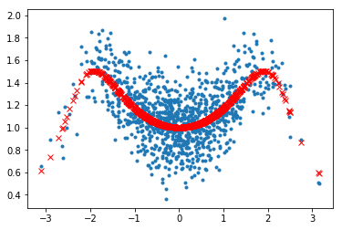

1c. best CV was k=3

2. The histogram

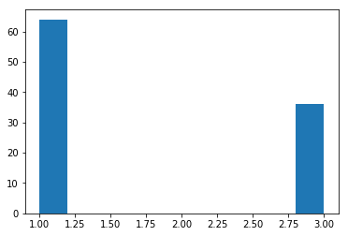

3.

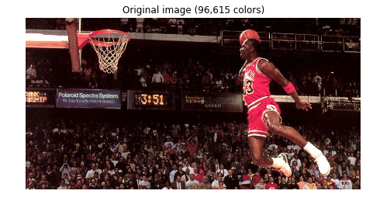

This image uses 3 colors.



3i. The image got more animated looking as you decreased the number of colors.

3ii. This can be really useful for making games that have a small number of memory usage.

3iii. The picture looked funny in the end because there is such a high contrast between colors in the real world, that trying to condense it into a small number of colors makes images look less clean.