Ryan Shipman

Nov 16, 2020

IT FDN 110 A

Assignment05

ToDoListMod05.py

**Introduction.**

In this essay I will be going over how I completed the mod 5 script. I was tasked with taking a template script, inserting my own code into that script to make it work. To accomplish this tricky task I will need a basic understanding of lists and dictionaries, I will need to utilize some functions as well. Let's get started.

**Declare the variables**

To start off I noticed that at the beginning of the script that certain variables were defined. In Python you don't need to do this in order for the script to work as intended like in other languages. However, it is a tool to use if you want to keep your script organized and especially helpful if you plan on coming back to the project off and on. See figure 1 for reference.

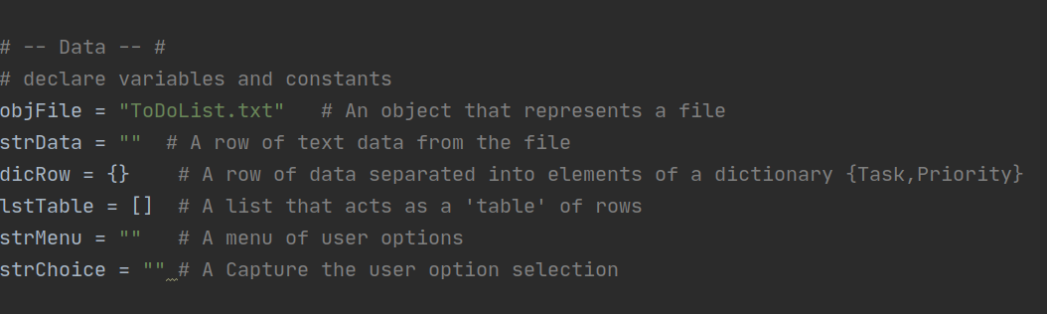

Figure 1.

**Processing.**

Our next objective is to pull data from our ToDoList.txt to memory for processing. In this particular assignment we were asked to pull the data to a list of dictionary rows and save it to memory as a list of dictionary rows.

See figure 2 for reference.

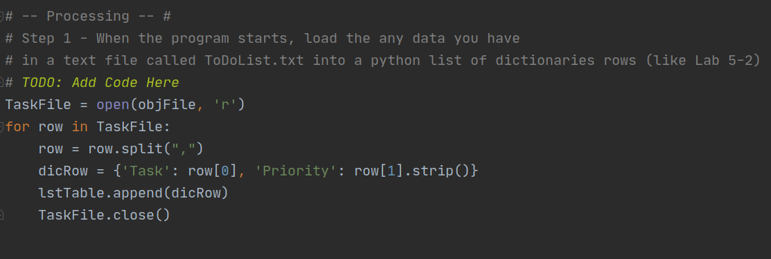

Figure 2.

This little bit of code is fairly simple. It just takes the data *if any in the file* and stores it as a dictionary row and then appends that row to the table of dictionaries or ‘lstTable’ in memory. Essentially we are adding the 2 dictionary keys of ‘task’ and ‘priority’ to the first row of the table to be used in the next section of our while loop or main body of the script.

**The menu and while loop.**

Now, this menu has 5 selectable options. See figure 3 for reference. 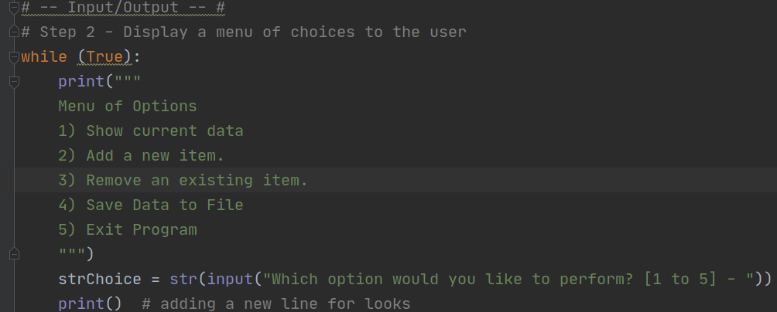

Figure 3.

So, in order to build this process of cycling through the menu and selecting the option you want we will be using a while loop with if, elif, else statements. If the user selects 1 we want it to show the current data that we pulled from the text file in the ‘processing’ section and since that data is already stored as a dictionary with two keys (Task, Priority) we can technically call it, however it won't have any values or items attracted to those keys yet. That is in the next step option 2.

See figure 4 for reference on how to code option 1.

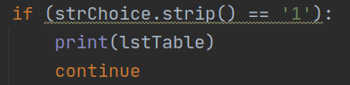Figure 4.

Pretty simple, next we want to add new items to our list of dictionary rows that are still stored in memory. So in order to do this we code in some user input functions. Save those to a dictionary and append that to the list of dictionary rows in memory. See Figure 5 for reference.

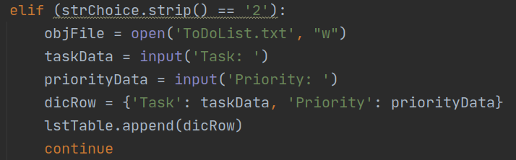

Figure 5.

Next for option 3 we need to code in a way to remove a dictionary row from the table and give the user control over which row they want to delete. To achieve this I used a nested for loop combined with an if statement and the remove function. See figure 6 for reference.

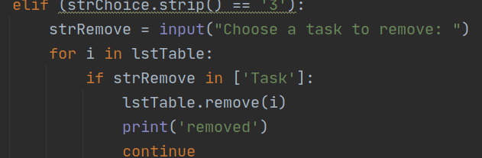

Figure 6.

For the last option we need to save the data to the file, in order to do that we simply need to open the file where we want to save the data and use a for loop to write the list of dictionaries that are still floating around in memory. To do this see my code in figure 7.

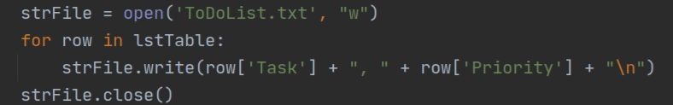

Figure 7

**Summary**

This was a quick and dirty explanation on my thought processes behind adding the code to the script for this assignment. Thanks for reading.