**CE301 Final Report**

**Designing and Manufacturing a Data Glove**

**Ryan J Taylor / 1605364**

**BSc Computer Science**

Supervisor: Dr. Adrian Clark

Second Accessor: Dr. Serafeim Perdikis

# Acknowledgements

Firstly, I would like to thank my supervisor, Dr Adrian Clark, for the support received from undertaking this project. He helped to make the project stay fun, interesting, and easy to comprehend, whilst also guiding me in the right directions.

I would also like to thank my colleagues for keeping me motivated to work on the project during this time of ‘home’ learning, by way of having ‘study sessions’ where we work on our own projects over Zoom, where I believe I was at my most productive.

Lastly, I would like to thank my mum, for teaching me how to sew so that I could successfully develop my project, my sister for buying me countless Monster Ultra Zeros for the long sleepless nights and I wish to thank my dog, for accompanying me during those nights.

# Abstract

Data gloves are used throughout the world and have been proven very popular, especially in the realms of gaming and entertainment, the biggest issue we face with these gloves is their portability or the lack thereof. This project challenges this issue and looks to implement central processing straight onto the glove itself by using a Raspberry Pi Zero W paired with a power source, with the idea being to eliminate the requirement of attaching the glove directly to a desktop.

Ultimately, I have created this data glove with the intention being to mimic a computer keyboard, the glove supports switching between multiple different keysets, so that the user can input characters into a text field.

This document provides a literature survey; based around the designs and implementations of previously manufacture data gloves, full technical documentation of both the hardware and software, including designing and implementing both systems. This technical documentation is provided on a GitLab repository, which also holds all of the technical work, Python code, design files and reports. Following on from the technical documentation a project planning report is provided, and finally my overall conclusions about the project.

# Table of Contents

Acknowledgements 2

Abstract 3

Table of Contents 4

Literature Survey 5

Data Gloves 5

Data Glove Applications 5

Interacting with Data Gloves 6

Issues with Data Gloves and How my Project Solves this 7

Technical Documentation 8

Project aims and objectives 8

Technical Documentation Summary and Link 8

Project Planning 9

Planning Methodology 9

The Jira Tool 9

Jira in Action in this Project 10

Conclusions 13

Project Results 13

Future Work 14

References 15

# Literature Survey

## Data Gloves

According to Techopedia, a Data Glove is an input device that is essentially a glove worn on the users’ hand, the glove houses various electronic sensors that can capture inputs from the hand, and then transform these inputs into a form of input for applications such as virtual reality [1].

The first form of Data Glove was invented in the United States of America at the University of Illinois, in 1997. Labelled the ‘Sayre Glove’ [2], after it’s conceptualist Richard Sayre and created by Daniel J. Sandin and Thomas Defanti.

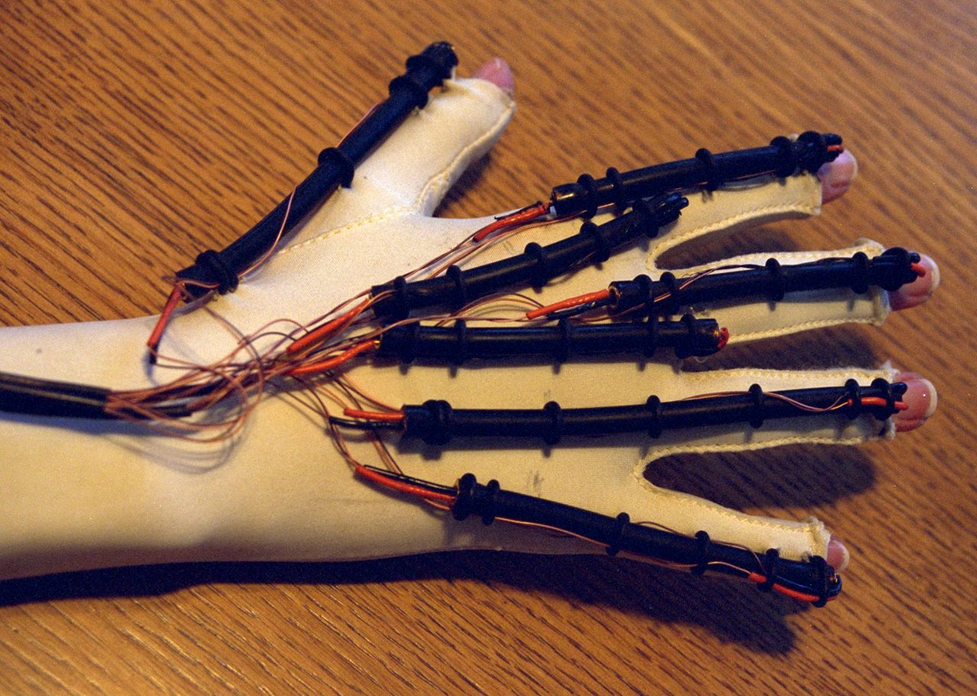

Figure 1. Sayre Glove

The Sayre Glove was an inexpensive and lightweight device, at only having the functionality of monitoring the movement of an individuals’ hand. The Sayre Glove paved the way for many different iterations from the glove’s original design, with similar types of Data Gloves now used all over the globe in various industries and for very different applications. More recently invented gloves include:

1. CyberGlove http://www.cyberglovesystems.com/
2. HumanGlove https://www.hmw.it/en/research-and-development/humanglove/
3. LightGlove B. Howard and S. Howard, "Lightglove: wrist-worn virtual typing and pointing," Proceedings Fifth International Symposium on Wearable Computers, 2001, pp. 172-173, doi: 10.1109/ISWC.2001.962130.
4. AcceleGlove <https://www.anthrotronix.com/>
5. <https://bebopsensors.com/arvr/>

## Data Glove Applications

This section of the report provides an overview of the different industries that data gloves are prevalent in, and how they have been applied.

One of the biggest industries that data gloves are found is in the Robotics sector. There have been many examples of using them to control robots, becoming increasingly influential in the military sector [6][7], or using the devices to teach robots to simulate our movements, so they can be better used in industries such as manufacturing [8][15].

Medically, a data glove can be used in rehabilitation, used to assess the functionality of a persons’ hand (functionality referring to areas like the grip, finger movements and their sensitivity to temperature) [9]. Another field in medicine where data gloves are seen is understanding sign language, using forms of ASL to recognise hand signals from the user and being able to output the signal in the form of speech [10][11].

Another field where data gloves are used is in entertainment, especially within the gaming sector. The most obvious use we see for data gloves is when they are paired with a Virtual Reality Headset, allowing used to be immersed into a virtual world where they can interact with the environment [12][13][14].

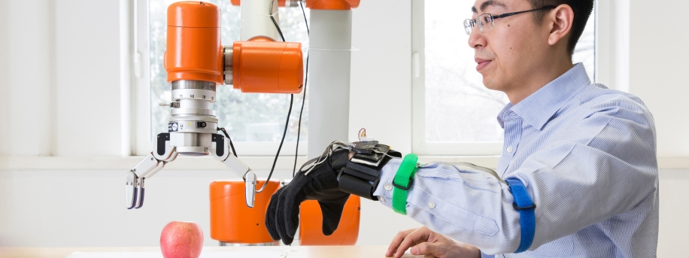

Figure 2. Using a Data Glove to control a robot.

Using this knowledge gained, I was far more confident that there was an actual market for data gloves.

## Interacting with Data Gloves

After seeing the possibilities of what a data glove can achieve, I needed to research the ergonomics and human-computer interaction elements of them, understanding the different gestures, movements and inputs that can be tracked using a data glove. Using this source [5] I was able to gain insight into exactly what we can achieve by way of gestures, movements, and inputs, with clear examples of how these actions are used. The mentioned examples below helped to form the design of my glove. Using the standard pinch glove design, accompanied with an accelerometer planted on top of the glove, I became aware of the following computing example that I could incorporate into my designs:

* Inputting a ‘mouse buttons click’ by pressing your thumb to your finger.
  + Using this action to also drag and drop icons on the desktop screen.
* Using the rotation of the hand, this rotation can be used to control a side scroll bar.
* Controlling a volume bar by raising or lowering your hand.
* Swiping away with your hand to close a program to the system tray.

## Issues with Data Gloves and How my Project Solves this

The biggest problem that data gloves face is their lack of portability regarding their central processing. Data Gloves are required to be connected to a computer desktop tower to control the inputs and then manipulating these inputs, and these towers as we know, are big, heavy and do not move unless forced.

What my project aims to do is to challenge this narrative by implementing a Raspberry Pi Zero W onto my data glove, dubbed the RyPi. While there may already be solutions to this issue prevalent, the price you have to pay to access a device like this can be extremely high, so my project tackles this and looks to implement the system as inexpensive as possible while also being easy to reproduce, including having all the material opensource, for anyone to re-create. For my project I have adopted the model of a ‘Pinch Glove’. This works by way of placing a sensor on each fingertip and another sensor on the tip of the thumb, when the thumb sensor comes into contact with a fingertip sensor an output should be produced, it is referred to as a ‘pinch glove’ as it is mimicking the action of a pinch [4].

Solving this issue, underlined above, could prove important as it opens the door for making similar systems like mine readily available to everyone who would could make use of one, for instance a mute person could use the device to interact with people, and as the system aims to be compact and not require bulky computers they can use the device anywhere with a stable UDP connection. Another way in which my project is unique from others is that it makes used of the whole hand, what I mean by this is adding sensors to the base of each finger to act as another input, which in turn should allow for increased functionality for the system.

As stated earlier on in this discussion, my project is created with the view in mind to be completely opensource, meaning that I would renounce the copyright and patent, while this does technically mean anyone can use the material created in my project, they still will need to agree to the licencing terms that I will need to create for this project, before being able to release the data to the public.

# Technical Documentation

This section of the report goes over what I am looking to achieve in this project and provides a summary of my technical achievements, with suitable links to my full technical documentation.

## Project aims and objectives

The aim of this project is to design and create a complete working data glove infrastructure, in the form of a pinch glove. Keeping with the points made earlier in the report, the glove should be able to interpret inputs in the form of finger presses via sensors placed on to the glove. Using UDP packets to transfer these inputs to a server, where the inputs can be manipulated and implemented to an output. For this project I have decided that the output should be in a form of a keystroke, like a keyboard.

The main objectives of this project being are as followed, in terms of both hardware and software.

Hardware:

* Designing a pinch glove, considering the ergonomics of the device and the supporting hardware that will be needed.
* Manufacturing the pinch glove, based on the created designs.
* Producing an input response from the glove, using sensors based on the glove.

Software:

* Transforming the input into an appropriate output response.
* Implementing a system to allow the device to switch between different keysets, e.g. switching between English keys and French keys.
* Implementing error handling features to ensure the integrity of the system.

## Technical Documentation Summary and Link

The complete technical documentation for this project is available [**here**](https://cseegit.essex.ac.uk/ce301_2020/ce301_taylor_ryan_j), it is held on a University of Essex GitLab repository. The documentation is organised through a TOC readme file, located on the front page of the repository, and contains the following:

* A brief introduction to my project, including what it is, what it produces and how it produces this.
* Details on the design and implementation of both the hardware and software side of this project. This includes details on the basic logic of the pieces of software and the different achievements that were made during these processes and suitable references used for the project.
* An in-depth guide on how to install and execute my project to successfully get an output, including details on the software needed, how to install relevant libraries and how to use the software.

Again, the technical documentation can be found by following this [**link**](https://cseegit.essex.ac.uk/ce301_2020/ce301_taylor_ryan_j).

# Project Planning

The section of the report will go into the planning methodology used for this project, followed by how I have used the Jira tool. Lastly touching on drawing conclusions from reports that can be generated in Jira using the project management tools.

## Planning Methodology

The planning for this project utilised an Agile methodology through a Jira Kanban Board tool. I believe using this methodology proved successful and was by far superior to other methods such as Waterfall, as it allowed me to continuously refine any work that I created. Another advantage I found using this methodology is that I did not have to worry about opening and closing weekly sprints, which for my project was not necessary considering I was the only participant in the development.

## The Jira Tool

I believe my planning for this project, for the most part was very good, below in Figure 3 is an example of how I structured each of my issues. You will see that the title of the issue is short and concise, there is a description to further explain what needs to be done and who the issue is assigned to. After the completion of the issue, I made sure to add a comment to the issue, giving a brief overview of what has been implemented, and always including the supporting GitLab commit id(s), so that they may be referred back to in the future.

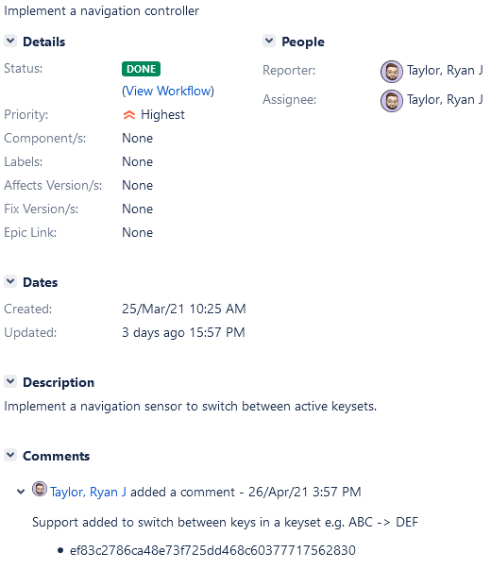

Figure 3.

Shown in Figure 4 are my releases on Jira, using significant milestones to release versions for my project. We can see from the figure that I only managed to release 4 out of 5 of the intended releases.

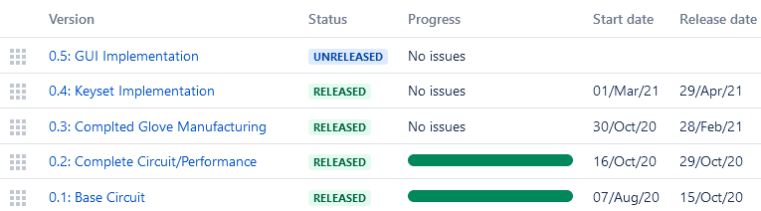

Figure 4. Jira Releases.

## Jira in Action in this Project

Using reports that we can create using the Jira Tool, we can get an overview of how I performed in this project. The first report, Figure 5, a cumulative flow diagram. Drawing conclusions from this diagram we can see that over the course of the development of this project there was a steady increase in issues of both created and completed issues.

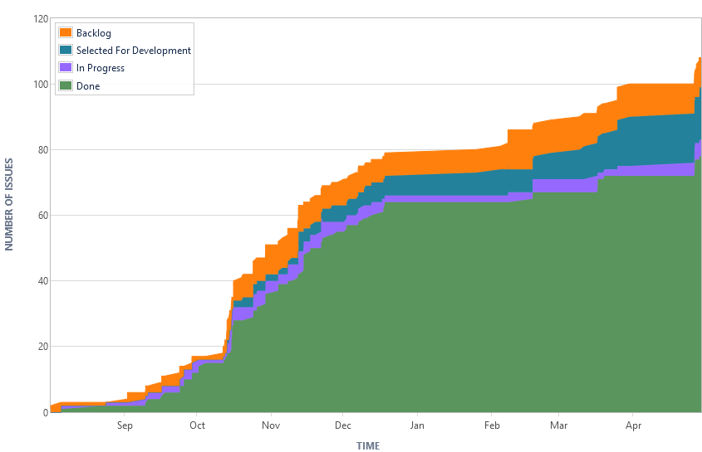

Figure 5. Cumulative Flow Diagram.

The next report, shown in Figure 6, shows the cycle time for my product. What we can conclude from this report is that at the start of the project, issues were created far more frequently and generally solved in less time than that of issues in the second part of the chart. I believe this to be the case as at the start of the project there are much smaller tasks to complete in and in the end of the project only the bigger tasks should remain, that would take a lot more effort to complete.

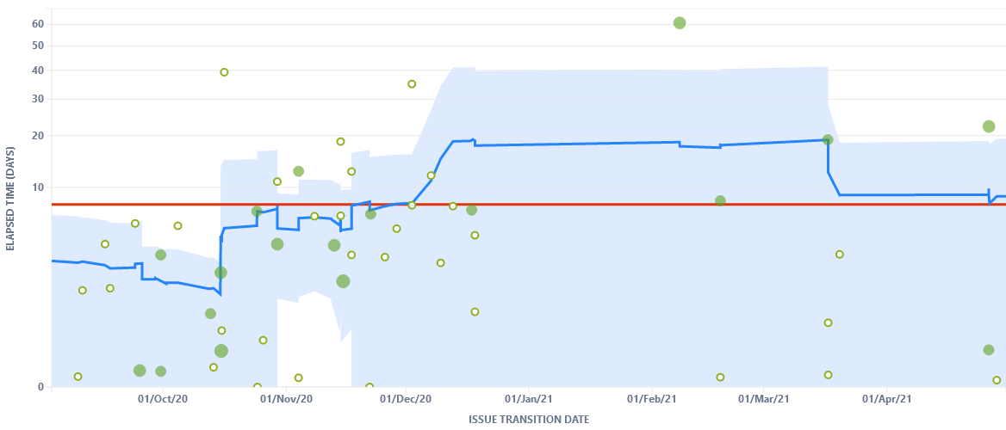

Figure 6. Control Chart.

It is clear in both reports that there was a period between 1st January to mid-February where there is no data, this would indicate that my project stagnated between this time frame.

The last report, shown in Figure 7 below, is a Pie chart containing the types of issues used in the development of my project. We can see largely that as expected the most populated issue in my Jira are tasks, but it also shows that I used a suitable number of epics combined with the sub-tasks for the larger, more complex tasks. What is interesting is that I was not very good at tracking the bugs and risk issues on my Jira page, so that is something I can work on in the future when planning future projects. Another takeaway from this chart is that I received an excellent amount of supervisor feedback throughout the project lifetime, which undoubtably helped me with this project.

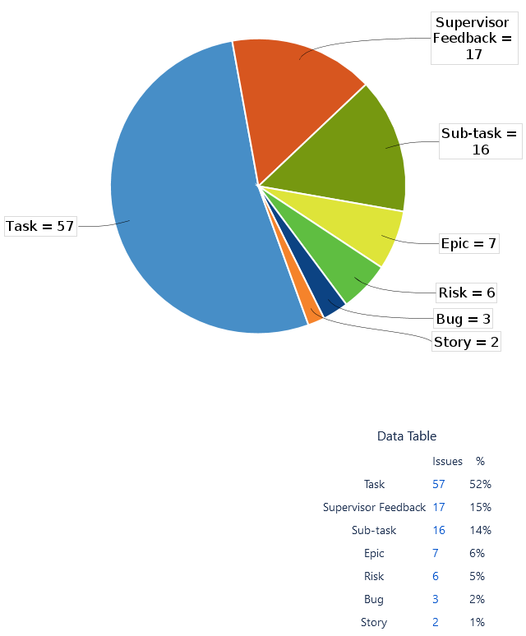

Figure 7. Issue Pie Chart.

I believe I adapted to an ever-changing workflow with this project and did not let bumps in the road affect my overall project too much. For instance, manufacturing the glove proved very time consuming, due to an ever-changing work environment, not having access to required equipment and manufacturing items. A good example of this is that in my original plans we were to solder pieces of wire to the electronic sensors, however we had to adapt and settled for sewing the wires to the sensors on the glove.

# Conclusions

Overall, my project completed what it set out to achieve, which as stated was to add central processing straight onto a data glove, making the device both portable and removing the requirement that a data glove must be plugged into a desktop pc.

The work that has been produced in this project includes:

* The creation of an electronic circuit capable of sending input and output signals to and from a Raspberry Pi.
* Using these signals, paired with UDP packets, to send and receive the data on two separate devices.
* Using the electronic circuit to design an ergonomic pinch glove.
* Implementing the designs to manufacture my glove.
* Implementing software that can transform the input data to a readable format, in this case a keyset.

In my designs, found in the technical document, an accelerometer is present, labelled the ‘MPU-6050’, while it was my intention to implement this piece of hardware, which would have enabled me to track the movements of the device, due to technical limitations in this pandemic and not being able to gain access to hardware equipment needed to implement it on to the glove, it was decided that it would be excluded at this stage.

Another area in which my designs fell short was with the ribbon cable, upon testing the ribbon cable in my system, instead of receiving one input signal from a sensor, I received all the signals from all sensors at once. I spent a lot of time trying to fix this issue, however in the end it was easier to revert to using singular wires, which just means that it is a bit more time-consuming setting up my system.

## Project Results

Below, in Figure 8, is my constructed data glove. When it is properly configured, as shown in the technical document figures, it can produce results as shown in Figure 9, where I have made use of two different keysets to create some text.

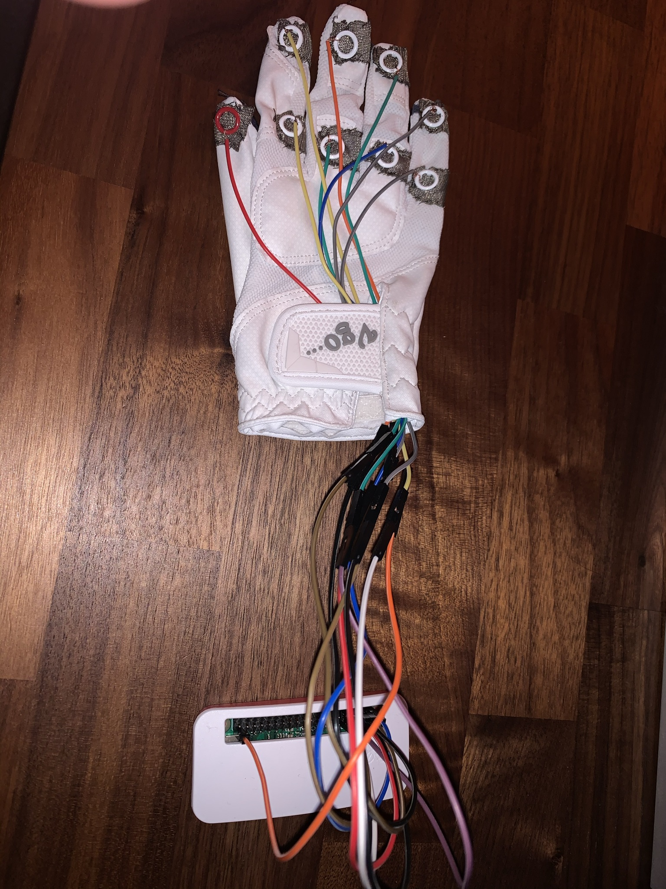

Figure 8. My data glove, ‘RyPi’.



Figure 9. Program Output.

To best show off the results of my project I thought it would be appropriate to show a live demonstration in a video format of the full system in action, this can be found [**here**](https://cseegit.essex.ac.uk/ce301_2020/ce301_taylor_ryan_j/product-demo.mov)in my git repository.

## Future Work

If I were to develop this project in the future there are several areas, I feel would benefit in being improved on, these are in no specific order:

* The first area I would develop is the implementation of the accelerometer, as stated earlier this was not possible, but now that the world is returning back to normal it would definitely be possible to add the accelerometer to get more functionality from the glove. Developing or finding a suitable connector that can link my glove to the Raspberry Pi and it’s supporting hardware.
* Afterwards, I would like to develop a GUI so that the user can see the ‘active’ keys, this would improve the user experience dramatically as the user would not need to learn the keysets and the active keys on each finger beforehand.
* Next, I would like to create a more ‘interactive’ text input system, currently the input only prints to the python console, but developing the system further I could make the user inputs output to a .txt file, so that the user can create a text document with their inputs.
* Lastly, implementing a way to insert new keysets, without having to manually coding them into the program. For instance, importing a keyset from a .txt file, which when loaded is assigned values in the program.

To conclude this report, I would like to say that I thoroughly enjoyed undertaking this project. It came with some challenges along the way but given the up and down nature of the last year, I am happy with what I was able to produce.

# References

[1] "What is a Dataglove? - Definition from Techopedia", *Techopedia.com*, 2021. [Online]. Available: https://www.techopedia.com/definition/3634/dataglove. [Accessed: 03- Sep- 2021].

[2] D. Sandin, "US NEA R60-34-163 Final Project Report", Undergraduate, University of Illinois, 1977.

[3] L. Dipietro, A. M. Sabatini and P. Dario, "A Survey of Glove-Based Systems and Their Applications," in IEEE Transactions on Systems, Man, and Cybernetics, Part C (Applications and Reviews), vol. 38, no. 4, pp. 461-482, July 2008, doi: 10.1109/TSMCC.2008.923862.   
[4] Bowman, Doug & Wingrave, Chadwick & Campbell, Joshua & Ly, V. & Rhoton, C. (2002). Novel Uses of Pinch Gloves for Virtual Environment Interaction Techniques. Virtual Reality. 6. 122-129. 10.1007/s100550200013.   
[5] P. Kumar, S. S. Rautaray and A. Agrawal, "Hand data glove: A new generation real-time mouse for Human-Computer Interaction," 2012 1st International Conference on Recent Advances in Information Technology (RAIT), Dhanbad, 2012, pp. 750-755, doi: 10.1109/RAIT.2012.6194548.

[6] Tran, Nghia & Phan, Hoa & Dinh, Vince & Ellen, Jeffrey & Berg, Bryan & Lum, Jason & Alcantara, Eldridge & Bruch, Mike & Ceruti, Marion & Kao, Charles & Garcia, Daniel & Fugate, Sunny & Duffy, Lorraine. (2009). Wireless Data Glove for Gesture-Based Robotic Control. 5611. 271-280. 10.1007/978-3-642-02577-8_30.

[7] Ceruti, Marion & Dinh, Vincent & Tran, Nghia & Phan, Hoa & Duffy, Lorraine & Ton, Tu-Anh & Leonard, Guy & Medina, Emily & Amezcua, Omar & Fugate, Sunny & Rogers, Gary & Luna, Robert & Ellen, Jeffrey. (2009). Wireless communication glove apparatus for motion tracking, gesture recognition, data transmission, and reception in extreme environments. 172-176. 10.1145/1529282.1529320.

[8] Low-cost Sensor Glove with Force Feedback, Elmar Rueckert, Rudolf Lioutikov, Roberto Calandra, Marius Schmidt, Philipp Beckerle and Jan Peters. (2015).

<https://arxiv.org/pdf/1510.03253.pdf>

[9] Lin, Bor-Shing & Lee, I-Jung & Yang, Shu-Yu & Lo, Yi-Chiang & Lee, Junghsi & Chen, Jean-Lon. (2018). Design of an Inertial-Sensor-Based Data Glove for Hand Function Evaluation. Sensors. 18. 1545. 10.3390/s18051545.

[10] Mehdi, Syed Atif & Khan, Yasir Niaz. (2002). Sign language recognition using sensor gloves. 2204 - 2206 vol.5. 10.1109/ICONIP.2002.1201884.

[11] Mat Smith. “AcceleGlove teaches you sign language”, (2012). Available:

<https://www.engadget.com/2012-01-14-acceleglove-teaches-you-sign-language-we-go-hands-in-video.html>

[12] Temoche, Pablo & Ramirez, Esmitt & Rodríguez, Omaira. (2012). A Low-cost Data Glove for Virtual Reality. TCG 31-36.

[13] L. C. Pereira, R. V. Aroca and R. R. Dantas, "FlexDGlove: A Low Cost Dataglove with Virtual Hand Simulator for Virtual Reality Applications," 2013 XV Symposium on Virtual and Augmented Reality, 2013, pp. 260-263, doi: 10.1109/SVR.2013.34.

[14] H. Teleb and G. Chang, "Data glove integration with 3D virtual environments," 2012 International Conference on Systems and Informatics (ICSAI2012), Yantai, 2012, pp. 107-112, doi: 10.1109/ICSAI.2012.6223225.

[15] Marc Dupont. Glove-based gesture recognition for real-time outdoors robot control. Automatic.Université de Bretagne Sud, 2017. English. NNT: 2017LORIS437. tel-01593612