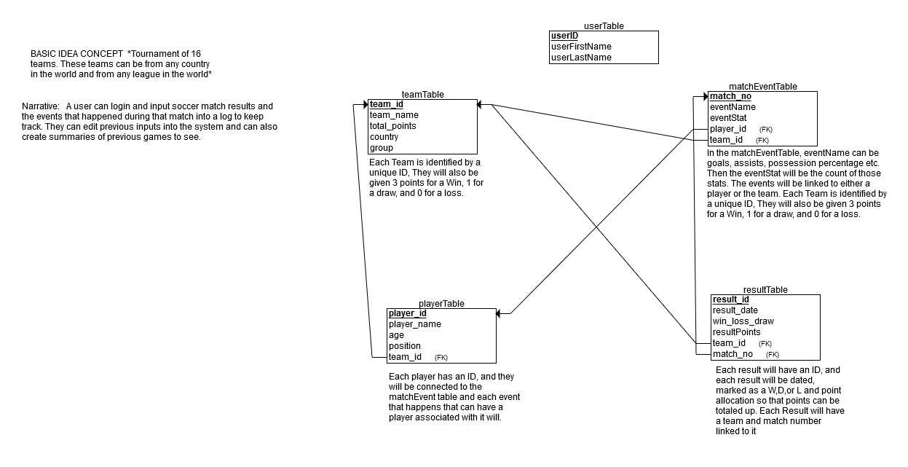

**GENERAL USE CASES:**

User logs in

User logs out

**HIGHER LEVEL USE CASES:**

Admin creates teams/players

Admin updates teams/players

Admin deletes teams/players

User creates match summary

User logs result

User logs match events